Presentation Framework of Entrepreneurship marketing based on the components of product innovation in order to achieve competitive advantage in the Fairview realty group Ltd company

Sajad Farkhi¹, Alireza Eslambolchi²

¹Ph.D. Student Management, Hamedan Branch, Islamic Azad University, Hamedan, Iran.
corresponding Author

²Assistant Professor of Management, Hamedan Branch, Islamic Azad University, Hamedan, Iran.
omrande@yahoo.com

Abstract: The purpose of this research is to provide a framework for entrepreneurial marketing based on the components of product innovation in order to achieve a competitive advantage. This research is in terms of the developmental purpose. Using a combination method, two methods have been used to identify the indices by the method of analysis and its correlation test. The statistical population of the research is the managers and employees of the Fairview realty group Ltd company with 40 people. Data were collected using a researcher-made questionnaire. The results of the research Using expert opinions showed that focus on innovation, risk Tendency, Leader, creating value, opportunistic and customer orientation have been identified as factors influencing entrepreneurial marketing. Also in the quantitative part of the research, Amos software has been used to investigate the relationship between entrepreneurial marketing variables, product innovation and competitive advantage. The results also show a significant relationship between entrepreneurial marketing, product innovation and competitive advantage.
[Sajad Farkhi, Alireza Eslambolchi. Presentation Framework of Entrepreneurship marketing based on the components of product innovation in order to achieve competitive advantage in the Fairview realty group Ltd company. Researcher 2020;12(10):51-59]. ISSN 1553-9865 (print); ISSN 2163-8950 (online). http://www.sciencepub.net/researcher. 8. doi:10.7537/marsrsj121020.08.

Keywords: Entrepreneurship marketing, product innovation, competitive advantage

Introduction
The world economic environment is characterized by rapid changes in all frameworks, especially the technological sides which become the most important discussion axe that affects the economic company’s strategies. Under this new atmosphere that features the external and internal company's environment, it becomes necessary for company to fit itself in these changes in order to maintain its market place, and to face the aggressive competition in such an open world market. Under such a situation, companies are imposed (compiled) to carry out research and development in all fields through innovation and creativity regarding their methods that include: management process, product, marketing…etc, in order to find out new innovation ideas which distinguish the company from others and give it an efficient competitiveness (Reguian, 2014). Innovation leads to a process of change in organizations and its market offerings, and is a key weapon that marketing strategists use to win customers and markets, through the development of sustainable competitive advantage. In the words of Peter F Drucker (1954) ‘there is only one valid definition of business purpose: to create a customer’ and ‘the business enterprise has two and only two basic functions: marketing and innovation’. Innovations use assets and competencies (skill and knowledge in both technical systems and management systems) of the organization along with innovation processes to bring about new or different market offerings, which when successful in the market bring in immense value to the firm (Kanagal, 2015).
Entrepreneurship has been defined as the process of creating value by bringing together a unique set of resources, an opportunity to exploatrii. The process includes the set of activities to identify opportunities, business definition, evaluation and acquiring the necessary resources, management and getting results (Ambler & Kokinakki, 2000). Marketing Entrepreneurship is approached as an integrative concept marketing approach to adapt to new environmental conditions in which the enterprise operates (Bruner et al, 2001). There is growing evidence to support the idea that, over time, companies that have been most successful are those
engaged in entrepreneurial activities of character. The need for an entrepreneurial approach is high in situations where firms are faced with these situations: rapid changes in the technology, needs consumer and social values, decision-making situations in which reaction time is reduced, reduced possibility of long-term control of environmental variables (Burns, 2004). So, given the fact that innovation and entrepreneurship today give companies access to a new business opportunity, we seek to investigate how marketing entrepreneurship and product innovation can bring benefits to the company?
Research Background And Theoretical Framework
Entrepreneurial Marketing
The term “Entrepreneurial Marketing” (EM) has come to describe the marketing activities of small and new ventures. As such, EM has developed within a vibrant and promising fresh field of research. While the analysis of marketing in new and small ventures is an important issue, given the large share of economic activities that can be attributed to these kinds of firms, we argue that EM is more than that: it can also describe marketing activities with an entrepreneurial mindset, irrespective of firm size or age. EM research might want to explore the idea that EM can be implemented regardless of firm size or age in order to broaden the scope of the field (Kraus et al, 2017).
Entrepreneurial marketing model that we propose is a development from the perspective of organizational learning theory, the model of Morris, Schindehutte and LaForge (2002), based on the following assumptions:
a) environmental conditions determine the need and extent of manifestation of the spirit entrepreneurial marketing processes;
b) entrepreneurship event marketing processes is conditioned by three factors: entrepreneurial orientation towards the enterprise market; organizational climate and communication system based on ICT, in particular ERP (Enterprise Resource Planning) collaborative;
c) entrepreneurship event marketing processes induces a higher level of performance marketing.
Since there might be many different conceptualizations for each entrepreneurship and marketing, it is no wonder that a multitude of definitions exist for entrepreneurial marketing. On the one hand, Morris etal. (2002) identify a stream of usage in which the term refers to marketing activities in firms that are resource-constrained and hence apply marketing in an unsophisticated and personal way. On the other hand, Morris et al. also find a stream of research that describes “unplanned, non-linear, visionary marketing actions of the entrepreneur” (Morris et al., 2002). The following table (see Table 1) lists some of the definitions of EM which could be identified in the literature.

Table 1 Definitions of Entrepreneurial Marketing
Bäckbrö an Nyström (2006) | “Entrepreneurial marketing is the overlapping aspects between entrepreneurship and marketing; therefore it is the behavior shown by any individual and/or organization that attempts to establish and promote market ideas, while developing new ones in order to create value.”
Bjerke and Hultman (2002) | “EM is the “marketing of small firms growing through entrepreneurship.”
Duus (1997) | “The distinguishing feature of this new interpretation, which isessentially a market-oriented inside-out perspective, could be the development of the specific competencies of the firm by entrepreneurial action with a view to serving future customers' latent demand for products that do not yet exist. […] this can be called "the entrepreneurial marketing concept.””
Hill and Wright (2000) | “A new stream of research describes the marketing orientation of small firms as ‘entrepreneurial marketing’. This means a style of marketing behavior that is driven and shaped by the owner manager’s personality.”
Miles and Darroch (2006) | “firms adopting EMPs [entrepreneurial marketing processes, the authors] will engage in marketing processes emphasizing opportunity creation and/or discovery, evaluation and exploitation.”
Morris et al. (2000) | “the proactive identification and exploitation of opportunities for acquiring and retaining profitable customers through innovative approaches to risk management, resource leveraging and value creation.”

Product innovation
Product innovation means different things to different people. Some, for example, tend to think in terms of a product which is ‘first of its kind’, whether in the UK or in some larger market. Naturally, few small firms achieve innovation of that degree. And such radical innovation is not necessarily more important than the steady, incremental improvements to existing ranges of products, which far more firms take part in. Indeed, since about 1970 there seems to have been a steady swing towards product improvement rather than totally new products, throughout the industrial world1. We felt there was good reason, therefore, to adopt a broad rather than a narrow view of product innovation. As we stated briefly in the Introduction, we defined it as development of new products, changes in design of established products, or use of new materials or components in manufacture of established products.
Innovation is a major driver of business growth and expansion because it allows firms to transform their dynamic capabilities to become more adaptive and develop the ability to learn and exploit new ideas, given that every firm possesses a bundle of resources, skills and competencies as argued by the resource-based theory of the firms (Peres et al, 2010). Product innovation is particularly important in marketing context because it allows firms to not only develop new market segments but to also expand its current market segments and product portfolios (Slotegraaf & Pauwels,2008). However, product innovation may also lead to higher costs (Lynn, 1998) as well as higher risks and management challenges.
Competitive Advantage
In recent years, the concept of competitive advantage has been a hot issue in the field of competitive strategies and much controversy has been raised in relation to competitive advantage. Nevertheless, providing a precise definition of competitive advantage is a difficult task. On the one hand, the competitive advantage has been defined as too much returns, and on the other hand, it has been linked to the performance of capital markets and expectations. However, the most common definition of competitive advantage in the field of competitive strategy and in the context of value creation is whatever cause revenues increase over expenses (Rumelt Richard, 2003). Competitive advantage is a key concept in strategic management, because it is a competitive strategy that is designed to be exploited by a company. However, the position of superiority affect the company as a search arena of competitive advantage. According to the perspective of business management, competitor is a company that is able to meet the needs of the same customers. The perspective of strategic group, competitor is a collection of companies that compete in an industry that has in common strategies and resources. Strategic dimension to distinguish between strategic groups include: price, quality, degree of vertical integration, geographic scope, depth of product line, the level of diversification, R & D expenditure, market share, profits, and product characteristics (Ibrahim & Primiana, 2015).
Kurt Christensen (2010) gives a clear definition of competitive advantage: “Competitive advantage is whatever value a business provides that motivates its customers (or end users) to purchase its products or services rather than those of its competitors and that poses impediments to imitation by actual or potential direct competitors.” Meanwhile, Ambastha and Momaya (2004) single out the competitiveness as: “the ability of a firm to design, produce and/or market products and services that are superior to those offered by competitors, taking into account the price and non-price qualities”. So, in overall this concept possesses features that stimulate buying intentions via unique and hard-to-imitate characteristics and differentiates company in the competitive landscape. Meanwhile, Martin (2003) stresses the importance of this concept for business as it’s main goal to be competitive, grow and be profitable. The make-up of the competitive advantage is being explained by Singh (2012) noting: “Competitive advantage occurs when an organization acquires or develops an attribute or combination of attributes that allows it to outperform its competitors”.
Research Methodology
This study is a developmental research, because its purpose is to model and identify entrepreneurial marketing factors based on the components of product innovation in order to achieve competitive advantage. On the other hand, the research is a combination of which in the first stage, to identify the dimensions of marketing entrepreneurship, the method of the analysis of the content and then in the next step, using the correlation-structural equation modeling and confirmatory factor analysis, to examine the construct validity and validity of the relationship between entrepreneurship marketing, innovation Product and competitive advantage. The first phase of the research included identifying the components of marketing entrepreneurship based on product innovation. At this stage, using in-depth and non-structured interviews, we gathered data on the components of marketing entrepreneurship based on product innovation. At this stage, the judiciary or target sampling method was used to select the statistical sample of experts. In this way, the researcher tries to choose, on the basis of his own judgment and expert opinion, a model which is as specific as possible to the characteristics of the real society. This method is essentially applied when the number of persons with the characteristics or requirements in the field of study Limited. Following the selection of experts, interviews with them on the topic of study continued to theoretical saturation. It should be noted that after conducting 18 interviews with experts in the company, theoretical saturation of the research was obtained and the researcher concluded that the continuation of the interview did not add new information to previous findings, then analysis of the data in this phase using the method Qualitative analysis of the theme was done.
After completing the qualitative phase of the research and identifying the final indicators, the required questionnaires were designed by the researcher and after determining the reliability and validity of the questionnaires, its distribution was made in the statistical population. To assess the reliability of the Marketing Entrepreneurship Questionnaire and product innovation and competitive advantage questionnaires, Cronbach Alpha has been used. Cronbach's alpha coefficient for marketing entrepreneurship (0.857), inventory inventory (0.825) and competitive advantage questionnaire (0.77). Considering the Cronbach's alpha coefficients, it can be concluded that the research tool has a desirable reliability. To assess the validity of the questionnaire.
Entrepreneurship Marketing and Product Innovation Questionnaire and Competitive Advantage have been used by five experts. The Content Validity (CVR) of the Marketing Entrepreneurship Questionnaire was 0.88 and the content validity of the Product Innovation Questionnaire and Competitive Advice was 0.90 and 0.85. The validity of the questionnaire structure was also verified by using confirmatory factor analysis.
The statistical population of the research in quantitative phase was all employees and employees of the Fairview realty group Ltd company. Regarding the low volume of statistical population, a simple random method was used. After returning, collecting and modifying the questionnaires was analyzed using SPSS and AMOS software using structural equation modeling technique. In order to answer the main question of the research and according to the research method, interviews were conducted with 18 professors, managers and experts in the topic of the company and universities. Interviews with experts were fully recorded with permission from them. In order to analyze the data and to measure the reliability of the results, the interviews recorded by the research team (researcher and two colleagues) were analyzed separately, and the lack of The difference in the results obtained by each of the researchers showed the reliability of the results. In order to measure the validity of the method, in addition to the general, organizing, and basic themes based on theoretical foundations and research backgrounds, the views and views of a group of experts have also been used. The specifications of the participating experts in the research are listed in Table 2.

Table 2. Describe the status of the experts
Frequency percentage valid | Frequency | Abundance | education
33/3 | 33/3 | 6 | Masters
66/7 | 66/7 | 12 | Phd
100/0 | 100 | 18 | Total

Stages of data analysis by the method of analysis
The temporal analysis process starts when an analyst looks at semantic patterns and topics that have potential attraction. This analysis includes a continuous sweep between the data set and the set of codings, and the analysis of the data that was generated. Writing an analysis starts from the first stage. In general, there is no unique way to start a study on thematic analysis (Clarke and Brun, 2006). In this research, the Clarke and Bronchine six steps are used as follows: first stage. Data Acquisition: In order for a researcher to become familiar with the depth and breadth of content, it is necessary to immerse themselves in them. Data immersion usually involves "repeated data readout" and read data actively (ie, searching for meanings and patterns).
Second stage. Creating Primary Codes: The second stage begins when the researcher reads the data and becomes familiar with them. This step involves creating primary data codes. Codes introduce a feature of the data that the analyst finds interesting. Coded data are different from analytical units. Encoding can be done manually or through software programs. At this stage, 240 initial codes of interviews were counted.
Step Three: Selecting Selection Codes: This step involves categorizing different codes in the selective codes and regularizing all the encoded data summary. In fact, the researcher starts analyzing his codes and looks at how different codes can be combined to create a theme. At this stage, 148 selective codes were obtained by the researchers. At this point, the researchers abandoned incomplete or irrelevant codes as well as repetitive codes to achieve this selective code number.
Step Four Formation of constructive themes: The fourth stage begins when the researcher creates a set of themes and reviews them. This stage involves two stages of review, refinement and formulation of constructive themes. The first stage involves a revision at the level of the encoded summary. In the second stage, the validity of constructive themes is considered in relation to the data set. At this stage, the researchers have achieved 6 constructive themes.
Step Five Defining and naming pervasive themes: The fifth step begins when there is a satisfying image of the themes. The researcher at this stage defines and re-examines the pervasive content that has been presented for analysis, and then analyzes the data inside them. By defining and revising, the nature of what a topic discusses is determined and determines which part of the subject matter is covered by each inclusive subject.

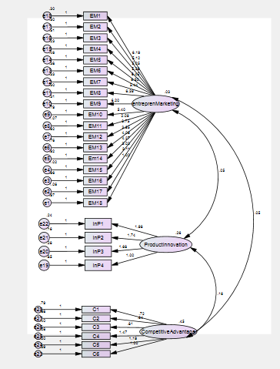
Chi-Square =91.946 DF = 41, P-Value = 0.000, RMSEA= 0.05
Chart 1. Confirmatory factor analysis of structural factors

Table 4. The constructive themes and the basis of interview analysis
The theme is constructive | Basic themes | Abundance
Focus on innovation | Thinking and behaving in an innovative way in business | 11
 | Technology and new ways of doing things | 9
Risk tendency | The tendency to test and apply risky ideas and projects | 6
 | Paying attention to the competitive environment is constantly changing | 8
 | Faced with ambiguity and uncertainty | 8
Leader | Introducing new products to customers | 7
 | Identifying and using new technologies | 6
 | Staying in a stable and peaceful situation | 10
Create value | Creating more value for customers | 9
 | High value of non-competitive products to competitors | 11
Opportunity Orientation | Understanding Innovative Opportunities for Better Marketing | 7
 | Use new ideas to gain competitive advantage | 11
 | Influencing favorite markets and excelling competitors | 8
 | Make more effective and more efficient activities | 12
Customer Orientation | Close contact with customers | 8
 | Understanding the needs and expectations of our customers | 9
 | Monitor customer status in getting feedback | 10

Research findings
After conducting in-depth and semi-structured interviews with corporate executives and industry experts on marketing entrepreneurship, all of the interviewing codes that seemed to be directly related to the subject matter of the research were extracted. After the analysis of the topic, the researchers eventually achieved 6 basic themes. According to the categorization obtained from the qualitative analysis of the subject and according to the terms in each factor, the first factor, entitled "Focus on Innovation," is the second factor, entitled "Risk to Risk" "From the third factor," Pioneering, "from the fourth factor," Creating Value, "from the fifth factor, entitled" Opportunity Orientation, "from the sixth factor, called" Customer Orientation ". These themes represent the most abstract level of classification and analysis of the data collected in this research. These pervasive themes are in fact the six dimensions of marketing entrepreneurship found in expert interviews.
In the quantitative research, for evaluating the structure's validity, the model of the relationship between entrepreneurial marketing, product innovation and competitive advantage was used from the first order confirmatory factor analysis with AMOS software (Fig. 1).
The results of verifiable factor analysis with partial index P were investigated to examine the acceptability of factor load for observational variables. The results show that the factor loads are all greater than 0.4 and the value of P is less than 0.05, which means that the observation variables are well measured by the hidden variable. Also, according to the results of model fit analysis, in Table 5 and according to the fit indices, it can be said that the model of the analyzed factor has suitable fit.

Table 5: Fitness Indicators for Model
index | ϰ² | Df |  | P | GFI | AGFI | FI | TLI | CFI | NFI | RMSEA
Fitting values | 946/91 | 41 | 35/1 | 000/0 | 90/0 | 88/0 | 93/0 | 92/0 | 93/0 | 90/0 | 05/0

Therefore, considering the relationship between the dimensions of entrepreneurship marketing, product innovation and competitive advantage, the conceptual model of the research can be formulated in Fig. 2 to examine the relationship between entrepreneurship marketing components, product innovation and competitive advantage.

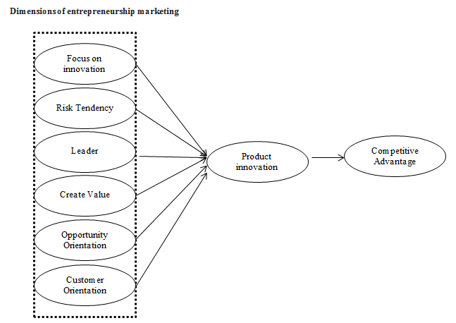
Chart 2. Conceptual model of research

In order to determine the relationship between entrepreneurship marketing, product innovation and competitive advantage, and its fitting, Amos software was used and fitness values were calculated. According to the model, the focus was on innovation (0.21), risk Tendency (0.41), lead (0.07), value creation (0.15), opportunistic (0.97) and customer Ordinary (0.36) In this study, the product innovation and product innovation variance in this study predicts a total of 23.0 of the variance of the company's competitive advantage (Figure 3).

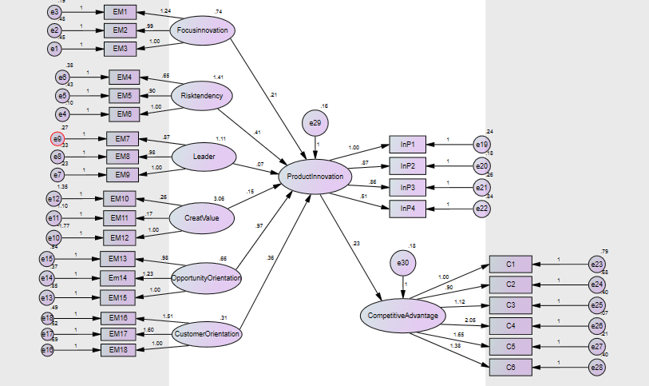
Chi-Square =85.62, df = 35, P-Value = 0.000, RMSEA= 0.07
Chart 3. Investigating the Relationship Between Entrepreneurship Marketing Components, Product Innovation and Competitive Advantage

According to Table 6, with respect to the elevation of the fitting indices CFI (adaptive fit index), IFI (additive fitting index), GFI (fitting index), NNFI (abnormal fit index) and low RMSEA error (mean square error Standardized Root), it can be said that the model has a favorable fit.

Table 6: Fit the final model
CFI | IFI | GFI | NNFI | RMSEN | index
0.93 | 0.93 | 0.90 | 0.92 | 0.08 | Fitting values

Conclusion
Product innovation is one of the key factors in the success of several brands. It was described by Vazquez-Brust and Sarkis (2012) as new product design launched by a brand for profitable purposes that aim to promote the quality and features of products which basically stem from the creative designs during production process. Product innovation covers several aspects such as new product development, improvement in design of established products, or utilization of new resources or components in the creation of established products (Policy Studies Institute [PSI], 2010). The purpose of this study was to identify the components of marketing entrepreneurship with respect to the product innovation variable, which is critical for the company to gain competitive advantage. As innovation brings business growth and business growth into business, as the business environment is constantly evolving, and these changes are not foreseeable, companies need to do a lot of work. The actions are women who go ahead with their rivals and take their market share. In this research, using the theme analysis method and 6th experts' views, they were introduced as entrepreneurial marketing in the company. These six dimensions are focusing on innovation, risk appetite, Leader, creating value, Opportunity and customer orientation. Also, results indicate that there is a meaningful relationship between the dimensions of entrepreneurial marketing, product innovation and competitive advantage. On the other hand, the fitting of the research model is desirable. Therefore, paying attention to entrepreneurship and innovation in business practices and activities, companies in the competitive market can achieve significant benefits and have better performance than competitors.

References
- Ambastha, A., Momaya, K., (2004), Competitiveness of Firms: Review or Theory, Frameworks and Models // http://www.faracididattica.it/files/dott_ajitabh_et_al_2004.pdf (Referred on 12/11/2015).
- Ambler, T., Kokinakki, F. (1997). Measures of Marketing Success, Journal of Marketing Management, 13, p. 665-678.
- Bäckbrö, J. and Nyström, H. (2006) Entrepreneurial marketing: Innovative value creation, Jönköping, Master Thesis.
- Bjerke, B. and Hultman, C.M. (2002) Entrepreneurial marketing: The growth of small firms in the new economic era, Gloucestershire, Edward Elgar Publishing Limited.
- Bruner, G., James, K.E., Hensel, P.J. (2001), Marketing Scales Handbook: A Compilation of Multi-Item Measures, Vol. III. Butterworth Heinemann.
- Burns, P. (2004). Corporate Entrepreneurship: Building an Entrepreneurial Organization, Macmillan.
- Drucker, P (1999). Management challenges for the 21st century. Harper Collins.
- Duus, H.J. (1997) 'Economic foundations for an entrepreneurial marketing concept', Scandinavian Journal of Management, Vol. 13, No. 3, pp.287-305.
- Hill, J. and Wright, L.T. (2000) 'Defining the scope of entrepreneurial marketing: A qualitative approach', Journal of Enterprising Culture, Vol. 8, No. 1, pp.23-46.
- Ibrahim, R., & Primiana, I. (2015). Influence Of Strategic Competitive Advantage On Cooperation Performance, International Journal of Economics, Commerce and Management, 2(4): 1-18.
- Kanagal, N.B. (2015). Innovation and product innovation in marketing strategy, Journal of Management and Marketing Research, 8(1): 1-25.
- Kraus, S., Harms, R., & Fink, M. (2017). Entrepreneurial Marketing: Moving beyond Marketing in New Ventures, Int. J. Entrepreneurship and Innovation Management, 1-20.
- Lynn, G.S. (1998). New Product Team Learning: Developing and Profiting from your Knowledge, California Management Review, 3(38): 74-93.
- Martin, R. L. (2003), A Study on the Factors of Regional Competitiveness. Draft final report for The European Commission Directorate-General Regional Policy. http://ec.europa.eu/regional_policy/sources/docgener/studies/pdf/3cr/competitiveness.pdf (Referred on 12/11/2015).
- Miles, M.P. and Darroch, J. (2006) 'Large firms, entrepreneurial marketing processes, and the cycle of competitive advantage', European Journal of Marketing, Vol. 40, No. 4/5, pp.485-501.
- Morris, M.H., Schindehutte, M. and LaForge, R.W. (2002) 'Entrepreneurial marketing: A construct for integrating emerging entrepreneurship and marketing perspectives', Journal of Marketing Theory & Practice, Vol. 10, No. 4, pp.1-19.
- Peres, R., Muller, E., & Mahajan, V. (2010). Innovation diffusion and new product growth model: A critical review and research directions, International Journal of Research in Marketing, 27(2): 91-106.
- Policy Studies Institute, (2010). Small Firms Innovation, University of Westminste. Retreived on 26 October, 2014 from: http://www.psi.org.uk/publications/archivepdfs/Small%20firms/SF1.pdf
- Reguia, Ch. (2014). Product Innovation And The Competitive Advantage, European Scientific Journal, 11(1): 140-158.
- Rumelt Richard, P. (2003). What in the world is competitive advantage. Policy Working Paper, 105(3): 1-5.
- Schumpeter, J.A. (1971). The fundamental phenomenon of economic development, in Kilbey (Ed.), Entrepreneurship and economic development, New York: Free-Press, pp.43-70 Sheth, J.N., Sisodia, R.S. (1999). Revisiting marketing’s lawlike generalizations, Journal of the Academy of Marketing Sciences, 17 (1), 71-87.
- Singh, P. K. (2012). Management of Business Processes Can Help an Organization Achieve Competitive Advantage. International Management Review, Vol. 8, No. 2.
- Slotegraaf, R.J., & Pauwels, K. (2008). The impact of Brand Equity and innovation on the Long- Term Effectiveness of Promotions, Journal of Marketing Research, 45(3): 293-306.
- Vazquez-Brust, D. A., and Sarkis, J. (2012). Green Growth: Managing the transition to a sustainable economy. Springer Dordrecht Heidelberg New York Londo.

10/24/2020

