Invention of Eco-Friendly Catalyst-Free One Pot Synthesis of Novel 3-Phenyl-3,4-Dihydro -2h- [1,3] Oxazino [5,6-H] Quinoline Derivatives Via Reaction of 8-Hydroxyquinoline

Yannawar Sonali Balajirao

School of Chemical Sciences, Swami Ramanand Teerth Marathwada University, Vishnupuri, Nanded- 431606, Maharashtra, India
Email: sonaliby24@gmail.com

Abstract: The main objective of this paper is to present a developed an eco-friendly catalyst-free one pot synthesis of novel 3- phenyl-3,4-dihydro-2H- [1,3] oxazino [5,6-h] quinoline derivatives via the reaction of 8-hydroxy quinoline, aromatic amines, and paraformaldehyde under reflux condition in high to excellent yield. Our protocol achieves the highest level of green chemical process in terms of economy, ecology, avoidance of catalyst as well as conventional volatile organic solvents, operable under mild reaction conditions, no waste formation, easy separation, and purification of products.
[Yannawar Sonali Balajirao. Invention of Eco-Friendly Catalyst-Free One Pot Synthesis of Novel 3-Phenyl-3,4-Dihydro -2h- [1,3] Oxazino [5,6-H] Quinoline Derivatives Via Reaction of 8-Hydroxyquinoline. Researcher 2020;12(10):1-7]. ISSN 1553-9865 (print); ISSN 2163-8950 (online). http://www.sciencepub.net/researcher. 1. doi:10.7537/marsrsj121020.01.

Keywords: Eco-friendly, Catalyst-free, Novel, Quinoline derivatives, 8-Hydroxy Quinoline

1. Introduction
In view of environmental aspects, designing of novel, catalyst-free methods to synthesize a variety of pharmacological agents has acquired immense importance in recent years [1]. The rich and efficient chemistry that stems from multicomponent reactions [MCRs] provide a convenient approach to pursue these ambitions [2]. One pot MCRs often shorten reaction periods and higher overall chemical yields compared to multiple-step syntheses, and thus reduces the use of energy and manpower [3]. Replacement of hazardous solvents with environmentally benign solvents [4-5] is one of the major focus areas of green chemistry. Also, catalyst-free synthetic method not only for laboratory synthesis but also in the chemical industry have acquired immense interest because of reduced, lower cost, mild conditions, and ease of purification [6]
1,3-Oxazine ring system is a core structure present in a number of biodynamic heterocycles. The compound containing dihydro-1,3-oxazine ring system exhibit a wide spectrum of pharmacological activities such as anti-tumor [7], anti-bacterial [8], anti-HIV [9] and antimalarial [10]. Particular attention has been paid to this class of compounds since the discovery of the non-nucleoside reverse transcriptase inhibitor trifluoromethyl -1,3-oxazine-2-one, which shows high activity against a variety of HIV-1 mutant strains [11]. This 1,3-oxazine ring system also finds its applicability in photo induced ring opening and thermal ring closing [12,18].
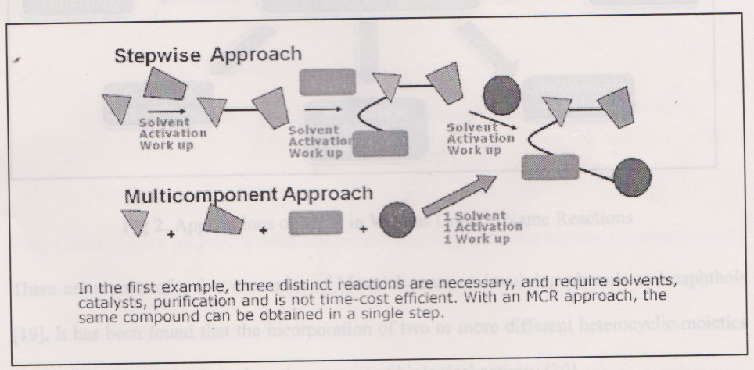
Fig 1. Advantages of Multi Component Reactions over Stepwise Approach

Mannich reaction is one of the most useful carbon-carbon bond formation reactions in organic synthesis. Most of the current Mannich reactions involve the condensation of enolizable ketones with formaldehyde and amines.
There are reports of a few examples of mannich reaction involving phenols and naphthols [19]. It has been found that the incorporations of two or more different heterocyclic moieties in a single molecule leads to the enhancement of biological activity [20]. In the present work, reported a facile one pot synthesis of 3-phenyl-3,4-dihydro-2H- [1,3] oxazino [5,6-h]
quinoline derivative by Mannich reactions using 8-hydroxy quinoline, substituted aniline, and paraformaldehyde.

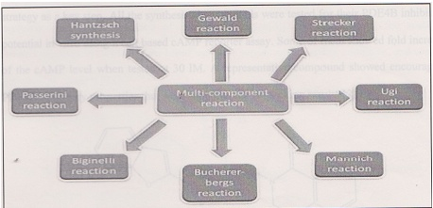
Fig 2. Applications of MCR in Various Organic Name Reactions

In the present study I try to innovation of eco-friendly catalyst-free one pot synthesis of novel 3-phenyl-3,4-dihydro -2h- [1,3] oxazino [5,6-H] quinoline derivatives through reaction of 8-Hydroxyquinoline.
2. Review of literature: -
There are derivatives of Benzo [1,3-e] oxazine were reported in the literature due to its wide applications in the fields of medicinal chemistry, benzo [1,3-e] oxazine derivative have occupied a unique position in the field of medicinal chemistry due to its versatile building block. Raja Moahan Rao et al., have reported number of 2H-1,3-benzoxazin -4(3H)-one derivatives containing indole or benzofuran moieties by using pd/C-Cu mediated coupling-cyclization strategy as a key step. All the synthesized compounds were tested for their PDE4B inhibitory potential in vitro using a cell-based CAMP reporter assay. Some of them Showed fold increase of the cAMP level when tested at 30 1M. A representative compound showed encouraging PDE4B inhibitory properties that were supported by its docking results [21].

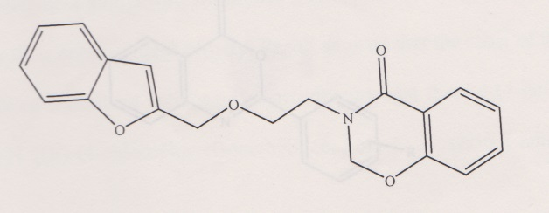

Peng Leu et al have reported number of multi-component reaction involving arynes, N-heteroaromatic compounds (including pyridine, quinoline, and isoquinoline) and aldehydes or ketones for the synthesis of benzo-annulated 1,3-oxazine derivatives. The whole process was carried out under mild conditions and furnishes the desired products in 35 -85% yields. Furthermore, regioselectivity and diastereo selectivity can be observed when using 3-OCH₃ arynes precursor in this reaction [22].

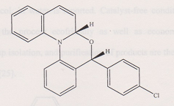

S K Manusamy et al have developed a particle and efficient synthesis of 2-phenyl-4H-benzo [d] [1,3]oxazine-4-one derivatives through copper catalyzed tandem reaction of 2-iodobenzoic acid with arylmethanamines under aerobic conditions. Compared to the literature methods to words the synthesis of 2-phenyl-4Hbenzo [d] [1,3] oxazine-4-one, the synthetic method reported in this letter has broad substrate scope, mild reaction condition, and uses an inexpensive catalyst [23].

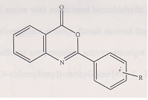

Laura Moreno et al have reported Synthesis of pyrido [2,1-a] isoquinoline-4-ones and oxazino [2,3-a] -4-ones: New inhibitory of mitochondrial respiratory chain [24].

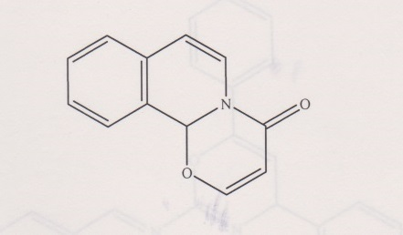

G Khanna et al have reported catalyst-free multicomponent reaction (MCR) capable of affording a wide range of novel benzo [a] [1,3] oxazino [6,5-c] phenazine derivatives via one pot two-step domino protocol, in water is reported. Catalyst-free conditions along with green solvent system make the process ecofriendly as well as economical. Simple reaction conditions, easy work-up isolation, and purification of products are the significant advantages of the present protocol [25].

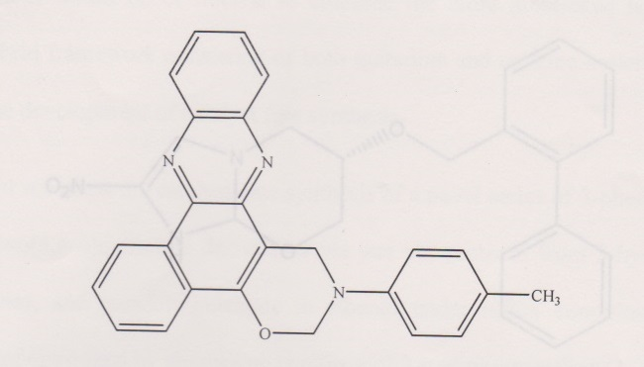

Sawant et al, synthesized a series of Schiff bases of 1,3-oxazines were synthesized via reaction of 1,3-oxzine-2 amine with substituted benzaldehyde. The synthesized compounds were screened for their anticoagulant activity amongst them 4-(4-Bromophenyl)-6-(4-chlorophenyl)-N [ (E)-(4-chlorophenyl)-methylidene]-6H-1,3-oxazin-2-amine was to be most active [26].

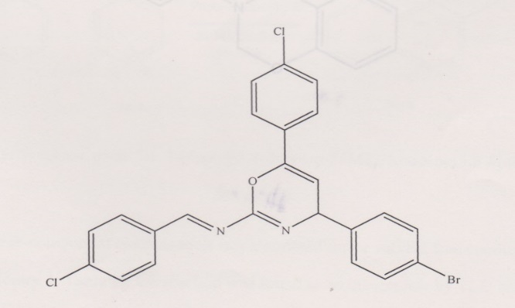

Kalra et al reported the antitubercular activity of ortho-, meta-, and -para-substituted biphenyl analogs of 2-nitroimidazo [2,1-b] [1,3] oxazine has been analyzed through combinatorial protocol in multiple linear regression using physicochemical and structure descriptors obtained from MOE software.

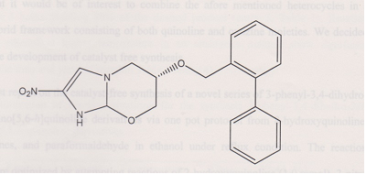

Kamble et al reported an efficient green synthesis and in silico investigation of dihydro-2H-benzo [1,3] oxazine derivatives as inhibitors of Mycobacterium tuberculosis. The some of the derivatives found to be potential inhibitors of Mycobacterium tuberculosis [27].

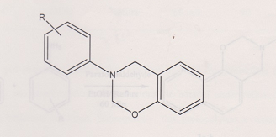

3. Result and Discussion
In the of our ongoing research toward the synthesis of heterocycles via MCRs, we envisaged that it would be of interest to combine the afore mentioned heterocycles in a molecular hybrid framework consisting of both quinoline and oxazine moieties. We decided to focus on the development of catalyst free synthesis.
This is the first report on the catalyst-free synthesis of a novel series of 3-phenyl -3,4-dihydro-2H- [1,3] oxazino [5,6-h] quinoline derivatives via one pot protocol from 8-hydroxyquinoline, aromatic amines, and paraformaldehyde in ethanol under reflux condition. The reaction conditions were optimized by attempting reaction of 2-hydroxyquinoline (1.0 mmol),3-nitro anilines (1.0 mmol), and par formaldehyde (2.0 mmol) as model substrates under different condition and temperatures.

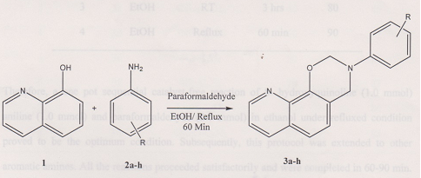

Scheme 1. Synthetic route for 3-phenyl-3,4-dihydro-2H- [1,3] oxazino [5,6-h] quinoline derivatives

When three component condensation was attempted under solvent free condition at room temperature (entry 1, Table 1), the reaction was found to be complete by TLC and showed a number of spots on TLC. After further manipulation of reaction conditions, we observed that if the reaction was performed under solvent free condition at elevated temperature, the reaction was found to be completed in 8 hours and afforded 70% of yield (entry 2, Table 1). Some reaction when performed in ethanol at room temperature was found to proceed to completion in 3 hours yielding 80% of the desired product (entry 3, Table 1). Reaction attempted in ethanol at higher temperature in an analogous manner show significant difference in the time and yield of reactions Table 1 (entry 4.)

Table 1. Optimization of reaction condition for the synthesis 3-phenyl-3,4-dihydro-2H- [1,3] oxazino [5,6-h] quinoline derivatives
Entry | Solvent | Temp | Time | Yields (%)
1 | - | RT | >8hrs | Traces
2 | - | 80 | 8hrs | 70
3 | EtOH | RT | 3hrs | 80
4 | EtOH | Reflux | 60min | 90

Therefore, a one pot sequential catalyst-free reaction of 8-Hydroxyquinoline (1.0 mmol) aniline (1.0 mmol) and paraformaldehyde (2.0 mmol) in ethanol under refluxed condition proved to be the optimum condition. Subsequently, this protocol was extended to other aromatic amines. All the reactions proceeded satisfactorily and were completed in 60-90 min. The desired 3-phenyl-3,4-dihydro-2H- [1,3] oxazino [5,6-h] quinoline [5,6-h] quinoline derivatives were obtained in high yields by a simple work up.
The structures of all the above synthesized 3-phenyl-3,4-dihydro-2H- [1,3] oxazino [5,6-h] quinoline derivatives were fully characterized by ¹H NMR, IR and mass spectra. The IR spectrum of compounds showed the characteristic absorption peacks of 3-phenyl-3,4-dihydro-2H-[1,3] oxazino [5,6-h]quinoline ring structure at 1226 cm⁻¹ (asymmetric stretching of C-O-C), and at 1035 cm⁻¹ (symmetric stretching of C-O-C). In ¹H NMR, characteristic peaks of two methylene groups of 1,3-oxazine ring are observed at 4.79 corresponding to O-CH₂-N. Further evidence for the formation of 3-(4-nitro-phenyl)-3,4-dihydro-2H-benzo [1,3] oxazine was obtained by recording its mass spectrum. The mass spectrum of compound showed M⁺ion peak at m/z at 307. 30 for the molecular formula C₁₇H₁₃N₃O₃. The typical synthetic procedure and characterization data of compounds (3a-h) are presented in the Experimental Section.

Table 2. Synthesis of 3-phenyl-3,4-dihydro-2H-[1,3] oxazino [5,6-h]quinoline derivatives
Sr. No | Compounds | R | Time (min) | Yields (%)
1 | 3a | 4Me-C₆H₄ | 60 | 90
2 | 3b | C₆H₅ | 55 | 90
3 | 3c | 4NO₂- C₆H₄ | 60 | 89
4 | 3d | 3NO₂- C₆H₄ | 60 | 91
5 | 3e | 4Cl-C₆H₄ | 50 | 83
6 | 3f | 4Br- C₆H₄ | 70 | 81
7 | 3g | 3,4Cl-C₆H₃ | 65 | 86
8 | 3h | 4MeO-C₆H₄ | 60 | 85

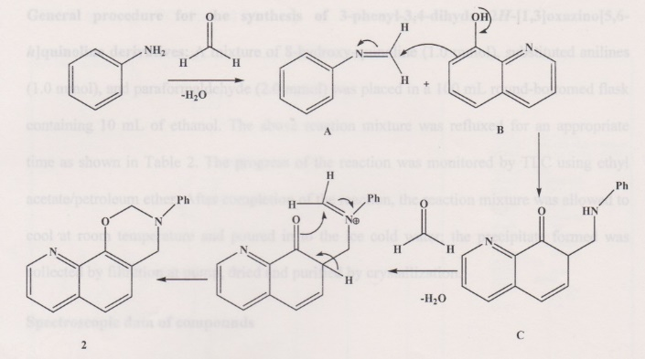

Scheme 2. A Plausible mechanistic pathway for the synthesis of 3-phenyl-3,4-dihydro-2H- [1,3] oxazino [5,6-h] quinoline derivatives.
A proposed mechanistic route for the formation of the products is exhibited in Scheme 2. At first, amination reaction occurs between the paraformaldehyde and amine (RNH₂) followed by H₂O elimination providing imine intermediate ‘A’.’A’ is then attacked by 8-hydroxy quinoline (B) to form ‘C’ which further reacts with formaldehyde and eliminates H₂O, further cyclization occurs to form final product (2).

3.2. Experimental
All reagents were obtained from commercial suppliers and used without further purification. Reaction progress was monitored through thin layer chromatography (TLC) on pre-coated Merck alu-foil plate (silica gel 60F-254, 0.25 mm thickness) visualized by iodine vapours. Melting points where determined by open capillary method and are uncorrected. IR spectra were recorded (in KBr pallets) on SCHIMADZU spectrophotometer. ¹H NMR spectra were recorded on a Avancw / Bruker 300/400 MHz spectrophotometer using TMS as an internal standard. All NMR spectra were obtained in DMSO d_{6/} deuterated chloroform (CDCl₃); chemical shifts are reported as follows: s (singlet), d (doublet), t (triplet), m (multiplet). The mass spectra were recorded on GC-MS SHIMDZU (Q2010PLUS) in EI mode spectrometer and mass values are reported in m/z.

General procedure for the synthesis of 3-phenyl-3,4-dihydro-2H- [1,3] oxazino [5,6-h] quinoline derivatives:
A mixture of 8-hyroxy-quinoline (1.0mmol), substituted anilines (1.0mmol), and paraformaldehyde (2.0mmol) was placed in a 100 ml round bottomed flask containing 10ml of ethanol. The above reaction mixture was refluxed for an appropriate time as shown in table 2. The progress of the reaction was monitored by TLC using ethyl acetate/petroleum ether. After completion of the reaction, the reaction mixture was allowed to cool at room temperature and poured in to the ice-cold water; the precipitate formed was collected by filtration at pump, dried and purified by crystallization.

Spectroscopic data of compounds
3-(4-methyl phenyl)-,4-dihydro-2H- [1,3] oxazino [5,6-h] quinoline (3a);
IR (KBr, cm⁻¹) vmax;3018(Ar C-H), 2916(C-H), 1409 (C=C),1223 (C-O-C), 742;¹H NMR (CDCl₃, 300 MHz, 25⁰C) δppm; 2.31(s,3H,CH₃),4.73 (s,2H,-N-CH₂-),5.40(s, 2H, -O-CH₂-N),6.85(d,1H, J=7.4 Hz), 6.93 (t, 1H, J=7.4 Hz), 6.97 (d,1H,j=7.6 Hz), 7.04 (t,2H,J=7.6 Hz),7.14(d,2H, j=8.0 Hz), 7.17 (d,2H, J=8.0 Hz, H-13,15); ESI-MS: m/z:276 [M]+; chemical formula; C₁₈H₁₆N₂O.

3-phenyl-3,4-dihydro-2H- [1,3] oxazino [5,6-h] quinoline (3b);
IR (KBr, cm⁻¹) vmax;3030(Ar C-H), 2966(C-H),1409 (C=C),1220 (C-O-C), 742;¹H NMR (CDCl₃, 300 MHz, 25⁰C) δppm; 4.78 (s,2H,-N-CH₂-),5.64(s, 2H, -O-CH₂-N),6.89(d,1H, J=7.4 Hz), 6.91(t, 1H,J=7.4 Hz),6.99 (d,2H,j=7.6 Hz), 7.04 (t,2H,J=7.6 Hz),7.14(d,2H, j=8.0 Hz), 7.17 (d,2H, J=8.0 Hz, H-13,15); ESI-MS: m/z:276 [M]+; chemical formula; C₁₇H₁₄N₂O.
3-(4-nitro phenyl-3,4-dihydro-2H- [1,3] oxazino [5,6-h] quinoline (3c);
IR (KBr, cm⁻¹) vmax;3028 (Ar C-H), 2961(C-H),1533 (NO₂), 1419 (C=C), 1225 (C-O-C), 742;¹H NMR (DMSO-d₆ 400 MHz, 25⁰C) δ ppm; 4.71 (s,2H,-N-CH₂-),6.01 (s, 2H,-O-CH₂-N),7.97-8.04(m,9H) ESI-MS: m/z:307.1 [M]+; chemical formula; C₁₇H₁₃N₃O₃.

4. Conclusions
In Conclusions, I have developed an eco-friendly catalyst-free one pot synthesis of novel 3- phenyl-3,4-dihydro-2H- [1,3] oxazino [5,6-h] quinoline derivatives via the reaction of 8-hydroxy quinoline, aromatic amines, and paraformaldehyde under reflux condition in high to excellent yield. Our protocol achieves the highest level of green chemical process in terms of economy, ecology, avoidance of catalyst as well as conventional volatile organic solvents, operable under mild reaction conditions, no waste formation, easy separation, and purification of products. In short is the ecofriendly product development as per the current needful development in recent era.

Acknowledgements:
We are thankful to the School of Chemical Sciences, Swami Ramanand Teerth Marathwada University, Nanded for providing laboratory and library facilities.

Corresponding Author:
Yannawar Sonali Balajirao
School of Chemical Sciences
SRTM University Nanded 431606, India
Telephone: 02462-229242
Email: sonaliby24@gmail.com

References
- (a) Charati, F. R.; Hossaini, Z. Synlett2012, 2397; (b) Gu, Y, De Sousa, R, Frapper, G.; Bachmann, C,; Barrault, J,; Jerome, F. Green Chem. 2009,11,1968.
- (a) Valiulin, R. A.; Halliburton, L. M.; Kutateladze, A. G. Org, Lett.2007,9,4061; (b) Li, M.; Shao, P.; Wang, S. W.; Kong, W, Wen, L. R. J. Org. Chem.2012,77,8956.
- (a) Balme, G.; Bossharth, E,; Monteiro, N. Eur. J. Org. Chem.2003,4101; (b) Zhu, J. Org. Chem.2003,1133.
- (a) McNulty, J.; Das, P. Eur. J. Org. Chem.2009, 24,4031; (b) McNulty, J.; Das, P. Tetrahedron Lett. 2009, 50, 5737; (c) McNulty, J.; Das, P.; McLeod, D. Chem. Eur. J.2010, 16, 6756; (d) Narayan, S.; Muldoon, J.; Finn, M. G.; Fokin, V. V.; Kolb, H. C.; Sharpless, K. B. Angew. Chem., Int. Ed.2005,21, 3157; (e) Das, P.; McLeod, D.; McNulty, J. Tetrahedron Lett. 2011, 52, 199; (f) Andrade, C. K. Z.: Alves, L. M. Curr. Org. Chem.2005,9,195.
- (a) Breslow, R. In Organic Reactions in water; lindstrom, M., Ed.; Blackwell: Oxford, 2007; pp1-28; (b) Breslow, R. Rideout, D. C. J. Am. Chem. Soc.1980, 102,7816; (c) Breslow, R. Acc. Chem. Res. 1991, 24, 159.
- (a) Choudhary, G.; Peddinti, R. K. Green Chem.2011, 13, 276; (b) Liu, J.; Lei, M.; Hu, L. Green Chem.2012, 14, 2534; (c) Kumaravel, K.; Vasuki, G. Green Chem. 1945, 2009, 11.
- (a) Kuehne, M. E.; Konopke, E. A. J. Med. Chem. 1962, 5, 257; (b) Chylinska, J. B.; Urbanski, T. J. Med. Chem. 1963, 6, 484; (c) Hus, L.-Y.; Lin, C.-H. Heterocycles 1996, 43, 2687.
- (a) Chylinska, J. B.; Janowiec, M.; Urbanski, T. Br. J. Pharmacol. 1971, 43, 1037.
- (a) Pedersen, O. S.; Pedersen, E. B. Syanthesis 2000, 479; (b) Cocuzza, A. J.; Chidester, D. R.; Cordove, B. C.; Jeffrey, s.; Pedersen, R. L.; Bacheler, L. T.; Erickson-Viitanen, S.; Trainor, G. L.; Ko, S. S. Bioorg. Med. Chem. Lett. 2001, 11, 1177.
- Duffin, W. M.; Rollo, I. M. Br. J. Pharmacol. 1957, 12, 171.
- Zanatta, N.; Squizani, A. M. C.; Fantinel, L.; Nachtigall, F. M. Brochhardt, D. M.; Bonacorso, H. G.; Martins, M. A. P. J. Braz. Chem. Soc. 2005, 16, 1255.
- Tomasulo, M.; Sortion, S.; Raymo, F. M. Org. Lett.2005, 7, 1109.
- Hussain, H.; Specht, S.; S. R.; Saeftel, M.; Hoerauf, A.; Schulz, B.; Krohn, K. J. Med. Chem.2011, 54, 4913.
- Franzblaul, S. G.; O’ Sullivan, J. F. Antimicrob. Agents Chemother. 1988,32,1583.
- (a) Ge, Y.; Pei, D.; Zhao, Y.; Li, W.; Wang, Sh.; Xu, Y. Curr. Microbiol. 2007, 54, 277; (b) Liu, H.; He, Y.; Jiang, H.; Peng, H.; Huang, X.; Zhang, X.; Thomashow, L. S.; Xu, Y. Curr. Microbiol. 2007, 54, 302; (c) Wang, M.; Xu, H.; Yu, S.; Feng, Q.; Wang, S.; Li, Z. J. Agric. Food Chem. 2010, 58, 3651.
- Rewcastle, G. W.; Denny, W. A.; Baguley, B. C. J. Med. Chem.1987,30,843.
- (a) Funayama, S.; Eda, S.; Komiyama, K.; Omura, S. Tetrahedron Lett. 1989, 30, 3151; (b) Wang, S.; Miller, W.; Milton, J.; Vicker, N.; Stewart, A.; Charlton, P.; Mistry, P.; Hardick, D.; Denny, W. Bioorg. Med. Chem. Lett.2002, 12, 415; (c) Vicker, N.; Burgess, L.; Chuckowree, I.; Dodd, R.; Folkes, A.; Hardick, D.; Hancox, T.; Miller, W.; Milton, J.; Sohal, S.; Wang, S.; Charlton, P.; Dangerfield, W.; Liddle, C.; Mistry, P.; Stewart, A.; Denny, W. J. Med. Chem. 2002,45,721; (d) Gamage, S.; Spicer, J.; Rewcastle, G.; Milton, J.; Sohal, S.; Dangerfield, W.; Mistry, P.; Vicker, N.; Charlton, P.; Denny, W. J. Med. Chem. 2002,45,740.
- Fischer, B. B.; Krieger-Liszkay, A.; Eggen, R. I. L. Environ. Sci. Techol. 2004, 38,6307.
- (a) Nguyen, T. B.; Wang, Q.; Gueritte, F. Eur. J. Org. Chem. 2011, 35, 7076; (b) Cimarelli, C.; Fratoin, D.; Palmieri, G. Tetrahedron: Asymmetry 2011, 22, 1560; (c) Kumar, A.; Gupta, M. K.; Kumar, M. Tetrahedron Lett. 2010, 51, 1582; (d) Phillips, J. P.; Keown, R.; Fernando, Q. J. Am. Chem. Soc. 1953, 75, 4306.
- Balini, R.; Bosica, G.; Conforti, M.; Magi, R.; Mazzacannt, A.; Righi, P.; Sarton, G. Tetrahedron 2001, 57, 1395.
- Raja, M. R., Bethala, J. L., Chekuri S. R., Namburi, S. R. K., Kishore V. L. P., Mandava V. B. R., Pal, M.; Bioorg Med Chemi Lett., 2014, 24, 1166.
- Peng, L., Min, L., Lihong, H., Tetrahedron, 2013, 69, 1405.
- Munusamy, S., Venkatesan, S., Sathiyanarayanan, K. I., Tetraheron Letters, 2015, 56, 203.
- Meron, M., Cabedo, N., Boulange, A., Parrage, J., Galan, A., Leleu, S., Sanz, M. J., Cortes, D., Franck, X., Eur J. Med Chem., 2013, 69, 69.
- Khanna, G., Chaudhary, A., Khurana, J. M., Tetrahedeon Letters, 2014, 55, 6652.
- Kalra, S., Kumar, A., Gupta, M. K., Med Chem Res., 2013, 22, 444.
- Kamble, R. D., Hese, S. V., Meshram, R. J., Kote, J. R., Gucche, R. N., Dawane, B. S., Med Chem Res., 2015, 24, 1077.

9/25/2020

