The effect of some urinary species on crystallization of calcium oxalate monohydrate in simulating urinary environment

Naema S. Yehia¹, Abdelrahman A. Badawy²*, Mai A. Ibrahim¹

¹ Chemistry Department, Faculty of Science, Menoufia University, Egypt
² Physical Chemistry Department, Division of Inorganic Chemical Industries and Mineral Resources, National Research Centre, 33 El Behooth St., Dokki Giza, Egypt
*Corresponding author: aabadawy107@yahoo.com

Abstract: The mechanism of crystallization of COM crystals at conditions simulating to artificial urine was studied. XRD, FTIR, SEM, SSA and EDX techniques have been used to elucidate the structure of prepared crystals. The crystallization rates of COM crystals carried out at 37 ºC, I = 0.3 mol.dm⁻³, pH = 5.5, ɣ = 0.4 and the reaction experiment initiated using 0.01 g of seed crystals in each experiment. The order of crystallization of COM crystals at experimental condition was2, which suggests surface-controlled mechanism. The effect of fluid dynamics on the rates of crystallization of COM crystals and the lower value of Ea ( 0.95634 J / mole), supported the surface-controlled mechanism. The rates of crystallization of COM crystals were increased by increasing the values of ionic strength of the medium. Increasing the values of pH of the medium, increased the crystallization rates of COM crystals till pH = 8, after it, the rates decreased with increasing pH values. The effect of concentrations of urine components using concentrations of components similar to that of artificial urine was studied.
[Naema S. Yehia, Abdelrahman A. Badawy, Mai A. Ibrahim. The effect of some urinary species on crystallization of calcium oxalate monohydrate in simulating urinary environment. Researcher 2020;12(9):46-52]. ISSN 1553-9865 (print); ISSN 2163-8950 (online). http://www.sciencepub.net/researcher. 5. doi:10.7537/marsrsj120920.05.

Keywords: Calcium oxalate, Urine stone, crystal growth, Inhibition, sparingly soluble salt

1. Introduction
Sparingly soluble salts of calcium have been studied with respect to pathological crystallization like kidney stones (calcium oxalates), ^{(1,2)} and physiologic crystallizations such as bone and tooth mineralization (calcium phosphates) ^{(3,4)} or marine exoskeletal systems and egg shells (calcium carbonate). ^{(3,5,6)}
The importance of calcium oxalate formation in solution in both analytical and biological fields points to the need for a quantitative study of the ionic interactions in solutions of this electrolyte and also the kinetics of its crystal growth ⁽⁷⁾.
Calcium oxalate (CaOx) is the main component of uroliths. There are three different hydrated forms of calcium oxalate, calcium oxalate monohydrate (COM, whewellite ) oxalate dihydrate (COD, weddillite) and oxalate trihydrate (COT). The monoclinic COM is the thermodynamically most stable phase, followed by the triclinic COT and the tetragonal COD ⁽⁸⁾. Each form of hydrate can be easily recognized, COM usually precipitates in the form of dendrites or boat/coffin morphology, COD shows a bipyramidal morphology, and COT gives plate-like morphology ^{(9,10)}. COM and COD together with calcium phosphate (hydroxyapatite) are the major components of most of the urinary calculi. COT has been rarely found in urines and in kidney stones ⁽¹¹⁾, but it might be important as a possible precursor in their formation.
Urinary stone disease (USD) is defined as a disease caused by endogenous (including hereditary) and/or exogenous factors due to formation of stones in the urinary tract. USD is one of the most common diseases that are prone to relapse, and in many cases it is a severe acute disease ⁽¹²⁻¹⁵⁾. Crystal formation in the urinary tract can be considered as a syndrome that is related to pathological biomineralization ⁽¹⁶⁾.
CaOx is the major component in 60–80 % of human stones ⁽¹⁷⁻¹⁹⁾. The crystallization of calcium oxalate has been the subject of an increasing number of investigations since, it is the most common component of pathological deposits in the urinary tract. The majority of kidney stones (80%) contain calcium oxalate (CaOx) as their primary mineral phase. The urinary stones are comprised of the crystals not resolved or disposed in the urine. Any increase in urinary supersaturation, the crystallization of CaOx starts and solid crystalline particles can be observed. Then, nucleation occurs and stone-forming salts in
supersaturated urinary solution join, so the size of the particles increases ^{(11,20-24)}. Nucleation and the growth of calcium oxalate crystals in urine affect the formation of kidney stones. The level of supersaturation of Ca²⁺ and C₂O₄²⁻, urinary components such as proteins and citrate and interactions with the kidney epithelium are thought the essential factors for the formation of kidney stones ⁽²⁵⁾. Calcium oxalate monohydrate (COM) and dihydrate (COD) can be formed in urine or at epithelial cell surface. Thermodynamically stable COM has a bigger tendency to form stones than COD. COD crystals are considered as less urolithic than COM, so COD is easily expelled out from body ⁽²⁶⁾. A number of studies have been carried out to understand the effect of various additives such as metallic ions ⁽²⁷⁾ and their complexes, sodium dodecyl sulphate ⁽²⁸⁾, a-ketoglutaric acid ⁽²⁹⁾ (a normal physiological constituent of urine), plant extracts ⁽³⁰⁾, maleic acid copolymers ⁽³¹⁾ and protein from human kidney ⁽³²⁾ on inhibition of calcium oxalate crystallization. This protein plays a physiologically significant role in inhibiting the stone formation in acidic urine Inhibitory activity was found to increase with increasing concentration of protein.
Citrate and calcium effects on Tamm-Horsfall glycoprotein as a modifier of calcium oxalate crystal aggregation was studied ⁽³³⁾. The authors measured the effects of Tamm-Horsfall glycoprotein (THP) on calcium oxalate monohydrate (COM) crystal aggregation (Ac) in vitro as well as intrinsic viscosities (Vi) of (THP) at pH 5.7 and 200mM NaCl and studied the effects of calcium and citrate on these parameters.
In the present study, the effect of concentration of some components of urine in ranges indicated in artificial urine was studied. The effect of change of conditions on the mechanism of crystallization of COM crystals in absence and the presence of different components of urine was studied.

2. Experimental
2.1. Materials
Calcium chloride, sodium oxalate were from analyzed analytical grade reagents (EL. Nasr pharmaceutical chemicals company, fisher scientific company and Baker chemical company). Ethylene diamine tetra- acetic acid (EDTA) was standardized using magnesium sulphate of suitable concentration using EBT as indicator. Calcium Chloride stock solution was standardized using the standardized EDTA. Concentration of Sodium Oxalate stock solution was determined by titration against standardized potassium permanganate solution.
2.2. Techniques
Energy-dispersive X-ray spectroscopy (EDX) and transmission electron microscope (TEM) measurements were obtained using JEOL-SEM and JEOL TEM-1230 with an acceleration voltage of 80 kV. FTIR spectra for the prepared samples were recorded using Perkin Elmer Fourier transform infrared spectroscopy. X-ray diffraction patterns of the produced solids were determined using a Bruker diffractometer (Bruker D 8 advance target). CuKα radiation source with secondly monochromator (λ= 1.5405˚A) at 40 kV and 40 mA was used. The scanning rate (0.2 min⁻¹) was adjusted for phase identification and line broadening profile analysis. The textural properties of the samples were determined by physical adsorbing nitrogen (N₂) at 77K using a Quantochrome Nova-Touch 4LX automated gas-sorption apparatus (USA). Before each N₂- sorption measurement, samples were degassed at 200 ºC for 2 h. The N₂-adsorption on the samples was used to calculate the specific surface area by means of the Brunauer–Emmett–Teller (BET) equation ⁽³⁴⁾. The pore size distribution was calculated from desorption branch of the isotherm by the Barrett, Joyner and Halenda (BJH) method. pH measurements were made with a combined pH glass electrode (model 9100 metrohm AG company). emf measurements were made by calcium ion selective electrode (CH-9101Herisau), in conjugation with a calomel reference electrode (model 90.02 orion Research Incorporated Laboratory products Group). The electrodes were checked before and after each dissolution experiment using the buffer solutions recommended by Bates ⁽¹⁵³⁾, pH glass electrode and using calcium chloride solutions with definite concentration in case of selective electrode. In crystallization experiments-using potentiostate, the studies were made at constant emf. Mtrohm combi- titrator (model 718 STAT Titrino connected with printer model EPSON LX 300T and stirrer model E649) was used to control the addition of titrant solution consisting of 0.5M sodium chloride solution into the reaction cell.
2.3. Synthesis of calcium oxalate seeds
One liter of 0.1M calcium chloride solution was added to one liter of 0.1M sodium oxalate solution at 298K at a rate of 500 ml/ per half an hour. The mixture was constantly stirred for one week and then the seed crystals were aged for one month, then, filtered and washed further with deionized distilled water to remove surface contamination due to chloride and oxalate ions and this process was repeated several times. The prepared seed was dried at 40 °C.
2.4. Synthesis of inhibitors
Solutions of sodium chloride, potassium chloride, sodium sulphate, magnesium sulphate, sodium citrate and sodium di-hydrogen phosphate were prepared by weighing amounts of the salts and dissolving in a volume of deionized distilled water. Different concentrations of them were prepared by dilution.

3. Results and Discussion
3.1. X-ray Diffraction (XRD) and surface characteristics
Fig. 1 reveals that the prepared solid is calcium oxalate monohydrate (JCPDS, 13-0379) with good degree of crystallinity.
The surface properties of the prepared samples were investigated from N₂-adsorption-desorption (Fig. 2). The S_{BET} of the prepared solid measured 35 m²/g.

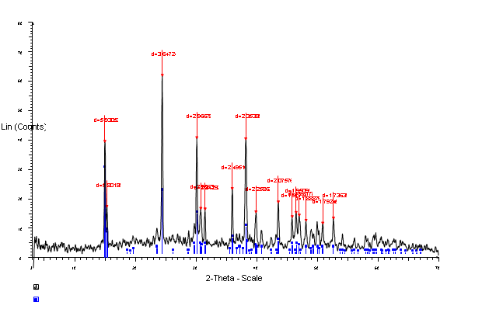
Fig.1. X-ray pattern of the prepared crystals

3.2. Fourier Transform Infrared (FTIR)
FTIR spectrum of calcium oxalate monohydrate. The spectrum of a pure calcium oxalate monohydrate showed a high absorbance at 1616 -1600 cm⁻¹ and 1314 -1302 cm⁻¹ belonged to C=O and C-O stretching vibration, respectively. The frequency region was 779 -775 cm⁻¹ corresponding to C-H bending. The absorption band observed at 3446 - 3021 cm⁻¹ which happened due to symmetric and asymmetric O-H bending. The absorption band at 1387– 1364 cm⁻¹ was happened due to C-C dan C-O stretching, 891 -874 cm⁻¹ was due to C-C stretching, and 693 -687 cm⁻¹ was due to O-H bending (Fig. 3).

Fig.2. isotherm for the prepared sample

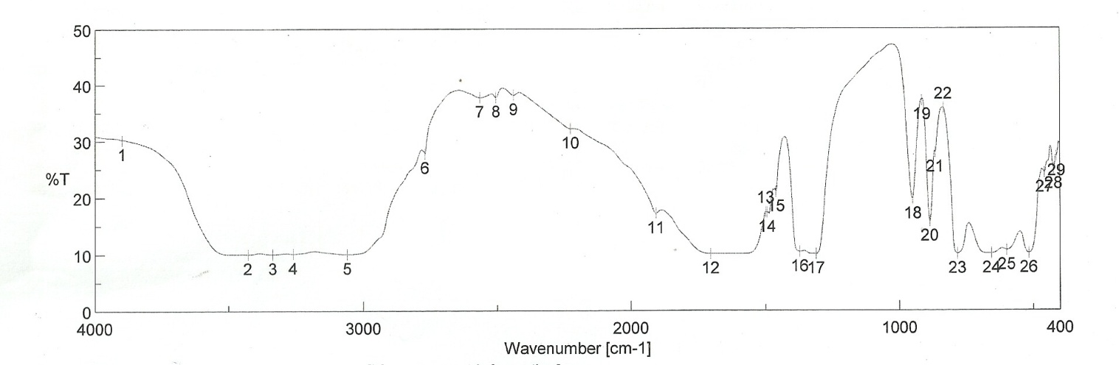
Fig. 3. IR spectrum of prepared crystals

3.3. Scanning Electron Microscope (SEM)
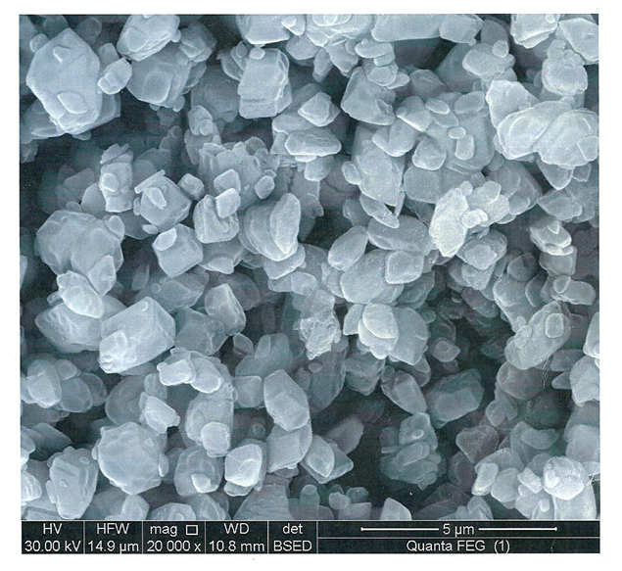
Fig. 4. SEM of the prepared solid

Scanning electron micrographs were taken for the prepared solid (c.f. Fig.4) at low magnification. Fig. 4 exhibits the spherical structure of regular shape. No doubt, these results are totally harmonious with the XRD measurements.
3.4. Studying the mechanism of crystallization of COM crystals in absence of additives
Various crystal growth systems have been subject to investigation the effects of growth conditions on mineral formation. Growth from solution is profoundly affected by numerous factor – supersaturation (SS), ionic ratios, temperature and pH will all affect nucleation and growth ⁽¹⁶⁷⁾.
In the present study, the rate of crystallization of COM crystals at 37 ºC, ionic strength ( I ) = 0.3 mol dm⁻³, pH =5.5 (natural crystal – forming medium) and using 0.01 g of prepared seed crystals were studied. The rate of crystallization were studied at values of degree of supersaturation ranged from 0.04 – 0.7 (c.f. Table 1).

Table 1: Crystallization of calcium oxalate crystals T_{Ca}⁺²: T_{Ox}⁻² = 1:1 at t=37 ºC, ionic strength 0.3 mol.dm⁻³, pH=5.5 and 0.01 g of seed crystals.
Wt. of seed mg | -Log R | Rate x 10⁻⁶ | -Log ɣ | ɣ x 10⁻² | T_{Ca}⁺²x 10⁻⁴
10 | 5.305 | 4.955 | 0.398 | 04 | 2.791
10 | 5.200 | 6.310 | 0.347 | 45 | 2.891
10 | 5.100 | 7.943 | 0.301 | 50 | 2.991
10 | 5.020 | 9.550 | 0.260 | 55 | 3.090
10 | 4.930 | 11.749 | 0.222 | 60 | 3.190
10 | 4.895 | 12.735 | 0.200 | 63.1 | 3.252
10 | 4.800 | 15.849 | 0.155 | 70 | 3.389
10 | 5.305 | 4.956 | 0.398 | 40 | 2.791
10 | 5.305 | 4.958 | 0.398 | 40 | 2.791
a, b: at stirring rates of 300 and 500 r.p.m.

3.4.1. Effect of degree of supersaturation (ɣ) on the rates of crystallization of COM crystals
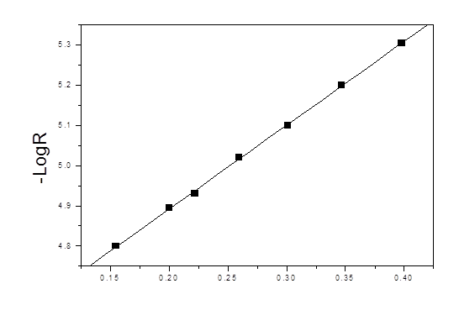
Fig. 5. Plot of -log R against - log ɣ for crystallization of calcium oxalate monohydrate crystals at t = 37 ºC, pH = 5.5, I = 0.3 mol.dm⁻³ and wt. of seed = 0.01 g

The order of reaction can be determined by plotting (-log R) against (-log ɣ) (Fig. 5), where R is the rate of crystallization of COM crystals at certain degree of supersaturation (ɣ). The effective order of reaction at the experimental conditions of t = 37 ºC, pH = 5.5, I = 0.3 mol dm⁻³ and using 0.01 g of prepared seed crystals was ≈ 2 (Fig.5), which suggest surface-controlled mechanism. The assumption of surface-controlled mechanism over a relative supersaturation (ɣ) under study was supported by the observation of the independence of the rates of crystallization of COM crystals on the changes in the rates of stirring (fluid dynamics). However, this evidence may be inconclusive for such small particles for which changes in the stirring rates may have little influence on the fluid shear forces at crystal surfaces (c.f. a and b in Table 1). The particles will tend to move with the fluid flow. The rates of crystallization of COM crystals were also found to be affected by the weight of inoculating seed used to initiate the crystallization process, which may confirm the surface-controlled mechanism.
For surface-controlled crystallization, the rate will be independent on the size of the crystals. Moreover the concentration of electrolyte near the crystal surface will be the same as that in the bulk solution ⁽¹⁶⁹⁾.

3.4.2. Effect of change of pH values of the medium on the rates of crystallization of COM crystals
Urine pH value has been thought to be an important factor that can modulate kidney stone formation. The normal urine is slightly acidic with pH of approximately 6.0 although it can range from 4.5- 8.0. The urine pH has been observed to associated with many disease: eurothetical carcinoma, metabolic disorders and kidney stone disease.
The crystallization rates of COM crystals were studied at 37ºC, I = 0.3 mol dm⁻³, ɣ = 0.4 and 0.01 g of prepared seed crystals at pH values range of 2-13 as shown in Fig. 6. Inspection of Fig. 6 revealed that the rates of crystallization of COM crystals increase by increasing the value of pH till pH = 7 and began to decrease from pH = 8. Previous studies proved that COM (pathogenic form) was crystallized with greatest size, number and total mass of pH = 4 and least crystallized at pH = 8, whereas COD was crystallized with the vice versa order. Crystal cell- adhesion assay showed the greatest degree of crystal-cell adhesion at the most acidic pH and least at the most basic pH. The crystal internalization into renal tubular cells was maximal at neutral pH = 7. The acidic urine pH may promote CaOx kidney stone formation whereas; the basic urine pH (i.e by alkalization) may help to prevent CaOx kidney stone diseases (³⁵⁾.

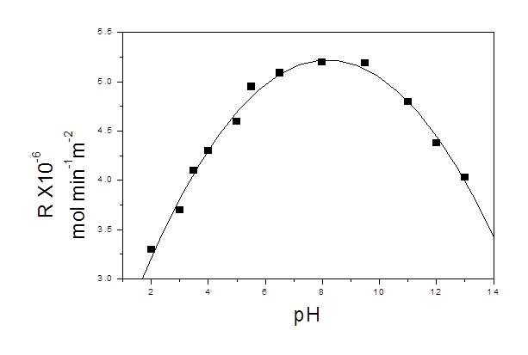
Fig. 6. Effect of change of pH on the rates of crystallization of COM crystals at I = 0.3 mol dm⁻³, ɣ = 0.4, t=37 ºC and 0.01 g of seed crystals

3.4.3. Effect of change of ionic strength of the medium on crystallization of COM crystal
The rate of crystallization of COM crystals at 37 ºC, pH=5.5, ɣ = 0.4, weight of seed of 0.01 g and at range of ionic strength from 0.05- 0.7 mol.dm⁻³corresponding to human urine (using NaCl solution) has been studied as shown in Fig. 7. The results that have been obtained in Fig. 7 showed that the rate of crystallization of COM crystals was decreased by increasing the ionic strength of the medium. Previous study showed that ionic strength was inhibitor of crystallization of COM ⁽³⁶⁾. Decreasing of rates of crystallization of COM crystals with increasing the ionic strength of the medium can be attributed to a strong effect of repulsive electrostatic forces between similar ions in high ionic strength medium which inhibit chemical interaction between Ca²⁺ and Ox²⁻ ions ⁽³⁶⁾.
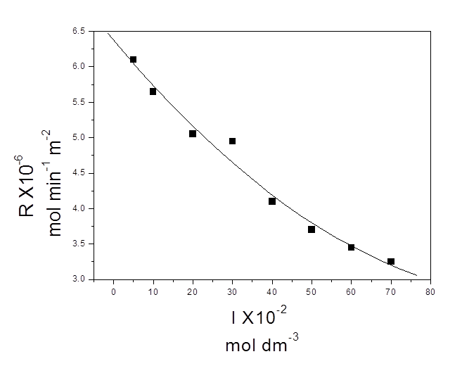
Fig.7. Effect of change of the value of ionic strength ( I ) of the medium on the rate of crystallization of COM crystals at t= 37 ºC, pH =5.5, ɣ =0.4 and 0.01 g of seed crystals

3.4.4. Effect of temperature on crystallization rates of COM crystals
The effect of change of the value of temperature on the rates of crystallization of COM crystals at pH = 5.5, ɣ = 0.4, I = 0.3 mol.dm⁻³, weight of seed crystal = 0.01 g and at temperature range from 283- 310 K was studied (c.f. Fig. 8). Plotting – log R against 1/ T straight line was obtained and the activation energy, Ea, was determined. It was found to equal 0.956 J / mol. The order of two, the independence of the rates of crystallization of COM crystals on the fluid dynamics and the low value of Ea ruled out and confirmed the surface-controlled mechanism of crystallization of COM crystals at the conditions of the present study.
3.5. Studying the mechanism of crystallization of COM crystals in the presence of additives
In this study, the effects of change in some urine components, acidity, ionic strength, temperature and degree of saturation on the rates of crystallization of COM crystals at conditions similar to that of urine were studied. Composition of synthetic urine was used in this study. Table 2 showed the concentration of some urine components as present in synthetic saturated urine.

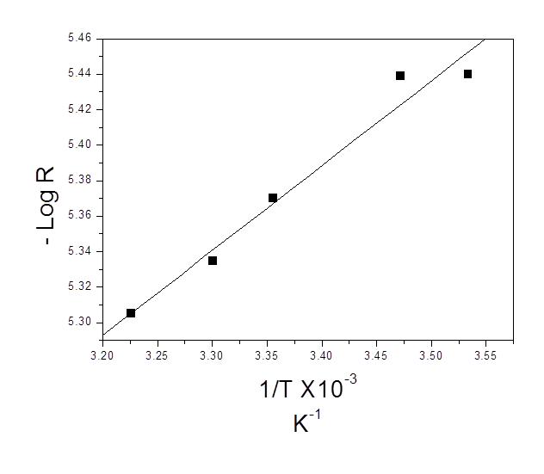
Fig.8. Plot of - log R against 1 / T x 10⁻³ K⁻¹ at I = 0.3 mol.dm⁻³, pH = 5.5, ɣ=0.4 and 0.01 g of seed crystal

Table 2. The concentration of some urine components that has present in synthetic saturated urine.
Concentration in synthetic  urine M | Constituent
0.060 | KCl
0.100 | NaCl
0.004 | MgSO₄
0.017 | Na₂SO₄
0.032 | Na₂HPO₄
0.003 | Sod.citrate

3.5.1. The effect of change of concentration of NaCl in the presence of 0.06 M KCl on the rate of crystallization of COM crystals
The rates of crystallization of COM crystals were studied at 0.06 M KCl and different concentration of NaCl at 37 ºC, I = 0.3 mol.dm⁻³, pH = 5.5 and ɣ = 0.4 using 0.01 g of COM seed crystals to initiate crystallization (c.f. Table 3). It was found that the rates of crystallization of COM crystals decreased with increasing the concentrations of NaCl i.e it inhibited the rates of crystallization of COM crystals. In the present study, NaCl solution was used to adjust the ionic strength of the medium. In absence of additive and on studying the effect of change of the value of ionic strength of the medium on the rate of crystallization of COM crystals in absence of additives, it was found that the rate of crystallization of COM crystals decreased by increasing the value of ionic strength (using NaCl) at experimental conditions. So, this effect now can be explained by the inhibitory effect of NaCl used to adjust the ionic strength of the medium. Table 3 showed that the rate of crystallization decreased with increasing the ionic strength of the medium (via increasing of concentration of NaCl). This supported the inhibitory effect of NaCl in concentration range of 0.08-0.52 mol dm⁻³ on rates of crystallization of COM crystals and in the presence of 0.06 M of KCl.

Table 3. Effect of concentration of NaCl on the rates of crystallization of COM crystals, T_{Ca}⁺²: T_{Ox}⁻² = 1:1 at t=37 ºC, ionic strength 0.3 mol dm⁻³, pH=5.5, ɣ=0.4 and 0.01 g of seed crystals and at 0.06 M KC
R X 10⁻⁶ mol min⁻¹m⁻² | C (mol dm⁻³)
4.790 | 0.08
4.769 | 0.09
4.746 | 0.10
4.711 | 0.12
4.655 | 0.15
4.565 | 0.20
4.409 | 0.29
4.041 | 0.52
2.159 | 3.04

3.5.2. The effect of change of concentration of KCl in the presence of 0.1 M NaCl on the rate of crystallization of COM crystals
The rates of crystallization of COM crystals was studied at different concentrations of KCl differ in the range of its concentration in artificial urine (0.06 M ) and at 0.1 M NaCl at the experimental conditions. Fig. 9, illustrates the rates of crystallization of COM crystals against the concentration of KCl in the presence of 0.1 M NaCl. Fig.9 revealed that at concentration of 0.04 and 0.05, the rates of crystallization of COM crystals decreased and after concentration of KCl of 0.05, the rates of crystallization of COM crystals began to increase.
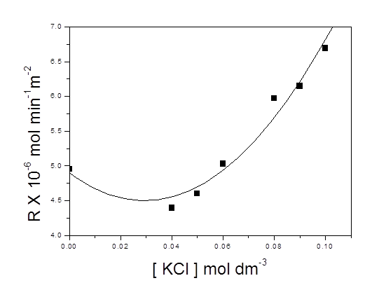
Fig.9. Plot of rates of crystallization of COM crystals against concentration of KCl in mol.dm⁻³at t=37 ºC, ionic strength 0.3 mol.dm^{-3,} pH=5.5, ɣ = 0.4 and 0.01 g of seed crystals and at 0.1 M NaCl

4. Conclusion
On studying the mechanism of crystallization of COM crystals at conditions simulating the synthetic urine:
1. The order of reaction was equal two which suggest surface-controlled mechanism of crystallization of COM crystals.
2. The low value of activation energy in the absence of additives; 0.9563 J/mol and the independence of rates of crystallization on the fluid dynamic supported the surface-controlled mechanism.
3. The rates of crystallization of COM crystals increased by increasing the value of ionic strength of the medium which indicated that the reaction in this case was electrostatic in its nature.
4. The rates of crystallization of COM crystals at conditions of study increased by increasing the value of pH of the medium till pH = 8, then by increasing the value of pH after 8, the crystallization rates of COM crystals decreased.
5. At constant concentration of KCl and changing the concentration of NaCl, the crystallization decreased with increasing the concentration of NaCl while the reverse study by changing concentration of KCl and using constant concentration of NaCl the crystallization rates increased by increasing the concentration of KCl.

References
- E. M. Worcester, A. M. Beshensky, L. Hung, J. Am. Soc. Neph; 4 (7), (1993) 716.
- R. L. Ryall, C. M. Hibberd, B. C. Mazzachi, V. R. Marshall, Clin Chim Acta. 154, (1986) 59.
- R. W. Romberg, P. G. Werness, B. L. Riggs, K. G. Mann. Biochemistry (N Y) 25, (1986) 1176.
- R. Donnelly, A. Boskey. Calcif. Tissue Int. 44, (1989) 138.
- J. M. Dominguez-Vera, J. Gautron, J. M. Garcia-Ruiz, Y. Nys. Poult Sci. 79, (2000) 901.
- G. Falini, S. Albeck, S. Weiner, L. Addadi. Science. 271, (1996),67.
- G. H. Nancollas and G. L. Gardner, Journal of Crystal Growth, (1974) 267.
- J.-M. Ouyang, S.-P. Deng, N. Zhou and B. Tieke, Colloids and Surfaces A: Physicochem. Eng. Aspects 256, (2005) 21.
- C. P. East, A. D. Wallace, A. Al-Hamzah, W. O. S. Doherty, C. M. Fellows, J Appl. Polym. Sci. 115, (2010) 27.
- M. Donnet, N. Jongen, J. Lemaitre, P. Bowen, J Mater. Sci. Lett. 19 (7) (2000) 49.
- F. J. Opalko, S. R. Khan, J. Crystal. Growth 181 (1997) 410.
- V. V. Borisov, Urolithiasis, (2011) 96.
- I. S. Kolpakov, Urolithiasis, (2006) 224.
- U. G. Aliev, Urolithiasis, (2010) 224.
- O. L. Tiktinskiy, Urolithiasis, (2000) 384.
- G. H. Nancollas, Biological mineralization and demineralization. (1982) Springer, Berlin.
- T. Knoll, A. B. Schubert, D. Fahlenkamp, D. B. Leusmann, G. Wendt- Nordahl, G. Schubert, J. Urol. 185 (2011) 1304.
- R. Moses, Pais VM Jr, M. Ursiny, Prien EL Jr, N. Miller, B. H. Eisner Urolithiasis 43 (2015) 135.
- J. C. Lieske, A. D. Rule, A. E. Krambeck, J. C. Williams, E. J. Bergstralh, R. A. Mehta et al. Clin J Am Soc. Nephrol. 9 (2014) 2141.
- S. Kırboğa, M. Öner, Colloids and Surfaces B: Biointerfaces, (2010) 357.
- N. S. Yehia, Ph. D. thesis (1996). Department of chemistry, faculty of Science, Menoufia university.
- G. H. Nancollas, Advances in colloid and interface science 10 (1979) 215.
- A. E. Nielsn and J. Christofferser, Biological Mineralization and Deminerlization ed. G. H. Nancollas PP. 37-77. Dahlem Konferenzen (1982). Berlin. HeidIberg. New york- Springer verlag.
- C. W. Davis, " Ion Association", Dutterworth, Londin (1962). 25. E. Akyol, A. Bozkurt, M. Oner, Polymers for advanced Technologies, 17(1) (2006) 58.
- L. J. Wang, W. Zhang, S. R. Qiu, W. J. Zachowicz, X. Y. Guan, R. K. Tang, J. R. Hoyer, J. J. De Yoreo, G. H. Nancollas, J. Crystal Growth, 291(1) (2006) 160.
- F. Grases, C. Genestar, A. Millan, J. Crystal Growth 94 (1989)507. 28. D. Skrtic, N. Filipovic-Vincekovic, J. Crystal Growth 88 (1988) 313.
- S. Atanassova, K. Neykov, I. Gutzow, J. Crystal Growth 160 (1996) 148.
- F. Atamani, S. R. Khan, Br. J. Urol. 85 (2000) 621.
- K. Bouropoulos, N. Bouropoulos, M. Melekos, P. G. Koutsoukos, G. C. Chitanu, A. G. Anghelescu-Dogaru, A. A. Carpov, Am. Urol. Assoc. 159 (1998) 1755.
- R. Selvam, P. Kalaiselvi, Br. J. Urol. Int. 86 (2000) 7.
- Z. A. Khan, A. M. Assiri, M. A. Hani Al-Afghani, M. A. T. Maghrabi, Intern. Urology and Nephrology 33 (2001) 605.
- F. Rouquerol, J. Rouquerol, K. Sing, Academic Press, San Diego,1999, p. 19.
- J. Manisson, K. Fong-ngerm and P. Peevapen, www. Nature. Com / scientific reports (2017) 1.
- Golovanova and V. V. Korol'kov, J. Crystal Growth, 62(5), (2017) 787.

9/19/2020

