**Study On Comparison Between Sine-Gordon & Perturbed Nls Equations**

*Dr. Rajeev Kumar and **Arvind Yadav

*Associate Professor, Department of Mathematics, OPJS University, Churu, Rajasthan (India)

**Research Scholar, Department of Mathematics, OPJS University, Churu, Rajasthan (India)

Email: arvinddahiya6@gmail.com

**Abstract:** The cognitive load work by Kirschner, Sweller, and Clark (2006) gives an explanation for the necessity of fluency with prerequisite knowledge. Without prerequisite fluency, short-term memory becomes overloaded and unable to effectively process the new concepts being learned. Hattie (2009) noted that fluency with prerequisite knowledge, even at a very early stage, was highly predictive of latter success. The key prerequisite concepts and processes necessary to engage meaningfully with quadratics include basic whole number fluency, fraction computation, linear algebraic procedures, and coordinate geometry. A key process in working with quadratics is solving or finding the intercepts, should there be any. In most curricula this has involved factorization, the square root method, completing the square, and the use of the quadratic formula.

[Kumar, R. and Yadav, A., **Study On Comparison Between Sine-Gordon & Perturbed Nls Equations.** *Researcher* 2020;12(8):35-39]. ISSN 1553-9865 (print); ISSN 2163-8950 (online). <http://www.sciencepub.net/researcher>. 6. doi:[10.7537/marsrsj120820.06](http://www.dx.doi.org/10.7537/marsrsj120820.06).

**Keywords:** Comparison, Sine-Gordon & Perturbed Nls Equations

**Introduction:**

In 1D, the Maxwell framework displaying light engendering in nonlinear media concedes steady speed voyaging waves as accurate arrangements, otherwise called the light air pockets (unipolar heartbeats or solitons),. The total inerrability of a Maxwell–Bloch framework is appeared. In a few space measurements, consistent speed voyaging waves (mono-scale arrangements) are more earnestly to dropped by. Rather, space-time wavering (numerous scale) arrangements are increasingly powerful. The supposed LBs are of numerous scale structures with unmistakable stage/bunch speeds and abundancy elements. Despite the fact that direct numerical recreations of the full Maxwell framework are rousing, asymptotic guess is vital for examination in a few space measurements. The estimate of 1D Maxwell framework has been widely considered. Long heartbeats are all around approximated by means of envelope guess by the cubic centering nonlinear Schrödinger (NLS) for χ(3) medium An examination between Maxwell arrangements and those of an all-inclusive NLS likewise demonstrated that the cubic NLS estimation works sensibly well on short stable 1D beats. Scientific investigation on the legitimacy of NLS guess of heartbeats and counter-proliferating beats of 1 D sine–Gordon condition has been done [93,125]. Notwithst that basic breakdown of the cubic centering NLS happens in limited time ( [33,38,60,61,137,142] and references in that). Then again, because of the inborn physical instrument or material reaction, Maxwell framework itself commonly acts fine past the cubic NLS breakdown time. One precedent is the semi-old style two dimension dissipation less Maxwell–Bloch framework where smooth arrangements persevere perpetually [50]. It is hence a fascinating inquiry how to adjust the cubic NLS estimation to catch the right material science for demonstrating the engendering and association of light flag in 2 D Maxwell type frameworks. One methodology will be talked about in the accompanying.

**Review of Literature:**

Kieran (1992) considered a student's inability to acquire an in-depth sense of the structural aspects of algebra to be the main obstacle.

Sfard and Linchevski (1994) have analysed the nature and growth of algebraic thinking from an epistemological perspective supported by historical observations. They indicated that the development of algebraic thinking was a sequence of ever more advanced transitions from operational (procedural) to structural outlooks.

Mason (2000) has argued that "... the style and the nature of questions encountered by students strongly influences the sense that they make of the subject matter". The questions that come to the mind of an educator are influenced by the perspective and disposition that he/she has towards mathematics and pedagogy. These questions in turn influence the sense

learners make of the subject matter. In this article I focus on the outcomes and implications of research on (a) use of symbols in mathematics, (b) algebraic/trigonometric expressions, (c) solving equations, and (d) functions and calculus.

When introducing algebra the use of letters should be withheld until it is evident that learners are ready for their use, and teaching should recognise and prepare learners for the various uses of letters in algebra as the need arises (Harper, 1987; Stols, 1996 ).

The Historical Roots of Elementary Mathematics (Bunt, Jones, & Bedient, 1976) is very similar in style and information to Math through the Ages. Both books present information in short chapters specific to a main idea (e.g. Greek numeration systems). In addition, both books cover a wide range of topics that are broken down by date. However, The Historical Roots of Elementary Mathematics does not delve into the stories describing the people behind the discoveries. The four volume collection.

The World of Mathematics (Newman, 1956) consists of individual articles compiled together in an effort to convey the "...diversity, the utility and the beauty of mathematics" (Newman, iii). Newman attempted to show the richness and range of mathematics. This collection spans ideas from the Rhind Papyrus to the "Statistics of Deadly Quarrels" (Newman, 1956).

The World of Mathematics presents an amazingly broad view of the many applications of mathematics to the sciences. An Introduction to the History of Math (Eves, 1956) covers the same topics as several of the other books, in much the same manner. It traces the development of mathematics from numeration systems through to the development of calculus. It includes specific information of the individuals that developed many of the critical ideas in the history of mathematics.

Boyer's (1968) A History of Mathematics is almost entirely about Greek mathematics. It covers ancient Greek mathematics to a degree that none of the other mentioned texts do. Perhaps one of the most valuable tools for a secondary teacher available is Historical Topics for the Mathematics Classroom (National Council for Teachers of Mathematics, 1989).

**Comparison between Equations**

Considering the transverse electric regime, after taking a distinguished asymptotic limit of the two level dissipation less Maxwell–Bloch system studied in [70], Xin [149] found that the well-known sine-Gordon (SG) equation (1.14)–(1.15) also admits 2D LBs solutions. In the SG equation (1.14)–(1.15), it is well-known that the energy.

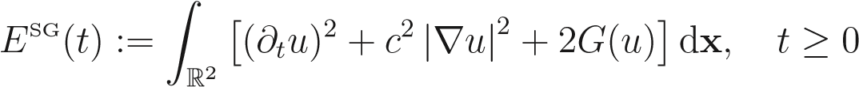, (1.1)

with

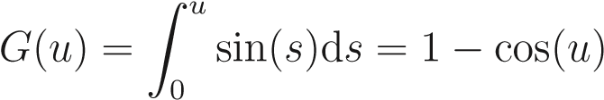, (1.2)

is monitored. Direct numerical recreations of the SG condition in 2D were performed in which are a lot less complex undertakings than mimicking the full Maxwell framework. Moving heartbeat arrangements having the option to keep the general profile over quite a while were watched, much the same as those in Maxwell framework See likewise [113,114] for related breather-type arrangements of the SG condition in 2D dependent on a regulation examination in the Lagrangian plan.

Likewise, as determined in [149], with the SG-LBs as beginning stage one can search for an adjusted planar heartbeat arrangement of the SG condition (1.14) in the structure:

u (**x**,t) = εA (ε(x−νt),εy,ε2t)ei (kx−ω(k)t)+c.c.+ε3u2, **x** = (x,y) ∈R2, t ≥ 0, (1.3)

where 0,

the group velocity, and c.c. refers to the complex conjugate of the previous term. Plugging (1.3) into (1.14), setting X = ε(x−νt), Y = εy and T = ε2t, figuring subsidiaries, communicating the sine work in arrangement and expelling all the reverberation terms, one can acquire the accompanying total annoyed NLS condition (see subtleties in [149]):

c2 −2iω∂T A + ε2∂TT A = ω 2 ∂XXA + c2∂Y Y A + 2εν∂XT A

| |2A ∞ (−1)l (ε||)2l, T >0, (1.4)

X

+ A (l + 1)! (l + 2)! l=0

where A:= A (**X**,T), **X** = (X,Y ) ∈ R2, is a complex-esteemed capacity. This new condition is second request in space-time and contains a nonparaxiality term, a blended subsidiary term, and a novel nonlinear term which is immersing for enormous plentifulness.

Introducing the scaling variables Xe = (ω/c)X, Ye = Y/c and Te = T/(2ω), NLS equation, as already introduced in Section 1.2e,

Substituting them into and then removing all, one gets a standard perturbed

, (1.5)

With initial conditions,

A (**X**,0) = A (0) (**X**), ∂T A (**X**,0) = A (1) (**X**), **X** ∈R2,

where,

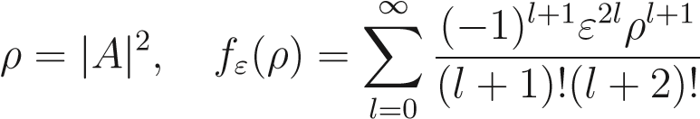.

Indeed, condition (1.5) can be seen as an irritated cubic NLS condition with both an immersing nonlinearity (arrangement) term and no paraxial terms (the ATT and AXT terms). As demonstrated in it monitors the vitality, i.e.,



With

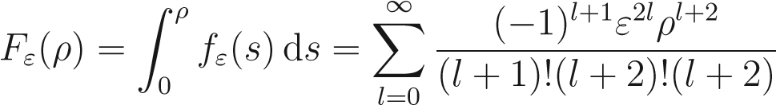, (1.9)

and has the mass balance identity d



dT R2 | | − 2ω2 R2 T c X T .

Likewise, the bothered NLS condition (1.5) is all around well-presented and does not have limited time breakdown [149], i.e., for some random beginning information A (0) (**X**) ∈ H2(R2) and A (1) (**X**) ∈ H1(R2), the initial value problem of (1.5) with initial conditions (1.6) has a unique global solution A ∈ C ([0,∞]; H2(R2)), AT ∈ C ([0,∞]; H1(R2)), and ATT ∈ C ([0,∞]; L2(R2)).

By and by, the endless arrangement of nonlinearity in (1.5) could be truncated to limited terms with centering defocusing cycles. Mean

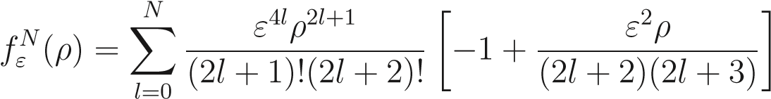,

at that point the irritated NLS condition (1.5) can be approximated by the accompanying truncated NLS condition:



Like the evidence in [149] for the bothered NLS condition (1.5), one can demonstrate that the truncated NLS condition (1.12) with the underlying conditions (1.6) additionally moderates the vitality, i.e.,



With



And has the mass balance identity (1.10).

When ε = 0, the bothered NLS condition (1.5) and its estimate (1.12) breakdown to the outstanding basic cubic centering NLS condition:

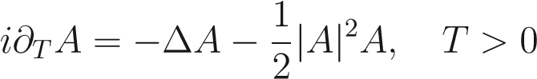, (1.15)

with initial condition,

A (**X**,0) = A (0) (**X**), **X** ∈R2. (1.16)

It is well-known that this cubic NLS equation conserves the energy, i.e.,

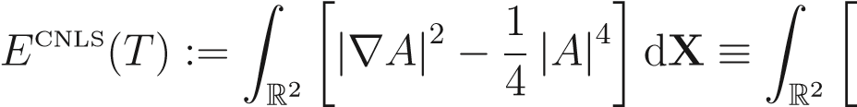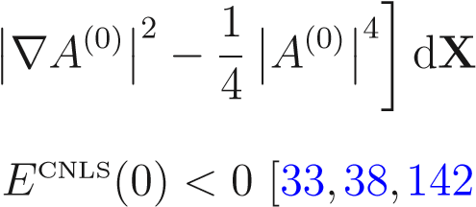, (1.17)

Furthermore, falls in limited time when the underlying energy], which propels various decisions of starting information in (1.16) and (1.6) for numerical examinations.

By shutting this segment, it is wanted to bring up some numerical difficulties so as to perform broad correlations among the LBs arrangements of the SG condition, bothered NLS and basic centering NLS equations. The calculation.

challenge engaged with SG reproduction is that the dissimilar time scales between the SG and annoyed NLS equations require a long-term recreation of the SG condition. To delineate this, taking note of (1.3), the unique time scales for the irritated NLS condition (1.12) and the SG condition (1.14) are T = O (1) and t = O (ε−2), individually, which promptly suggests that it requires an any longer time recreation for the SG condition (1.14) if the time routine past the breakdown time of the basic NLS condition (1.15) is of intrigue, when ε is little. Additionally, the calculation area for SG reenactment should be broadened if the intrigued time call attention to out to be further away because of the engendering property of the SG-LBs (cf. (1.3)). Then again, for annoyed NLS reenactment the test is that high spatial goals is required to catch the centering defocusing system which avoids the basic NLS breakdown. In what pursues, so as to adjust the strength and effectiveness, rather than utilizing those completely understood preservationist techniques semi-certain sine pseudo ghostly discretizations are proposed, which can be explicitly solved in phase space and are of spectral order accuracy in space.

**Corresponding author:**

Mr. Arvind Yadav

Research Scholar, Department of Mathematics,

OPJS University, Churu,

Rajasthan (India)

Contact No. +91-9992837999

Email- [arvinddahiya6@gmail.com](mailto:arvinddahiya6@gmail.com)

**References:**

1. Lima, R. N. de, & Tall, D. (2006). The Concept of Equations: What have students met before? In J. Novotná et al. (Eds.), PME 30, Vol. IV (pp. 233–240). Prague: PME.
2. Lima, R. N. de, & Tall, D. (2008). Procedural embodiment and magic in linear equations. Educational Studies in Mathematics, 67(1), 3–18. doi: 10.1007/s10649-007-9086- 0.
3. Lima, R. N. de. (2007). Equações Algebricas no Ensino Médio: Uma jornada por diferentes mundos da Matemática. São Paulo: Tese de Doutorado, Pontifícia Universidade Católica de São Paulo.
4. M. A. Abido, “Multiobjective evolutionary algorithms for electric power dispatch problem,” IEEE Trans. Evol. Comput., vol. 10, no. 3, pp. 315– 329, Jun. 2006.
5. M. Dehghan and M. Hajarian, New iterative method for solving non-linear equations with fourth-order convergence. Int. J. Comput. Math., in press.
6. M. Dehghan and M. Hajarian, On some cubic convergence iterative formulae without derivatives for solving nonlinear equations. Communications in Numerical Methods in Engineering, in press.
7. M. Drexler, Newton method as a global solver for non-linear problems, Ph.D. thesis, University of Oxford, 1997.
8. M. Frontini and E. Sormani, Modified Newton’s method with third order convergence and multiple roots, J. Comput. Appl. Math., 156(2003), 345- 354.
9. M. Frontini and E. Sormani, Modified Newton’s method with third-order convergence and multiple roots. J. Comput. Appl. Math., 156 (2003), 345–354.
10. M. Frontini and E. Sormani, Some variants of Newton’s method with third order convergence, Appl. Math. Comput., 140(2003), 419-426.
11. M. Frontini, E. Sormani, Modified Newton’s method with third-order convergence and multiple roots, J. Comput. Appl. Math. 156 (2) (2003) 345–354.

8/25/2020