**Anemia of Pregnancy: A cross section research study at department of gynecology and obstetrics Liaquat University Hospital, Hyderabad, Pakistan**

Erum Samreen Siddiqui, Naheed Parveen, Madiha Abbasi

Department of Gynecology and Obstetrics, Liaquat University of Medical and Health Sciences Jamshoro, Sindh, Pakistan

[e.siddiqui@yahoo.com](mailto:ashiquepmd77@yahoo.com)

**Abstract:** Anemia related toPregnancy is of multifactorial etiology but lack of antenatal care is a common reason behind this condition. Out recent work was aimed at evaluating the anemia status in pregnant women presenting for caesarian section at our hospital. The mean age found for study participants was 28.5+6.5 years and mean hemoglobin level was measured as9.8+4 gm/dl. There were 50% women with moderate stage anemia, 16% had mild anemia while 6% were having severe anemia and 28% women had no anemia. The most common blood group was B+ve (30%), followed by B +ve (25%), O +ve (22%), AB+ve (13%) while A-ve and O-ve were 2% each and B-ve and AB-ve were 3% each. The anemia was corrected with blood transfusion where required before surgery however post discharge follow-up of patient could be achieved as the majority was from remote rural areas.

[Erum Samreen Siddiqui, Naheed Parveen, Madiha Abbasi. **Anemia of Pregnancy: A cross section research study at department of gynecology and obstetrics Liaquat University Hospital, Hyderabad, Pakistan.** *Researcher* 2020;12(7):6-9]. ISSN 1553-9865 (print); ISSN 2163-8950 (online). <http://www.sciencepub.net/researcher>. 2. doi:[10.7537/marsrsj120720.02](http://www.dx.doi.org/10.7537/marsrsj120720.02).

**Keywords:** Pregnancy, Severe Anemia, blood group.

**1. Introduction**

The pregnancy related Anemia associated needs early diagnosis and management for the reduction of maternal mortality rate by 3% to 4% because it is responsible for many fatal conditions like antepartum hemorrhage, eclampsia, postpartum hemorrhage and puerperal sepsis etc (Binay K et al 2000, Ministry of Population Welfare, GOP, 2002). The prevalence of anemia of pregnancy is reported to be ranging from 33% to 75% in under developed countries, while it is found to be around 15% in well developed nations. There are many reasons for the development of anemia in pregnancy like multiparity, child spacing, poverty, lack of antenatal care, lack of awareness but iron deficiency is the common entity responsible in majority of cases (Cyril C et al, 2007). The WHO classification of in Anemia of pregnancy is based on hemoglobin levels which describes Hb% >11g/dl as no anemia and Hb% <11gm/dl as mild anemia with a prevalence rate of 65.8% in Africa while 24% in Uganda and 40% to 60% in other poor countries (Gerald Obai et, 2016). Some researchers have reported the pregnancy induced anemia as 14% and 51% prevalent in developing and developed countries respectively (Lee AI et al, 2011). Anemia adversely affects the baby and mother even in its milder forms resulting into fatigue, low birth weight and mortality owing to an imbalance between the increased demand and poor supply of the nutrients (Balarajan Y et al, 2011, Okeke PU, 2011, Kozuki N et al, 2012). The predisposing factors for anemia in pregnancy are excessive abnormal menstrual cycles in preconceiving periods, non-healthy food, no birth spacing, multiparity and lack of knowledge about the anemia during pregnancy and awareness issue concerning the antenatal care. The current research is based on women undergoing caesarian section at Obstetrics department of Liaquat University of Medical and Health Sciences at Hyderabad City of Sindh Province of Pakistan. The purpose behind is to develop a general awareness in doctor and patient communities that will help in the prevention of pregnancy related anemia and its related comorbidities and complications in the long run.

**2. Material and Methods**

The biodata and information was obtained from patients after an informed consent. Blood samples were obtained under a septic environment for the laboratory checking of the anemia status of the patients along with the blood groups of respective patients for required transfusion. C-sections were undertaken according to international protocols of surgery and anesthesia by respective field experts. The data information was obtained on a proforma designed for study and the selection of samples was done

through the inclusion criteria of pregnant ladies undergoing caesarian deliveries of any age group while the exclusion criteria was normal deliveries and comorbid conditions. Data was analyzed for mean, SD, Frequency, percentage, minimum, maximum and ranges for various variables. No test of statistical significance and non-significance was applied. Results were presented in the form of tables and charts.

**3. Results**

The mean age of study population was 28.5+6.5 years with 21 years as minimum age and 31 years as maximum. The mean hemoglobin level was 9.8+4gm/dl with 5.5 gm/dl as lowest and 13 as highest level [Table-1]. Most common blood group was B +ve which was 30%(30) followed by A +ve which was 25%(25), O +ve in 22%(22), AB +ve was found in 13%(13) patients, A-ve and AB-ve each were found in 3%(3) patients whereas B-ve and O-ve were found each in 2%(2) patients**.**

**Table -1. Mean age and hemoglobin with ranges**

|  |  |  |  |
| --- | --- | --- | --- |
| **Parameters** | **Mean and SD** | **Minimum** | **Maximum** |
| **Age in Years** | **28.5+6.5** | **21** | **31** |
| **Hemoglobin**  **gm/dl** | **9.8+4** | **5.5** | **13** |

**Table-2: Distribution of study subjects as anemia**

|  |  |  |
| --- | --- | --- |
| **Anemia** | **Frequency** | **Percentage** |
| **Women with Normal Hb%**  **(Hb% > 11gm/dl)** | **28** | **28%** |
| **Women with mild Anemia**  **(Hb%10-10.9gm/dl)** | **16** | **16%** |
| **Women with moderate Anemia**  **(Hb%07-9.9gm/dl)** | **50** | **50%** |
| **Women with severe Anemia**  **(Hb%<07 gm/dl)** | **06** | **06%** |

There was no anemia is 28%(28) patients as their hemoglobin level was recorded as >11gm/dl, Mild anemia was noticed in 16%(16) patients with their hemoglobin level was between 10gm/dl to 10.9gm/dl. Anemia of moderate severity was found in 50%(50) patients as the hemoglobin level was between 7gm/dl to 9.9gm/dl in these patients. There were 6%(06) severely anemic patients in our study with hemoglobin level <7gm/dl [Table-2].

**Table-3: Blood group distribution**

|  |  |  |
| --- | --- | --- |
| **Blood Groups** | **Rh +ve** | **Rh - ve** |
| **Blood group A** | **25 (25%)** | **02 (2%)** |
| **Blood group B** | **30 (30%)** | **03 (3%)** |
| **Blood group AB** | **13 (13%)** | **03 (3%)** |
| **Blood group O** | **22 (22%)** | **02 (2%)** |
| **Total** | **90 (90%)** | **10 (10%)** |

**4. Discussions**

The current study observed the anemia prevalent in 72% of patients which falls consistent with 65.6% reported by (Cheema et al, 2016 and Singh et al, 2009). Our results are also consistent with another study published from Pakistan by (Partab Puri et al, 2019) reporting the prevalence of anemia as 75.8% in the study subjects however the study population for their study was only pregnant ladies where as our study population was pregnant ladies undergoing C. sections. Study results from (Kefiyalew et al, 2014) reported anemia prevalence as 27.9% and its moderate form as the most common one while the severe anemia was reported as 12.9% in Ethiopia which is partially consistent and partially inconsistent with the current findings. Study by (Vanamala VG et al, 2018) also reported moderate anemia as the most common form (58%) which is in agreement with what we observed similarly they also reported Severe anemia as 7.8% which is near to 6% of our results although they additionally found68.5% of the patients as nutritionally deficient and multiparous women as majority of anemic studies. Mild anemia was reported as majority (67.3%) by (Fikre Asrie, 2017) whereas 32.7% as moderate anemia and no patient was reported to suffer from severe anemia that was contrasting with our results.Another Pakistani authored research by (Baig-Ansari N et al 2008) found mild anemia as most common form (75.0%) of anemia in pregnancy followed by moderate anemia as 14.8% and severe form of anemia was reported only 0.7% by them which is inconsistent with the present findings. Moderate anemia was reported as 50.9% in an Indian study by (Vijaynath et al, 2010) which is consistent with our findings while severe anemia was reported as 18.9% by them which is inconsistent to our results.Anemia was corrected in patients where required prior to surgery however no follow up could be maintained as majority of patients were from remote area.

**5. Conclusion**

Majority of patients was moderately anemic followed by milder form in pregnant women.

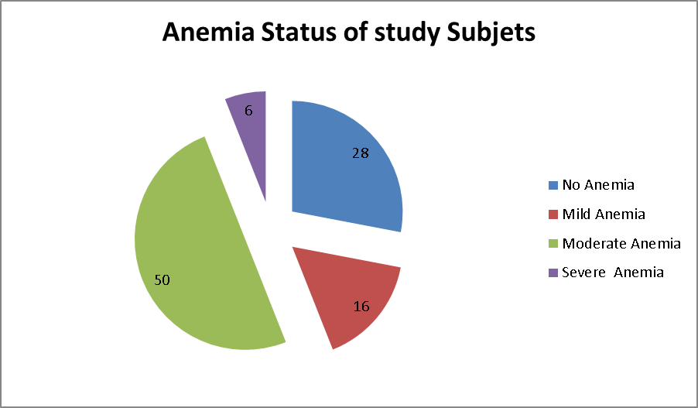

**Corresponding Author:**

Dr. Erum Samreen Siddiqui

Assistant Professor

Department of Gynecology and Obstetrics

Liaquat University of Medical and Health Sciences Jamshoro, Sindh, Pakistan

E-mail: [ashiquepcmd77@yahoo.com](mailto:ashiquepcmd77@yahoo.com)

**References**

1. Binay K. Shah, Lubna A. Baig. (2000). Association of anemia with parasitic infestation in pregnant Nepalese women. Journal of Obs and gynae. 79(5):341-149.
2. Situation analysis and evidence based approach to maternal and child health in Pakistan, Ministry of Population Welfare, GOP, (2002):3-20.
3. Cyril C. D, Hyainth E. Onali. (2007). The prevalence of anemia among pregnant women at booking in Enugu, Nigeria, American J of Public Health. 97(11):247-256.
4. Gerald Obai, Pancras O, Ronald W (2016). Prevalence of anemia and associated risk factors among pregnant women attending antenatal care in Gulu and Hoima Regional Hospitals in Uganda: A cross sectional study. BMC Pregnancy and Childbirth 16:76 DOI 10.1186/s12884-016-0865-4.
5. Lee AI, Okam MM (2011). Anemia in pregnancy. Hematol Oncol Clin North Am. 25(2):241-59.
6. Balarajan Y, Ramakrishnan U, Ozaltin E, Shankar AH, Subramanian SV (2011). Anaemia in low-income and middle-income countries. Lancet.378: 2123–35.
7. Okeke PU (2011). Anaemia in pregnancy-is it a persisting public health problem in Porto Novo- Cape Verde? Res J Med Sci. 5(4):193–9.
8. Kozuki N, Lee AC, Katz J (2012). Moderate to severe, but not mild, maternal anemia is associated with increased risk of small-for gestational- age outcomes. J Nutr. 142:358–62.
9. Cheema HK, Bajwa BS, Kaur K, Joshi H (2016). Prevalence and possible risk factors of anemia in different trimesters of pregnancy IJCMR. 3(4):1194-7.
10. Singh AB, Kandpal SD, Chandra R, Srivastava VK, Negi KS (2009). Anemia amongst pregnant and lactating women in district Dehradun. Indian J Prev Soc Med.1:19-22.
11. Partab Puri et al., Anemia Of The Pregnancy: A Survey From Mirpurkhas, Sindh Pakistan, Indo Am. J. P. Sci, 2019; 06(02).4243-4246.
12. Kefiyalew F, Zemene E, Asres Y, Gedefaw L (2014). Anemia among pregnant women in Southeast Ethiopia: prevalence, severity and associated risk factors. BMC research notes.7(1):771.
13. V. G. Vanamala, Aruna Rachel, Sushil Pakyanadhan, Somavathi (2018). Incidence and outcome of anemia in pregnant women: a study in a tertiary care centre Int J Reprod Contracept Obstet Gynecol. 7(2):462-466.
14. Fikir Asrie (2017). Prevalence of anemia and associated risk factors among pregnant women attending antenatal care at Aymiba Center, northwest Ethopia. Journal of blood medicine8:35-40.
15. Baig-Ansari N, Badruddin SH, Karmaliani R, et al (2008). Anemia prevalence and risk factors in pregnant women in an urban area of Pakistan. Food Nutr Bull. 29:132–139.
16. Vijaynath, Jitendra, Ramesh P, Abhishek P (2010). Prevalence of anemia in pregnancy. Indian J Appl Basic Med Sci. 12:23–35.

7/6/2020