Estimation Of The Relative Spatial Proximity Of Human Population To The Hospitals Of Ethiopia

Belege Tadesse

Wollo University School of Veterinary Medicine, PO. Box. 1145, Desse, Ethiopia
tadessebelege@gmail.com

Abstract: This study was done with the objective of estimating the proximity of human population to hospitals in Ethiopia. The study materials were collected from different websites. The study showed that from the total population of the country a population of 11.27%, 53.12% and 35.61% are situated within 0-10km, between 11-40km and greater than 40km distance from hospitals of Ethiopia respectively. The study also showed that from the total area of a country an area 2.29%, 27.24% and 70.48% is located within 0-10km, between 11-40km and greater than 40km distance from hospitals respectively.

[Belege T. Estimation Of The Relative Spatial Proximity Of Human Population To The Hospitals Of Ethiopia. Researcher 2020;12(5):5-16]. ISSN 1553-9865 (print); ISSN 2163-8950 (online). http://www.sciencepub.net/researcher. 2. doi:10.7537/marsrsj120520.02.

Key Words: Ethiopia, Hospital, people, buffer zone

1. Introduction
Health in Ethiopia has improved markedly in the last decade, with government leadership playing a key role in mobilizing resources and ensuring that they are used effectively. A central feature of the sector is the priority given to the Health Extension Programme, which delivers cost-effective basic services that enhance equity and provide care to millions of women, men and children. Health and health services have improved significantly in Ethiopia since 2000, despite Ethiopia remaining a low-income country. A huge and rapid increase in the numbers of health facilities and health workers contributed greatly to these improvements in health outcomes and service delivery a very deliberate decision was made to prioritise improved access to basic services in this enormous country [1].
The modern Ethiopian health system has a relatively short history. A progress was achieved in the last two decades, in response to new health reform programs and policies launched locally to coincide with Worldwide Initiatives on Health Sector Reforms [2].
Expectedly the number of hospitals varies from region to region in response, partly, to differences in population size. The most populous region, Oromiya has 30 hospitals. The other two predominantly rural regions Amhara and SNNP have 19 and 20 respectively with Tigray in fourth place with 16 hospitals. When ranked in terms of the hospital-population ratio, Tigray’s population-hospital ratio is much lower than all of the other predominantly rural regions [3].

The health sector development program (HSDP) has introduced a four-tier health service system which comprises: a primary health care unit, (a network of a health centre and five health posts), the hospital, regional hospital and specialized referral hospital [4]. Hospitals are mainly constructed in towns, so the rural people take several hours to reach these hospitals. Therefore; this study was done with the objective of estimating the proximity of human population to hospitals in Ethiopia.

2. Materials And Methods

2.1. Study Materials
For studying the relative proximity of human population to hospitals in Ethiopia using proximity analysis, the data collected were Ethiopian population raster data downloaded from ILRI GIS [5]; administrative boundaries of Ethiopia from DIVA GIS Country data and Ethiopian hospitals shape file clipped from the Ethiopian health facility shape files downloaded from http/data.humdata.org/dataset/Ethiopia-health. QGIS software was used as operating software for performing the proximity analysis.

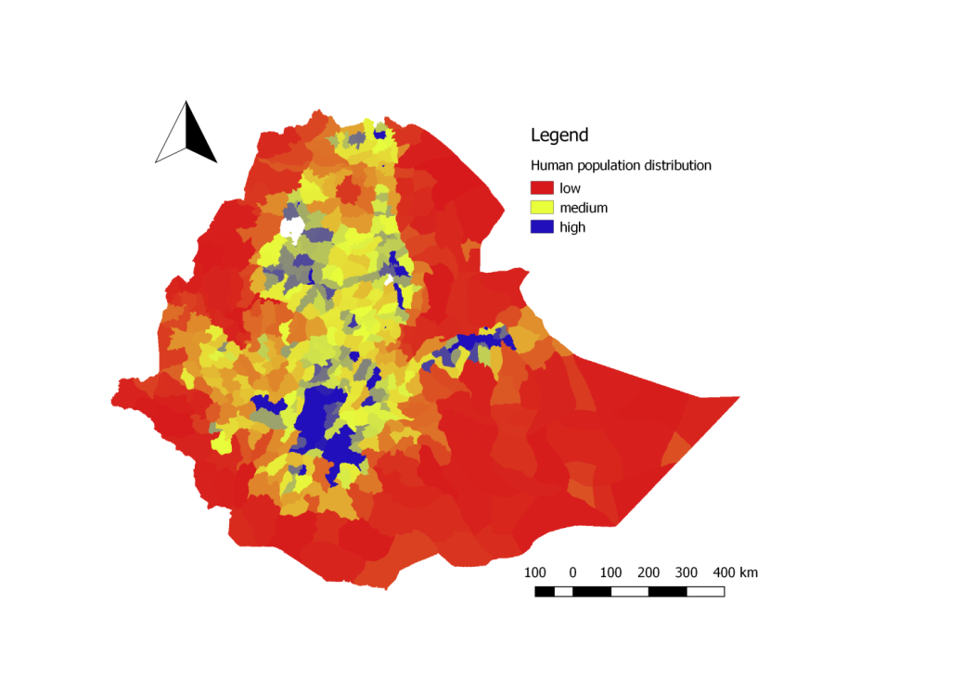
Figure1. a. Spatial distribution of human population

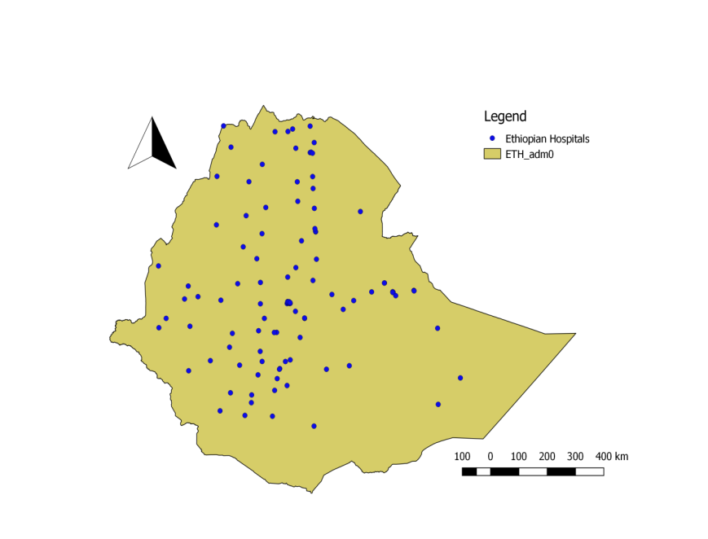
Figure 1. b. Hospitals distribution in Ethiopia

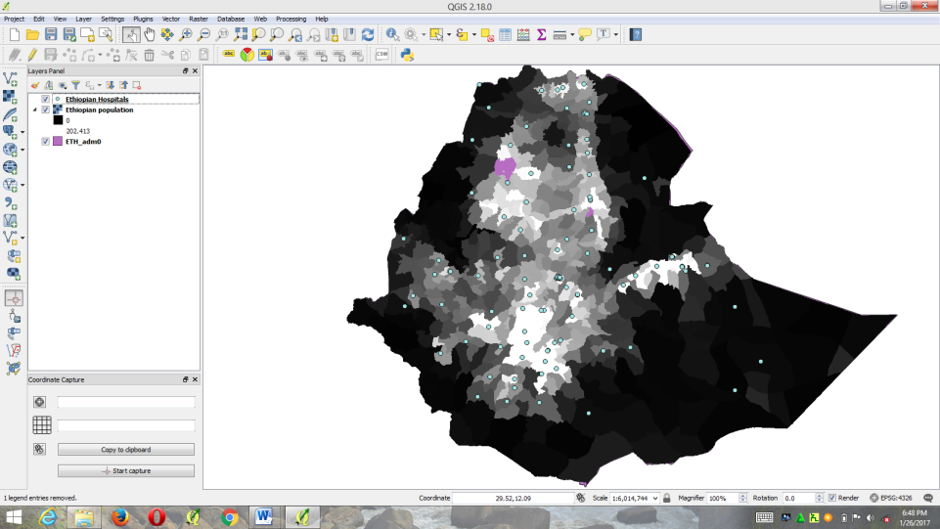

2. Classify Ethiopia´s land mass in to three zones (i.e. areas within 10km radius, areas between 11 to 40km radius and areas greater than 40km radius) from all hospitals in the country. We can do this by making buffer based on the distances designated above round the Ethiopian hospitals shape file. Click on Vector>> Geoprocessing Tools>> fixed distance buffer (fill the required information in the coming dialog box for each zone).

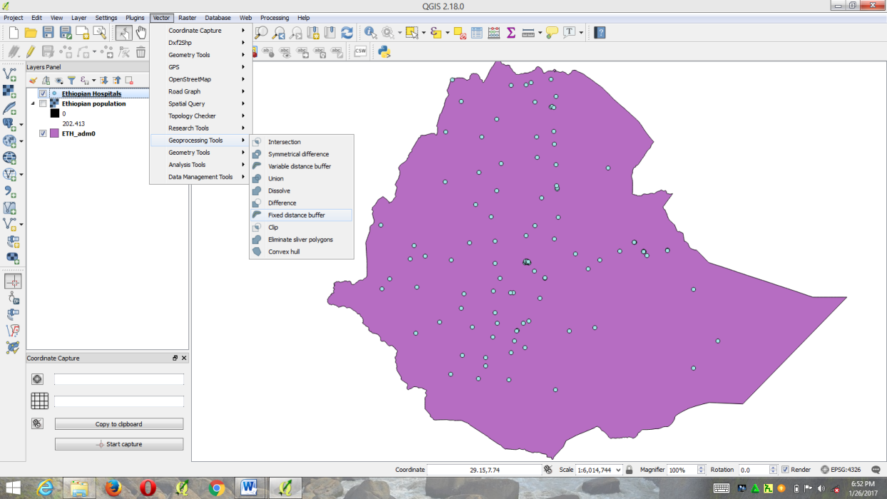

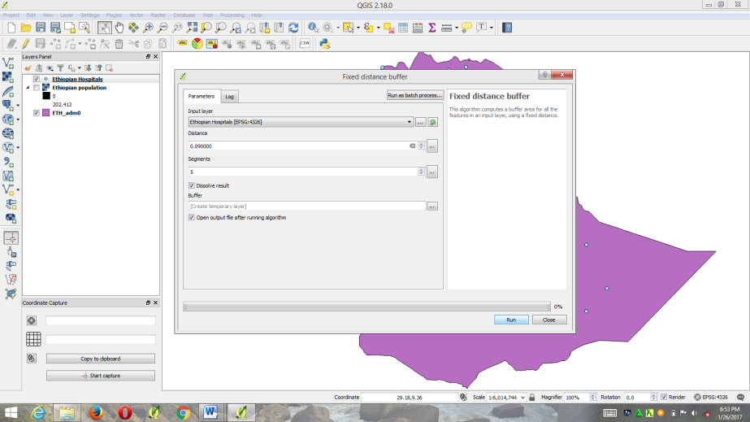

3. Use the Vector >> Geoprocessing Tools>> Difference functionality to cut out the overlaying buffers and to get buffers of areas greater than 40km.

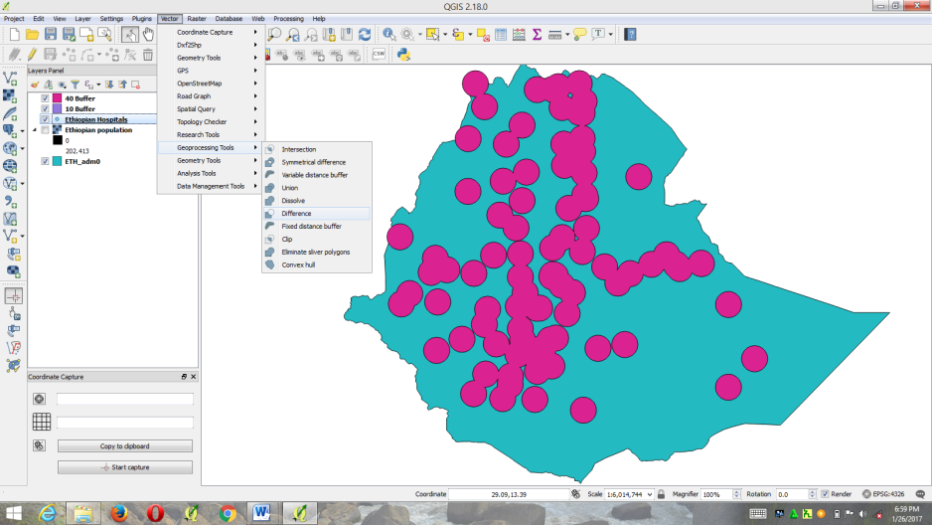

4. After doing buffer for all the three zones, I had obtained shape files which look like the following picture. The centre of the circular shape files (blue color) are Ethiopian hospitals. The pale red-pink colour is area within 10km radius from hospitals. The green area is the area between 11 -40km radius from the hospitals and the pink colour is area greater than 40km radius from the hospitals of Ethiopia.

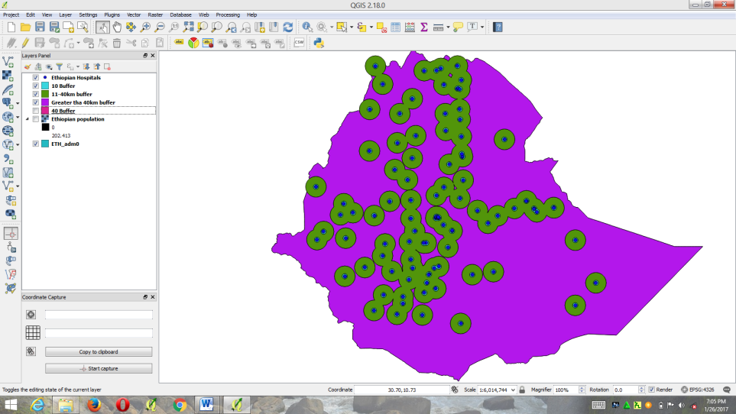

5. Clipping the buffer zones that extend beyond the administrative border of Ethiopia one by one within the extent of Ethiopia. As indicated above, the pale red-pink colour is area within 10km radius from hospitals. The green area is the area between11 -40km radius from the hospitals and the pink colour is area greater than 40km radius from the hospitals of Ethiopia. Click on Vector>>>geoprocessing pool>>>clip>>> fill the required information in the coming dialog box for each zone one by one.

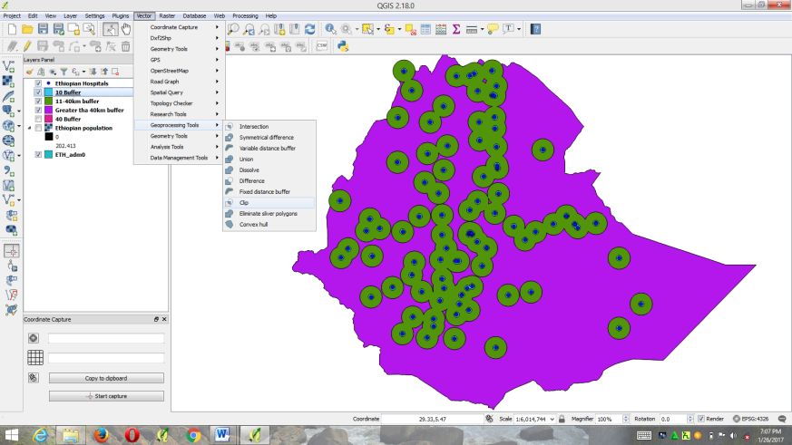

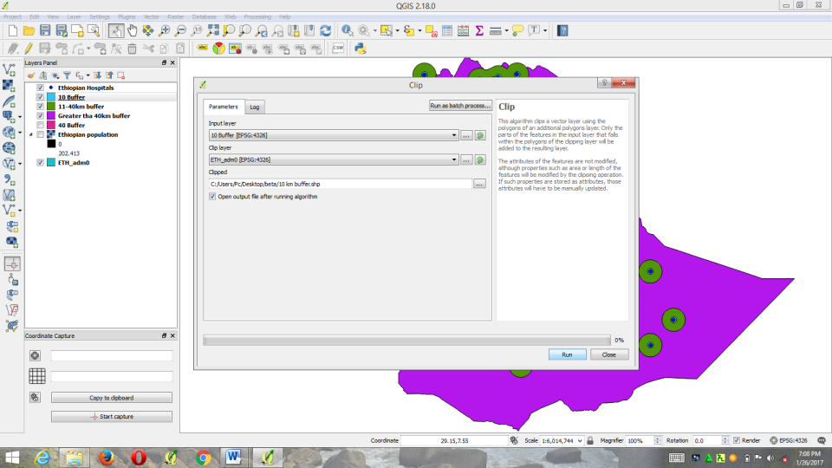

6. After clipping the buffers that extends the administrative borders of Ethiopia (buffers with in 10km and buffers of the area between 11-40km radiuses from all hospitals), I got the following picture.

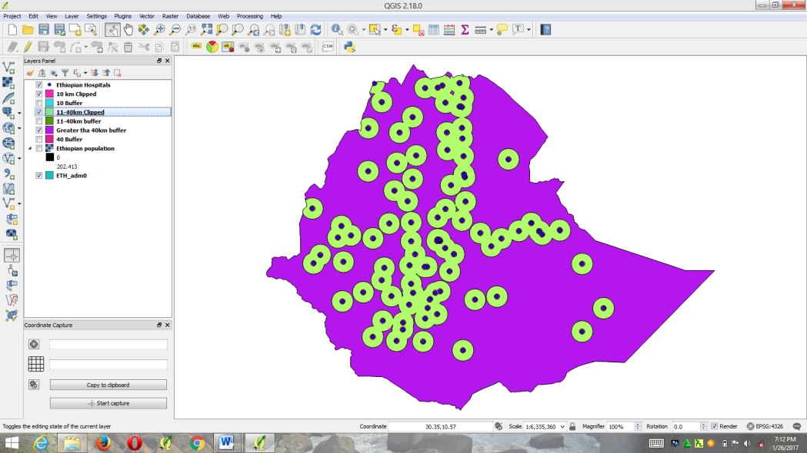

When zooming the above picture to clearly observe all the three zones it looks like this.

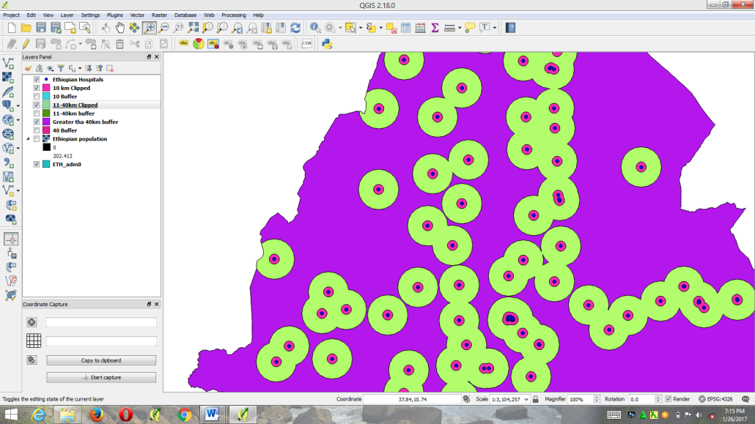

7. Estimate/calculate the human population of Ethiopia within the three buffer zones (within 10km radius, 11-40km radius and greater than 40km radius) by using zonal statistics. Click on raster >>Zonal statistics >> Zonal statistics (fill the required information in the coming dialog box for each zone). In the dialog box provide the population raster data containing information on human population density and the polygon of each zone separately. Provide also the name of the column in which the analysis output will be stored. It is done separately for each zone.

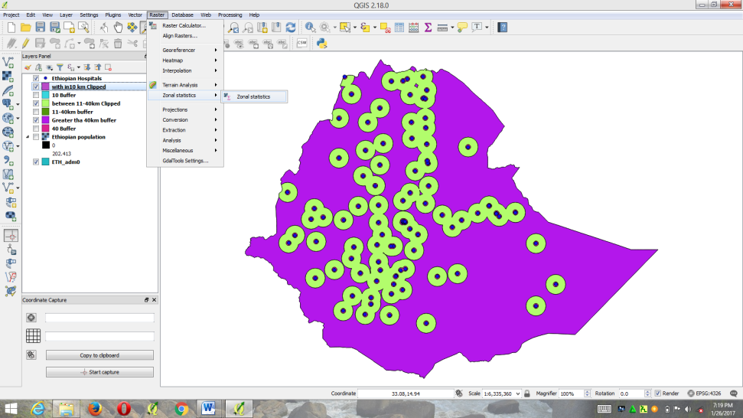
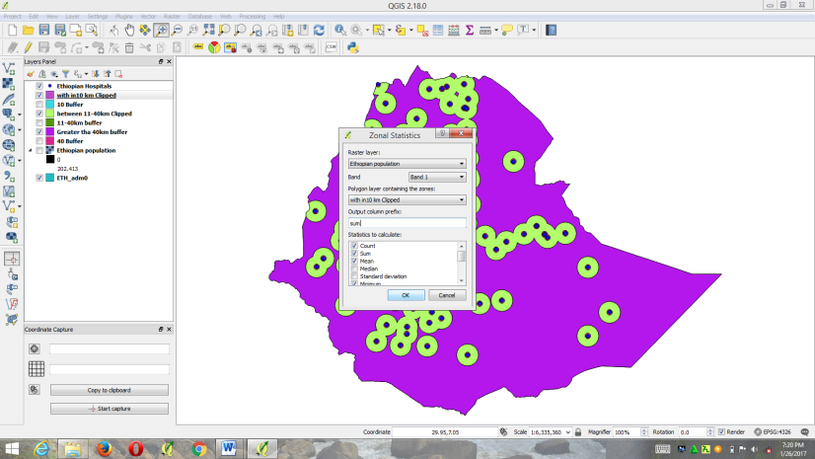

8. We can observe the result of zonal statistics (human population in each zone) in the attribute table of each zone after completion of the process for each zone. Note here that the values are estimated human population density per square kilometre, so the values should be multiplied by the estimated area of each of the polygon zone to get the estimated human population in that polygon.
9. Open the attribute table of each zone and calculates the estimated area for each zone and save the value as CSV excel file to calculate the total human population size and over all area covered by each zone.

3. Result And Discussion
This study is carried out to estimate the population distance from hospitals with the aim of providing information about the closeness of the human population to hospitals in Ethiopia. The analysis tried to show the spatial relationship between distances of population from hospitals in a country by creating three buffer zones (within 10km radius, 11-40km radius and greater than 40km radius) around hospitals. The results are shown on three buffer zone in figure 2.1, 2.2, 2.3 and 2.4. The human population and area of each zone are summarized in table1.

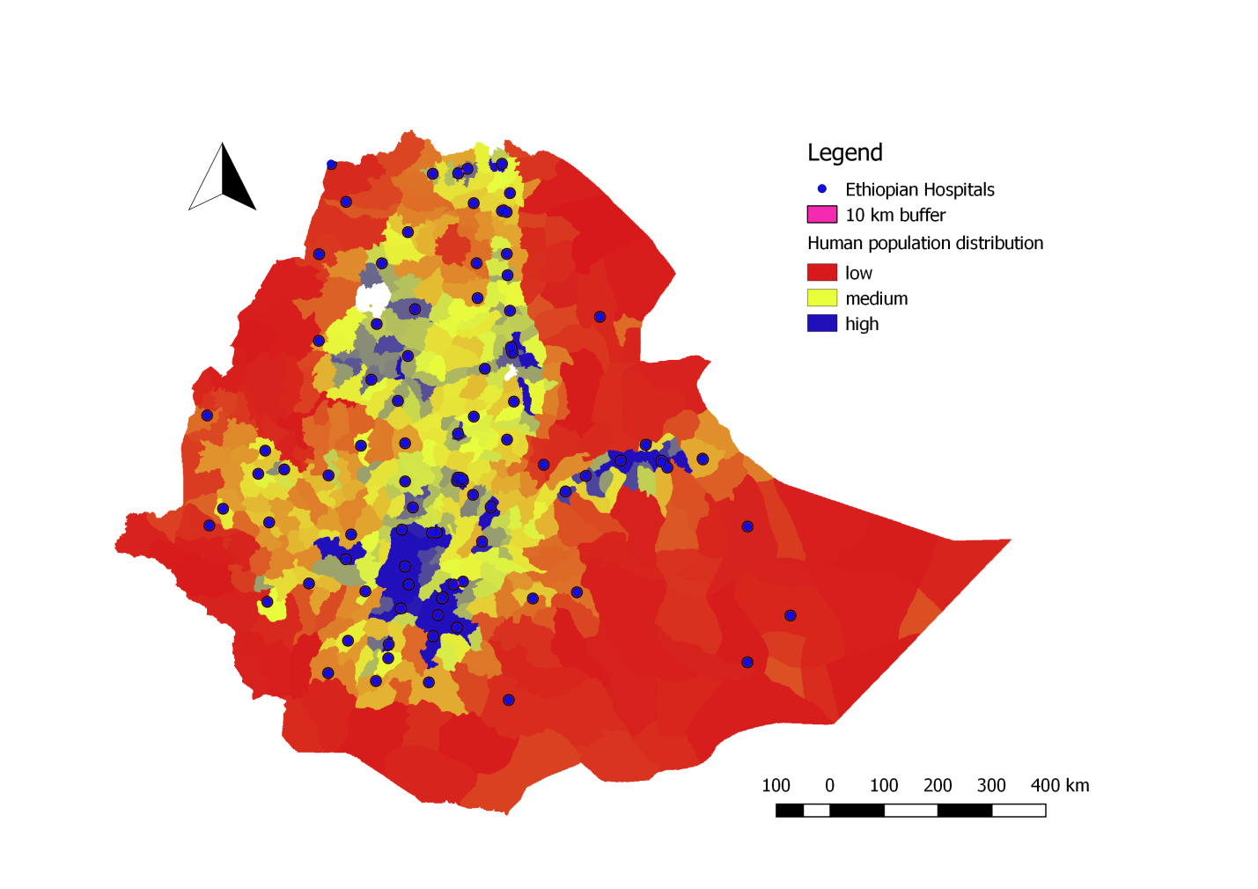
Figure.2.1.a). Population distribution with in 10km radius from hospitals

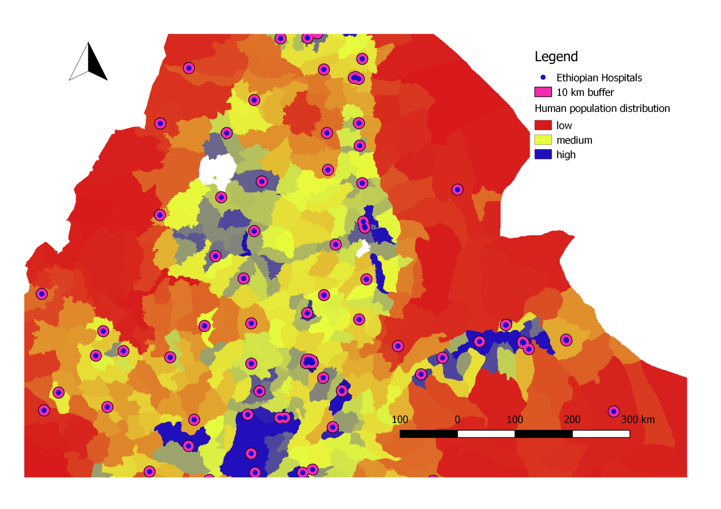
Figure 2.1.b). Population distribution with in 10km radius from hospitals (zoomed picture)
Note: Zooming is performed to clearly observe the 10km buffer zone.

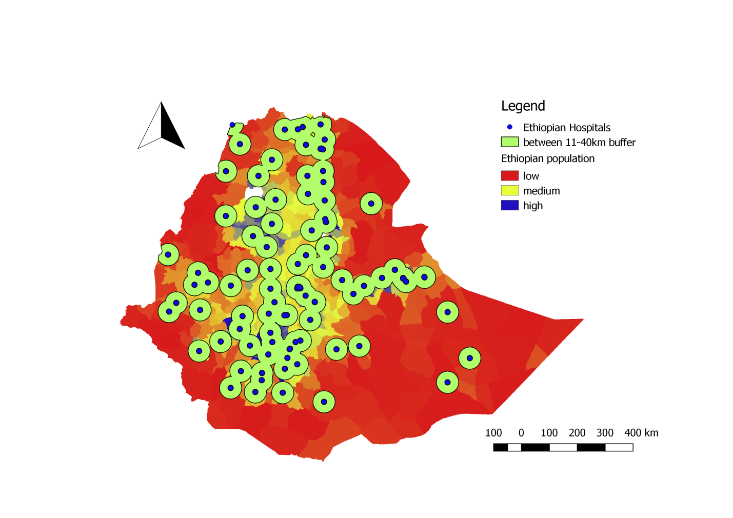
Figure 2.2. Population distribution between 11-40km from hospitals

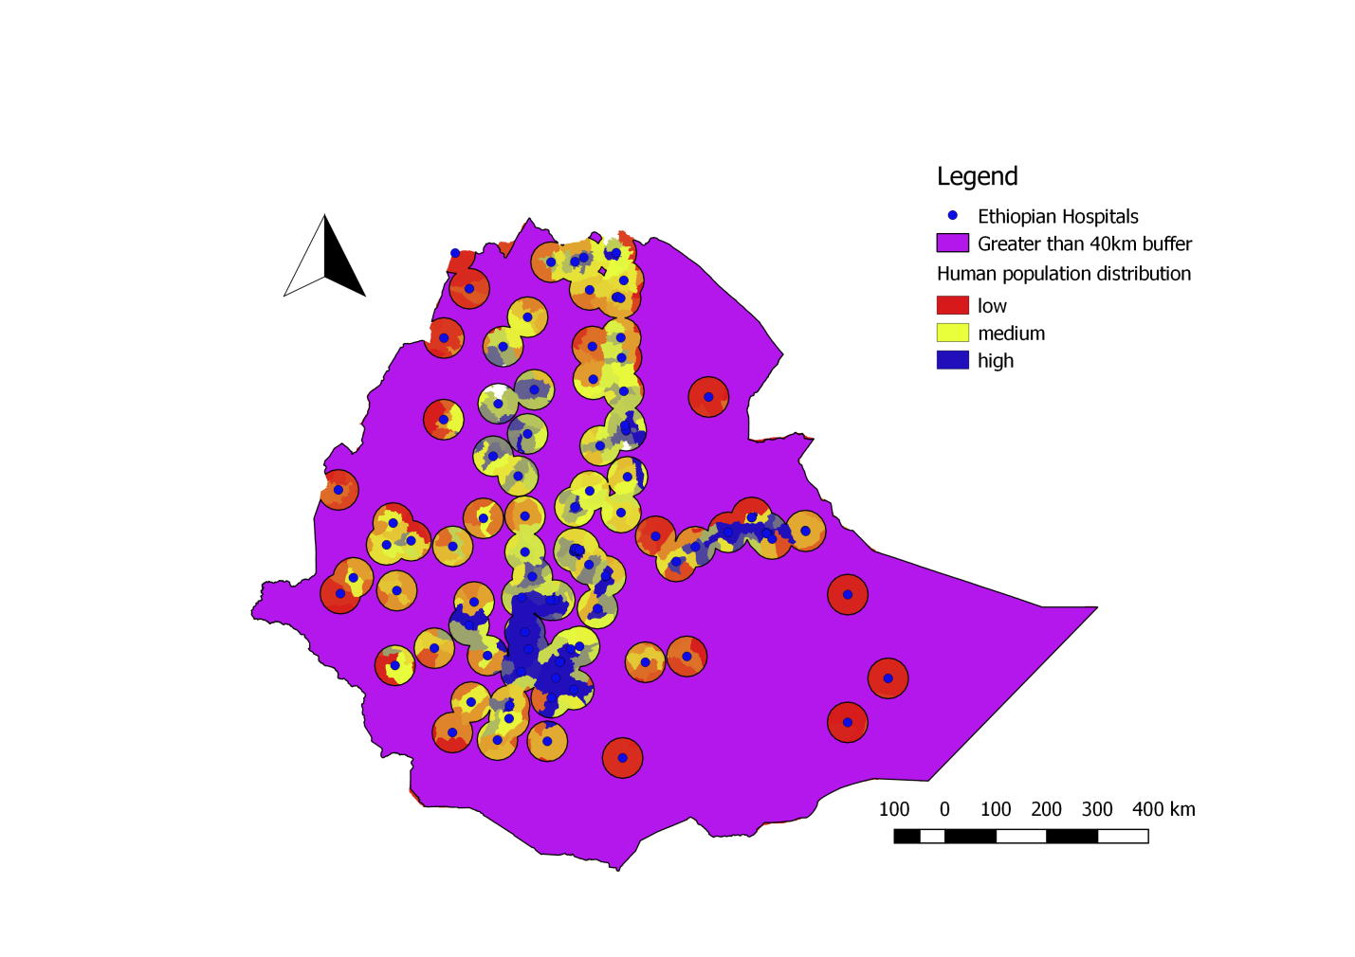
Figure2.3. population distribution in greater than 40km area from hospitals

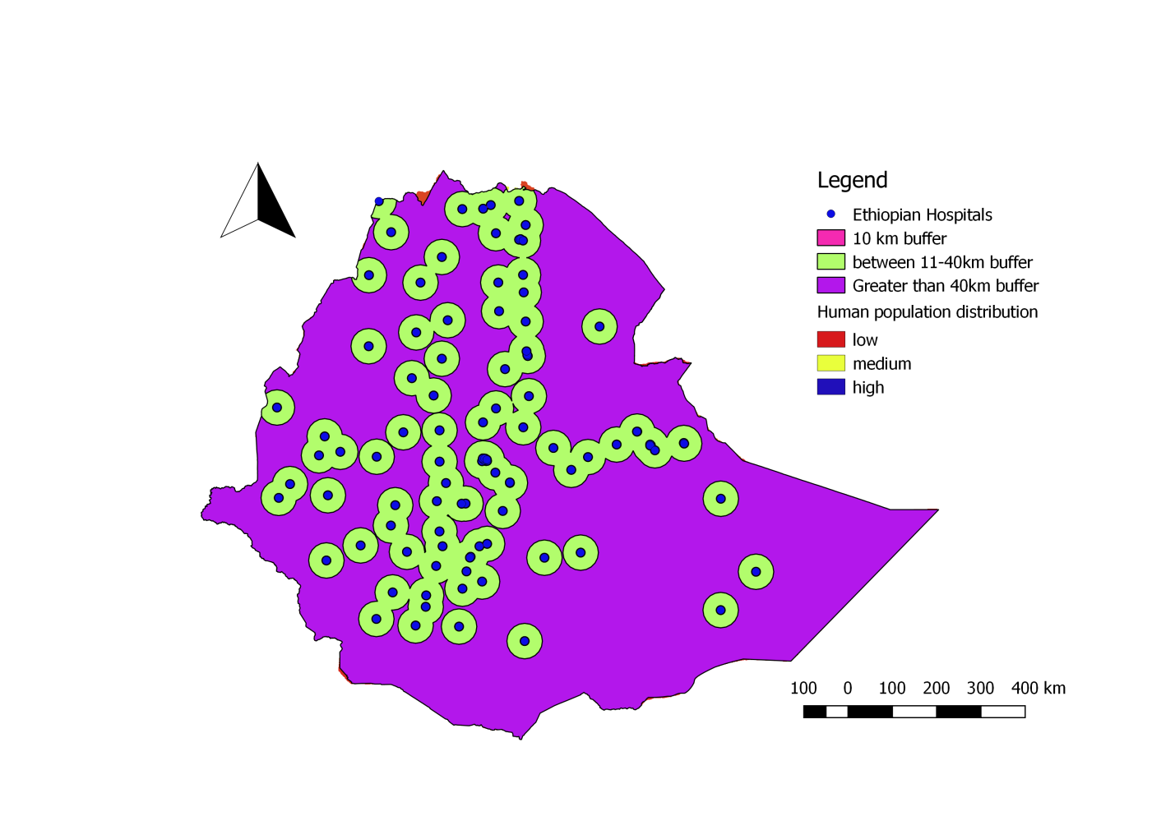
Figure 2.4. a). Population distribution in each of the three zones

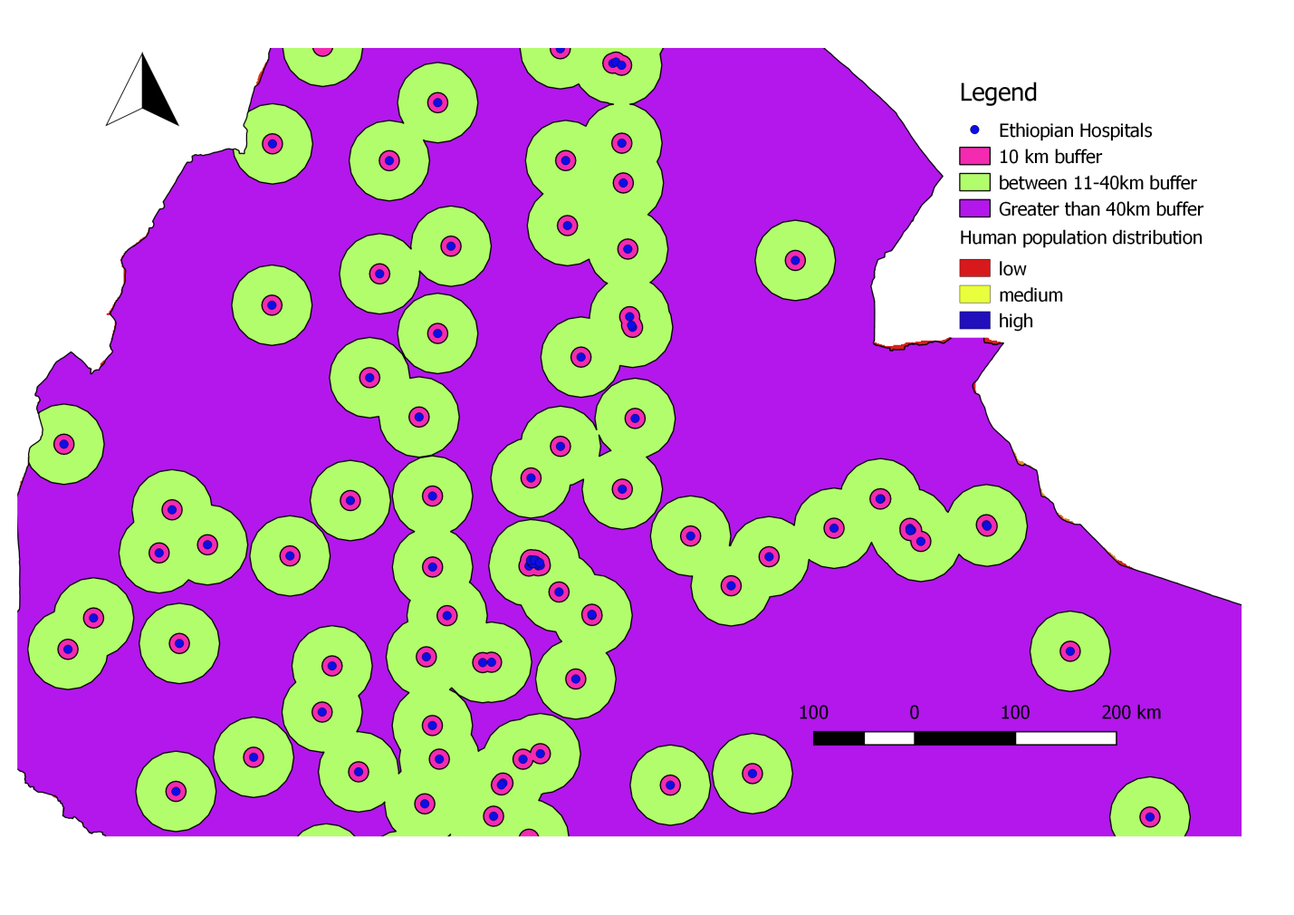
Figure 2.4. b). Population distribution in each of the three zones (zoomed picture)

This is when I zoom figure 2.4.a. to clearly observe the three zones. Especially the 10km buffer (pale red-pink colour) located between the hospitals (blue color) and 11-40km buffer (green colour) is clearly seen when I zoom the picture. Area greater than 40km (pink colour) is the area next to the green colour (11-40km buffer).

Table 1: population distribution and estimated area in each buffer zone.
Buffer zone | Estimated area (km²) | Areas covered by each zone from total area of the country (%) | Estimated human population | Population distributed in each zone from total population of the country (%)
0-10 km | 26194.77 | 2.29 | 9216068 | 11.27
11-40 km | 312133.99 | 27.24 | 43430208.46 | 53.12
>40 km | 807654.47 | 70.48 | 29112722.46 | 35.61
Total | 1,145,983 | 100 | 81,758,999 | 100

The above table shows that from the total population of the country a population of 9,216,068 (11.27%), 43,430,208 (53.12%) and 29,112,722(35.61%) is situated within 0-10km, between 11-40km and greater than 40km distance from hospitals of Ethiopia respectively. The table also shows that from the total area of a country an area of 26,194.77km²(2.29%), 312,133.99km² (27.24%) and 807,654.47km² (70.48%) is located within 0-10km, between 11-40km and greater than 40km distance from hospitals respectively.
The result showed that the majority of population of Ethiopia distribute within 11 to 40km distance from hospitals. This shows that most people’s travels from 11-40km to reach to the nearest hospital. About 35.61% of the population settles far from hospitals (above 40km), this shows the need of constructing additional hospitals in the rural areas to minimize the distance between the population and hospitals.

4. Conclusion And Recommendations
According to this study only 11.27% of the total populations were settled close to the hospitals within 10km from the hospital and these populations get immediate access to the hospitals. The result also showed that majority (53.12%) of population of Ethiopia settle in an area between 11-40km away from hospitals. This may lead a risk on the life of patients if the transportation facility is not good. 35.61% of the population settles in an area greater than 40km away from hospitals; this is mainly in rural areas and peoples travel long distance to reach these hospitals. Here the patients are in danger if other health facilities are not available in the near area. Based on the above conclusion the following recommendations are forwarded:
- Other health service stations like clinics must be constructed in areas where hospitals are very far.
- Further research should be conducted to determine the population to hospital ratio and impact of geographic distance of human population from hospitals.
- By considering the population to the hospital ratio additional hospitals must be constructed in densely populated areas.

Acknowledgements:
The Author thanks the institutions who develop the shape files that were used in this study.

Corresponding author:
Belege Tadesse, Wollo University School of Veterinary Medicine, PO. Box. 1145, Desse, Ethiopia,
phone +251931201843,
Email. tadessebelege@gmail.com

References
- https://www.internationalhealthpartnership.net/fileadmin/uploads/ihp/Documents/Country_Pages/Ethiopia/Ethiopias_Health_Sector_Excellent_Returns_Feb2013.pdf.
- Damen Haile and Helmut Kloos in Yemane Berhane et. al. (eds.) Epidemiology and Ecology of Health and Disease in Ethiopia. Shama Books. 2006. Addis Ababa.
- http://www.ethiodemographyandhealth.org/HealthInstitutionsServicesAynalemAdugna.pdf.
- Nada Chaya, Poor access to Health Services. Ways Ethiopian is overcoming it. http://www.populationaction.org/Publications/Research_Commentaries/Poor_Access_to_Health_Services_in_Ethiopia/Summary.shtml.
- http://192.156.137.110/gis/zipfiles/Ethiopia/Ethi_po...
- http/data.humdata.org/dataset/Ethiopia-health.

5/16/2020

