Simulating Methods for WAG Injection and Selecting an Optimal Method for Injection in a fractured reservoir

Meysam Yousefzadeh and Abbasali Changalvaie

Department of petroleum, Omidiyeh Branch, Islamic Azad University, Omidiyeh, Iran.
yousefzadeh.meysam@yahoo.com

Abstract: Extraction increasing methods play an important role in global demand for energy in the future. Following primary and secondary methods for oil extraction, several millions oil barrels have remained in pools. Regarding increasing global demand for oil, oil companies attempt to extract oil by optimal methods. A technique is water alternating gas injection (WAG). Evaluations conducted on types of WAG methods show that these techniques sweep oil toward productive wells by increasing the links between oil zones and controlling movements. According to information obtained from different reservoirs, WAG increases 5-10% oil recycling in carbonated pools. The present study evaluates types of WAG in a fractured carbonated reservoirs located in western south of Iran by industrial software Eclipse. Different simulations showed that increase in amount of injected gas into water increases reservoir efficiency. Among WAG techniques, selected technique has always the most oil productivity in the reservoir.
[Meysam Yousefzadeh and Abbasali Changalvaie. Simulating Methods for WAG Injection and Selecting an Optimal Method for Injection in a fractured reservoir. Researcher 2020;12(3):80-84]. ISSN 1553-9865 (print); ISSN 2163-8950 (online). http://www.sciencepub.net/researcher. 13. doi:10.7537/marsrsj120320.13.

Keywords: simulation, WAG injection, hybrid injection, immiscible injection, simultaneous WAG.

1. Introduction
Almost 70 percent of global oil is produced in reservoir which has been used to produce for over 40 years. Therefore, some techniques are needed to increase and improve production from these reservoirs. WAG projects play an important role to increase oil recycling, particularly during recent years. The process controls gas fingering and improves oil sweeping yields. Recently, many gases have been injected both miscibly and immiscibly in reservoir [1]. Reservoir engineers attempt to predict future behavior of a fractured reservoir using its production history and evaluating its future behavior by available methods and strategies for ordinary reservoirs; however, in most cases, the behavior predicted by calculations of an ordinary reservoir cannot be consistent with past behavior of a fractured reservoir [2]. Therefore, oil yields can increase in fractured reservoir by changes in previous extraction increasing techniques [3]. Properties of rock and fluid differ in each reservoir. Success or failure of WAG depends on rock and fluid properties of that reservoir. A most important parameter to develop WAG projects is gas and gas compounds. Gas compounds play an important role in selecting miscible and immiscible alternating injection techniques [4] [5].

2. Types of Techniques for Water Alternating Gas Injection
2.1. Immiscible Water Alternating Gas (IWAG) Injection
Through this technique, a gas which is not able to combine with oil remained in reservoir is injected to the reservoir; then water is alternatively injected in the reservoir. This kind of injection is conducted to increase stability of movement front and increase contact area injected fluids with swept parts of reservoir in compared to ordinary techniques for water and gas injection. IWAG is used in pools which in stabilize injection front due to strong heterogeneities or angularities. IWAG increases production and pressure of reservoir [6] [7].
2.2. Hybrid Water Alternating Gas (HWAG) injection
Through this process, large amount of gas is initially injected in reservoir. Then, a small amount of water and gas is injected to reservoir in equal values [8].
2.3. Simultaneous Water Alternating Gas (SWAG) Injection
Through SWAG, water and gas are continuously and simultaneously injected to reservoir so that water and gas are combined on the surface and injected as a single phase to the reservoir.

An advantage of SWAG is that more gas permeates to lower parts of pool and prevents isolation of gas phase and formation of gas cap over reservoir [9].
2.4. Selective Simultaneous Water Alternative Gas (SSWAG) Injection
Through SSWWAG, water and gas are combined on the surface; a hydrocarbon layer is injected by twofold completion of vertical injected water and gas well upward and downward, respectively. Through this technique, density difference between injected fluids moves water downward and gas upward followed by drift mechanism and increased displacement process yield. Accordingly, displacement is done microscopically and macroscopically and production is increased [10].
2.5. WAG after Water Flooding
Through this technique, water is injected during several years into reservoir followed by water alternating gas injection. Since through this technique WAG injection is done after water, this injection is known as a secondary extraction increasing technique [11].

3. Simulating and Comparing WAG Techniques
Here, different types of WAG injection are compared determining the best productive technique. Table 1 shows properties of reservoir and information related to reservoir grading.
3.1. Comparing Field Efficiency
Figure 1 indicates field efficiency for five WAG injections. Field efficiency is quite similar for five injections during first 120 days of simulation. The longer simulation time, the more efficiency for SSWAG than other four techniques; so that, efficiency reaches 8.4% for SSWAG injection.
3.2. Field Production
A most important and essential goal of extraction increasing techniques is to increase oil production in the field; so that, most extraction increasing techniques rely on this goal. As simulation is conducted, production through SSWAG injection is more than other 4 techniques. Production is higher through SWAG for first 40 days of simulation; hereafter, however, production through SSWAG proceeds others. Finally, production of SSWAG is constantly maximum after 1500 days. Meanwhile, production of other four alternating injections considerably decreases. Figure 2 clearly shows that the longer simulation, the higher production through SSWAG than other techniques.
3.3. Total Filed Production
According to Figure 3, total field production is similar for five WAG injections during first 200 days of simulation; after200 days, however, production through SSWAG proceeds other four techniques.

Table 1. Information and properties of reservoir
Number of blocks along x, y and z axis | 10×10×6
Selected part area, acre | 3036
reservoir length along x, y، ft | 300,50
Matrixporosity | 0.3
Crackporosity | 0.07
md in the first layer, Matrix permeability along x axis | 0.09
md in the second layer, Matrix permeability along x axis | 39.71
md in the third layer, Matrix permeability along x axis | 119.2
md in the first layer, crack permeability along x axis | 512.26
md in the second layer, crack permeability along y axis | 831.56
md in the third layer, crack permeability along z axis | 1450.88
Rock compressibility in psi 14.7 | 4.29×10⁻⁶
Oil density, lbm/ft³ | 48.87
Solution gas density, lbm/ft³ | 16.49
Water density, lbm/ft³ | 64.19
API | 45
Volume factor of water | 1.021
Volume factor of oil | 1.3779
Basic pressure in 3001 in depth، psi | 3180
Primary temperature, F | 172.2
Contact area of water and gas, ft | 8796.6
Contact area of oil and gas, ft | 4642.5

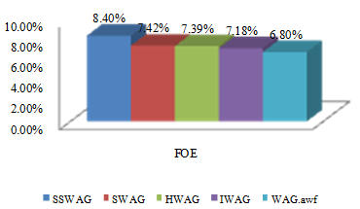
Figure 1. field efficiency

3.4. Reservoir Pressure
Reservoir pressure is the most essential parameter which needs to be constantly considered in the pool. Amount of oil production is directly related to reservoir pressure. As Figure 4 shows, three techniques (IWAG; HWAG; WAG-AWF) experience considerable pressure loss during first 120 days. While, SSWAG and SWAG experience considerably lower pressure loss than above techniques. Expectedly, SSWAG experiences the lowest pressure loss in the reservoir than others after 120 days.

3.5. Water cut
The lower water shear in the reservoir, the better reservoir efficiency. According to conducted simulations, water shear is maximum for WAG-AWF. The lowest water shear of the reservoir is related to SSWAG (Figure 5).

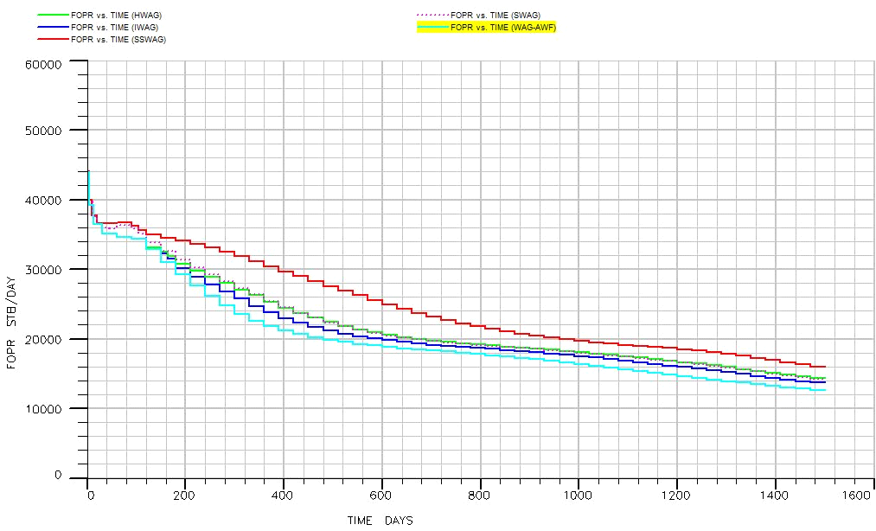
Figure 2. field production

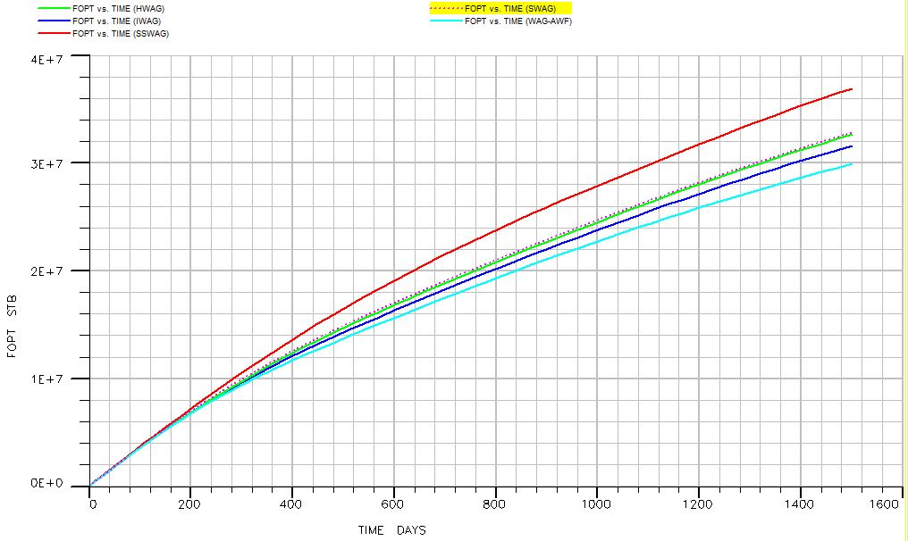
Figure 3. total field production

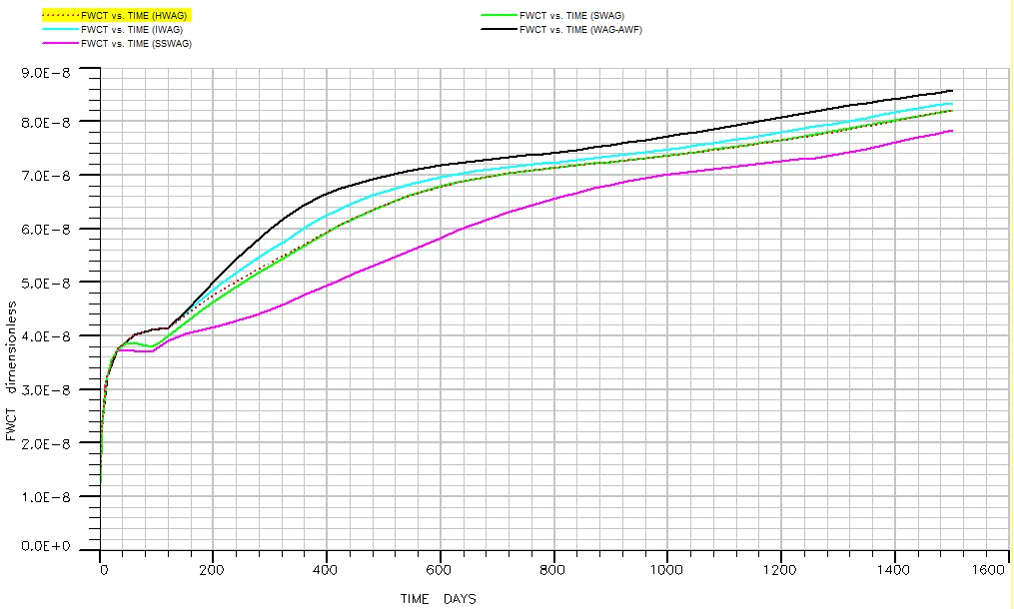 Figure 5..Water cut

4. Conclusion
According to different simulations conducted on five different WAG techniques, following results obtained:
- Productivity and collective production of SSWAG are higher than others; thus, SSWAG was introduced as optimal extraction increasing technique for studied field.
- Higher productivity and production of SSWAG, compared to other WAG techniques, indicates higher microscopic and macroscopic sweeping displacement and efficiency of this technique compared to others.
- If gas is injected sooner than water, WAG has more efficiency and production than a situation in which water is injected sooner as a primary fluid to the reservoir.
- Lower yield and production through SWAG, compared to SSWAG, indicates that single phase water and gas injection have lower displacement efficiency and production than separate injection of water and gas up and down.

Corresponding Author:
Meysam Yousefzadeh
Department of petroleum, Omidiyeh Branch, Islamic Azad University, Omidiyeh, Iran.
E-mail: yousefzadeh.meysam@yahoo.com

References
- Christensen, J. R., Stenby, E. H., & Skauge, A. (2001). Review of WAG field experience. SPE Reservoir Evaluation & Engineering, 4(2), 97–106.
- Odeh, A. S. (1965). Unsteady-state behavior of naturally fractured reservoirs. Old SPE Journal, 5(1), 60–66.
- De Swaan, O. (1976). Analytic solutions for determining naturally fractured reservoir properties by well testing. Old SPE Journal, 16(3), 117–122.
- Barnawi, M. T. (2008). A simulation study to verify Stone’s simultaneous water and gas injection performance in a 5-spot pattern. Master Of Science Thesis, Texas A & M University, May 2008.
- Taheri, A., & Sajjadian, V. (2006). WAG performance in a low porosity and low permeability reservoir, Sirri-A Field, Iran. In SPE Asia Pacific Oil & Gas Conference and Exhibition. Retrieved from http://www.onepetro.org/mslib/servlet/onepetropreview?id=SPE-100212-MS.
- Tewari, R., Riyadi, S., Kittrell, C., Abdul Kadir, F., Abu Bakar, M., Tengku Othman, T. R., & Banu, N. (2010). Maximizing the Oil Recovery through Immiscible Water Alternating Gas (IWAG) in Mature Offshore Field. Society of Petroleum Engineers. doi:10.2118/133345-MS.
- Kulkarni, M. M., & Rao, D. N. (2005). Experimental investigation of miscible and immiscible Water-Alternating-Gas (WAG) process performance. Journal of Petroleum Science and Engineering, 48(1), 1–20.
- Haghighat, S. A. (2004). WAG Modeling in Fractured Reservoirs. Thesis Report MTA/PW/04-15 TU Delft.
- Heeremans, J., Esmaiel, T., & Van Kruijsdijk, C. (2006). Feasibility study of WAG injection in naturally fractured reservoirs. In SPE/DOE Symposium on Improved Oil Recovery. Retrieved from http://www.onepetro.org/mslib/servlet/onepetropreview?id=SPE-100034-MS.
- Salager, J. L. (1977). Physico-chemical properties of surfactant-water-oil mixtures: Phase behavior, microemulsion formation and interfacial tension. University of Texas at Austin. Retrieved from http://www.firp.ula.ve/archivos/material_web_4xx/77_DR_Salager.pdf.
- Krechetnikov, R., & Homsy, G. M. (2005). Experimental study of substrate roughness and surfactant effects on the Landau-Levich law. Physics of Fluids, 17, 102108.

3/25/2020

