**Optimization of Combined Layers Produced by the Ceramic/Composite and Aluminum/Composite Plates**

Ali Akbar Mobasseri, Hamid Reza Zarei, Mohammad Sadighi, Houman Ansari

Shahid Sattari Air University, Graduate Center, Tehran, Iran

[mobasserialiakbar14@yahoo.com](mailto:mobasserialiakbar14@yahoo.com)

**Abstract:** In this dissertation the high velocity impact behavior of the ceramic/composite and aluminum/composite plates were investigated. With the use of finite element method the perforation and energy dissipation mechanisms of the mentioned plates were determined. The existing analytical model which is applied to find optimum ceramic/composite plates was reviewed. With the use of optimization method the optimum plate which has maximum energy absorption capacity and minimum weight was determined. In this optimization process the responses of the plates were determined with the use of finite element method and the response surface method was applied to construct the approximate optimization functions and constrains. A genetic algorithm optimization method was applied to find the optimum thicknesses of ceramic and composite layers, respectively. Finally the presented optimum plate and the optimum solutions which have been extracted from analytical models were compared.

[Ali Akbar Mobasseri, Hamid Reza Zarei, Mohammad Sadighi, Houman Ansari. **Optimization of Combined Layers Produced by the Ceramic/Composite and Aluminum/Composite Plates.** *Researcher* 2020;12(2):78-87]. ISSN 1553-9865 (print); ISSN 2163-8950 (online). <http://www.sciencepub.net/researcher>. 10. doi:[10.7537/marsrsj120220.10](http://www.dx.doi.org/10.7537/marsrsj120220.10).

**Keywords:** Projectile, Composite materials, Ceramic-Aluminum, High velocity impact, Optimization.

**1. Introduction**

Current statistics of the injuries caused by transportation has proved that passenger jet airplanes are among the safest transportation vehicles. However, the crashes which have happened in this area can't be ignored. One of the most common underlying reasons in aviation is the failure of jet engines. Total failure and partial destruction (breaking down of small parts) of main rotor and disks of such engines have led to air crashes.

Among the most disastrous crashes in this area, is the crash of DC-10 airplane in Ivan state of the U.S which resulted in the death of 103 people. Breaking down of small pieces of rotary disc and their impact to the hydraulic linkages was distinguished as the reason of this crash. Every year the world sees similar crashes and events, in which the main reason is the impact of separated parts of different sections of airplane to sensitive systems.

Therefore, airplane markers put great emphasis on the protection of vital sections of airplane such as oxygen capsule, hydraulic, fuel and etc. which contain highly flammable material.

Thus strength and impact problems of aviation structures have attracted the researchers' attention. Crashes due to malfunction of turbojet engines, has been identified as a common problem in federal aviation FAA, NASA and airplane industries [1-5] federal aviation association (FAA), has issued procedures, and failures which are caused because of separation of turbine engine stages which result in crash of airplane. [6]

The failure of rotary section, the separated parts of which has great power can pass the engine and reach the fuel tanks and hydraulic reservoirs, and lead to destructive damages to airplane and passengers. [7] Also such malfunction, influence the operation of airplane in flight either directly or indirectly. [8]

To prevent such problems, the sensitive sections of airplane must be protected against impacts using resistant materials.

Considering the strength and lightness of composite materials, the use of them seems to be the appropriate choice in different parts of aircrafts. So, the strong versions of such materials can be used in order to prevent sensitive sections of aircraft.

Light ceramics have been permanently used as armored covers. Effective reaction of ceramic layers is during the primary stages of impact. Thus far, many studies have been conducted regarding estimation of resistance against penetration of compound plates made of composite material and light ceramics. [9-24]

**2. Material and Methods**

In 1978, Wilkins presented calculation methods in investigating fracture models in ceramics used in

compound plates of ceramic and aluminum. In this method ceramic has been employed as the front plate and aluminum has been used as back plate. [9]

In 1987, Myseless, studied penetration in ceramics and found out that the necessary energy for fracture ceramic, is a fraction of the total energy of the projectile. [10]

Tate presented a model about the penetration of projectiles in ceramic targets. According to which reformed equation of Bernoulli in liquids, is about the balance of pressure on the interface surface of target projectile. In 1990 this model was employed by Rosenberg in impact of long rod projectiles, in ceramic targets. [12]

In 1990, Woodward presented a one-dimensional model about penetration in ceramic-composite targets. This model considered the erosion of projectile and ceramic and presented a proper estimation of projectile velocity, reduced mass of that, and penetrability or impenetrability of projectile and target. [13]

In 1998, Checron presented a completed and simple one-dimensional model from the ballistic of impact against ceramic composite. This model gives the residual velocity, residual mass, projectile velocity and strain histories of backup material. This model has been compared with ballistic test and numerical simulation and the results have shown great compatibility. [14]

Fellows in 1999 presented a model that predicated the penetration of projectile in semi-infinite ceramic targets. This model simplifies the study of material properties and the change of target making on penetration. The literature and theoretical decoration results have been investigated in two positions of long rod penetrate and spherical projectiles. A good agreement was seen between practice and theory.

Lundlburg in 2000, investigated the critical impact velocity for the transition between interface defeat and normal penetration theoretically and experimentally. He established two models which permit the determination of the surface load and the conditions for incipient and large-scale yield, respectively.

Wen and He in 2007 conducted a theoretical study on the penetration of projectile in FRP layers. The formulations were based on the assumption that the deformation is localized and that the pressure offered by the laminate targets to resist the projectiles was velocity dependent which can be divided into two parts: a quasi-static part due to the elastic–plastic deformation of the laminate materials and a dynamic part due to penetration velocity. Equations have been derived for the depth of penetration, residual velocity, and ballistic limit.

In 2008 Lee and colleagues conducted a numerical study on an armor which was made of 4 layers of metal, ceramic, metal and three layers composite using the NET3D software. A great number of conducted studies have tried to optimize the compound armors, ceramic-composite.

Also some studies have been done, in this area, to present analytical models. The model presented by Florence can be mentioned as an example.

In 1967, Florence in addition to investigating the penetration of projectile in compound targets of ceramic-composite, presented a model to estimate the velocity of ballistic limits.

Hetherington in 1991 used the Florence model to improve a composite target. He considered the total thickness of target to be stable, but the density wasn’t stable and his target was to maximize the ballistic velocity limit.

Dor and colleagues in 2000 improved the Florence model and optimized a compound target model of a front plate model of ceramic and a back plate made of composite. They considered the surface density to be stable and made optimization with the minimum areal density with the velocity of presented ballistic limit.

Shi in 2007, discussed about the maximum impact velocity under constraint of the total thickness or the areal density of the armor. The design optimization of two-component armor system is viewed from a new perspective in which both. The total thickness and the areal density become the constraints.

In 2009 Dor and colleagues improved a target made of ceramic-composite and considered the maximum ballistic velocity limit for areal density and presented thickness.

Although it seems as if comprehensive studies have been done to optimize the compound target of ceramic-composite the studies show that the aforementioned researches need more investigation in three aspects.

a) In all articles, the basic model was presented by Florence model [15]. In this model the projectile has been considered to be cylindrical that is not necessarily always the issue under analysis in these studies.

b) In all articles, except the article presented by Ben-Dor 2009 [19] the required energy for fracture of ceramic has been ignored.

c) All of the presented models have tried to maximize armor resistance against penetration of projectile. Some of these studies have considered total density of construction as a constant value in optimizing equation. [19, 20, 23, 24]. Considering the high importance of weight in air structures in this article, in addition to investigating resistance against penetration of compound surfaces made of ceramic and composite material, these surfaces due to having maximum high resistance against penetration and minimum in weight have been optimizing. In the process of optimizing, resistance against penetration of compound surfaces is determined with finite element method and using genetic Algorithm of optimizing parameters. Here having numerically solved the problem of penetration, the response surface method has been used to determine the optimizing equation (the resistance of surfaces and weight) in terms of optimizing parameters.

The numerical modeling of penetration in compound surfaces:

1. The numerical modeling of penetration in ceramic-composite plates.
2. The numerical modeling of penetration in ceramic-aluminum plates.

1-The numerical modeling of penetration in ceramic-composite plates.

In numerical modeling, armor has been considered cubic rectangular with two layers, the front layer is boron carbide with Kevlar 49/Epoxy as the backup layer With dimensions of the plates 80×80 mm. Numerical simulation is done using LS-Dyna-explicit software. The interface of the plate consists of a kind of silicone adhesive. The 45_ conical–cylindrical steel projectile has 30 mm length and 10 mm diameter.

In this simulation the normal impact is considered with the velocity of 400 m/s. Figure 1 shows finite element model of target and projectile. Because of existing the large deformation and high strain rate condition, a three-dimensional solid-64 element and the strain rate dependent plasticity material are used for modeling. Both layers of material used in the armor system are modeled with eight-node uniform hexahedron solid elements whilst the projectile is modeled with six-node tetrahedron solid elements. Also an elastic-plastic model with the ability of considering failure in projectile. The contacts occurring during impact process are: (1) contact between projectile and ceramic, (2) contact between projectile and composite, and (3) contact between ceramic and composite.

**3. Results**

The contact type that used is ‘‘eroding’’. The eroding contact options are needed when the elements forming one or both exterior surfaces experience material failure during the contact. Contact is allowed to continue with the remaining interior elements. The eroding contact is used for contact between the projectile – boron carbide ceramic and the projectile – Kevlar/Epoxy composite.

The ‘‘Tied’’ contact is used for contact between ceramic and composites. The tied contact options actually ‘glue’. the contact nodes (ceramic) to the target surfaces (composites). The effect of tied contact is that the target surfaces can deform and the slave nodes are forced to follow that deformation. When defining tied contact, the body with the coarser mesh should always be defined as the target surface.

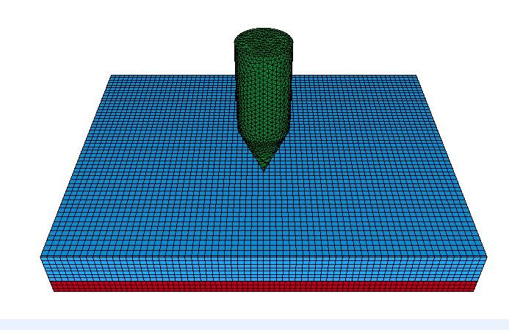

Figure 1- modeling of projectile and target

The mechanical characteristics of the required material in modeling projectile and target have been extracted from the reference [25]. The mechanical properties of target and projectile are shown in Table [1-3]. In picture 2 the penetration of projectile in target is shown in 0.05 microseconds. Also the change of projectile velocity is shown in figure 3.

Table 1-Mechanical properties of boron carbide [25]

|  |  |  |  |  |
| --- | --- | --- | --- | --- |
| Poisson’s  ratio, ν | Density, ρ  (kg/m3) | Stiffness,  E (GPa) | Yield strength,  σy (GPa) | Tangent  modulus, Et (GPa) |
| 0.17 | 2500 | 440 | 15.8 | 0 |

Table 2- Mechanical properties of steel projectile [25]

|  |  |  |  |  |
| --- | --- | --- | --- | --- |
| Poisson’s  ratio, ν | Density, ρ  (kg/m3) | Stiffness,  E (GPa) | Yield strength,  σy (GPa) | Tangent  modulus, Et (GPa) |
| 0.3 | 7890 | 202 | 1069 | 2 |

Table 3- Mechanical properties of Kevlar 49 composites [6]

|  |  |  |
| --- | --- | --- |
| Poisson’s  ratio, ν | Stiffness,  E (GPa) | Density, ρ  (kg/m3) |
| 0.28 | 105 | 1382 |

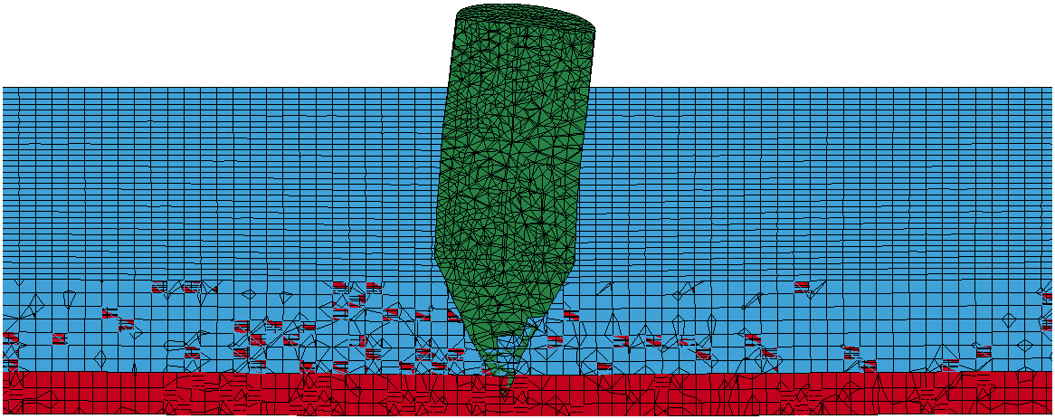

Figure 2- penetration of projectile in target in 0.05 microseconds

According to figure 3 the impact velocity of projectile in target is 400 m/s and residual velocity of projectile is 211 m/s.

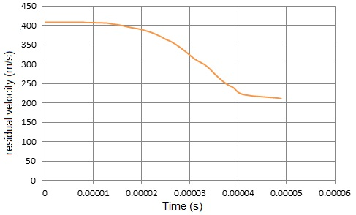

Figure3 -Projectile velocity variation curve versus time during impact on an armor

The simple model presented in reference (25) is used to evaluate the gained numerical result. In this analytical model the energy equation (11) has been used. In this equation mp is the constant projectile mass, vs is the impact velocity, vr is the residual velocity, v50 is the ballistic limit velocity.

$$\frac{1}{2}m_{p}v_{s}^{2}=\frac{1}{2}m_{p}v_{r}^{2}+\frac{1}{2}m_{p}v_{50}^{2} (1)$$

$$v_{s}^{2}-v_{50}^{2}=v_{r }^{2} (2)$$

By considering 310 m/s as the ballistic limit velocity, according to the previous model, the results from analytical and numerical model are compared in figure 4 also the analytical and numerical results are compared in this figure. Here it can be seen that there is a good agreement between the numerical and analytical results. It is clear that the projectile stops at the target with a velocity of 310 m/s and in higher impact velocities the remained velocity will be higher too. This shows the fact that at velocities of lower than ballistic limits, when the impact velocity increases, the absorption capability of energy increases too. Although at velocities higher than ballistic limits with the increase in impact velocity, the capacity of energy absorption has a considerable reduction. It should be noted that the validity of the simulation results are evaluated using the results presented by Shokrieh & Javadpour (25). In this article the ballistic limit velocity for the similar plate to the one discussed in the present article has calculated to be 328 m/s that has a difference of about 5.5 percent with the present ballistic limit velocity. Considering the difference infinite element model like size of used mesh in the present numerical simulation, these differences can be justified.

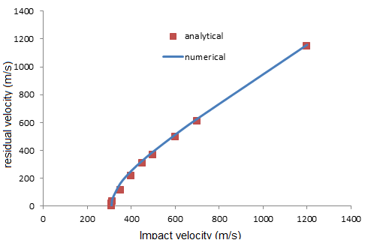

Figure 4- compare between analytical and numerical model

2-Numerical modeling of penetration in ceramic-aluminum plates

In this modeling the compound plate of the upper plate of ceramic is made of alumina and the lower plate is made of aluminum 2024. The numerical modeling is done using the finite element LS-Dyna. Here the projectile is modeled with half cylinder tip. The dimensions of half cylinder projectile are modeled according to figure 4 and the target panels with the dimensions of 250×250 mm and thickness of 10mm. In this simulation the normal impact is considered with the impact velocity of 457 m/s. Both layers of material used in the armor system are modeled with eight-node uniform hexahedron solid elements. The eroding contact is used for contact between the projectile and target (Eroding-Node-to-Surface). Johnson-Cook's material model that is capable of applying the effect of strain and destruction rate is used for aluminum. Also an elastic-plastic model with the capability of considering the destruction in ceramic and projectile is used. The mechanical properties of materials in modeling projectile and target are derived from reference [27]. Fig 6 shows the compound surface finite element with thicknesses of 7.1mmand 2.9mm for ceramic and aluminum respectfully. Fig 7 shows the penetration of projectile in the mentioned surfaces in 0.6 micro-second. The changes of projectile velocity are presented in fig 8 as it is clear from the figure the projectile is penetrated with a velocity of 457 m/sand the residual velocity of projectile is 225 m/s.

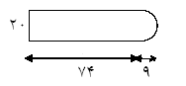

Figure 4: Projectile geometry dimensions in millimeters

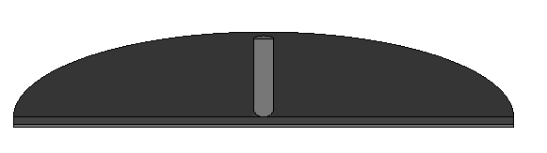

Figure 5: Projectile Modeling and Target

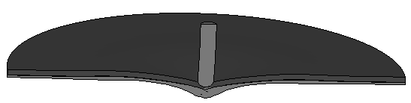

Figure 6: Influence of the projectile in the target in 0.6 Microseconds

In table 5the results of the remained velocity taken from simulation of the penetration of projectile in compound targets with 10 impact velocities. in these simulations the thickness of ceramic and aluminum plates are 7.1 mm and 2.9 mm respectfully as it can be seen in this table the compound plate has been able to stop the projectiles up to a velocity of 250 m/s and in higher velocities the projectile penetrates in target. The simple model presented in Borovicrefrence [28] is used to evaluate the numerical results. In this analytical model, the ballistic limit velocity and the residual velocity of projectile are presented as the equations 2 and 3.



Figure 7: Graph of projectile velocity changes with time

 (3)



 (4)

In this equation σs is:

 (5)

In equation 5 Y is the Yield strength and is the Yang model. In equation 2 L is the length of projectile, and the amount of l is Its diameter. The amount of K1 is a number that is related to the geometrical parameters of projectile and vs is the impact velocity of projectile to the target.

If in the previous equations the limit velocity of ballistic in projectile is considered to be 250 m/s, the results of analytical and numerical models are compared in Table 5.

Table 5-result of residual velocity in numerical and analytical model

|  |  |  |
| --- | --- | --- |
| Remaining fast from numerical method (m/s) | Remaining fast from analytical method (m/s) | Velocity (m/s) |
| 0 | 0 | 250 |
| 25 | 47 | 255 |
| 100 | 125 | 280 |
| 125 | 160 | 300 |
| 312 | 295 | 400 |
| 528 | 532 | 600 |
| 617 | 633 | 700 |
| 725 | 740 | 800 |
| 830 | 846 | 900 |
| 945 | 961 | 1000 |

Also in fig 8 the numerical and analytical results are compared. Here it can be seen that there is a reasonable coincidence between numerical and analytical results. What can be distinguished is that the projectile is stopped at the target with a velocity of 250m/s and in higher impact velocities the remained velocity will be higher too. This shows that in velocities lower than ballistic limit, when the impact velocity increases, the energy absorption capability increases too. But in higher velocities higher than ballistic limit, with the increase of impact velocity, the absorption capability of the target reduces considerably. It should be pointed out that the validity of simulated models has been evaluated using the presented results by Borovic28. In this article the analytical velocity limit for the plate similar to the one presented in this article is 276 m/s which has a difference of 26 m/s with the gained limit ballistic. That the error possibility is 0.9 that can be justified according to the difference in the finite element model the sizes of the used meshes in the present numerical simulation.

The limitations of the study

Although it seems that comprehensive studies have been conducted in order to optimize the compound ceramic-composite targets, it is necessary to investigate in 3 more aspects;

A; In all articles the base model presented by Florance [19] is used, in this model the geometrical form of projectile is considered to be cylinder that necessarily is not always so.

b: in all articles except the article by Ben Dor (2009) the necessary energy for breaking of ceramic has been ignored.

C: the presented models all try to maximize the resistance against the penetration of compound plates. Some of these studies have entered the total weight of the structure as a fixed amount in optimization equations.

Considering the importance of weight in areal structures in this article in addition to investigating the resistance against the penetration of the compound plates of ceramic and compound materials. because of maximum resistance of these materials against penetration and their minimum weight, these material have been optimized. In this optimization process, the resistance against the penetration of compound plates is determined by the finite element method and in later the optimization parameters have been determined by the genetic algorithm. Here after numerical solution of penetration problem, in order to determine the optimization functions (the strength of plates and weight) according to the optimization parameters, the surface response method has been used. Using the equations presented above, the optimized thickness of compound plates comprised of the lower layers of composite has been determined from Epoxy Kevlar and the upper layer of ceramic from boroncarbid and also the optimized thickness of compound plates comprised of lower plates from aluminum and the upper layer of ceramic from alumina using finite element method and is presented in tables 6 and 7. In which the total thickness of compound surface is considered to be 10 mm. as can be seen in both models the optimized plate gained from the presented equation by Ben Dor (2009) has the highest energy absorption rate, but the optimized plate gained by Wang has the lowest weight.

A review of the methods of optimizing of compound structures

Recently most of the studies in this field have tried to optimize the compound armor of ceramic-composite. In this regard, so far some studies have been conducted to present analytical models. The model presented by Florence 1967 is a case in this point.

In 1967, Florence considering the impact of projectile on ceramic-composite targets like figure (1) presented equation (1) to estimate the velocity of ballistic limitation:

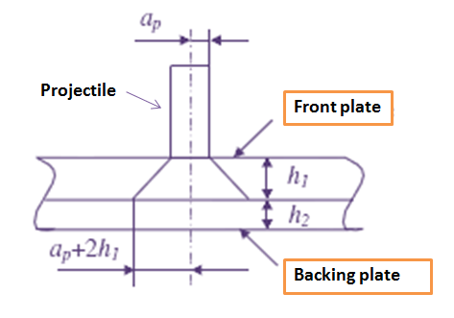

Figure 8: Florence model



Where VP is limit velocity, a is a coefficient which is gained from laboratory information, ɛc is breaking strain of backing plate,ρ1 and ρ2 are the densities of ceramic and backing plates respectively.

Vp is the predicted value of V50, the ballistic limit velocity (m s- 1). (V50 is the velocity at which the projectile has a 50% chance of perforating the target at normal incidence.)

S = σc. h2

σc is the ultimate tensile strength of the backing plate (N m-2)

Mp is the mass of the projectile (kg)



a = ap + 2h1 (m)

ap is the radius of the projectile's armour piercing core (m)

h1 = ceramic plate thickness (m)

h2 = backing plate thickness (m)

d1 = density of ceramic (kg m-3)

d2 = density of backing plate (kg m-3).= density of backing plate (kg m-3).

Hetherington in 1991 extended the Florence model and optimized a target which was made of the front plate of Alumina and back plate of Aluminum he considered areal density, temperature parameters and total thickness of armor to be constant and reached the following equation. Hetherington reached equation (2) through improved Florence model.



Wang in 1996 used Florence model to improve compound surfaces as well he considered the total thickness of armour to be constant but didn’t consider the density to be constant. The purpose of optimizing was to maximize the ballistic limit. This equation is as follow.

T= the total thickness of armour

ap is the radius of the projectile

mp is the mass of projectile.

Ben-Dor and his colleagues in 2000 to some extent corrected Florence model to impact under the following condition.

1- Consider a normal impact.

2- The projectile is rigid.

3- He used armour consisting of aceramic front plate and composite back plate.

4- Areal density of the armour is constant.

5- Hedid optimization for the least areal density with ballistic limit velocity.

6- They claimed that a proper thickness must be gained for ceramic to reach the least areal density and finally they presented equation (8).



In this equation is the ballistic limit velocity, analytical and numerical model ρ1andρ2 are density of front plate and back plate, respectively.



Ben-Dor and his colleagues in 2009, because of leaving maximum ballistic limit velocity, improved the compound armour and reached equation (9).



In this equation, b1 and b2 are the thickness of front plate and back plate, respectively.γ2andγ1are the volume density of plates, A1and A2are the amount of the improved plate density.

In conditions that ceramic plate and back plate are made of alumina and aluminum. equation 10 can be stated as fallow.



Total thickness of armour: b=b1+b2

Using the presented equations, the improved thickness of compound plates composed of lower plate of composite and upper plate of ceramic and are presented in table4, in which the total thickness of armour is 10 millimeter. As can be seen, the improved surface gained from the above equation by Ben-Dor has the maximum capacity of energy absorption, but the gained improved plate through the equation presented by Wang has the minimum weight.

Table 6- mechanical properties of boron-carbide

|  |  |  |  |  |
| --- | --- | --- | --- | --- |
| Poisson’s ratio, ν | Density, ρ (kg/m3) | Stiffness, E (GPa) | Yield strength, σy (GPa) | Tangent modulus, Et (GPa) |
| 0.17 | 2500 | 440 | 15.8 | 0 |

Table 7: mechanical properties of steel projectile

|  |  |  |  |  |
| --- | --- | --- | --- | --- |
| Poisson’s ratio, ν | Density, ρ (kg/m3) | Stiffness, E (GPa) | Yield strength, σy (GPa | Tangent modulus, Et (GPa) |
| 0.3 | 7890 | 202 | 1069 | 2 |

Table 8: Mechanical properties of Kevlar 49 composites

|  |  |  |
| --- | --- | --- |
| Poisson’s ratio, ν | Stiffness, E (MPa) | Density, ρ (kg/m3) |
| 105 | 105 | 1382 |

Table 9: improved amounts for every one of the presented models

|  |  |  |  |  |
| --- | --- | --- | --- | --- |
| Total mass [Kg] | Absorbed Energy [J] | Ceramic thickness [mm] | Composite thickness [mm] | Optimization |
| 0.130 | 873 | 5.8 | 4.2 | Wang |
| 0.1337 | 880 | 6.4 | 3.6 | Ben-dor 2000 |
| 0.137 | 889 | 6.9 | 3.1 | Hetherington |
| 0.142 | 908.6 | 7.7 | 2.3 | Ben-dor 2009 |

The purpose of optimization is to gain the proper thickness for ceramic and composite which for the shield in additional to having the least areal density, can absorb the most amount of energy produced by the impact of projectile. Therefore, using numerical method, the reaction of surfaces with different thickness of layers has been calculated and sited in table (5). In this table the amount of absorbed energy in each layer and their total weight has been presented.

Here, the purpose is to find the optimized thickness of upper and lower surfaces, in such away so as to the target surface would have the minimum absorbed energy and minimum total weight. so in this process of optimization the density of surfaces, their absorbed energy, optimization equation and the thickness of layers have been considered as the optimization of parameters. Also the total thickness of armour is constant and equal to 10 mm.

Table 9: reaction of surfaces with different thickness of layers

|  |  |  |  |  |
| --- | --- | --- | --- | --- |
| Number | Composite thickness [mm] | Ceramic thickness [mm] | Absorbed Energy [J] | Total mass [Kg] |
| 1 | 1 | 9 | 921.2 | 0.1528 |
| 2 | 2 | 8 | 897.8 | 0.1446 |
| 3 | 3 | 7 | 889 | 0.1375 |
| 4 | 4 | 6 | 860 | 0.1315 |
| 5 | 5 | 5 | 824 | 0.1240 |
| 6 | 6 | 4 | 827 | 0.1172 |
| 7 | 7 | 3 | 775 | 0.1095 |
| 8 | 8 | 2 | 709 | 0.1020 |
| 9 | 9 | 1 | 677 | 0.0955 |

Table 10 -reaction of surfaces with different thickness of layers

|  |  |  |  |  |
| --- | --- | --- | --- | --- |
| Total mass [Kg] | Absorbed Energy [J] | aluminum thickness [mm] | Ceramic thickness [mm] |  |
| 2.692 | 551.24 | 1 | 9 | 1 |
| 2.667 | 702.71 | 2 | 8 | 2 |
| 2.641 | 3254.27 | 3 | 7 | 3 |
| 2.612 | 3609.83 | 4 | 6 | 4 |
| 2.586 | 5301.25 | 5 | 5 | 5 |
| 2.56 | 6276 | 6 | 4 | 6 |
| 2.532 | 5212.82 | 7 | 3 | 7 |
| 2.506 | 3604.75 | 8 | 2 | 8 |
| 2.48 | 5777.29 | 9 | 1 | 9 |

Using the response surface method, mathematical equation between equation and optimization parameters has been calculated and finally using the genetic algorithm optimization model (26) the thickness between the layers has been calculated. Table (6) shows the result of optimization. Comparing the result of tables 5 and 6 one can conclude that the optimized surface in addition to being able to absorb acceptable energy, is lighter.

Table 11- Optimize thickness for ceramic- composite

|  |  |  |  |
| --- | --- | --- | --- |
| Composite Thickness  [mm] | Ceramic thickness  [mm] | released Energy  [J] | Total mass  [kg] |
| 5.6 | 4.4 | 788 | 0.119 |

**4. Discussions**

The final results of the present study are as follow:

1. The study of all the present optimization models for compound plates shows that so far no method has tried to optimize this plate in order to have high resistance against high penetration and low weight at the same time.
2. Using the finite element method and genetic algorithm as efficient and cheap instruments the thickness of different layers of compound plate has been determined.
3. Comparing the present optimized plate with the results of previous methods, it can be concluded that the present optimized plate in addition to the capability of reasonable energy absorption, has a lower weight in comparison with the previous optimized plates.

**Corresponding Author:**

Ali Akbar Mobasseri

Shahid Sattari Air University, Graduate Center, Tehran, Iran

[mobasserialiakbar14@yahoo.com](mailto:mobasserialiakbar14@yahoo.com)

**References**

1. E. A. Witmer (Ed.), An assessment of technology for turbojet engine rotor failures, Proceedings of a Workshop Sponsored by NASA Lewis Research Center, MIT, March 29}31, NASA CP-2017, August 1977.
2. S. Sarkar, S. N. Atluri, Impact analysis of rotor fragments on aircraft engine containment structures, in: C. I. Chang, C. T. Sun (Eds.), Structural Integrity in Aging Aircraft, AD-Vol. 47, ASME, New York, 1995, pp. 87}97.
3. Federal Aviation Administration, Design considerations for minimizing hazards caused by uncontained turbine engine and auxiliary power unit rotor failure, FAA Advisory Circular No. 20-128A, March 25, 1997.
4. J. A. Mathis, Design procedures and analysis of turbine rotor fragment hazard containment, Federal Aviation Administration Report No. DOT/FAA/AR-96/121, March 1997. engine and auxiliary power unit rotor failure, FAA Advisory Circular No. 20-128A, March 25, 1997.
5. Federal Aviation Administration, Turbine engine rotor blade containment/durability, FAA Advisory Circular No.33-5, June 18, 1990.
6. Society of Automotive Engineers Committee on Engine Containment, Report on aircraft engine containment, SAE AIR 4003, September 1987.
7. D. D. Le, Evaluation of lightweight material concepts for aircraft turbine engine rotor failure protection, Federal Aviation Administration Report No. DOT/FAA/AR-96/110, July 1997.
8. National Transportation Safety Board, Uncontained engine failure delta air lines flight 161, McDonnell Douglas MD-88, N919DE, Atlanta, Georgia, June 13, 1996, Aircraft Accident Report, NTSB MIA96SA157.
9. M. L. WILKINS, Mechanics of penetration and perforation. Int. JENGNGsci.16,793_807 (1978).
10. M. Myseless, W. Goldsmith. S. P. Virostek, S. A. Finnegan, Impact on ceramic targets, J. off applied mechanics v (58)-pp373-378, (1987).
11. A. Tate, A theory for the deceleration of long rods after impact., J. Mec. Phes. solids,14,378-399(1967)
12. Z. Rosenberg, I. Tsaliah, Applying Tate`s model for the interaction of long rod projectiles whit ceramic targets. Int. J. Imact Engng 9(2), 247-251(1990).
13. R. L. Woodward, A simple one _ dimentional approach to modeling ceramic composite armour defeat. Int. J. Imact Engng 9, 455-474(1990).
14. I. S. Checron Benlolo, V. SA`NCHEZ_GA`LVEZ. A new analytical model simulate impact on to ceramic Impact. Engng 2(6), PP,461-471 (1998).
15. N. A. Fellows, PC. Bartan, Development of impact model for ceramic faced semi_infinite armour. Int,. J. Impact Engng. 22,793-811 (1999).
16. P. Lundburg, Renstrom, V. Lundburg, Impact of metalic projectiles on ceramic targets: transition between interface defeat and penetration. Int. J. Impact Engng.24, PP, 259-275 (2000).
17. T. He, H. M. Wen, Y. Qin, Penetration and perforation of FRP laminates struck transversely by conical-nosed projectiles. Int. Composite Structures, 81, PP,243–252 (2007).
18. M. Lee, E. Y. Kim, Y. H. Yoo, Simulation of high speed impact into ceramic composite systems using cohesive-law fracture model. Int. Impact Engineering 35, PP, 1636–1641 (2008).
19. Florence AL. Interaction of projectiles and composite armour, Part II, Standford Part II, Standford Research Institute, Menlo Park, California, AMMRC-CR-69-15, 1969 August.
20. J. G. Hetherington, the optimization of two component composite armours. Int. J. Impact Engng, pp, 409-414. ( 1992).
21. B. Wang, G. Lu, On the optimisation of two-component plates against ballistic impact. Int. Materials Processing Technology,57, PP,141-145 (1996).
22. G. Ben-Dor, A. Dubinsky, T. Elperin, N. Frage, Optimization of two component ceramic armor for a given impact velocity. Int. Fracture Mechanics,33, PP, 185-190 (2000).
23. Jing Shi, Dana Grow, Effect of double constraints on the optimization of two-component armor systems. Int. composite structures 79, PP,445 – 453 (2007).
24. G. Ben-Dor, A. Dubinsky, T. Elperin, Improved Florence model and optimization of two-component Improved Florence model and optimization of two-component. Int. composite structures 88, PP, 158–165 (2009).
25. M. M. Shokrieh, G. H. Javadpour, Penetration analysis of a projectile in ceramic composite armor, Int. composite structures 82, PP,269-276 (2008).
26. www.nimbus.mit.jyu.fi/cgi-bin/N4/new_prob.py

2/25/2020