**Improve image contrast using the histogram of the matrix obtained in a uniform method of histogram and without noise histogram overlay**

1Javad Kangarani Farahani, 2Reza Ahmadi, 3Zahra Askari, 4Mohammad Hosein Bayat

1Department of Electrical Engineering, Tafresh Branch, Islamic Azad University, Tafresh, Iran

2Department of Electrical Engineering, Ashtian Branch, Islamic Azad University, Ashtian, Iran

3Department of Electrical Engineering, Tafresh Branch, Islamic Azad University, Tafresh, Iran

4Department of Electrical Engineering, Tafresh Branch, Islamic Azad University, Tafresh, Iran

[Farahani.javad@gmail.com](mailto:Farahani.javad@gmail.com), [rockmantry@gmail.com](mailto:rockmantry@gmail.com), [Zahra.askari22@yahoo.com](mailto:Zahra.askari22@yahoo.com), [Hossain_bayat@yahoo.com](mailto:Hossain_bayat@yahoo.com)

**Abstract:** In this paper, we approach used in the original paper, which improved the image contrast of the histogram is based on informal we represent. The source of the original histogram using the histogram below with reference to the brightness level and a limited range of the mean and variance improves. As a final total weighted images obtained histogram is consistent with the Uniform Building. By the range of the minimum and maximum values of each individual operator draws the histogram equalization is limited. We use in this method, the matrix obtained from the histogram method. The histogram of the image without using the histogram of uniform methods and Using the histogram method improves the overall image is described and finally we will compare these two methods. [Kangarani Farahani J, Ahmadi R, Asgari Z, Bayat H. **Improve image contrast using the histogram of the matrix obtained in a uniform method of histogram and without noise histogram overlay.** *Researcher* 2020;12(2):63-68]. ISSN 1553-9865 (print); ISSN 2163-8950 (online). <http://www.sciencepub.net/researcher>. 8. doi:[10.7537/marsrsj120220.08](http://www.dx.doi.org/10.7537/marsrsj120220.08).

**Keywords:** Improve contrast; Histogram of uniform; the uniform of the histogram; Noise Uniform; image processing.

1. **Introduction**

Improve the contrast, brightness provides a clear picture of the amount. In other words, as the distances stretch characteristics between the bright and dark improves. The two techniques can improve the overall community image did. General methods [2] through the normal cumulative distribution function are extremely helpful. This method will make the narrow Noisy many pixels as noise overlap occurs. To solve this problem, we use a uniform method of local histogram [3,4] we use. Thus local histogram method is that the original image is divided into several sub-blocks of non-overlapping sub-blocks and the uniformity of the histogram does. Image results obtained with one of the blocks is. In this way the problem of discontinuity in the block nears the block boundaries that happen -. Local methods within each sub-block only local information without a complete picture of the balance of uses.

1. **Method of uniform size with cumulative distribution function**

Uniform method of histogram overall scale factor normalized cumulative distribution rate and the image brightness values on the original scale factor used to intensity will be distributed.

An image data is shown below:

(1)



Here the components of L if X (i, j) is shown.

Normalized intensity of the screen Xk, k the level of intensity. For uniform histogram of the intensity function of the form shown in Equation 1, we use.

(2)



(3)



In this equation, n the total number of pixels in the image and me nk, k is the number of pixels.

To obtain a uniform histogram function, the cumulative distribution function of the probability distribution function is calculated using equation (2) has the form beyond. [2]

(4)



The level of cumulative distribution function of T (Xl-1) = 1 and k = 0, 1... 1-1

K is the intensity of the image. Then the histogram of an image consistent with a uniform distribution, we may be a function of the distribution of the output image is equal to all distributions.

The resulting image of the form (1) with the original image histogram and histogram has improved.

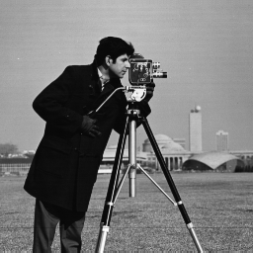

A

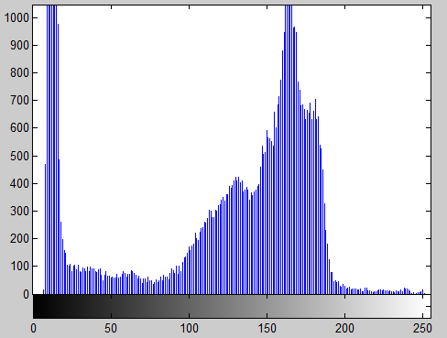

B

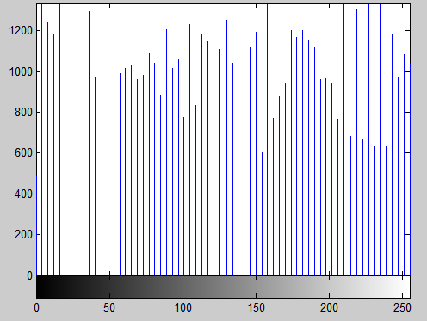

C

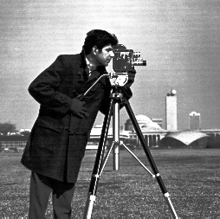

D

Figure (1): A - original image. B - Tsvyrasly histogram. C - The uniform histogram. D. - the image histogram is uniform.

1. **From the histogram of uniform**

The original article [1] by using Gaussian approximation and calculate the mean and variance of the equation 3 and 4 in which the definition is applied to remove unnecessary areas be



in equation 3 and the variance of the Gaussian distribution of selected regional centers by the center is created. When the two equations are used, the Gaussian approximation can be obtained similar to Figure 2.



Figure (2): the Gaussian approximation

Figure (3) below shows the uniform.

Uniform illumination of the area under the histogram and cumulative distribution function by the district to act this form is divided into three sub-histogram and a histogram showing the uniform sub and the resulting image is obtained by one of these three images is.



A



B



C



D

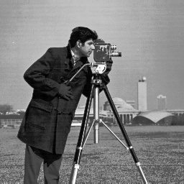

E

Figure (3): A - Histogram divided. B - 46 ~ 0 C- the histogram of the uniform - the uniform histogram region of 165 ~ 47 D - a uniform region of 255 ~ 196 E - the final image.

1. **characteristics of binary histogram method of maintaining uniform brightness**

The histogram method is based on the average brightness of the input is divided into two parts. XB is the first independently and then equations (5) and (6) are formed.

(5)



(6)



This method can be symmetrically distributed around a mean average brightness of the input histogram itself be preserved, but the video does not have this feature. Average brightness of the input image is dependent.

Improved image at this stage in the form of (2) is shown. [5]

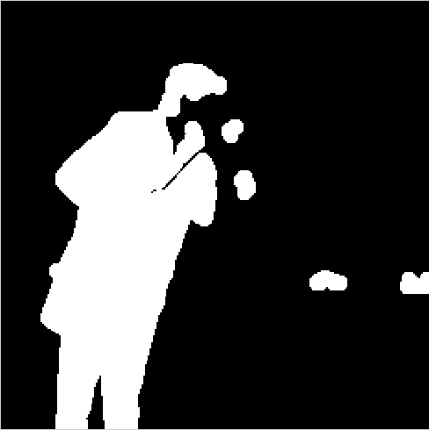

Figure (4): the image of the average threshold

This method is very similar approach to the uniformization technique called two-component histogram of the image [6], with the difference that here we separate the input image is gray XD as the middle class and the equation (6) is calculated.



This method is applied to the image on the image in the form (3) is shown.

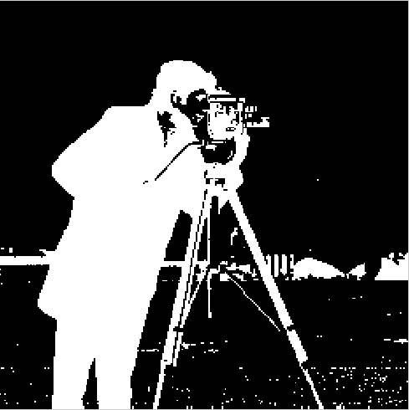

Figure (5): the image of a moderate threshold.

Result of improved image after combining the two methods is better. Histogram of the image using the mean or average and median as the threshold in the form (6) with the histogram has improved.

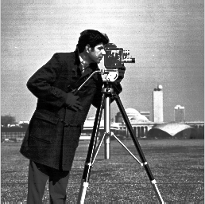

A

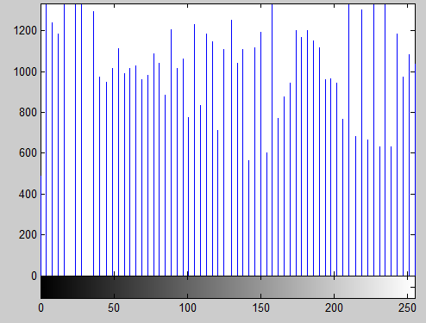

B

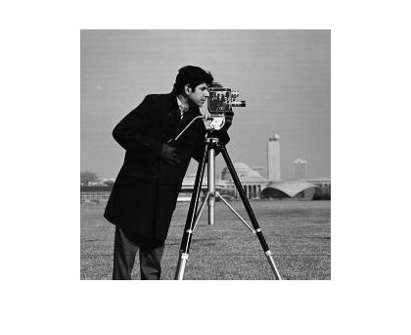

C

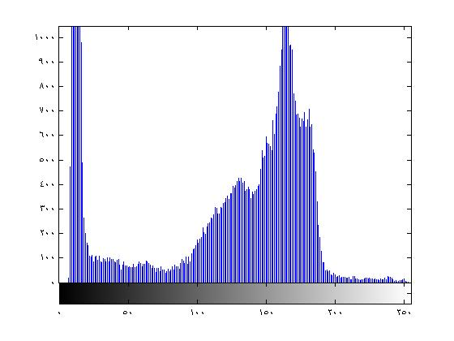

D

Figure (6): A and C - the final image using the second method. B and D - the histogram of the image

1. **Compare**

According to the source article of the figure3 (e), and the results obtained from the combination of the two methods improve the contrast of the average mid see Figure 6, Figure 6 is the result looks much better.

1. **Conclusions**

This paper presents a new method to enhance the contrast of the density histogram of the uniform acts. In the paper the problem of the origin of most general way some of the images that are high-density histogram distribution are narrow, the regional distribution of low density and wide distribution. To solve this problem, the histogram of the input image histogram and density sub histogram is uniform. The algorithm assumes a uniform impact of a number of small high density area of the histogram is narrow, split. Another area of the histograms normally operates smoothly. The method described in this article was not the source of problems in the article picture and the result is better.

The impact of this approach on a satellite photo you can see in Figure 7.

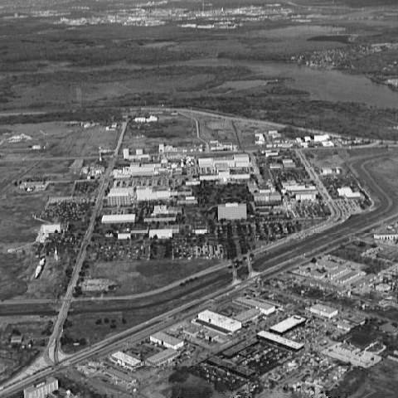

A

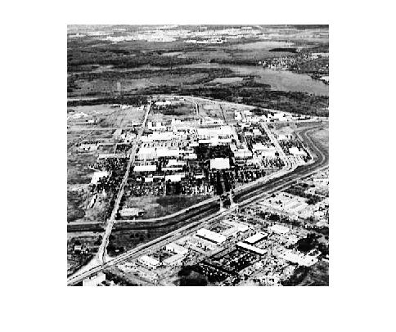

B

Figure (7): a and b - Satellite Image Using the second method

**References**

1. Hyunsup Yoon, Youngjoon Han, and Hernsoo Hahn, Image Contrast Enhancement based Sub-histogram Equalization Technique without Over-equalization Noise, 2009.
2. A. K. Jai, Fundamentals of Digital Image Processing, Prentice-Hall, 1989.
3. J. A. Stark, "Adaptive Image Contrast Enhancement Using1 - Generalizations of Histogram Equalization, "IEEE Transactions on Image Processing, 9 (5), pp.889-896, 2000.
4. Y. T. Kim, "Contrast Enhancement Using Brightness Preserving Bi-Histogram Equalization," IEEE Transactions on Consumer Electronics, 43 (1), pp.1-8, 1997.
5. Y. Wan, Q. Chen, B.-M. Zhang, "Image enhancement based on equal area dualistic sub-image histogram equalization method", IEEE Trans. Consum. Electron. 45 (1) (1999) 68-75.
6. S. D. Chen, A. Rahman Ramli, "Contrast Enhancement using Recursive Mean-Separate Histogram Equalization for Scalable Brightness Preservation," IEEE Transactions on Consumer Electronics, 49 (4), pp.1301-1309, 2003.
7. Soong-Der Chen, A. Rahman Ramli, “Preserving brightness in histogram equalization based contrast enhancement techniques,” Digital Signal Processing, 12(5), pp.413-428, September 2004.
8. Chao Wang and Zhongfu Ye, “Brightness Preserving Histogram Equalization with Maximum Entropy: A Variational Perspective,” IEEE Transactions on Consumer Electronics, 51(4), pp.1326-1334, 2005.
9. K. S. Sim, C. P. Tso, and Y. Y. Tan, “"Recursive sub-image histogram equalization applied to gray scale images”", Pattern Recognition Letters, 28(10), pp. 1209-1221, 2007.
10. Z. Chen, B. R. Abidi. D. L. Page, M. A. Abidi, “Gray-Level Grouping (GLG): An Automatic Method for Optimized Image Contrast Enhancement-Part I: The Basic Method,” IEEE Transactions on Image Processing, 15(8), pp.2290-2302, 2006.
11. S. M. Pizer, E. P. Amburn, J. D. Austin, R. Cromartie, A. Geselowitz, T. Greer, B. H. Romeny, J. B. Zimmerman, K. Zuiderveld, “Adaptive Histogram Equalization and Its Variations,” Computer Vision Graphics and Image Processing, Vol. 39, pp.355–368, 1987.
12. F. Lamberti, B. Montrucchio, A. Sanna, “ CMBFHE_a novel contrast enhancement technique based on cascaded multistep binomial filtering histogram equalization,” IEEE Transactions on Consumer Electronics, 52(3), pp.966-974, 2006.
13. Z. Q. Wu, J. A. Ware, I. D. Wilson, J. Zhang, “Mechanism analysis of highly overlapped interpolation contrast enhancement,” IEEE Proceedings Vision, Image & Signal Processing, 153(4), pp.512-520.
14. Majid Amirfakhrian, Reza rouzdor, Maryam Nahvi, Improve image contrast using the histogram of the matrix obtained in a uniform method of histogram and without noise histogram overlay, 9rd Regional Conference on Computing and Intelligent Systems, (2012), Islamic Azad University, Science and Research, East Azarbaijan.

2/21/2020