**Improvement of geometric and optical distortion for the scanned document images based on text boundary lines and brightness estimation function**

Pegah Nouri1,*, Yaser Baleghi2, Mehrdad Ahmadi Kamarposhti1

1. Young Researcher Club, Jouybar Branch, Islamic Azad University, Jouybar, Iran

2. Faculty of Computer and Electrical Engineering, Babol Noshirvani University of Technology, Babol, Iran

*Corresponding Author

**Abstract:** While the pages of a book or thick document to be scanned; two types of geometric and optical distortion for the scanned images arise. As a result of the damages, hick curvy lines of text in the document find and book binding are shaded. This problem makes it difficult to read. In the near future, it is an attempt to correct such images. In this paper, we review the methods for correcting the curvature and shadow images of scanned documents in the thick boundary lines of text books; we estimate the lighting function.

[Nouri P, Baleghi Y. Kamarposhti M A. **Improvement of geometric and optical distortion for the scanned document images based on text Boundary lines and brightness estimation function.** *Researcher* 2020;12(1):90-95]. ISSN 1553-9865 (print); ISSN 2163-8950 (online). <http://www.sciencepub.net/researcher>. 8. doi:[10.7537/marsrsj120120.08](http://www.dx.doi.org/10.7537/marsrsj120120.08).

**Keywords:** Destruction, border lines, text, images, documents, curved, image correction, thick book, Shadow Correction.

**1. Introduction**

With the development of office automation, more and more traditional volumes need to be transformed into electronic documents. Therefore, scanners are widely applied. However, problems with the quality of the scanner are easy to use. However, scanning thick bound volumes always leads to distortions, shadow and warping near the spine of the volume which not only diminished document’s readability, but also reduces the accuracy of OCR application. Thus, images of scanned thick documents are necessary to retrieve and read texts for human. In this paper, methods are presented for restoring wrapped document images. These methods can be divided into two Categories such as three-dimensional shape reconstruction method and Two-dimensional image processing to classify. Methods of the first category have been reported by many authors. Kanungo et al [1] have presented a global degradation method for perspective distortion. However, it is assumed that the curved surface of a circular cylinder and the lighting direction is vertical. Wada and et al. [2] a complicated technique to reconstruct the three-dimensional book surface, have developed the method assumes that the surface is cylindrical, and requires that the scanner light source is parallel to the book binding. Complicated computation of the inter reflection made the method having high computational cost. Pilu [3] presented a method that uses the applicable surface and restored the document image by unrolling the applicable surface to a plane. Yamashita and et al. [4], a method using NURBS curves are presented for the reconstruction of three-dimensional surface. However, their method requires a system with two cameras. It appears that the three-dimensional model based on traditional methods require many parameters the computational complexity is increased in fact, some of the parameters are difficult to obtain.

Tsoi et al. proposed a method [5] which models the curled page as a ruled surface. Based on this model, they formulated shading extraction as a problem of scale change estimation between two image columns. Tang and et al. [6] proposed a method that estimates the 3-D distortion using the 2-D geometry variations.

Zhange et al. [7] adopted a regression model of curved text lines to restore the wrapped text lines. This method has a limitation that the word, especially long word, may be still wrapped after restoration. Catos and colleagues [8], a new method based on text line and word detection are presented. They recovered the document image word by word according to the word boundary lines. Ulges et al. [9] proposed a method based on document image dewarping using robust estimation of curled text lines. Although Zhang and et al. [10] uses a page border for correcting the wrapped document, yet all the help page boundaries, which makes it hard to get the scanner to limit its application. Brown and et al. [11] are presented

interpolation method for correcting shadow boundary. This method can give good results for various image shadows but this method is limited to the iso-parametric folding lines. This paper aims to propose a method which can correct warped Chinese document images, especially the documents which have both text regions and non-text regions without special setups and page boundaries. And also in this paper, a general-purpose method propose based on an assumption that the reflectance function of the page surface is piecewise constant and the illumination function is smooth for shading extraction and correction in scanned book images.

**2. Analysis and Discussion**

The proposed method for correcting curvature, images scanned documents are analyzed according to some previous assumptions, it is important and necessary for correct operation. it Can be obtained only when the text boundary lines could be acquired correctly and wrapped side is known.

Also, the proposed method for correcting shadow, can correct all types of non-uniform shadow images around the boundary of the damaged books completely. Also the proposed method, modified the method Zhang and used for various scanned images of the books with wide range of images. Then we explain these two methods.

*2.1. Detection of curved side*

While scanning thick books, the gray-scale images can be seen with different brightness and darkness. As shown in Fig. 1, shadow exists along the spine of the volumes. Shadow on the left side of the image, and only the wrapped side of the images suffers wrapping. Therefore, the curved sides can be identified with gray scale analysis function V (x), which can be obtained as follows:

(1)



(2)



Where H is the height of the document image, s (i, j) is the intensity value of pixel (x, y), and T is a predefined threshold.

*2.2. Text boundary lines*

In this paper, area of the document except the page footer and header page is named main body.  In the main body, the first text line upper boundary line and the last text line lower boundary line is named upper text boundary line and lower text boundary line respectively.

At this step, an efficient text boundary lines method for wrapped document images is presented. The lines segment to estimates the high and low text boundary lines is used. The steps are as follows:

A) Linear segmentation is used to fit the curve named text upper and lower text boundary lines.

B) Analysis of inflexion is named to improve the results.

C) curvature based smooth treatment is applied to get final the curved boundary line.

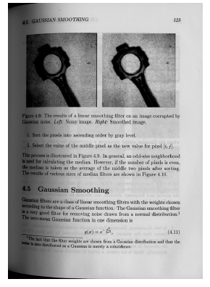

Fig 1: Example of image scanned thick books.

*2.2.1. An estimate of the text boundary lines*

Because most of the characters except some simple characters in the same line have the same height, line segment which is not longer than the character's width can be used as a character's upper baselines and lower baselines which delimit the body of the character. Documents without distortion, the main lines of the letters are in the same line. The line segments can be connected as text line's boundary line. The line segment could be acquired from the local Vertical projection. The length of the segment lines are detected by width characters in unwrapped area. The length of character's boundary segment lines is 2/3 character's width.

*2.2.2. Inflexion analysis*

Although some characters are simple and less complex, but segment line of them may not be accurate. However, inflexion analysis method can adjust the location of the segment lines' location correctly.

*2.2.3. The use of adjacent pages*

The proposed correction method is based on the text boundary lines. So, if it do not succeed, the restoration will fail too. In fact, in most documents, there are text lines exiting in the top and bottom area of document, it causes the text boundary lines could be acquired in most of them. If the top and bottom areas are non-text regains, such as fig. 2(a), the upper boundary lines can't be properly achieved. In this case, use of similar to the adjacent pages to restore documents image approximately, then the follow-up adjacent pages can be used to inspect and correct the results. The proposed approach plates adjacent the side adjacent pages book. For example, page N's adjacent pages are page N +2 * i (i = ± 1, ± 2, ± 3,...). Because of only the same side's pages adjacent have wrapped similarity. The adjacent pages page N +2 * i (i = -1, -2, -3,...) are used to detect the boundary lines approximately, while the pages page N +2 * i (i = 1,2,3,...) are used to further inspect and correct approximate results. The boundary lines could be acquired correctly. The final boundary lines of fig. 2(a) are shown in Fig. 2(b).

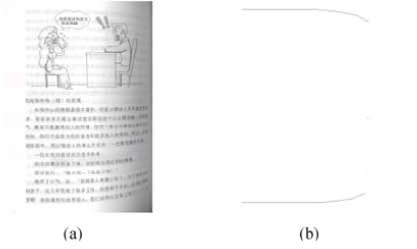

Fig 2: (a) The sample of non text document image (b) The final boundary lines

**3. Restoration of document image**

After processing, a restoration method based on the upper and lower boundary lines is presented. The result image of Fig.1 is shown in Fig. 3. As shown in Fig. 2(b), the text boundary lines have parallel components. Between two parallel lines is the unwrapped area, while the area between the curved lines is wrapped area.

For doing this, adjust the pixel's location of the wrapped area as same as unwrapped area. The main objective of the proposed method can reflected in Figure 4. As you know, when scanning thick books occurs both geometrical and optical distortion. This distortions caused by the overlap of information, reflecting to the obtained images is that some pixels in the wrapped images are lost. The purpose of restoration is to create and insert these pixels to the obtained images. Therefore, a vertical column-by-column adjustment by nearest interpolation algorithm is performed. Then the lens imaging distortion is restored by bilinear interpolation algorithm.

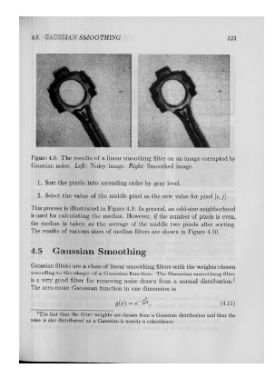

Fig 3: Result of Figure 1.

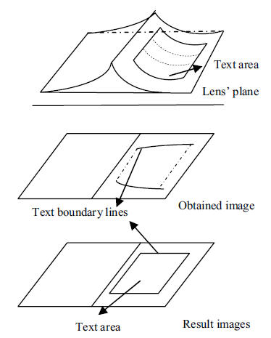

Fig 4: The text boundary lines based restoration.

**4. Shading extraction and correction**

*4.1. Proposed Method*

According to The optical image model [12], the intensity of a scanned image Ι (x, y) can be expressed as follows:



Where is the source intensity of the scanner light, and R (x, y) and 0 <C (x, y) ≤ 1 are the reflectance value and the illumination reduction at point (x, y), respectively.



When C (x, y) is calculated, image free from shadow can be improved as follows:



Since the page surface is generally smooth, and the printed contents are of high contrast to the background, this assumption is appropriate for most scanned book images. Where I (x, y) is the shading-corrected image and K is a prescribed constant. An appropriately selected k can attenuate the background noises in the shading area, which are caused due to the transmission of printed contents on the back of the scanned page. However, due to the unknown reflectance component R (x, y), the solving C (x, y) from (3) is ill-posed. To solve this problem, it is assumed that R (x, y) is a piecewise constant and C (x, y) is smooth. Since, the page surface is generally smooth, and the printed contents are of high contrast to the background, this assumption is appropriate for most scanned book images. Converting (3) into its logarithm form, we have:



To solve a smooth C (x, y) from (5), the energy function is expressed as follows be:



where Ω is the image domain. This energy function can be used for measuring the smoothness of C (x, y).



Fig 5: Shading correction for scanned book image. (a) Image with non-uniformly distributed shading artifacts. (b) Image regions with uniform reflectance values. (c) Extracted shading image. (d) Smoothing shading image with RBF. (e) Shadow-free image.

*4.2. Smoothing with RBF*

The corrected Shadow from images scanned books is shown in Fig. 5. When r (x, y) is calculated, c (x, y) can be obtained immediately from (5). However, the estimation of may contain some noises [see Fig. 5(c)] due to the segmentation errors of or the existence of gradually changed areas in the photographic regions of the image. To resolve this problem, we smooth by using a surface fitting algorithm with radial basis functions (RBF) proposed in [13]. In tests, we selected 15 20 collocation points and used Gaussian kernel function for surface smoothing, where C is a prescribed constant. We set c=10 in the experiments. An example of smoothed is shown in Fig. 5(d), and the image after shading correction is shown in Fig. 5(e).



**5. Discussion and results**

In order to evaluate proposed method, the OCR testing as a measure of success is carried out both on the original and the result images. The OCR average character precision and recall [14] defined as below:

Character Precision

=



Character Recall

=



The OCR average character recall and precision results are improved by proposed restored method. This paper proposed compares our method with Tsoi’s method [5], Brown's method [11] and Zhang's method [13]. The corrected images are illustrated in Fig. 6(c)–(f), respectively. As can be observed from the results, Tsoi’s method cannot remove shading artifacts at the top and bottom sides of the image simultaneously.

Brown’s method produces a satisfactory output, but the shading near the spine region is not completely corrected. Zhang’s method generates desirable results in the textual regions but fails for the photographic regions, as illustrated in Fig. 6(e). Compared with the above methods, the proposed method shows good result on the tests. It is able to completely correct shading artifacts occurred in the textual or photographic regions. Also, the output performance of the proposed method, mean absolute error and improve the standards of error variance between the original and corrected images are compared to other methods.



Fig 6: Comparison results of shading correction on a synthetic shading image. (a) Ground truth image. (b) Synthetic shading image. (c)–(f) Shading corrected images by using Tsoi’s method, Brown’s method, Zhang’s method, and proposed method, respectively.

**5. Conclusion**

In this paper, a new method for correcting images based on text boundary lines are curved documents. The proposed method can make the curved boundary lines of text, even for short text lines above and below the image in the document is not set. The proposed method is based on the analysis of two-dimensional images, with no text areas can also be improved by this method. Moreover, the proposed approach to a Chinese introduction does not require text content of the page. The images show the success of this approach. To eliminate shadows of images, assuming a fixed point on the screen surface reflection is essential. With this assumption, the area gradually changed to improve the image of shadow damage. However, this assumption may be wrong photo in altered areas progressively eliminated. In this paper the problem of filtering the illumination function is estimated to be solved by RBF. This approach to areas such as the area of most picture books scanned images with good results is small.

**References**

1. T. Kanungo, R.M. Haralick, and I. Phillips, “Nonlinear Global and Local Document Degradation Models,” Int’l J. Imaging System and Technology, pp. 220-230, Oct. 1994.
2. T. Wada, H. Ukida, and T. Matsuyama, “Shape from Shading with Interreflections under a Proximal Light Source: Distortion-Free Copying of an Unfolded Book,” Int’l J. Computer Vision, vol. 24, no. 2, pp. 125-135, 1997.
3. M. Pilu, “Undoing Page Curl Distortion Using Applicable Surfaces,” Proc. IEEE CS Conf. Computer Vision and Pattern Recognition, vol. 1, pp. 67-72, Dec. 2001.
4. A. Yamashita, A. Kawarago, T. Kaneko, and K. T. Miura. Shape reconstruction and image restoration for non-flat surface of document with a stereo vision system. IEEE International Conference on Pattern Recognition, 2004.
5. Y. C. Tsoi and M. S. Brown, “Multi-view document rectification using boundary,” in Proc. CVPR, 2007.
6. C.L. Tan, Z. Zhang, L. Zhang, and T. Tao, “Restoration Warped Document Images through 3D Shape Modeling,” IEEE Trans. Pattern Analysis and Machine Intelligence, vol. 28, no. 2, pp. 195-208, 2006.
7. Z. Zhang and C.L. Tan, “Correcting Document Image Warping Based on Regression of Curved Text Lines,” Proc. Int’l Conf. Document Analysis and Recognition, pp. 589-593, Aug. 2003.
8. B. Gatos, I. Pratikakis, K. Ntirogiannis, “Segmentation Based Recovery of Arbitrarily Warped Document Images”. Document Analysis and Recognition, 2007. ICDAR 2007. Ninth International Conference on Volume 2, 23-26 Sept. 2007 Page (s):989 – 993.
9. A. Ulges, C. H. Lampert & T.M. Breuel, ”Document image dewarping using robust estimation of curled text lines ”, Proc. ICDAR’05, 2005. pp.1001-1005.
10. X. Zhong, X. Li, Z. Tang, ”Correction of Images Scanned form Books”, Journal Of Software 2002, Vol.13, No.11. (in Chinese)
11. M. Brown and Y. Tsoi, “Geometric and shading correction for images of printed materials using boundary,” IEEE Trans. Image Process., vol. 15, no. 6, pp. 1544–1554, Jun. 2006.
12. H. G. Barrow and J. M. Tenenbaum, Recovering Intrinsic Scene Characteristics From Image. New York: Academic, 1978.
13. L. Zhang, A. M. Yip, and C. L. Tan, “A restoration framework for correcting photometric and geometric distortions in camera-based document images,” in Proc. ICCV, Rio de Janeiro, Brazil, Oct. 2007, pp. 14–20.
14. M. Junker, R. Hoch, and A. Dengle, “On the Evaluation of Document Analysis Components by Recall, Precision and Accuracy,” Proc. Int’l Conf. Document Analysis and Recognition, pp. 713-716, 1999.

1/25/2020