Kaveh’s Uprising and Fereidoun’s Sovereignty in Historical Texts and on the Façade of Afshins’ Palace

Mahin Ahbabi

PhD Student of "ancient history", Tajikistan Academy of Sciences, Tajikistan

Abstract: Kaveh’s revolt was a public movement against foreigners’ oppression. Kaveh, who belonged to artisan class, protested to his children’s being murdered by Zahak and called on people to fight against the cruelty of Zahak. In the façade of Afshins’ palace, Kaveh and Fereidoun were united since the beginning of the revolt and were fighting against Zahak and his puppet rulers and gained victory; a point which is not referred to in historical texts. After the victory, Fereidun became the king with the agreement of Kaveh and people. Kaveh didn’t become the king because he didn’t have three characteristics that Iranian kings had: “He wasn’t from royal family (descendents of Jamshid), he didn’t own king glory, and he didn’t have spiritual status.” As a result, he couldn’t be a king because in a hierarchical system no one was permitted to leave a class and move to a higher class. After his sovereignty, Fereidoun appointed Kaveh and his children as commanders-in-chief. Therefore, he promoted to army class. Fereidoun ordered to decorate the flag, which was made by Kaveh out of his leather apron to raise up in his revolt against Zahak, with jewels and it was carried in front of the army in different wars. In fact, this uprising shows the cooperation between different classes of people and the king in their battles with foreign aggression against the territory of Iran and Aryan religion.
[Mahin Ahbabi. Kaveh’s Uprising and Fereidoun’s Sovereignty in Historical Texts and on the Façade of Afshins’ Palace. Researcher 2020;12(1):84-89]. ISSN 1553-9865 (print); ISSN 2163-8950 (online). http://www.sciencepub.net/researcher. 7. doi:10.7537/marsrsj120120.07.

Keywords: Derafsh Kaviani (the standard of the Kings), Fereidoun, Zahak, Dave, Mehregan, wooden façade of Afshins’ Palace, Farr

1. Introduction
The story of the revolt of Kaveh and Fereidoun against Zahak is in fact the battle of the force of good against the force of evil and darkness. Finally good defeats evil with the help of Ahura Mazda. The only discovered image which displays this event is the façade of Afshins’ palace which has survived from Sassanid era which is in historical city of Bonjeh Kant in Autroshan in the state of Soughed, Tajikistan. This palace existed in 6-7th C A.D. and it was burned by Arabs in 9th century A.D. and the façade of the palace is now kept in national museum of Tajikistan (Boyce, Mary (1975), Buda and Nirvana…, Mullah Babayof, P. 21).
The façade of the palace is a semicircle which is typically made of wood on which some mythical images and the story of the revolt of Kaveh and the battle of Fereidoun against Zahak is carved. It is the unique historical and cultural heritage of ancient Persians. In other words, it expresses the Persians’ beliefs and feelings and illustrates the victory of Iranian heroes in their battles against evil and darkness (Figure 1).

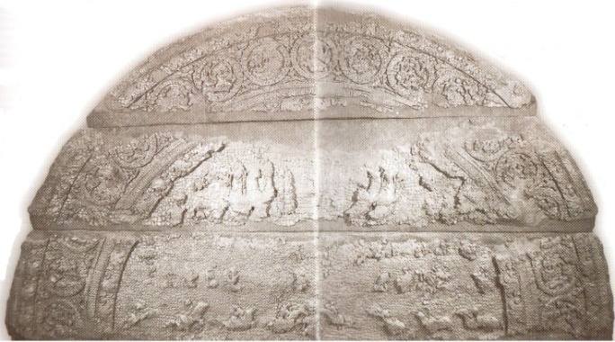
Figure 1: façade of the palace

The important point is that this work is very old in comparison to historical texts because historical texts (such as Shahnameh and The History of Al-Tabari) have been compiled after the Islam (10th century AD) from the remaining resources of Sassanid era (such as Khoda Nameh) while this façade belongs to pre-Islam era (6-7centuries AD).
The description of the events of the struggle of Kaveh and Fereidoun in historical texts is slightly different from that of the façade of Afshins’ palace. What is that difference? Possibly their sources have been different which need to be investigated.
Around the upper part of semicircle, there are totally 17 rings with a diameter of 20 cm for each one.
The middle semicircle is also divided to two upper and lower parts on which the story of the battle of Kaveh and Fereidoun against Zahak and his puppet rulers have been carved (Buda and Nirvana, Mullah Babayof, P. 23).
This article aims to investigate the reason of eliminating Kaveh from historical texts and the difference of the story in historical resources and in the image of the façade of Afshins’ palace. The researcher hopes to express every detail accurately.
1.1. Kaveh the blacksmith
The name of Kaveh is not mentioned in Avesta. It is not even mentioned in the abridgements of Sassanid Avesta in 8th and 9th volumes of Dinkard. More importantly, his name is not mentioned in any of Pahlavi’s religious literature which offers comprehensive information about the most ancient part of legendary history.
In historical texts, Kaveh first appears in the books of Islamic era historians such as Shahnameh and the History of Al-Tabari (Skjærvø, P. O (1989). In fact, Firdausi and other historians have set their history based on Khoda Nameh of Sassanid era. Christian’s opinion about Khoda Nameh is: “Generally, it offers a newer interpretation of legendary history in comparison to religious tradition of Pahlavi’s texts. Pahlavi’s religious texts display legendary history in such a way that this history had changed before the era of Parts and during their sovereignty, while in Khoda Nameh the legendary history is illustrated in its Sassanid form. In Sassanid era, the legends were quite terrestrial and belonged to the human territory without eliminating their imaginative and mythical aspects. For example, in Khoda Nameh Zahak changes from a three-head snake to a human-like king who had grown two snakes on his shoulders? But this feature is not seen in religious texts which have remained from Mullahs’ tradition (Kaveh the blacksmith and derafsh Kaviani, Christian Sin, P.36).
It is quite obvious that Khoda Nameh has been compiled and written by the Sassanid Court. Possibly there had been another non-court public history which cared for public and non-court heroes and winners whose bravery and sacrifice in their battles against oppression and foreign invaders and their cooperation with kings in battles against enemies had been mentioned; but in Sassanid Khoda Nameh the role of such heroes and people is paled.
There are different opinions about the uprising of Kaveh the blacksmith against zahak. In History of Al-Tabari and Balami it is mentioned that after 200 years of tyranny and murdering the youth by Zahak, a blacksmith named Kaveh whose sons were murdered for the serpents of Zahak, launched an uprising against zahak. He went to the palace of Zahak and protested against his tyranny. Zahak commanded to release his only remaining son and asked Kaveh to sign Zahak’s justice certificate, but he tore the document, came back to the city and rebeled against the foreign ruler of Persia and led the people to overthrow the tyrant king. As a symbol of resistance and unity, he raised his leather apron on a spear, known as the Derafsh Kaviani. People helped him. Kaveh killed Zahak’s Caliph in Isfahan. To suppress the rebellion, Kaveh sent an army from Tabarestan (Damavand) to Isfahan. Kaveh defeated them. He conquered the cities one after the other until he reached to Ray. Fereidoun, a descendant of Jamshid came to Ray and Kaveh accepted him and gave him the corps (Firoozeh Kashani-Sabet (2000)).
However, the story of the battle of Kaveh on the entrance façade of Afshins’ palace is a little different from the narrations of Shahnameh, The History of Balami, and The History of Al-Tabari. In 17 circles curved on the façade, the moments of the battle are displayed in which two winners riding on horses and a warrior fallen under the hooves of horses are pictured (Buda and Nirvana, p.23), (figure 2).

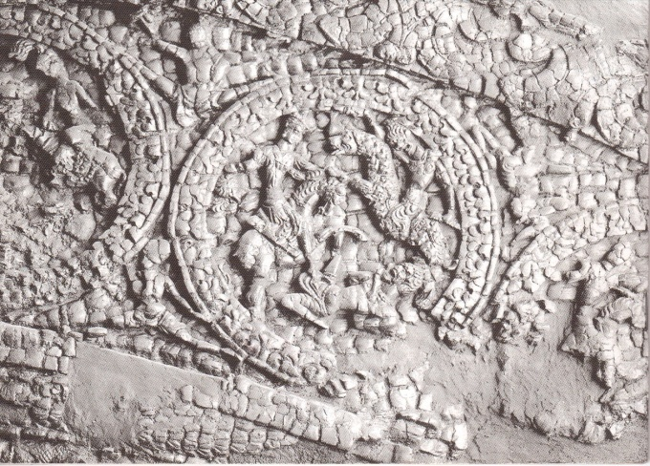
Figure 2: the moments of the battle are displayed in which two winners riding on horses

Two winners ridiong the horses are Kaveh and Fereidoun and the third person falling under the hooves of horses is Zahak’s puppet ruler. Riding men are alike in all circles. There are some differences in the details of war tools and dress in some circles. In one case, instead of the falling warrior, a twisted serpent or dragon is pictured that is Zahak himself (Iran almanac and book of facts 1964-1965). It means that Kaveh and Fereidoun were together and united since the beginning of the uprising. The conquered the cities with each other, defeated zahak and captured him. The point is not referred to or is deliberately ignored in historical books.
Another important point is that two scenes of fighting with a devil creature are curved on the façade which are originated from the myths. One scene is the battle of Kaveh and Fereidoun (riders) against the serpent or dragon in the rings. The other one is the battle of two groups of riders against a human like Dave in the middle of the lower part of façade and these two devil creatures probably symbolize Zahak, as in myths Zahak is shown in two forms as well (a devil-like human and a dragon) (figure 3).

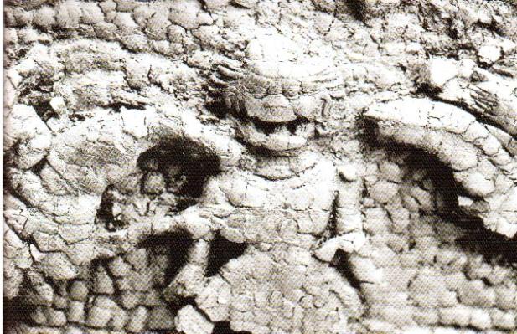
Figure 3: two scenes of fighting with a devil creature are curved on the façade

Another important point is that in the battle of killing serpent or dragon (in the ring) only Kaveh and Zahak are present, but in the battle against human figure of Zahak, they are not alone and two groups of riders are seen in left and right sides. There are four riders in every row with thin waste that are uniform in dress and face and the first riders of each row who are probably Kaveh and Zahak attack the human-like creature.
The main question here is the reason of the number of riders which is eight. It’s quite clear that two riders out of eight are Fereidoun and Zahak, but who are the six other riders? Maybe these six riders symbolize the heads of Iranian tribes who were united with Fereidoun in the battle against Zahak. Together with Karen family (son of Kaveh), the symbol of 7 great families in Ashkanian (Parthian) era is probably derived from them or it might be the symbol of people’s unity with the kings to fight against foreign invaders.
In the History of Al-Tabari, the unity of people with Kaveh in fighting against Zahak is referred to as well: “Kaveh and his followers left Isfahan and people joined him in the way. ”
2.1. Fereidoun’s Sovereignty
Now, two questions are raised: why Zahak who was so cruel and powerful was so lenient against Kaveh and people’s protest?
In the History of Al-Tabari it is mentioned that Zahak was afraid of Kaveh. Even Zahak’s mother was surprised by his son’s leniency towards Kaveh and people. “Oudak, mother of Zahak who was more tyrant and crueler than her son and was near her son and heard people who were blaming him and was very angry and upset. When people left, she was shocked, came to Zahak and blamed him. Zahak replied that people surprised him by their true speech. As I wanted to show my authority off, the right appeared and I couldn’t do anything. He even fulfilled the promises he had made to people of provinces and treated them leniently (Russell, J. R (1989).
The reply lies in the profession of Kaveh. He was a blacksmith. It probably had an ironic reference to the discovery of Iron or making a new arm with high efficiency among Iranians. Kaveh’s being blacksmith refers to the development of weapon industry of Ariaeeha in that period of time and Zahek’s leniency towards Kaveh and people was for that reason.
Like before the main reason of Ariaeeha’s victory over the foreign invaders was the superiority of their arms. The arms which were made by Ariaeeha and they had the superiority to others who were using older weapons. What was that weapon called? “Mace!”
In some rings of the façade of Bonjeh Cant there is a weapon like a mace in the hand of one of the riders (figure 4).

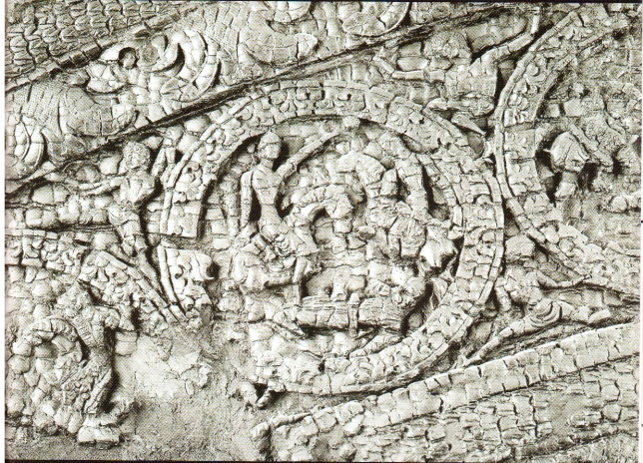
Figure 4: façade of Bonjeh Cant

Referring to making the bull-head mace in historical texts confirms this point as well. It is stated in Shahnameh that Fereidoun commanded the blacksmiths to make bull-head mace:
Bring, you skilled Blacksmiths
a heavy mace, he commanded.
A painter painted on the soil
A tool like the head of a bull (Shahnameh, V.1 p.42).
Mace was made in the past. So what technological preference did it have to the past? Maybe this mace was made from iron or a new combination of iron and other elements which was stronger and heavier than bronze mace. Making a mace like the bull head was also ritually associated with the sacred cow among Fereidoun family and was related to Mithraism among Iranians because it is a description of the same magic power that exist in the head of the bull. By making the mace like the head of a bull, the power of the bull which exists in his head is also given to the new weapon (Kaveh the blacksmith…., p. 54).
It also refers to the importance of blacksmith’s craft and its association with fire and Iranian religion (Mithraism) at that time. Even in Greek myths, Hephaestus, the god of blacksmiths was originally the go of fire which was coming out of some parts of the Earth as igniting gas. Then it was associated with the volcanoes of Sicily and Italy. Its name as fire was used by Homer and Greek poets. It is not in fact a Greek god and has no origin in Greek language. Hephaestus religion spread from Lycia (Lydia) in southwestern Anatolia (Minor Asia) to multiple locations in Greece territory (Encyclopedia of World Mythology, Rex Varner, p. 395). This myth is possibly associated with the myth of the war between the god of fire and dragon which is narrated in religious texts.
The second question is that why Kaveh, who was the leader of the uprising and the beginner of the battle, did not become the king himself. Christian Sin believes that “Kaveh’s legend was created after Ashkanian Era and was introduced placed in the history of Sassanid era (Khoda Nameh) and the whole story is a linguistic mistake; because Kaveh was derived from ancient Avestan term “Kavi” and its plural form (Kavian) means the kings and its Pahlavi equivalent is Kavian and the whole story of Kaveh is narrated just to explain the origin of national flag (Derafsh Kavian)” (Khaleghi-Motlagh, Djalal (1996).
Of course, Christian Sin’s opinion about the term (Kaveh) might be right. However, the reason that Kaveh didn’t become the king is not the creation of the story in Sassanidera and the justification of Derafsh Kaviani but it is due to the issue of hierarchical society. Kaveh, as a blacksmith, belonged to craftsmen class and in a hierarchical society no one was permitted to leave a class and enter a higher class unless by the command of the king. As Jamshid told each group after forming hierarchical society, “nobody must do anything except his own task.” Moreover, in such a hierarchical society, in Iranians religious beliefs, the king was considered as the representative of God on the Earth.
Farr which is the essence of fire in Avesta, was a kind of splendor, glory, and force which was giving the power of leading and ruling on the Earth to the king or the messenger on behalf of Ahura Mazda. (Wiesehofer, Joseph. 1996). God didn’t grant Farr to anybody. An average person from a low class or and evil, cruel or a devil person didn’t not deserve to obtain the Farr; as Afrasyab Toorani vainly jumped to Farakhkart Sea three times to hold the Farr but failed, or Zahak sacrificed thousands of cows and sheep for Ardevisura Anahita but failed.
Another point is the royal ancestors. Iranian kings were descendants of Houshang and Jamshid Pishdadi. They were the first outstanding and selected Ahooraee people. They were religious and political leaders of the society who were leading people. Ahoora Mazda granted gold ring and stick to Jamshid as he decided to rule on the earth. (T. Pellechia.2006).
Stick was the sign of ruling and commanding and ring was the sign of knowledge, wisdom, and spirituality. It was also a sign of love. When the religion of Mithra’s rituals became one of the mysterious religions, the ring and stick became the particular signs of the great clergyman of the Mithraism. In fact, the Persian king had three special privileges: he was the descendant of Jamshid, he had the Farr of God, and he was known as the representative of God on the Earth, that is he had the position of (king-God) or the highest political and religious position on the Earth. In third Dinkard, Kurd invited people to follow the king who was religious and selected by Mazda, “ On the earth the kings are protecting the world and the achievements of the former kings and the enemies who have disobeyed the orders of the kings, have infact disobeyed the orders of Persian kings who were religious leaders (T. Pellechia.2006). Before Zahak, Persian Kings had all three features as well. It was due to this belief that the kings of Achaemenid and Sassanid dynasties associated themselves to Pishdadi and Kiani dynasties in terms of race and ethnicity, and in stone paintings they got the kinship ring and stick from Mitra or curved the symbol of Faravahar above the head of the king. Also in third Dinkard, the race of the kings is referred to: “The best kings are those of the religion of Jam that is those kings who are like the sun among people and who are the best and the nicest for all the creatures and from the best race like Jamshid Jam (T. Pellechia.2006).
On the façade of Afshins’ Palace there are three masculine figures around the curved circles which are holding the circles with their hands. They are probably angels or gods or celestial images. There are even two crested birds on the middle of the upper part of the image and two men are mounted on them that possibly refer to helping and supporting Kaveh and Fereidoun by Ahoora Mazda and other gods. Maybe those birds are the symbols of roosters and the men mounted on them are the gods of Mithra and Soroush which are above the two rows of riders and help them in their battle against Zahak (Figure 5).

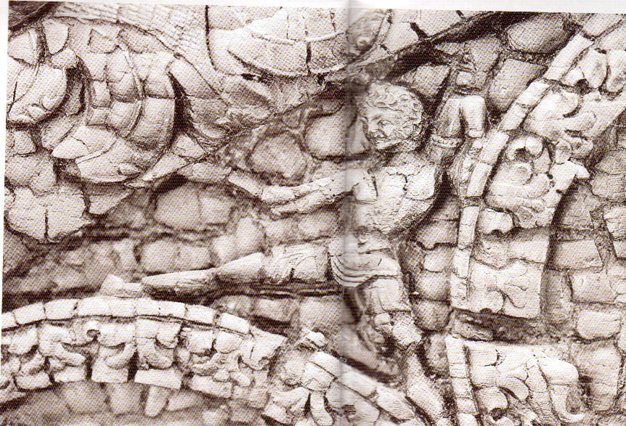
Figure5: the gods of Mithra and Soroush

Because one of the tasks of the roosters was to help the two gods of Mithra and Soroush in the battle against Dave and devils (Sundermann, Werner. 1989). It was a traditional belief in Central Asia because people thought roosters were like Simurgh and Homa and would bring them good luck and happiness and believed that they had some miracles (Joseph Beikof, imaginations of people of Pamir about animals and birds, p.26).
Based on this ritual belief, the minor local rulers obeyed the king and the country got stability. If every person could become the king, then every ruler or army commander could claim to be the king and people would also admit him and the order and the coherence of the country would destroy. In historical texts it is narrated that when people finally suggest this position to Kaveh, he replies, “ I don’t deserve it because I’m not a member of royal family and someone must be king who is from royal family. I am a blacksmith; my purpose was to relase people from Zahak’s oppression and cruelty. If I claimed to be a king, everyone would say that he wouldn’t deserve it and the sovereignty and the world would be destroyed and would not last for me.” (Sundermann, Werner. 1989). That is why in Sassanid Khoda Nameh his role is paled and Fereidoun appears, then people and Kaveh fade away. Fereidoun, the bull-head mace and national flag (Derafsh Kaviani) play the main role. Fereidoun fulfills the task and brings peace and stability to people. Who was Fereidoun? In Bondahesh he is the 10th descendant of Jamshid. (Bondahesh, pp. 149-150). All their names have the suffix –gav as a part of them such as Pourgav, Siahgav, Dafargav,…. It is narrated in Avesta that his father was “Abtin” which is an adjective in Avestan language meaning “from the family of Athooyeh”. He was the second person who touched Hoom according to the tradition and was rewarded a son who was called Fereidoun. (Avesta, V. 1, p. 137). Athavi Family (Abtin) is remembered in Avesta with attributes which indicate their power and wealth. In Vandidad the place of residence of Fereidoun Family is mentioned to be “Varn”. (Avesta, V.2, p.663).
The mother of Fereidoun is not mentioned in Avesta, but his ancestors, his mother’s name and the way in which Fereidoun achieved to Jamshid’s Farr are explained: As she committed a sin, Farr was separated from Jamshid as poultry. She landed on the reeds in Farakhkard Sea. “Dargah” the father of Faranak (grandfather of Fereidoun) released a cow there magically so that Farr could go inside the cow, and he could achieve Farr, but by drinking milk Farr entered to Faranak “mother of Fereidoun” and Fereidoun achieved her after her birth (Bondahesh, pp.150-151).
Zahak feels he is endangered by Asooyeh family and orders to kill Abtin:
Fereidoun whose father was Abtin
Was close to Abtin on the ground.

They caught him and tied him like a cheetah Zahak appeared before him by force. (Shahnameh, V.1, p.35)
Another point was the religion of Fereidoun and his family. In Shahnameh his religion is referred to as Mithraism.
His religion is to worship Mehregan (Mithra) his custom is to relax and to eat. (Shahnameh, V.1, p.53)
In The History of Balami it is narrated about his religion that the magicians are told that they are fire worshippers and Hindus are told that they are idol worshippers (The History of Balami, V.1, p.107). In one of the circles the sun is shining above two riders which might refer to their Mithraism. It is concluded from the whole content that Verne territory was ruled by ruled by Athooyeh dynasty and Abtin, father of Fereidoun, was the ruler of that land. They had the religion of Mithraism, but invaders (Followers of Zahak) felt endangered by them and attacked that land and killed the men and the ruler (Abtin).
Fereidoun was grown and trained by Moghan from his childhood in a hidden mount. Therefore Fereidoun was a descendant of the kings, had the Farr of god, and was a hero, clergyman, magician, and doctor. In Avesta, farvardin Yasht, chaoter 31, line 131, his Faravahar is admired to keep people against diseases. (Avesta, V. 1, p. 426).
A magic of Fereidoun was that he changed the skilled sailor “Pa U’roy” to a vulture and made it fly in the sky. This story is mention just in Aban Yasht and nothing is found about it in any historical books or Shahnameh. (Yashtha, V. 1, pp. 194-195).
He was also against the religion of Zahak and revived Aryaee religion. According to historical texts Fereidoun came to the throne on Mehr 16th (October 7th) and declared that day as a national holiday which was called “Mehregan Celebration”. (The History of Balami, V. 1, p. 106). Mehregan Celebration which was a reminiscent of Iranians victory over foreign invaders was one of the greatest Persian celebrations which were held after Islam in primary centuries of hegira.
Now the month of Mehr (October) is a souvenir from him, Do strive and don not show pain and suffer on your face. (Shahnameh, V.1, p.53).
Fereidoun appointed Kaveh as the commander-in-chief. Kaheh became the ruler of Isfahan and its neighboring areas. (Gnoli, Gherardo (2000). In this way, Kave and his family become the members of army family. Wherever he was fighting, Kaveh carried the flag which was made from his leather apron in front of the army and gained victory. After his death, Fereidoun called on his two sons “Karen” and “Ghobad” and admired them and appointed them as the commander-in-chief (Rozatosafa, V. 1, p. 114).
Then Fereidoun commanded to bring Derafsh Kaviani, and it was decorated with gold and jewels and was raised in wars as a symbol of good omen and victory. After Fereidoun, Persian Kings respected Derafsh Kavian and decorated it with different kinds of jewels until in the era of Yazdegerd III, the last king of Sassanid dynasty it was captured by Arab army in Qadisiya war and its jewels were divided among the soldiers of Islam by Omar’s order. (Gnoli, Gherardo (2000).

2. Discussions
Public revolution of Kaveh against invaders (Zahak) and electing Fereidoun by as the king and the political and religious leader by people was an example of ritual struggle for freedom against the tyranny and aggression of foreign invaders. It also displayed the unity of ordinary people with royal family against evil so that Fereidoun, the leader of uprising, had the position of god-king.
That is why Farr of god was given to him to fight against evil, tyranny and corruption of devil foreigners with the help of people and other gods to develop freedom, justice, and Persian rituals and religion. In fact, it was a religious battle.
The battle of Iranian Mithraism against foreign rituals in which Iranian ritual and religion finally gained victory. This unity between the king and people and their religious battle against foreign invaders is well pictured in the façade of Afshins’ palace.

Acknowledgements:
Authors are grateful to the persons to carry out this work.

Corresponding Author:
Mahin Ahbabi
PhD Student of "ancient history", Tajikistan Academy of Sciences, Tajikistan

References
- Boyce, Mary (1975). History of Zoroastrianism, Vol. I. Leiden: Brill.
- Ferdowsi Tusi, Abolqasem. The Shahnameh. Passages was extracted from the Moscow edition by Saeed Hamidian. Fifth edition. Tehran. Qatreh Publications.
- Gnoli, Gherardo (2000). Zoroaster in History. New York: Oxbow.
- Iran almanac and book of facts 1964-1965. Fourth edition, new print. Published by Echo of Iran, Tehran 1965.
- Kaveh the Blacksmith, Persian Hero". Iran Daily. March 15, 2011. Retrieved 2012-09-08.
- Khaleghi-Motlagh, Djalal (1996). "Derafš-e Kāvīān". Encyclopedia Iranica 7. Costa Mesa: Mazda.
- Russell, J. R (1989). "Aždahā: Armenian Aždahak". Encyclopedia Iranica 3. New York: Routledge & Kegan Paul. pp. 204–205.
- Skjærvø, P. O (1989). "Aždahā: in Old and Middle Iranian". Encyclopedia Iranica 3. New York: Routledge & Kegan Paul. pp. 191–199.
- Sundermann, Werner. 1989. Mittelpersisch. P. 141. In Compendium Linguarum Iranicarum (ed. Rüdiger Schmidt).
- T. Pellechia.2006. Wine: The 8,000-Year-Old Story of the Wine Trade pg XI-XII Running Press, London 2006 ISBN 1-56025-871-3.
- Wiesehofer, Joseph.1996. Ancient Persia New York: I. B. Tauris.

1/25/2020

