Face Detection using open-CV and Python

Saima Kanwal, Abdul Sattar, Muhammad Farhan Arif, Jalil Abbas

Department of Computer Science, Lanzou University of Technology, China
Department of CS & IT, Govt. College University Faisalabad Layyah Campus, Punjab, Pakistan
School of Computer Science and Technology, Anhui University, China
Corresponding Author: sjshah786@gmail.com

Abstract: The interest in computer vision has been popularised since a few decades. With the passage of time, its efficiency and accuracy of face detection is being improved day after day. As per the speed of computer is being rapidly increased but we are still willing for much better, similarly the speed of detecting a face is also being improved for Excellency. This document describes the concepts and techniques to get a face detected through a camera by using open-CV and Python. In this process, a neural network is used to get accurate results in face detection and there are different algorithms adopted for a neural network such as Deep Neural Networks (DNN), Convolutional Neural Networks (CNN), etc. Tensor-Flow recently uplifted by Google while working on Neural Networks, is the great tool to train data set in a better way having three layers named input layer, hidden layer and output layer. With the help of open source libraries an image or a frame can be detected if there present the specific functionalities the library is about, similarly face detection library also focusses the face in the image and to get more accuracy hence we have the concept of Artificial Neural Network (ANN).
[Saima Kanwal, Abdul Sattar, Muhammad Farhan Arif, Jalil Abbas. Face Detection using open-CV and Python. Researcher 2019;11(12):14-18]. ISSN 1553-9865 (print); ISSN 2163-8950 (online). http://www.sciencepub.net/researcher. 3. doi:10.7537/marsrsj111219.03.

Keywords: ANN, CNN, DNN, open-CV, Face, Detection, Python, Deep Learning

1. Introduction
The concept of combining open-source Computer Vision Library (open-CV) with Python for this purpose is the major topic of this document from which a neural network is trained for a specific person or a group of people in regards of combination of both open-CV and Python. The artificial technologies are increasing day by day and getting more attentions of the World to it. These days, the concept of artificial intelligence is taking place and has the evidence in the shape of automated machines, robotics, auto-pilot modes, remotely controlled drones, etc. these are the evidences that artificial intelligence exits in the real World. Many problems are covered through artificial technologies as the machines are being trained in regards of medicines and by the help of machines the surgical operations are being done.
The neural network itself is not an algorithm, but rather a framework for many different algorithms of machine learning that enables them to work together and process the complex data input [3].
The open source computer vision libraries are helpful in capturing more computer attention in regards of vision which means that pointing the visualization in form of images or videos of a specific point or figure. These liberaries are useful in connecting the python language or other programming languages to work at the computer vision sight. These liberaries have built-in functions to be overridden in other languages as we desire because we do not need to write the whole function again and again.
As [1] defined that an image can be detected through the open source computer vision liberay (open-CV in short) by using the hue, saturation, and value of colour of the image. Hence, the image contains different contrasts, hue, saturation and colour values. On basis of all of these elements the specific point can be visualized and so that can be detected through computer vision with the help of builtin function of computer vision liberaries. As we know the image can be detected through grayscale contrasts inside the image further as [2] defined that the grayscale conversion of an image is necessary before processing to make it more efficiency because RGB (Red Green Blue) pictures are more bulky and heavy to process to detect a face inside the image using computer vision. Hence, according to the new research the grayscale conversion of an image before processing is being recommended because all of the images are not same and also have different pixels intesities and colour combinations so that grayscale conversion is more likely popular to reduce all of these drawbacks and we should get more accuracy in the output results. Computer vision has become an interesting topic these days just because of increasing its popularity and demand to reduce our time as it provides every liberary to get our work done easily and quickly.

2. Python
Python is a programming language discovered by Gudo Van Rossum in 1991. With the passage of time, python got more popularity because of the use in different kind of areas such as data analysis, web development, artificial intelligence, machine learning and desktop applications development. The most popular companies such as YouTube, Google, Cora, Pinterest etc, these companies use python language.
2.1. Python2 vs Python3
In 2008, Gudo Van Rossum thought that there are many features should be added to python and the currenlty used python2 has some missing features so that he decided to move on python3. But the real problem was the companies who were still using python2 liberaries at that time and to migrate their codes of python2 to python3 was not really easier as it seems to be. The major drawback was that the python3 does not allow the backward compatibility, as the code written in python2 cannot be run in python3 so that he decided that the python2 will continuously receive the liberary updates and also the python3 would be maintained continuously with the new liberaries and features. Hence, all of the companies should have to move towards python3 and there are a long gap been decided for the python3 uplifting. In 2020, the python2 will stop receiving the liberaries maintenance and till then all the companies will be surely moved towards python3. Hence, in today’s world python3 is more popular than python2 and is being used by Windows, Linux and MacOS operating systems as [4] described it in detail.
3. Neural Network
In neural network node is known as neuron or perceptron. It is a computational unit which have one or more than input connections, a transfer connection combines these inputs, and to output connection. Nodes are organized in such a way to comprise a network. Single layer artificial network directly connects to a input variable and it contributes to single output variable. A single-layer network can be extended to make multi-layer network also known as Multi-layer perceptron [6].
MLP is divided in three basic layers:
Input Layer: input variables are used in this layer, also known as visible layer.
Hidden Layer: this is the intermediate layer between the nodes of input and output layers. Hidden layer can consist of more than one layers of it.
Output Layer: Its layer of nodes which produces the output variables.

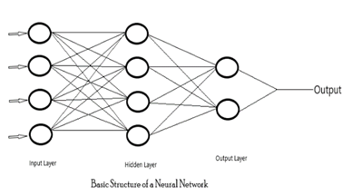
(figure 3.1)

3.1. Algorithms of Neural Network
There are some possible algorithms for implementing a neural network in artificial intelligence or in image processing named Deep Neural Network (DNN), Artificial Neural Network (ANN) and Convolutional Neural Network (CNN).
3.1.1. Deep Neural Network (DNN)
Deep Neural Network (DNN) is the widely used neural network’s algorithm for data representation and also widely used in artificial intelligence and machine learning. The deep learning can be supervised or unsupervised based on the project where it is being used [7].
3.1.2. Artificial Neural Network (ANN)
Artificial Neural Network (ANN) is the most commonly used algorithm in machine learning and image processing. ANN is the interconnected group of nodes similar as the neurons in human mind in vast case [8]. Each node represents the neuron and the arrows represent the connections among these nodes or between two nodes as shown in figure 3.1.
3.1.3. Convolutional Neural Network (CNN)
Convolutional Neural Network (CNN) can be described as a class of deep learning. It is multilayer perceptron based algorithm which is mostly used in visual imagery [9]. For a machine learning or a deep learning based on artificial intelligence the CNN algorithms are used to make the preprocessing as minimal as possible.
4. Face Detection
The basic code for face detection using opens liberary is shown in the figure 4.1 below.

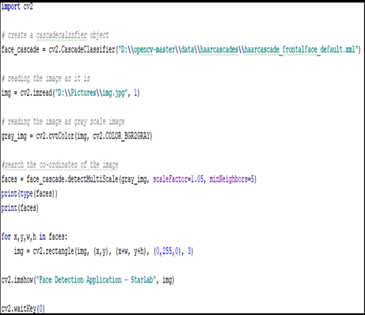
(Figure 4.1)

As the above image states that an image is being detected if there exist any face then numpy is being used to get the accurate matrix as possible and making a rectangle shape along with the face considering x,y,w,h points. And at the debugging time, numpy produces the matrices of the faces as shown in figure 4.2.

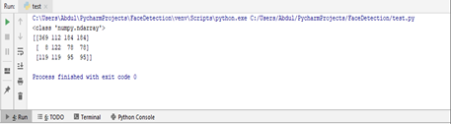
(Figure 4.2)

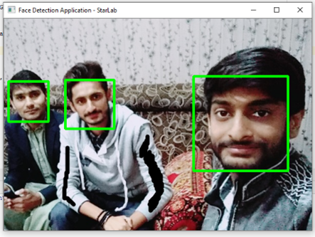
(Figure 4.3)

The output of the above program is shown below in figure 4.3 and a green colored rectangle is finally differentiating the faces inside the image and making sure where the faces are present inside the image.
4.1. TensorFlow
TensorFlow is a program that is recently uplifted by Google while working on neural networks and is a best optimal program which reduces the time complexity in image processing. TensorFlow is a basic program needed for image processing, as it gives its best results in reducing the data set training time complexity. Without TensorFlow, the data set can be trained but it takes more time because of the old algorithms, hence TensorFlow is the best optimal program to overcome this problem. It is used in machine learning at large scale to reduce data set training time [10], it can also be used at small scale but it suites at the large-scale where a data set is to be trained as soon as possible and to provide quick response in machine learning. TensorFlow is the best program or system in latest machine learning techniques.
5. Detecting vailed Face
If there is an image of faces where the faces are covered by the vail then the real question is that our algorithm will work correctly or not. If we are using grayscale system for image processing and we are going through black and white combination by represented 0 for black and 1 for white. If both (0,1) match the pattern of an eye then it will represent an eye and through this we can also guess the actual face present behind the vail. The problem which will occur there is the combination of black and white found on the clothes where there a black dot exists having white background and our algorithm will now matching the pattern as it is an eye exist but is really not. Hopefully, the most advanced researches in the future can cover or overcome this problem in a better manner. The possible problems that might happen can be clearly defined through figure 5.1.
When there present a vail in front of a human face and the vail colour is also contains black dots having white backgrounds then this is the real challenging situation to detect a face instead of pointing the rectangles along the black dots on vail or clothes. Hence, we need more accuracy in algorithms to overcome or handle this problematic situation.

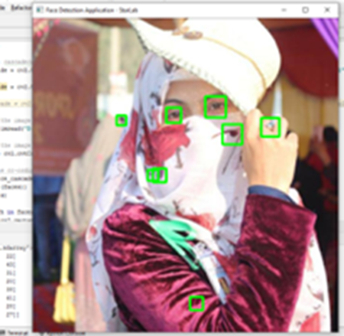
(Figure 5.1)

The numpy matrices of these spotted grayscale combination is shown in figure 5.2 where x,y,w,h are the points making rectangle around the spotted combination 0 for black and 1 for white in grayscale image.
How Algorithm Works?
First of all, python and its open source liberaries should be installed on a computer and then opens liberaries can be downloaded and installed. After that, the next step is coding the program, where python file (.py) is coded and all of the liberaries are imported there and then we can use our algorithm according to our code or work to be done. Finally, we can get an output from the program by running it through command prompt or through any IDE (if installed). The algorithm will first of all use your webcam or any external camera to collect rapid image frames and then will further process by converting into grayscale or black and white contrasts. It will then further go for numpy matrices for detecting the points (eyebrows, eyes, mouth, etc) in each of the image frame rapidly. After that, it will make an rectangle along the face so that a face is being detected and making sure. The border of the rectangle along the face can be increased or decreased from the code.

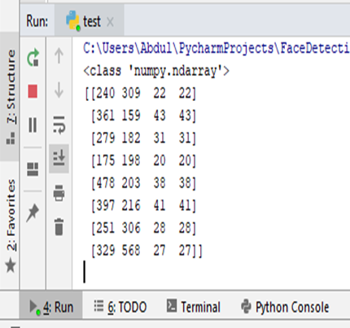
(Figure 5.2)

Future Work
As the new technologies are being introduced so rapidly, the new algorithms are also being discovered and these algorithms are more faster than the previous ones. Similarly there can an algorithm be discovered for the face detection behind vails through eyes combination. The future work should be done for more accuracy of a vailed face image. Hence, there exist a face behind the vail and we can detect it through eyes combination by having advanced algorithms in future. Image processing still need more and more hard work as it is in high demand in these days.

Conclusion
Time complexity of the neural network data set is improved if we use opens liberaries to crop the faces from the image first and then add to the data set of Neural Network. Also the grayscale pattern will be reduced and the accuracy of face detection and recognition might be improved by this cropping method because now neural network has not to pass through the whole image but the faces only. In the future, the accuracy of image processing can also be increased by using advanced algorithms for this purpose.

References
- Goyal, K., Agarwal, K., & Kumar, R. (2017, April). Face detection and tracking: Using OpenCV. In 2017 International conference of Electronics, Communication and Aerospace Technology (ICECA) (Vol. 1, pp. 474-478). IEEE.
- Singh, H. (2019). Advanced Image Processing Using OpenCV. In Practical Machine Learning and Image Processing (pp. 63-88). Apress, Berkeley, CA.
- Hinton, G., Vinyals, O., & Dean, J. (2015). Distilling the knowledge in a neural network. arXiv preprint arXiv:1503.02531.
- Sanner, M. F. (1999). Python: a programming language for software integration and development. J Mol Graph Model, 17(1), 57-61.
- Kadir, K., Kamaruddin, M. K., Nasir, H., Safie, S. I., & Bakti, Z. A. K. (2014, August). A comparative study between LBP and Haar-like features for Face Detection using Open CV. In 2014 4th International Conference on Engineering Technology and Technopreneuship (ICE2T) (pp. 335-339). IEEE.
- Tang, J., Deng, C., & Huang, G. B. (2016). Extreme learning machine for multilayer perceptron. IEEE transactions on neural networks and learning systems, 27(4), 809-821.
- LeCun, Y., Bengio, Y., & Hinton, G. (2015). Deep learning. nature, 521(7553), 436.
- Afram, A., Janabi-Sharifi, F., Fung, A. S., & Raahemifar, K. (2017). Artificial neural network (ANN) based model predictive control (MPC) and optimization of HVAC systems: A state of the art review and case study of a residential HVAC system. Energy and Buildings, 141, 96-113.
- Lavin, A., & Gray, S. (2016). Fast algorithms for convolutional neural networks. In Proceedings of the IEEE Conference on Computer Vision and Pattern Recognition (pp. 4013-4021).
- Abadi, M., Barham, P., Chen, J., Chen, Z., Davis, A., Dean, J.,... & Kudlur, M. (2016). Tensorflow: A system for large-scale machine learning. In 12th {USENIX} Symposium on Operating Systems Design and Implementation ({OSDI} 16) (pp. 265-283).

12/9/2019

