Genetic Relatedness and Phylogeny among Egyptian Cichlidae Species Based on mitochondrial D-Loop Region

Hagar T. Elhifnawy¹, Yosur G. Fiteha¹, Mahmoud Magdy^{1*}, Ahmed M. Serag², Aiman H. A. Atta¹, Mohamed A. Rashed¹

^{1.} Genetics Department, Faculty of Agriculture, Ain Shams University, Cairo, Egypt
^{2.} Genetics Department, Faculty of Agriculture, Benha University, Benha, Qalyubia, Egypt
m.elmosallamy@agr.asu.edu.eg

Abstract: Several species of fish, determined in the aquatic and saltwater habitats, shape the Cichlidae tilapia group. The common genera names for tilapia is Oreochromis, Sarotherodon, and Tilapia. Tilapias (family Cichlidae) are sizable in aquaculture and fisheries. The aim of the study is to estimate the genetic diversity, disclose polymorphism, and constructing the phylogenetic relationships between three tilapia species, Tilapia zillii, Sarotherodon galilaeus, and Oreochromis niloticus. Therefore, a total number of six fish specimens were sampled from different seven locations of Egyptian aquatic habitats and subsequently were assembled, aligned, and compared to GenBank databases based on the mtDNA D-loop region sequencing. In total, reported a length of 286 bp, 58 (20.2%) polymorphic sites, of them 51sites (17.8% two variants) and seven sites (2.4% three variants) and six haplotypes, 58 mutations were detected, the haplotype (Hd) and nucleotide variation (π) was calculated as 0.81and 0.10. The higher values of haplotype and nucleotide variation were observed in O. niloticus species. Based on the neighbor-joining (NJ) were assessed distances and genetic relationships. Among the three species, genetic distance representing different genera estimated, between O. niloticus and S. galilaeus was 0.97, S. galilaeus and T. zillii was 0.99, while between O. niloticus and T. zillii was 0.98, indicating that S. galilaeus and O. niloticus are closely related and the T. zillii is far more distant to O. niloticus than the S. galilaeus. Based on the data obtained from using the mtDNA D-loop region as candidate DNA markers, was confirmed accurate genetic diversity and phylogenetic relationships between three tilapiine species.
[Elhifnawy HT, Fiteha YG, Magdy M, Serag AM, Atta AH, Rashed MA. Genetic Relatedness and Phylogeny among Egyptian Cichlidae Species Based on the mitochondrial D-Loop Region. Researcher 2019;11(11):79-84]. ISSN 1553-9865 (print); ISSN 2163-8950 (online). http://www.sciencepub.net/researcher. 10. doi:10.7537/marsrsj111119.10.

Keywords: Tilapia species, Mitochondria control region, Genetic distance, Phylogeny, Egypt

1. Introduction
Tilapias are a group of aquaculture organisms of enormous potential and transplanted from their natural range in Africa to one form or another in most of the world. Although the typical environmental tolerances of various tilapia species, the species have minimal morphological variation, and the classification of species and its phylogenetic connections have been uncertain (McAndrew & Majumdar, 1983). In Egyptian waters, numerous tilapiine cichlid species were registered (Oreochromis niloticus, O. aureus, Sarotherodon galilaeus, and Tilapia zillii; Da Silva et al., 1994). The tilapiine species are constituted an essential and economical fish in Egypt, especially O. niloticus (El-Sayed, 2006).
Statistics on molecular variation has shown to be very helpful in recent years in the solving of systematic problems, based on phylogenetic trees drawn from molecular studies (Mickevich & Johnson, 1976). Several researchers used tilapiine molecular data to support their classification (e.g., Saad et al. 2012; Wu & Yang 2012).
Variation and relationships between groups analyzed by developmental and genetic studies, form an integral part of farm programs, to use for reproductive stock choice and species identification for future conservation (De Silva, 2015). Tilapia are highly migratory and introgressive ratio fish that can change their genetic originality. Therefore, it becomes necessary to determine the genetic strategy and partnerships for the management and development of this essential organisms (Ekerette et al. 2017).
The D-loop sequences are non-coding regions of mtDNA, with no recombination and a high rate of evolution that became one of the most ordinarily used mtDNA sequences for processing the evolutionary relationship of closely related and/or subspecies (Romana et al., 2004). Genetic studies of aquaculture organisms, originally concerned with genetic differences (Yokoyama & Goto 2002) and species validity (Genner et al., 2007), phylogeny and molecular differentiation (Ozoje et al. 2018), were at this period extensively used in genetic analysis.
In the current study, the phylogenetic relationship was evaluated among three Egyptian tilapiine using D-loop mtDNA sequencing.

2. Material and Methods
2.1 Material sampling
Tilapias were sampled at 7 locations along the stream of the Nile, namely Suez Canal (SC), Ismailia aquafarms (IS), Nasser Lake (NL), El-Qanater (QN), Broulus Lake (BL), Qaroun Lake (QL) and Al-Sirw Canal (SS), species individuals were collected based on their morphological characterization (Trewavas, 1983) and bulked into four morpho-homogenate samples.
2.2 DNA extraction and PCR amplification
Genomic DNA was isolated from the fin tissue of two samples from each one tilapiine species studied (O. niloticus, T. zillii, and S. galilaeus). DNA extraction and purification were performed, according to (Al-Zafiri et al. 2018). The mtDNA region D-loop was amplified using 2x RedMix PCR master-mix (Bioline, UK) by applying the primer pair ormt-F (5’-CTA ACT CCC AAA GCT AGG AAT TCT-3’) and ormt-R (5’-CTT ATG CAA GCG TCG ATG AAA-3’), the PCR conditions were set as standard with annealing Tm of 55 ◦C. Successful PCR products were cleaned and concentrated using ISOLATE II PCR and Gel kit (cat. no. BIO-52059, Bioline, UK); cleaned fragments sequenced by private service (Macrogene, Netherlands).
2.3 Data analysis
The chromatographs were assembled and collapsed into haplotypes using Bioedit Hall, 1998. Sequence ID was issued according to BLAST tool (NCBI). Mega X Tamura and Kumar, (2007) was used to perform pairwise alignment and construct the phylogenetic tree. DNASP6 Librado & Rozas, (2009) was used to estimate the genetic diversity within and between the Egyptian tilapiine.

3. Results
3.1 Identification by BLAST analysis
The sequence analysis of all the sequences sent to GenBank contributed to a clear correspondence of three studied organisms showing significant species-specific commonalities centered on GenBank databases. These databases reported conclusive identification matches for mtDNA D-loop consensus sequences in the Genebank with a distance of 96 –100 %. Accession numbers MG728029, MG728033, MG728035, and MG728040 for O. niloticus; KY940665, KY940662, KY940661, and KY940660 for S. galilaeus; EU163710, EU163714, and AF328853 for T. zillii (Table 1).
After alignment, mtDNA D-loop region for the 5 samples from the current study and additional 15 accessions retrieved from GenBank reported a length of 286 bp, in which 209 (73.0%) monomorphic sites, 58 (20.2%) polymorphic sites, 51 of them were parsimony informative sites, 17.8% were two-variants sites, and 7 were three-variant sites (Site position 18, 89, 92, 93, 225, 280, 285; Fig. 2).

Table 1. BLAST results for the D-loop region for the studied tilapiine species Including species, % pairwise, %, GC, accessions number.
Species | Pairwise% | D-loop accessions | Sample code
O. niloticus | 99.8% | Sample 1 | Oni
 | 99.5% | MG728029 | Oni
 | 99.5% | MG728033 | Oni
 | 99.5% | MG728035 | Oni
 | 99.5% | MG728040 | Oni
S. galilaeus | 96.1% | Sample 2 | Sga
 | 96.1% | KY940665 | Sga
 | 96.1% | KY940662 | Sga
 | 96.1% | KY940661 | Sga
 | 96.1% | KY940660 | Sga
T. zillii | 100% | Sample 3 | Tzi
 | 100% | Sample 4 | Tzi
 | 100% | AF328853 | Tzi
 | 100% | EU163710 | Tzi
 | 100% | EU163714 | Tzi

Based on D-loop sequences, the overall haplotype diversity and nucleotide diversity were 0.81, 0.10, respectively. Haplotypes number was 1-3 per species. For each species, the O. niloticus species, three segregating sites were detected, three haplotypes, and showed the highest level of haplotype diversity (0.7). The S. galilaeus species, one segregating site was detected, and one haplotype was found, haplotype and nucleotide diversity were 0.4, 0.00, respectively. The T. zillii species had no segregating sites and recorded a single haplotype, and the haplotype and nucleotide diversity were 0.00 for both (Table 2).

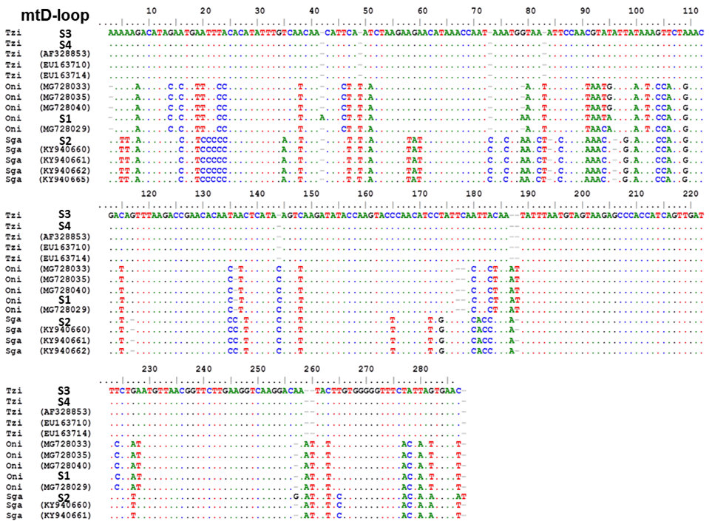
Figure 1. Comparative nucleotide alignment of the mtDNA D-loop region between tilapiine species, alignment length of 286bp shown. Abbreviations: O. niloticus (Oni), S. galilaeus (Sga), T. zillii (Tzi).

Table 2. DNA polymorphism indices between the studied tilapia species based on the mtDNA D-loop region. Number of sequence (N), haplotype diversity (Hd), number of haplotypes (H), number of segregation sites (S), nucleotide diversity (π).
Species | N | S | H | Hd | Pi
O. niloticus | 5 | 2 | 3 | 0.70 | 0.00
S. galilaeus | 5 | 1 | 2 | 0.40 | 0.00
T. zillii | 5 | 0 | 1 | 0.00 | 0.00
Total | 15 | 58 | 6 | 0.81 | 0.10

According to the mtDNA D-loop sequences, the genetic distances of the tilapiine species studied determined between O. niloticus and T. zillii were 0.98, O. niloticus, and S. galilaeus was 0.97, while between S. galilaeus and T. zillii was 0.99 (Table 3).

Table 3. The genetic distance between the studied tilapia species based on the mtDNA D-loop region.
Species | O. niloticus | S. galilaeus | T. zillii
O. niloticus | - | - | -
S. galilaeus | 0.97 | - | -
T. zillii | 0.98 | 0.99 | -

The phylogenetic tree was conducted in MEGA X and was generated using the Neighbor-Joining method, and the distances were computed using the Tamura 3-parameter method.
The tree divided into one main cluster rooted by an outgroup (flathead gray mullet fish, Mugil cephalus). Two main clusters were found, one cluster included at one branch, the O. niloticus of the current study (sample no. 1) grouped with the O. niloticus retrieved from GenBank (accession number: MG728029, MG728033, MG728035, and MG728040), and recorded a bootstrap value of 99. And another branch where the S. galilaeus of the current study (sample no. 2) and S. galilaeus retrieved from GenBank (Accession number: KY940665, KY940662, KY940661, and KY940660) were grouped together with bootstrap support of 100.
The second cluster included the T. zillii samples of the current study (samples no., 3 and 4) and T. zillii retrieved from the GenBank (accession number: EU163710, EU163714, and AF328853) together, with a bootstrap value of 100 (Fig. 3).

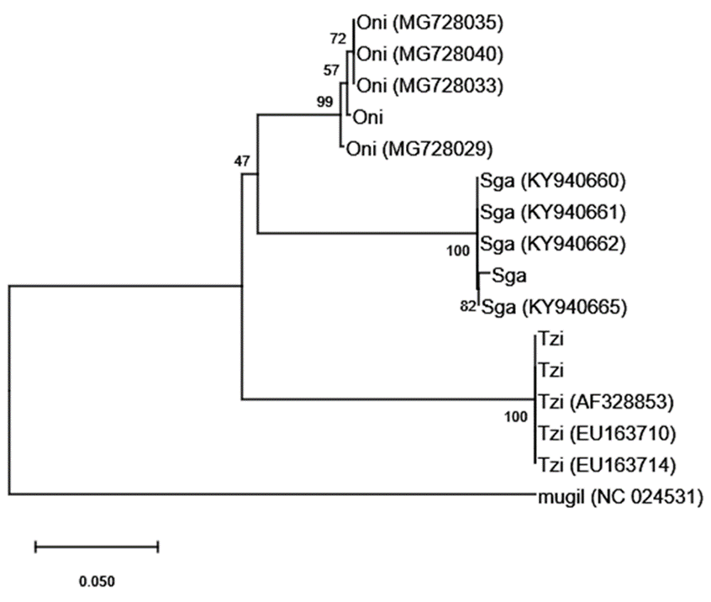
Figure 2. The phylogenetic tree showing the relationship between tilapiine fish according to mtDNA D-loop region O. niloticus (Oni), S. galilaeus (Sga), T.zillii (Tzi) the tree is rooted by the flathead grey mullet Mugil cephalus (mugil; accession number NC024531) from the family Mugilidae.

4. Discussion
Several molecular methods were used to identify tilapia species Liu & Cordes, (2004) e.g. Microsatellite. The mitochondrial DNA is known as a more accurate and functional molecular approach to species classification (Al-Zafiri et al., 2018), because they characterized by high rate of mutations, and therefore used as a tool to build phylogenetic tree and identify species Cheng & Stoneking, (1994). The D-loop region is considered to be the most variable site in mtDNA and therefore represents the maximum level of contrast (Cheng et al., 2015). Accordingly, haplotype analysis of the D-loop region is commonly used as a useful tool for classifying the genetic diversity of fish species (He et al., 2011). The results we have achieved indicated that, the largest number of haplotypes and haplotype diversity was found among O. niloticus species, followed by S. galilaeus species. A previous study had indicated that the high levels of genetic diversity may ensure strong adaptability and survival skills of species (e.g. Gasterosteus aculeatus; Barrett & Schluter, 2008).
Tilapia fish are highly migratory species with a high ratio of introgression, which may affect their genetic originality, widely used to research aquaculture, phylogeny and molecular differentiation. Therefore, it is necessary to analyze their genetic characteristics and their relationship with other species to fully understand these genetic species (Ekerette et al., 2017).
The results showed that there is a relationship between the two different genera of tilapia fish (O. niloticus and S. galilaeus) and are close the each other than T. zillii genus, in accordance with previous studies (Pouyaud & Agnese, 1995; Schwarzer et al., 2009), the conclusion of the same results was confirmed using other markers such as SNP markers (Shirak et al., 2009; Syaifudin et al., 2019). This relationship can be explained by two Hypotheses: hypothesis one, the development of the mtDNA D-loop region is not environmentally affected, but it is possible to trace variations with other factors influences the genome (Ekerette et al., 2017). Hypothesis two, the ancestors that lived before the extinction of both groups may be one of these species Duvernell & Aspinwall, (1995).
In conclusion, based on the data obtained from the mtDNA D-loop region results, an accurate genetic diversity and phylogenetic relationships between three tilapiine species were reached, reflecting the usefulness and importance in D-loop region, not only for population analysis, but further for species-based identification.

Acknowledgments:
Foundation item: The current work was totally funded by the internal funds of Molecular Ecology and Evolution Laboratory, Genetics Department, Ain Shams University, Egypt. The authors are grateful to Dr. Samah Mohamed Rizk Soliman for her insightful edits, revision, and comments.

Corresponding Author:
Dr. Mahmoud Magdy
Department of Genetics
Faculty of Agriculture, Ain Shams University
68 Hadayek Shubra, Cairo, 11241, Egypt
Telephone: 00201093411288
E-mail: m.elmosallamy@agr.asu.edu.eg

References
- McAndrew, B. J., & Majumdar, K. C. (1983). Tilapia stock identification using electrophoretic markers. Aquaculture, 30(1-4), 249-261.‏
- Silva, V. M. F., & Best, R. C. (1994). Tucuxi Sotalia fluviatilis (Gervais, 1853). Handbook of marine mammals, 5, 43-69.‏
- El-Sayed, A-FM. (2006). Tilapia culture. Wallingford, UK; Cambridge, MA: CABI Pub.
- Mickevich, M. F., & Johnson, M. S. (1976). Congruence between morphological and allozyme data in evolutionary inference and character evolution. Systematic Zoology, 25(3), 260-270.‏
- Saad, Y. M., Rashed, M. A., Atta, A. H., & Ahmed, N. E. (2012). Genetic diversity among some tilapia species based on ISSR markers. Life Sci J, 9(4), 4841-4846.‏
- Wu, L., & Yang, J. (2012). Identifications of captive and wild tilapia species existing in Hawaii by mitochondrial DNA control region sequence. PLoS One, 7(12), e51731.‏
- De Silva, M. P. K. S. K. (2015). Genetic diversity of genetically improved farmed tilapia (GIFT) broodstocks in Sri Lanka. International Journal of Scientific Research and Innovative Technology, 2, 66-76.
- Ekerette, E. E., Ikpeme, E. V., Udensi, O. U., Ozoje, M. O., Etukudo, O. M., Umoyen, A. J.,... & Wheto, M. (2017). Phylogenetics and molecular divergence of tilapia fish (Oreochromis species) using mitochondrial D-loop and cytochrome b regions. American Journal of Molecular Biology, 8(01), 39.‏
- Romana-Eguia, M. R. R., Ikeda, M., Basiao, Z. U. & Taniguchi, N. (2004). Genetic diversity in farmed Asian Nile and red hybrid tilapia stocks evaluated from microsatellite and mitochondrial DNA analysis. Aquaculture, 236(1-4), 131-150.
- Yokoyama, R., & Goto, A. (2002). Phylogeography of a freshwater sculpin, Cottus nozawae, from the northeastern part of Honshu Island, Japan. Ichthyological Research, 49(2), 147-155.
- Genner, M. J., Seehausen, O., Lunt, D. H., Joyce, D. A., Shaw, P. W., Carvalho, G. R., & Turner, G. F. (2007). Age of cichlids: new dates for ancient lake fish radiations. Molecular Biology and Evolution, 24(5), 1269-1282.
- Ozoje, M., Ikpeme, E., Johnny, U., Durosaro, S., Peters, S., & Ekerette, E. (2018). Psiv-23 Genetic diversity of freshwater clam (Egeria Radiata) In Nigeria. Journal of Animal Science, 96(suppl_3), 132-132.‏
- Trewavas, E. (1983). Tilapiine fishes of the genera Sarotherodon, Oreochromis, and Danakilia. British Museum (Natural History).‏
- Al-Zafiri, B., Magdy, M., Ali, R. A. M., & Rashed, M. A. S. (2018). DNA Barcoding of Common Commercial Sea Catfish (Genus: Plicofollis) from Kuwait. American Journal of Molecular Biology, 8(02), 102.‏
- Hall, T.A., 1999. BioEdit: a user-friendly biological sequence alignment editor and analysis program for Windows 95/98/NT. Nucleic Acids Symp. Ser. 41, 95–98.
- Tamura, K., Dudley, J., Nei, M., & Kumar, S. (2007). MEGA4: molecular evolutionary genetics analysis (MEGA) software version 4.0. Molecular biology and evolution, 24(8), 1596-1599.‏
- Librado, P., and Rozas, J. (2009). DnaSP v5: a software for comprehensive analysis of DNA polymorphism data. Bioinformatics, 25(11), 1451-1452.‏
- Liu, Z. J., & Cordes, J. F. (2004). DNA marker technologies and their applications in aquaculture genetics. Aquaculture, 238(1-4), 1-37.‏
- Cheng, S., Higuchi, R., & Stoneking, M. (1994). Complete mitochondrial genome amplification. Nature genetics, 7(3), 350.
- Cheng, Y. Y., Tao, W. J., Chen, J. L., Sun, L. N., Zhou, L. Y., Song, Q., & Wang, D. S. (2015). Genome-wide identification, evolution and expression analysis of nuclear receptor superfamily in Nile tilapia, Oreochromis niloticus. Gene, 569(1), 141-152.‏
- He, A., Luo, Y., Yang, H., Liu, L., Li, S., & Wang, C. (2011). Complete mitochondrial DNA sequences of the Nile tilapia (Oreochromis niloticus) and Blue tilapia (Oreochromis aureus): genome characterization and phylogeny applications. Molecular biology reports, 38(3), 2015-2021.‏
- Barrett, R. D., & Schluter, D. (2008). Adaptation from standing genetic variation. Trends in ecology & evolution, 23(1), 38-44.‏
- Ekerette, E. E., Ikpeme, E. V., Udensi, O. U., Ozoje, M. O., Etukudo, O. M., Umoyen, A. J.,... & Wheto, M. (2017). Phylogenetics and molecular divergence of tilapia fish (Oreochromis species) using mitochondrial D-loop and cytochrome b regions. American Journal of Molecular Biology, 8(01), 39.‏
- Pouyaud, L., & Agnèse, J. F. (1995). Phylogenetic relationships between 21 species of three tilapiine genera Tilapia, Sarotherodon, and Oreochromis using allozyme data. Journal of Fish Biology, 47(1), 26-38.‏
- Schwarzer, J., Misof, B., Tautz, D., & Schliewen, U. K. (2009). The root of the East African cichlid radiations. BMC Evolutionary Biology, 9(1), 186.
- Shirak, A., Cohen-Zinder, M., Barroso, R. M., Seroussi, E., Ron, M., & Hulata, G. (2009). DNA barcoding of Israeli indigenous and introduced cichlids.‏
- Syaifudin, M., Bekaert, M., Taggart, J. B., Bartie, K. L., Wehner, S., Palaiokostas, C.,... & Baroiller, J. F. (2019). Species-Specific Marker Discovery in Tilapia. Scientific reports, 9(1), 1-11.
- Duvernell, D. D., & Aspinwall, N. (1995). Introgression of Luxilus cornutus mtDNA into allopatric populations of Luxilus chrysocephalus (Teleostei: Cyprinidae) in Missouri and Arkansas. Molecular Ecology, 4(2), 173-182.‏

11/24/2019

