Reflection of Femininity in Tang Furniture: Chairs and Tables

Ladan Abouali, Jianlin Ni, Jake Kaner

Post-doctoral fellow, College of Fine Arts, Nanjing Normal University, Nanjing 210046 China.
Email: L.abouali@yahoo.com

Abstract: This paper reviews the Tang dynasty chairs and tables used by Tang court women that are depicted in contemporary visual art of that time. With the help of surviving extant paintings, this topic covers the wooden chairs and tables designed for women, and examines how the pieces were used in daily life. This topic is essential, as the so called ‘Golden age of China’ the Tang dynasty, was one of the most significant periods in defining the hierarchy of women’s social status. As Tang women became bolder members of society, in addition to the mat and low-level furniture, new forms of high-level chairs and tables were introduced for women that became important pieces raising the status in the lives of high-ranking women. During this period, this new furniture structure was also a part of China’s growth under the Tang dynasty and was influenced by the forms found in skeletal architectural structures. The paintings selected for study in this research show high-ranking Tang women using their traditional furniture and the new types of high-level seats and tables that were used mostly in palace gatherings.
[Ladan Abouali, Jianlin Ni, Jake Kaner. Reflection of Femininity in Tang Furniture: Chairs and Tables. Researcher 2019;11(11):62-70]. ISSN 1553-9865 (print); ISSN 2163-8950 (online). http://www.sciencepub.net/researcher. 8. doi:10.7537/marsrsj111119.08.

Keywords: Tang dynasty, women’s status, women’s furniture, paintings, chairs, tables.

1.0. Introduction
Throughout history the World has witnessed omnipotent emperors who had a significant influence on all layers of society, including inventions, art, literature, and social status of citizens. In China, the Tang dynasty, which was the successor to the Sui dynasty, was one of these superpowers, during the 8th and 9th centuries CE and was the first of its kind; it was later followed by the Five dynasties and Ten- Kingdoms (Peng 1960).
The Tang dynasty’s open-door policy, in addition to the advantages of the Silk Road attracted many foreigners to China to learn about the new technology and developments and, of course, to do business. China welcomed travelers (mostly commercial people), who not only brought their products but also presented their own cultures and beliefs. At the start of the Tang dynasty (618-907) Taoism was announced as the national religion of the country by the Lǐ family (李), the dynasty’s founder was also open to frequent inter-ethnic and cultural exchanges. As a result, Buddhism (as the most influential religion), Islam, and Zoroastrian were some of the religions that were practiced freely, and they are still reflected in temples and pagodas around the country (Xiong and Liu 2015).
However, in addition to individual and national developments, as living standards improved, women’s social status also increased significantly, and unlike in other empires, women received more respect and a highly upgraded lifestyle (Benn 2004). During this era of improvement (618–907 CE), women’s livelihood and leisure activities such as music, writing and reading became more extensive and creative (Peng 1960) and women became more engaged in many activities that revealed how well- evolved China was under the Tang dynasty.
In this paper, the primary objective is to examine female figures using Tang furniture as illustrated in the visual representations of that era. These illustrations are frequently in the medium of paintings, which provide visual evidence of what is referred to here as “women’s furniture” which appears on traditional rugs, with the furniture mostly commonly seen in these types in paintings are tables and chairs. The visual analysis used here will help to better comprehend the role of the furniture in some aspects of Tang women’s lives, such as their implied social status and contemporary leisure activities (Wang 2009). We aim to establish through this research an improved understanding of the furniture that was employed to depict these activities, notwithstanding the scene selection of furniture as props by artists who produced these visual accounts (Peng 1960).
Women of the Tang Dynasty were privileged to be a part of high society exposed to so called civilized ideas that raised the said women’s social status. Compared with other periods, women had a higher social position and more enriched lives (Peng 1960). Both high-ranking and middle-class women enjoyed a great deal of freedom (Chiu-Duke 2006). The cosmopolitan culture of the period (during 7th to 10th centuries) allowed women to engage in the world of men. For instance, Tang women were allowed to rent out land and participate in the land cultivation leading to the production of goods and subsequent wealth. Culturally, with the rise of the imperial examination system (the official exam system for Civil service) the priority based on social position had been broken, (Chiu-Duke 2006) the focus of education had expanded downwards through society, and women began receiving education of a similar quality to that which men received (Peng 1960).
Regarding marriage and family, Tang women had certain levels of autonomy and rights to choose their spouses or getting divorced or remarried (Sun 2009). From the aspect of social life, upper-class women frequently participated in social leisure activities, such as taking part in a polo game with men or playing chess (Chiu-Duke 2006) (Fig. 1).

Fig. 1. Zhou Fang (a painter, 730–800), Court ladies playing double sixes, Tang dynasty. Available at: wikiwand.com (accessed 22 November 2018).

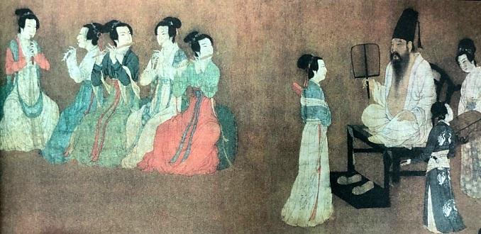
Fig. 2. Court gathering, women sitting on the round type stool playing music. Available at: http://blog.sina.com.cn (accessed 22 November 2018).

In Tang archival documents, the story of women’s positions and their daily activities were summarized and discussed in very general forms: as a wife and mother and through their responsibilities toward the family (Chiu-Duke, 2006). Both women’s and men’s lives were described using work-related topics and steps more than routine daily tasks (Xiong and Lium 2015). Cen Jingwen in his book daily life in traditional China believes that women’s responsibilities had not changed much and at home, they were mainly expected to receive the proper education (reading, writing stories and poems, singing and playing an instrument) (Benn 2002), get married, give birth (ideally to a son) and bring the children up in the best possible way (with good household skills, education, manners, and so on) (Pissin 2012). Outdoor activities for Tang women, especially upper-class women, included riding, watching drama, playing a role in theatrical productions, watching and playing ball games such as football (Wang 2009), travelling, hosting and going to banquets (Benn 2002).
The Tang dynasty supported women's practice of reading and writing that was influenced by the downward expansion of education under the imperial examination system. Reading and writing as essential activities in daily leisure, were popular among civilian women (Benn 2004).

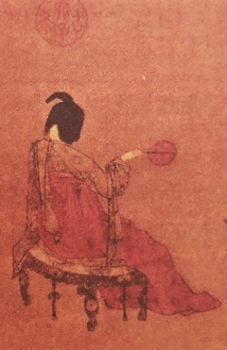

Figs. 3, 4, 5. Tang dynasty, Lady with Servants attributed to Zhou Fang, Three forms of Tang furniture in one painting. Available at: baike.baidu.com/item/挥扇仕女图/4563220 (accessed 20 November 2018).

  - Material and background of the study
Although the main types of women’s wooden furniture under investigation here, such as chairs and tables from the Tang dynasty, it is not evident that these are more plentiful than the chairs and tables from previous dynasties (Zhang 2009). The significant neglect of such furniture justifies that research about this subject is necessary. The existing literature on the furniture of the Tang dynasty have studied fashion, architecture, social culture, and furniture from a general aspect (Xiaoming 2009). However, the study of furniture types used by Tang women has been neglected, and there is no significant research that has focus on female use of chairs and tables of this period.
It should also be recognized that during the Tang dynasty, as in other kingdoms in China, the creation of artifacts was in the jurisdiction of the Emperor and his family. The primary purpose of these visual recordings of the interior habitat was to provide an account of the court’s daily life. The furniture discussed here also reflects those elite women who employed chairs and tables in both their formal and informal activities.

  - Methods

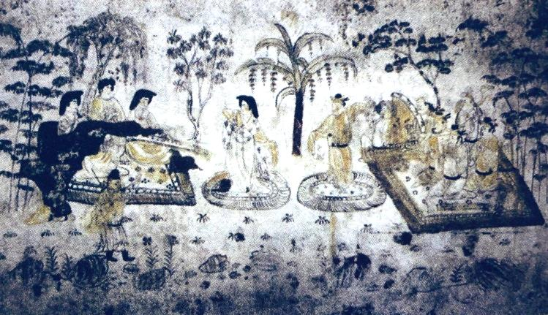
Fig. 6. “Music and dance” Mural painting of Tang dynasty, Xi an. Available at: Tang han xiu tomb, Art express, news.arton.net (accessed 22 February 2019).

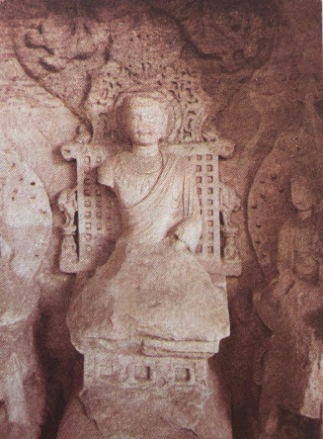
Fig.7. seated stone Buddha in Bieshan, dazu (四川大足北山石刻释迦坐像). Source: Xiong and Liu (2015) Research on Tang dynasty Furniture, Figs 2-111.

To understand the context and purpose of this research, a literature review was conducted that examined materials written both by Chinese and by international scholars (Handler, 2001; Benn, 2002 and 2004; Xiong and Liu, 2015) where it became apparent that recent literature that referred to the period relied on paintings from older sources as well as extant examples depicted in surviving carvings from caves (Western niche caves, Dunhuang), which mostly presented the furniture used by religious figures and emperors (Figs. 6 & 7).
The research has established a need to study the types of chairs and tables used by women in the Tang dynasty, but the surviving furniture from the Tang Dynasty is sporadic being both rare and disparate, which presents a significant challenge for this research due to access difficulties and therefore examination limitations. This is why painted visual representations from various Tang artists in which the female figures are using chairs and tables like in Yan Liben paintings (600-673 CE), & Zhang Xuan (713-755 CE) are the primary source of visual evidence that can retell the story provide an historical account of women’s furniture (Juan 2015; Abouali 2018). Although the reviewed studied paintings mostly illustrated the life of court females during joyful gatherings, the types of furniture that are depictured with the women reflect the women’s needs and expectations of the period (Figs. 5, 4, & 15).
2.0. Tang women and furniture
The architecture of the Chinese wooden building structure, developed quickly in the Tang dynasty (Zhang 2009) in parallel with traditional Chinese furniture, especially high-level examples slowly evolved both in function (reliability and stability) and in material (Handler 2001). Unlike in previous dynasties, furniture in the Golden Age of the Tang dynasty became an essential part of interior design and gained highly characterized aesthetic and decorative elements (body composition, colour, and so forth) including ink paintings of landscape and nature patterns (Tong 2014).
Women’s roles became bolder and in some cases, the use of chairs by female elites appeared in paintings increasingly often: the paintings showed different types of chairs that were designed to meet the daily needs of their users. The furniture presented here shows heritage form the Northern and Southern dynasties’ low-level to high-level chairs and tables with the new developments of box-shaped furniture (used to design chairs with back height used symbolically for ranking a citizens status), as seen in form Fig. 5, which shows an example of a nailed and stamped skeletal structure that was borrowed from architectural practice.
As mentioned earlier, the types of furniture in the Tang dynasty were various; however, for women, there were less alternatives than the range available to men. This may be because of social status as well as less recognition for feminine daily rituals and tasks. Chairs, stools (smaller in size and shorter in height than chairs) and tables with varying heights as well as dressers and cabinets were the most common pieces of furniture appearing in the palaces and high-class families’ homes. However, it was a sign of tradition that mats (low seating platforms) were still customarily used to sit on the floor (Fig. 13 & 15).
2.1. Tradition comes first: the “mat”
The mat was the earliest woven form used for seating and reclining. During the early Tang dynasty, the mat still occupied a considerable role in women’s daily lives. As visual documents show, from early times in China until around the tenth century, the mat and shallow platforms were standard types of furniture among middle-class families, who still sat on the floor (Figs. 4, 13 & 15). With the progress of society, the classification of the mat’s function became more detailed, although it could not compete with the popularity of higher seats. Although Tang mats became more sophisticated, according to the paintings left from that time (Gu 2016) their position was not different from that in previous dynasties.
In addition to the general usage of the mat for sitting or lying on the floor, the bed mat (mattress), which was made according to the scale of the particular wooden bed, also became popular later (Xiong 2015: p 50). Unfortunately, due to the ease with which the materials could be damaged, few of the existing archaeological discoveries in China are the actual remains of a mat from the Tang dynasty. Surviving paintings such as “Lady with Servants” and “Dancing women”, which show how the mat was included with other high-level, developed wooden furniture (Figs. 4 & 14), can provide readers with an understanding of the appearance and different uses of mats in the Tang period (Fig. 6).
2.2. High-level wooden furniture
Chinese furniture has always been built in relation to building characteristics and structural properties and has pursued a unity of architectural design sometimes affected by a foreign entities influence on the country. The Tang dynasty was not an exception in this matter, and its furniture developed through a range of various factors culmination. For instance, the aesthetic orientation of the customary Buddhist lifestyles came to resemble those from previous dynasties such as the Han dynasty. The decorative patterns of such dynasties were both innovative and creative and were reflected in Tang dynasty furniture (Handler 2001).
The skeletal structures used in Chinese wooden buildings were frequently repeated in making high-level wooden furniture, as its vertical function operated to counteract gravity and to balance the weight in order to keep the furniture upright, while the horizontal parts acted to coordinate the whole and build up the furniture’s stability and security (Handler 2001). The box-type structure (also known as the basket shape in chairs) created a new form of furniture with the architectural skeleton structure for support (Figs. 2, 5, & 11.); “waisted structure” furniture as mentioned by Gu Yang (顾杨) (Yang 2016) in his book is a good example of the skeletal structure (Gu 2016) (Fig. 9).
The history of high-level seating structures dates back to the Northern and Southern dynasties (420-589 CE) and continued to advance in the form of low and high-level chairs and tables in the Tang dynasty. Tang dynasty furniture is mostly categorized under the name “bed” (床), though furniture with this name carried with it a wide range of forms and functions. Furniture could be called “bed” (床) regardless of its size (large or small) and shape (square or circular), as long as there was a wooden panel on the top and legs on the bottom. The scope of "bed" as discussed in this paper refers to those pieces that have either sitting or sleeping functions such as chairs (椅子), square stools (方凳), [15, p38] “hu beds" (胡床), "rope beds" (绳床), "tea beds" (茶床), and "food beds" (食床) (which are used to eat), as well as tables with a pot door base that are known as "ivory inlaid beds" (牙床), and small pen rests that are called a "pen beds" (笔床) (Zhang, 2009: p39).
2.2.1. Chairs and stools
As a simple way to increase comfort, chairs are very important thus, it is natural that chairs became the most sculpturally formed furniture in China; chairs received significant attention from high-class families and became a symbol of having a “good life” (Azadegan 2016) Before the Tang dynasty, in the Zhou dynasty (1046-256 BCE), high seats were occasionally used, and it was at some points between the Tang and the Song dynasties ( 960–1279 CE) that using chairs and stools (Xiong 2015) (Figs. 15 & 12.) became a part of the wider Chinese lifestyle (Azadegan 2016). In that era, chairs’ status changed from low-value objects to impressive furniture owned by the powerful and wealthy (Xiong 2015).
The invention of higher seats started with people moving from mats to chairs to meet the needs of a new lifestyle, and the chair developed in both structure and design as a mirror of its users’ communities. The success of the Tang dynasty also influenced furniture, and the period became a turning point in the furniture industry. With the help of tradition and other arts of the period brought creativity and innovation into this industry. This transformation started with those in privileged positions such as high officials and palace women, or with high ranking religious leaders, such as monks who used furniture including, the high-level armchair (Fig. 12), high-level tables (Fig. 4), as well as beds and screens (Handler 2001). As mentioned earlier, paintings illustrated the popularity of these pieces among courtiers, and ordinary people still used mats as their primary mode of seating furniture.
Surviving images illustrate a combination of these different seats, such as chairs and stools in women’s daily lives (court women) with other types of furniture, such as mats and tables. Paintings of Tang court ladies (e.g., Fig. 13.) show their habit of employing stools, while high ranking men benefited from chairs with a higher back (Figs. 2 & 12.) or used benches around large tables.
Information received from the above-mentioned sources, suggests that there were two general categories for chairs used by Tang women. One type is a kind used for “to sitting on a low couch” (Xiong and Liu, 2015) (Fig. 8) and it came in two sizes, a small stool and a wider stool (also known as a bed because of its similar structure to a bed). This wider design materialized when Buddhism spread into China bringing with it the high-level pot door design (with legs shaped like the lid of a copper pot) (Yang and Lang, 2011) (Fig. 10) and low platform design (Fig. 16). The second type was more like a basket shape and included seats with backrests (with or without armrests) that was, based on the user’s rank and this, came in different sizes (Figs. 5 & 12).

Fig. 8. Huchuang or folding stool. Source: Xiong and Liu (2015), Picture No. 169, p 431.

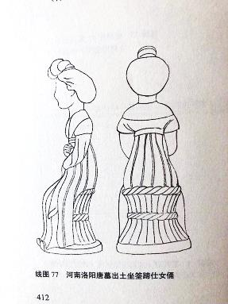
Fig. 9. Drum stools made of straw and basketwork also began to appear during the Northern and Southern Dynasties (386-586 AD) period. Source: Xiong and Liu (2015) Picture No 77, P 412.

Fig. 10. Pot-door bed with a screen, which flourished during the Tang dynasty, Mogao Caves. Source: Xiong and Liu (2015), Picture No. 22p 399.
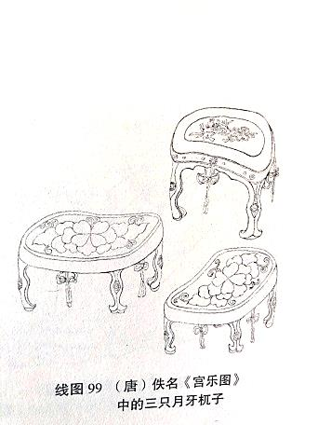
Fig. 11. Tang dynasty, Crescent stool (Four-sided stools). Source: Xiong and Liu (2015), Picture No. 99, p 417.

Fig. 12. A court lady sits on an armchair. The fifth generation. Source: Xiong and Liu (2015), Picture No. 103, p 418.

Among the above-mentioned seating types, the most common and traditional high-level seat among women was the stool with a skeleton structure and heavy woodcarvings. Such stools are presented in a variety of forms, such as crescent stools (Figs. 11 & 13), drum stools (Fig. 9), elliptical stools (Fig. 2), and folding stools (Fig. 8) mostly with four legs and a flat plate for sitting (Tong 2014).
The large number of small-sized stools in the painting “A Palace Concert” (Fig. 11), which depicts a scene of twelve court ladies around a very large table with thirteen crescent stools (four-sided stools), shows how this piece of furniture became fashionable among highly ranked women during the mid-Tang dynasty (in 712 CE). The second glorious time of Tang dynasty) (Xiong and Liu 2015) (Figs. 1, 3, & 13). The design of the crescent stool’s legs seems to have been favored by carpenters, since chairs with armchairs and backrests used the same style (Figs. 5, 11, & 13). In contrast, furniture with the larger sized, widely used “pot-door” style, as seen on tables and beds (both for sitting and sleeping) (Fig. 9) in the Tang dynasty proves that more than just the pot door stool was produced during this period, (Fig. 2) and larger pot-shaped furniture was also not difficult to manufacture (Figs. 9 & 14).

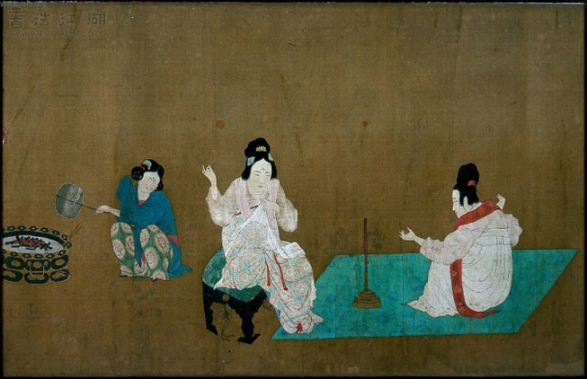

Fig. 13. A part of the painting titled “Court ladies preparing newly woven silk”, Zhang Xuan (907), Boston Museum of Fine Arts (波士頓美術館). Available at: artsandculture.google.com (accessed 15 April 2019).

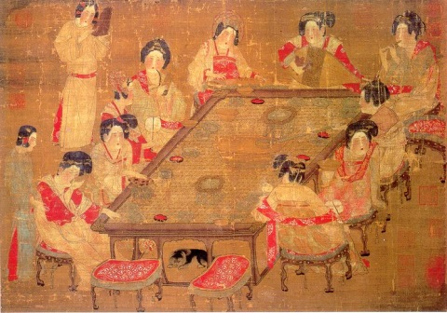
Fig. 14. A palace concert, this work holds no seal or signature of the artist. Available at: Tang China,www.huntertangdynasty.weebly.com/culture (accessed 17 April 2019).

2.2.2. Tables
Tables designed during the Tang dynasty included both low- and high-level, four-sided forms that employed the skeleton structure to secure their stability and function. One common type of table, which was influenced by the Northern dynasty, was a small rectangular desk-shaped table with straight legs that was designed for only one person who would be sitting on the floor (Fig. 17) to do their formal work and daily activities such as writing letters. The basic features of the form were formed created during the Tang Dynasty (Xiong and Liu 2015).
In high grade furniture such as tables and cabinets, the structure of the plate was dominated by thick, squared wood (20 to 3.0.8 mcm in thickness). The plate was secured with a frame to save the sides, and probably to prevent the objects from falling. Some styles show the simplicity of early tables, such as those with a large square top and recessed splayed legs (Fig. 4), while some received more attention in the form of carvings and or were designed with copper pot lid legs (legs shaped like the lid of a copper pot) (Azadegan 2016) (Fig. 16).

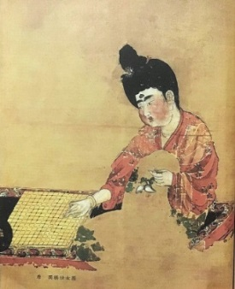
Fig. 15. Low platforms, Lady playing chess, unknown painter, Xinjiang Uygur Autonomous Region Museum (新疆维吾尔自治区博物馆). Available at: Fact and details, www.factsanddetails.com (accessed 15 April 2019).

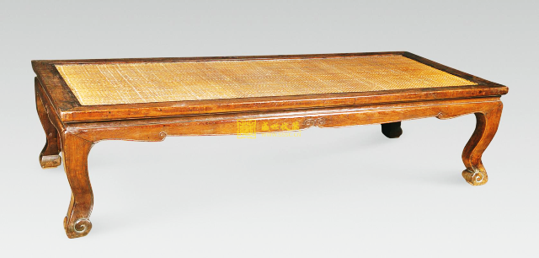

Fig.16. Japanese table with sides, commonly seen in Japanese Nakakura furniture that was influenced by Tang dynasty furniture. Available at: www.image.baidu.com/受唐朝影响的日式家具.

Fig.17. Partial screen paintings unearthed in Cui Fen's tomb in Linyi, Shandong Province. Source: Xiong and Liu ( 2015), figure 27, P 400.

From mid- to late Tang dynasty (805–820 CE), the adoption of higher seats drove the development of tables from being single-person tables to being larger-sized tables for both men and women to sit around during their gatherings. These forms started as low-level tables with stools and benches, though sitting around these may not have been comfortable (Handler 2001). Later, however, table heights improved that led to more comfortable sitting positions with more complex designs and woodcarvings (Figs. 1 & 14).
A typical model of table, which had large pot door legs, was known as the “stone kettle gate table” with a height of approximately 600 mcm to 1300 mcm; the style was also used in the design of matching chairs (Fig. 14). The most developed sets of “higher furniture” were seen after the Tang dynasty in the Song and Yuan dynasties (1206-1368), and the use of these types of furniture with high legs became part of ordinary family homes (Xiong and Liu 2015). For instance, a pottery pattern from the Northern Song dynasty with the figure of a woman preparing food on a high-level table can be found in the Museum of Chinese History in Beijing, and the pattern shows the everyday use of these higher tables with stretched legs in kitchens (Handler 2001).

3.0. Conclusion
During the Tang dynasty, as a result of grew in women’s public presence, the use of high-level furniture by women also flourished with the impact of foreign design and significant growth in architectural structures. The lack of surviving of women’s furniture of that era is compensated by paintings show that there is not much diversity in the general form of the female’s chairs and tables depicted alongside women's figures compared to those designed for men in the paintings of that time.
In the studied paintings, four different forms of stools were in use among court ladies. It is supposed that there could be more forms if ordinary female figures were also in these painting. In contrast, depictions of female chairs with backs and armrests used were shown very few in numbers, but were designed with complex details and lower back for women than men. From the female figures clothing and hairdressing in the paintings, it is clear that these models of chairs were likely designed and used by the high-class women and did not have a place in female’s everyday life.
In contrast to the history of the chair, the presence of tables used by female figures seem to go back to a much earlier time when using a smaller size of low-level tables, and mostly sitting on the floor or a mat seemed to be enough satisfy functional needs by women. Considering what the paintings show, tables used by females during the Tang dynasty were offered in a rectangular form with two leg designs (simple design and a form of the copper pot lid) and completed with a simple surface plate. By comparing the design and motifs used to decorate these tables and chairs alongside women, it can be seen that detailed patterns and carving were done less frequently on the legs and lower part of the tables and were not as complex as those presented on chairs.

Bibliography
- Abouali Ladan; Wu Zhuhui; Kaner Jake (2018) Chinese visual traditions encountered on Safavid furniture. Romania: Bulletin of the Transilvania University of Brasov. Vol.11.
- Azadegan Eman (2016) A review of the historical transformation of the furniture design from the perspective of cognitive style. Available at: http://www.baniform.ir/, history of furniture (accessed 10 January 2019).
- Benn Charles D. (2002) Daily life in traditional China. Westport Conn: Greenwood Press.
- Benn Charles D. (2004) China’s Golden age: everyday life in the Tang Dynasty 1st (first). UK: Oxford university press.
- Chiu-Duke J. (2006) Mothers and the well-being of the state in Tang China. Men, Women and gender in early and imperial China. Available at: www.brill.com/abstract/journals/nanu/10/2/article-p305 (accessed 7 June 2019).
- Gu Yang (顾杨) (2016) Chinese red: Traditional Chinese Furniture. China: Huangshan Publishing House.
- Handler, Sarah (2001) Austere Luminosity of Chinese Classical Furniture. USA: University of California Press, Fundamental principle, 2nd edition, pp16-20.
- Mazurkwich Karen (2006) Chinese furniture: a guide to collecting antiques. Singapore; Tuttle Publishing.
- Peng Ding (1960) “Full tang Poetry”, from the collection of Yuefu poetry on the Tang poetry. China: Zhonghua Book Company.
- Pissin Annika (2012) Women in Tang dynasty. Available at: www.academia.edu/34681804/Women_in_the_tang_Dynasty._Prescribed_dependent_and_scary.pdf (accessed 7 July 2019).
- Sun Yurong (孙玉荣) (2009) 论唐代社会变革期的女性婚姻地位［Ｊ］．妇女研究论丛 (On the status of women's marriage in the period of social transformation in the Tang Dynasty [J]. Women's Studies). Available at: http://www.wsic.ac.cn/womenstudyluncong (Accessed 25 April 2019).
- Tong Meng (2014) The synchronous evolution of architecture and furniture in Tang dynasty. In: International Conference on Humanity and Social Science (ICHSS), China. Available at: www.researchgate.net/publication/316846338_The_Synchronous_Evolution_of_Architecture_and_Furniture_in_Tang_Dynasty (accessed 20 April 2019).
- Wang Ying, 2009, A history of Chinese ladies paintings. China; South East University Press.
- Xiong Juan（熊隽） (2015) 唐代家具及其文化价值研究 (Furniture and Its Cultural Value in Tang). PhD dissertation, Hangzhou Normal University, China.
- Xiong Juan; Liu Xian-bo (2015) Research on Tang dynasty Furniture. China: Hubai Social project Science.
- Yang, F.; Lang, G. (2011) Social scientific studies of religion in China: methodology, theories, and findings. USA: Brill, pp. 109-132.
- Zhang Xiaoming (2009) Chinese Furniture. US: Cambridge University Press.

11/18/2019

