**Multi-detector CT Minimum Intensity Projection and Volumetric High Resolution CT Images in Diagnosis of Interstitial Lung Diseases**

Suzan Aly Fahmy Swelum, Abdullah Hussein Ahmed and Doaa Zainelabdeen Ahmed Abdulhafeez

Radiodiagnosis Department, Faculty of Medicine for Girls Al-Azhar University, Egypt

[duaazain.dz@gmail.com](mailto:duaazain.dz@gmail.com)

**Abstract: Aim of the work:** This study aims to estimate the role Multi-detector CT Minimum Intensity Projection and Volumetric High Resolution CT Images in Diagnosis of Interstitial Lung Diseases. **Patients and Methods:** It is a cross sectional study carried out at Al-Zahraa University Hospital. It recorded data concerning assessment of Interstitial Lung Diseases with Multi-detector CT Minimum Intensity Projection and Volumetric High Resolution CT during the period from January 2019 to October 2019. The study included 20 patients; suspected or diagnosed of having Interstitial Lung Diseases. The scans were performed using 84-MDCT scanner. Scans were acquired at end inspiration with patients placed in the supine position. No contrast medium administered Conventional HRCT images and MinIP Images were interpreted together and the results of HRCT and MinIP images were compared with HRCT considered as the study reference in our work since it is the well-established technique in the diagnosis of ILD in literature and in most institutes. **Results:** A total number of 20 patients (7 males and 13 females) with various confirmed or suspected diagnoses including 11 IPFs, 2 Sarcoidosis, CILD, PLCH, NSIP, LAM and HP. Diagnoses were made based on CT characteristic findings, associated CT findings and clinical history. MinIP added value to the assessment in some finding more evident than others such as GGOs, bronchiectasis, cysts and honeycombing more than fibrotic and high density changes. **Conclusion:** MinIP is one of the multiplanar techniques of HRCT. It proved throughout our study to be an informative complementary tool increasing the observer confidence and agreement regarding some findings as compared with HRCT alone.

[Suzan Aly Fahmy Swelum, Abdullah Hussein Ahmed and Doaa Zainelabdeen Ahmed Abdulhafeez. **Multi-detector CT Minimum Intensity Projection and Volumetric High Resolution CT Images in Diagnosis of Interstitial Lung Diseases.** *Researcher* 2019;11(11):25-32]. ISSN 1553-9865 (print); ISSN 2163-8950 (online). <http://www.sciencepub.net/researcher>. 4. doi:[10.7537/marsrsj111119.04](http://www.dx.doi.org/10.7537/marsrsj111119.04).

**Keywords:** Interstitial Lung Diseases, High Resolution Computed Tomography, Minimum Intensity Projection.

**1. Introduction**

Interstitial lung diseases (ILDs) comprise around 200 different rare diseases that are mostly associated with high mortality **(1)** and display considerable variation in terms of clinical course, treatment and prognosis. Broadly speaking, they can be subdivided into those with an identifiable cause and those without; the latter being referred to as idiopathic interstitial pneumonias. Clinical assessment aims to identify a possible cause; screening for features of systemic disease (eg connective tissue disease) or environmental triggers. Relevant exposures include pneumotoxic drugs, radiation therapy, occupational exposures (eg asbestosis) or implicated allergens (hypersensitivity pneumonitis) **(2).** Proper classification of interstitial lung diseases (ILDs) requires multidisciplinary expertise with input from pulmonologists, thoracic radiologists, and lung pathologists. Despite this coordinated effort, some patients cannot be confidently classified with a specific ILD subtype **(3).** The diagnosis of an ILD involves questioning the patient about their clinical history, a thorough physical examination, pulmonary function testing, a chest X-ray and a CT scan. **(4).** Computed tomography (CT) is the most important and valuable radiological modality to detect, analyze and diagnose diffuse interstitial lung diseases, based on the unsurpassed morphological detail provided by high-resolution CT technique **(5).** High resolution computed tomography (HRCT) is generally considered to be the most appropriate protocol, due to the specific radiation attenuation properties of the lung tissue **(4).** Traditionally CT and HRCT were strongly differentiated with the latter being defined by a section thickness of <1.5 mm and the use of an edge-enhancing high-resolution reconstruction kernel **(5).** Several developments have contributed to the fact that over the last years, discontinuous HRCT acquisition has been increasingly replaced by volumetric data acquisition: 1) Modern MDCT scanners allow for acquisition of volumetric HRCT with high image quality at acceptable dose levels, 2) Modern scanners perform faster, allowing for a single continuous scan in deep breath-hold instead of acquiring discontinuous slices with multiple scans that require repetitive breath-hold maneuvers, 3) Volumetric 2D and 3D display techniques such as multiplanar reconstructions (MPR), maximum and minimum intensity projections (MIP and MinIP), as well as advanced volumetric quantification techniques became only possible with continuous volumetric data acquisition, 4) Volumetric scans allow for an easier and also more precise comparison of disease development over time, 5) Volumetric scans will also capture subtle and focal disease, potentially missed when data are acquired. **(6).** New MDCT (multi-detector computed tomography) multiplanar volumetric rendering techniques of the chest enable better visualization and provide more diagnostic capabilities. They allow more exploration of the fine anatomical details and are now widely available. Still not all radiologists are familiar with such techniques; therefore, they are not fully utilized in daily clinical practice. **(7).**

**2. Patients and Methods**

**2.1. Patients**

The study was approved by the hospital’s ethical committee, 20 patients (7 males and 13 females) with various confirmed or suspected ILD diagnosis cross sectional study that took place over the duration from January 2019 to October 2019. All patients were sent to do HRCT of the chest as a part of the diagnostic process to investigate the possibility of ILD or to monitor the treatment response and the disease.

**2.2. Methods**

HRCT and reconstruction of MinIP images were performed for all patients in the radiology department of Al-Zahraa hospital- Al-Azhar University.

The scans were performed using Toshiba 160-MDCT scanner. Scans were acquired at end inspiration with patients placed in the supine position. No contrast medium administered. The scout was taken during holding breath in full inspiration using parameters of 120 kV and 25 mA. The scan parameters were as follows: slice thickens 1 mm, interval 0.7 mm, pitch 1.5, gantry tilt 0, FOV depending on the patient’s size, kV 120, mAs130, rotation time 0.5 s and total exposure time was 8–10 s. The scan covered the whole thorax. Following acquisition, the acquired images were transferred to the post-processing workstation. MinIP coronal images were reconstructed then coronal reformatted images were obtained using almost the same kV and mA used in the conventional HRCT with special emphasis on the central airways and the lower lobes.

**2.3. Image evaluation and data analysis**

Conventional HRCT images and MinIP Images were interpreted together and the results of HRCT and MinIP images were compared with HRCT considered as the study reference in our work since it is the well-established technique in the diagnosis of ILD in literature and in most institutes.

The main items that were compared in both techniques are:

* Ground-glass opacities.
* Fibrotic changes.
* Reticular opacities.
* Honeycombing.
* Cysts.
* Nodules.
* Consolidation.

**2.3. Data Collection and Analysis**

The collected data were organized, tabulated and statistically analyzed using SPSS software statistical computer package version 22 (SPSS Inc., USA). For quantitative data, the mean and standard deviation (SD) were calculated. Qualitative data were presented as number and percentages.

**3. Results.**

The study included 20 patients (13 females to 7 males) which is 65% to 35%. The age of participating patients is ranging from 38 to 80 years old with mean 61 years old and 11.6 Standard Deviation.

The related operations represent only 5 % of the cases while the comorbidities found in 65 % of them and the occupational/environmental or smoking exposure represent 15% of the cases.

The distribution and predominance in interstitial lung diseases varies according to the possible diagnosis. It is more predominant in the upper lobe in chronic sarcoidosis, hypersensitivity pneumonitis, pneumoconiosis and Langerhans cell histiocytosis. It is more predominant in the lower lobe in UIP (IPF), connective tissue diseases and asbestosis. While in advanced extensive fibrosis, it is equal throughout the lungs.

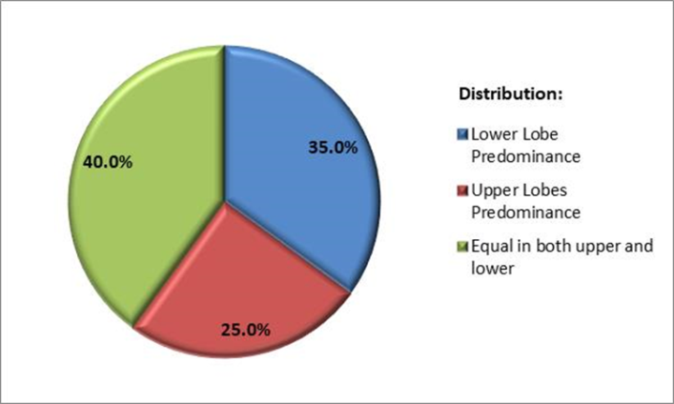

**Figure (1):** Distribution and predominance.

Ground-glass opacities were better visualized in MinIP images being seen in 42%, equal in both in 42% and more evident in volumetric HRCT only 16% of the cases. Traction fibrotic bronchiectasis was seen in 60% of the cases and was more evident in the MinIP images (seen in 100% of cases) than in those of conventional HRCT images. Regarding the cystic lung changes reported in our study; they were seen in 45% of the cases and it was noted that MinIP was ahead of HRCT in visualizing the lucencies of the cysts only in 77.8% of cases but not their walls. Other lung findings were seen in 85% and more evident in volumetric HRCT in 76.5% of cases. The associated mediastinal findings are seen in 55% of cases and more evident in HRCT in 54.5% of cases.

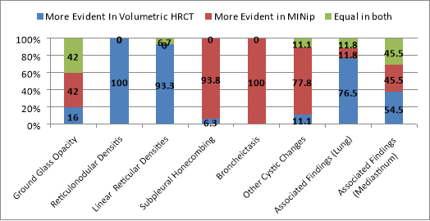

**Figure (2): Findings in HRCT and MinIP.**

The ground glass opacity is seen in most of the cases varying form patchy veiling to diffuse. It is noted that when the fibrosis is extensive, the GGO is more evident in MinIP projection images. The fibrotic changes and reticular opacities are seen more evident in the Volumetric HRCT. In the MinIP, they are much less evident. The decreased attenuation patterns are generally more evident in the MinIP and the walls are more evident in Volumetric HRCT. Based on that, in the cases where there are multiple adjacent cysts the walls are not well visualized in MinIP so the cysts take a bizarre shape. The associated lung findings considered are architectural distortion, peribronchial fibrosis, nodules and pleural thickening. The associated mediastinal findings and others considered lymphadenopathy, cardiomegaly, atherosclerosis, pulmonary HTN, esophageal dilatation dorsal spine spondylo-degenerative or thyroiditis.

The possible diagnosis was based upon the clinical history and CT radiological criteria including the distribution, fibrosis, honeycombing, traction bronchiectasis, other cystic changes and associated findings. It is found that in the 20 cases there are 11 (55%) with possible IPF while the others are thought to have other types of the interstitial lung diseases including sarcoidosis, CILD, PLCH, NSIP, LAM and HP.

**Table (1):** Possible Diagnoses.

|  |  |  |
| --- | --- | --- |
|  | N | % |
| Idiopathic Pulmonary Fibrosis (IPF) | 11 | 55.0% |
| Sarcoidosis | 2 | 10.0% |
| Interstitial lung disease associated with autoimmune thyroiditis (ILD-AT) | 1 | 5.0% |
| Lymphangioleiomatosis (LAM) | 1 | 5.0% |
| Non Specific Interstitial Pneumonia (NSIP) | 1 | 5.0% |
| Pulmonary Langerhans Cell Histiocytosis (PLCH) | 1 | 5.0% |
| Sarcoidosis/IPF | 1 | 5.0% |
| Connective Tissue (Scleroderma) ILD (CILD) | 1 | 5.0% |
| Hypersensitivity Pneumonitis (HP) | 1 | 5.0% |

Figure (4) explain the role of Volumetric HRCT and MinIP projection in assessing each IPF finding separately. The GGO was seen in all cases of possible IPF and was more evident in MinIP in 36.4% to only 18.2% more evident in volumetric HRCT and 45% equal in both. Traction fibrotic bronchiectasis was seen in 82% of the cases and was more evident in the MinIP images (seen in 100% of cases) than in those of conventional HRCT images. The other cystic lung changes were seen in 54% of the cases and it was noted that MinIP was ahead of HRCT in visualizing the lucencies of the cysts only in 83.3% of cases but not their walls. The fibrotic changes and reticular opacities are seen more evident in the Volumetric HRCT in 80% of cases. In the MinIP, they are much less evident. The associated mediastinal findings are seen in 36% of cases and more evident in HRCT in 75% of cases.

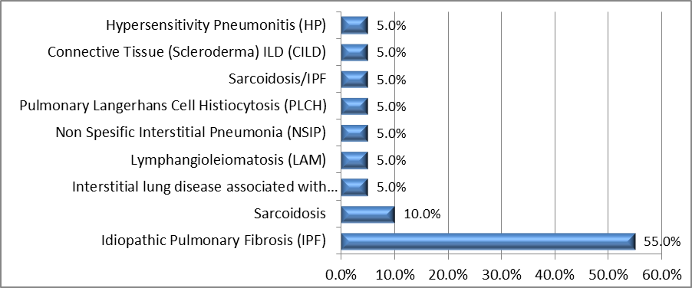

**Figure (3): Possible Diagnoses.**

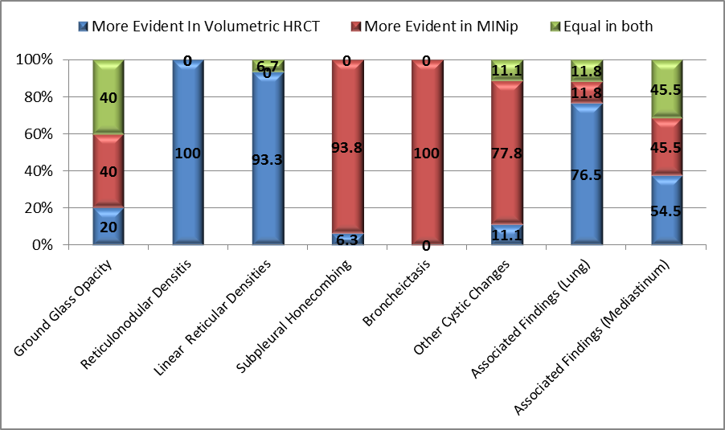

**Figure (4): Volumetric HRCT & MinIP findings in IPF.**



**Figure (6):** A 60 year old male patient (known ILD) presented with dyspnea and productive cough, no fever, no history of trauma, no related operations and no comorbidities. Axial Section and coronal reconstruction of non-contrast CT chest scan (a, c). Volumetric HRCT shows extensive fibrosis, bilateral apical minimal pneumothorax, cardiomegaly and dilated pulmonary artery; note that bronchiectasis is more evident at (b, d) MinIP projection in addition to other low attenuation patterns.



**Figure (7):** A 48 years old female (known Lymphangioleiomyomatosis) presented with dyspnea, there is history of left nephrectomy due to benign mass lesion (Angiomyolipomas) with ectopic malrotated right kidney and hepatic focal lesions of benign nature Axial Section and coronal reconstruction of non-contrast CT chest scan (a, c) Volumetric HRCT shows multiple variable sized thin walled cystic lesions seen distributed throughout both lung fields; note how the cystic lesion are more evident in (b, d) MinIP projection images even small cysts that could not be visualized in HRCT are visible in MinIPs.



**Figure (8):** A 42 years old female patient (known sarcoidosis) is presented by dyspnea. Axial Section and coronal reconstruction of non-contrast CT chest scan (Case 9) (known sarcoidosis) shows (a, c) Volumetric HRCT shows bilateral apical Reticulonodular infiltrates, mild bronchial tree dilation with peribronchial thickening. The cystic changes are better visualized in the (b, d) MinIP images.

**4. Discussion:**

In our study we incorporated MinIP images in each HRCT exam as an additional complementary tool, in order to reach an accurate diagnosis in the assessment of different types of ILD based on its value in distinguishing the difference in attenuation of the lung parenchyma and in better visualization of air-filled structures, mainly the bronchial tree, especially those affected by fibrosis leading to traction bronchiectasis and bronchiolectasis. We compared the positive findings in the HRCT and in the MinIP images. During our study, MinIP proved to be an excellent tool in visualization of traction bronchiectasis and bronchiolectasis resulting from fibrotic changes. The dilated airway structures were more evident in the MinIP images compared to the HRCT ones and those at the periphery were easily detected in MinIP images. This agrees with the conclusion of **Semple *et al*.** **(8)** and also agrees with **y Milliron *et al*. (9)** article in the Annual General Assembly of the Royal Belgian Society of Radiology.

In our study, cases showing areas of ground-glass opacities and mosaic attenuation pattern of the lung parenchyma were better visualized in the MinIP images in 42% of cases and equally visualized in both in 42% while more evident in Volumetric HRCT in only 16% of cases.

This agrees with **Ghonge and Chowdhury (10)** study. While the**. Sabri *et al*. (7)** study showed that Mosaic attenuation and ground-glass opacities were seen in78% of cases and better visualized in MinIP images being seen in 66.6% and 80.3% respectively of the cases which is higher than our results by 20% to 40% respectively but still in favor of MinIPs.

Regarding the cystic changes of the lungs included LAM and PLCH patients in addition to cases showing honeycombing, MinIP showed great value. In the lymphangioleiomyomatosis case, multiple variable sized cysts having thin walls against the normal lung parenchyma were seen. They are more evident in MinIP projection images compared to HRCT. Furthermore, MinIP could detect smaller cysts that were not seen in the HRCT. This agrees with **García-Peña *et al*. (11).**

In the case of possible pulmonary Langerhans’ cell histiocytosis; it showed bizarre shaped cystic lesions with relatively irregular thickened walls; that were accurately seen in the HRCT images, while MinIP was not informative as the thickened walls were not detected. However, MinIPs were not valuable in detecting the walls of the cysts or honeycombing changes.

The honeycombing changes which are pathognomonic findings in UIP (Usual interstitial pneumonia) and can confirm the diagnosis of IPF (Idiopathic interstitial pneumonia) if combined with its clinical features. The lucencies were better visualized in the MinIPs while their thick walls and the surrounding fibrosis were better visualized in HRCT. We considered the lucencies as the honeycombing to be assessed while the fibrotic changes are assessed under separate category. This agrees with the **Hovinga et al. (5)** study while in the **Sabri et al. (7)** study results that the honeycombing was accurately visualized in HRCT images showing different forms of lung fibrosis and architectural distortion, however, it was hardly detected in MinIP images which was not able to delineate their thickened walls. 66% of the cases were more evident in HRCT images and 33% equal in both.

The fibrotic changes and reticular opacities are seen more evident in the Volumetric HRCT (more than 90% of cases). In the MinIP, they are much less evident.

Additional lung findings including the architectural distortion, peribronchial fibrosis, nodules and pleural thickening are seen (one or more) in 85% of cases being more evident in volumetric HRCT in 76.5% of cases. This agrees with **Raoof *et al*. (12)** and **jia Li *et al*. (13).**

The possible diagnosis was based upon the clinical history and CT radiological criteria including the distribution, fibrosis, honeycombing, traction bronchiectasis, other cystic changes and associated findings. This agrees with **Meyer (14).** In our study, it was found that in the 20 cases there are 11 (55%) with possible IPF while the others are thought to have other types of the interstitial lung diseases including sarcoidosis, CILD, PLCH, NSIP, LAM and HP.

The diagnosis of a possible IPF (UIP pattern) on HRCT was based on the presence of bilateral, predominantly subpleural, basal reticular characteristic findings and the absence of additional features considered incompatible with a diagnosis of IPF. In 2018, the American Thoracic Society (ATS), European Respiratory Society (ERS), Japanese Respiratory Society (JRS), and Latin American Thoracic Society (ALAT) published a clinical practice guideline on the diagnosis of idiopathic pulmonary fibrosis (IPF), updating guidelines from 2011. The new guidelines 1) used systematic reviews to inform each recommendation in strict accordance with the Institute of Medicine Standards for Trustworthy Guidelines, 2) eliminated the radiological categories of “possible UIP pattern” and “inconsistent for UIP pattern” and the pathological categories of “possible UIP” and “nonclassifiable fibrosis,” and 3) refined the radiological and pathological patterns of “UIP” and defined “probable UIP” and “indeterminate for UIP.” The overriding goal of the guidelines was to help clinicians diagnose IPF more accurately, thereby facilitating appropriate treatment, as described in the 2015 guidelines for the treatment of IPF (Raghu G *et a*l., 2019). **(15).**

**5. Conclusion:**

HRCT is the imaging modality of choice in the evaluation process of ILD. Proper utilization of its technical capabilities provides precise interpretation. MinIP is one of the multiplanar techniques of HRCT. It proved throughout our study to be an informative complementary tool increasing the observer confidence and agreement regarding some findings as compared with HRCT alone. We recommend adding it as a complementary tool in the routine HRCT protocol in the diagnostic process of ILD.

**References:**

1. Larissa Schwarzkopf, Sabine Witt, Julia Waelscher, Markus Polke and Michael Kreuter. 2018, Associations between comorbidities, their treatment and survival in patients with interstitial lung diseases – a claims data analysis, 201819:73 https://doi.org/10.1186/s12931-018-0769-0© The Author (s). 2018 .
2. Theresia A Mikolasch, Helen S Garthwaite, and Joanna C Porter (2017). Update in diagnosis and management of interstitial lung disease. Royal College of Physicians 2017, ISSN: 1473-4893 vol. 17 no. 2 146-153, https://doi.org/10.7861/clinmedicine.17-2-146.
3. Christopher J. Ryerson, Thomas H. Urbania, Luca Richeldi, Joshua J. Mooney, Joyce S. Lee, Kirk D. Jones, Brett M. Elicker, Laura L. Koth, Talmadge E. King, Paul J. Wolters, Harold R. Collard (2013). European Respiratory Journal Sep 2013, 42 (3) 750-757; DOI: 10.1183/09031936.00131912.
4. M. Anthimopoulos, S. Christodoulidis, L. Ebner, A. Christe and S. Mougiakakou (2016). "Lung Pattern Classification for Interstitial Lung Diseases Using a Deep Convolutional Neural Network," in IEEE Transactions on Medical Imaging, vol. 35, no. 5, pp. 1207-1216, May 2016.
5. Hovinga M., Sprengers R., Kauczor HU., Schaefer-Prokop C. (2016) CT Imaging of Interstitial Lung Diseases. In: Schoepf U., Meinel F. (eds) Multidetector-Row CT of the Thorax. Medical Radiology. Springer, Cham.
6. Cornelia Schaefer-Prokop and Helmut Prosch, 2015, Interstitial Lung Diseases, ESR Monogr 2015; 70: 99-115. DOI: 10.1183/2312508X.10003015.
7. Youssriah Y. Sabri, Iman M. Hamdy Ibrahim, Shady Mohamed Tarek Gamala and Hebatallah H. Assal (2016), Multi-detector CT (MDCT) evaluation in interstitial lung disease (ILD): Comparison of MinIP and volumetric high resolution CT (HRCT) images, The Egyptian Journal of Radiology and Nuclear Medicine, ISSN: 0378-603X, Vol: 48, Issue: 1, Page: 87-95.
8. Semple T, A. Calder, C. M. Owens and S. Padley (2017). Current and future approaches to large airways imaging in adults and children, Clinical Radiology, http://dx.doi.org/10.1016/j.crad.2017.01.012.
9. Bethany Milliron, Travis S. Henry, Srihari Veeraraghavan and Brent P. Little (2015). Bronchiectasis: Mechanisms and Imaging Clues of Associated Common and Uncommon Diseases. Radiographics, 35 (4) (2015), pp. 1011-1030, <https://doi.org/10.1148/rg.2015140214>.
10. Ghonge, N. P., & Chowdhury, V. (2018). Minimum-intensity projection images in high-resolution computed tomography lung: Technology update. Lung India: official organ of Indian Chest Society, 35(5), 439–440. doi:10.4103/lungindia.lungindia_489_17.
11. García-Peña P., Watson T. A., Owens C. M. (2014). Helical Multidetector Chest CT. In: Garcia-Peña P., Guillerman R. (eds) Pediatric Chest Imaging. Medical Radiology. Springer, Berlin, Heidelberg.
12. Suhail Raoof, Praveen Bondalapati, Ravikanth Vydyula, Jay H. Ryu, Nishant Gupta, Sabiha Raoof, Jeff Galvin, Mark J. Rosen, David Lynch, William Travis, Sanjeev Mehta, Richard Lazzaro and David Naidich (2016). Cystic Lung Diseases: Algorithmic Approach. American College of Chest Physicians. Published by Elsevier Inc. doi.org/10.1016/j.chest.2016.04.026.
13. Wang-jia Li, Zhi-gang Chu, Yan Zhang, Qi Li, Yi-neng Zheng, and Fajin Lv (2019). Effect of Slab Thickness on the Detection of Pulmonary Nodules by Use of CT Maximum and Minimum Intensity Projection. American Journal of Roentgenology 2019 213:3, 562-567.
14. Keith C Meyer (2014). Diagnosis and management of interstitial lung disease. Transl Respir Med (2014) 2: 4. https://doi.org/10.1186/2213-0802-2-4.
15. Raghu G, Remy-Jardin M, Myers J, Richeldi L and Wilson KC (2019). The 2018 Diagnosis of Idiopathic Pulmonary Fibrosis Guidelines: Surgical Lung Biopsy for Radiological Pattern of Probable Usual Interstitial Pneumonia Is Not Mandatory. Am J Respir Crit Care Med. 2019 Nov 1;200(9):1089-1092. doi: 10.1164/rccm.201907-1324ED.

11/2/2019