**Evaluation of Boron Concentration in Water Samples of the Rivers in Al- Diwaniya-Iraq Using CR-39 Track Detector**

Thaer M. Salman and Abbas A. Sweaf

Department of Physics, College of Education for Pure Science, University of Basrah, Basrah, Iraq

[badran_hussein@yahoo.com](mailto:badran_hussein@yahoo.com)

**Abstract:** Significant risks for human health may results from exposure to non pathogenic toxic contaminants that are often globally ubiquitous in waters from which drinking water is derived to measure the Boron, 105B concentration in water samples in Al- Diwaniya governorate in Iraq. The measurements were performed by analyzing the water samples collected from 24 location using CR-39 Track Detector. The Boron concentrations which are obtained ranged from 2.116 mg/l in ((ghmas1)) river belt and minimum 0.651 mg/l was recorded in ((ghmas6)) river in water samples. The results are presented and compared with other studies. The results could be utilized to make distinctive supplementary contributions when contamination event occurs and to implement water quality standards by concerned authorities to maintain radioactive contamination-free drinking water supplies for the people. The study further reveals that 24 surface water samples have boron below detection limit. The presence of boron in drinking water sources in this territory is of natural origin. Thus, there is possibility of severe pollution problem with boron in near future.

[Thaer M. Salman and Abbas A. Sweaf. **Evaluation of Boron Concentration in Water Samples of the Rivers in Al- Diwaniya-Iraq Using CR-39 Track Detector.** *Researcher* 2019;11(10):64-70]. ISSN 1553-9865 (print); ISSN 2163-8950 (online). <http://www.sciencepub.net/researcher>. 10. doi:[10.7537/marsrsj111019.10](http://www.dx.doi.org/10.7537/marsrsj111019.10).

**Keywords:** Neutron Source, Boron, SSNTDs, water samples.

**1. Introduction**

Boron is a nonmetallic element that belongs to Group IIIA of the periodic table and has an oxidation state of +3. It has an atomic number of 5 and atomic weight of 10.81. Boron is actually a mixture of two stable isotopes, 10B (19.8%) and 11B (80.2%) [1]. Boron is a naturally-occurring element found in rocks, soil, and water. The concentration of boron in the earth’s crust has been estimated to be <10 mg/l, but concentrations as high as 100 mg/l can be found in boron-rich areas [2]. Solid state nuclear track detectors (SSNTDs) of different materials are important for investigations in basic science and technology [3]. Among such applications, SSNTDs are widely used in radiation protection and environmental radiation monitoring. Their theory was developed more than 40 years ago, the basic fundamentals can be found in Somogyi [4] and in more details in Durrani et al. [5]. Even more details for detecting alpha particles, which is important from Boron Neutron Capture Therapy (BNCT) point of view, can be found in Nikezic [6]. Therefore, here we touch some aspects of interest, only. Popularly saying, an ionizing particle produces a narrow damaged zone in the plastic, 10-100 nm in diameter, which can be enlarged and visualized by a chemical treatment, so that the particle movement in the detector material, let us say the footprint of the particle or its track can be followed under optical microscope. Depending on the chemical treatment (called etching) and observation method there are basically two requirements: the range and energy deposition of the particle should be adequate [7]. This work represents the preliminary findings from Boron concentration measurement data which were collected from different regions in Al-Diwaniya City. The general aim is to investigate the complex interactions and exchanges with the flow of water, and estimate how much hazards brought with waters. In fact, the study area is located inside Al-Diwaniya Governorate. The chemical structure of some boron compounds is found in Fig.1.

Solid state nuclear track detectors SSNTDs of different materials are important for investigations in basic science and technology [8]. Among such applications, SSNTDs are widely used in radiation protection and environmental radiation monitoring. Their theory was developed more than 40 years ago, the basic fundamentals can be found in Somogyi [9,10]. Even more details for detecting alpha particles, which is important from BNCT point of view [11]. The 10BNC-reaction to take place requires a sample containing, even at ppb among the known boron compounds, several hundred are employed in today’s applications and a growing level, 10B, a source set for irradiation with thermal or lower neutron energy (0.025eV or less) and a reaction fragment detecting device. The reaction phenomenon is related to a neutron interacting with boron nucleus, followed by breakup in two fragments of the 10B+n compound nucleus (that survives a short time in the order of picoseconds). The two fragment nuclei depart acquiring kinetic energy due to a strong Coulomb field moving in opposite direction under the momentum conservation law, synthesized by the following process:

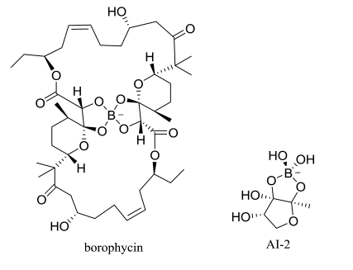

Figure 1. Chemical Structures of some boron compounds

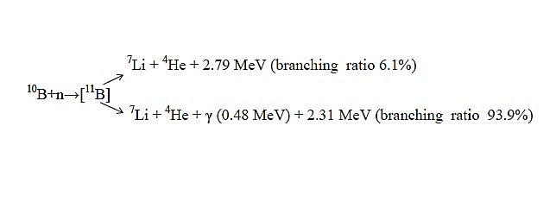

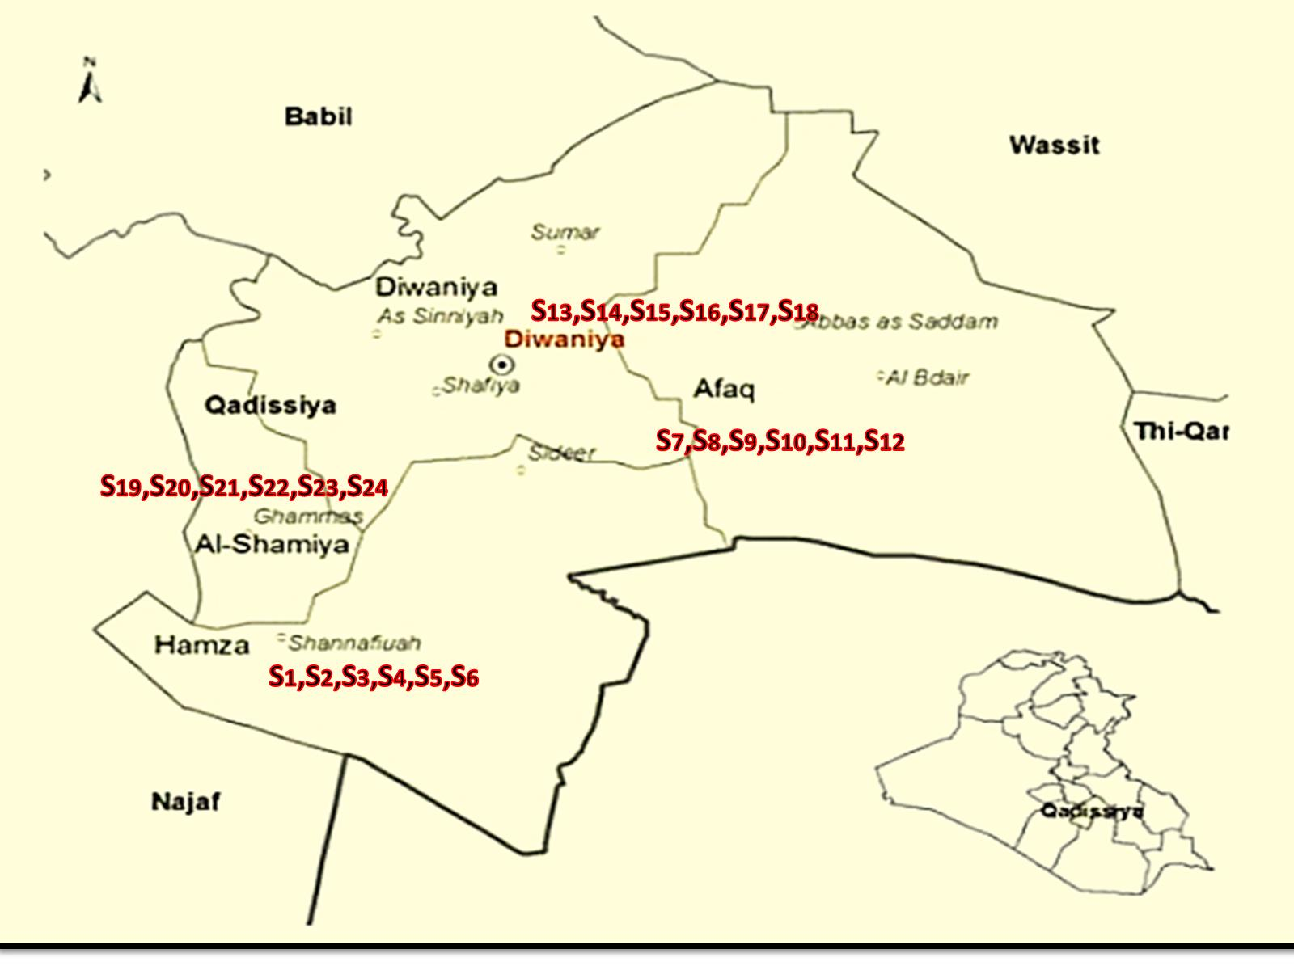

Figure 2. Al-Diwaniya Governorate, dots represent the places where samples taken from, numbering in station number

The reaction occurs with different branching ratio: the first has a relatively low frequency occurrence (6.1%) but has the advantage that the reaction is photon less and therefore the induced damage leads to a higher "Linear Energy Transfer" (LET) or dE/dx. The other, with higher occurrence is accompanied by a 0.48MeV photon. If the alpha particle (4He+) leaves the sample surface, with sufficient kinetic energy, then it can be detected e. g. by nuclear track techniques. The alpha particle fingerprint given by a suitable detecting material, provides information on the boron presence and it is recognized as a powerful analytical method for boron studies**.** This work represents the preliminary findings from Boron concentration measurement data which were collected from different regions in Al-Diwaniya city. The general aim is to investigate the complex interactions and exchanges with the flow of water, and estimate how much hazards brought with waters. In fact, the study area is located inside Al-Diwaniya Governorate which is located in the extreme Euphrates part of Iraq, see fig.2.

**2. Material and Methods**

In Al- Diwaniya governorate*,* the Samples from 24 stations and locations were collected during May 2018*.* The measurements of Boron concentration water were carried out by passive methods; we used the Solid State Nuclear Track Detectors SSNTDs, for the measurements of Boron concentration in water. The SSNTD, CR39, (1x1 cm) films. Many samples of water from different places have been supplied. One milliliter from different boron concentrations standard was dropped on the same area of the *CR*-39 track detector and it is left to dry. After drying the standard samples are exposed to a thermal neutron source for the same period of time 7days. A nuclear reaction of type *10B* (n, α) 73Li has been occurred Alpha particles are emitted with energy 2.31 MeV which can make suitable track in CR-39 plastic detector. The samples, after being exposed, are washed in distilled water, then etched in a solution of 6.25 N (Normality) NaOH at 60 0C temperature, 6 hrs (etching time), by using a bath held at a constant temperature. The track diameters and track density have been carried out using transmission optical microscope and a suitable calibration curve is used to calculate the concentration of Boron. The pieces of the each to the detector sets were irradiated with neutrons that emitted from Am-Be.

**2.1 Irradiation of the samples**

The pellets (water samples of river) were covered with *CR*-39 detector and put in a plate of paraffin wax at a distance of 5cm from the neutron source *Am-Be*, with flux of thermal neutron (5x103 n cm -2 S-1) as shown in Fig.3.

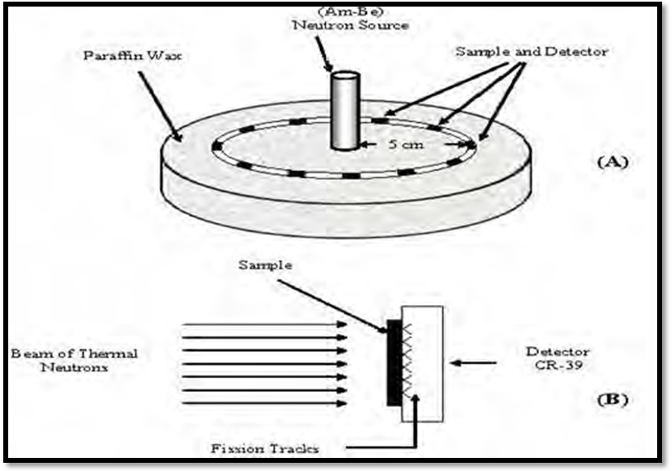

Fig.3. Water samples and detector irradiation in front of the thermal neutron source.

**2-Chemical etching and microscopic scanning**.

After the irradiation time 7 days the CR-39 detectors were removed and etched in a 6.25 N aqueous solution of NaOH maintained at 60 C° for 6 hr, which was the normal employed etching time [12]. The detectors were rinsed with distilled water and dried in air. The tracks recorded in CR-39 detectors were counted by using optical microscope at a magnification of 400 X. The density of the tracks ρ in the detectors was calculated according to the following relation:

*x* = 

Where ρ is the Track density (Track/mm2), N is the a average of total tracks and A is the area of field view.

**2.2 Calibration Curve for standard sample**.

For the calibration curve plot between standard of different Boron solutions of known concentrations from 2 mg/l to 10 mg/l has been prepared to calibration our studying and track density by using neutron induced radiography which is based on the principle of solid state nuclear detectors SSNTDs CR-39. The Boron concentrations were measured by comparison between track densities register on the detectors of the samples and that of the standard samples from the Regression equation: y=2767.67+352.715*X, R2 =0.97354. A linear calibration as shown in Fig. 4 was observed, followed by the calculation of the slope factor. The results are experimented in (mg B/l).

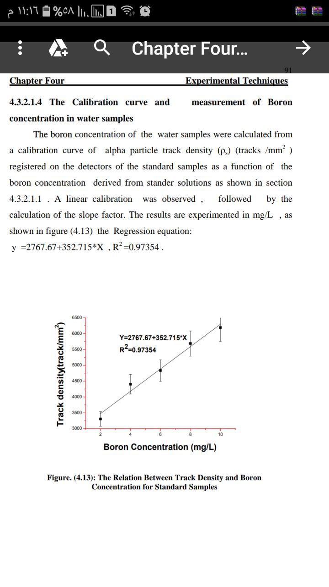

Figure 4. The relation between track density and Boron concentration (mg/l) for standard Boron samples.

**3*.* Result and Discussion**.

Table 1 present the tracks density, Boron concentration samples that measured by *CR* –39 detectors. The water samples of the rivers collected from fifteen locations distributed in different sites in Alshanaafia, Afak rufieat, Umalkhayl and ghmas, districts in Al- Diwaniya governorate. Fig.5 show the relationship between Boron concentration and number of the location of the soils sample.

Table 1. Boron Concentration in the water in Al- Diwaniy rivers using SSNTDS method

| **Boron Concentrations**  **(mg/l)** | **tracks density**  **(tracks/mm2)** | **Site Name** | **site Number** |
| --- | --- | --- | --- |
| 1.641 | 3346.617 | alshanaafia 1 | S1 |
| 0.913 | 3089.914 | alshanaafia 2 | S2 |
| 1.631 | 3342.976 | alshanaafia 3 | S3 |
| 1.147 | 3172.318 | alshanaafia 4 | S4 |
| 0.710 | 3018.203 | alshanaafia 5 | S5 |
| 0.898 | 3084.452 | alshanaafia 6 | S6 |
| 0.925 | 3094.213 | Afak 1 | S7 |
| 0.872 | 3075.576 | Afak 2 | S8 |
| 1.014 | 3125.415 | Afak 3 | S9 |
| 0.722 | 3022.552 | Afak 4 | S10 |
| 0.931 | 3096.259 | Afak 5 | S11 |
| 1.086 | 3150.904 | Afak 6 | S12 |
| 1.427 | 3271.050 | rufieat 1 | S13 |
| 1.231 | 3201.862 | rufieat 2 | S14 |
| 0.660 | 3000.705 | rufieat 3 | S15 |
| 0.981 | 3113.895 | Um alkhayl 1 | S16 |
| 0.790 | 3046.455 | Um alkhayl 2 | S17 |
| 0.678 | 3007.077 | Um alkhayl 3 | S18 |
| 2.116 | 3514.111 | ghmas1 | S19 |
| 1.200 | 3190.956 | ghmas2 | S20 |
| 1.132 | 3167.289 | ghmas3 | S21 |
| 1.453 | 3280.165 | ghmas4 | S22 |
| 1.243 | 3206.432 | ghmas5 | S23 |
| 0.651 | 2997.499 | ghmas6 | S24 |



Figure 5. Boron concentrations in alshanaafia, Afak, rufieat, Um alkhayl and ghmas water as a function of number location.

For the measurement of boron concentration level water, samples for the rivers table 1 and Fig.5, reflect the fact that, there was some high level of boron concentration in this water higher than the most of public tap and washing surface water in the governorate. The results for these 24 samples categorized into 24 locations, from S1 to S24, shown in Fig.5. Boron content found maximum 2.116 mg/l in ((ghmas1)) river belt and minimum 0.651 mg/l was recorded in ((ghmas6)) belt. Out of the 24 water samples of the rivers 11 samples recorded higher which are beginning from 1.014 mg/l to 1.641 mg/l while the 6 water samples of the rivers are beginning from 0.872 mg/l to 0.981 mg/l while the 3 water samples of the rivers are beginning from 0.710mg/l to 0.790 mg/l than the prescribed WHO limit 0.5 mg/l. The World Health Organization (WHO) in 1993 the WHO established a health-based Guideline of 0.3 mg/L for boron. This value was raised to 0.5 mg/L in 1998 primarily. Furthermore, in 2000 it was decided to leave the guideline at 0.5 mg/L until data from ongoing research becomes available that may change the current view of boron toxicity or boron treatment technology [13,14]. The European Union established a value of 1.0 mg/L for boron in 1998 for the quality of water intended for human consumption [15.16]. New Zealand has established a drinking water standard for boron of 1.4 mg/L [17,18]. The interim maximum acceptable concentration (IMAC) for boron in Canada is 5 mg/L. The Canadians have established this value on the basis of practical treatment technology. They believe available technologies are inadequate to reduce boron concentrations to less than 5mg/L. They will review this IMAC periodically as new data becomes available [19 ].

**4. Conclusion**:

Well water are in many rural localities in rural areas and which were existent in the Al- Diwaniya Governorate Iraq. The analytical results of chemical water analysis revealed the presence of Boron in the limit of New Zealand 1.4 mg/l and IMAC 5 mg/l, with a variation between (0.651- 1.641) mg/l. The values of Boron concentration are small and within the natural limits in most of the sample of the water samples of the rivers. The correlation factor, 97.35%, between the boron concentration of standard samples and Track density (track/mm2) of the samples in water samples of the rivers are very good correlation. Access to safe water of the rivers is essential to human well-being and is a key public health issue.

**References**

* 1. Nielsen FH, Gallagher SK, Johnson LK, Nielsen EJ Boron enhances and mimics some effects of estrogen therapy in postmenopausal women. J Trace Elem Exp Med 5: 237-246. 1992.
  2. Young A. The Saturn V F-1 Engine: Powering Apollo Into History. Springer. p. 86. ISBN 978-0- 387-09629-2. 2008.
  3. Lyday, P. A. “Boron in the Environment”, Journal of Critical Reviews in Environmental Science and Technology Volume 35, Pages 81-114;2005.
  4. Xiangyi Ren, Hanguang Fu," Effect of boron concentration on microstructures and properties of Fe–B–C alloy steel', Journal of Materials Research, Volume 32, Issue 16. pp. 3078-3088; 28 August 2017.
  5. Jeffrey L. Parks, "Sorption of Boron and Chromium on to Solids of environmental significance: Implication for sampling and removal in water treatment ' Dissertation submitted to the Faculty of the Virginia Polytechnic Institute and State University in September 6, 2005.
  6. Kha L. Tu, Long D. Nghiem, Allan R. Chivas, Boron removal by reverse osmosis membranes in seawater desalination Applications, Separation and Purification Technology 75, 87–101.2010.
  7. D. Hermsdor f, Evaluation of the sensitivity function V for registration of α-particles in PADC CR-39 solid state nuclear track detector material" Article in Radiation Measurements 44(3):283-288 · March 2009.
  8. Thaer, M. Salman, Muntadher, A. Qasim'' The Measurements of Borates Concentration in Waters of Basra city using different Techniques' Journal of Basrah Researches ((Sciences)) Vol. ( 39). No. ( 1). A ( 2013 ).
  9. Somogyi, G., Szalay ' Track diameter kinetics in dielectric track detectors' Journal of Nuclear Instruments and Methods Volume 109, Issue 2, 1. Pages 211-232 · June 1973.
  10. Durrani, S. A., Bull, R. K., Solid State Nuclear Track Detection: Principles, Methods and Applications. Pergamon Press Oxford.1987, pp 284.
  11. Nikezic, D., Yu, K. N., 'Three dimensional analytical determination of the track parameters. over-etched tracks; Radiation Measurments' 37,39-45;2003.
  12. Singh S., Malhotra R., J Kumar, B Singh, L Singh, 'Uranium analysis of geological samples, water and plants from Kulu Area, Himachal Pradesh, India'; journal of Radiation Measurements, Volume 34, Pages 427-431 June 2001.
  13. World Health Organization. Environmental Health Criteria 204: Boron. Geneva, Switzerland: World Health Organization (as cited in U.S. EPA, 2004). 1998.
  14. Vadivel, S., Manickam A., Ponnusamy S. 'Physico-chemical and adsorption studies of activated carbon from Agricultural wastes, Pelagia Research Library, Advances in Applied Science Research, 3 (1):219-226;2012.
  15. Council of the European Union Council Directive 98/83/EC, November3, 1998 on the quality of water intended for human consumption. 1998.
  16. Neelesh, S., Mishra D. D., Mishra P. K. 'A study on the sewage disposal into the Machna river in Betul City, Madhya Pradesh, India'; Pelagia Research Library, Advances in Applied Science Research, 3 (5):2573-2577; 2012.
  17. New Zealand Ministry of Health Drinking-Water Standards for New Zealand; Wellington, PO Box 5013, Wellington, New Zealand ISBN0-478-23963-7(Booklet)2000.
  18. Abdul, R. H. S., Master, A. A.,' Measurement of Radon Exhalation Rate from Core of some Oil -Wells in Basra Governorate in the Southern Iraq', Pelagia Research Library, Advances in Applied Science Research, 3 (1):563-571, 2012.
  19. Federal–Provincial–Territorial Committee on Drinking Water "Summary of Guidelines for Canadian Drinking Water Quality by Federal–Provincial–Territorial Committee on Environmental and Occupational Health, in April, 2003.

10/21/2019