T-Tube Drainage versus Primary Common Bile Duct Closure after Laparoscpic Choledochotomy

Mohammad Mohsen Ahmed Salem¹, Yaser Ahmed Elsayed Amer¹, Magdy Abd El-Hamed El-Sebae², Mostafa Farag El-Shafie³ and Rani Mohammed Saleh Khattab⁴

¹ Professor of General Surgery, Faculty of Medicine, Al-Azhar University, Egypt.
³ Professor of General Surgery, Theodor Bilharz Research Institute, Egypt.
⁴ Lecturer of Radiology, Theodor Bilharz Research Institute, Egypt.
⁵ M.B.B.CH, M.SC., Assistant Researcher of General Surgery, Theodor Bilharz Research Institute, Egypt.
ranikhattab@hotmail.com

Abstract: Background: Gallstones are an extremely common condition, arising in approximately 10% to 20% of the adult population, and as such pose an important public health problem. Choledocholithiasis is a common problem that necessitates intervention, it is managed either endoscopically or surgically. Objectives: To study the comparison between primary closure of common bile duct and T-tube drainage after laparoscopic choledocholithotomy in choledocholthiasis. Patients and Methods: This prospective randomized study included 50 patients with history of calcular obstructive jaundice preoperatively which was conducted in the department of surgery, Theodor Bilharz Research Institute (TBRI) and Al-Azhar University Hospital from May 2017 to May 2019 each patient undergo laparoscopic cholecystectomy together with laparoscopic common bile duct exploration, then they will be allocated in to two groups;(groupA) for T tube insersion and (group B) for primary closure.Results: In our study mean age in group (A) was (45.40 ± 3.004), mean age in group (B) was (48.40 ± 2.540) (P value 0.4494). In our study mean total bilirubin in group (A) was (4.24 ± 0.49), mean total bilirubin in group (B) was (4.42 ± 0.5) (P value0.8048). In our study mean direct bilirubin in group (A) was (3.16 ± 0.42), mean direct bilirubin in group (B) was (3.43 ± 0.46) (P value0.6736). In our study mean alkaline phosphatase in group (A) was (264.9 ± 30.93), mean alkaline phosphatase in group (B) was (290.2 ± 30.87) (P value0.5656). In our study mean U/S CBD diameter in group (A) was (0.93 ± 0.058), mean U/S CBD diameter in group (B) was (1.02 ± 0.07) (P value0.3224). In our study meanU/S Stones Diameter in group (A) was (1.05 ± 0.08), mean U/S Stones Diameter in group (B) was (1.12 ± 0.08) (P value0.519). In our study thirty nine out of fifty patients (78 %) had clinical jaundice at presentation (19 patients in group A and 20 patients in group B).Conclusion:Both primary closure of CBD and T-tube drainage after CBD exploration are equally good procedures for the treatment of uncomplicated choledocholithiasis. However, primary closure of CBD is having significantly lower operating time and less duration of stay at hospital. Therefore, it can be recommended for treatment in selective patients of choledocholithiasis.
[Mohammad Mohsen Ahmed Salem, Yaser Ahmed Elsayed Amer, Magdy Abd El-Hamed El-Sebae, Mostafa Farag El-Shafie and Rani Mohammed Saleh Khattab. T-Tube Drainage versus Primary Common Bile Duct Closure after Laparoscpic Choledochotomy.Researcher2019;11(10):1-8]. ISSN 1553-9873 (print); ISSN 2375-7205 (online). http://www.sciencepub.net/researcher.1. doi:10.7537/marsroj111019.01.

Keywords:T-Tube Drainage, Primary Common Bile Duct Closure, Laparoscpic Choledochotomy

1. Introduction
Gallstones are an extremely common condition, arising in approximately 10% to 20% of the adult population, and as such pose an important public health problem (Fried et al., 2009).
Choledocholithiasis is a common problem that necessitates intervention, it is managed either endoscopically or surgically (Kharbutli and Velanovich, 2008).
Common bile duct stones may be small or large, single or multiple, and are found in 6 to 12% of patients with stones in the gallbladder, the incidence increases with age, about 20 to 25% of patients above the age of 60 with symptomatic gallstones have stones in the common bile duct as well as in the gallbladder (Ko and Lee, 2002).
Choledochal stones may be silent and often are discovered incidentally,they may cause obstruction, complete or incomplete, or they may manifest with cholangitis or gallstone pancreatitis (KO and Lee, 2002).
Common bile duct stones can be caused either by primary bile duct stones that originate in the bile duct or by secondary bile duct stones that have descended from the gallbladder, in the primary stones, bilirubin is dominant component and is associated with biliary stasis and infection, in secondary stones, cholesterol is dominant component, it is therefore important to distinguish between primary and secondary stones (Schirmer et al, 2005).
With the development of laparoscopic equipment and technology, laparoscopic common bile duct exploration (LCBDE) has been widely used in clinical practice (Gupta, 2016).
CBD exploration can be performed either trans-cystic or trans-choledochal, trans-cystic approach is preferred where ever possible as it is associated with minimal morbidity and fewer complications as compared to trans-choledochal approach because its post-operative course is just like cholecystectomy, but it has got limitations, it has got high failure rate as visualization of proximal CBD is mostly not possible, stones larger than 6mm are difficult to retrieve and sometimes cystic duct has tortuous course and cannot be negotiated (Khan et al.,2010).
Standard common bile duct (CBD) exploration includecholedochotomy in the supra-duodenal part, then stone extraction, with confirmation of CBD clearance by passing soft catheter or dilator proximally or distally (Williamson, 2000).
The modern era of common bile duct surgery started with Mirizzi, who introduced the intra-operative cholangiography in 1932, intra-operative choledochoscopy had been developed as an adjunctive to intra-operativecholangiography, which helped to detect the common bile duct stones in anadditional 10% to 15% of instances that otherwise an important technique for efficient and effective management of common bile duct stones (Lyass and Phillips, 2006).
T-shaped tube drainage is the standard practiceto decompress the biliary tree and prevent bile leakage due to edema and spasm of the sphincter of Oddi,it has the advantages of easy post operative X-ray visualization of CBD, and the potential for T-tube tract extraction of missed stones (Zhang et al., 2009).
Potential of complications exists with this therapeutic modality, these includes bacteremia, dislodgement of tube, obstruction and/or fracture of tube Furthermore, leakage of bile may be encountered after removal, patients may have to carry it for several weeks before removal, all of these lead to prolong length of hospital stay (Zhang et al., 2009).
Primary CBD closure was safely and effectively done provided that no evidence of pancreatitis, cholangitis, or ampullary obstruction, and it regains its popularity recently by the advances in endoscopic sphincterotomy and stone extraction,and it seems to be a more satisfactory technique for both surgeon and patient, and should be considered, patients have a shorter hospital stay, with smooth post operative course, with lower cost, post discharge X-ray is not required, with rapid return to work,however this Post-operative cholangiography for detection of retained calculi is not possible after primary closure and this is considered as a disadvantage (Gurusamy and Samraj, 2007).
Intra-operative deployment of biliary stent was done via the choledochotomy incision before its closure; it reduces operative morbidity, eliminates the complications of T-tube, and allows the patient to return to quickly unrestricted activity, as the median post operative hospitalization is two days, it is safe, effective, time sparing, and cost effective (Martin et al., 2002).
Aim of the Work
To study the comparison between primary closure of common bile duct and T-tube drainage after laparoscopic choledocholithotomy in choledocholthiasis.

2. Patients and Methods
This prospective randomized study included 50 patients with history of calcular obstructive jaundice preoperatively which was conducted in the department of surgery, Theodor Bilharz Research Institute (TBRI) and Al-Azhar University Hospital from May 2017 to May 2019 each patient undergo laparoscopic cholecystectomy together with laparoscopic common bile duct exploration, then they will be allocated in to two groups; (groupA) for T tube insersion and (group B) for primary closure.
Inclusion criteria:
Patients with CBD stones or CBD more than 9mm in diameter accompanied with calcular cholecystitis included in our study.
Exclusion criteria:
Patients with CBD stones who are unfit for general anesthesia,history of pancreatitis, supportive cholangitis and malignancy.
All patients included in the study subjected to:
- History taking (history of obstructive jaundice which is still present or releaved by ERCP stenting or spontaneously) and physical examination.
- Laboratory investigations including Aspartate aminotransferase (AST), alanine aminotransferase (ALT), total and direct serum bilirubin, alkaline phosphatase (ALP), and other routine pre-operative investigations as complete blood picture, coagulation profile, serum creatinine, serum urea, serum K and Na.
- Abdominal ultrasonography done for all patients detecting common bile duct stones in 46 patients.
- Magnetic resonance cholangiopancreatography (MRCP) diagnoses 4 cases with common bile duct stones, those cases showing elevated ALP and dilated common bile duct on ultrasonography but no common bile duct stones could be detected by abdominal ultrasonography with clinical picture of jaundice.
- Ten cases referred from our endoscopy unit in TBRI underwent ERCP with failure of stones extraction but sphincterotomy and stenting were done over the stones.
- Also preoperative anesthetic assessment for any contraindication oflaparoscopic surgery will be conducted in the clinic of anesthesia of TBRI.
- Informed written consent approved by Ethics Committee of TBRI.
- The patient informed in great details about the operative strategy of either technique.
- Evaluation of operative time, number of CBD stones extracted, their average size, conversion to open procedure, and any intraoperative complications.
- Evaluation of the post-operative complications in the form of duration of hospital stay and any complications like bile leakage, and intra-abdominal collection, wound infection.
- Results recorded, tabulated and statistically analyzed.
Operative technique:
- The apex of the gall bladder fundus is grasped with a ratcheted forceps through the lateral port, and the gall bladder and liver are then lifted superiorly.
- Omental or other loose adhesions to the gall bladder are gently teased away.
- The infundibulum of the gall bladder is grasped with forceps through the middle port, lateral traction with the middle forceps exposes the region of the cystic duct and artery.
- Dissecting forceps are used through the epigastric port to open the peritoneum over the presumed junction of the gall bladder and cystic duct.
- With gentle teasing and spreading motions, the cystic duct and artery are exposed, each structure is identified and exposed circumferentially.
- A distal clip is applied to the duct near the gall bladder neck securing the infundibulo-cystic junction.
- Then cystic duct was opened using scissors for intraoperative cholangiography, for all cases operative cholangiography was performed using the olsen/reddish cholangiography forceps with a 4 or 5Fr uretric catheter,dynamic fluoroscopic images were obtained with mobile C- arm. Fig. (1)
- Then management of choledocholithiasis diagnosed intraoperativelydone by removing the stones from CBD through choledochotomy incision in the supra-duodenal part of CBD. Fig. (2), laparoscopic common bile duct exploration is done using atraumatic forceps and gentle Manipulation, sometimes we use Fogarty catheter or a three wire dormia basket under direct vision.Fig. (3,4)
- After removing the stones from CBD through the choledochotomy incision, flexible 5F choledochoscope (Karl Storz, Germany) used to detect biliary ductal clearance, introduced from outside firstly through the epigastric port to explore the proximal part of the biliary tree and then through the mid-clavicular port to explore the distal part of the biliary tree and continuous irrigation with normal saline using a pressure bag infusion system was used to aid in visualizing the biliary tract.Fig. (5)
- The absence of ampullary stenosis and impacted stones at the lower end of CBD was confirmed by passing the scope to the duodenum and visualization of duodenal mucosal folds.
- The method of closure of CBD (external drainage over a T tube, or primary closure) was decided intraoperatively depending on the merits of each case. Fig. (6)
- The choledochotomy was closed with interrupted sutures of 3-0 polydioxanone (PDS, Ethicon, Johnson&Johnson international, 2 Ph. Eur.).
- Cholecystectomy was performed following the closure of choledochotomy, and a 28-Fr abdominal drain was placed in the Morrison’s pouch in all the patients in both the groups.
- The patients were kept nil per oral for 12–48 h postoperatively, depending on the recovery from anesthesia and presence of nausea/vomiting and ileus.
- Clear liquids were allowed initially and gradually built up to semisolid diet over the next 48–72 h.
- Antibiotics (injection Ceftriaxone (1g i.v. 12 hourly) and injection.
- Metronidazole (500 mg i.v. 8 hourly)) were administered for 48 h postoperatively, and were continued further only if indicated.
- The abdominal drain was removed once its output reduced to less than 50 ml of non-bilious fluid over 72 h in primary closure groups, and the patients were discharged once they accepted a full oral diet.
- The patients with a T-tube drainage, Cholangiography were done first before discharged from hospital on 9thpost operative day to detect any missed stones, then closed T tube for one day after cholangiograhy.
- T tube removed first then hepatorenal drain removed after abdomino pelvic US were done to detect any collection.
- An ultrasound of the hepatobiliary system was done after 2nd and 6th week of surgery to look for any collection or retained CBDS, and LFT was done at 4 weeks to look for any derangements.
- Parameters evaluated intraoperatively included operative time, number of CBD stones extracted, their average size, conversion to open procedure, intraoperative blood loss, and any intraoperative complications. Postoperatively, the patients were evaluated for duration of hospital stay and any complications like bile leakage, and intra-abdominal collection, wound infection.

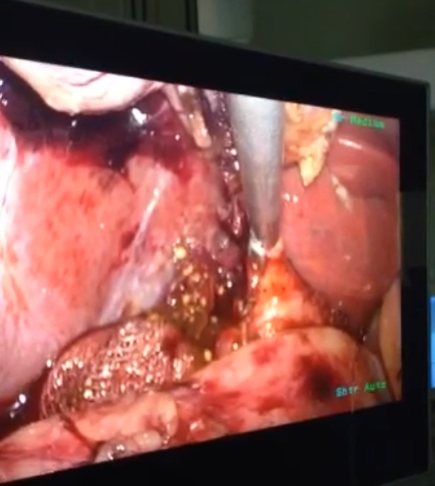 | 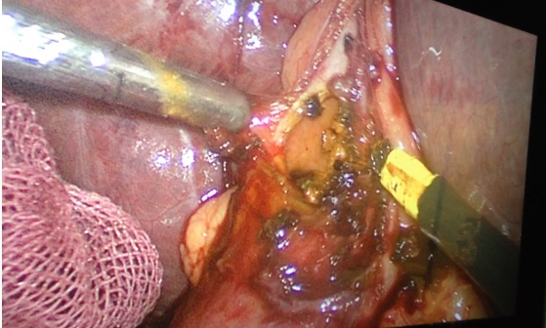
Fig. (1): Intraoperative cholangiography through cystic duct | Fig. (2): Supradudenal choledochotomy
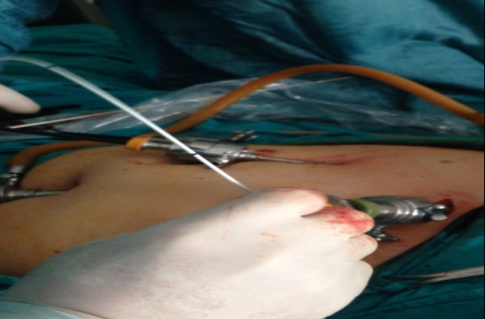 | 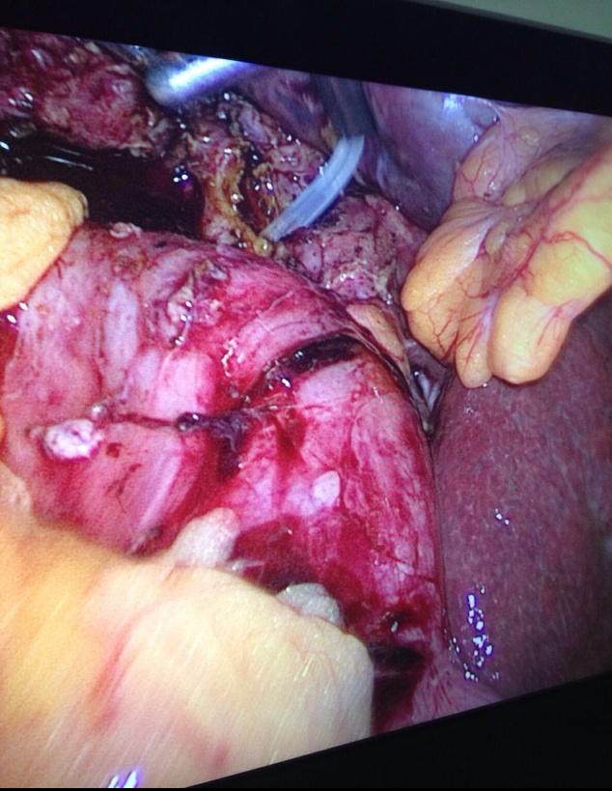
(A) | (B)
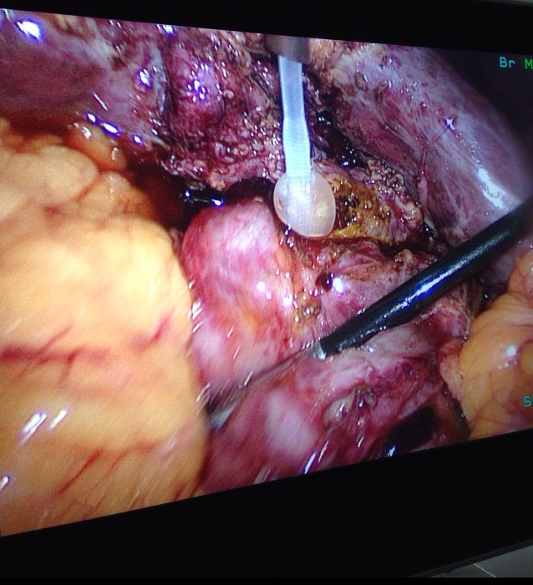
(C)
Fig. (3) (A, B, C): Fogartycatheter for stones extractions

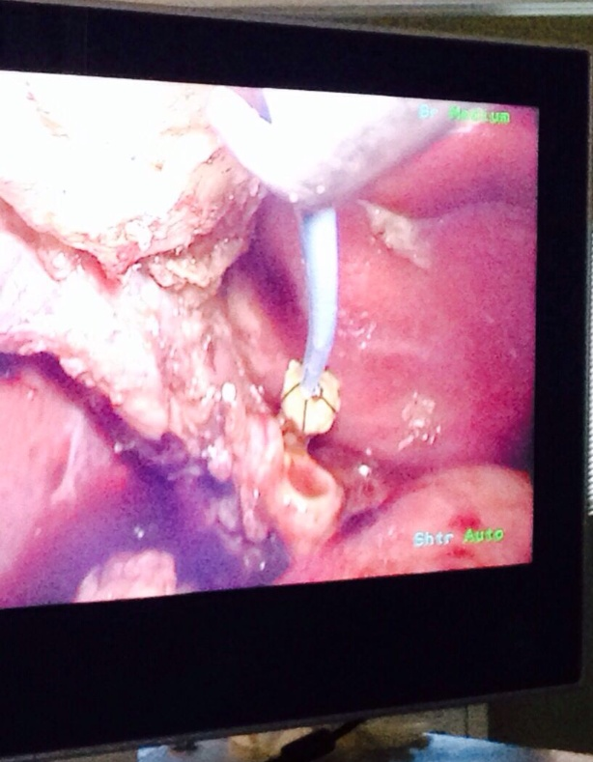 | 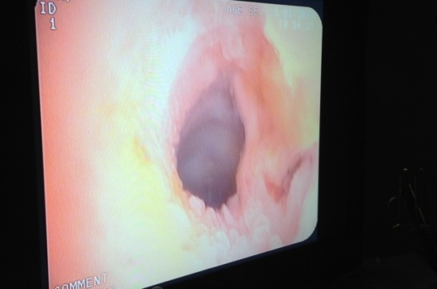
Fig. (4): Dormia basket for stones extractions | Fig. (5): Choledocoscope to detect clearancebefore closure of CBD
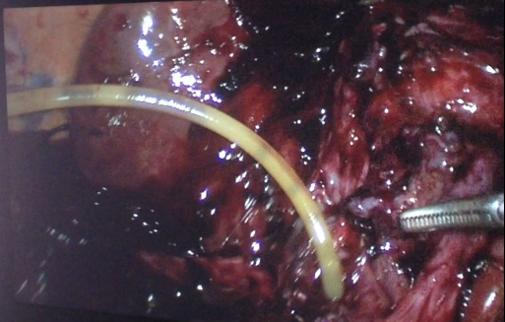 | 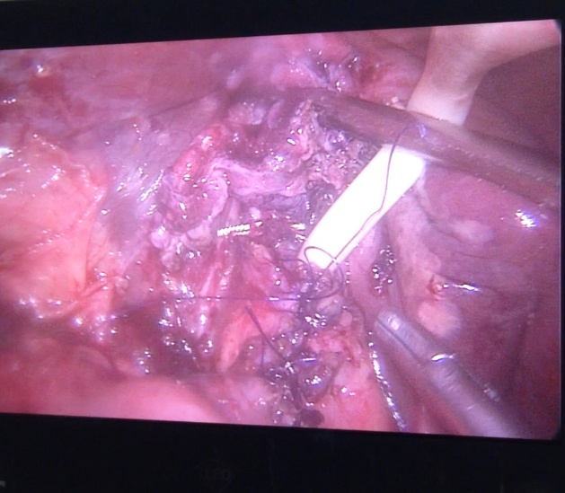
(A) | (B)
Fig. (6) (A, B): Closure of CBD over T tube

3. Results

Table (1): Intra-operative assessment.
 | T tube (group A) | Primary closure (Group B) | P-Value
Operating time mean +SD (minutes) | 153.8 ± 4.49 | 107.2 ± 3.68 | < 0.0001
Number of CBD stones mean + SD | 3.0 ± 0.32 | 3.08 ± 0.38 | 0.8743
CBD stones size mean +SD (mm) | 13.44 ± 0.74 | 13.72 ± 0.6 | 0.7837
Conversion to open | Two case (8%) | Two case (8%) | -
Blood loss mean +SD (ml) | 176.0 ± 14.12 | 154.4 ± 13.86 | 0.2803
Intra-operative bleeding | One case (4%) | - | -

Table (2): Post-operative parameters.
 | T tube (group A) | Primary closure (Group B) | P-Value
Hospital staymean +SD (days) | 11.08 ± 0.30 | 5.0 ± 0.42 | < 0.0001
Residual stones | 1(4%) | 3(12%) | -
Bile leak | 2 (8%) | 4(16%) | 0.6671
Abdominal collection | 2(8%) | 3(12%) | 1
Wound infection | 1(4%) | 1(4%) | 1

There were no postoperative deaths.Patients had retained or residual calculi one in group A and three in group B. Six cases are complicated with bile leak proved by presence of bile in the drains bags, two casesin group (A) and four cases in group (B).Five cases are complicated with abdominal collection two cases in group (A) and three in group (B). Two cases are complicated with wound infection one in each group.

4. Discussion
The management of CBD stones has gone through various stages of development and innovation, and laparoscopic CBD exploration (LCBDE) is now considered a better procedure than other alternatives with comparable morbidity and mortality and a shorter hospital stay in fit patients (Costi et. al., 2010).
Definitive treatment of patients with CBD stones includes not only cholecystectomy, but also clearance of the entire biliary ductal system. This has presented a technical challenge to the surgeon since the earliest days of biliary tract surgery (Vindal et. al, 2014).
In the early stages, laparoscopic treatment of CBDS was neither feasible nor desirable because the surgeons lacked the necessary skills. As a consequence, a patient with even the slightest suspicion of CBDS underwent preoperative ERCP, thereby resulting in a high number of unnecessary procedures (Fletcher, 1994).
ERCP introduced itself as a minimally invasive procedure for diagnosis and treatment of CBDS, then the patient allowed to laparoscopic cholecystectomy (either two or one stage procedures).The morbidity after ERCP as bleeding, pancreatitis, cholangitis…etc, and also mortality rate are not negligible (Tenconiet. al, 2008).
Treatment of CBD stones by open duct exploration during laparotomy is also fraught with high complication rates and inadequate stone clearance along with considerable postoperative morbidity (Moreaux, 1995).
Laparoscopic exploration of CBD has been developed over the past 2 decades to extract CBDS discovered incidentally during the course of laparoscopic cholecystectomy (Christensen et. al, 2004).
Also with increasing skills, laparoscopic surgeons turned their attention to the CBD. Laparoscopic common bile duct exploration can be technically demanding and may include extensive manipulation of the bile ducts as well as laparoscopic suturing of the CBD (Paganini et. al, 2001). However, over the last decade or so, laparoscopic common bile duct exploration has become the treatment of choice for CBD stones in expert hands due to the various advantages that it offers over the open and the endoscopic methods (Chander et. al, 2011).
Besides Laparoscopic common bile duct exploration is safe and cost effective, it provides a single stage management of gallstones and CBD stones with minimum morbidity and all the advantages of minimal access surgery to the patient (Clayton et. al, 2006).
Because instrumentation of the CBD and maneuvers for stone extraction may cause edema to the papilla, leading to an increase in pressure inside the biliary tree, temporary postoperative biliary drainage is usually required and T-tube placement has been historically chosen as the drainage method of choice. (Paganini et.al, 2001)
Postoperative T-tube drainage has been used to prevent bile stasis, decompress the biliary tree, and minimize the risk of bile leakage, A T-tube has also provided an easy percutaneous access for cholangiography and extraction of retained stones. (Paganini et.al, 2001)
The T tube- related complications include accidental T-tube displacement leading to CBD obstruction, bile leakage, persistent biliary fistulas and excoriation of the skin, cholangitis from exogenous sources through the T-tube, and dehydration and saline depletion, Additionally, CBD stenosis has been reported as a long-term complication after T-tube removal. (Lygidakis,1983)
After discharge, indwelling T-tubes become uncomfortable, requiring continuous management, thus restricting patient activity because of the risk of dislodgement (Gersin and Fanelli D, 1998).
Our parameters were compared with that in the other studies. Our patients were grouped into two groups, (group A; for T tube) and (group B; for primary closure), 25 patients each, the two groups were nearly similar as regard the preoperative parameters as age, sex, incidence of jaundice, CBD diameter and others.
In the study group of 50 patients, there were 25 male patients and 25 female patients. In Group (A) (T-tube drainage) the male: female ratio was 11:14 while in Group (B) (Primary closure) the male: female ratio was 14:11.
In our study, extraction of multiple stones was present in more than half of patients (22 patients in group A and 21 patients in group B). The number of stones extracted in group A was 1-7 stones, their size was 10-20mm (13.44 ± 0.74 mm), while in group B, the number of stones extracted was 1-8, and their size was 9-20mm (13.72 ± 0.68mm). There was no difference between the two groups; these results were compared with a lot of literatures, (El-Geidie, 2010), in their studies on 122 patients also observed that most patients had multiple stones 1-4 in group A (T tube), while in group B (primary closure)1-3with a (p-value0.0812).
In our study four patients (one patient in group A (4%) and three patient in group B (12%), presented with retained stones, were managed by ERCP first, with failure of extraction in two patients only in group B (primary closure). These results were compared with, (El-Geidie, 2010), only one patient in the T-tube group had a retained stone diagnosed by postoperative T-tube cholangiogram and was successfully removed by endoscopic sphincterotomy, and with (Rathore et.al, 2016), two (6.7%) patients In group A (T tube) had residual stones in the T-tube cholangiogram which was managed by saline irrigation via T-tube for three days under antibiotic cover.
In our study six patients (two patient in group A (8%) and four patients in group B (16%), developed postoperative bile leak evident by bile stained drainage in the abdominal drain. One patient in group (A) developed biliary peritonitis on the second and third post operative daydue to T tube dislodgement and was treated by laparotomy, peritoneal lavage and T tube replacement on third post operative day, second patient in group (A) due to retained stone and was treated by ERCP.
in primary closure group (B) one patient were managed conservatively and management included anti-spasmodic measures as we suspected the cause of leak might be the spasm of sphincter of Oddi with stoppage of leakage after 4 days, another Three patients in group (B), due to retained stones were managed by ERCP first, one of them was successfully removed by endoscopic sphinctrotomy, two of them required re exploration due to failure of extraction of stones by ERCP, These results were compared with, (Shakya et al., 2017), patients of Group B (primary closure) 1 patient suffered bile leakage that subsided on the third postoperative day. No biliary peritonitis was observed. While in Group A (T-tube drainage), biliary leakage occurred after the removal of T- tube in a total of 3 patients, which was managed by ultrasound guided aspiration, and with (Rathore AK et al.,2016), one case (3.3%) in group B (primary closure) developed biliary leakage which was managed by keepingsub-hepatic drain for 5 days.
In our study five patients (two patients in group A (8%) and three patients in group B (12%) developed post operativeabdominalcollection, patients in group (A) one of them were managed by pigtail insersion, another patients was managed by exploration and Ttube replacement due to T tube dislodgement. Patients in group (B) one of them managed by pig tail insersion, another two patients required re exploration with T tube insersion.
In our study four cases, two in each group were converted from laparoscopic to open procedures, this was attributed to bleeding and severe adhesion with unclear anatomy, bleeding was controlled in the one case by Pringle maneuver, compression and electrocautery.
In our study two patients (one patient in group A (4%) and one patient in group B (4%), developed post operative wound infection, the infection was superficial and treated by antibiotic and local dressing. These study were compared with (Rathore AK et al.,2016), two patients (6.7%) developed wound infection, The infection in all casestreated by antibiotics.
The average postoperative hospital stay in our study was 11.08 ± 0.30 (9-15 days) for group A (T tube) and 5.0 ± 0.42 (2-10 days) for group B (primary closure) (P value< 0.0001). These results were compared with, (Shakya JPS et al.,2017), The total duration of hospital stay in Group B (primary closure)patients ranged from 5-15 days with an average duration of 8.2 days which was much shorter than that of Group A (T-tube drainage) patients which ranged from 8 to 25 days with average of 15.7 days, (El-Geidie, 2010), The total duration of hospital stay in Group A (T-tube drainage) patients ranged from (4–11.25) days with an average duration of 5.5 days which was much longer than that of Group B (primary closure), patients which ranged from (1–5)days with average of 2.2 days (p value 0.005), (Rathore K et al.,2016), the average duration of hospital stay In group B (primary closure) was 8.2 days (ranging 5-15 days) and in group A (T tube), the average hospital stay was 15.7 days (ranging from 8-25 days),These values were statistically significant, andwith (Sun etal.,2011), The length of postoperative hospital stay was shorter in group B (primary closure) (3.1 ± 2.4 days) than in group A (T tube) (5.7 ± 4.3 days) (P value<0.05).

5. Conclusion
Both primary closure of CBD and T-tube drainage after CBD exploration are equally good procedures for the treatment of uncomplicated choledocholithiasis. However, primary closure of CBD is having significantly lower operating time and less duration of stay at hospital. Therefore, it can be recommended for treatment in selective patients of choledocholithiasis.

References
- Chander J, Vindal A, Lal P, et al. Laparoscopic management of CBD stones: an Indian experience. Surg Endosc, 2012; 25: 172 -181.
- Christensen M, Matzen P, Schulze S and Rosenberg J. “Complications of ERCP: a prospective study,” Gastrointestinal Endoscopy, 2004; 60(5): 721–731.
- Clayton ES, Connor S, Alexakis N, Leandros E. Metaanalysis of endoscopy and surgery versus surgery alone for common bile duct stones with the gallbladder in situ. Br J Surg, 2006; 93:1185–1191.
- Costi R, Mazzeo A, Tartamella F, Manceau C, Vacher B, Valverde A. Cholecystocholedocholithiasis: a case–control study comparing the short-and long-term outcomes for a ‘‘laparoscopy first’’ attitude with the outcome for sequential treatment (systematic endoscopic sphincterotomy followed by laparoscopic cholecystectomy). Surg Endosc, 2010; 24:51– 62.
- El-Geidie AAR. Is the Use of T-tube Necessary after Laparoscopic Choledochotomy? J Gastrointest Surg (2010) 14:844–848.
- Fletcher DR. Changes in the practice of biliary surgery and ERCP during the introduction of laparoscopic cholecystectomy to Australia: their possible significance. Aust N Z J Surg, 1994; 64:75–80.
- Fried Gerald M., Lorenzo E. Ferri and Katherine E. H, 2009.“V - Diseases of the Liver and Biliary Tract, chapter 32, Laparoscopic Cholecystectomy, in Mastery of Endoscopic and Laparoscopic Surgery; Edited by Soper, Nathaniel J. and Swanstrom et al, 3rd Edition, by Lippincott Williams & Wilkins.
- Gersin KS, Fanelli RD. Laparoscopic endobiliary stenting as an adjunct to common bile duct exploration. Surg Endosc 1998;12:301–304.
- Gupta N. Role of laparoscopic common bile duct exploration in the management of choledocholithiasis. World J Gastrointest Surg. 2016; 8(5):376–81.
- Gurusamy KS and Samraj K. Primary closure versus T-tube drainage after open common bile duct exploration. Cochrane Database Syst Rev, 2007a; 24 (1): CD005640.
- Khan M, Quadri SJF, Nazir SS. Use of Rigid Nephroscope for Laparoscopic Common Bile duct Exploration-A Single-Center Experience. World J Surg. 2010; 34:784-90.
- Kharbutli B and Velanovich V. Management of preoperatively suspected choledocholithiasis: adecision analysis,” J Gastrointest Surg.2008; 12:1973-80.
- Ko C. and Lee S. Epidemiology and natural history of common bile duct stones and prediction of disease. Gastrointest Endosc.2002;56:S165.
- Ko CW, Murakami C, Sekijima JH, et al. Chemical composition of gallbladder sludge in patients after marrow transplantation. Am J Gastroenterol, 1996; 91:1207–10.
- Lyass S and Phillips H. Laparoscopic trascystic duct common bile duct exploration. Surg. Endosc. 2006; 20:441-445.
- Lygidakis NJ. Choledochotomy for biliary lithiasis: T-tube drainage or primary closure. Effect on postoperative bacteremia and T-tube bile infection. Am J Surg 1983;146:254–256.
- Martin CJ, Cox MR, Vaccaro L. Laparoscopic transcystic bile duct stenting in the management of common bile duct stones. Anz J. Surg. 2002;72:252–3.
- Moreaux J. Traditional surgical management of common bile duct stones: a prospective study during a 20-year experience. Am J Surg, 1995; 169:220–226.
- Paganini AM, Feliciotti F, Guerrieri M, Tamburini A, De Sanctis A, Campagnacci R, Lezoche E. Laparoscopic common bile duct exploration. J Laparoendosc Adv Surg Tech A, 2001; 11:391–400.
- Rathore AK, Gupta R, Vishal K, et al. Primary closure after common bile duct exploration versus T-tube drainage: a prospective randomized study and review of literature. Int Surg J. 2016 Aug;3(3):1368-1371.
- Schirmer B, Winters KL, and Edlich RF. Cholelithiasis and cholecystitis, Journal of Long-Term Effects of Medical Implants. 2005; vol. 15, no. 3, pp. 329–338.
- Shakya JPS. Primary closure versus T-tube drainage after laparoscopic choledocholithotomy: a prospective randomized study. Int Surg J. 2017, May;4(5):1762-1764.
- Sun D, Cai H, Sun Y, Bai J, Zhao H, Miao Y. Primary closure following laparoscopic common bile duct exploration combined with intraoperative cholangiography and choledochoscopy. World J Surg. 2012;36:164 –170.
- Tenconi SM, Boni L, Colombo EM, et al. Laparoscopic cholecystectomy as daysurgery procedure: current indications and patients’ selection. Int J Surg 6(1), 2008; S86-S88.
- Vindal A, Chader J, Lal P, et al. Comparison between intraoperative cholangiography and choledochoscopy for ductal clearance in laparoscopic CBD exploration: a prospective randomized study. Surg Endosc. Published online 26 Aug 2014: DOI 10.1007/s00464-014-3766-5.
- Williamson. General Surgical Operations (R. M. Kirk), 4th ed.: Open biliary operations, 2000; Vol. 1Ch.20: p. 375–96.
- Zhang WJ, Xu GF, Wu GZ, Li JM, Dong ZT, Mo XD. Laparoscopic exploration of common bile duct with primary closure versus T-tube drainage: a randomized clinical trial. J Surg Res. 2009; 157:e1-5.

10/5/2019

