Role of diffusion weighted MRI in early detection and staging of rectal cancer

Fathy Hussein Ali¹; Ahmed Abdelsamie Mahmoud²; Fadila Mamdouh ELsayed³; Lamiaa Raafat Elsayed⁴

¹Professor of Radiodiagnosis Department, Faculty of Medicine (For Girls), Al-Azhar University, Cairo, Egypt
²Assistant professor of Radiodiagnosis Department, Theodor Bilharz Research Institute, Egypt
³Assistant professor of Radiodiagnosis Department, Faculty of Medicine (For Girls), Al-Azhar University, Cairo, Egypt
⁴Assistant Lecturer of Radiodiagnosis Department, Theodor Bilharz Research Institute, Egypt
Email: dr.lamia_lamia@yahoo.com

Abstract: Background: Magnetic resonance imaging has become the most accurate non invasive technique in preoperative local staging of rectal carcinoma (T and N stages), and in evaluating mesorectal fascia involvement. Aim of the work: Was to assess the added role of diffusion-weighted imaging to conventional MRI in preoperative staging of rectal cancer. Materials and Methods: Fifty patients with pathologically proven rectal carcinoma underwent pelvic MRI on a 1.5 T magnet using pelvic phased array coil with IV gadolinium and transrectal gel administration. 30 patients were operated upon and their postoperative specimens’ pathology was compared with preoperative MRI results. Results: We found that combination between DWI with conventional MRI increased the accuracy in assessment of different stages of rectal cancer. Comparable to histopathological examination, MRI correctly diagnosed 27 patients out of 30 regarding different T stages (accuracy 94.3%), 21 patients out of 30 in different N stages (accuracy 87.8%) and 28 patients out of 30 in CRM status assessment (accuracy 93%). Conclusion: Addition of DWI to conventional MRI raises its accuracy in TN staging as well as CRM status assessment.

[Fathy Hussein Ali; Ahmed Abdelsamie Mahmoud; Fadila Mamdouh ELsayed; Lamiaa Raafat Elsayed. Role of diffusion weighted MRI in early detection and staging of rectal cancer. Researcher 2019;11(9):41-47]. ISSN 1553-9865 (print); ISSN 2163-8950 (online). http://www.sciencepub.net/researcher. 6. doi:10.7537/marsrsj110919.06.

Keywords: MRI, diffusion-weighted imaging, apparent diffusion coefftcient, pathology, staging, rectal cancer, prognosis.

1. Introduction
Colorectal cancer is the second most common cancer in females and third most common cancer in males worldwide. In recent years, mortality rates have decreased due to significant changes in therapeutic management, in particular the standardization of the operative procedure and more important accurate pre-operative strategy depending on imaging [1].
Preoperative imaging for rectal carcinoma staging is useful to choose which surgical technique is more appropriate. Ideal imaging modality should accurately assess the depth of tumor penetration (T), lymph node involvement (N), presence of distant metastatic disease (M), mesorectal fascia involvement, CRM status and anal sphincter involvement which affect the prognosis of rectal cancer [2].
MRI is currently one of the most accurate noninvasive modalities for staging rectal carcinoma. The introduction of phased-array coil and the development of T2-weighted fast-spin sequences have enabled accurate determination of prognostic factors and anatomic assessment of the pelvis by delineating rectal tumors through increases in spatial and contrast resolution [3].
Recently diffusion weighted imaging (DWI) is increasingly incorporated into standard magnetic resonance imaging (MRI) protocols for tumor imaging due to its ability to detect and characterize tumors. Moreover, when the DWI is co-registered with conventional MRI, the TN staging as well as the MRF status can be performed with high accuracy [4].

2. Materials and Methods
This study was done between July 2017 and June 2019 at the National Cancer Institute in Cairo and some private centers including fifty patients with adenocarcinoma of the rectum on the basis of their colonoscopic findings and the pathologic features of the biopsy specimen. All patients were pre-operatively staged with MRI scan performed on a 1.5T magnet (Philips Achieva) using pelvic phased array coil. After total mesorectal excision in 30 patients; the extent of local tumor staging was histopathologically assessed according to TNM system.
Inclusion criteria:
- Histologically (biopsy) proven rectal carcinoma.
- Underwent conventional high-resolution rectal MRI with DWI sequence.
- Treatment plan by surgical resection except those who required neoadjuvant therapy.
- Availability of pathological reports of surgical specimens.
Exclusion criteria:
- Pathologically proven as not rectal carcinoma.
- Neoadjuvant therapy was administered before MR examination.
- Lack of pathology results.
- Recurrent carcinoma.
- The tumor did not have a sufficiently large parenchyma area for selecting ROIs.
Magnetic resonance imaging
Pelvic MRI was performed on a 1.5 T magnet (Philips Acheiva) with pelvic phased array coil and rectal gel administration.
The MRI protocol was T1 in the axial plane, T2 in the axial, coronal, and sagittal planes, and T1 postcontrast fat saturation in the axial, coronal, and sagittal planes. Diffusion-weighted MRI was performed for T staging, lymph node staging, evaluation of mesorectal fat invasion, evaluation of mesorectal fascia invasion, and assessment of CRM. Mean ADC values were calculated for each case.
The criteria for MRI interpretation were as follows:
T staging interpretations
• T1 was staged if the tumor was confined to the mucosal layer of the rectal wall.
• T2wasstaged if there was invasion of the rectal layer up to the muscularis propria, with no penetration of the muscularis propria or perirectal fat.
• T3 was staged if there was invasion of all rectal layers with perirectal fat infiltration yet without pelvic organ involvement.
• T4 was staged if there was invasion of mesorectal fascia and visceral peritoneum or surrounding organ infiltration.
Lymph node staging interpretations
• N0 was diagnosed if there was no lymph node metastasis.
•N1 was diagnosed if there was metastasis in one to three lymph nodes.
• N2 was diagnosed if there was metastasis in four or more perirectal lymph nodes.
Circumferential resection margin interpretations:
CRM is the distance between the outer margin of the tumor and the mesorectal fascia. It is critical for surgical planning, and for determining potential recurrence after total mesorectal excision. An involved CRM was considered if the shortest distance from either the extramural tumor extension, a suspected lymph node, or a tumor deposit in the mesorectum, to the mesorectal fascia was ⩽1 mm.
30 cases out of 50 were operated upon usually within 1 month from the last MRI and the postoperative specimens pathology results were compared with preoperative MRI reports.
Statistical analysis:
Data were statistically described in terms of mean ± SD, median and range, or frequencies (number of cases) and percentages when appropriate. Accuracy was represented using the terms sensitivity, specificity and overall accuracy. P-values less than 0.05 were considered as statistically significant.

3. Results
This study included 50 patients, their age ranged from 21 to 82 years with the mean age 51 years. They were 29 females and 21 males. The patients’ ages ranged from 20 to 69 years (mean age of 41.9 years). There were 21 (42%) men and 16 (58%) women. All 50 patients had preoperative pathologically proven rectal carcinoma of two pathological types; mucinous adenocarcinoma found in 11 patients (22%) and non mucinous adenocarcinoma found in 39 patients (78%).
Rectal tumors were located at different sites of the rectum and were more common at the lower third of the rectum in 16 patients (32%), as shown in Table 1.

Table (1): Location of the rectallesions and the number of cases at the affected site.
Tumorlocation | No. of cases | Percentage
Upper third of the rectum | 2 | 4%
Middle 1/3 of the rectum | 2 | 4%
lower 1/3 of the rectum | 16 | 32%
Upper and middle 2/3 of the rectum | 9 | 18%
Middle and lower 2/3 of the rectum | 8 | 16%
Whole rectal length | 13 | 26%
Total | 50 | 100%

Out of 50 patients 8 were staged as T2, 24 as T3 and the remaining 18 were considered to be T4, 5 patients were staged as N0 while 45 had positive nodal disease (N1 & N2). The CRM was free in 21 patients and involved by tumor in the remaining 29 as shown in Table 2.

Table (2): MRI and Histopathological Findings.
 |  | Count | Percentage
 |  | 50 | 100%
CRM | +ve | 29 | 58%
 | -ve | 21 | 42%
Lymph nodes Involvement | Yes | 45 | 90%
 | No | 5 | 10%
T Stage | T2 | 8 | 16%
 | T3 | 24 | 48%
 | T4 | 18 | 36%

30 patients out of 50 have been operated and post operative pathological results were correlated with preoperative MRI staging.
T staging:
27 out of 30 patients diagnosed by MRI their results were comparable to histopathological examination in different T stages with sensitivity, specificty and accurcy 94 %, 94% and 94.3% respectively ( p value = < 0.001 ) as shown in Figure 1.

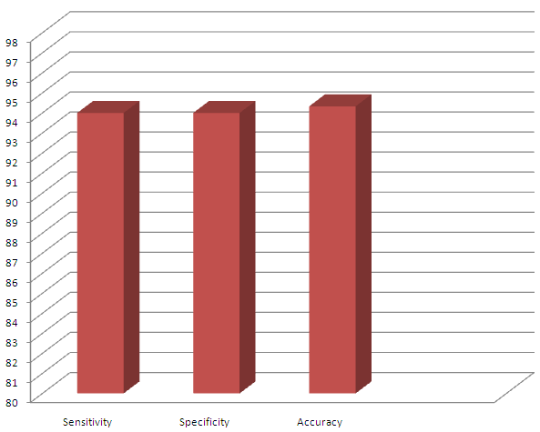
Figure (1): Column chart showing Sensitivity, specificity and accuracy in evaluation of T staging in correlation to the histopathological examination.

N stage:
21 patients out of 30 diagnosed by MRI their results were comparable to histopathological examination in different N stages with sensitivity, specificity and accuracy of lymph nodes involvement were 95.8 %, 84.8%, 87.8% respectively ( p value = < 0.001) as shown in Figure (2)

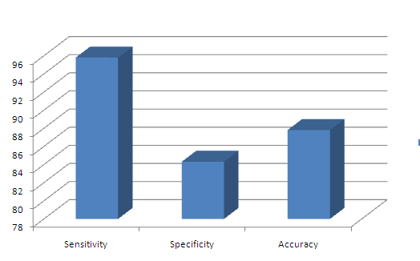
Figure (2): Column chart showing Sensitivity, specificity and accuracyin evaluationof N staging in correlation to thehistopathological examination.

CRM status:
28 patients out of 30 diagnosed by MRI their results was comparable with histopathological examination in CRM status assessment with sensitivity, specificity and accuracy100 %, 87.5%, 93% respectively (p value = < 0.001) Figure 3.

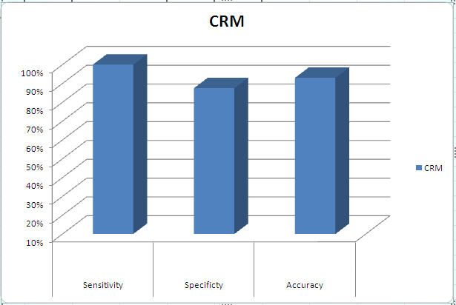
Figure (3): Column chart showing Sensitivity, specificity and accuracy in evaluationof CRM involvementin correlationto the histopathological examination.

Case 1
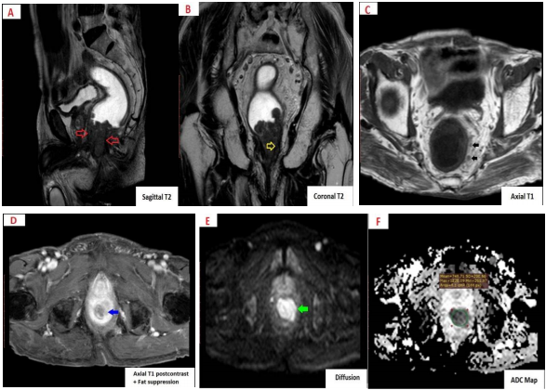
Figure (4):82 - year - old male patient pathologically proven adenocarcinoma grade II, staged by both MRI and histopathology as T2 N1, MRF –ve: (A) Sagittal T2 shows a no-rectal soft tissue mass is seen involving the lower 1/3 of the rectum & compromising the anal & rectal lumens, it is seen measuring 3.7 cm in its maximum thickness with cranial extension for a distance of about 6.4 from the anal verge (red arrows). (B): Coronal T2 shows involvement of internal anal sphincter on the left side with extension into the intersphintric plane (Yellow arrow). (C): Axial T1 shows few tiny perirectal lymph nodes (black arrows). (D): Axial T1 postcontrast + fat suppression shows avidly enhancing anal mass with involvement of the internal anal sphincter on the left side with extension into the intersphintric plane (blue arrow).: (E) This anal mass shows diffusion restriction (green arrow). (F) The anal mass shows ADC value of 0.748 x 10-3 mm2/sec (green circle).
Case 2
Figure (5): A 31-year- old male patient pathologically proven to has grade II adenocarcinoma staged as T3 N2, MRF +ve by both MRI and Histopathplogy.: (A): Sagittal T2 shows mid & upper rectal irregular circumferential mural thickening with large soft tissue mass lesion arising from posterior rectal mucosa markedly compromising the lumen, it starts about 7 cm from the anal verge reaching to 5 cm in maximal thickness with cranial extension for a distance of about 10 cm (white arrow heads). (B): Axial T2 shows haziness of the serosal outline along left side with linear strandings reaching to the MRF (red arrow ) which is seen also invaded by a lymph node with spiculated margin, the distance between the LN & MRF is less than 1 mm resulting in +ve CRM ( yellow arrow (C): Axial T1 post contrast + fat suppression shows avidly enhancing mass with serosal invasion along left side with trans serosal spread reaching to the MRF ( black arrow heads) as well as invasion of MRF by lymph node (orange arrow). (D): Coronal T1 shows multiple tiny perirectal lymph nodes (blue arrows). (E): This rectal mass shows diffusion restriction (green arrow). (F): The anal mass shows ADC value of 0.814 x 10-3 mm2/sec (green circle in F).

Case 3
Figure (6): A 49 -year- old female pathologically proven to have adenocarcinoma GII, staged by MRI and histopathology as T4 N1, MRF +ve: (A) Sagittal T2 shows irregular circumferential constrictive mural thickening of the middle rectum starting 7 cm from the anal verge with maximum thickness measuring 1.5 cm (white arrows) and seen infiltrating posterior cervical wall (yellow arrow). (B:) Axial T2 shows hazy serosal outline with spiculations invading through mesorectal fat (red arrows), one of them is seen invading of posterior cervical wall (orange arrow) with subsequent invasion of the MRF. (C): Axial T1 shows few small perirectal lymph nodes (blue arrow). (D): Axial T1 postcontrast + fat suppression shows heterogeneously enhancing mucosal thickening with hazy serosal outline with spiculations invading through mesorectal fat (black arrows ) and one of them is seen invading posterior cervical wall (pink arrow ) as well as MRF (E): This rectal constrictive mucosal thickening shows diffusion facilitation (green arrow). (F): This rectal constrictive mucosal thickening shows ADC value of 1.114 x 10-3 mm²/sec (green circle in F).

4. Discussion
Colorectal cancer is considered the second most common cancer in females and third most common cancer in males worldwide [1].
The prognosis of rectal cancer is closely related to its stageat the time of diagnosis, so appropriatetreatment decisions require knowledge of theexact stage of th tumor, accurate radiologic T staging (depth of cancer invasion) and N staging (lymph node metastasis) [5].
The major aim of the present study was to determine the role of MRI in preoperative local staging of colorectal. Our study was conducted on 50 patients pathologically proven to have rectal cancer, their age ranged from 21 to 82 years with the mean age 51 years. They were 29 females and 21 males, all of them underwent rectal preoperative MRI assessment with special focus on evaluating the role of DWI in local staging and assessing aggressiveness of this malignancy.
Regarding the pathological types, Out of the 50 patients,11 patients were mucinous adenocarcinoma (22%) and 39 patients were non mucinous adenocarcinoma (78%) this agrees with Veruttipong et al. [6] and Abd El-Kader et al [7] who reported that the percentage of mucinous adenocarcinoma was present in 23.3% and 20% respectively.
In our study, we were in agreement with Kaur et al [8] in using pelvic phased array coil with administration of endorectal warm gel to distend the involved rectal lumen ministration of with I.V. MR Contrast material with a bolus dose of 0.1 mmol of gadolinium per kilogram of bodyweight to enhance tissue contrast.
30 patients out of 50 have been operated and post operative pathological results were correlated with preoperative MRI staging.
Regarding T staging on MRI, 27 patients out of 30 their results were comparable with histopathological examination in different T stages with sensitivity, specificity and accuracy 94 %, 94% and 94.3% respectively. these results agreed with Teama et al [5] reported that MRI has sensitivity (91.7%), specificity (100%) and accuracy (93%) in T staging of rectal cancer.
Our study also shows no significant changes in comparison to Zhang et al [9] (specificity100% and accuracy 92.1) and Mercury group [10] (specificity 92%).
There is little difference with Iannicelli et al [11] who studied 44 patients with primary rectal cancer who underwent high-resolution MRI without DWI, the study performed before surgery then MRI results were compared to post histopathological findings which showed overall accuracy 86.4%.
Regarding N staging, 21 patients out of 30 diagnosed by MRI their results was comparable with histopathological examination in different N stages with sensitivity, specificity and accuracy of lymph nodes involvementwere95.8 %, 84.8%, 87.8%respectively. This agrees with Abd El Samei et al [12] with the sensitivity, specificity, and accuracy were 88.89, 94.74, and 91.89% respectively, and also agrees with Teama et al [5] with sensitivity, specificity and accuracy of lymph nodes involvement were 95%, 88%, and 91% respectively.
The study disagrees with the findings of Arya et al [13] with sensitivity of 77% and a specificity of 71%. This difference might be due to the fact that, in our study we depend mainly on morphological criteria of the lymph nodes, diffusion pattern and its ADC value and considering the lymphnodesize significant even if it small up to 5mm. but Arya et al [13] depended in their study on heterogeneity of signal intensity on T2W sequences and irregular margins.
Features that are suggestive of malignancy include irregular or speculated nodal margins and heterogenous signal intensity, in addition to the restricted diffusion pattern of the involved node. The evaluation of these features requires high-resolution images that cover all nodes of importance, including superior rectal and pelvic sidewall adenopathy [9].
As regards the assessment of CRM status, 28 patients out of 30 diagnosed by MRI their results was comparable with histopathological examination in CRM status assessment with sensitivity, specificity and accuracy of lymph nodes involvementwere100 %, 87.5%, 93% respectively which agrees with the findings of Iannicelli et al. [11], who reported sensitivity, specificity, and overall accuracy of 89.5, 96.3, and 94.5%, respectively.
Mercury group [10] also reported that high resolution MR imaging is a reliable technique predicting the relationship of the tumor to the CRM with no significant changes with our study (specificity 92%), also Zhang et al [9], reported (specificity100% and accuracy 92.1).

Conclusion:
In our study we concluded that DWI MRI is a highly accurate noninvasive diagnostic modality for preoperative local staging of rectal carcinoma (T and N stages) as well as for determining the extent of mesorectal fascia involvement.

References
- Gürses B, Böge M, Altınmakas E, Balık E. Multiparametric (2019): MRI in rectal cancer. Diagn Interv Radiol.;25(3):175–182.
- Nougaret S, Rouanet P, Molinari N et al. (2012): MR volumetric measurement of low rectal cancer helps predict tumor response and outcome after combined chemotherapy and radiation therapy. Radiology, 263:409–418.
- Horvat N, Carlos Tavares Rocha C, Clemente Oliveira B, Petkovska I, Gollub MJ. MRI of Rectal Cancer (2019): Tumor Staging, Imaging Techniques, and Management. MJ1 Radiographics; 39(2):367-387.
- Schurink NW, Lambregts DM. J, Beets-Tan RG. H (2019). Diffusion-weighted imaging in rectal cancer: current applications and future perspectives. Br J Radiol; 92: 20180655.
- Teama AH, Alarabawy R A, Mohamed H A, Eissa HH (2015): Role of magnetic resonance imaging in assessment of rectal neoplasms, The Egyptian Journal of Radiology and Nuclear Medicine, Volume 46, Issue 4, Pages 833-846.
- Veruttipong D, Soliman AS, Gilbert SF, Blachley TS, Hablas A, Ramadan M, Rozek LS, Seifeldin IA (2012). Age distribution, polyps and rectal cancer in the Egyptian population-based cancer registry. World J Gastroenterol.; 18(30):3997-4003.
- Abd El-Kader M U, Hussein RS, El-Gendy WM, Abd El-Hamid HA (2018): DWI in Assessing Aggressiveness of Rectal Cancer The Egyptian Journal of Hospital Medicine, Vol. 70 (7), Page 1381-1387.
- Kaur H, Choi H, You YN, et al (2012). MR imaging for preoperative evaluation of primary rectal cancer: Practical considerations. Radiographics; RSNA;32:389–409.
- Zhang XM, Zhang HL, Yu D, Dai Y, Bi D, Prince MR, Li C. 3-T MRI of rectal carcinoma: preoperative diagnosis, staging, and planning of sphincter-sparing surgery. Am J Roentgenol 2008; 190:1271–1278.
- Mercury Study Group (2007). Extramural depth of tumor invasion at thin section. MR in patients with rectal cancer: results of the MERCURY study. Radiology;243(1):132–9.
- Iannicelli E, Di Renzo S, Ferri M,. (2014): Accuracy of high-resolution MRI with lumen distention in rectal cancer staging and circumferential margin involvement prediction. Korean J Radiol.;15(1):37–44.
- Abd El Samei R A, Abdullah M S, El-Kholy MR (2018): Preoperative MRI evaluation of mesorectum in cases of rectal carcinoma30 (1 ): 122-127.
- Arya S, Das D, Engineer R, Saklani A. (2015). Imaging in rectal cancer with emphasis on local staging with MRI Indian J Radiol Imaging; 25:148.

9/5/2019

