**Analysis of Mathematical Model of Bessel Beamformer and LMS Algorithm for Smart Antenna Array System**

M Yasin, Pervez Akhtar

National University of Sciences and Technology, Islamabad, Pakistan

[myasin@pnec.edu.pk](mailto:myasin@pnec.edu.pk)

**Abstract:** In this article, we analyzed the mathematical model of Bessel beamformer with least mean square (LMS) beamforming algorithm along with its efficiency in terms of directive gain, minimum mean square error (MMSE), angular resolution and convergence rate in presence of one desired user and two interferers operating with same carrier frequency but in different direction. Based on simulation results, Bessel beamformer provides cost effective solution with 2 dB improvements in terms of gain by suppressing interference, almost zero minimum MSE as compared to LMS (3.7*), -40 dB null depth performance, 60 dB angular resolution with respect to LMS (70 dB) when spacing between elements is taken as 0.25λ. Bessel beamformer can accommodate more users in real time base stations of mobile communication system when employ in smart antenna array system.

[M Yasin, Pervez Akhtar. **Analysis of Mathematical Model of Bessel Beamformer and LMS Algorithm for Smart Antenna Array System.** *Researcher* 2019;11(8):74-81]. ISSN 1553-9865 (print); ISSN 2163-8950 (online). <http://www.sciencepub.net/researcher>. 10. doi:[10.7537/marsrsj110819.10](http://www.dx.doi.org/10.7537/marsrsj110819.10).

**Keywords:** Smart antenna array system; Bessel beamformer; LMS algorithm

**1. Introduction**

It is usually considered that Bessel functions are only useful for the solution of partial differential equations [B.G. Korenev 2002] whereas the application of Bessel functions is many more to solve the real world problems such as in signal processing its utility is not limited to FM synthesis, sampling, Kaiser window, Bessel filter but also in other areas of engineering sciences includes propagation of electromagnetic waves in waveguides, acoustical vibration etc. Bessel beamformer [M Yasin et al. 2010] is based on Bessel functions which are usually known as cylinder functions, or occasionally, functions of Fourier-Bessel. A Fourier-Bessel (FB) function generates FB series which converges absolutely [G. N. Watson 1995]. In [Smith, L.M. 2009], a method is presented for generating a maximally-flat chirp signal whose discrete values of samples are calculated using the nth-order Bessel function at a fixed argument and the utility of these signals is demonstrated by their application to the spectral analysis of audio systems. In [Nikolaos E. Myridis et al. 2001], a theorem based on the nth order FB series expansion using Bessel function is developed which can be employed in diverse areas of signal processing, information representation, communications system. Coding of speech signals using Bessel functions as orthogonal signals in the FB expansion has been explored in [K. Gopalan 2001] and it is found that speech quality and the bit rate increase when higher number of FB coefficients is used. In [D. Saxena et al. 2002], frequency modulation (FM) signals using the Bessel function have been analyzed in order to determine the amplitudes of the available sidebands and thereby the bandwidth. It is extremely useful for efficient FM transmission as employed in mobile and other commercial communication services. In [Elisabet Tiana Roig 2009], a problem of practical interest is addressed for outdoor acoustic measurements to estimate the noise contributions from different directions around the measurement point by means of microphone/circular arrays using Bessel and Neumann functions in combination with proper signal processing techniques. In [T. D. Abhayapala 2008], a generalized framework to decompose a sourcefield into its spatial and frequency components using a spherical microphone array employing spherical Bessel functions. A new method for time-frequency representation (TFR), which combines the FB transform and the Wigner-Ville distribution (WVD), is presented in [Ram Bilas Pachori et al. 2006]. In this FB transform decomposes a multi-component signal into a number of mono-component signals, and then the WVD technique is applied on each component of the composite signal to analyze its time-frequency distribution (TFD). A particular application where this method will be useful is speech analysis, because speech can be modeled as a sum of AM and FM signals corresponding to formant frequencies. One of the main objectives of this method in the analysis of speech signals is to estimate the formant frequencies. This method is more advantageous over the technique based on the filter bank approach [M. J. Narasimha et al. 2002], because here, there is no need of any prior information about the frequency-band of the signal. Whereas utilizing the spherical Bessel functions for pattern synthesis of linear antennas [Hsien-Peng Chang et al. 2000], which leads to antenna current distribution by the Legendre polynomials of the first kind as, they are easy to compute numerically.

In case [M Yasin et al. 2010], the researchers have used Bessel functions of the first kind in order to compute adaptive weights so that it minimizes the cost function for spatial filtering i.e. beamforming [M Yasin et al. 2011, S.F. Shaukat et al. 2009, Raja Muhammad Asif Zahoor et al. 2009].

This research is the extension of previous work reported in [M Yasin et al. 2010], whereas in the present study we investigate its complete mathematical model and compared with LMS for its efficiency in terms of directive gain, MMSE, angular resolution and convergence rate in a scenario of one desired user and two interferers operating with same carrier frequency but in different direction.

The next section describes the material and methods. Section 3 displays simulation results. Section 4 includes discussions. Finally, section 5 concludes the paper.

**2. Material and Methods**

Smart antenna array system consists of number of elements, having uniform distance between each two elements and equipped with digital signal processor containing adaptive beamforming algorithms i.e. Bessel beamformer and LMS as shown in Figure 1.

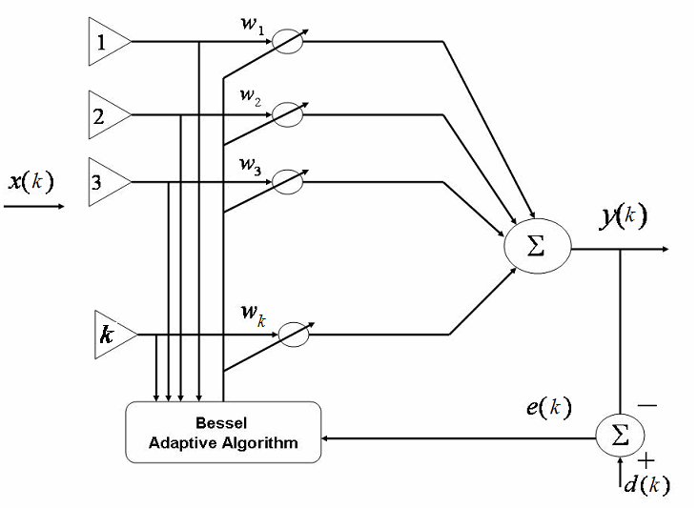

Figure 1. Smart adaptive antenna array system

These adaptive beamforming algorithms are used to update the weights dynamically so that mean square error is reduced and signal to noise ratio (SNR) of the desired signal is optimized. Smart antenna array system is the combination of adaptive signal processor and antenna array system as said before is used for achieving optimum gain. The proposed algorithm is based on the Bessel function of the first kind [John G. Proakis et al. 2009, J. Schroeder 1993] and provides computationally efficient adaptive weights calculation [M Yasin et al. 2010]. This is used for implementation of Beamforming therefore it is named as Bessel beamformer. The proposed algorithm finds the minimum of MSE and thus yields the set of optimum weights of the beamformer.

## 2.1. Bessel Beamformer

The proposed algorithm finds the minimum of MSE and thus yields the set of optimum weights of the beamformer. Now consider a linear Bessel beamformer using multiple inputs at its array’s elements as shown in Fig. 1 then its output will be



The expression  means that an outer product which yields not a scalar but a matrix where  is the initial estimate weight vector which equals to the product of starting weight vector and basis vector of Bessel function. Bessel function of the first kind is given by



where  denotes the order of the Bessel function of the first kind and must be a real number. The number of elements in array is presented by  and  is the gamma function.

Bessel function can be written using power series method known as the Frobenius method [Arthur L. Schoenstadt 2006] which yields general power series



From this, we simply assert that only one linearly independent power series solution exists.

The function represented by this series is conventionally referred to as the Bessel function of first kind.

Bessel function can be shown to converge at all values of N. This is an alternating term series and displays the characteristic of oscillating waves, i.e. they change sign every term. As the terms alternate, the errors in approximating this series by partial sums are reasonably easy to monitor and control. Therefore multiplication of this series with weight vector helps the proposed algorithm to converge efficiently [Arthur L. Schoenstadt 2006].

As a practical matter, Bessel function is useful primarily when N is small. Therefore, mathematicians have devoted significant efforts to develop simple expressions, commonly called asymptotic formulas, which give approximate values for the various Bessel functions - values that become more and more accurate the larger N is. The most widely used approximation is given by asymptotic expansion which generates many roots like sine and cosine that geometrically convergent [Arthur L. Schoenstadt 2006]. This property of Bessel function is important for our purpose as the Eigen values are related to such axis crossings (roots or zeros) which share with the sine and cosine property.

Bessel function of the first kind is a mathematical function that generates an output array for each element of the input array [Mathnium.]. Occasionally Bessel functions are also known as functions of FB [G. N. Watson 1995]. It is important to note that initial estimate weight vector ideally has no impact on the end results. Bessel function of the first kind is a highly convergent series that helps the algorithm to converge efficiently to compute the array factor [Constantine A. Balanis 2005]. Bessel functions are Eigen functions which are all mutually orthogonal. To use the orthogonality property for determining each of the coefficients that make the infinite series as a whole conform to the initial conditions. The infinite series is the solution of time-dependent problem involves a wave and forms a basis for series expansion, similar to Fourier series. Fourier series expresses a function in terms of frequency components. In applying Fourier series to signal processing, the individual terms should be what you would get if you applied a narrow bandpass filter to the signal. The Eigen functions may have little physical significance and are really just useful mathematical tools, because of the property of orthogonality [K. Gopalan. 2001, B. Widrow et al. 1985, Simon Haykin. 2002, Sasa Nikolic et al. 2010]. Bessel beamformer employing Bessel functions have the ability to discriminate between the desired signal, noise and other unwanted components using the principle of orthogonality. Because of this property desired user and interferer are orthogonal; therefore we can achieve perfect recovery at the receiver.

The signal array vector received on the elements of antenna is written by



As signal array vector consists of desired and other interfering signals [Linrang Zhang et al. 2004], therefore it can also be written as



where  and  are the desired and interfering signals arriving at the array at an angle  and  respectively.  is the number of interfering signals and  is a white and zero mean complex Gaussian noise at the array elements.  and  are the steering vectors for the desired and interfering signals respectively. The steering vector is described as



where  is the phase shift observed at each sensor due to the angle of arrival of the wave front and assume  is the uniform distance between array elements.  where  is in Hertz. Therefore, the steering vector can be written as



The error signal used for adjustment of adaptive system by optimizing the weight vector is given by



putting value of  in this equation and differentiate w.r.t. weight , then we have



putting this value in the gradient estimate of the form giving by



From steepest decent method [B. Widrow et al. 1985, chap 2 (2.35) and 4 (4.36)], [T. Schirtzinger et al. 1995] which is being used for developing and analyzing a variety of adaptive algorithms, we have



putting value of gradient estimate, we get



where  is the step-size that can be varied between 0 and 1. This is the required weight vector using Bessel function of first kind  for Bessel beamformer where  is a constant used for stability of adaptation which is also known as gain constant. If we compare weight vector of Bessel beamformer with LMS, it is apparent that this equation is similar in form but with an additional parameter .

Flow chart of the proposed Bessel beamformer [M Yasin et al. 2010] is given in Figure 2 as appended below for easy understanding and implementation.

The proposed Bessel beamformer has same feedback error which is used for each correlation loop for its adaptation.

In loop No. 1, the Bessel function interacts with signal induced on array’s element No. 1 and weight of this loop is adapted accordingly by its own correlation loop. The output of this loop is coupled to the summer. This output of the summer is compared with desired signal (d) and error is generated. This error is used as a feedback to control the loop for updating the weight vector. Similarly in the loop No. 2 to the last loop of beamformer, the above stated process is repeated.

It means that the Bessel function interacts with each signal induced on array’s elements separately and each weight () of the Bessel beamformer is being adapted by its own correlation loop. It is to be noted that all weights () of the Bessel beamformer use the same feedback error () to control/update their loops. Therefore it can be said that the combine effect of Bessel function with signals produces optimum weights so that MSE is minimized and output of the beamformer is enhanced in terms of gain/SNR.

The proof for decorrelation between the error signal and input signal of Bessel beamformer can be computed from the error signal as given by



Multiplying both sides by , then we have



Take expected value on both sides





If we put value of ,and  then we have



where  is the autocorrelation matrix describing correlation between various elements of signal array vector and  is the cross correlation.

The optimum weight vector for Bessel beamformer is derived from gradient estimate and is given by



putting this values in



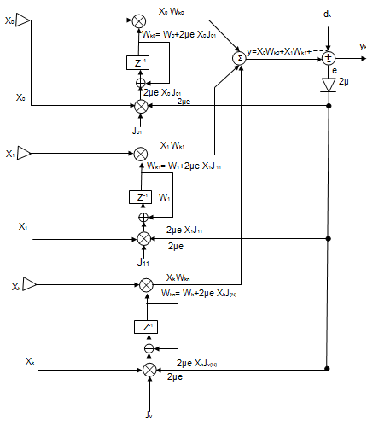

Figure 2. Flow chart of proposed Bessel beamformer

As per mathematical assumptions  and  then we have







It is proved that error signal is uncorrelated with (or orthogonal to) the input signal. This result shows that impulse response/weight function of a Bessel beamformer is optimized and it gets validation from well known result of Wiener filter theory [John G. Proakis et al. 2009, chap 13, and], [B. Widrow et al. 1985, chap 2] and [Simon Haykin. 2002, chap 2,].

## 2.2. Least Mean Square Algorithm

The algorithm is based on the estimate of the gradient vector that uses available data for this purpose [S.F. Shaukat et al. 2009, Raja Muhammad Asif Zahoor et al. 2009, B. Widrow et al. 1985]. The algorithm makes successive corrections to the weight vector in the direction of the negative of the gradient vector which finally concludes to minimum MSE. The weight vector for LMS algorithm is defined by



The weight vector of LMS algorithm is look similar in form as weight vector of Bessel beamformer but with an additional parameter .

The optimum weight vector for LMS algorithm is given by



where  is the cross correlation and  is the autocorrelation between desired signal and input signals respectively.

**3. Simulation Results**

The simulations are designed to analyze the properties of Bessel beamformer and LMS algorithms. The desired signal is phase modulated with  dB, used for simulation purpose. It is given by



where is the phase angle of the applied signal.

3.1. Gain Enhancement by Smart Antenna Array

The uniform linear array is taken with  and distance between two elements is maintained as . Five hundred samples are taken for simulation purpose. The angle of arrival (AOA) for desired user is 0 degree and two interferers are placed at -30 and 60 degrees to judge the efficiency of algorithms under study. The linear array factor is shown in Figure 3. The beam width is measured between the first two nulls of the array response function. The desired signal and interferers are received by an array of 8 elements with 8 weights. It is observed that the array directivity increases with the number of elements but at the same time number of side lobes also increases. The directivity of Bessel beamformer and LMS algorithms are observed as 20 dB and 18 dB respectively which clearly indicates 2 dB gain improvements of Bessel beamformer over that of LMS algorithm, by suppressing interference. Both algorithms have their main beam towards the desired direction. The ratio between the powers of the main lobe and the first side lobe is 6.22 dB and 5.25 dB for Bessel beamformer and LMS algorithms respectively. It is ascertained that Bessel beamformer is giving 2 dB gain improvements over that of LMS.

When space between two elements is kept as  for same number of elements with -10 degrees AOA for desired user as shown in Figure 4. Two interferers are placed at an angles -40 and 30 degrees. The performance of Bessel beamformer is quite obvious than that of LMS as Bessel beamformer places correct null towards an interferer at angle -40 degrees. Subsequent data obtained from Figure 4 is given in Table 1 which clearly indicates that Beam width/angular resolution for Bessel beamformer and LMS is 60 dB and 70 dB as the beam width is measured between the first two nulls of the array response function.

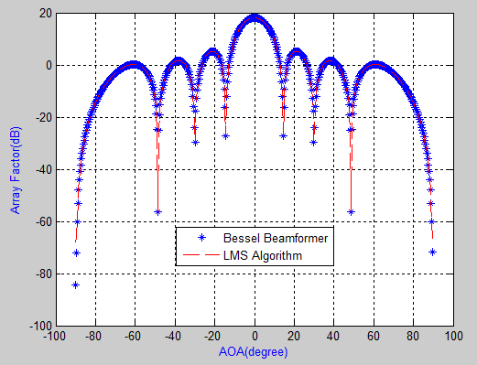

Figure 3. Array factor for Bessel beamformer and LMS algorithms with AOA for **desired user is 0 degree** with two interferers at an angles -30 and 60 degrees with constant space of  between elements for 

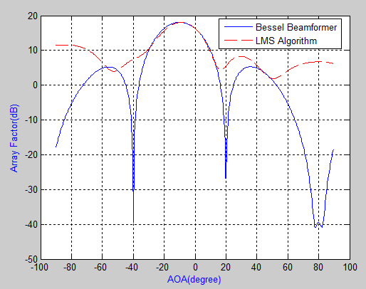

Figure 4. Array factor for Bessel beamformer and LMS algorithms with AOA for **desired user is -10 degrees** with two interferers at an angles -40 and 30 degrees with constant space of  between elements for 

The ratio between the powers of the main lobe and the first side lobe is 5 dB and 8 dB for Bessel beamformer and LMS algorithms respectively. Therefore the performance of Bessel beamformer is bettering terms of gain (2 dB), angular resolution (60 degrees) and Sidelobe Level (5 dB) over that of LMS algorithm.

Table 1. Performance Analysis of Algorithms under study

|  |  |  |
| --- | --- | --- |
| Algorithms | LMS | Bessel  beamformer |
| Input parameters | | |
| Element Spacing | 0.25 | 0.25 |
| AOA (degree) | -10 | -10 |
| No. of Elements | 8 | 8 |
| No. of two interferers | 2 | 2 |
| Output parameters | | |
| Beam width (degree) | 70 | 60 |
| Null depth performance (dB) | 4 | -40 |
| Sidelobe Level (dB) | 8 | 5 |

3.2. Mean Square Error Performance

The MMSE describes the performance of the given system. An adaptive beamformer like Bessel beamformer or LMS combines the signals received by different elements of smart antenna array to form a single output. This is achieved by minimizing the MSE between the desired output and the actual array output. The minimum MSE for both these algorithms are shown in Figure 5.

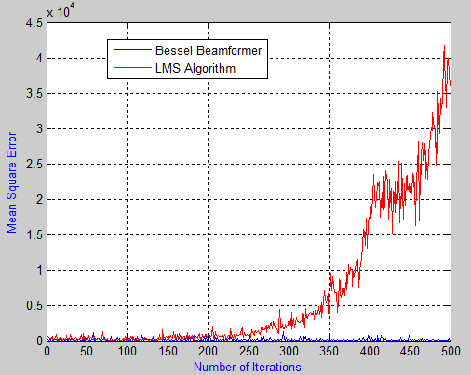

Figure 5. Mean Square Error performance for Bessel beamformer and LMS algorithms for 

It indicates that Bessel beamformer has minimum MSE (almost zero) as compared to LMS (3.7*) when measured after 500 iterations. Therefore it is proved that performance of Bessel beamformer is better over that of LMS. Initially, both algorithms starts from lower value i.e. (almost zero) and after 200 iterations LMS gets start to obtain higher values whereas MMSE for Bessel beamformer is same and seems stable.

3.3. Weight Convergence Performance

Correct and fast convergence is also one of the performance criteria. The weights value obtained at minimum MSE are the optimum weights that minimize the power in the error signal indicating that system output has approached the desired output as shown in Figure 6.

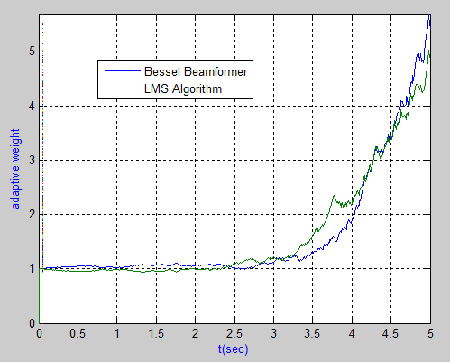

Figure 6. Weight convergence plot for Bessel beamformer and LMS algorithms

The weight values of both algorithms converge to their optimum values and have taken almost the same convergence path. The data given in Table 2 is extracted from Figures 3, 5 and 6.

Table 2. Performance Analysis of Algorithms under study for System Throughput Estimate

|  |  |  |
| --- | --- | --- |
| Algorithms | LMS | Bessel  beamformer |
| Input parameters | | |
| Element Spacing | 0.5 | 0.5 |
| No. of Sample | 500 | 500 |
| AOA (degree) | 0 | 0 |
| No. of Elements | 8 | 8 |
| No. of two interferers | 2 | 2 |
| Output parameters | | |
| Beam width (degree) | 36 | 36 |
| Array Gain (dB) | 18 | 20 |
| Null depth performance (dB) | 4 | -40 |
| Minimum MSE | 3.7* | 0 |
| Sidelobe Level (dB) | 5.25 | 5.29 |
| Convergence rate (S) | 0.047 | 0.095 |

The convergence rate for Bessel beamformer and LMS is found 0.0959 and 0.0474 S respectively at 500 iterations. Therefore LMS is slightly faster over that of Bessel beamformer.

**4. Discussions**

The detailed analysis is carried out for both algorithms which includes the signal recovery, suppression of interference, performance analysis in terms of directive gain, beam width, beam steering capabilities, reduction in MSE, null depth performance, Sidelobe level and convergence rate. The findings of simulation are:

Bessel beamformer has more directive gain (2 dB) over that of LMS algorithm, by suppressing interference as shown in Figure 3 and tabulated in Table 2. Therefore Bessel beamformer saves power because a directional gain of Bessel beamformer is maximum over that of LMS

Bessel beamformer is giving -40 dB null depth performances over that of LMS as shown in Figure 4.

Bessel beamformer has minimum MSE (almost zero) as compared to LMS (3.7*) when measured at 500 iterations. Therefore it is proved that performance of Bessel beamformer is better over that of LMS as shown in Figure 5.

The convergence rate for Bessel beamformer and LMS is 0.0959 and 0.0474 seconds respectively when 500 iterations are taken for simulation purpose. Therefore LMS is slightly faster over that of Bessel beamformer.

Bessel beamformer is giving 60 dB beam width/angular resolution as compared to LMS (70 dB) when spacing between elements is taken as  as shown in Figure 4 and tabulated in Table 1.

**Corresponding Author:**

M Yasin

Department of Power and Electronics, PNEC

National University of Sciences and Technology

Islamabad, Pakistan

E-mail: [myasinkhattak@gmail.com](mailto:myasinkhattak@gmail.com), [myasin@pnec.edu.pk](mailto:myasin@pnec.edu.pk)

**5. Conclusion**

Bessel beamformer provides: (1) 2 dB enhancements in gain by suppressing interference, (2) almost zero minimum MSE as compared to LMS (3.7*),(3) -40 dB null depth performance and (4) 60 dB angular resolution with respect to LMS (70 dB) when spacing between elements is taken as . However the convergence rate of LMS is slightly lower (0.0474 sec) than that of Bessel beamformer (0.0959 sec). From these facts and figures, it is deduced that performance of Bessel beamformer is good over that of LMS algorithm which can increase capacity and quality of mobile communication systems when employ for smart antenna array system.

**References**

1. B.G. Korenev. 2002. Bessel Functions and Their Applications: Analytical Methods and Special Functions. CRC Press, Boca Raton, FL.
2. M Yasin, Pervez Akhtar, M Junaid Khan, and S.H Zaheer Naqvi. 2010. Proposed Bessel Beamformer is a Better Option for Smart Antenna System for Capacity Improvement. World Applied Sciences Journal 10 (4): ISSN 1818-4952, 433-439.
3. G. N. Watson. 1995. A Treatise on the Theory of Bessel Functions. Birminghan, UK.
4. Smith, L.M. 2009. Wideband Bessel Function Chirp Signals and their Application to the Test and Evaluation of Audio Systems. System Theory, 2009. SSST 2009. 41st Southeastern Symposium on, ISSN:0094-2898, 355 – 359.
5. Nikolaos E. Myridis, and Christodoulos Chamzas. 2001. 1-D Sampling Using Nonuniform Samples and Bessel Functions. IEEE Conf, Xanthi, 67100 GREECE, 242-246.
6. K. Gopalan. 2001. Speech Coding using Fourier –Bessel Expansion of Speech Signals. IECON’01, (c) 2001 IEEE, 2199-2203.
7. D. Saxena, Mridul Kumar Mathur, and Seema Loonker. 2009. Determination and Analysis of Sidebands in FM Signals using Bessel Function. IJECSE, ISSN 2277-1956, Vol. 1, No. 2, www.ijecse.org, 454-458.
8. Elisabet Tiana Roig. 2009. Beamforming Techniques for Environmental Noise. Master’s Thesis, Technical University of Denmark.
9. T. D. Abhayapala. 2008. Generalized Framework for Spherical Microphone Arrays: Spatial and Frequency Decomposition. ICASSP, (c) 2008 IEEE, 5268-5271.
10. Ram Bilas Pachori, and Pradip Sircar. 2006. Analysis of Multiple Component Non-stationary Signals Using Fourier-Bessel Transform and Wigner Distribution. 14th European Signal Processing Conference (EUSIPCO 2006), Florance, Italy.
11. M. J. Narasimha, A. Ignjatovic and P. P. Vaidyanathan. 2002. Chromatic Derivative Filter Banks. IEEE Signal Processing Letters, Vol. 9, No. 7, 215-216.
12. Hsien-Peng Chang, Tapan K. Sarkar, and Odilon Maroja C. Pereira-Filho. 2000. Antenna Pattern Synthesis Utilizing Spherical Bessel Functions. IEEE Transactions on Antennas and Propagation, Vol. 48, No. 6, 853-859.
13. M Yasin, Pervez Akhtar, and S.H Zaheer Naqvi. 2011. Design and Performance Analysis of Blind Algorithms for Smart Antenna System Using Window techniques. Middle East Journal of Scientific Research 7 (4): ISSN 1990-9233, 458-466.
14. S.F. Shaukat, Mukhtar ul Hassan, R. Farooq, H. U. Saeed, and Z. Saleem. 2009. Sequetial Studies of Beamforming Algorithms for Smart Antenna Systems. World Applied Sciences Journal 6 (6):, ISSN 1818-4952, 754-758.
15. Raja Muhammad Asif Zahoor, and Ijaz Mansoor Qureshi. 2009. A Modified Least Mean Square Algorithm Using Fractional Derivative and its Application to System Identification. European Journal of Scientific Research ISSN 1450 – 216X, Vol. 35, No. 1, 14-21.
16. John G. Proakis, and Dimitris G. Manolakis. 2009. Digital Signal Processing, Principles, Algorithms, and Applications. Fourth Edition, Pearson Education Inc.
17. J. Schroeder. 1993. Signal Processing via Fourier Bessel Series Expansion. Digital Signal Processing, Vol. 3, 112-124.
18. Arthur L. Schoenstadt. 2006. An Introduction to Fourier Analysis Fourier Series, Partial Differential Equations and Fourier Transforms. Monterey, California 93943.
19. Mathnium. A System for Numerical Computing, Data Analysis, and Graphics. http://www.mathnium.com/help/doc.html
20. Constantine A. Balanis. 2005. Antenna Theory: Analysis and Design. McGraw-Hill Higher Education.
21. K. Gopalan. 2001. Speech Coding using Fourier –Bessel Expansion of Speech Signals. IECON’01, (c) IEEE, 2199-2203.
22. B. Widrow, and S.D. Stearns. 1985. Adaptive Signal Processing. Pearson Eduation, Inc.
23. Simon Haykin. 2002. Adaptive Filter Theory. Fourth edition, Pearson Eduation, Inc.
24. Sasa Nikolic, Antic D, Dankovic B, Milojkovic M, Jovanovic Z, and Peric S. 2010. Orthogonal Functions Applied in Antenna Positioning. Advances in Electrical and Computer Engineering, Vol. 10, No. 4, 1582-7445, 35-42.
25. Linrang Zhang, H.C. So, Li Ping, and Guisheng Liao. 2004. Adaptive multiple-beamformers for reception of coherent signals with known directions in the presence of uncorrelated interferences. Signal Processing 84, 1861–1873.
26. T. Schirtzinger, X. Li, and W. K. Jenkins. 1995. A Comparison of three Algorithms for Blind Equalization based on the Constant Modulus Error Criterion. 0-7803-2431-5/95/ supported by NSF and JSEP, IEEE.

8/21/2019