Dietary pattern among a sample Attention deficit hyperactivity primary school children in Egypt

Safaa T. El Hussein PhD¹, Salwa M. Saleh M.D², Hany El Gazar PhD³, Hoda, A. abed EL Salam PhD³

¹Assistant professor of child health, National Nutrition Institute, Cairo, Egypt
²Assistant professor of pediatrics, National Nutrition Institute, Cairo, Egypt
³Assistant professor of nutrition and food science, National Nutrition Institute, Cairo, Egypt
drsalwamahmoud@yahoo.com

Abstract: This study investigated the quality of diet, in Attention Deficit Hyperactivity Disorder (ADHD) primary schools children. A case-control study was designed for this purpose. Individuals participating in this work were chosen from the public clinic of psychiatry and a private psychiatric clinic following Behira Health Directorate. Categorized as ADHD according to diagnostic criteria of American Psychiatric Association2013, A total of 102 students participated in the study (51) cases (51) control, Both boys and girls were involved. Anthropometric measurements were performed, Assessment of the nutritional status was performed by using 24 H dietary recall, food frequency questionnaire. The study result showed that there was significantly lower consumption of healthy dietary elements., milk, and fruits with significant increase consumption of sweetened products, chocolate, soft drinks. Overweight and obesity was more in cases than control. We need to encourage ADHD children to follow healthy dietary pattern. Emphasizing of an educational system pursuing needed of parents. The proposed program goals at advising the parents about the types of foods their reduction intake may elevate the signs of ADHD like sugary foods, chocolate, sugar, caffeinated beverages and soft drinks.
[Safaa T. El Hussein, Salwa M. Saleh, Hany El Gazar, Hoda, A. Abed ELSalam. Dietary pattern among a sample Attention deficit hyperactivity primary school children in Egypt. Researcher 2019;11(8):42-49]. ISSN 1553-9865 (print); ISSN 2163-8950 (online). http://www.sciencepub.net/researcher. 6. doi:10.7537/marsrsj110819.06.

Keywords: ADHD, heathy, dietary, childern, pattern

1. Introduction
Attention-deficit hyperactivity disorder (ADHD) is a neuro-developmental disorder comprised a tenacious form of negligence, impulsivity and hyperactivity that inhibits the functioning capacity of children (1). The incidence of ADHD is a comparatively common disease that influences about 5% of the peoples (2). The frequency is higher in males (2:1) than in females (3) ADHD associated with significant impairment in academic and social development (1). Symptoms are typically manifested early in life and are chronic across the lifespan for most individuals ( 4). The causal pathways of ADHD are largely unknown. Up to now, the synergistic effects amongst genetic, neurological, and environmental factors is mostly known (1). Suggested ADHD environmental risk factors comprise chemical exposures like mercury, lead, organophosphates, organ chlorine, heavy metal in addition to psychosocial and nutritional factors (5). The current multimodal standard of ADHD treatment composed of psycho-social therapy and drug therapy (6) Psycho stimulants are the first-choice pharmacological treatment which shown beneficial short-term efficacy. (7) Children taking psycho stimulants may perhaps quiet encounter the ADHD-criteria (8). Complete recovery from the symptoms is still low. (9) One of the adverse effects of drugs used in the treatment may also influences the development and the health of bones after long administration of drugs (10). In conclusion, drug therapy does not reduce the increased risk for school failure and job loss. (11) The target from any treatments to this situation is mainly for prevention of ADHD to affect younger ages of children and at directing the fundamental etiologies are welcomed. (12). There is a lot of misconception and controversy regarding dietary interventions for ADHD children but the agreement on a practical method to feeding of children affected with ADHD is the similar mentioned for all children healthy diet: diet that contains whole grains, vegetables and fruits, good sources of protein and healthful unsaturated lipids; avoid eating rapidly easy digested carbohydrates, fast foods, unhealthy trans and saturated fats, in addition to consistent physical movements (13). Some investigators advised with many things for overcoming the symptoms of ADHD and improving overall nutrition and health for a lifetime through taking a healthy diet which not contain artificial additives and chemical coloring materials and supplement with fats rich with omega-3 and micronutrients (14). Many researchers studied the impact of food kind on ADHD. They postulated that both foods and artificial food additives (colorings and flavors) rich in salicylates (chemicals occurring naturally in some foods) might be considered as an important cause for inducing the hyperkinetic syndrome. (15). The same author followed his studies by another study not containing artificial food color (AFC), few studies dealing with the impact of food diet (FFD) and supplements such as poly-unsaturated fatty acids (PUFA), minerals and vitamins on ADHD. The result were inconclusive (16,17). Recently systematic review for ADHD found that the previous interventions until now should not be proposed as a treatment of ADHD generally (13). One of the disadvantages of increasing consumption of sugars in the infant diet is possible impact on dopamine regulation and hence may be a causative agent in ADHD. Certainly, the American Academy of Pediatrics recommended that the level of sugar in the infant diet not exceed 10% of total calories to support good mental health (18, 19). Soda drinks often have many of the sugars, sweeteners and high-fructose corn syrup and caffeine ingredients that may worsen ADHD symptoms. (20). Many researched studied the role played by caffeine in the treatment of ADHD. The pharmacological action of caffeine via the effect on CNS as a drug exhibiting psychoactive stimulation, where it can reduce drowsiness and elevate the alertness. High doses of caffeine has adverse effect particularly when administered for long period with irregular manner (21, 22). Caffeine usually supplemented to some spirits drinks such as soda drinks (23), caffeine is usually accompanied sugars which are concentrated in soda which used as a vehicle for caffeine (24). For that reason, a high percentage of the children is unprotected to repeated combinations during childhood, caffeine combined with high concentration of sugars added in beverages and foods may act synergistically to release dopamine in addition to exaggerate the supporting characters of beverages and sweetened foods, contributes to enhanced preference for foods and beverages containing added sugar (25). Our study conducted to investigate the dietary pattern of ADHD children investigating the adherence to the recommended healthy pattern for their age, Investigating popular belief, of eating excessive amounts of sugar or, Caffeine containing product in ADHA children.

2. Materials and Methods
A case-control study was conducted to achieve the research aim. Patients were selected from the public and private clinic of psychiatry and addiction following Behira Health Directorate. Apparently healthy aged matched controls were selected. Both boys and girls were recruited. Participants who had chronic diseases such as diabetes mellitus were excluded. Ethical permission to conduct this study was obtained from the facilities were the sample was collected. Dietary intake was assessed using quantities and qualitative methods of assessment 24 hours recall and food frequency questionnaire. Parents were asked specifically about the intake of milk, vegetables’ and fruit consumption, caffeinated drinks including chocolate, tea, soft drinks and Sweetened beverages, Portion sizes were estimated using local utensils. (26, 27). Parents of ADHD children were further asked if they noticed any relationship between certain foods and an increase in the symptoms of ADHD. Selected anthropometric measurements were taken from both cases and controls. Weight and height, Body mass index (BMI) was calculated and results were compared with the World Health Organization standards using growth charts. (WHO., 2007) (28). The mid-upper arm circumferences (MUAC) was measured by a non stretchable tape and results were compared between both groups. Descriptive data included mean, standard deviation and frequencies. Pearson’s correlation was used to determine the association between different variables. Student’s t-test was to find the differences between cases and controls. Statistical significance difference was set at 5%. p value at (<o.o5 using SPSS version 21. ( 29)

3. Results
The total number of child participating in the study was 102 children, their ages ranged from 7 to 12 years; 51 children were healthy while the remaining 51 were diagnosed with ADHD.

Table (1): Demonstrating demographic data of the children in the control and treated groups.
 | Cases (n = 51) |  | Control (n = 51) |  | Test of Sig. | P
 | No. | % | No. | %
Sex
Male | 38 | 74.5 | 34 | 66.7 | χ²=  0.756 | 0.385
Female | 13 | 25.5 | 17 | 33.3
Age (years)
Min. – Max. | 7.0 – 12.17 |  | 7.0 – 12.0 |  | t=  0.342 | 0.733
Mean ± SD. | 8.68 ± 1.57 |  | 8.79 ± 1.62
Median | 8.08 |  | 8.17
χ²: Chi square test t: Student t-test
p: p value for comparison between the two studied groups

Demographic Characteristics of the Sample:

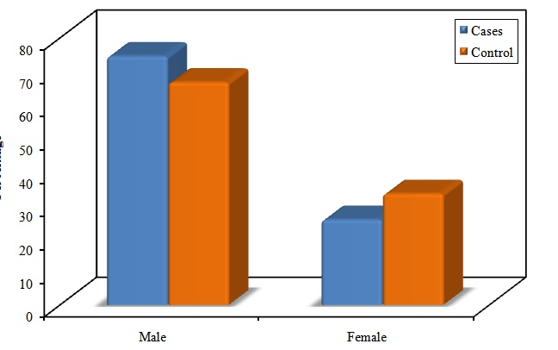
Figure (1): Comparison between the two studied groups according to sex

Mean age of cases group was 8.68 years with standard deviation 1.57 year while mean age of control group was 8.79 years with ‘2standard deviation 1.62 year. Cases group consisted of 38 boys (74.5%) and 13 girls (25.5%) while control group consisted of 34 boys (66.7%) and 17 girls (33.3%).According statistical comparison set at P<.05 level of significance age and sex variables were insignificant. (Table 1) (Figure 1 & 2).

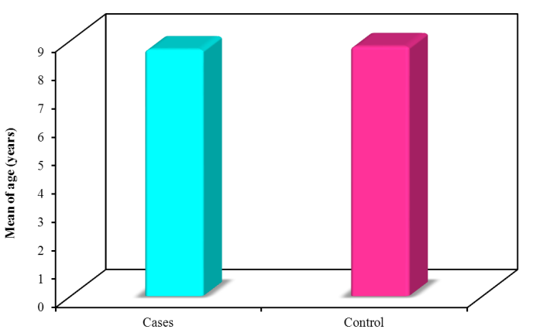
Figure (2): Comparison between the two studied groups according to age (years)

Table (2): Showing anthropometric Measures among the two studied groups (control and treated).
Anthropometric measures | Cases (n = 51) | Control (n = 51) | T | P
Height (meters)
Min. – Max. | 1.01 – 1.65 | 1.05 – 1.67 | 0.261 | 0.795
Mean ± SD. | 1.33 ± 0.14 | 1.33 ± 0.12
Median | 1.34 | 1.34
Weight ( kilograms)
Min. – Max. | 23.0 – 81.20 | 17.50 – 74.80 | 2.212* | 0.029*
Mean ± SD. | 38.11 ± 10.90 | 33.15 ± 11.74
Median | 35.80 | 30.10
BMI (kg/m²)
Min. – Max. | 15.45 – 37.25 | 12.90 – 26.80 | 4.373* | <0.001*
Mean ± SD. | 21.42± 3.93 | 18.11 ± 3.72
Median | 20.16 | 17.10
MUCA (cm)
Min. – Max. | 16.0 – 43.0 | 12.60 – 39.80 | 2.932* | 0.004*
Mean ± SD. | 25.71 ± 6.22 | 22.08 ± 6.27
Median | 24.50 | 21.0
t: Student t-test: p value for comparison between the two studied groups
*: Statistically significant at p ≤ 0.05

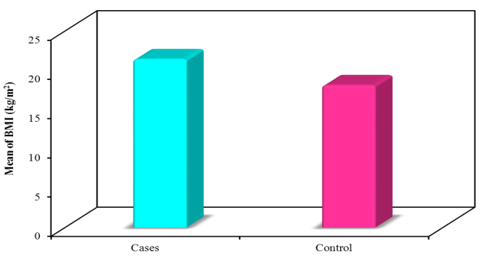
Figure (5): Comparison between the two studied groups according to BMI (kg/m²)

Anthropometric Data Analyses:
Mean height in both groups were 1.33 meter with standard deviation 0.12 in cases group and 0.14 in control group that was statistically insignificant variation. (Table 2) (Figure 3)
Mean weight in cases group was 38.11 kg. with standard deviation 10.90 while control group mean weight was 33.15 kg. with standard deviation 11.74. (Figure that was statistically significant variation. (Table 2) (Figure 4)
Mean BMI in cases group was 21.42 with standard deviation 3.93 while control group mean BMI was18.11 with standard deviation 3.72. (that was statistically significant variation. (Table 2) (Figure 5).
Mean MUAC in cases group was 25.71 with standard deviation 6.22 while control group mean BMI was 22.08 with standard deviation 6.27. (that was statistically significant variation. (Table 2) (Figure 6).
According statistical comparison set at P<.05 level of significance.
Weight, BMI and MUAC variables were significant.

Table (3): Comparison between the two studied groups according to food frequency
Food frequency | Cases  (n = 51) | Control  (n = 51) | U | P
Milk (cups/day)
Min. – Max. | 0.0 – 4.0 | 0.0 – 4.0 | 806.0* | 0.001*
Mean ± SD. | 1.52 ± 0.93 | 2.08 ± 0.80
Median | 1.0 | 2.0
Soft drinks (can/week)
Min. – Max. | 0.0 – 7.0 | 0.0 – 6.0 | 944.5* | 0.015*
Mean ± SD. | 2.84 ± 1.87 | 1.98 ± 1.45
Median | 3.0 | 2.0
Sweetened beverages
(juice cartoons)
Min. – Max. | 0.0 – 9.0 | 0.0 – 6.0 | 768.0* | <0.001*
Mean ± SD. | 4.45 ± 2.0 | 3.16 ± 1.42
Median | 4.0 | 3.0
Tea (cups/week)
Min. – Max. | 0.0 – 3.0 | 0.0 – 2.0 | 1054.0 | 0.080
Mean ± SD. | 1.20 ± 0.98 | 0.86 ± 0.66
Median | 1.0 | 1.0
Vegetable (servings/day)
Min. – Max. | 0.0 – 5.0 | 0.0 – 6.0 | 1067.50 | 0.112
Mean ± SD. | 2.78 ± 1.47 | 3.27 ± 1.42
Median | 3.0 | 3.0
Fruits (servings/day)
Min. – Max. | 0.0 – 4.0 | 0.0 – 4.0 | 979.50* | 0.023*
Mean ± SD. | 1.73 ± 0.98 | 2.18 ± 0.93
Median | 2.0 | 2.0
Chocolate (servings /week)
Min. – Max. | 0.0 – 17.0 | 0.0 – 15.0 | 894.0* | 0.006*
Mean ± SD. | 7.51 ± 3.99 | 5.37 ± 3.63
Median | 7.0 | 5.0
U: Mann Whitney test p: p value for comparison between the two studied groups
*: Statistically significant at p ≤ 0.05

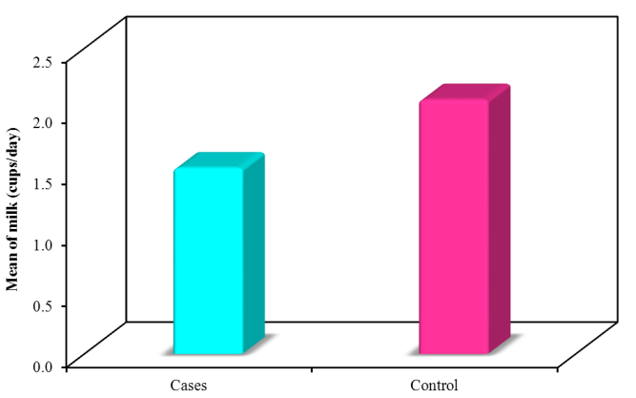
Figure (7): Comparison between the two studied groups according to Milk (cups/day)

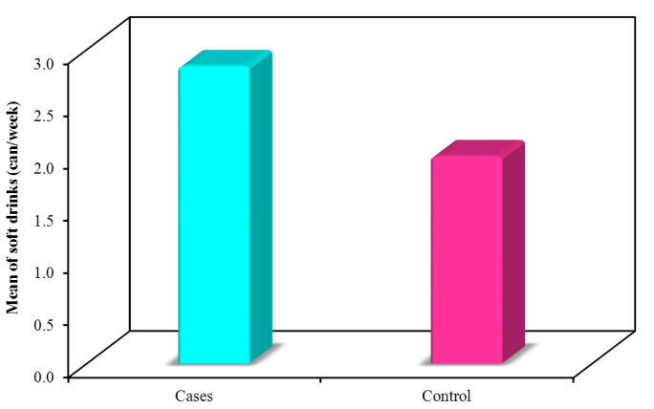
Figure (8): Comparison between the two studied groups according to Soft drinks (can/week)

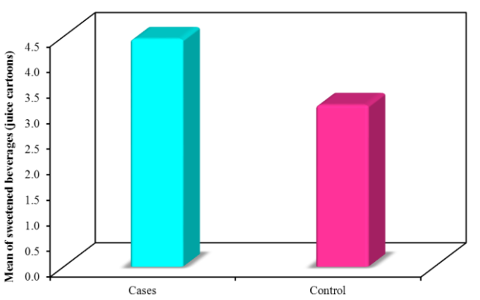
Figure (9): Comparison between the two studied groups according to Sweetened beverages (juice cartoons)

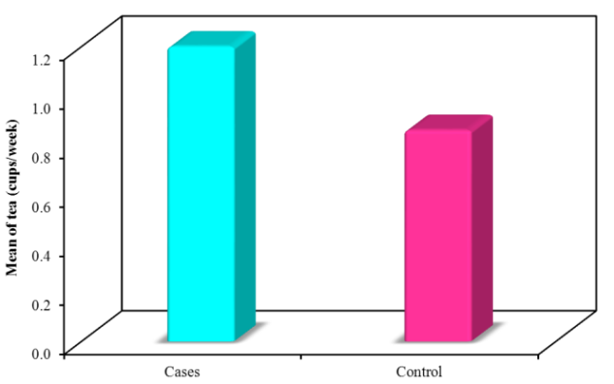
Figure (10): Comparison between the two studied groups according to Tea (cups/week)

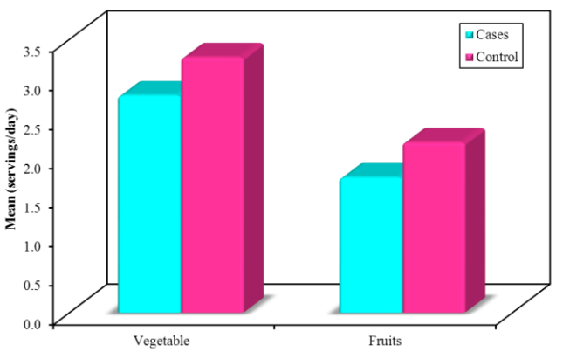
Figure (11): Comparison between the two studied groups according to Vegetable (servings/day) and Fruits (servings/day)

Table (3) Nutritional Assessment
Dietary intake of milk, fruits and vegetables, caffeinated drinks including soft drinks, tea, chocolate and Sweetened beverages (juice cartoons). Portion sizes were estimated using local utensils, Statistical comparison between the two groups showed significant increase in soft drinks, sweetened beverages (juice cartoons) and chocolate consumption and insignificant increase in tea consumption among cases group while there was significant increase in milk and fruits consumption and insignificant increase in vegetables consumption ( Table 3) ( figs 7-12)

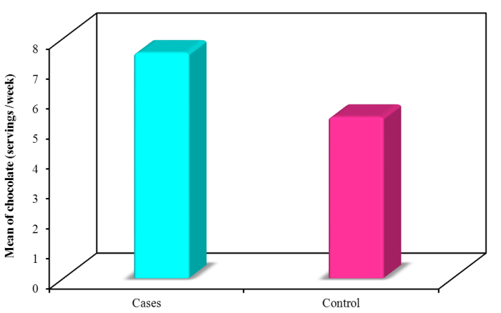
Figure (12): Comparison between the two studied groups according to Chocolate (servings /week

4. Discussion:
The most common behavioral disorder in children is known as the attention deficit hyperactivity disorder (ADHD), according to the National Institutes of Health it affects about 3-5% of similar age group (7-12 years) (30). Proposed ADHD environmental risk factors include nutritional factors (5). Many investigators postulated that unbalanced diet and an insufficient nutrition that starting from the fetal period may initiate undesired behavioral patterns and hyperactivity in children (31). The role played by the kind of diet in controlling the behavior of children has been debated, Many nutritional factors has been continually suggested (32). This is A case-control study conducted to achieve the research aim., the correlation between quality of diet, and ADHD in primary school children. Apparently healthy control children at the ranged age (7-12 years) were chosen. Equally boys and girls were enrolled we found that ADHD was more pounced in boys than in girls 3 times this was in concordance with pervious literature which reported ADHD more relevant in boys than girls (33). Comparison according anthropometric measures suggests that more children with ADHD were defined as overweight depending on their mean body mass index (BMI-for age) which could be explained on bases of disease nature, as the inattentiveness that describe ADHD lead to changed habits of eating and, subsequently, weight gain. ( 34). According to the statistical comparison of our study. There was significance difference regarding BMI between cases and control. Several studies (35-38) provide support to our results as the overall findings from these studies proved significant association between obesity and ADHD., one of the drawbacks of all studies highlighted by some authors (34) was that a part of researches had not found a correlation between psychiatric comorbidities and the extent of increasing in the obesity rates among children affected by ADHD. There is a rareness of works on this subject and we think that this should give great attention in future researches, high intakes of fruit, grains, vegetables, dairy product, and little intake of beverages and fast foods is called the traditional-healthy dietary pattern, thought to be negatively correlated with ADHD (39). The Assessment of Quality of diet of ADHD children in our study revealed that dietary pattern was in side of western pattern and offside with healthy pattern., As we found significant increase in soft drinks, sweetened beverages and chocolate consumption among cases group with significant decrease in milk and fruits consumption with the reveres of the control group we found supportive evidence for our result from (40 ). They reported that the dietary patterns of ADHD children characterized by a high intake of sweets and fast and decreased intake of healthy dietary patterns. The traditional-healthy dietary pattern was associated with lower odds having ADHD., (41,42). Recently (43) concluded that A Western-style diet may be associated with ADHD. Some previous studies suggests that caffeine could be useful as a treatment, in ADHD as it appears to normalize levels of dopamine and improve attention in ADHDA in adult., Caffeine consumption during childhood may have particularly harmful consequences (44,45). our study provided that ADHD children consumed excessive empty nutrients due to consumption of soda. In-between all beverages, soda consumption is a main positive interpreter of empty nutrients intake which was in line with some authors (20). Many researchers postulated that taking large quantities of sugars may affect the regulation of dopamine release and consequently may be play a role as an etiological factor in appearance of ADHD (18). 10% of total calories per day or less is the recommended level of sugar in the diet as advised by the American Academy of Pediatrics to support good mental and physical health. (18). our result recommend the public health labors should be actively working to support healthy dietary pattern and healthy beverage choices and decrease soda consumption.

Conclusion
The present study shows the existence of low adherence of Healthy diet pattern among a group of ADHD children. This evidence supports that the food pattern of children is in a transitional state characterized by the loss of the traditional dietary pattern towards a Western dietary pattern These findings, which have also been observed in other countries, raise the question of the healthy diet’s capacity to persist into the future, The traditional-healthy dietary condition, which consumed high quantities of bonefish and grains, and low intake of beverages and fast foods considered protective factor against ADHD

Recommendations
Study endorses the expansion of an educational program concerning parents of ADHD children. The goal from this program is informing them about the healthy dietary pattern intake, the reduction of certain types of foods that could exaggerate the signs of ADHD such as sugar, sugary foods and chocolate, soft drinks and caffeinated beverages. Further studies should focus on the nutrient intake and nutritional status of ADHD children including large sample size.

References
- American Psychiatric Association. (2013). Diagnostic and statistical manual of mental disorders (5th ed.) Washington, DC: Author.
- Willcutt, E. G. (2012). The prevalence of attention-deficit/hyperactivity disorder A meta-analytic review. Neurotherapeutics, 9, 490–499.
- Owens, E. B., Cardoos, S. L., & Hinshaw, S. P. (2015). Developmental progression and gender differences among individuals with ADHD. In R. A. Barkley (Ed.), Attention-deficit/hyperactivity disorder: A handbook for diagnosis and treatment (4th ed. pp.223–255). New York, NY: Guilford.
- Barkley, R. A. (Ed.). (2015). Attention-deficit/hyperactivity disorder: A handbook for diagnosis and treatment (4th ed.). New York, NY: Guilford.
- Academy of Medical Sciences. Identifying the environmental causes of ADHD disease: how should we decide what to believe and when to take action? London: Academy of Medical Sciences; 2007.
- Rytter MJ, Andersen LB, Houmann T, Bilenberg N, Hvolby A, Molgaard C, et al. Diet in the treatment of ADHD in children—a systematic review of the literature. Nord J Psychiatry. 2015;69(1):1–18. 10.3109/08039488.2014.921933.
- Charach A, Ickowicz A, Schachar R. Stimulant treatment over five years: adherence, effectiveness, and adverse effects. J Am Acad Child Adolesc Psychiatry. 2004;43(5):559–67. doi: 10.1097/00004583-200405000-00009 .
- Childress AC, Sallee FR. Attention-deficit/hyperactivity disorder with inadequate response to stimulants: approaches to management. CNS Drugs. 2014;28(2):121–29. doi: 10.1007/s40263-013-0130-6
- Lichtenstein P, Halldner L, Zetterqvist J, Sjolander A, Serlachius E, Fazel S, et al. Medication for attention deficit-hyperactivity disorder and criminality. N Engl J Med. 2012;367(21):2006–14. doi: 10.1056/NEJMoa1203241.
- Van der Kolk A, Bouwmans CA, Schawo SJ, Buitelaar JK, van Agthoven M, Hakkaart-van Roijen L. Association between societal costs and treatment response in children and adolescents with ADHD and their parents. A cross-sectional study in the Netherlands. Springerplus. 2015;4:224doi: 10.1186/s40064-015-0978-7.
- Riddle MA, Yershova K, Lazzaretto D, Paykina N, Yenokyan G, Greenhill L, et al. The Preschool Attention-Deficit/Hyperactivity Disorder Treatment Study (PATS) 6-year follow-up. J Am Acad Child Adolesc Psychiatry. 2013;52(3):264–78.e2. doi: 10.1016/j.jaac.2012.12.007.
- Arnold LE, Hurt E, Lofthouse N. Attention-deficit/hyperactivity disorder: dietary and nutritional treatments. Child Adolesc Psychiatr Clin N Am. 2013;22(3):381–402. doi: 10.1016/j.chc.2013.03.001.
- Pelsser LM, Frankena K, Toorman J, Rodrigues Pereira R Diet and ADHD, Reviewing the Evidence: A Systematic Review of Meta-Analyses of Double-Blind Placebo-Controlled Trials Evaluating the Efficacy of Diet Interventions on the Behavior of Children with ADHD. PLoS One. 2017 Jan 25;12(1):e0169277. doi: 10.1371/journal.pone.0169277. Collection US National Library of Medicine National Institutes of Health Page last reviewed: September 21, 2018.
- Sarris J, Logan AC, Akbaraly TN, Amminger GP, Balanza-Martinez V, Freeman MP, et al. Nutritional medicine as mainstream in psychiatry. Lancet Psychiatry. 2015;2(3):271–74. 10.1016/S2215-0366(14)00051-0.
- Feingold BF. Hyperkinesis and learning disabilities linked to artificial food flavors and colors. Am J Nurs. 1975;75(5):797–803.
- Stevens LJ, Kuczek T, Burgess JR, Hurt E, Arnold LE. Dietary sensitivities and ADHD symptoms: thirty-five years of research. Clin Pediatr (Phila). 2011;50(4):279–93.
- Arnold LE, Hurt E, Lofthouse N. Attention-deficit/hyperactivity disorder: dietary and nutritional treatments. Child Adolesc Psychiatr Clin N Am. 2013;22(3):381–402. doi: 10.1016/j.chc.2013.03.001.
- Johnson RJ, Gold MS, Johnson DR, et al. Attention-deficit/hyperactivity disorder: is it time to reappraise the role of sugar consumption? Postgrad Med. 2011;123:39-4924.
- Kim Y and Chang H. Correlation between attention deficit hyperactivity disorder and sugar consumption, quality of diet, and dietary behavior in school children. Nutr Res Pract 2011;5(3):236-45.
- Lien, l MD, MSc, Lien, N PhD, Heyerdahl, SPhD, Consumption of Soft Drinks and Hyperactivity, Mental Distress, and Conduct Problems Among Adolescents in Oslo, Norway Am J Public Health. 2006 October; 96(10): 1815–1820.
- Collingwood, J. (2018). Caffeine’s Effect on ADHD Symptoms. Psych Central. Retrieved on February 20 2019, from https://psychcentral.com/lib/caffeines-effect-on-adhd-symptoms.
- Caffeine and ADHD: Effects, safety, and use in childrenhttps://www.medicalnewstoday.com/articles/315169.php.
- Friedman M. Overview of antibacterial, antitoxin, antiviral, and antifungal activities of tea flavonoids and teas. Mol Nutr Food Res. 2007;51:116–34.
- Frary CD, Johnson RK, Wang MQ. Food sources and intakes of caffeine in the diets of persons in the United States. J Am Diet Assoc. 2005;105:110–3.
- Bernstein GA, Carroll ME, Thuras PD, Cosgrove KP, Roth ME. Caffeine dependence in teenagers Bernstein GA, Carroll ME, Thuras PD, Cosgrove KP, Roth ME. Caffeine dependence in teenagers. Drug Alcohol Depend. 2002;66:1.
- National Nutrition Institute for Egypt, NNI (2006): Food composition table based on local food analysis and food compositio Recommended Intakes for Individuals, Vitamins. The National Academies Press. 2004.
- FAO/WHO/UNU (2004): Human energy requirements report of a joint FAO/WHO/UNU Expert Consultation.
- WHO.,2007: Onis M, Onyango AW, Borghi E, Siyam A, Nishda C and Siekmann J (2007): Development of a WHO growth reference for school –age children.
- SPSS (2008). Statistical Package for Social Science, Computer Software, IBM, SPSS Ver. 16.0 in 2008., SPSS Company, London, UK.
- National Institute of Mental Health. March 2016. Attention Deficit Hyperactivity Disorder". Archived from the original on 23 July 2016. Retrieved 5 March 2016.
- Shaw M, Hodgkins P, Caci H, Young S, Kahle J, Woods AG, et al. A systematic review and analysis of long-term outcomes in attention deficit hyperactivity disorder: effects of treatment and non-treatment. BMC Med. 2012;10:99doi: 10.1186/1741-7015-10-99
- Schnoll R, Burshteyn D, Cea-Aravena J. Nutrition in the treatment of attention-deficit hyperactivity disorder: a neglected but important aspect. Appl Psychophysiol Biofeedback. 2003;28:63–75.
- Owens, E. B., Cardoos, S. L., & Hinshaw, S. P. (2015). Developmental progression and gender differences among individuals with ADHD. In R. A. Barkley (Ed.), Attention-deficit/hyperactivity disorder: A handbook for diagnosis and treatment (4th ed.pp.223–255). New York, NY: Guilford Willcutt, E. G. (2012). The prevalence of attention-deficit/hyperactivity disorder A meta-analytic review. Neurotherapeutics.
- Cortese S, Vincenzi B. Obesity and ADHD: clinical and neurobiological implications. Curr Top Behav Neurosci. 2012;9:199–218. doi: 10.1007/7854_2011_154.
- Docet M, Larranaga A, Perez Mendez L, Garcia-Mayor R. Attention deficit hyperactivity disorder increases the risk of having abnormal eating behaviours in obese adults. Eat Weight Disord. 2012;17:e132–e136. doi: 10.1007/BF03325337.
- Kim EJ, Kwon HJ, Ha M, Lim MH, Oh SY, Kim JH, et al. Relationship among attention-deficit hyperactivity disorder, dietary behaviours and obesity. Child Care Health Dev. 2014;40:698–705. doi: 10.1111/cch.12129.
- Nazar BP, Suwwan R, de Sousa Pinna CM, Duchesne M, Freitas SR, Sergeant J, et al. Influence of attention-deficit/hyperactivity disorder on binge eating behaviors and psychiatric comorbidity profile of obese women. Compr Psychiatry. 2014;55:572–578. doi: 10.1016/j.comppsych.2013.09.015.
- Patte KA, Davis CA, Levitan RD, Kaplan AS, Carter-Major J, Kennedy JL. A behavioral genetic model of the mechanisms underlying the link between obesity and symptoms of ADHD. J Atten Disord. 2016.
- Wolraich M, Milich R, Stumbo P, Schultz F. Effects of sucrose ingestion on the behavior of hyperactive boys. J Pediatr. 1985;106:675–682.
- Kim EJ, Kwon HJ, Ha M, Lim MH, Oh SY, Kim JH, et al. Relationship among attention-deficit hyperactivity disorder, dietary behaviours and obesity. Child Care Health Dev. 2014;40:698–705. doi: 10.1111/cch.12129.
- Howard A., Smith G., Ambrosini G.: ADHD Is Associated With a "Western" Dietary Pattern in Adolescents Article in Journal of Attention Disorders 15(5):403-11 · July 2011 with.
- A, Hossein M., Ahmad R Esmaillzadeh Dietary patterns in children with attention deficit/hyperactivity disorder (ADHD). Nutrients. 2014 Apr 14;6(4):1539-53. doi: 10.3390/nu6041539.
- Abbasi K, Beigrezai S, Ghiasvand R, Pourmasoumi M, Mahaki B Dietary Patterns and Attention Deficit Hyperactivity Disorder Among Iranian Children: A Case-Control Study. J Am Coll Nutr. 2019 Jan;38(1):76-83. doi: 10.1080/07315724.2018.1473819. Epub 2018 Oct 1.
- Haskell CF, Kennedy DO, Wesnes KA, Scholey AB. Cognitive and mood improvements of caffeine in habitual consumers and habitual non-consumers of caffeine. Psychopharmacology (Berl) 2005;179:813–25.
- Jennifer L. Caffeine Use in Children: What we know, what we have left to learn, and why we should worry Neurosci Biobehav Rev. 2009 Jun; 33(6): 793–806.

8/18/2019

