Technical aspects of ultrasound-guided fine needle biopsy of thyroid nodules

Mohamed Abdellkader Abdelkader Alrashidy¹, Prof. Dr. Amr Mahmoud zayed¹, Prof. Dr. Ibrahim Hassan Yousef², Dr. Mohamed Salah El-Din Abdelbaky¹

¹Radiodiagnosis Department, Faculty of Medicine, Al-Azhar University, Egypt
²Pathology Department, Faculty of Medicine, Al-Azhar University, Egypt
Mohamed.ahrashidy2020@gmail.vom

Abstract: Fine needle biopsy of thyroid nodule is minimally invasive, simple, reliable and inexpensive procedure, so it's considered the procedure of choice in preoperative management of thyroid nodules. Using the ultrasound (US) as an imaging guidance for fine needle biopsy increases the samples adequacy by accurately targeting the nodule and continuously monitoring the needle's tip inside the nodule during the sampling procedure. In our study we evaluate the technical aspects of US-guided Fine needle biopsy of thyroid nodules using single needle pass and the patients complications related to the procedure.
[Mohamed Abdellkader Abdelkader Alrashidy, Amr Mahmoud zayed, Ibrahim Hassan Yousef, Mohamed Salah El-Din Abdelbaky. Technical aspects of ultrasound-guided fine needle biopsy of thyroid nodules. Researcher 2019;11(7):24-40]. ISSN 1553-9865 (print); ISSN 2163-8950 (online). http://www.sciencepub.net/researcher. 3. doi:10.7537/marsrsj110719.03.

Keywords: Technical; aspect; ultrasound-guided; fine; needle; biopsy; thyroid nodules

1. Introduction
Thyroid nodules are common in clinical practice. They arediscovered by palpation in 3% to 7% (Remonti et al. 2015), by US in 20% to 76% in the general population, and by autopsy in approximately 50% (Nguyen et al. 2015).
Prevalence increases linearly with age, exposure to ionizing radiation, and iodine deficiency (Dean and Gharib 2008).
Epidemiologic studies have shown the prevalence of palpable thyroid nodules to be approximately 5% in women and 1% in men living in iodine-sufficient parts of the world (Ha et al. 2018; Haugen 2017).
The clinical importance of thyroid nodules, besides the infrequent local compressive symptoms or thyroid dysfunction, is primarily the possibility of thyroid cancer, which occurs in about 5% of all thyroid nodules regardless of their size (Ha et al. 2018).
Because of the high prevalence of nodular thyroid disease, it is not economically feasible or clinically necessary to perform a complete structural and functional assessment for all or even most thyroid nodules. Therefore, it is essential to develop and follow a systematic, `cost effective strategy for diagnosis and treatment of thyroid nodules and to avoid unnecessary, potentially harmful surgery. The gray-scale ultrasound (GSUS) and color Doppler ultrasound (CDUS) are the conventional imaging methods used to detect thyroid nodules and are considered valuable in the differential diagnosis of benign and malignant thyroid nodules. (Ma et al. 2014) However, interpretative pitfalls remain. Previous studies have demonstrated that the characteristics of thyroid nodules on GSUS (i.e., micro calcifications, marked hypo echogenicity and the absence of a hypo echoic halo around the nodule) are associated with an increased risk of malignancy (Bastin, Bolland, and Croxson 2009).
The sensitivity and specificity of GSUS were not high (Peccin et al. 2002), demonstrating limited performance for detecting malignancies. The assessment of color flow signals on CDUS has yielded controversial results. Some results have shown that benign thyroid nodules tend to have no internal flow or minimal internal flow, with the presence or absence of a peripheral ring, and malignant nodules tend tohave a peripheral ring with an extensive internal flow (Ivanac et al. 2007).
Fine Needle Aspiration (FNA) with cytologic evaluation has become the accepted method for screening a thyroid nodule for cancer, and, in the hands of an experienced cytologist, FNA has a high accuracy rate (Grani et al. 2018).
Cytologic specimens are typically classified as negative (or benign), suspicious for cancer or follicular neoplasm, positive (or diagnostic for cancer), or non-diagnostic. In general, the false-positive rate for aspirates classified as positive for cancer is less than 1%. Of the aspirates read as suspicious for cancer, 30%– 65% will prove to be cancer at surgery (Tessler et al. 2018).
FNA is safe, accurate, and inexpensive. Complications of the procedure, such as hematoma or pain, are rare and usually minor. The use of US guidance ensures that the sample is obtained from the nodule in question and permits direction of the needle into the solid portions of partially cystic nodules, which will improve the diagnostic yield (Vadvala et al. 2017)
Aim of the Work
To evaluate the technical aspects of the fine needle biopsy under ultrasound guidanceand to assess the patient's complications related to the procedure, sufficient samples for pathological diagnosis will be considered as a success of the ultrasound guided biopsy technique and insufficient samples will be considered as a failure.

2. Patients and Methods
This study was conducted on 41 nodules in 41 patients (38 women and 3 men) referred mainly from the Surgical Departments to the interventional radiology unit at the sayedgalal hospital, their ages ranged between 13 and 74 years (mean age 38.2).
Selection of the thyroid nodules to be biopsied was done on the basis of the presence of:
- One or more factor Suggesting increased risk of malignant potential which are:
Patient's personal history:
Patient's age less than 14 years or more than 70 years old, male gender, growing nodule, persistent dysphonia, dysphagia or dyspnea, history of neck radiation or surgery and family history of medullary thyroid carcinoma, multiple endocrine neoplasia type 2, or papillary thyroid carcinoma.
Patient's clinical data:
Firm or hard consistency of thyroid nodule
Fixed nodule
Cervical adenopathy
2- One or more ultrasound criteria of suspicious thyroid nodule:
All patients were examined by US B-mode and US color Doppler of the thyroid gland and the cervical lymph nodes searching for:
Thyroid nodule with maximum diameter more than 1 cm
Hypoechoic nodule
Irregular margin
A taller than wide shape
Microcalcification
Intranodular vascularity
Any size with US findings suggestive of extra capsular growth or metastatic cervical lymph nodes, for patients with multinodular goiter, the nodules also were selected based on the previous criteria.
Patients with cold nodules and patients with initial non diagnostic palpation-guided fine needle biopsy were included in this study. All the patients included in this study were in euothyroid state and had a normal coagulation profile and none of them was under anti coagulation therapy.
Patients with hot nodule on thyroid scan, nodule smaller than one cm without any suspicious ultrasound criteria and patientswith abnormal coagulation profile were excluded from thisstudy.
The procedure of US- guided FNB was explained in details to all adult patients and the accompanied guardians of underage patients, they were informed of the complications related to the procedure and the possibility of non diagnostic samples and all their questions were answered.
We told all the patients that we would do a single puncture and we will not use a local anesthesia, but during the study some of the patients requested FNB to be done after administration of local anesthesia.
The FNB biopsies were taken in the presence of assisting nurse, who set up a cart with sterile equipment's (Fig.27).
5-8 sterile gauzes
1 setrile glove
povidone-iodinefor skin sterilization
18, 21, 22 and 23 G needle attached to 3 ml syringe
1% Lidocaine HCL vial
27 G needle for local anaesthesia
6-9 slides for the collected sample
95% ethyl alcohol for slides fixation

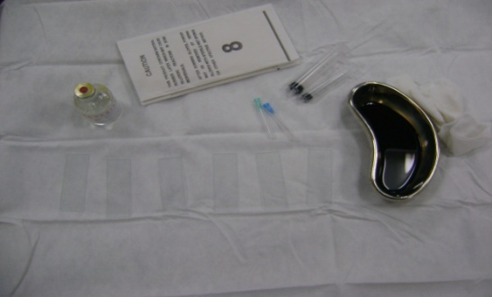
Fig.27 Sterile FNB cart.

The patients were placed in a supine position with their necks exposed down to the level of both clavicles and slightly extended using a small pillow placed under their shoulders.
Before the biopsy, using 7.5 MHz linear probe (Philips HD6) we examined the thyroid nodule by US B- mode and US color Doppler to localize the nodule and determine the safest path for the needle entry by avoiding vital neck structures as trachea, common carotid artery and internal jugular vein and avoiding the vascular parts of the nodules.
We used sterile gauzes immersed in povidine iodine solution for sterilization of all sides of the linear probe then placed it on the sterile cart. We used alcohol-based surgical hand-scrub before wearing the sterile gloves, then we used other sterile gauzes immersed in povidine iodine to sterilize the exposed area of the patient's neck starting in the center and moving out to the periphery.
The linear probe was placed on the patient's neck using the povidine iodine as a coupling agent, the patient was instructed not to swallow or speak during the needle insertion. After the localization of the nodule, in patients requesting local anesthesia 1 ml of 1% loidocaine HCL was injected using 27 G needle and after two minutes a FNB needle was inserted to obtain the sample.
We used different needle sizes to study the correlation between the size of the needle, the adequacy of the samples and the patient's complications following the FNB procedure (Fig.28).

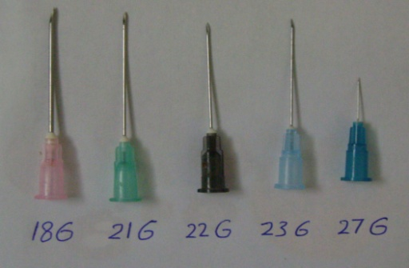
Fig.28 Different needle sizes used in the study.

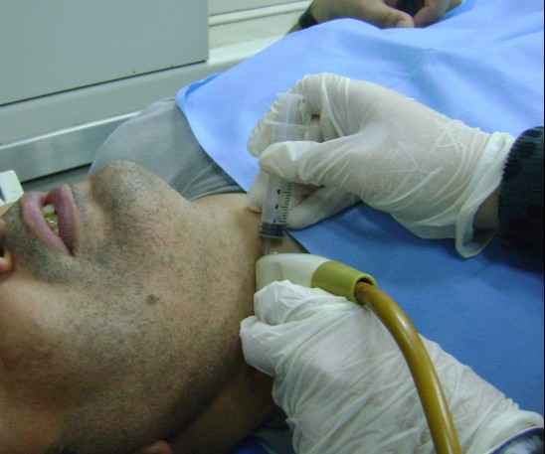
Fig.29 FNB with parallel approach

We used the parallel approach for all the patients, after the needle tip was seen inside the nodule, we applied a minimal amount of negative pressure gradually using the first finger of the right hand and did the to-and-fro needle movements, the needle tip was continuously seen on the US monitor to ensure that the needle tip remains within the target nodule (Fig.29).
After a proper amount of material filled the needle bulb and portion of the syringe, the needle was withdrawn with releasing the negative pressure slowly.
The puncture site was compressed by sterile gauze for 5 minutes, while the main radiologist spread the collected samples on glass slides (Fig.30) and fixed by 95% ethyl alcohol.
Post biopsy US B-mode examination of the biopsied nodule was done to evaluate the presence of possible complications like neck hematoma and hemorrhage inside a cyst.

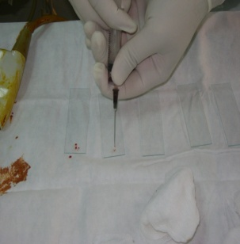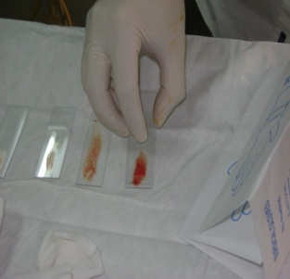
Fig.30 Spreading the sample on glass slides.

The patients were told to sit down and were asked about any pain felt during the procedure, the feeling of dizziness, dyspnea afterwards. The patients were observed for 15 minutes for complications, the puncture site was covered by a small bandage and they were instructed to apply cold fomentation 4-6 times on the same day of the biopsy to help ease the pain and to guard against the bruising.
A follow up interview was done 1 week later, patients were asked about any pain and its duration, whether they used analgesics or not, the presence of bruises, neck swelling, fever, dysphagia and it's duration if present, discharging sinus, hoarseness of voice, cough and hemoptysis.
In our study we evaluate the adequacy of the samples obtained by single needle pass using different needle sizes and their correlation with the clinical and ultraosongraphic characteristic of the nodules, so the cytology results were divided into:
Adequate samples that result in cytological diagnosis.
Inadequate samples (non diagnostic) which include:
Acellular smear, hemorrhagic smears or when less than six clusters of follicular thyroid cells with no identifiable colloid were observed in a preparation.

3. Results
The total number of the biopsied nodules was 41 in 41 patients including38 females (92.7 %) and 3 males (7.3%). The mean age was 38.2 years.
CM cytological material
Table (I) illustrates age and gender distribution of the studied cases, it was found that mean age in patients with adequate CM was 36.9 and was 41.2 in patients with inadequate CM. The result was statistically significant (p-value <0.05).

Table (I): Illustrates the age and gender of the patients:
 | Total  (n:41) | Adequate CM  (n:26) | Inadequate CM  (n:15)
Age (years) | 38.3 | 36.9 | 41.2
Male | 3 | 3 (11.5%) | 0
Female | 38 | 23 (88.5) | 15 (100%)

Table (II) illustrates the patient's complaints; the main complaint among the patients was dyspnea (58.5 %) due to the pressure of the thyroid nodules on the trachea.

Table (II): Illustrates the patient's complaints:
Symptom | No. | %
Dyspnea | 24 | 58.5
Dysphagia | 16 | 39
Dizziness | 1 | 2.4
DM | 6 | 14.6
HTN | 5 | 12.2

MNGmultinodular goiter
Table (III) illustrates the characteristics of the thyroid nodule by clinical examination; the highest inadequate CM was in firm nodules (57.1%) yet it wasn’t statistically significant (p-value= 0.842).
Table (IV) illustrates the site and size of the studied thyroid nodules; the highest adequate CM was obtained from nodules measuring 1-3 cm (80.8%) and the lowest adequate CM was obtained from nodules larger than 3 cm (19.2%), yet the result was statistically insignificant (p-value= 0.622).

Table (III): Illustrates the characteristics of the studided thyroid nodules by clinical examination:
Thyroid nodule | No.  (total:41) | Adequate CM  (no:26) | Inadequate CM  (no:15)
Solitary | 17 (41.5%) | 11(42.3%) | 6 (40%)
MNG | 24 (58.5%) | 15 (57.7%) | 9 (60%)
Palpable | 38 (92.7%) | 24 (92.3%) | 14 (93.3%)
Not palpable | 3 (7.3%) | 2 (7.7%) | 1 (6.7%)
Soft | 15 (39.5%) | 9 (37.5%) | 6 (42.9%)
Firm | 17 (44.7%) | 9 (37.5%) | 8 (57.1%)
Hard | 6 (15.8%) | 6 (25%) | 0

Table (IV): Illustrates the site and size of the studied thyroid nodules:
 | No.  (total: 41) | Adequate CM  (no:26) | Inadequate CM  (no:15)
Site  Right lobe  Isthmus  Left lobe | 17(41.5%)  5 (12.2%)  19 (46.3) | 13 (50%)  4 (15.4%)  9 (34.6%) | 4 (26.7%)  1 (6.6%)  10 (66.7%)
Nodule size (cm)  1-3  >3 | 23 (56.1%)  18 (43.9%) | 21 (80.8%)  5 (19.2%) | 10 (66.7%)  5 (33.3%)

Table (V) illustrates the B-mode and color Doppler characteristics of the studied thyroid nodules; the highest inadequate CM was obtained from nodules with Doppler pattern III (46.7%) yet the result was statistically insignificant (p-value= 0.643).
Table (VI) illustrates the different needle sizes were used during the study; the highest adequate CM was obtained by 21G needle (57.7%) of the total adequate CM however, this result was statistically insignificant (p-value = 0.921).
The lowest adequate CM was obtained by 18G needle (3.8%) of the total adequate CM andthis result was statistically insignificant (p -value = 0.602).
Hemorrhagic smear were obtained by 18G (40%) and 21G (40%) Of the total hemorrhagic smears. This result was statistically insignificant (p-value= 0.732).

Table (V): Illustrates the B-mode US, color Doppler US and thyroid scan characteristics of the studied thyroid nodules:
 | No.  (total: 41) | Adequate CM  (no:26) | Inadequate CM  (no:15)
Echogenicity  Hypoechoic  Isoechoic  Hyperechoic  Heterogenous | 8 (19.5%)  27 (65.9%)  1 (2.4%)  5 (12.2%) | 4 (15.4%)  19 (73.1%)  1 (3.8%)  2 (7.7%) | 4 (26.7%)  8 (53.3%)  0  3 (20%)
Totally solid  Cystic component | 18 (43.9%)  23 (56.1%) | 11 (42.3%)  15 (57.7%) | 7 (46.7%)  8 (53.3%)
Hypoechoic halo | 27 (19.5%) | 19 (73.1%) | 8 (53.3%)
Calcifications  Microcalcification  Macrocalcification | 2(4.9%)  6 (14.6%) | 0  1 (3.8%) | 2 (13.3%)  5 (33.3%)
Doppler pattern  Type I  Type II  Type III | 7 (17.1%)  19 (46.3%)  15 (36.6%) | 4 (15.4%)  14 (53.8%)  8 (30.8%) | 2 (13.3%)  6 (40%)  7 (46.7%)
Cold nodule | 14 (34.2%) | 9 (34.6%) | 5 (33.3%)

Doppler patterntype I: no peripheral or central vascularity, type II: only peripheral vascularity and type III: central vascularity with or without peripheral vascularity.

Table (VI): Illustrates the different variables used during the FNB:
 | No.  (total: 41) | Adequate CM (no:26) | Inadequate CM (no:10) | Hemorrhagic  Smear (no:5)
Local anesthesia  Used  Not used | 19 (46.3%)  22 (53.7%) | 11 (42.3%)  15 (57.7%) | 5 (50%)  5 (50%) | 3 (60%)  2 (40%)
Needle size (G)  18  21  22  23 | 4 (9.8%)  25 (60.9%)  8 (19.8%)  4 (9.8%) | 1 (3.8%)  15 (57.7%)  6 (23.1 %)  4 (15.4%) | 1 (10%)  8 (80%)  1(10%)  0 | 2 (40%)  2 (40%)  1 (20%)  0

Table (VII): Illustrates the patient's complications related to the FNB:
Complications | No.
Immediate  Mild pain  Moderate pain  Dizziness  Bleeding in cyst | 39 (95.1%)  2 (4.9%)  12 (29.3%)  2 (8.7%)
One week follow up  Pain duration (days)  Patients used analgesics  Bruise  Ice pack fomentation | 3 (average)  6 (14.6%)  7 (17%)  24 (58.5%)

Table (VII) illustrates the patient's complications related to the FNB, only 4.9% of the patients reported moderate pain during the procedure, bleeding in cyst occurred in (8.7% ) of the cystic nodules.
One week follow up after the FNB, only 14.6% of the patients used paracetamol for pain relief and the average days for the pain after the FNB was 3 days.
Bruise was reported by 17% of the patients, 58.5% of the patients used ice pack fomentation and compression during the week following the FNB procedure.
To sum up, the adequate CM obtained from the studied thyroid nodules using single needle pass was 63.4% and the inadequate CM was 36.6% (Fig.31).

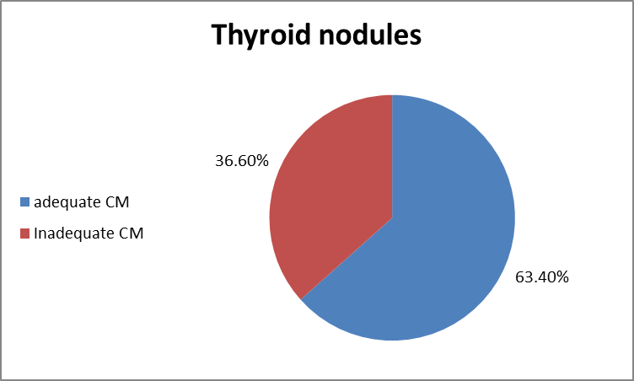
Fig 31. Cytological material adequacy in the studied thyroid nodules.

CASE -1-
36 years old female presented with right neck swelling.

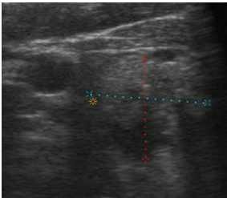

B-mode US revealed a solitary right isoechoic mixed thyroid nodule, measuring 1.6x1.7 cm with macrocalcification and incomplete hypoechoic halo.

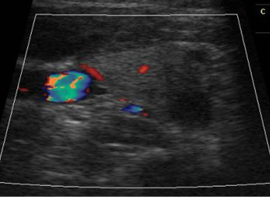

Color Doppler US showed faint peripheral and intranodular vascularity.

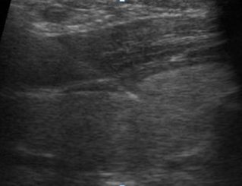

FNB was done using 21G needle after injection of local anaesthesia, one week follow up; the patient reported pain lasted 3 days with no other complications.
Cytology: Adequate CM
CASE-2-
22 years old female presented with bilateral neck swelling.

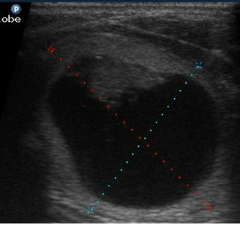

B-mode US examination of the neck revealed MNG, the nodule selected for biopsy was left isoechoic mixed nodule measuring 3.7x3 cm.

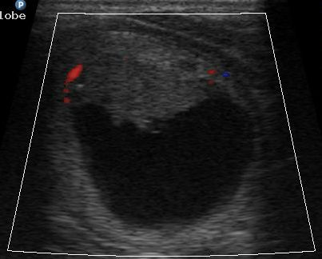

Color Doppler US revealed faint intranodular vascularity.

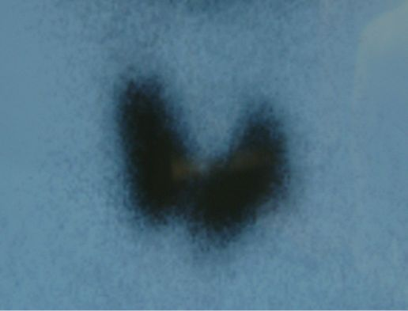

Thyroid scan revealed cold nodule.

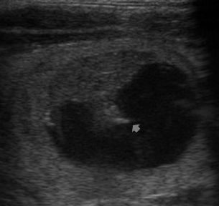

FNB was done using 21G needle without local anesthesia first fluid was aspirated.

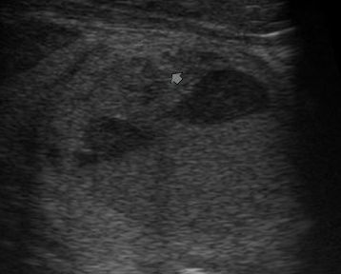

The needle was reinserted to obtain biopsy from the solid part.

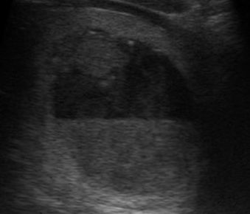

We noticed fluid level and blood clot formation during the FNB which indicates bleeding inside the cyst. One week follow up; the patient reported pain resolved within 2 days with bruise at the site of the needle puncture.
Cytology: Adequate
CASE-3-
44 years old female presented with bilateral neck swelling.

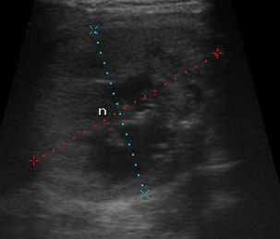

B-mode US revealed MNG, the selected nodule for biopsy was right isoechoic mixed nodule measuring 4x3.5 cm with macrocalcification and microcalcification.

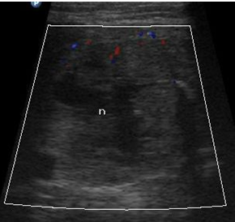

Color Doppler US showed faint peripheral and intranodular vascularity.

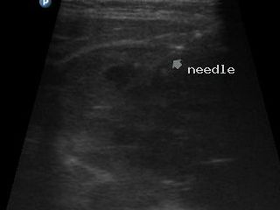

FNB was done using 18G needle after injection of local anesthesia. One week follow up; patient reported that the pain resolved after 5 days with no other complications.
Cytology: Inadequate CM.
CASE-4-
45 years old female presented with bilateral neck swelling.

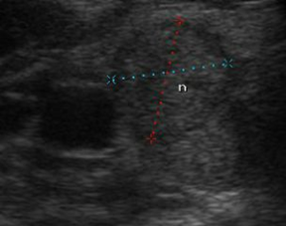
B-mode US revealed MNG, the selected nodule for biopsy was right hypoechoic mixed nodule measuring 1.3x1.2 cm with hypoechoic halo.

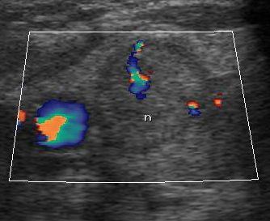

Color Doppler US revealed intranodular vascularity.

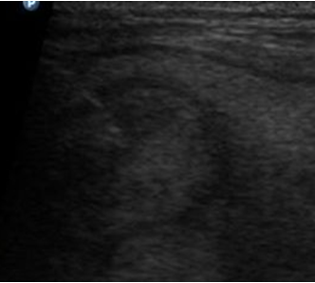

FNB was done using 22G needle without local anesthesia. One week follow up; the patient reported the pain resolved on the same day with no other complications.
Cytology: Adequate CM.
CASE-5-
34 years old female presented with bilateral neck swelling.

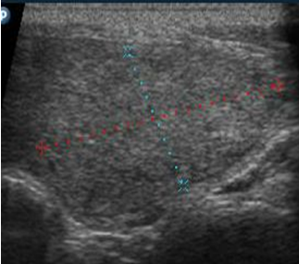

B-mode US examination revealed MNG, the nodule selected for the biopsy was left hyperechoic solid nodule measuring 3x1.6 cm.

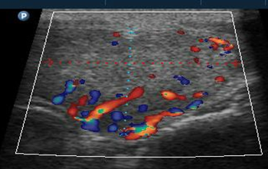

Color Doppler US revealed peripheral and intranodular vascularity.

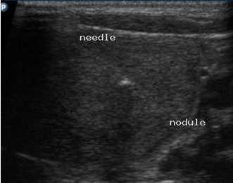

FNB was done using 21G needle without local anesthesia. One week follow up; the patient reported that the pain resolved after 3 days with no other complications.
Cytology: Inadequate CM.
CASE-6-
30 years old female presented with right neck swelling.

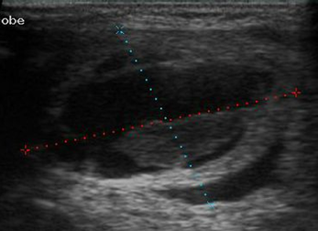
B-mode US examination of the neck revealed solitary right isoechoic mixed thyroid nodule measuring 3x2.4 cm.

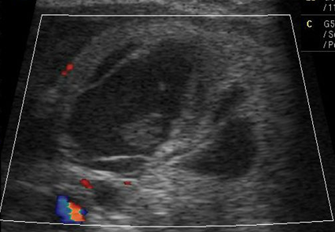

Color Doppler US examination of the nodule revealed very faint peripheral vascularity.

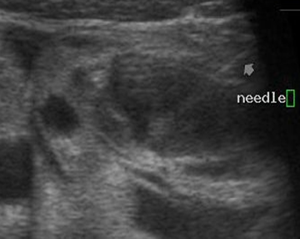

FNB was done using 22G needle without local anesthesia. One week follow up; the patient reported that the pain resolved after 2 days with no other complications.
Cytology: Adequate CM.
CASE-7-
45 years old female presented with right neck swelling.

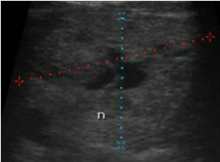
B-mode US revealed solitary right isoechoic mixed nodule measuring 4x3cm.

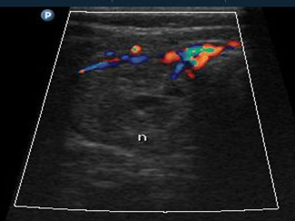

Color Doppler US revealed incomplete peripheral vascularity.

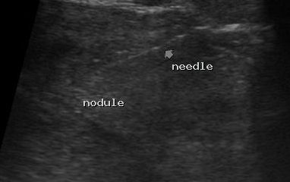

FNB was done using 21G needle without local anesthesia. One week follow up; the patient reported that the pain resolved in 2 days with no other complications.
Cytology: Adequate CM.
CASE-8-
39 years old female presented with left neck swelling.

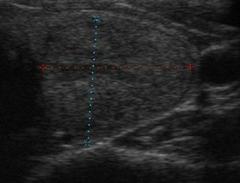
B-mode US examination of the thyroid gland revealed solitary left isoechoic solid nodule measuring 2x2 cm.

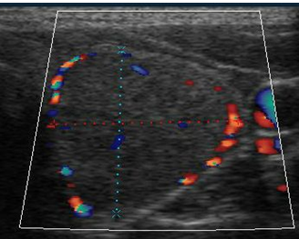

Color Doppler US showed peripheral vascularity with dots of intranodularvascularity.

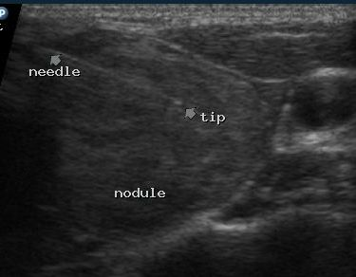

FNB was done using 21G needle without local anesthesia. One week follow up; the patient reported that the pain resolved on the same day with no other complications.
Cytology: Inadequate CM
CASE-9-
26 years old female presented with left neck swelling.

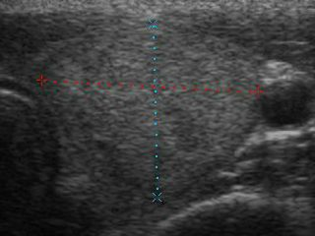
B-mode US revealed solitary left isoechoic solid nodule measuring 2x1.7 cm.

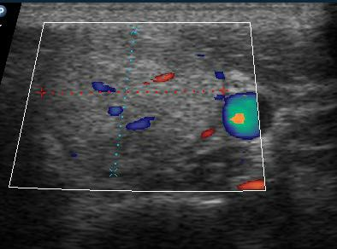

Color Doppler US revealed peripheral and intranodular vascularity.

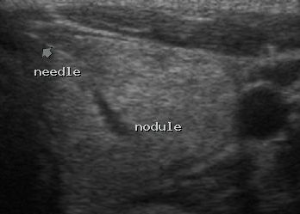

FNB was done using 23G needle without local anaesthesia. One week follow up; the patient reported that the pain resolved on the same day.
Cytology: Adequate CM.
CASE-10-
13 years old female presented with left neck swelling.

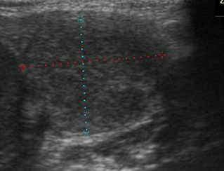

B-mode US examination of the thyroid revealed left solid heterogenous nodule measuring 2x1.6 cm.

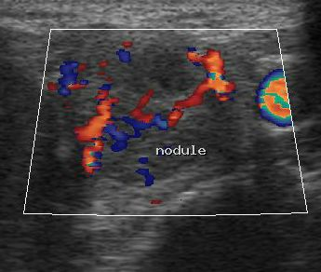

Color Doppler US showed peripheral and intranodular vascularity.

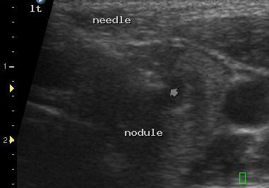

FNB was done using 21G needle after injection of local anesthesia. One week follow up; the patient reported that the pain resolved after 4 days and bruise at the site of the needle puncture.
Cytology: Inadequate CM.

4. Discussion
A thyroid nodule is discrete lesion within thyroid gland. it may or may not be palpable. Palpable thyroid nodules are usually discovered or physical examination, but could be felt by patient initially. Non-palpable nodules often are incidentally discovered on CT and have termed (incidentalomatous) Non palpable nodules have the same risk of malignancy as palpable nodules of the same size (Volander et al, 2010)
High resolution thyroid US is the most useful diagnostic tool for evaluation thyroid nodules. Numerous published studies report the diagnostic accuracy of thyroid US for thyroid nodules, and several US characteristics have been introduced as potential predictors of thyroid malignancy (Horvath et al, 2009 & Moon et al, 2011). However, there is considerable overlap of the US characteristics between benign and malignant thyroid nodules in many reports (Salmasligolu et al, 2008, Lee et al, 2009 & Kim et al, 2010).
Scintigraphy is not accurate enough to predict malignancy (Leenhardt, 2009). Therefore, FNAB has emerged as standard diagnostic test for the preoperative evaluation of intra thyroid lesions (Chammas et al, 2005).
Fine needle aspiration (FNA) biopsy of thyroid nodules is minimally invasive and safe procedure that is usually performed on an outpatient basis (Hamburger, 1994)
Either palpation or ultrasound (US may be used for guidance of FNA (Yokozawa et al, 1996 & Wiest et al, 1998)
Several studies have shown that US guidance increase the sensivity and specificity of thyroid FNABs and decrease the inadequate cytological material (CM) rate especially in posteriorly located nodules too small for palpation, and with underlying disease including Graves and hashimoto’s thyroiditis that make palpation difficult (Layfield et al, 2009 & Gul et al, 2009).
Real time US permits visualization of the needle within the lesion, thereby facilitating accurate biopsy of small non palpable nodules, even in palpable thyroid nodule, US guidance is superior to palpation for obtaining adequate material for an accurate cytologic evaluation (Yokozawa et al, 1996).
In our study 5 nodules were previously biopsied by palpation and their CM were insufficient, after US guided biopsy the CM of 4 cases were sufficient as US guidance enabled the proper localization of the nodule and real time monitoring of the needle during the biopsy.
In addition, US evaluation of nodule before biopsy ensures that the solid component of heterogeneous nodules is sampled. targeting of the hypoechoic nodules, nodules with poorly defined, indistinct, or blurred margins, nodules with ashape greater in anteroposterior dimension than transverse dimension, the solid component of heterogeneous nodules, and nodules with microcalcification increase the rate of diagnosis of malignancies in patients with multiple nodules (Kim et al, 2002 & Namgoong et al, 2004).
The routine use of this procedure has successfully increased in the detection rate of malignant nodules after thyrodectomy therefore US FNAC is considered the gold –standers method for diagnostic evaluation of the thyroid nodules because of its safety, accuracy, and cost-effectiveness (kim et al, 2011) the number of biopsies performed with the guidance of US has increased in clinical practice (Algin et al, 2010).
However, thyroid US FNAC has not yet been standraised and different technical procedures are applied in various institutional or by various physicians. There for, the efficacy of thyroid US FNACs have been reported discrepantly ( kim et al, 2011)
Yokozawa et al. introduced a free-hand technique with partial US guidance without the application of local anesthesia (Yokozawa et al, 1995).
Whereas Rausch et al demonstrated the use of Doppler vascular mapping and real time US guidance ( Rausch et al, 2001)
In our study we used free hand technique with complete US guidance and with the application of local anesthesia in 46.3 % of cases.
The allowable number of needle passes or sampling necessary to obtain an adequate specimen for cytology is debated (Redman et al, 2006, degirmenci et al, 2007 & Pitman et al, 2008).
Haugen et al reported that as the number of aspiration increased, the false negative rate of FNAC decreased (Haugen et, al 2002).
However, multiple needle passes can include undesirable histological changes in the target nodules. These changes, which include papillary Endothelial hyperplasia, hemorrhage, vascular thrombosis, or fibrosis, may render cytological evaluation difficults (Degirmenci et al, 2007).
The literature reveals highly variable rate of achieving adequate cytological material (CM), varying from 68-96.6 % authors generally performed two to five aspirations for each nodule (Ravetto et al, 2000, poller et al, 2000 & et al, 2000).
In our study, using a single needle pass for FNB the adequate CM rate was 63.4% this is close to degirmenci et al who reported adequate CM as 66.4 % (Degirmenci et al, 2007) and inci et al who reported the adequate CM rate as 68.1 % while Kim et al reported adequate CM rate as 88.5% (Inci et al, 2012 & Kim et al, 2011).
The current FNAB needle sizes commonly range from 20-to25-g.
However, a well acceptedguidline for a suitable needle size for FNB has not been established (Inci et al, 2012).
Therefore in this study we aimed to evaluate the most appropriate needle size for FNB of thyroid modules; 18,21, and 23-g needles were compares with respect to providing better specimens in terms of adequate CM and there was no significant difference the dour different needle sizes we used.
In the literature, FNB with thick needles (14 to 18 G) may yield more hemorrhagic specimens. Therefore, thin needles (20 to 25 G) were recommended for FNB of thyroid nodules, another advantage of thin needles is that they are more comfortable for patients (Tangpricha et al, 2001 & suen 2002).
Inciet reported that the thin needles supply aspirates with less cellular material but without apparent bleeding (Inci et al, 2012).
In our study 33.3 % of inadequate sample were hemorrhagic, 40% from 21 G needles, 40 % from 18G needles and 20 % from 22G needles.
Two postoperative studies showed that there was no significant difference in diagnostic yield was found between cellular specimens obtained with 23 and 27G needles (Hanbidge et al, 1995) and specimens obtained with 21 and 25G needles (Tangpricha et al, 2001).
In our study, (3.8%) of adequate CM was obtained by 18G needles, (57.7%) by 21G needles, (23.1%) by 22G needles and (15.4%) by 23G needles but there was no statistically significant difference in adequacy between 18,21,22 or 23G needles.
The literature mentions several reasons for inadequate CM, including technical errors and palpation-guided FNB, and cystic changes of the nodules (Rosen et al, 1993 & Moon et al, 2008).
Alexander et al. reported that the cystic content of the nodule were the only significant and inadequate predictors of inadequate CM (Alexander et al, 2002).
However, in our study the highest adequate CM rate was 65% in nodules with cystic component and the adequate CM rate was 61% in totally solid nodules with no statistically significant difference between adequate CM obtained from totally solid nodules and nodules with cystic component.
Another important result of Inci et al is that the inadequate CM rates of heterogeneous nodules were significantly higher than that for other types of nodules (Inci et al, 2012). This situation may be related to the fibrotic, hemorrhagic, necrotic and increased cellular structure within the heterogeneous nodules (Gumus et al, 2010).
Degimenci et al. reported that the highest specimen adequacy rate was observed among nodules smaller than 1 cm (76.4%) and the lowest rate was observed among nodules smaller than 3 cm (56.9%) (degirmenci et al, 2007).
This is close to our study where is the lowest adequate CM rate was observed in nodules larger than 3 cm (19.2%), however the highest specimen adequacy rate was observed in nodules measuring 1-3 cm (80.8%) with no statistical difference in the adequate CM rate between nodules of different sizes.
Inci et al also found that there was no statistical difference in the adequate CM rate between nodules of different sizes, the highest rate was observed in nodules smaller than 1 cm (73.5%), and the lowest rate was in nodules larger than 3 cm (61%) (Inci et al 2012).
Degirmenci et al concluded that the lower rate in larger nodules probably resulted from increased vascularity and the larger size of blood vesicles, with resultant blood staining of the material obtained by fine- needle biopsy. Another probable cause of the inadequacy in largeg nodules is that larger nodules are more often heterogeneous nodules containing cystic and necrotic areas (Degirmenci et al, 2007).
We found significant correlation between inadequate CM and patient age, the mean age was36.9 in patient with adequate CM and it was 41.2 in patient with inadequate CM, this similar to Inci et al who reported significant correlation between inadequate CM and patient age.
In their study the mean age in patients with adequate CM was 44and it was 49 in patients with in adequate CM. the higher inadequacy in elderly patients may be related to the increased rate of heterogenous nodules in elderly patients and to their physical condition, such as stiffness of the cervical spine, which makes it difficult to obtain the appropriate patient positioning and cooperation between operator and the patient necessary for optimal biopsy (inci et al, 2012).
On of the advantages of US –FNB is its application without local anesthesia (Kim et al, 2009). Kim et al performed US-FNB without local anesthesia and did not result in significant pain when compared to procedures with local anesthesia (Kim et al, 2011)
In our study we performed FNB with local anesthesia in46.3%of patients and without local anesthesia in 53.7% of patients and there was no significant difference between the two groups regarding the pain during FNB procedure.
Kim et al stated that performing US-FNB without local anesthesia shortens the duration of the procedure and can prevent that micro- air- bubbles formation by lidocaine injection may cause a disturbance for us guidance. However, local anesthesia is used when two or more needle punctures are performed in US-FNB of a thyroid nodule (Kim et al 2011).
In our study we used the parallel approach in all nodules. According to Kim et al, using perpendicular puncture for US-FNB shortens the distance between the puncture site and the target nodule, it is superior to parallel puncture technique when small diameter nodules (<0.5cm) or deep seated nodules are targeted. Recently, one of the authors has reported the high rate of adequacy and efficacy of US-FNB using perpendicular puncture for the thyroid nodules of <.5 cm diameter (Kim et al 2009).
During the entire duration of the perpendicular puncture, the needle tip should be continuously monitored by US to prevent vascular, tracheal or esophageal injury. on the other hand, a parallel puncture, which is preferred by some operators in other institutions, is advantageous because it allows easy identification of the entire needle length by US (kim et al, 2011).
Some investigators have reported that fine needle capillary biopsies are superior to fine needle aspiration biopsies because they extract adequate sample of high quality without any blood contamination (Hamaker et al, 1995 and ceresini et al, 2004).
Some other investigators believe that blood contamination or cellular trauma is more common in FNB procedures but better diagnostic yields can be achieved when fine needle capillary sampling and fine needle aspiration sampling are combined (Haddadi-nezhad et al, 2003, Tublin et al, 2007 and Romitelli et al, 2009).
Kim et al reported that adequate sampling was achieved despite small amount of aspirate (1ml). Based on his study, it is preferable that Kim et al reported that adequate sampling was achieved despite small amount of aspirate (1 ml). based on his study, it is preferable that the “ mixed sampling technique” is performed by a single operator without an assistant, using the “two-hand technique” while taking the syring-needle unit in the right hand and the US probe in the left. Therefore, it is convincing that the use of the “mixed sampling technique” enables one to obtain both the advantages of fine-needle capillary and fine-needle aspiration sampling, resulting in an increase in the adequacy of a US-FNB, simplification of the procedure and shortening of the procedure duration (Kim et al, 2011). In our study we used the previously mentioned “mixed sampling technique”.
Baloch et al reported that immediate on- site cytologic examination it was previously reported that immediate onsite examination by a cytopathologist of material collected at FNB helps avoid repeat biopsy (Baloch et al, 2000).
However, O’ Malley et al did not find a statistically significant difference in specimen adequacy between FNB biopsies of thyroid nodules with immediate cytologic analysis and those with delayed analysis, and thery stated that immediate cytologic analysis prolonged the biopsy procedure considerably (O’Malley et al, 2002).
In our study all the CM collected underwent delayed analysis.
Complications due to thyroid US-FNB include pain, vasovagal reaction, acute transient swelling, infection, recurrent laryngeal nerve palsy, small hematoma along the needle path, bruising, vascular injury, hemorrhage, tracheal, esophageal puncture, needle track seeding and needle track sinus (Polyzos & anastasilakis, 2009).
Kim et al reported that were no major complication, but pain was only reported by a small number of patients (Kim et al, 2011).
In our study, we interviewed patients one week after FNB and the only reported complications were mild pain with average 3 days duration abd bruises in 17% of patients. there was no statistically significant correlation between the needle sizes we used and the pain duration reported by the patients.
This may be due to several technical factor we considered during the study, such as single –needle pass, short duration of procedure, accurate nodule targeting and close monitoring of the needle tip under US guidance during the biopsy while using the parallel puncture technique in order to prevent vascular injury or other significant complication.

Summary
Thyroid nodules are common in clinical practice, differentiating between benign and malignant nodule is essential step in their management.
Clinical assessment of the thyroid nodules is the first step in their evaluation; male gender, patient younger than 14 years old or older than 70 years old, history of neck radiation, family history of medullary carcinoma, hard fixed nodule and cervical adenopathy are factor suggesting increased risk of malignant potential.
Normal or elevated TSH level mandates further evaluation of the nodule to exclude malignancy.
B-mode US and color Doppler US are the conventional imaging methods used to detected non palpable thyroid nodules and further evaluate the palpable nodules.

Hypoechoic pattern, Irregular margins, a more-tall-than-wide shape, Microcalcifications, Intranodular vascular spots are identified as a criteria associated with increased malignancy risk.
Cytological examination of material obtained by fine needle biopsy (FNB), due to its high sensitivity and specificity, is the best single test for differentiating malignant from benign thyroid lesions.
FNB can be performed palpation-guided or ultrasound-guided, non diagnostic biopsies were decreased from 14% in free hand to 8% using US-guided technique.
The aim of our work is to evaluate the technical aspects of US-guided FNB of thyroid nodules and patient's complications related to the procedure.
Two approaches are used perpendicular approach and parallel approach. During the experimental invitro visualization of the needle we found that the perpendicular approach is more difficult than the parallel approach because the needle tip is the only visible part on us imaging, so it requires an experienced operator.
The study was conducted on 41 nodules using the parallel approach, we used local anesthesia in 19 cases (46.3%), and there was no difference between cases done with local anesthesia and cases done without local anesthesia regarding the needle visualization or the patient's cooperation during the biopsy. Injection of local anesthesia before the biopsy only lengthened the procedure's duration for 2-3 minutes.
FNB is usually performed by 2-5 needle passes after injection of local anesthesia, we obtained the biopsies using single needle pass and the adequate CM was 63.4%.
We used 18G, 21G, 22G, 23G needles; the CM adequacy was statistically insignificant among them.
There were no major complications after the FNB, 2 patients had bleeding inside a cyst (8.7%) of the total patients with mixed nodules, 7 patients (17%) reported bruise at the site of needle puncture. The average duration for the post biopsy pain was 3 days.

Recommendation:
We recommend examination of the thyroid nodule by B-mode and color Doppler US before the FNB to select the suspicious nodule and to plan the safest path for needle insertion.
FNB of thyroid nodule is tolerable without application of local anesthesia especially if the FNB is done using single needle pass.
We recommend using 21G needle as it obtained the highest adequate CM in our study.
Single needle pass is enough for obtaining adequate CM, it's tolerable by the patients and it causes less complication.
We recommend continuous monitoring of the needle by US guidance during the FNB to target the nodule accurately and to avoid complications.

References
- Alexander, E., Heering, J., Benson, C., Frates, M., Doubilet, P., Cibas, E. and Marqusee, E. (2002). Assessment of Nondiagnostic Ultrasound-Guided Fine Needle Aspirations of Thyroid Nodules. The Journal of Clinical Endocrinology & Metabolism, 87(11), pp.4924-4927.
- Algin, O., Algin, E., Gokalp, G., Ocakoğlu, G., Erdoğan, C., Saraydaroglu, O. and Tuncel, E. (2010). Role of Duplex Power Doppler Ultrasound in Differentiation between Malignant and Benign Thyroid Nodules. Korean J Radiol, 11(6), pp.594-602.
- Baloch, Z., Tam, D., Langer, J., Mandel, S., Li Volsi, V. and Gupta, P. (2000). Ultrasound-guided fine-needle aspiration biopsy of the thyroid: Role of on-site assessment and multiple cytologic preparations. Diagn. Cytopathol., 23(6), pp.425-429.
- Ceresini, G., Corcione, L., Morganti, S., Milli, B., Bertone, L., Prampolini, R., Petrazzoli, S., Saccani, M., Ceda, G. and Valenti, G. (2004). Ultrasound-Guided Fine-Needle Capillary Biopsy of Thyroid Nodules, Coupled with On-Site Cytologic Review, Improves Results. Thyroid, 14(5), pp.385-389.

Chammas, M., Rene, G., Ilka, R., Azzo, W., Nestor, B., Marcelo, D., Alberto, F., Giovanni, G. (2005). Thyroid nodules: evaluation with power Doppler and duplex Doppler ultrasound. Otolaryngology Head Neck surg, 132(6), pp. 874-882.
- Dean, D. and Gharib, H. (2008). Epidemiology of thyroid nodules. Best Practice & Research Clinical Endocrinology & Metabolism, 22(6), pp.901-911.
- Degirmenci, B., Haktanir, A., Albayrak, R., Acar, M., Sahin, D., Sahin, O., Yucel, A. and Caliskan, G. (2007). Sonographically guided fine-needle biopsy of thyroid nodules: the effects of nodule characteristics, sampling technique, and needle size on the adequacy of cytological material. Clinical Radiology, 62(8), pp.798-803.
- Gul, K., Ersoy, R., Dirikoc, A., Korukluoglu, B., Ersoy, P., Aydin, R., Ugras, S., Belenli, O. and Cakir, B. (2009). Ultrasonographic evaluation of thyroid nodules: comparison of ultrasonographic, cytological, and histopathological findings. Endocr, 36(3), pp.464-472.
- Gümüş, M., Cay, N., Algin, O., Ipek, A., Unlu Ersoy, R., Belenli, O. and Ugras, S. (2010). Comparison of 21-g and 27-g needles for the sample adequacy in the aspiration biopsy of the thyroid nodules. Diagnostic and Interventional Radiology, 18(1), pp.102-105.
- Haddadi-Nezhad, S., Larijani, B., Tavangar, S. and Nouraei, S. (2003). Comparison of Fine-Needle-Nonaspiration with Fine-Needle-Aspiration Technique in the Cytologic Studies of Thyroid Nodules. Endocr Pathol, 14(4), pp.369-374.
- Hamaker, R., Moriarty, A. and Hamaker, R. (1995). Fine-needle biopsy techniques of aspiration versus capillary in head and neck masses. The Laryngoscope, 105(12), pp.1311-1314.
- Hamburger, J. (1994). Diagnosis of thyroid nodules by fine needle biopsy: use and abuse. The Journal of Clinical Endocrinology & Metabolism, 79(2), pp.335-339.
- Hamburger, J. (1994). Diagnosis of thyroid nodules by fine needle biopsy: use and abuse. The Journal of Clinical Endocrinology & Metabolism, 79(2), pp.335-339.
- Hanbidge, A., Arenson, A., Shaw, P., Szalai, J., Hamilton, P., Leonhardt, C. (1995). Needle size and sample adequacy in ultrasound-guided biopsy of thyroid nodules. Can. Assoc. Radiol. J, 46(3), pp.199–201.
- Haugen, B., Woodmansee, W. and McDermott, M. (2002). Towards improving the utility of fine-needle aspiration biopsy for the diagnosis of thyroid tumours. Clinical Endocrinology, 56(3), pp.281-290.
- Horvath, E., Majlis, S., Rossi, R., Franco, C., Niedmann, J., Castro, A. and Dominguez, M. (2009). An Ultrasonogram Reporting System for Thyroid Nodules Stratifying Cancer Risk for Clinical Management. The Journal of Clinical Endocrinology & Metabolism, 94(5), pp.1748-1751.
- Horvath, E., Majlis, S., Rossi, R., Franco, C., Niedmann, J., Castro, A. and Dominguez, M. (2009). An Ultrasonogram Reporting System for Thyroid Nodules Stratifying Cancer Risk for Clinical Management. The Journal of Clinical Endocrinology & Metabolism, 94(5), pp.1748-1751.
- İnci, M., Özkan, F., Yüksel, M., Şalk, İ. and Şahin, M. (2012). The effects of sonographic and demographic features and needle size on obtaining adequate cytological material in sonography-guided fine-needle aspiration biopsy of thyroid nodules. Endocrine, 43(2), pp.424-429.
- Kim, D., Choo, H., Park, J., Lee, E., Kim, S., Jung, S. and Ryu, J. (2011). Ultrasonography-guided fine-needle aspiration cytology for thyroid nodules: An emphasis on one-sampling and biopsy techniques. Diagn. Cytopathol., 40(1), pp. 48-54.
- Kim, D., Lee, E., In, H. and Kim, S. (2010). Sonographic Differentiation of Partially Cystic Thyroid Nodules: A Prospective Study. American Journal of Neuroradiology, 31(10), pp.1961-1966.
- Kim, D., Rho, M. and Kim, K. (2009). Ultrasound-Guided Fine-Needle Aspiration Biopsy of Thyroid Nodules: is it Necessary to Use Local Anesthesia for the Application of One Needle Puncture?. Korean J Radiol, 10(5), p.441-446.
- Kim, E., Park, C., Chung, W., Oh, K., Kim, D., Lee, J. and Yoo, H. (2002). New Sonographic Criteria for Recommending Fine-Needle Aspiration Biopsy of Nonpalpable Solid Nodules of the Thyroid. American Journal of Roentgenology, 178(3), pp.687-691.
- Layfield, L., Cibas, E., Gharib, H. and Mandel, S. (2009). Thyroid Aspiration Cytology: Current Status. CA: A Cancer Journal for Clinicians, 59(2), pp.99-110.
- Layfield, L., Cibas, E., Gharib, H. and Mandel, S. (2009). Thyroid Aspiration Cytology: Current Status. CA: A Cancer Journal for Clinicians, 59(2), pp.99-110.
- Lee, M., Kim, E., Kwak, J. and Kim, M. (2009). Partially Cystic Thyroid Nodules on Ultrasound: Probability of Malignancy and Sonographic Differentiation. Thyroid, 19(4), pp.341-346.
- Leenhardt, L. (2009). Management of thyroid nodule. Radiol, 90(3), pp.354-61.
- Ma, J., Ding, H., Xu, B., Xu, C., Song, L., Huang, B. and Wang, W. (2014). Diagnostic Performances of Various Gray-Scale, Color Doppler, and Contrast-Enhanced Ultrasonography Findings in Predicting Malignant Thyroid Nodules. Thyroid, 24(2), pp.355-363.
- Moon, W., Baek, J., Jung, S., Kim, D., Kim, E., Kim, J., Kwak, J., Lee, J., Lee, J., Lee, Y., Na, D., Park, J. and Park, S. (2011). Ultrasonography and the Ultrasound-Based Management of Thyroid Nodules: Consensus Statement and Recommendations. Korean J Radiol, 12(1), pp.1-14.
- Moon, W., Jung, S., Lee, J., Na, D., Baek, J., Lee, Y., Kim, J., Kim, H., Byun, J. and Lee, D. (2008). Benign and Malignant Thyroid Nodules: US Differentiation, Multicenter Retrospective Study 1. Radiology, 247(3), pp.762-770.
- Nguyen, Q. T. et al. (2015) ‘Diagnosis and treatment of patients with thyroid cancer.’, American health & drug benefits. Engage Healthcare Communications, LLC, 8(1), pp. 30–40. Available at: http://www.ncbi.nlm.nih.gov/pubmed/25964831 (Accessed: 29 October 2018).
- O’Malley, M., Weir, M., Hahn, P., Misdraji, J., Wood, B. and Mueller, P. (2002). US-guided Fine-Needle Aspiration Biopsy of Thyroid Nodules: Adequacy of Cytologic Material and Procedure Time with and without Immediate Cytologic Analysis1. Radiology, 222(2), pp.383-387.
- Pitman, M., Abele, J., Ali, S., Duick, D., Elsheikh, T., Jeffrey, R., Powers, C., Randolph, G., Renshaw, A. and Scoutt, L. (2008). Techniques for thyroid FNA: A synopsis of the National Cancer Institute Thyroid Fine-Needle Aspiration State of the Science Conference. Diagn. Cytopathol., 36(6), pp.407-424.
- Poller, D., Ibrahim, A., Cummings, M. et al. (2000). Fine-needle aspiration of the thyroid. Cancer cytopathology, 90(4), pp. 239–244.
- Polyzos, S. and Anastasilakis, A. (2009). Clinical complications following thyroid fine-needle biopsy: a systematic review. Clinical Endocrinology, 71(2), pp.157-165.
- Rausch, P., Nowels, K., Jeffrey, R. (2001). Ultrasonographically guided thyroidbiopsy: A review with emphasis on technique. J Ultrsound Med, 20(1), pp.79–85.
- Ravetto, C., Colombo, L. and Dottorini, M. (2000). Usefulness of fine-needle aspiration in the diagnosis of thyroid carcinoma. Cancer, 90(6), pp.357-363.
- Redman, R., Zalaznick, H., Mazzaferri, E. and Massoll, N. (2006). The Impact of Assessing Specimen Adequacy and Number of Needle Passes for Fine-Needle Aspiration Biopsy of Thyroid Nodules. Thyroid, 16(1), pp.55-60.
- Romitelli, F., Di Stasio, E., Santoro, C., Iozzino, M., Orsini, A. and Cesareo, R. (2009). A Comparative Study of Fine Needle Aspiration and Fine Needle Non-Aspiration Biopsy on Suspected Thyroid Nodules. Endocrine Pathology, 20(2), pp.108-113.
- Rosen, I., Azadian, A., Walfish, P., Salem, S., Lansdown, E. and Bedard, Y. (1993). Ultrasound-guided fine-needle aspiration biopsy in the management of thyroid disease. The American Journal of Surgery, 166(4), pp.346-349.
- Salmaslıoğlu, A., Erbil, Y., Dural, C., İşsever, H., Kapran, Y., Özarmağan, S. and Tezelman, S. (2008). Predictive Value of Sonographic Features in Preoperative Evaluation of Malignant Thyroid Nodules in a Multinodular Goiter. World Journal of Surgery, 32(9), pp.1948-1954.
- Suen, K. (2002). Fine-needle aspiration biopsy of the thyroid. CMAJ, 167(5), pp.491–495.
- Tangpricha, V., Chen, B., Swan, N., Sweeney, A., de las Morenas, A. and Safer, J. (2001). Twenty-One–Gauge Needles Provide More Cellular Samples than Twenty-Five–Gauge Needles in Fine-Needle Aspiration Biopsy of the Thyroid but may not Provide Increased Diagnostic Accuracy. Thyroid, 11(10), pp.973-976.
- Tublin, M., Martin, J., Rollin, L., Pealer, K., Kurs-Lasky, M., Ohori, NP. (2007). Ultrasound-guided fine-needle aspiration versus fine-needle capillary sampling biopsy of thyroid nodules: Does technique matter? J Ultrasound Med, 26(12), pp.1697–1701.
- Vorländer, C., Wolff, J., Saalabian, S., Lienenlüke, R. and Wahl, R. (2010). Real-time ultrasound elastography—a noninvasive diagnostic procedure for evaluating dominant thyroid nodules. Langenbeck's Archives of Surgery, 395(7), pp.865-871.
- Wiest, P., Hartshorne, M., Inskip, P., et al. (1998). Thyroid palpation versus high-resolution thyroid ultrasonography in the detection of nodules. J Ultrasound Med, 17(8), pp.487–496.
- Yokozawa, T., Fukata, S., Kuma, K., Matsuzuka, F., Kobayashi, A., Hirai, K., Miyauchi, A. and Sugawara, M. (1996). Thyroid Cancer Detected by Ultrasound-Guided Fine-Needle Aspiration Biopsy. World Journal of Surgery, 20(7), pp.848-853.
- Yokozawa, T., Miyauchi, A., Kuma, K. and Sugawara, M. (1995). Accurate and Simple Method of Diagnosing Thyroid Nodules by the Modified Technique of Ultrasound-Guided Fine Needle Aspiration Biopsy. Thyroid, 5(2), pp.141-145.

7/1/2019

