Demulsification of Emulsified Crude Oil Using Local Demulsifier And Urea

¹Ejikeme, Patrick C. N., ¹Ejikeme, Ebere M,. ²Okechukwu, Judith O.

¹Department of Chemical Engineerng, Enugu State University of Science and Technology, Enugu, Nigeria.
²Department of Pure and Industrial Chemistry, University of Nigeria, Nsukka, Nigeria
ebemoca@yahoo.com, pykecyril@yahoo.com, judith4life45@yahoo.com

Abstract: This work studied the demulsification of emulsified crude oil using locally formulated demulsifier and commercial demulsifer (Urea). Water in oil emulsion was prepared by mixing crude oil with synthetic brine of 2.4% salinity in the ratio of 1:1v/v. Effect of process factors; time, dosage of demulsifier and temperature on the chemical demulsification process was studied. FTIR analysis of the raw, emulsified and demulsified crude oils as well as the formulated demulsifier was studied. It was observed that these process factors had effect on the water separated. Increase in the temperature and time increased the amount of water separated after demulsification. Increase in dosage of formulated demulsifier increased the amount of water separated at lower time interval, but the separated water was constant at higher time interval. Use of solvent as a carrier was seen not to have effect on the water separated. FTIR of the formulated demulsifier confirmed it as anionic in nature, while urea was cationic in nature. It was observed that the formulated demulsifier was more effective than urea in water separation. 63% of water was separated using formulated demulsifier, while 35% of water was separated using urea. The basic sediment and water (BS & W) contents of the crude oil demulsified with both demulsifiers were lower than that on the raw crude oil.
[Ejikeme, Patrick C. N., Ejikeme, Ebere M,. Okechukwu, Judith O. Demulsification of Emulsified Crude Oil Using Local Demulsifier And Urea. Researcher 2019;11(7):1-8]. ISSN 1553-9865 (print); ISSN 2163-8950 (online). http://www.sciencepub.net/researcher. 1. doi:10.7537/marsrsj110719.01.

Keywords: BS & W, Crude oil, Demulsifier, Emulsification, FTIR, Urea

1. Introduction
Emulsion of oil and water is one of many problems encountered in the petroleum industry (Swindle et al., 2010) Although the formation of heavy crude oil-in-water (O/W) emulsions has been used as a technical strategy to reduce the viscosity of heavy oils to facilitate their transportation (MartõÂnez-Palou et. al., 2011; MartõÂnez-Palou and Aburto (2015). According to Langevin et al., (2004), the presence of water is typically undesirable and can result in high pumping costs and pipeline corrosions and increase the cost of transportation. This word “emulsion” is defined as a system in which one liquid is relatively distributed or dispersed, in the form of droplets, in another substantially immiscible liquid (Salam et. al., 2013). Demulsification or emulsion breaking is used to treat the problem of water-in-oil emulsion. There are several physical (thermal, mechanical, electrical) and chemical (addition of demulsifiers) methods currently used to break crude oil emulsions and dehydrate crude oil (MartõÂnez-Palou et. al., 2015). Chemical demulsifiers is still the most widely employed method to break crude oil emulsions but in many cases these demulsifiers are toxic and generate environmental problem and can affect the health of operating personnel (Henderson et. al., 1999).
Emulsion breaking is achieved as a result of three main mechanisms known as flocculation, coagulation and coalescence. The research is focused on demulsification of emulsified crude oil using locally prepared demulsifier and commercial demulsifier (Urea).

2. Materials And Methods
2.1. Raw materials
Crude oil sample, commercial demulsifier (urea) and materials used for the formulation of local demulsifier were obtained from De-Cliff Integrated Company, Ogbeta main market in Enugu state of Nigeria.
2.2. Methods
2.2.1. Preparation of emulsifier
The preparation of emulsifier was done according to the work done by Oruwori and Ikiensikiame (2010). The crude oil was mixed with synthetic oil field brine (1:1 v/v). The emulsification was carried out using mixer set at medium speed for 2.5 min.
2.2.2. Preparation of synthetic oil field brine
The Brine was prepared by dissolving NaCl in water in order to obtain the required salinity similar to the average Niger-delta field which is about 2.4% (Oruwori, and Ikiensikiame, 2010). Equation below was used to calculate the concentration of sodium hydroxide needed to prepare 2.4% salinity.
$Salinity \left(Y\right)= 8.3566X-0.3582$
Where X = NaCl concentration (g/mol)
Y = Salinity (%w/w), % in per thousand

2.2.3. Preparation of local demulsifier
Table 1 below shows the components used in formulating the local demulsifier, the function and the quantity.

Table 1 Components of the local demulsifier (Oruwori, and Ikiensikiame, 2010)
S/no | Content | Function | Quantity
1 | Alum | To facilitate settling of sediment | 5g
2 | Castor oil | It acts as the lipophilic agent in the demulsifier | 30ml
3 | Starch | Coalescing of tiny water droplets | 5g
4 | Liquid soap | Destabilization of emulsion film | 50ml
5 | Camphor | It improves demulsifier’s performance | 10g

2.2.4. Formulation Procedure
A solution of 10g of camphor dissolved in 30ml of castor oil was stirred and heated in a magnetic stirrer until homogeneity of solution was obtained. A solution containing 5g of cassava starch, 50ml of detergent and 5ml of alum solution which was prepared separately was added into the camphor solution.
The new mixture was further stirred and heated for 2hrs after which all precipitate sediments were filtered off.
2.2.5. Bottle test Method for demulsification process
The crude oil samples were heated in water bath to achieve fluid mobility before placing in the bottles. A 10ml of emulsified crude was poured into calibrated bottles for each experiment. A known concentration of the demulsifier (local or commercial demulsfier) were added and agitated for proper mixture. The bottles were then placed in the water bath at different temperatures with water level at the 10ml mark.
The demulsification was done at different time and temperature after which the volume of water separated was read off and converted to percent.
2.2.6. Determination of basic sediment and water (BS & W)
Three calibrated centrifuge tube were filled with 5ml of crude oil, emul…………sified crude oil and demulsified crude oil sample respectively. 5ml of xylene was added to each one and they were shaken to obtain uniform mixture. They were then insert in a centrifuge and spin for 10mins at 3000rpm. After 10mins the tubes were brought out and the value of the basic sediment and water were read for each tubes.

3. Result and Discussions
3.1. Fourier-transform infrared spectroscopy (FTIR) Analysis
Table 2 shows the functional groups and bond for both raw and emulsified crude, Table 3 shows that of the demulsified crude, while Table 4 shows that of the locally formulated demulsifier. That of raw and emulsified crudes show that N─H bond of amide group which is present in crude oil at 3403cm⁻¹ wave number was not found in the emulsified oil, instead a weak broad band of O─H bond was detected in the emulsified oil. Both bonds found in the amide group and alcohol show that they have poor hydrophilic properties which act as surfactant. Amine group was equally found in the emulsified oil and was detected between the bands of 1699.7cm⁻¹and 1461.3cm⁻¹. The FTIR analysis of the demulsified oil shows that there was formation of alkyne, ester, acid anhydride and ester compounds at 2124.6 cm⁻¹, 1748.1 cm⁻¹, 1300.8 cm⁻¹ and 1155.5 cm⁻¹ respectively. The alcohol compound of O─H bond found in the emulsified oil was observed to have disappeared. This may be attributed to the demulsification process which has eliminated the functional group alongside with the water. The presence of functional groups in the demulsified crude that were absent in the emulsified crude oil can be attributed to the functional groups present in the local demulsifier used for demulsification.
The analysis on the local demulsifier reveals that the O−H, C=O, C=O, O−H, C−O and C−O bonds found in alcohol, ester, ketone, esters and alcohol respectively are negatively charged hydrophilic group which confirmed it as an anionic demulisifier. The FTIR analysis of a pure urea done by Manivannan et al., (2011) depicts that urea is a cationic demulsifier because of the nitrogen found in the amine group and nitro compound which has a positively charged hydrophilic group.
3.2. Basic sediments and water (BS & W)
According to Ojinnaka et al., (2016), quality of crude oil depends heavily on its water and salt contents usually referred to as Basic Sediments and Water (BS & W), which is co-produced with the crude oil in the form of emulsion. The lower the BS & W, the higher the market value of the crude. The presence of water in crude oil causes corrosion, lowers capacity utilization of production and processing plant parts and pipelines, reduces oil recovery and increases the oil content of the effluent water.

Table 2: FTIR analysis of the raw and emulsified crude oils
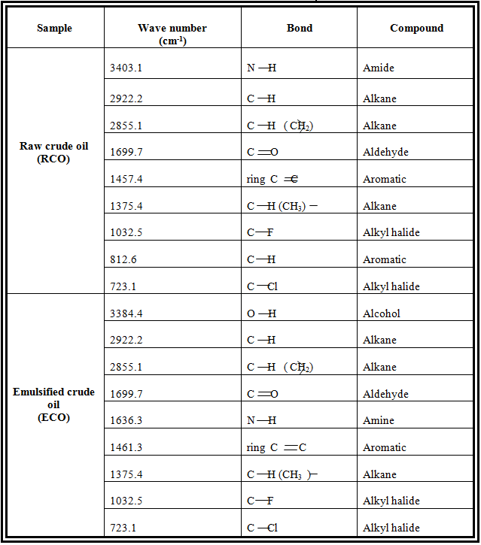

Table 3: FTIR analysis of demulsified crude oil
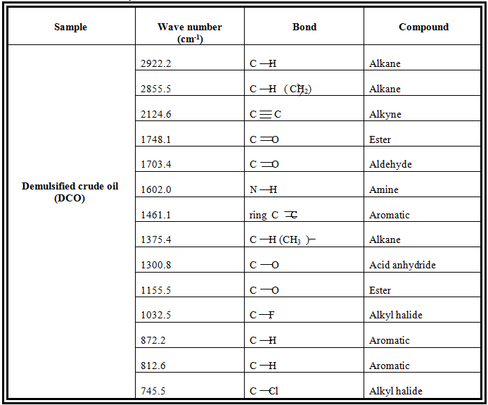

Table 4: FTIR analysis of local demulsifier
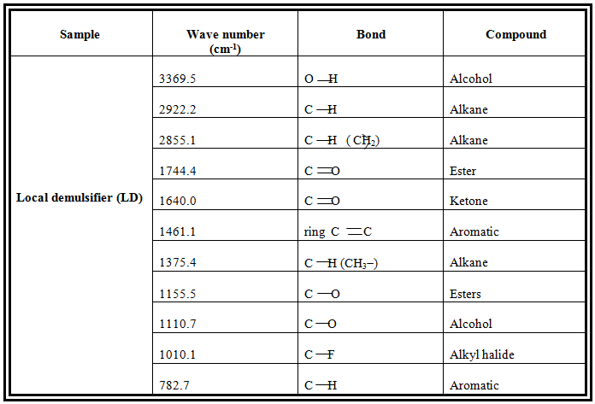

BS & W of the raw crude oil, emulsified oil and the demulsified oil was determined to access the quality of the oil. Table 5 shows the BS & W of the raw, emulsified and demulsified crude oils. It was observed that the BS & W of the crude oil increased after emulsification and it can be attributed to the brine introduced during emulsification. After demulsification, BS & W decreased from 80% to 20% using local demulsifier and to 25% using Urea. The decrease can be attributed to the effectiveness of the demulsifier in breaking off the bonded water on the crude oil sample.

Table 5: BS & W result using demulsifiers
Sample | BS & W (%)  Local Demulsifier | BS & W (%)  Urea
Raw crude oil | 40 | 40
Emulsified oil | 80 | 80
Demulsified oil | 20 | 25

3.3. Effect of solvent on water separation
The effect of using toluene as solvent on the demulification process was studied. It was stated in literature that the work of the solvent is to help in uniform distribution of the demulsifier along the interface of the water and the oil. From the study, it was observed that there was no water separation when solvent and urea were used but water was separated when solvent was used with local demulsifier the result of this is shown in Figure 1.
The use of the solvent and formulated demulsifier separated water at the temperature of 80ºC but when the test was carried out at temperatures of 40, 50, 60 and 70^{O}C, there was no water separation. This may be attributed to the fact that there was no proper dissolution of the demulsifier in the solvent which resulted to non uniform distribution along the interface of the water/oil emulsion. This was in line with works done by these researchers (Dimitrov et. al., 2012; Hajivand and Vaziri 2015; Udonne 2012). They treated the emulsion with demulsifiers only, which gave them a high yield of water separation compared to the one done with solvent.

Figure 5: Effect of solvent on water separation using local demulsifier.

3.4. Effect of temperature on water separation
Figure 6 shows the effect of temperature on the demulsification process using local demulsifier. When urea was used in the process constant water separation was observed at 80ºC for different time intervals. This shows that time had no effect on the demulsification process using Urea. It was observed from the graph that increase in temperature increased the water separation at different time intervals. The maximum water separation was obtained as 63% at 90ºC. This means that higher temperatures promote destabilization effects caused by increased Brownian motion and mass transfer across the interface. This is mainly due to the fact that the interfacial viscosity of the internal phase decreases as the temperature increases; as a result, the momentum between two water droplets increases, coalescence occurs, and the two phases of immiscible liquids separates due to their different densities and polarities (Hajivand and Vaziri 2015).

Figure 6: Effect of temperature on water separation using local demulsifier

3.5. Effect of time on water separation
Figure 7 shows the effect of time on water separation using local demulsifier. It was observed that at constant temperature of 60ºC and 70ºC that the water separation increases as the time was increased. But the water separation was constant when the temperature of system was at 80ºC and 90ºC.
It was also observed that increase in the resident time of a demulsification process increased the water separated but was constant irrespective of the time at higher temperature. Therefore, the process will be more economical when operating on low resident time at a high temperature. The constant water separation at 80ºC and 90ºC can be attributed to the denaturing of the compounds in the demulsifier which are responsible for the demulsification process.

Figure 7: Effect of time on water separation using local demulsifier

3.6. Effect of demulsifier’s dosage on water separation
Figure 8 and 9 depict the effect of dosage of local demulsifier and urea on water separation respectively. It was observed that water was not separated when the urea was increased from 0.1g to 0.3g, but slightly increased above 0.3g. Separation occurred at 60 - 80mins interval when 0.1g of urea was used but reached to a constant value when the dosage was increased to 0.3 and 0.4 g. 35% of water was separated using urea.
Temperature of 90ºC was used for the demulsification using local demulsifier. The figure reveals that for 20mins and 40mins the water separation increased as the dosage of the local demulsifier was increased. For both 60mins and 80mins the separation was constant at the same points for the various dosages and a high level of water separation of 63% was achieved. This implied that further increase in the dosage will not have any change on the water separation which was in line with what Dimitrov et al., (2012) concluded about overdosing of demulsifier. They reported that the overdosing of demulsifier will not lead to optimal emulsion breaking.
Increase in demulsifier dosage may lead to increase in the rate of partition and to increase the adsorption of demulsifier molecules at the water/oil interface. This may strongly affect the water in oil dynamic interfacial properties such as interfacial gradient or Marangoni-Gibbs stabilizing effect (Al-Sabagh et. al., 2011).

Figure 8: Effect of urea’s dosage on demulsification process

Figure 9: Effect of local demulsifier’s dosage on demulsification process

3.7. Comparison of demulsifiers used
Figure 10 shows the maximum separated water using local demulsifier and commercial demulsifier (urea). It was observed that the water separated using local demulsifier was higher than that separated using Urea. This confirmed the efficacy of the demulsifer formulated. From FTIR analysis, it was observed that local demuslifier is anionic in nature while urea is cationic in nature. This work was line with the work done by Hajivand and Vaziri (2012), where it was discovered that urea gave low water separation.

Figure 10: Comparison of demulsifiers used at maximum separation

Conclusion:
The following conclusion can be drawn from this study;
- The FTIR analysis shows that the locally formulated demulsifier is anionic while the commercial demulsifier (urea) is cationic in nature.
- The use of solvent as a carrier did not have appreciable effect effect on the water separated.
- It was observed that overdosing of demulsifier will not lead to optimal emulsion breaking.
- It was observed that the locally formulated demulsifier recorded lower water separation compared with the commercial demulsifier, urea.

Acknowledgement:
The authors wish to thank PYMOTECH RESEARCH CENTRE AND LABORATORIES ENUGU, ENUGU STATE NIGERIA for all their facilities used throughout the research work.

Corresponding Author:
Dr. Ejikeme, Ebere Monica
Department of Chemical Engineering,
Enugu State University of Science and Technology, Enugu, Nigeria.
Telephone: 08035495912
E-mail: ebemoca@yahoo.com

References
- Swindle J, Wang S, Kuznik L. Breaking Oil/Water Emulsions to Lower Chemical Oxygen Demand in Washrack wastewater – A Treatability Study, A paper presented at the SPE International Conference on Health, Safety and Environment in Oil and Gas Exploration and Production held in Rio de Jeneiro, 2010.
- MartõÂnez-Palou R, Mosqueira, ML, Zapata-RendoÂn B, Mar-JuaÂrez E, Bernal-Huicochea C, de la Cruz Clavel-LoÂpez J, Aburto J. Transportation of Heavy and Extra-heavy Crude Oil by Pipelines, A review, J Petrol Sci Eng. 2011:75: 274-282.
- MartõÂnez-Palou R, Aburto J. Ionic liquids as Demulsifiers. Application as demulsifiers of petroleum emulsions. In: Ionic Liquids, Hardy, S. Ed., Intech, Rijeka, Croatia 2015: 305-326.
- Langevin, D, Poteau S, Hénaut I, Argillier JF. Crude Oil Emulsion Properties and their Application to Heavy Oil Transportation, Oil & Gas Science and Technology, Rev. IFP, 2004:59 (5):511-521.
- Salam KK, Alada AO, Arinkoola AO, Opawale A. Improving the Demulsification Process of Heavy Crude Oil Emulsion through Blending with Diluent, Hindawi Publishing Corporation Journal of Petroleum Engineering Volume, Article ID 793101, 2013.
- MartõÂnez-Palou R., Reyes J, CeroÂn-Camacho R., Ramirez de Santiago M, Villanueva D, ChaÂvez B, Vallejo AA, Aburto J. Study of formation and breaking of extra-heavy-crude-oil-in-water emulsions-A proposed strategy for transporting extra heavy crude oils, Chem Eng Proc; 2015:98: 112-122.
- Henderson SB, Grigson SJW, Johnson P, Roddie BD. Potential Impact of production chemicals on the toxicity of produced water discharges from North Sea Oil Platforms. Marine Pollution Bulletin.; 1999:38:1141-1151.
- Oruwori, Ikiensikiame. A new Demulsifier Formulation for crude oil emulsion Treatment by Paul Ebikapower and Kelani Olafihon Bello. Petroleum Technology Development. An Internal Journal, 2010:6(2).
- Manivannan M, Rajendran S, Rajendran, S, (2011) Investigation of inhibitive action of urea-Zn2+ system in the corrosion control of carbon steel in sea water; International Journal of Engineering Science and Technology (IJEST) 2011: 3(11)8048-8060.
- Ojinnaka CM, Ajienka JA, Abayeh OJ, Osuji LC, Duru RU. (2016). Formulation of best-fit hydrophile/lipophile balance-dielectric permittivity demulsifiers for treatment of crude oil emulsions Egyptian Journal of Petroleum 2016: 25: 565–574.
- Dimitrov AN, Yordanov DI, Petkov PS. (2012) Study on the Effect of Demulsifers on Crude oil and Petroleum Products, Int. J. Environ. Res., 2012:6(2):435-442.
- Hajivand P, Vaziri A. Optimization of Demulsifier Formulation for Separation of Water from Crude Oil Emulsions, Brazilian Journal of Chemical Engineering 2015: 32 (01): 107 – 118.
- Udonne JD. Chemical treatment of emulsion problem in crude oil production, Journal of Petroleum and Gas Engineering 2012:3(7):135-141.
- Al-Sabagh AM, Kandile NG, Noor El-Din MR. Functions of Demulsifiers in the Petroleum Industry; Separation Science and Technology, 2011: 46: 1144–1163.

6/25/2019

