**Synthesis, Characterization, X-Ray Diffraction Study And Biological Activities Of Iron (Iii) And Cobalt (Ii) Complexes Of L-Valine**

Shuaibu Musa1, *, S.O. Idris1 And A.D. Onu2

1 Departmet Of Chemistry Ahmadu Bello University, Zaria-Nigeria

2 Federal College Of Education, Zaria-Nigeria

Corresponding Author E-Mail Address: shuaibumusa@abu.edu.ng

**Abstract:** Two metal- amino acids complexes in aqueous basic solution, [CoL2(H2O)2], [FeL3] with L=Valine anions were synthesized and analyzed by means of IR spectroscopies, powder X-ray diffraction analysis, magnetic susceptibility measurements and molar conductivity. Molar conductivity measurements showed that the composition of the metal complexes correspond to a metal-amino acid ligand ratio of 1:2 for Cobalt (II) complex and 1: 3 for iron (III) complex. The IR spectra showed that the amino acids act as bidentate ligands with coordination involving the carboxyl oxygen and the nitrogen of the amino group. The result also suggests the presence of coordinated water in cobalt (II) complexes. Magnetic susceptibility measurements suggested a six coordinate local symmetry around the (octahedral symmetry) around Co (II) and Fe (III) ions. Magnetic susceptibility studies also revealed that the complexes of Co and Fe are paramagnetic with values of magnetic moments ranging from 5.10-6.00 BM for Fe (III) and 4.3-5.2 BM for Co (II) complexes, respectively. The results also suggest that the ligand, valine is a weak field ligands as its formed high spin complexes. Powder XRD studies confirmed that the amino acid complexes are crystalline in nature and that they largely crystallized in monoclinic. It also suggests that the bonding mode in the complexes is similar. The antimicrobial studies showed that the amino acid ligands are biologically active and their metal complexes showed significantly enhanced antimicrobial sensitivity against the studied microbial strains in comparison to the free ligands.

[Shuaibu Musa, S.O. Idris And A.D. On. **Synthesis, Characterization, X-Ray Diffraction Study And Biological Activities Of Iron (Iii) And Cobalt (Ii) Complexes Of L-Valine.** *Researcher* 2019;11(5):78-83]. ISSN 1553-9865 (print); ISSN 2163-8950 (online). <http://www.sciencepub.net/researcher>. 12. doi:[10.7537/marsrsj110519.12](http://www.dx.doi.org/10.7537/marsrsj110519.12).

**Keywords:** magnetic susceptibility, FTIR, x-ray diffraction, electrolyte, microbial inhibition.

1. **Introduction**

Interactions between transition metal ions and amino acids are very interesting in the biological applications and in catalysis. Complexes of some metals ions with amino acids can be used as models to study the pharmacodynamic effects of drugs or for increasing the biocompatibility and minimize toxic effects of some metal (Schroev and Abram, 2010).

The transition metal complexes which contain amino acid moieties, are an important class of ligands in coordination chemistry and have been widely reported (El-Sonbati *et al.,* *1993;* El-Sonbati *et al., 2004;* Raman *et al., 2006*). Several transition metal complexes of amino acids have synthesized and characterized but their X-ray diffraction for the most part is not investigated, which is very important in the chemistry of inorganic and organometallic complexes, which give information about the crystalline phase, orientation and geometry of complexes. For this reason we are synthesizing these new complexes and focus on their X-ray diffraction.

However, in this paper, complexes of iron (III) and cobalt (II) are synthesized and characterized with elemental analysis, molar conductivity, electronic spectra, X-ray diffraction, magnetic susceptivility, FTIR analysis, and x-ray diffraction study were carried out.

The analytical data and the physical properties of the complexes are listed in Table 1. The complexes can be represented by the formulae [M1L3] and [M2L2X2] where [M1= Fe (III), M2=Co (II) L=Valine anion and X = H2O]. The complexes are stable in air and soluble in DMF and DMSO. The low molar conductance values of 10-3 M solutions in DMSO (Table 1) indicate that all the complexes behave as non-electrolytes (W.J.Geary, 1971)

**2.1 Material and Methods**

**2.2 Experimental:**

All chemicals and reagent were of quality grade and were purchased from commercial sources (BDH and Fluka). They were used without further purification.

**2.21. Physical characterization and x-ray diffraction:**

metal content analysis were made on Shimadzu AA670 atomic absorption spectrophotometer. Infrared spectra were recorded using the Fourier-Transform Spectrophotometer in the range 4000-400 cm-1 with KBr pellets. The electronic spectra were recorded on a Shimadzu UV160 for the 10-3 M solution of complex in dimethyl- sulphoxide (DMSO) at 25°C. Conductivity measurements were carried out with 10-3 M solution of complexes in DMSO at ambient temperature using a Jenway 4070 conductivity meter. The magnetic measurements were carried out on the solids by manual magnetic susceptibility balance.

**2.2.2 Anti-microbial screening:**

The compounds were screened using the disc diffusion method ( CLSI, 2016)

The in vitro biological screening effects of the investigated compounds were tested against the bacteria *Methacilin Resistance Staphylococcus aureus*, *Escherichia Coli* and Fungi *Candida Albicans*, and *Aspergillus niger*. All the microorganisms were standardized at 0.5 McFarland standard in a Mueller-Hinton broth. The standardized organisms were poured into a petri dish and allowed to be formed. Then four holes of 4 mm in diameter were bored on the agar. The compounds were introduced into the wells i.e 4 mm holes and incubated for 24 hours at 37 oC, and the zone of inhibition were observed and measured in millimeter (mm).

**2.3 Synthesis Of The Complexes**

**2.3.1 Preparation of the ligand solution**

1.2 g of amino acid was dissolved in 20ml of warm distilled water (0.02 mole of L-Valine) and stirred with a stirring rod until the amino acid dissolved completely with concentration of 0.004 M and 0.002 M respectively.

**2.2.2 Preparation of the metal salt solution**

0.4 g of CoCl2.6H2O and FeCl3.6H2O were dissolved in 25ml of distilled water respectively until a brown iron (III) solution and grey solution of cobalt (II) solution with concentration of 0.005 M and 0.004 M were formed.

**2.3.3 Synthesis of the complex**

20 cm3 of 0.004 M of valine and 0.002 M of alanine with 25 cm3 0.005 metal solutions were transferred into 500ml beaker and three drops 30% NaOH were added for the amino acid dissociation and with constant stirring with magnetic stirrer for about two hours. A brown for iron and grey for cobalt precipitated are formed, washed with ethanol and recrystallized on methanol and kept in a desiccator with percentage yield of 50-70 % (Stanila *et. al.* 2011)

**2.3.4 Equation for the complexation Reaction**



**Equation 1** proposed Cobalt (II) –Valine complexation reaction



**Equation 2** Proposed Iron (III) –Valine complexation reaction

**3.1 Result And Discussions**

The analytical data and the physical properties of the complexes are listed in Table 1. The complexes can be represented by the formulae [M1L3] and [M2L2X2] where [M1= Fe (III), M2=Co (II) L=Valine anion and X = H2O]. The complexes are stable in air and soluble in DMF and DMSO. The low molar conductance values of 10-3 M solutions in DMSO (Table 1) indicate that all the complexes behave as non-electrolytes (W.J.Geary, 1971)

**Table 1. Analytical and physical data of the complexes**

|  |  |  |  |  |  |
| --- | --- | --- | --- | --- | --- |
| Compounds | Colour | Melting (oc) point | Molar conductivity (cm2 Ω-1mol-1) | % of metal calculated (observed) | λmax (nm) |
| Valine | White | 298 |  |  | 270 |
| Fe-VALINE | Brown | 287-290 | 34 | 12.50(12.70) | 354 |
| Co-VALINE | Grey | 269-270 | 23 | 21.74(21.08) | 510 |

**3.2 Ftir Analysis**

The assignments have been done based on standard references and some published papers the characteristic bands of the complexes are listed in Table 2. The information about the metal coordination was obtained by comparing the IR frequency of the free ligands and the IR frequency of the iron (III) and Co (II) complexes.

In iron (III) valine complex, vibration stretching of N-H appears at 3425 cm-1 while that of the free ligand appears at 3350 cm-1 that provide involvement of NH2in complex formation. C=O stretching vibration appears at 1635cm-1 which provide involvement of oxygen in carboxylate group (COO-) in complex formation (Bhagat. *et. al*., 2012)

For cobalt Valine complex N-H stretching vibration appears at 3422 cm-1, and is found at 3350 cm-1, which provide the involvement of NH2 in complex formation. The absorption band at 1609 cm-1 was attributed to C=O stretching in the free ligands spectrum and shifted to 1643cm-1 in the cobalt- valine complex which show the involvement of oxygen in carboxylate group (COO- ) in complex formation The band above 3450 cm-1 indicates there is water acting as ligands in the complex *(*Stanila, *et al.,* 2008). It is further supported by the appearance of new band at 856 cm-1(Bhagat. *et. al.* 2012).

Moreover, the involvement of Oxygen and Nitrogen in the acid and amino groups respectively is further supported by the appearance of band around 432-486 cm-1 for M-O stretching, and around 535-700 cm-1 for M-N stretching (Nakamoto, 1978, and R. Selwin Joseyphus *et. al.* 2006,).

**Table 2 vibrational frequencies ( cm-1) of the important functional groups in the synthesized complexes and free ligands**

|  |  |  |  |  |  |
| --- | --- | --- | --- | --- | --- |
| Compounds | *v* N-H | *V* C=O | *V*M-N | *V*M-O | *V*OH, H2O |
| Valine | 3350 | 1650 |  |  |  |
| Fe-VALINE | 3425 | 1635 | 601 | 486 |  |
| Co-VALINE | 3422 | 1643 | 671 | 439 | 3626 |

**3.3 Magnetic Susceptivility Results**

Magnetic moments of all the complexes were measured using a manual magnetic susceptibility balance (at 300K) are reported in table 3. The measured values agree with the oxidation state of the metals. The effective magnetic moment values of the complexes show that all the complexes are sufficiently pure and no paramagnetic contaminations are present in the complexes. The complexes of Fe (III) and Co (II) are high spin paramagnetic as suggested by their magnetic moment values (Earnshaw, 1968; Foex *et al*., 1957; Selwood, 1956, Samy et. al.,2012).

**Table 3 table below summarizes the Magnetic measurement results for the synthesized complexes**

|  |  |  |  |
| --- | --- | --- | --- |
| **Complex** | **Xg × 10-5(cgs)** | **Xm × 10-2(cgs)** | **µeff Calculated (observed) (BM)** |
| **[FeVl3]** | 3.65 | 1.47 | 5.92(6.0) |
| **[CoVl2(H2O)2]** | 3.3 | 1.06 | 3.89(5.10) |

The values of the magnetic moments of these complexes are in the range (5.7-6.0) B.M for iron (III) and (4.3-5.2) for cobalt (II). Which are comparable with the values reported for octahedral iron (III) and Cobalt (II) complexes (El-Behery M and EI-Twigry H, 2007, and Buttrus H.N. and Saeed T.F, 2012, Samy et. al., 2012). The literature value crystal field stabilization energy (CFSE) of these types of complexes is favorable for the formation of octahedral complex. So, the proposed geometry for all these Complexes is octahedral.

**3.4 X-Ray Diffraction Result**

The basic building unit of the crystalline CoC12.6H2O compound is the complex M (H2O)4C12 with the chloride ions in trans positions and with an M-Cl distance of 2.43 Å which takes an octahedral geometry [J. Mizuno, 1960]. The same structural unit is present in the trivalent FeC13.H2O crystalline compound. [M. Magini, *et. al*. 1981].

The X-ray diffraction pattern of these complexes compared with major peaks of relative intensity greater than 10% has been indexed to their hkl value by using computer program [Shyam R Annapure et. al. 2016].

The diffractogram of Fe (III) complex of valine shows three reflections ( figure 2) with maxima at 2θ=16.3° corresponding to dspacing value 5.628 Å. Other reflections were at 2θ=15.0°, 15.8° and 18.1° with corresponding dspacing value of 5.385 Å, 4.192 Å.

The diffractogram of Co (II) complex of valine had seven reflections ( figure 1) with maxima at 2θ=37.8° corresponding to dspacing value of 2.384 Å. Other reflections were at 2θ=16.1°, 18.0°, 51.1°, 52.0°, 53.6° and 57.9° which has the least dspacing of 1.598 Å.

In respect of these cell parameters, these satisfies the condition to be required for sample to be monoclinic, such as a ≠ b ≠ c and α= γ= 90° ≠ β. Hence it can be concluded that Fe (III) and Co (II), complex of valine have monoclinic crystal system. The observed values fit well into the octahedral crystal system for all of the complexes.

**3.5 Anti-Microbial Result**

A comparative evaluation of the antimicrobial activity of the ligands i.e. amino acids, and the synthesized compounds.

The complexes were effective against both bacteria and fungi (table 4 and 5 respectively). The iron complex was better against both the gram positive and gram negative bacteria and fungi when compared with the standard Drugs. Growth of bacterial pathogens on each concentration was checked to determine the minimum concentration that inhibits the growth of the organism (table 4 and 5)

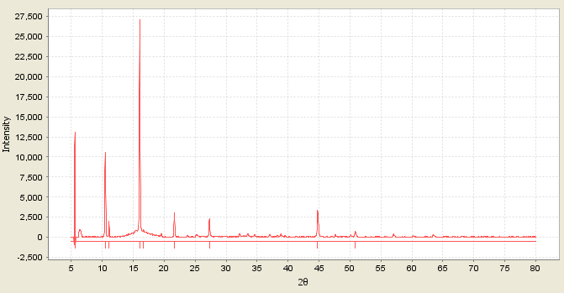

**Fig.1 XRD pattern of Co-Valine Complex (λ= Cu Kα 1 1.54056 Å)**

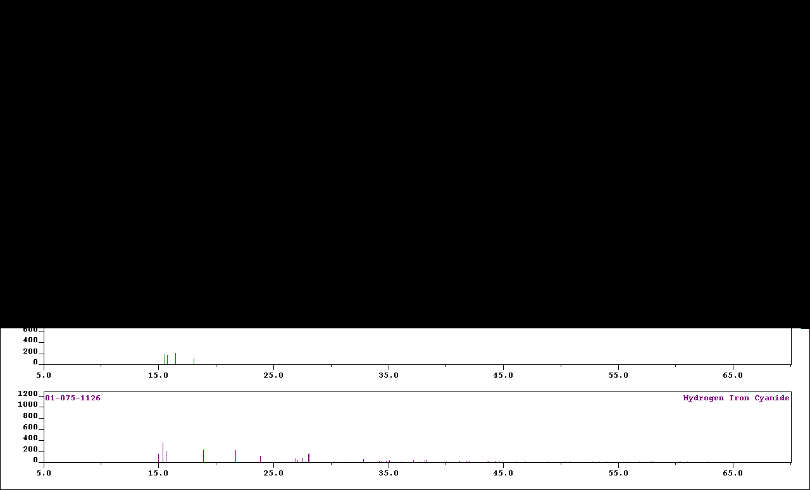

**Fig 2. XRD spectrum of Fe-valine Complex (λ= Cu Kα 1 1.54056 Å) [A plot of intensity against 2 $θ$]**

And also the metal complexes showed higher activity than free ligand, due to the effect of metal ions on the normal metabolic function of the cell. The findings are similar to that reported by Achut *et al*., 2010.

**Table 4 microbial inhibition zone (mm)**

|  |  |  |
| --- | --- | --- |
|  | Fungi | |
| Compounds | *C. albicans* | *A, niger* |
| Valine | 6 | 20 |
| Fe-VALINE | 40 | 30 |
| Co-VALINE | 20 | 13 |
| FULCIN | 30 | 28 |

**Table 5 microbial inhibition zone (mm)**

|  |  |  |
| --- | --- | --- |
| Compounds | *MRSA* | *E.choli* |
| Valine | 6 | 6 |
| Fe-VALINE | 29 | 26 |
| Co-VALINE | 6 | 6 |
| Ciprofloxacin | 22 | 16 |

**Conclusion**

Molar conductivity measurements showed that the composition of the metal complexes correspond to a metal-ligand ratio of 1:2 for cobalt (II) complexes and 1:3 for iron (III) complexes.

The IR spectra showed that the amino acids act as bidentate ligands with coordination involving the carboxyl oxygen and the nitrogen of the amino group. The result also suggests the presence of water of coordination in cobalt (II) complexes.

Electronic spectra and magnetic susceptibility measurements suggested a six coordinate local symmetry around the complexes. Magnetic susceptibility studies also revealed that all the complexes are paramagnetic.

Powder XRD studies confirmed that the amino acid complexes are crystalline in nature and that they largely crystallized in monoclinic fashion. It also suggested that the bonding mode in the complexes is similar.

The antimicrobial studies suggested that the amino acid ligands are biologically active and their metal complexes showed significantly enhanced antimicrobial sensitivity against the studied microbial strains in comparison to the free ligands.

The proposed structures of the complexes are as follows:



**Iron-Valine complex**



**Cobalt-valine complex**

**WHERE R= CH3-**

**Corresponding Author Name:**

Shuaibu Musa

Department Of Chemistry, Ahmadu Bello University, Zaria-Nigeria

Corresponding Author E-Mail Address:

shuaibumusa@abu.edu.ng

**References**

1. Achut, S.M., Amarnath, N.J., Sarika, M.J. and Trimbak, K.C (2010). Synthesis, Characterization and thermal study of some Transition Metal Complexes of an asymmetrical tetradentate Schiff base Ligand. Journal. Search. Chem. Soc. 0(0): 1- 11.
2. A. Stanila, C.Nagag, A. Mercu, D.Cozma, D.Rusu, L.David, (2008), Spectroscopic investigation of new metallic complexes with Leucine as ligands pp.25-52.
3. A Stănilă., Braicu C., Stănilă S., Pop R. M. (2011), Antibacterial Activity of Copper and Cobalt Amino Acids Complexes. Not Bot Horti Agrobo.;39 (2):124–9.
4. A. Stanila., Marcu A., Rusu D., Rusu M., David L., ( 2007), Spectroscopic studies of some copper (II) complexes with amino acids. J Mol Struct.;834-836.
5. Buttrus H.N. and Saeed T.F., (2012), Synthesis and Structural Studies on Some Transition Metal Complexes of Bis- (benzimidazole-2-thio) ethane, propane and butane ligands, Res. J. Chem. Sci., 2(6), 43-49.
6. Bhagat T.M., Swamy D.K. and Deshpande M.N., (2012), Synthesis and characterization of transition metal complexes with newly synthesized substituted benzothiazole, *J. Chem and Pharm Research*, 4, 100-104.
7. El-Sonbati, A.Z., Al-Shihri, A.S. and El-Bindary, A.A., ( 2004). Polymer Complexes XLV. Spectral Studies on Metal-Ligand Bonding in Novel Poly-Schiff Base Complexes, J. Inorg. And Organomet. Poly., Vol. 14, No. 1, pp.53-71.
8. El-Behery M and EI-Twigry H., (2007), Synthesis, Magnetic, Spectral and Antimicrobial Studies of Cu (II), Ni (II), Co (II), Fe (III) and UO2 (II) complexes of a new Schiff base hydrazone derived from 7-Chloro - 4- hydrazine quinoline, Spectro. Chim. Acta (A), 66, 28-36.
9. El-Sonbati, A.Z., El-Bindary, A.A., Diab, M.A. and Mazrouh, S.A., (1993). Polymer Complexes, XXIII: Synthesis and Physicochemical Studies on Transition Metal Complexes of Symmetric Novel poly (N, N-َO-O-phenylenediamine) - Bis (Cinnamaldehyde), Monatshefte fur Chemie, Vol. 124, No. (8/9), pp.793-801.
10. Foex, G., Coiter, G., (1957). J. Constantes Selectionnees, Diamagnetismeet Paramagnetisme.
11. Masson, Paris, A Collection of Diamagnetic and Paramagnetic Susceptibilities.
12. Earnshaw, A., (1968). Introduction of Magnetochemistry. Academic Press, London.
13. M. Magini The Journal of Chemical Physics 74, 2523; doi: 10.1063/1.441322].
14. Nagham S. Buttrus, (2014), Synthesis and Characterization of some Cr3+, Fe3+, Co2+, Ni2+, Cu2+ and Zn2+ Complexes with N-Phthalyl amino acid ligands, *Research Journal of Chemical Sciences,* Vol. 4(5), 41-47, May (2014) ISSN 2231-606X.
15. Nakamoto, K., (1988). IR and Raman Spectra of Inorganic and Coordination Compounds. third ed. John Wiley and Sons, NY, p.211.
16. Geary, W.J., (1971). Use of Conductivity Measurements in Organic Solvents for the Characterization of Coordination Compounds, Coord. Chem. Rev., Vol.3, pp.81-122.
17. R. Selwin Joseyphus, C. Justin Dhanaraj and M. Sivasankaran Nair, (2006), Synthesis and characterization of some Schiff base transition metal complexes derived from vanillin and L (+) alanine, Transition Metal Chemistry 31:699–702 Springer DOI 10.1007/s11243-006-0048-7.
18. Raman N., Dhaveethu Raja J. and Sakthivel A., (2007), Synthesis, spectral characterization of Schiff base transition metal complexes: DNA cleavage and antimicrobial activity studies, *J. Chem. Sci.,* 119, 303-119.
19. Raman N., Pitchaikani Raja Y. and Kulandaisamy A., (2001), Synthesis and Characterization of Cu (II), Ni (II), Mn (II), Zn (II) and Vo (II) Schiff base complexes derived from o-phenylenediamine and acetoacetanilide, *Proc. Ind Acad. Sci*., 113, 183-189.
20. Raman N., Dhaveethu Raja J. and Sakthivel A., (2007), Synthesis, spectral characterization of Schiff base transition metal complexes: DNA cleavage and antimicrobial activity studies, *J.* Chem. Sci*.,* 119, 303-119.
21. Shyam R Annapure, Achut S Munde and Shantilal D Rathod., (2016), Spectral, Thermal, X-Ray and Antimicrobial Studies of Newer Tetradentate N2O2 Schiff Base Complexes of First Transition Series, Pelagia Research Library Der Chemica Sinica, 7(4):47-54.
22. Samy M. El-Megharbel and Mohamed Y. El-Sayed (20012), Synthesis and thermal studies of MnII, CrIII and FeIII methionine complexes, Life science journal, Life Science Journal 2012;9(2).
23. Schroev and Abram U., (2010) Tetrameric rhenium complexes with a glycine-thiourea derivative, *Inorg. Chem. Commun*, 13(1), 26-29.

5/25/2019