A Study on Man-Monkey Conflicts in Bir Bara Ban Conservation Reserve Forest in district Jind, Haryana (India)

Hardeep Singh

Lecturer in Biology, Govt. Senior Secondary School, Singowal in Jind, Haryana (India)
Email: hssonadil@gmail.com

Abstract: The present study was planned from October, 2018 to March, 2019. To study man-monkey Conflicts in Bir Bara Ban Conservation Reserve Forest in district Jind, Haryana (India), Direct contact methods and scan sampling method followed by Kumar, 2009; Kumar and Malhotra, 2014; Kumar, 2014. The sighted individuals of rhesus macaques and its troops conflicted with nearby inhibited human beings was photographed by Sony cybershot camera DCR-H-9 and Sony handy cam model DCR-HC-42E. During the present study, habitat destruction through illegal felling, less numbers of fruit trees and shifting of rhesus macaques for feeding in particular day, i.e., Tuesday and Friday as well as in particular season nearby agricultural areas, villages areas and Hanuman Mandir (a holy temple) were the major reasons for conflicts with man and his pets (domestic dog, Canis familiaris) in Bir Bara Ban Conservation Reserve Forest in district Jind, Haryana (India)
[Hardeep Singh. A Study on Man-Monkey Conflicts in Bir Bara Ban Conservation Reserve Forest in district Jind, Haryana (India). Researcher 2019;11(5):73-77]. ISSN 1553-9865 (print); ISSN 2163-8950 (online). http://www.sciencepub.net/researcher. 11. doi:10.7537/marsrsj110519.11.

Keywords: Rhesus Monkey, Human Beings, Conflicts, Forest, Haryana.

Introduction:
Rhesus monkey (Macaca mulatta) and bonnet monkey (Macaca radiata) are the old world monkeys. Rhesus macaques are found throughout mainland of Asia; from Afghanistan to India and Thailand to southern China (Chopra and Kumar, 2009). In India, the dominate sub-species of rhesus macaques are Macaca mulatta villosa and Macaca mulatta mulatta are prevalent. The Macaca mullatta villosa is found in the Kashmir and Punjab region of India (the northern part of the country), Pakistan, and Afghanistan while Macaca mulatta mulatta is found in India, Bhutan, Burma, Nepal, Bangladesh, Thailand, Laos and Vietnam (Chopra and Kumar, 2009; Kumar, 2015). Rhesus macaques is found in good numbers in peninsular region (Assam, Madhya Pradesh and West Bangal), North region (Jammu and Kashmir, Himachal Pradesh, Punjab, Haryana, Uttar Pradesh, Rajasthan, Gujrat) and central region (Orrisa and Bihar) (Chopra et al., 2011). The strategies undermining social dimensions are perhaps not efficient in reducing the humananimal conflict (Madden 2004). Therefore information about feelings, perceptions and attitudes of public towards wildlife is a prerequisite in designing optimal management strategy (Bahuguna 1986; Berkmuller 1986; Borang and Thapliyal 1993; Brown and Decker 2005; Ipara 2005; Priston 2005; Wambuguh 2008).
Man-monkey association is as old as man’s own existence. Of nearly 225 living species of non-human primates, three Indian species have become urbanized. They are the rhesus macaque (Macaca mulatta), the bonnet macaque (Macaca radiata) and the Hanuman langur (Semnopithecus entellus). Human population growth and activities like deforestation, agriculture and urbanization lead to an ever-increasing encroachment on wildlife habitats. Reduction of wild animals’ natural habitats altered into small marginal patches. In contrast, species with a high degree of flexibility can adapt to living in, or near, areas inhabited by man, where in some cases they end up using easily accessible food resources, like human cultivations and garbage birds and small mammals, (Diamond, 1986; Ellins et al., 1983; Gabrey, 1997) hooded crows (Vuorisalo et al., 2003). Conflicts often occur when non-human primates raid crops (Forthman, 1986; Siex and Struhsaker, 1999; Hill, 2000) or when humans provision groups of primates (Gupta, 2002). Due to less and scanty information is available on various aspects on man-monkey conflicts in Haryana, particular. So the present study was planned to study on man-monkey conflicts in Bir Bara Ban Conservation Reserve Forest in district Jind, Haryana (India).
Study area:
Bir Bara Ban Wildlife Sanctuary is situated 5 km away from Jind on Jind-hansi Road in Haryana State, India. It is spread over an area of 419.26 hectares. It is 5 km away from Jind, 40 km from Hansi, 70 km from Hisar, 73 km from Panipat, 80 km from Bhiwani, 110 km from Kurukshetra, 144 km from Delhi and 190 km from Chandigarh. Haryana govt notified this area as sanctuary on 11 October 2007. Dominant tree species, namely, Kikar (Acasia nilotica), Neem (Azadirachata indica), Shisham (Dalbergia sissoo), Siris (Albizza lebbek), Gular (Ficus glomerata), Peepal (Ficus religiosa), Jaal (Salvadora oleoides), Beri (Ziziphus mauritinia) and Safeda (Eucalyptus hybrid); dominant herbs and shrubs species, namely, Bansa (Adhatoda vasica), Kandai (Aegemone maxicana), Kair (Capparis desidua), Bui (Kochia indica), Karaunda (Carissa opaca) and Bathua (Chenopodium album); dominant animal species, namely, Neelgai or Blue bull (Boselaphus tragocamelus), Jackel (Canis aureus), Hanuman Langur (Presbytis entelles) and Rhesus Monkey (Macaca mullata) and dominant birds species, namely, Blue peafowl (Pavo cristatus), Rufous treepie (Dendrocitta vagabunda), Greater coucal (Centropus sinensis), Indian grey hornbill (Ocyceros birostris) and Jungle babbler (Turdoides striata) are contributing significantly in biodiversity of Saraswati Plantation Conservation Reserve Forest in district Kurukshetra, Haryana (India) (Kumar and Malhotra, 2014; Kumar, 2014).

Methodology:
The present study was planned from October, 2018 to March, 2019. To study man-monkey Conflicts in Bir Bara Ban Conservation Reserve Forest in district Jind, Haryana (India), Direct contact methods and scan sampling method followed by Kumar, 2009; Kumar and Malhotra, 2014; Kumar, 2014. The sighted individuals of rhesus macaques and its troops conflicted with nearby inhibited human beings was photographed by Sony cybershot camera DCR-H-9 and Sony handy cam model DCR-HC-42E.

Results and Discussion:
In India, three species of macaques (Macaca mulatta, M. radiata and to a lesser extent M. assamensis) are known to cause damage to crops and threaten human wellbeing in urban spaces (Gupta, 2001). There are over 0.3 million Rhesus macaques (M. mulatta) in northern India (Malik, 1992), approximately 86% of which live in areas of human habitation. Intensification of agriculture and reduction of habitat heterogeneity has led to a reduction of food sources for macaques in the non-reserve matrix across many parts of India (Sinha, 2001). With their extensive repertoire of cooperative behaviour, opportunistic life-style and non-specialized omnivorous diets, macaques are highly adaptable and take readily to living alongside humans in rural or urban settings (Hill, 2000). Their ability to learn rapidly and behaviourally adapt to different situations makes macaques successful and troublesome when co-inhabiting space with humans.
Human-macaque conflict is an issue that impacts upon both primate conservation and human wellbeing. In India, Rhesus macaques (Macaca mullata) cause considerable damage to crops, and to a lesser extent, injury to people. Finding solutions to the issue requires assessments of the extent and scale of conflict, as well as understanding how affected communities view macaques and protection strategies in place locally. Most work on human-macaque conflict in India has been ecological.
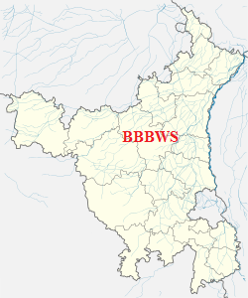
(a)

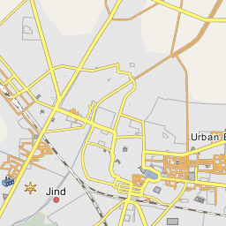
(b)
Fig. 1. (a) Bir Bara Ban Wildlife Sanctuary in district Jind, Haryana (India) and (b) its outline map.

During the present study, habitat destruction through illegal felling, less numbers of fruit trees and shifting of rhesus macaques for feeding in particular day, i.e., Tuesday and Friday as well as in particular season nearby agricultural areas, villages areas and Hanuman Mandir (a holy temple) were the major reasons for conflicts with man and his pets (domestic dog, Canis familiaris) in Bir Bara Ban Conservation Reserve Forest in district Jind, Haryana (India).
The competition between human and non-human primates is a major problem in some areas where they are sharing the same food resources. Globally, primates are being problematical because of stealing food from human settlement or garbage found around forest and urban areas to supplement their natural diet. Further, monkeys are being more aggressive towards human (Sharma et al., 2011). Due to this reason, monkeys are not liked in the areas of massive agriculture, horticulture and other plantations since they eat and damage the crops and orchards (Roonwal and Mohnot, 1977). Monkeys have become commensalism and competitors of human being in and around villages, towns and cities. These are “Urbanized monkeys” (Rajpurohit et al., 2006).

Conclusions:
Human-macaque conflict is a major issue in villages that affects peoples’ day to day lives. Although research on human-macaque conflict in India has received scant academic attention, the magnitude of the problem may be on the same scale as that of large carnivores or elephants. This partly stems from the low conservation priority of the Rhesus macaque and also because it is not as charismatic a species as the tiger or Asian elephant. However, as this study indicates, peoples’ daily lives and income are affected by macaques in rural areas. With macaque troupes being resident in the village / agricultural matrix, conflict is prolonged and takes place all year round. Depletion of available food sources and disappearance of foraging areas in villages has further aggravated the problem. In the study area, small patches of village woodland and homegardens were continually being urbanized or converted to small-holder tea estates and if this trend continues, it is likely to escalate conflict in the future.
Further study is thus required to find effective solutions to the problem, as the humanmacaque overlap continues to increase. Key areas for future research include: (1) determining the extent of human-macaque across the region and comparing its magnitude to that of other species such as large carnivores or elephants, (2) examining the relative importance in loss of subsistence vs. cash crops for farmers or householders, and (3) field-testing the effectiveness of various protection measures over a decent temporal scale that takes into account macaques’ abilities to adapt and change their behaviour. It is perhaps inevitable that some amount of conflict will occur wherever humans co-inhabit space with macaques. There is a need for an intervention-based project that directly tackles issues through practice. This will not only add to existing academic work, but would contribute to an overall project of fostering peoples’ tolerance and acknowledging the presence of macaques as part of the fabric of social life.
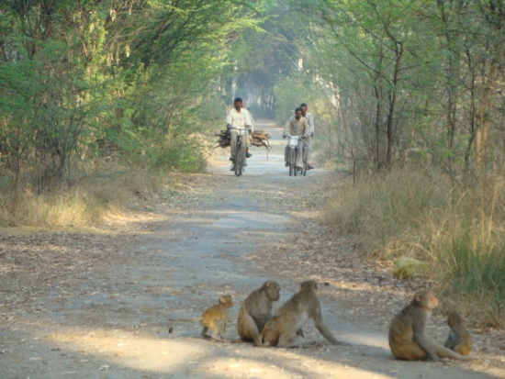
(a)
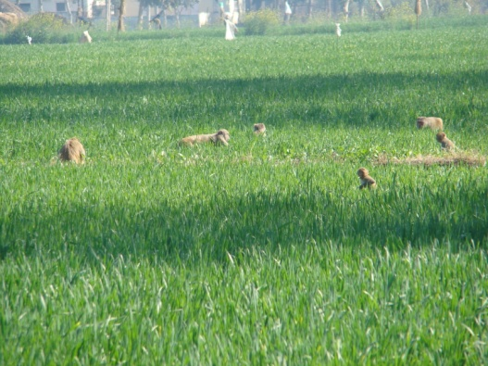
(b)
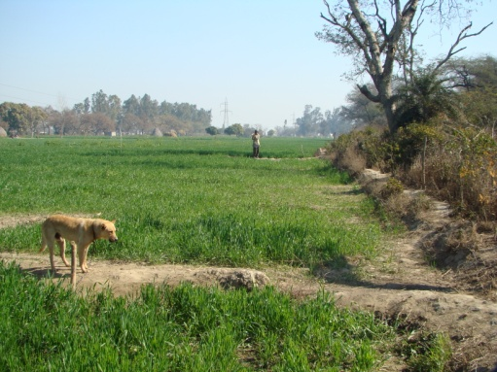
(c)
Fig. 2. Various reason for human-monkey conflicts i.e., (a) activity of human in forest area, (b) feeding of rhesus monkey in agricultural areas and (c) conflict with human pet (Dog).

Corresponding Author:
Hardeep Singh
Lecturer in Biology, Govt. Senior Secondary School,
Singowal in Jind, Haryana (India)
Email: hssonadil@gmail.com
Phone No. -91+9728706261

Bibliography:
- Bahuguna VK 1986. Survey of opinion for wildlife-A case study. Indian For, 112(10): 874-880.
- Berkmuller K 1986. Attitude barriers to eco-development and people’s participation. Indian For, 112(10): 949-952.
- Borang A, Thapliyal GS 1993. Natural distribution and ecological status of non-human primates in Arunachal Pradesh. Indian For, 119(10): 834-844.
- Brown TL, Decker DJ 2005. Introduction to special issue on global community-based wildlife management issues. Hum Dim Wildlife, 10: 81.
- Chopra, G. and Kumar, A. 2009. A study on the ecology and behaviour of rhesus monkey, Macaca mullatta (Zimmeemann, 1780), M. Phill dissertation, Department of Zoology, Kurukshetra University, Kurukshetra: 1-114.
- Chopra, G., Kumar, A., Kumar, T., Sharma, S.K. and Kadian, A. 2011. Study on troop size and troop composition of rhesus monkey, Macaca mulatta (Zimmermann, 1758) in Saraswati plantation wildlife sanctuary and Bir sonty reserve forest, Kurukshetra, Haryana (India). Nature and science. 9(12):44-50.
- Diamond J (1986). Rapid evolution of urban birds. Nature, 324: 107– 108.
- Ellins R, Thompson L, Swanson WE (1983). Effects of novelty and familiarity on illness-induced aversions to food and place cues in coyotes (Canis latrans). J. Comp. Psychol., 97: 302–309.
- Forthman QDL (1986). Activity budgets and the consumption of human food in two troops of baboons, Papio anubis, at Gilgil, Kenya. In: Else, J.G., Lee, P.C. (Eds.), Primate Ecology and Conservation. Cambridge University Press, Cambridge, pp: 221–228.
- Gupta AK (2002). Is Hindu religion responsible for man-monkey conflict? In: Caring for Primates. Abstracts of the XIXth Congress of the International Primatological Society, Beijing, China, p. 176.
- Gupta, A.K. (2001) Non-human primates of India: an introduction. Envis Bulletin: Wildlife and Protected Areas, 1(1): 1-29.
- Hill CM (2000). Conflict of interest between people and baboons: crop raiding in Uganda. Int. J. Primatol. 21(2): 299–315.
- Hill, C.M. (2000) A conflict of interest between people and baboons: crop raiding in Uganda. International Journal of Primatology, 21: 299-315.
- Ipara HI 2005. Indigenous wildlife resource management systems of the Isukha community of western Kenya. Hum Dim Wildlife, 10: 141-142.
- Kumar, A. 2014. Avian species of Saraswati plantation wildlife sanctuary and Bir sonty reserve forest in district Kurukshetra, Haryana (India). International journal of fauna and biological studies. 1(6):38-41.
- Kumar, A. and Malhotra, P. 2014. Flora of Saraswati plantation wildlife sanctuary (SPWS) and Bir sonty reserve forest (BSRF) in district Kurukshetra, Haryana (India). International journal of science and research. 3(9):1774-1778.
- Kumar, S., Rathi, R.K., Chawla, Y.K. and Chakarbirth, A. 2007. The incident of sporal hepatitis in North India monkey. Preliminary state.1-8.
- Malik, I. (1992) Introduction. In Schwibbe, MH & Malik, I (Eds.) Primate Report: Primatology in India. 34: 3-4.
- Priston NEC 2005. Crop-raiding by Macaca ochreala Brunnescens in Sulawesi: Reality Perceptions and Outcomes for Conservation. Ph. D. Thesis, Cambridge: University of Cambridge.
- Roonwal, M. L. and Mohnot, S. M. 1977. Primates of South Asia: Ecology, Sociobiology and Behavior. Harvard University Press, Cambridge.
- Sharma, G., Ram, C. and Rajpurohit, L.S. 2011. Study of man-monkey conflict and its management in Jodhpur, Rajasthan (India). Journal of Evolutionary Biology Research 3 (1): 1—3.
- Siex KS, Struhsaker TT (1999). Colobus monkeys and coconuts: A study of perceived human–wildlife conflicts. J. Appl. Ecol., 36: 1009– 1020.
- Sinha, A. (2001) The Bonnet Macaque Revisited: Ecology, Demography and Behaviour. Envis Bulletin: Wildlife and Protected Areas, 1(1): 30-39.
- Vuorisalo T, Andersson H, Hugg T, Lahtinen R, Laaksonen H, Lehikoinen E (2003). Urban development from an avian perspective: causes of hooded crow (Corvus corone cornix) urbanisation in two Finnish cities. Landsc. Urban Plann., 62: 69–87.
- Wambuguh O 2008. Human-urban wildlife interface: Interactions around Tilden Regional Park, San Francisco bay area, California. Hum Dim Wildlife, 13: 71-72.

5/25/2019

