Impact of Pencom Scheme on Civil Servants Productivity in Rivers State

Charles Ndubuisi Onyeche

Department Business Administration and Management, School of Business and Administrative Studies, Captain Elechi Amadi Polytechnic, Rumuola, Port Harcourt, Nigeria
charlesndubuisi62@gmail.com

Abstract: The study examined the impact of Pencom Scheme on civil servants’ productivity in Rivers State, Nigeria. The research design adopted was the survey approach through the use of structured questionnaire. The population of the study consisted of all the servants in Rivers State which is given as 2,794 employees. A sample of 350 staff selected from Rivers State civil servants in Port Harcourt was drawn for the study. The analysis was done through descriptive and inferential statistical tools. The findings among others revealed that majority of the respondents prefer to save outside any pension scheme while others do not know bow to calculate how much they need to save for retirement. The study also found that dependence on budgetary provisions, bribery and corruption, tedious payment procedures, poor staffing, poor record keeping, lack of adequate and timely budgetary provisions and increases in salaries constitute the key limitations to effective and efficient implementation of Contributory Pension Scheme (CPS) in Rivets State. It revealed that the main policy options open to government to ensure efficiency of the CPS in Rivers State included: Maintaining of discipline in pension administration and management, ensuring seamless funding of the retirement scheme, establishing a uniform set of rules, regulations and standards for the administration and payments of retirement benefits and improving the living standard of the elderly people through prompt payment of their retirement benefits. In conclusion, it is clear and evident in the study that: there is positive/significant relationship between the deductible-saving of worker’s salary and the efficiency of workers in Rivers State civil service and there is positive/significant relationship between the deductible- saving of workers’ salary and the efficiency in Rivers State civil service. Therefore, it is recommended that Pension Fund Administrators (PFAs) should be transparent and accountable in their dealings with their clients through regular update of their customers account status.
[Onyeche, C. N. Impact of Pencom Scheme on Civil Servants Productivity in Rivers State. Researcher 2019;11(5):48-59]. ISSN 1553-9865 (print); ISSN 2163-8950 (online). http://www.sciencepub.net/researcher. 8. doi:10.7537/marsrsj110519.08.

Keywords: Pencom Act Scheme, Civil Servants, Workers productivity, Workers.

1. Introduction/Background of the Study
Pension management in the creation and maintenance of an environment for the performance of individuals in an organisation cannot be over emphasized. Pension management is a tool that affects employment decision in a given organization because it is a form of income that employees or their beneficiaries receive after retirement, become disabled or die. It is one of the solid security attributes approved by the International Labour Organization (ILO) Convention No. 102 which has worked hard on social security matters since 1919 and more so since 1966 against all arguments that have been advanced, including the freedom of the individual worker to live life the way he deems fit with his hard-earned money without being burdened with pension issues (ILO, 1951).
Thus, pension is simply the amount set aside either by employer or employee or both to ensure that at retirement, there is something for employees to fall back on as income. It is referred to as a sum set aside for retirement purposes. It is a form of arrangement that hopes that at retirement, retirees will not be stranded financially. Furthermore, pension reform is not a new issue in any part of the world. It is usually a continuous process especially with the ever changing economic and political processes witnessed everywhere in the world (Blake, 2003). The scheme covers the private sector with five or more employees. Those exempted from the scheme are the Chief Justice of Nigeria, a Justice of the Supreme Court, President of the Court of Appeal, and a Justice of the Court of Appeal, who retires at or after the age of sixty-five years’ (Nigeria Constitution, 1999 Section 291), with their salaries. Among the exceptions are public employees who have three years or less to retire with effect from the date of enactment of the Pension Act being 30th June 2004.
The scheme replaced the pay-as-you go or defined benefit pension scheme (DBPS) which was a non- contributory, solely or fully funded scheme by the employer, that is, the government with respect to all public employees in Nigeria In the old scheme, academic staff in universities who retired after fifteen years as Professor, or at the age of sixty-five years, from 1991, retired with their salaries (Pension Decree, No. 102 of 1979).
Over the years, it seems that emphasis has always been laid on employee productivity by organisations and management for its long term corporate objectives without considering the human effort that carry out the task either during the course of service or after retirement. Retirement benefits of course aid retirees to sustain themselves when they retire or too old to do anything. This accounts for the importance that organisation must attach to retirement benefits to cater for retirees who have spent productive part of their lives for the organisation survival. As a result, many pensioners and would-be retirees that were not well informed about the operations of the contributory pension scheme need to be adequately educated. This low level of awareness has triggered off anxiety and uncertainty about their retirement years (Omoni, 2013). All of the above have been to the detriment of productivity of retired public servants, their dependents and a tell-tale on the image of the government. The whole problem has been predicated on the inability of the government to continue to maintain fully funded defined benefits pensions scheme (FFDBPS).
More importantly, supervision and regulation of the activities of Pension Fund Administrators are necessary to ensure safety and sustainability of the scheme. Thus, evaluation and provision of adequate information seem to have been, put in place to monitor dissemination of the new contributory pension scheme has not been adequately considered, this has however created a gap in awareness of the scheme hence, the needs for this study. The new pension reform in Nigeria adopted by Rivers State Government is contributory in nature with the intent of ensuring that every person who has worked in either the public or private sectors receives his or her retirement benefit when due. The reform was to serve as social welfare scheme for the aged, by ensuring that workers save to cater for their livelihood during old age (Sule, 2009).
Contributory pension scheme is a fully funded pension scheme that generates adequate funds through certain percentage of contributions from monthly earnings by both employee and employer through a form of savings. The introduction of the contributory pension scheme (CPS) through the pension reform Act in June, 2004 which commenced April, 2007 in Rivers State requires a civilian employee who is not a daily paid or casual worker, and the employer in either the public or private sector organization to contribute to the scheme. The employee and the employer are to contribute a minimum of seven and a half per cent (7.5%) each out of the employee’s consolidated monthly emoluments (basic, rent and transport) to the employee’s pension fund (or the employer alone can contribute the minimum fifteen per cent 15%) to the employee’s pension fund. For the armed forces, the government contributes twelve and a half percent (12.5%) and the armed forces personnel contribute two and a half percent (2.5%). The new scheme did not make such provision, except for judges. The Contributory Pension Law 2007 established the Contributory Pension Scheme for Rivers State Public Service with the objective to:
- Assist all persons in the employment of the State government to save towards their retirement.
- Ensure that persons who live or retire from the State public service receive their terminal or retirement benefits as at when due; and
- Establish a set of rules and regulations of the administration and payment of retirement.
- benefits in the public service of the state.
- Every employee in the state shall retire on attaining the age of 60 years or after 35 years of service, whichever comes earlier in time.
1.2 Statement of the Problem
The pension scheme applies to all pensionable employees in the public service of the state, employees of local government council, tertiary institutions and all parastatals established by the State Government Moreover, Pension consists of lump sum payment paid to an employee upon his disengagement from active service. This payment is usually in monthly installments, which may be contributory or non-contributory, fixed or variable benefits; group or individual; insured or trustee; private or public and single or multi-employer. Over the years, it seems that emphasis has always been laid on employee productivity by organisations and management for its long term corporate objectives without considering the human effort that carry out the task either during the course of service or after retirement. Retirement benefits, of course aid retirees to sustain themselves when they retire. This accounts for the importance that organisation must attach to retirement benefits to cater for retirees who have spent productive part of their lives for the organisation survival. As a result, many pensioners and would-be retirees that were not well informed about the operations of the contributory pension scheme need to be adequately educated.
This low level of awareness has triggered off anxiety and uncertainty about their retirement years. All of the above have been to the detriment of productivity of retired public servants, their dependents and a tell-tale on the image of the government. The whole problem has been predicated on the inability of the government to continue to maintain fully funded defined benefits pensions scheme (FFDBPS). More importantly, supervision and regulation of the activities of Pension Fund Administrators is necessary to ensure safety and sustainability of the scheme. Thus, evaluation and provision of adequate information seem to have been put in place to monitor dissemination of the new contributory pension scheme has not been adequately considered, this has however created a gap in awareness of the scheme hence, the needs for this research work.
  - Objectives of the Study
The purpose of the study was to examine the impact of Pencom Act Scheme on civil servants’ productivity in Rivers State. The specified objectives were:
- To determine the extent deductible-saving of workers’ salary impacted on their output in Rivers State civil service.
- To ascertain the extent to which the deductible-saving of workers’ salary has impacted on the efficiency of Rivers State civil service.
1.4 Research Questions
The following research questions have been investigated in the study:
- To what extent has the deductible-saving of workers’ salary impacted on their output in Rivers State civil service?
- To what extent has the deductible-saving of workers’ salary impacted on their efficiency in Rivers State civil service?
1.5 Research Hypotheses
The following hypotheses have been guided by the study: There is direct relationship between the deductible-saving of workers’ salary and their output in Rivers State civil service. There is no significant relationship between the deductible-saving of workers’ salary and the efficiency of workers in Rivers State civil service.

2. Review of Related Literature
2.1.1 Concept Pension Management Act
Pension as a programme is to improve the living standard of the elderly people who have outlived the labour force group and it is also a social security as well as welfare package for the old or retired people who are in their years of labour inactivity (Bertrand et al., 2003; Idowu, 2006). As for us, a pension scheme is a financial package which legally specifies its organization and operation, so as to provide rest of mind to workers, sustain or spur them to more productivity and ensure that a pensioner and his dependents live a decent life.
Pension schemes are social security maintenance plan for workers after their disengagement as employees through retirement (llesanmi, 2006). Pension consists of lump sum payment paid to an employee upon his disengagement from active service. Sterns (2006) observes that pensions could discourage labour turnover. If both the employees and employers contribute to the scheme, then it serves as a general area of joint interest and cooperation and therefore helps to foster better employment relations. He stated further that pension administration consists of five basic elements namely: flexibility; that is, to be able to cater for the needs of retirees’; amount of benefits which is sum accrued to an ex -employee of an organisation; finance, activity of managing pension money; contribution to cost of pension by employee and employer and death benefit that serves as a benefit for beneficiary of a deceased employee. From the account of Adegbayi (2005) payments are usually in monthly installments. Pension plans may be contributory or non-contributory; fixed or variable benefits; group or individual; insured or trustee; private or public, and single or multi-employer. In many advanced countries of the world, income from pension to an individual may be supplemented by social security benefits, which apply to all citizens in such country whether or not they belong to the working class.
However, since most citizens in such countries might have at one time or another, been workers, it would appear that social security benefits are co-terminus with the working class. It is different from gratuity (Adegbayi, 2005; Ozor, 2006). There are four main classifications of pensions in Nigeria. These are: Retiring Pension: This type of pension is usually granted to a worker who is permitted to retire after completing a fixed period of qualifying service usually practiced in Nigeria between 30-35years. Compensatory pension: This type of pension is granted to a worker whose permanent post is abolished and government is unable to provide him with suitable alternative employment. Superannuating Pension: This type is given to worker who retires at the prescribed age limit of 60-65 respectively and Compassionate Allowance: This occurs when pension is not admissible or allowed on account of a public servants’ removal from services for misconduct, insolvency or incompetence or inefficiency (Ugwu, 2006; Amujiri, 2009).
Pension helps employees to read just themselves properly into the society after leaving employment and a pension system is essentially an income security programme which provides benefits to beneficiaries who may be retirees, pensioners or destitute, thus, pension reform is not a new issue in any part of the world (Ako, 2004; Amstrong, 2010). In Nigeria from 1951 till date, many pension schemes have been established either through act of parliament and a decree under the military. Such pension schemes are, Nigeria Pension Scheme (NPS) of 1951, National Provident Fund (NPF) of 1961, Nigeria Social Insurance Trust Fund (NSITF) of 1990, Local Government Pension Scheme (LGPS) established by a military decree in 1977 which was later change to Civil Service Pension Scheme (CSPS) by a military decree in 1979, Armed Forces Pension Scheme established in 1979 by a military decree to cater for the military personnel and Police Pension Scheme (PPS) which was formed with other agencies pension scheme established by a decree in 1993 Pension Reform Act (PRA) (1958), Uzoma (1993), Balogun (2006) and Fapohunda (2013).
2.1.2 Deductible-Savings and Workers’ Output/Efficiency in the Civil Service
The contributory pension scheme is expected to have multiplier effect on workers attitude towards retirement, commitment to duty, and labour retention as well as attitude towards corruption especially in the civil or public service. This is because the uncertainty of receiving pension and gratuity after retirement was largely responsible for high labour turnover in the civil service. Ozor, (2006), posits that, poor remuneration, delay in payment of fridge benefits and poor condition of service among others are jointly responsible for the exodus of medical personnel from Nigeria to the United States of America and the United Kingdom. Workers commitment to organizational goals has received wide attention by scholars. Workers commitment here entails the level of job involvement (Fapobunda, 2013). It includes internal work motivation (Hackman & Oldham, 1978) and the willingness of an employee to invest personal effort for the sake of the organization (Amujuri, 2009). It involves attitudes or orientation towards organizational goals or objectives (Achimugu, Ocheni & Akubo, 2015). Commitment is positive and consistent attitude towards organizational goal that are produced by exchange consideration. Workers commitment is a function of many variables including, characteristics of job situation, the work environment, leadership style and career development (Egbe, 2013). Employees’ commitment could also be influenced by the level of job involvement or the responsibilities of the worker (Leigh, 2009). Commitment is also tied to how well an employee is motivated. Motivation here entails the process of influencing employees’ behaviour towards the attainment of organizational goal (Omoni, 2013). Motivation includes meeting the psychological, financial and emotional needs of workers. Pension is part of motivation and could help attain the psychological and emotional needs of workers, because it assures them of life after retirement. A good pension scheme could determine the level of workers commitment as well as influence whether an employee will do his/her work properly. According to Sule (2009), good pension guarantees employee’s comfort and commitment to the organization during his/her active years. Figure 1: Conceptual Framework of the impact of Pencom Act Scheme on civil servants’ productivity in Rivers State Source: Researcher’s Review of Relevant Literature (2017).

Fig 1: Conceptual frame work of the impact of Pencom Act Scheme on civil servants productivity in Rivers State, Nigeria

2.1.3 Challenges of the old pension schemes
The need for pension reform was necessitated by the myriad of problems that plagued the defined benefit arrangement in the Public Sector and other forms of pension systems like occupational schemes, mixture of funded and defined benefit schemes that operated in the private sector. One of the challenges of the defined benefit was its dependence on budgetary provisions from various ties of government for finding. The scheme became largely unsustainable due to lack of adequate and timely budgetary provisions. This was the reason for soaring gap between pension fund obligations and revenues, which threatened not only economic stability but also crowded out necessary investments in education, health and infrastructure. It was worsened by various increases in salaries, which ultimately led to increase pensions and hence undue pressure on government fiscal responsibilities (Idowu, 2006; Fapohunda, 2013).
Pension administration had been largely weak, inefficient and cumbersome due to poor staffing and equipping that led to poor record keeping as a result, pensioners had to spend years before their retirement benefits were paid. The exit phase was quite challenging where payment procedure was often very tedious, sometimes the pensioners had to wait for months and years, to collect their entitlements. Similarly, the reimbursement process for the split of pension and gratuity payments in public service was very clumsy, untidy and sometimes fraught with bribery and corruption (Smart, 2012). The Private sector schemes were characterized by very low compliance ratio due to lack of effective regulation and supervision of the system. However, most of these schemes were akin to provident fund schemes which did not provide for periodic payment of benefits. Even at this, many private sector employees were not covered by any form of pension scheme (Omoni, 2013).
2.2 Theoretical Review
Many theories have been developed in relation to pension reform across the globe. Three of them that are practically germane to our study are utility and preference, life cycle, and productivity theories of pension.
2.2.1 Theory of utility and preference
The theory of utility and preference propounded by Samuelson (1950) quoted in Koszegi and Rabin (2007) recognizes that it is not always possible to obtain all necessary data to develop all alternatives to decision making. The theory posits that some decisions can be appropriately taken partly on subjective evaluation. Utility and preference theory states that a high risk, untested decision, which does not enjoy consumer or user or beneficiary acceptance, in spite of its potentialities, is not assured. Preference would be given to the high-risk decision in which utility is guaranteed, that is, inherent quality or value is potentially more assured to be constant than the low risk decision in which utility is not assured. That is, the consumer is able to rank any two baskets. For baskets A and B, for example, the consumer can state her preferences according to one of the following possibilities — She prefers basket A to basket B (written A B). — She prefers basket B to basket A (written A< B). — She is indifferent between, or equally happy with, baskets A and B (written A B). • By this we mean that the consumer makes choices that are consistent with each other. Suppose that a consumer tells us that she prefers basket A to basket B, and basket B to basket E. We can then expect her to prefer basket A to basket E• We can represent transitivity as follows: If A B and if B E, then A E.
2.2.2 Theory of life cycle
This is related to the consumption pattern and saving decision of the individual who is involved in administering a plan. The theory is mainly associated with Modigliani and Brumberg (1980) cited in Idowu (2006). It states that consumption is a function of life time wealth at one’s disposal. This wealth (financial, real assets and expected value of future income) is not affected by changes in the pattern of income that comes to one over time and the pattern of consumption is not also affected. The theory makes one exception to the above postulation, holding that there is one ground in which consumption can be affected. It is that pension reform plan can change the wealth of a pension plan participant. The life cycle theory believes or argues that pension reform can affect savings rate of a pension plan participant by affecting the average wealth of the person.
This is because a sustainable pension plan can grow huge financial resources for further investment earnings which can cause significant redistribution of income, leading to increased wealth to pension participants. This can encourage increased or sustainable saving propensity. While the theory implicates the power of huge income creation and redistribution to participants or contributors, leading to increased wealth, its provision is that the pension plan be institutionalized and sustainable while the pension reform has the power to change or affect the life cycle. However, the reliability of the PFA, the regulatory bodies and security agents is thus, brought to the fore. The last point is an indication of a caveat that the theory is not influenced to economic depression such as world economic recession and management.

2.3 Productivity theories of pension
Productivity theories of pension posited by Dorsey (1998) are of two sides; the demand and supply sides. Both sides of the theory agreed that pension schemes are established as incentives and motivation to encourage workers to increase their productivity or output or performance. The demand side of theory posits that employers make payments to employees’ pension funds because workers are keen or prefer pension savings to cash payments to their emoluments. This is because of the attaching benefits. This includes reduction in income tax of the employee, the retirement benefits, such as social security from the employer’s contributions, interest earnings and dividend earnings on pension flmd investment or assets that are not taxed.
The demand side of the pension productivity theory also states that employees, especially the high-income earners, prefer pension to cash payments because of a possible annuity (fixed amount of money paid at regular intervals) for as long as the pensioners lives. The supply side of this theory posits that employees’ gain from pension tends to raise the level of workforce productivity and reduce labour costs. This is because the employers’ investment in the Iraining of the workforce, improved conditions of service, provision of adequate resources, etc. are greatly off-set by the workforce, improved output or productivity.
There is also the perspective that the supply side of the theory serves as an incentive for personnel to remain in the organization for a long time. The theory enhances the average wealth of a pensioner, especially when the assets are invested to generate large income for redistribution to participants. The theories and concepts also inform that a good pension scheme motivates the workforce to put in their best in the work place as they look forward to a rewarding retirement period.
2.3 Empirical Review
2.3.1 Contributory pension schemes and Pension reform act (PRA) 2004
Contributory pension is the amount of money set aside by an employer or employee or both to ensure that at retirement there is something to fall back on as income. Contributory pension scheme is a system in which an employer pays certain amount of money regularly into a pension fund while the employee also pays some money into the same pension fund which forms the aggregate of what the employee gets at the time of retirement. Either the person has worked in the public or private sector; it serves as a social welfare scheme for the age and ensures workers save to cater for their livelihood during old age (Sule, 2009; Egbe, 2013). The 2004 Pension Reform Act is a paradigm shift from the 1979 pension Act. Under the new scheme, employers and employees alike are to contribute 7.5% of employees’ monthly emolument which include basic salary, housing and transport allowance. Nevertheless, military personnel are to contribute 2.5 percent while the Federal Government contributes 12.5 percent of the employees’ monthly emolument (Pension The scheme covers the private sector with five or more employees. The only exceptions are public employees who have three yeais or less to retire with effect from the date of enactment of the Pension Act being 30th June 2004 (National Pension Commission, 2004).
This is also applicable to Rivers State Government workers despite year 2007 as the commencement date and passage of the Rivers State Pension Law (2007) which has little differences in its Law to that of Federal pension reform Act 2004. The Pension reform act (PRA) 2004 provides for the establishment of a contributory pension scheme for any employment in the Federal Republic of Nigeria. It stipulates payment of retirement benefits to employees to whom the scheme applies: (a) public sector employees, (b) private sector employees in a firm with staff strength in excess of 5 employees. The Objectives of the scheme are to:
1. Ensure seamless funding of the retirement scheme by assisting improvident individuals save in order to cater for their livelihood at old age.
2. Ensure that private and public-sector employee receives his/her retirement benefits as at when due.
3. Establish a uniform set of rules, regulations and standards for the administration and payments of retirement benefits.
2.3.2 National pension commission (PENCOM) and Workers Efficiency in Rivers State Civil Service.
The duties of PENCOM as reflected in PENCOM (2004) include:
1. Regulation and supervision of effective administration of pension matters in Nigeria.
2. Approval, licensing and supervision of all pension fund administrators.
3. Establishment of standards, rules and issuance of guidelines for the management and investment of pension funds under the act.
Rivers State was amongst the first State to embrace the new pension scheme thereby establishing Rivers State Pension Commission through its contributory pension scheme Law 2007 with the following objective:
1. Regulate and supervise the scheme established under the Law.
2. Register and maintain a list of approved Pension Fund Administrators.
3. Monitor and ensure compliance with the investment guidelines.
4. Carry out public enlightenment and management of the scheme.
5. It shall liaise with National Pension commission and perform other duties necessary for the discharge of its functions under the Law.

3. Methodology
The research design adopted was the survey approach through the used structured questionnaire to collect. The population of the study consisted of the all the civil servants in Rivers State which is given as 2,794 employees, (Rivers State Information Bureau, 2017).
The sample selection of the civil servants recognized by the population of the study’s definition was done randomly through probabilistic sampling techniques, involving stratification. The use of stratification was mainly applied to the staff of the selected staff of Rivers State civil service. The sample size of the study was determined by using Prof Taro Yemane’s sample size determination approach given as follows:
n N1+N (e)²,
Where;
N = sample size
N = Level of significance @5%

Therefore, the size (n) for the study is derived thus:
Sample size = 2,794
1+2,794 (0.05)² = 2.794
7.985 = 349.90
Sample Size 350 civil servants
The analysis in the study was done through the use of descriptive and inferential statistical tools. Specifically, Pearson’s Product Moment Correlation coefficient was used to test the hypotheses formulated by the study.

4. Analysis and Discussion of Finding
4.1 Data Analysis
A sample of 350 staff selected from Rivers State civil servants in Port Harcourt was drawn for the study, for which they formed the sample elements. Accordingly, 350 copies of questionnaire were administered on the respondents (Rivers State civil servants). Out of the 350 copies of questionnaire administered, 314 copies were retrieved and after going through them 298 (Le. 85.14% response rate) copies were found useful for data analysis. Table 1: Extent of Deductible-Saving of Workers’ Salary in Rivers State Civil Service.

Table 1: Number of respondents Percentage Outcome
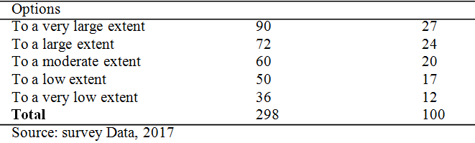

Table 2: Extent to which the Workers’ Output is improved in Rivers State Civil Service Number of respondents Percentage Outcome
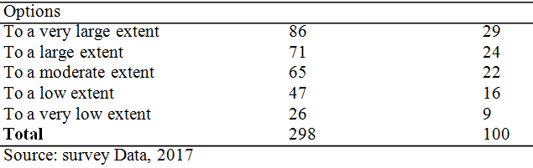

Table 1 shows that the respondents indicated the extent to which the deductible salary of workers’ salary is maintained in Rivers State civil service as follows:27% of the respondents indicated to a very large extent; 24% of the respondents indicated to a large extent; 20% of the respondents indicated to a moderate extent; 17% of the respondents indicated to a low extent while 12% of the respondents indicated to a very low extent.
Table 2 has revealed the opinions of the respondents on the extent to which the output of workers is improved in Rivers State civil; the details are as follows: 29% of the respondents indicated to a very large extent, 29% of the respondents indicated to a large extent; 22% of the respondents indicated to a very low extent.
Table 2 has revealed the options of the respondents on te extent to which the output of workers is improved in Rivers State Civil’ the details are as follows: 29% of the respondents indicated to a very large extent, 29% of the respondents indicated to a large extent; 22% of the respondent indicated to a moderate extent; 16% of the respondent indicated to a low extent; while 9% of the respondents indicated to a very low extent.

Table 3: Extent efficiency is sustained in Rivers State Civil Service
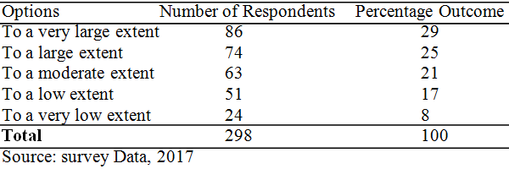

Table 3 has revealed that the responses of the respondents in connection with the extent to which efficiency is sustained in Rivers State civil service; the details are as follows: 29% of the respondents indicated to a very large extent; 25% of the respondents indicated to a large extent to the question; 21% of the respondents indicated to a moderate extent to the question; 17% of the respondents indicated to a low extent, and 8% of the respondents indicated that to a very low extent that efficiency is sustained in Rivers State civil service. Table 4has revealed the opinion of the respondents on the extent to which contributory pension scheme affects workers’ salary in Rivers State civil service.

Table 4: Extent efficiency is sustained in Rivers State Civil Service
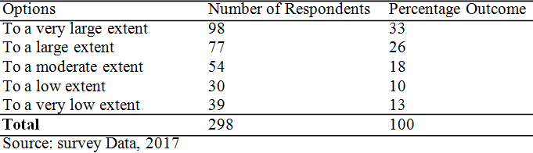

The details are given as follows: 33% of the respondents indicated to a very large extent; 26% of the respondents indicated to a large extent; 18% of the respondents indicated to a moderate extent; 10% of the respondents indicated to a low, while 13% of the respondents indicated to a very low extent that contributory pension scheme affects workers’ salary in Rivers State civil service.

Table 5: Factors hindering the efficient implementation of Contributory Pension Scheme in Rivers State
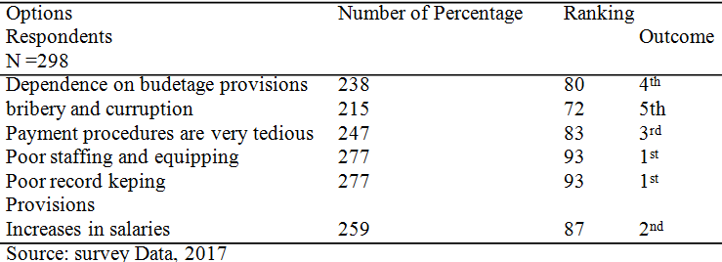

Table 5 shows that the respondents selected ‘poor staffing and equipping’ and ‘poor record keeping’ as the first problems or limitations to effective and efficient implementation of Contributory Pension Scheme in Rivers State., this has been indicated by 93% of the respondents. The next option selected by the respondents as a major problem of human resources development is ‘lack of adequate and timely budgetary provisions, 87% of the respondents indicated this placing the option 2nd in the ranking. Other problems identified by the respondents include:
• Increases in salaries indicated by 87% placing the option 2nd
• Payment procedures are very tedious selected by 83% of the respondents rated 3.
• Dependence on budgetary provisions selected by 80% of the respondents placing the option 4th
• Bribery and corruption indicated by 72% placing the options in the rating of the factors hindering the efficient implementation of Contributory Pension Scheme in Rivers State.

Table 6: Policy options open to government to ensure efficiency of the Contributory Pension Scheme in Riverss
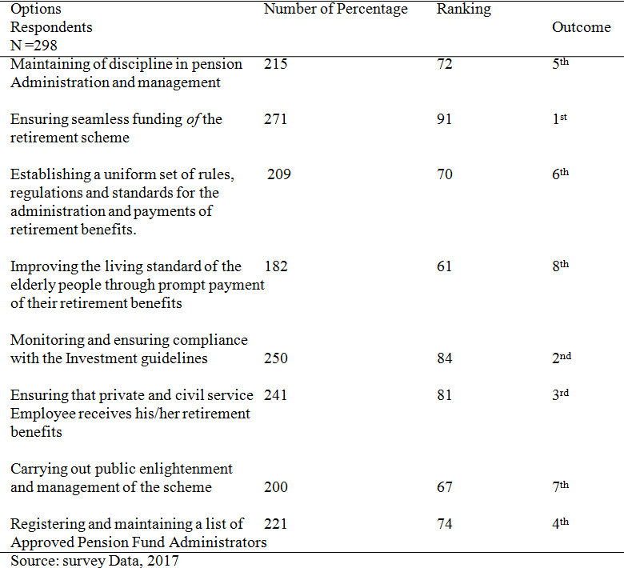

The data in table 6 as revealed by the opinion of the respondents indicated that ‘ensuring seamless funding of the retirement scheme’ is the main policy option open to government to ensure efficiency of the Contributory Pension Scheme in Rivers State.
The data show that 19% of the respondents indicated this placing the option 1 among others. Other policy options open to government to ensure efficiency of the Contributory Pension Scheme in Rivers State as identified by the respondents include the following:
- Monitoring and ensuring compliance with the investment guidelines — indicated by 84% of the respondents positioned in the rating.
- Ensuring that private and civil service employee receives his/her retirement benefits.
- Indicated by 81% of the respondents and positioned 3fh in the rating.
- Registering and maintaining a list of approved Pension Fund Administrators — indicated by 74% and positioned 4t in the rating.
- Maintaining of discipline in pension administration and management in salary assessment indicated by 72% of the respondents placing the option 5th in the rating.
- Establishing a uniform set of rules, regulations and standards for the administration and payments of retirement benefits, indicated by 70% of the respondents placing the option 6th in the rating.
- Carrying out public enlightenment and management of the scheme indicated by 67% of the respondents placing the option 7th the rating.
- Improving the living standard of the elderly people through prompt payment of their retirement benefits indicated by 61% respondent and positioned 8” in the rating of the main policy options open to government to ensure efficiency of the Contributory Pension Scheme in Rivers State.
4.2 Test of Hypotheses
Hypothesis 1 (Hoi: There is no significant relationship between the deductible-saving of workers’ salary and their output in Rivers State civil service. Table 7: Statistical Analysis of the Relationship between the Deductible-Saving of Workers’ Salary (x) and their Output in Rivers State civil service (y).

Table 7: statistical Analysis of the Relationship between the Deductible-Saving of Workers’ Salary (x) and their Output ion Rivers State Civil Service (y)
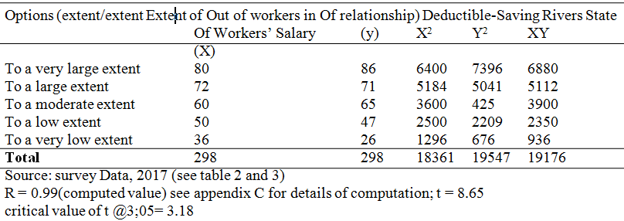

Based on the outcome of the two values ie the computed ‘t’ which is 8.65 and the critical value of ‘t’ which is 3.18, it becomes clear that ‘t’ calculated is greater than ‘t’ critical value @ a corresponding level of significance. Therefore, the study has to reject the null hypothesis 1 (H01) and instead accept the alternative hypothesis 1 (H1) which means that there is positive/significant relationship between the deductible-saving of workers’ salary and their output in Rivers State civil service.
Hypothesis II H0₂: There is no significant relationship between the deductible-saving of workers’ salary and the efficiency of workers in Rivers State civil service.

Table 7: statistical Analysis of the Relationship between the Deductible-Saving of Workers’ Salary (x) and their Output ion Rivers State Civil Service (y)
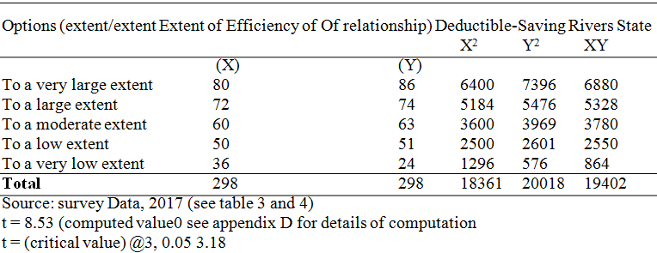

The results of statistical analysis show that the computed‘t’ value is greater than the value obtained from the table at the corresponding level of significance. Therefore, the study has rejected the null hypothesis H (H0₂) and accepted the alternative hypothesis II (H0₂) hence; “there is positive/significant relationship between the deductible-saving of workers’ salary and the efficiency of workers in Rivers State civil service.
4.3 Discussion of Findings
The civil service from our study is a very important sector whose services could be described as strategic to the development of the economy. The workers in this sector are graded by the Nigerian society as better rated employees compared to other sectors (Fapohunda, 2013). In line with this, the civil service sets standard for others to emulate. From the study, it is seen that the civil service uses various methods to educate the workers on retirement benefits. Of important note here according to Egbe (2013) is the fact that the greater number of jobs in the Rivers State civil service are of bureaucratic and procedural stuffs.
The study also found that dependence on budgetary provisions, bribery and corruption, payment procedures are very tedious, poor staffing and equipping, poor record keeping, lack of adequate and timely budgetary provisions and increases in salaries constitute the key problems or limitations to effective and efficient implementation of Contributory Pension Scheme in Rivers State. Except for few cases most of the problems outlined by the civil servants and adopted by this study are the conventional ones already outlined by authorities like Achimugu, Ocheni & Akubo (2015). Omoni (2013) has earlier indicated that fairness in pension scheme is designed to achieve the objective of effective performance and optimum productivity in the civil service.
The found that the main policy option open to government to ensure efficiency of the Contributory Pension Scheme in Rivers State include: Maintaining of discipline in pension administration and management, ensuring seamless funding of the retirement scheme, establishing a uniform set of rules, regulations and standards for the administration and payments of retirement benefits, improving the living standard of the elderly people through prompt payment of their retirement benefits, monitoring and ensuring compliance with the investment guidelines, ensuring that private and civil service employee receives his/her retirement benefits, carrying out public enlightenment and management of the scheme and registering and maintaining a list of approved pension fund administrators. The equity theory holds that a person must see a relationship between the rewards he obtains and the amount of work required to get them and this is based on fair and equity based pension scheme that is pragmatic.

5. Summary of Finding, Conclusion and Recommendations
5.1 Summary of Findings
The study has been embarked upon to evaluate the impact of Pencom Act Scheme on civil servants’ productivity in Rivers State, Nigeria. The study found that contributory pension scheme is a fully funded pension scheme that generates adequate funds through certain percentage of contributions from monthly earnings by both employee and employer through a form of savings.

5.2 Conclusion
Contributory pension scheme is one of the social security maintenance plan put in place by government to cater for the psychological, physiological and economic need of workers after their disengagement as employees through retirement. It is a paradigm shift from the 1979 Pension Act (which was noncontributory). The new scheme was to correct the irregularity that characterized pension schemes in Nigeria. It is evident and conclusive that: There is positive/significant relationship between the deductible-saving of workers’ salary and their output in Rivers State civil service and there is positive/significant relationship between the deductible-saving of workers’ salary and the efficiency of workers in Rivers State civil service.

5.3. Recommendations
Based on the findings and the conclusion reached in this study the following recommendations have been made in this study:
- The study therefore recommends the following: Government should put strict measures in place to ensure the proper monitoring and implementation of the provision of the Pension Reform Act of 2004. Pre-retirement enlightenment workshops should be organized for workers who are about to retire.
- Workers and employers of labour should be properly enlightened on the benefits of the contributory pension scheme. This would further ensure worker confidence towards retirement as well as reduce falsification of age in the civil service.
- Government should create more awareness on CPS to encourage and educate employees on the scheme as most workers are ignorant of its existence.
- Pension Fund Administrator (PFAs) should be transparent and accountable in their dealings with their clients through regular update of their customers account status.
- PENCOM as a regulatory agent should take proactive corrective measures on licensed operators whose situations, actions or inactions jeopardize the safety of pension assets as lay down by the PENCOM establishing laws.

References
- Achimugu, A., Ocheni, S.I. and Akubo, D. (2015). Evaluation of the contribution of portfolios of new contributory pension scheme on Nigerian economy, European Centre for Research Training and Development, United Kingdom.
- Adams, R.A. (2005). Public sector accounting and finance, Lagos Corporate Publisher Venture.
- Adegbayi, A. (2005). Pension industry development in Nigeria, provision of pension reform act, 2004. Online. Retrieved from www.Lcadway.com. Accessed on 13172017.
- Aire, JU. (1974). Problems of social security in Nigeria. Quarterly Journal of Administration. 8(4):409-425.
- Ako, M.K. (2004). Overview of the contributory pension scheme; paper presented to the Nigerian employers consultative association (NECA), Lagos.
- Amstrong, M. (2010). Hand book of personnel management practice, (10th ed), London: Kogan.
- Amujuri, B.A. (2009). New contributory pension scheme in Nigeria: A critical assessment, Nigerian Journal Public Administration &. Local Government. 4(1): 137-152.
- Atedo, N.A. (2006). The problems and challenges of the contributory pension scheme to Nigeria civil service, Publication of the Central Bank of Nigeria, 30(2) April-June, P 7.
- Balogun A. (2006). Understanding the new pension reform act 2004. CBN Bullion 30(2):7.
- Blake, D. (2003). United kingdom pension scheme in Nigeria pension institute, Bareback College University of London.
- Bertrand, M., Sendhii, M. & Douglas, M. (2003). Public policy and extended families: Evidence from pension in South Africa. World Bank Econ, 17(1 ):27-50.
- Egbe, G.A. (2013). Portfolio Optimization of Pension Fund Contribution in Nigeria. Math. Theory Model. 3(8).
- Emiola, A. (1982). Nigerian Public Officer and Right to Pension. Quarterly J. Aclmin. 16(1 & 2):81-l0l.
- Ezem, W (2011). Nigeria National Health Policy on Cervical Cancer, J. Public Admin. Policy Res. 3(7):207-212.
- Fapohunda, T.M. (2013). Pension system and retirement planning in Nigeria. Mediterranean Journal of Social Sciences 4(2).
- Wikipedia (2009). Canada pension plan. Online, retrieved from (accessed on 12/7/2017)
- World Bank (1994). Encyclopedia. Chicago, world book inc.

5/23/2019

