**Comparative study of the effects of X-ray and electron irradiations on the optical properties of the Solid State Nuclear Track Detector (CR-39)**

1KH.M. Abdel Raouf, 2Kh.M. Hella,, and 3A. Rashad

1,2Physics Department, Al- Qunfudhah University college, Umm Al-Qura University, Kingdom of Saudi Arabia

2Experimental Nuclear Physics Department, Nuclear research Center Atomic Energy Authority, Cairo Egypt B.O.13759

1Radiology Department Zagazig University Hospital Zagazig University Zagazig, Egypt

3Acceleration Department Nuclear research Center Atomic Energy Authority, Cairo Egypt B.O.13759

Corresponding Auther: [khalidhella@yahoo.com](mailto:khalidhella@yahoo.com) (KH.M. Hella)

**Abstract:** Recently Solid State Nuclear Track Detector (CR-39) has a very important place at the top of the radiation detector for passive measurement, For this reason many investigation were done to improve the properties of this detector. In this investigation the energy gap of the SSNTD were calculated by measuring transmission at different wave length for ten samples, five of them were irradiated by electron at different energies while the other five samples were irradiated using X-ray at radiation part of the university hospital of Zagzig university, Zagzig, Egypt. Another one sample was used as standard sample. The transmission for all samples was measured at the National Research Center Al-Doqe, Cairo Egypt.

[KH.M. Abdel Raouf Kh.M. Hella,, and A. Rashad. **Comparative study of the effects of X-ray and electron irradiations on the optical properties of the Solid State Nuclear Track Detector (CR-39).** *Researcher* 2019;11(5):41-47]. ISSN 1553-9865 (print); ISSN 2163-8950 (online). <http://www.sciencepub.net/researcher>. 7. doi:[10.7537/marsrsj110519.07](http://www.dx.doi.org/10.7537/marsrsj110519.07).

**Key word:** CR-39, energy gap

**Introduction**

In last Decades solid state nuclear track detector has the first priority of nuclear detectors in many fields; many types of detectors (organic and inorganic materials) were prepared to cover a wide range of nuclear measurements according to its properties It is well-known that Poly-allele-diglycol-carbonate (C-39) related to the chemical formula of C12H18O7(its molecular structure is shown in Scheme 1) is one of the solid-state nuclear track detectors (SSNTD) that often uses in detecting charging nuclear particles.



**Fig.1 shows the basic chemical structure of CR-39 monomer.**

The characteristic of CR-39 is visually transparent in the visible spectrum while most of it is completely opaque in the infrared and ultraviolet spectral regions [1]. It has been reported to the possibility of improving the properties of the polymeric materials through several treatments such as doping, irradiation, annealing *etc*., which make it a promising candidate for commercial applications [2]. Much of these effects, leads to modifying the materials polymeric structure *via* destroys the initial structure by way of the cross-linking which reflects an increase in the materials molecular weight and formation of a macroscopic network [6], *via*also a free-radical formation, irreversible bond cleavages *etc*. that results in the fragmentation of molecules and formation of saturated and unsaturated groups [7]. All of these processes which lead to introduce the so-called defects inside the polymeric materials are responsible [8=13] for the changes occur in the optical, electrical, mechanical and chemical properties of the material. These effects depend on the amount of energy deposited in the polymer. The polymer irradiations process became one of the most acceptable approaches to modify significantly the polymer physical properties.

Several authors [1-6] studied the optical properties of CR-39 irradiated with different doses of gamma rays, X-rays, and different particles fluencies. They found that the optical band gap energy was reduced with the increase of gamma-absorbed dose as-well-as ions fluencies. Similar studies have been carried out by other authors. Saad et al. [7] have indicated qualitatively the decrease in the band gap with increasing gamma dose with maximum up to 400 kGy. El-Shahawy [8] has reported the slight decrease in direct band gap with the increase in gamma dose up to a maximum of 100 kGy. El. Ghandoor *et al.* [9] have studied the effect of gamma irradiation on the refractive index of CR-39 polymer. Singh and Prasher [10] have quoted decrease in band gap with the increase in gamma dose without mentioning whether the band gap was direct or indirect. However, with respect to the effects of the irradiation process on the refractive index of CR-39 polymeric material the published data is rare in the reported literatures.

The present work aims to compare between the effects of low doses of X-ray and electron irradiations on the optical properties of the CR-39 polymeric material; namely the refractive index and the optical band gap energy.

**Experimental Technique**

Poly-Allyl-Diglycol-Carbonate, CR-39, sheets of thickness 0.5 cm The SSNTD's (CR-39) manufactured by TASTRAK factory (Track Analysis System Ltd., UK) with thickness 0.5 mm and density 1.31 g/cm3 were used in this study. The sheet was cut into pieces with an area of 1 × 1 cm2 before uses. One of the pieces was left without irradiation as a base sample, and two groups each contains five samples have been irradiated in air at the linear accelerators of radiology department, Zagazig University Hospital, Zagazig University-Egypt; the required doses was obtained by adjusting the electron beam parameters and conveyer speed. The 1stgroup was irradiated by an electrons with different energies of 4, 6, 8 12, 15 MeV while the 2ndgroup was irradiated by the X-ray with energies of 50, 100, 150, 6000, 15000 kV.

The transmission and reflection spectra of the un-exposed and radiation-exposed samples were measured within the wavelength optical range 190-2500 nm; using a double-beam spectrophotometer The measurement was carried out at room temperature at National Research Center-Egypt.

**Results And Discussions**

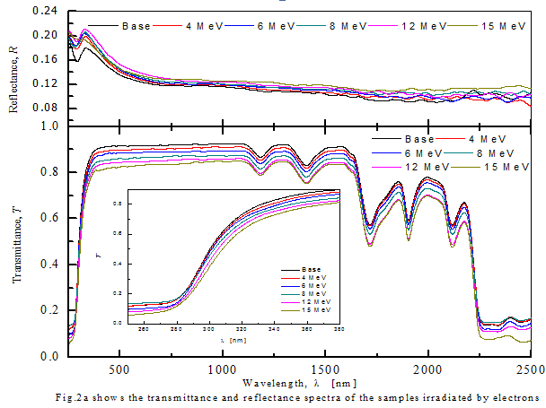

Fig.2a, b shows the transmittance, *T* and reflectance, *R* spectra of the samples irradiated by electrons (Fig.2 a) and X-ray (Fig.2 b) at different energies doses. It has been observed that the un-irradiated CR-39 sample is highly transparent reach a value of transparency of 90%. It was found that, once the samples were irradiated by such as electrons or X-ray the transmittance values decreases gradually while the reflectance increases with the increases the radiation dose. Furthermore, the transmittance spectra of the samples can be divided to three different regions; the 1st region characterizes the fundamental absorption edge in the wavelength optical range 250-400 nm; at which the materials are strongly absorption the incident light. The 2nd region in the wavelength range 400-2160; where the transmission spectra contain five absorption bands observed at 1180, 1400, 1720, 1900 and 2110 nm, respectively. These absorption bands are due to the C-H stretching. The 3rd region observed in the wavelength range 2110-2500 nm; where strong absorption has been occurred, indicates that the CR-39 are almost opaque in near-infrared spectral region (beyond 2110 nm). This result characterizes the most cited behavior of the transmission spectra of the CR-39 polymeric material [11]. Furthermore, for both types of radiations, a slight red shift in the fundamental absorption edge has been also observed with the increases of the radiation dose (See Fig.3a, b)

The real and imaginary parts of the complex refractive index, *n* and *k*, have been calculated as a function of the radiation doses from the recorded transmittance and reflectance spectra *via* the relations:

$$n=\left\{\sqrt{\frac{4R}{(R-1)^{2}}-k^{2}}-\frac{(R+1)}{(R-1)}\right\}…………….. (1)$$

Where *n* is the real part of the refractive index and *k* is the imaginary part of the refractive index and frequently called the extinction coefficient ($={αλ}/{4π; where, α isabsorption coefficent)}$. The absorption coefficient, $α$ can be also calculated from the well-known relation.

$$α=(\frac{1}{t})\ln\left(\frac{1}{T}\right){cm}^{-1}……………………….……. (2)$$

Where *t* is the sample thickness.

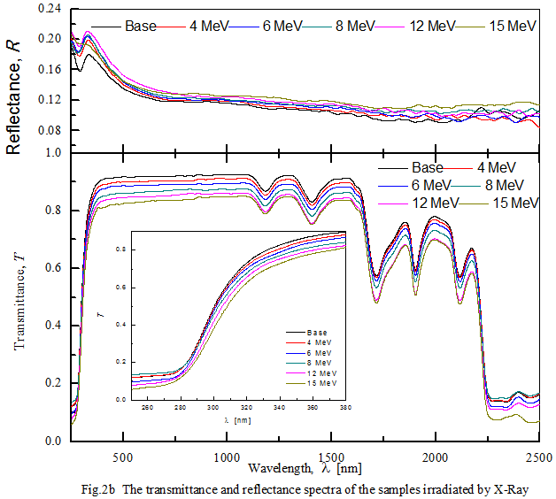

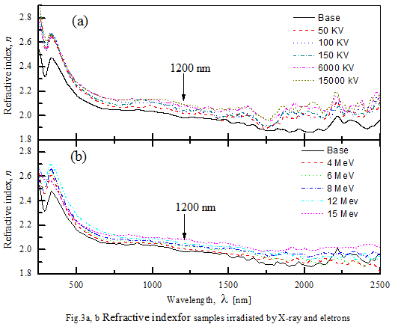

Fig.4a, b shows the spectral variation of the refractive index, *n* (Fig.4a) and the extinction coefficient, *k* (Fig.4b). The figures depict; that for such of the investigated samples, the refractive index, *n* (Fig.4a) decreases with the increases of the wavelength and also with increasing the radiation doses. The dispersion of the refractive index values observed beyond the wavelength 2110 nm can be attributed to the presence the absorption in this region. The estimated values of the refractive index as a function of the X-ray or electrons irradiation doses taken at 1200 nm; after the fundamental absorption edge and before the observed absorption bands are listed in Table 1. It has been observed that for both types of radiation the refractive index of CR-39 increases with the increase the radiation doses. In the other hand the extinction coefficient, *k* (Fig.4b) in the fundamental absorption edge (250-400 *nm*) showed decreases with the increase in the wavelength (see inset of Fig.4b), thereafter takes minimum values at the highest transmittance region (400-1200 *nm*). The characteristic bands observed in the extinction coefficient curves are related directly to the bands occurred in the transmittance spectra (See Figs.1 a, b). It has been observed that for both types of radiation the refractive index of CR-39 increases with the increase the radiation doses.

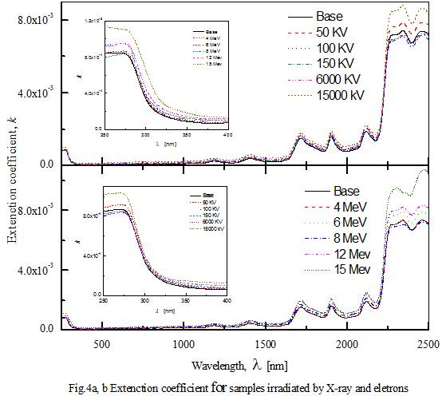

Fig.5 a, b shows the optical absorption coefficient, $α$ of the, investigated CR-39 samples at the fundamental absorption edge as a function of the X-ray and electron radiation doses. The figure depicts that the absorption coefficient increases with increasing the photon energy and for both types of radiations the absorption coefficient increase with the increase of the working dose.

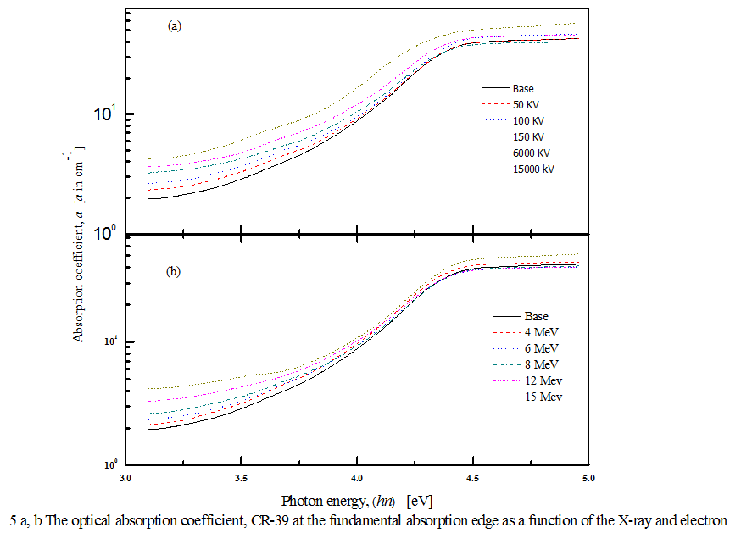

The analysis of the absorption coefficient according to the Taucs relation:

$$\left(αhν\right)=β(hν-E_{g})^{m}……………………….. (3)$$

Where $hν$ is the photon energy, ( $hν={1240}/{λ)}$ and $β$ is a constant. The exponent *m* determines the type of the optical transition, which takes the values of $1/2$, $2$ for direct and indirect optical transitions, respectively. The plots of $(αhν)^{1/2}$*vs*. photon energy, *hν* as shown in Fig.6 a, b enables us to determine the value of the optical band gap as a function of radiation doses; by extrapolation the linear parts to zero energy.

It has been observed that the values of the energy gap slightly decreases with the increase of the radiation doses, where X-ray radiation has slightly higher effects than the electron radiation.

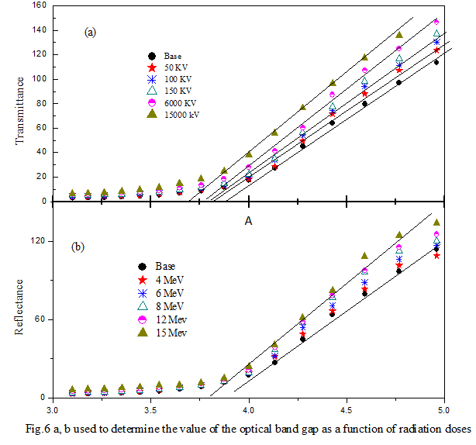

**Acknowledgment**

This work was supported by the Deanship of Scientific Research, under Grant no. 43405054. Great thank for the Physics Department, Al- Qunfudhah University college, Umm Al-Qura University, Radiology Department Zagazig University Hospital, Zagazig University Zagazig, Egypt.

**Reference**

1. G. Marletta, Chemical reactions and physical property modifications induced by keV ion beams in polymers. Nucl. Inst. Meth. Phys. Res. B46, (1–4), 295-305 (1990).
2. R. C. Ramola, S. Chandra, A. Negi, J. M. S. Rana, S. Annapoorni, R. G. Sonkawade, P. K. Kulriya and A. Srivastava. Study of optical band gap, carbonaceous clusters and structuring in CR-39 and PET polymers irradiated by 100 MeV O7+ ions Physica B404(1)26( 2009).
3. MF Zaki. Gamma-induced modification on optical band gap of CR-39 SSNTD. *J. Phys. D: Appl. Phys*. 2008; 41, 175404-175408.
4. S. Singh and S Prasher. The optical, chemical and spectral response of gamma-irradiated Lexan polymeric track recorder. *Radiat. Meas.* 2005; 40, 50-54.
5. T. Phukan, D. Kanjilal, T. D. Goswami and HL Das. Study of optical properties of swift heavy ion irradiated PADC polymer. *Radiat. Meas.* 2003; 36, 611.
6. HS Virk and AK Srivastava., Modification of optical, chemical and structural response of CR-39 by 50 MeV lithium ion irradiation. *Radiat Meas.* 2001; 34, 65-67.
7. A. F. Saad, S. T. Atwa, R. Yokota, M. Fujii, Radiation-induced modifications on spectroscopic and thermal properties of CR-39 and SR-90 nuclear track detectors. Radiat. Meas. Volume 40 (2–6), 780-784 (2005).
8. M. A. El-Shahawy, Spectral changes of CR-39 induced by irradiation and heat treatment. Journal of Polymer Degradation and Stability 57: 157-161 (1997)
9. H. El-Ghandoor, S. A. El-Fiki and S. Y. El-Zaiat, Interferometric investigation of the effect of gamma radiation on the refractive index of CR-39 polymer Opt. and Laser Tech 28(8) 585, (1996).
10. S. Singh, S. Prasher The etching and structural studies of gamma irradiated induced effects in CR-39 plastic track recorder. Nucl Inst. Meth. Phys. Res. B222 (3-4) 518-524 (2004).
11. J. Stejny, T. Portwood, Nucl. Tracks Radiat. Meas. 12, (1-6) 59(1986).

5/23/2019