Conventional Surgery versus Endovenous Laser Ablation in Treatment of Primary Varicose Veins

Mahmoud Ahmed Alshafei, Shaaban Mohamed Abd Almaged, Mohamed Korayem Fattouh, Mohamed Mohamed Fathi Morad Ghonium

Department of General Surgery, Faculty of Medicine, Ain Shams University
dr_morad34@yahoo.com

Abstract: Background: Conventional surgical management for varicose veins entails flush ligation of the SFJ, LSV stripping and stab avulsions of the varicosities. Although this surgical modality is safe and effective at short-term and midterm follow-up, it is not rare for recurrence, hematoma, and skin infection to occur after the surgical procedure. Rarely, massive bleeding due to injury to femoral veins, or even to the femoral artery during surgery, and mortality from pulmonary embolism and DVT can happen. Therefore, novel treatment modalities have been developed over recent years to overcome the limitations of conventional surgery. Within the last two decades, radiofrequency ablation and endovenous laser treatment (EVLA) have been introduced as an important new endovenous ablative techniques for the minimally invasive treatment of superficial venous reflux and varicose veins. Therefore, we performed the present systematic review and meta-analysis in order to evaluate the short and long-term outcomes of EVLA compared to conventional surgery. Objective: To assess the role of endovenous laser ablation in comparison to conventional surgery in treatment of primary varicose veins. Materials and Methods: An electronic search was conducted from the inception till December 2018 in the following bibliographic databases: Medline via PubMed, SCOPUS, Cochrane Central Register of Controlled Trials (CENTRAL), EMBASE, LILACS via Virtual Health Library, and Google Scholar to identify relevant articles. We used different combinations of the following queries: ((“("Laser Therapy"[Mesh] OR "endovenous laser ablation") AND "Varicose Veins"[Mesh]). The search have been done with no limit regarding the year publication. Results: In the present study, we searched Medline via PubMed, SCOPUS, Web of Science, Cochrane Central Register of Controlled Trials (CENTRAL), LILACS via Virtual Health Library, and Google Scholar from their inception till December 2018. The search retrieved 1645 unique records. We then retained 49 potentially eligible records for full-texts screening. Finally, 17 reports of 11 RCTs (Total No. of legs =2524) were included in the present systematic review and meta-analysis. Conclusion: EVLA is a safe and effective treatment alternative for patients with primary varicose veins. The present systematic review and meta-analysis show that EVLA has, at least, comparable efficacy to conventional surgery in terms of recurrence rates, disease severity, and quality of life. Further high-quality long-term studies are still needed to confirm our findings.
[Mahmoud Ahmed Alshafei, Shaaban Mohamed Abd Almaged, Mohamed Korayem Fattouh, Mohamed Mohamed Fathi Morad Ghonium. Conventional Surgery versus Endovenous Laser Ablation in Treatment of Primary Varicose Veins. Researcher 2019;11(5):22-32]. ISSN 1553-9865 (print); ISSN 2163-8950 (online). http://www.sciencepub.net/researcher. 4. doi:10.7537/marsrsj110519.04.

Keywords: Endovenous laser ablation, Clinical, Etiologic, Anatomic and Pathophysiologic

1. Introduction
References to varicose veins are found in early Egyptian and Greek writing and confirm venous disease was recognized in ancient times ⁽¹⁾.
Varicose veins are prominent, dilated tortuous superficial veins usually on the legs but occasionally can be found on other parts of the body such as the lower abdominal wall and perineal area. The size of varicose veins varies ranging from spider veins (telangiectasia) to large bulbous varicose veins. Telangiectasias are spider veins that often have connections with the larger reticular veins and varicose veins ⁽²⁾.
Varicose veins are extremely common, affecting approximately 30–40% of the population to some degree. They affect men and women roughly equally although women are more likely to present to their doctor ⁽³⁾.
Varicose veins are due to defective functioning of the valves within the vein, allowing reflux of blood. They can cause symptoms of pain, ankle swelling, heaviness, and itchiness. Symptoms are often worse at the end of the day and after prolonged standing ⁽⁴⁾.
Varicose veins may become more severe over time and can lead to complications such as changes in skin pigmentation, bleeding or venous ulceration. It is not known which people will develop more severe disease but it is estimated that 3–6% of people who have varicose veins in their lifetime will develop venous ulcers ⁽¹⁾.
Venous insufficiency of the great saphenous vein (GSV) and/or small saphenous vein (SSV) is the most common causes of varicose veins in the lower extremities. When incompetence of saphenofemoral junction (SFJ) is detected and/or incompetence of saphenopopliteal junction (SPJ), treatment should be first directed toward eliminating this source of reflux with ablation of the incompetent venous segments ⁽⁵⁾.
Colored Duplex ultrasonography is considered the cornerstone of varicose veins diagnosis and also can be used for interventional treatment. It is used to determine the accurate location and extent of the venous reflux and valvular incompetence ⁽⁶⁾.
It seems that the appearance and evolution of the disease occur due to multiple factors but mainly the modern lifestyle, characterized by sedentary, lack of exercise and obesity. Surgery is the gold standard in the treatment of varicose veins. For several decades high ligation at saphenofemoral junction (SFJ) and stripping of the GSV was the treatment of choice in order to eradicate the diseased vein. Insufficiency of small saphenous vein (SSV) is treated in a similar way, by ligation at the saphenopopliteal junction (SPJ) and stripping. In the last years, in the era of minimally invasive surgery, new techniques in the treatment of varicose veins, such as the endovenous laser ablation (EVLA) ⁽⁷⁾.
Saphenous vein ligation and stripping is still the more commonly performed procedure worldwide, and it may be the preferred therapy for patients with GSVs of very large diameter (>2 cm). Complications associated with GSV stripping include ecchymosis, lymphocele formation, DVT, infection, and saphenous nerve injury ⁽⁸⁾.
Aim of the Work
This review seeks to assess the role of endovenous laser ablation in comparison to conventional surgery in treatment of primary varicose veins.

2. Materials and Methods
We performed this systematic review and meta-analysis in accordance to the recommendations of the Preferred Reporting Items for Systematic Reviews and Meta-Analyses (PRISMA) statement. PRISMA is a reporting checklist for Authors, Editors, and Reviewers of Meta-analyses of interventional and observational studies. According to International committee of medical journal association (ICJME), reviewers must report their findings according to each of the items listed in those checklists (Moher et al., 2009).
Study Selection and Eligibility Criteria:
The present review included studies that fulfilled the following criteria: Studies that included adults’ patients with diagnosis of primary varicose veins; Studies that assessed the efficacy and safety of the management of primary varicose veins Endovenous Laser Ablation (EVLA); Studies that compared the EVLA with conventional surgery; Studies that reported any of the following outcomes: patient’s quality of life, post-operative complications, pain, and co-morbidity of the protocol of management. Studies that were randomized controlled trials (RCTs). We excluded non-English studies, theses, dissertations and conference abstracts, and trials with unreliable date for extraction.
Search Strategy and Screening
An electronic search was conducted from the inception till December 2018 in the following bibliographic databases: Medline via PubMed, SCOPUS, Cochrane Central Register of Controlled Trials (CENTRAL), EMBASE, LILACS via Virtual Health Library, and Google Scholar to identify relevant articles. We used different combinations of the following queries: ((“("Laser Therapy"[Mesh] OR "endovenous laser ablation") AND "Varicose Veins"[Mesh]). The search have been done with no limit regarding the year publication.
Screening:
Retrieved citations were imported into EndNote X7 for duplicates removal. Subsequently, unique citations were imported into an Excel sheet and screened by two independent reviewers; the screening was conducted in two steps: title and abstract screening, followed by a full-texts screening of potentially eligible records.
Data Extraction:
Data entry and processing were carried out using a standardized Excel sheet and reviewers extracted the data from the included studies. The extracted data included the following domains: (1) Summary characteristics of the included studies; (2) Baseline characteristics of studied populations; and (3) Study outcomes. All reviewers’ independently extracted data from the included articles and any discrepancies were solved by discussion.
Dealing with Missing Data:
Missing standard deviation (SD) of mean change from baseline was calculated from standard error or 95% confidence interval (CI) according to Altman ⁽⁹⁾.
Data Synthesis:
Continuous outcomes were pooled as mean difference (MD) or standardized mean difference (SMD) using inverse variance method, and dichotomous outcomes will be pooled as relative risk (RR) using Mantel-Haenszel method. The random-effects method was used under the assumption of existing significant clinical and methodological heterogeneity. We performed all statistical analyses using Review Manager (RevMan) 5.3 or Open Meta-analyst for windows.
Assessment of Heterogeneity:
We assessed heterogeneity by visual inspection of the forest plots, chi-square, and I-square tests. According to the recommendations of Cochrane Handbook of Systematic Reviews and meta-analysis, chi-square p-value less than 0.1 denote significant heterogeneity while I-square values show no important heterogeneity between 0% and 40%, moderate heterogeneity from 30% to 60%, substantial heterogeneity from 50% to 100%. If any trials were judged to affect the homogeneity of the pooled estimates, we planned to perform a sensitivity analysis to assess outcomes with and without the trials that were affecting the homogeneity of the effect estimates.
Assessment of publication biases
We intended to test for publication bias using funnel plots if any of the pooled analysis included more than 10 studies in the review.
Results
- Characteristics of the included studies
In the present study, we searched Medline via PubMed, SCOPUS, Web of Science, Cochrane Central Register of Controlled Trials (CENTRAL), LILACS via Virtual Health Library, and Google Scholar from their inception till December 2018. The search retrieved 1645 unique records. We then retained 49 potentially eligible records for full-texts screening. Finally, 17 reports of 11 RCTs (Total No. of legs =2524) were included in the present systematic review and meta-analysis (Figure 6).

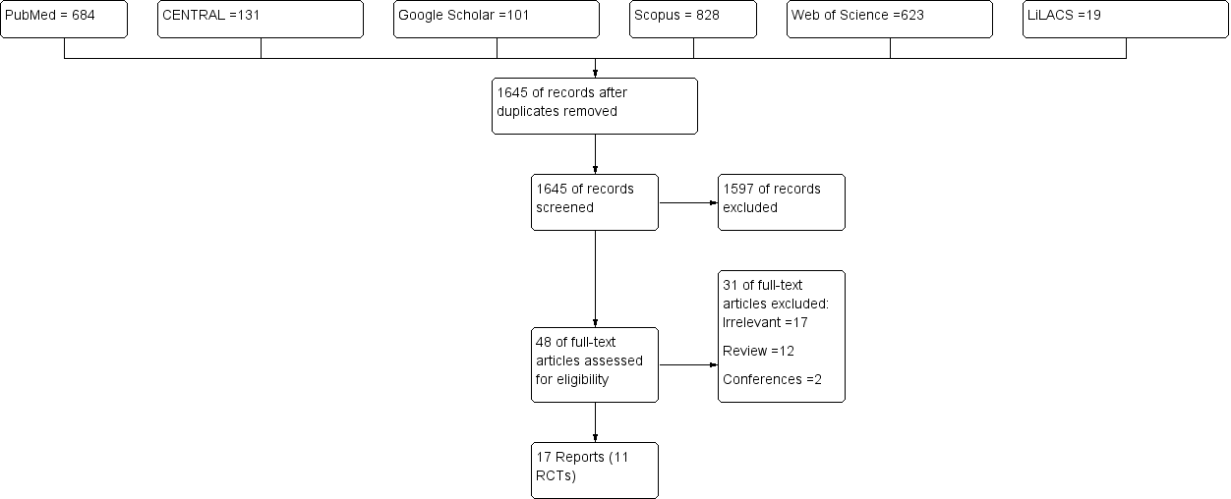
Figure (1): PRISMA flow-chart.

II. Characteristics of The included studies

Table (1): Summary Characteristics of the included studies.
Study ID | No. of Reports | Year of First Publications | Design | Setting | Sample Size | Vein involvement | EVLA dose | Type of Surgery | Follow-up (months) | Main Findings
CLASS | 1 | 2015 | Open-label RCT | UK | 798 | GSV and SVV | 980 nm | Proximal ligation and stripping (of the great saphenous vein only) and concurrent phlebectomies. | 6 | EVLA should be considered as the treatment of choice for suitable patients.
HELP 2 | 2 | 2013 | Open-label RCT | UK | 106 | SVV | 810-nm | SPJ ligation and strpping | 6 / 24 | EVLA produced the same clinical benefits as conventional surgery but was more effective
VESPA | 1 | 2013 | Open-label RCT | Netherlands | 189 | SVV | 810-nm | Ligation of the SPJ | 6 | EVLA provides an excellent alternative to conventional surgery in the treatment of symptomatic varicosis due to an incompetent SSV with SPJ.
Pronk et al, | 1 | 2010 | Open-label RCT | Netherlands | 121 | GSV | 980 nm | SFL/S | 12 | No difference in short-term recurrence rate.
RELACS Study | 2 | 2012 | Open-label RCT | Germany | 400 | GSV | 980 nm | HLS | 24 | Both EVLT and HLS are comparably safe and effective procedures to treat GSV incompetence
HELP-1 | 2 | 2011 | Open-label RCT | UK | 280 | GSV | 810-nm | SFL/S | 12/ 24/ 60 | EVLA was as effective as surgery for varicose veins, but had a less negative impact on early postintervention QoL.
Rasmussen, et al | 3 | 2007 | Open-label RCT | Denmark | 121 | GSV | 980 nm | HLS | 6/ 24/ 60 | Short-term efficacy and safety of EVL and HL/S are similar
Biemans et al, and Van der Velden et al | 2 | 2013 | Open-label RCT | Netherlands and Belgium | 240 | GSV | 940-nm | HLS | 12/ 60 | EVLA is as effective as CS and superior to UGFS according to occlusion on ultrasound duplex.
Christenson et al, | 1 | 2010 | Open-label RCT | Switzerland | 204 | GSV | 980 nm | HLS | 24 | Abolition of GSV reflux and improvement in quality of life was similar after HL/S and EVLT
Mozafar et al, | 1 | 2013 | Open-label RCT | Iran | 65 | GSV | 980 nm | HL | 18 | EVLT may offer a better long-term relief of symptoms.
Darwood et al, | 1 | 2008 | Open-label RCT | UK | 114 | GSV | 810-nm | Proximal ligation and stripping (of the great saphenous vein only) and concurrent phlebectomies. | 3 | Abolition of reflux and improvement in disease-specific quality of life was comparable following both EVLA and surgery.

Table (2): Baseline Characteristics of the included studies.
Authors | Group | Sample  Size | Age | Female  No. (%) | BMI | Unilateral | GSV | CEAP classification
 |  |  |  |  |  |  |  | C2 | C3 | C4 | C5
CLASS | EVLA | 210 | 49.7±14.4 | 120 (57.1) | 27.0±4.6 | 153 (72.9) | 182 (86.7) | 113 (54.1) | 28 (13.4) | 56 (26.8) | 12 (5.7)
 | Surgery | 289 | 49.2±13.7 | 163 (56.4) | 27.7±4.7 | 196 (67.8) | 239 (82.7) | 147 (51.2) | 39 (13.6) | 90 (31.4) | 11 (3.8)
HELP-2 | EVLA | 53 | 47.8±12.2 | 34 (64.2) | 25.9±3.2 | 53 (100) | 0 | 40 (75.5) | 2 (3.8) | 9 (17) | 2 (3.8)
 | Surgery | 53 | 47.5±12.9 | 40 (75.5) | 24.9±5.3 | 53 (100) | 0 | 46 (86.8) | 1 (1.9) | 4 (7.5) | 2 (3.8)
VESPA | EVLA | 118 | 52 (21-79) | 86 (73) |  | 118 (100) | 0
 | Surgery | 57 | 51 (19 -73) | 31 (54) |  | 57 (100) | 0
Pronk et al, | EVLA | 62 | 49±11 | 46 (75) | 25±3.3 | 62 (100) | 62 (100) | 26 (38) | 36 (53) | 5 (7) | 1 (1)
 | Surgery | 68 | 50±10.5 | 53 (77.9) | 24.5±3.7 | 68 (100) | 68 (100) | 29 (47) | 29 (47) | 4 (6) | 0
RELACS Study | EVLA | 185 | 47.9 (22-67) | 124 (67) | 26.2 (18.4-39.1) | 185 (100) | 185 (100) | 53 (29) | 95 (52) | 36 (20) | 1 (1)
 | Surgery | 161 | 48 (18-66) | 113 (70) | 26.3 (15.7-48.4) | 161 (100) | 161 (100) | 47 (29) | 76 (47) | 35 (22) | 2 (1)
HELP-1 | EVLA | 139 | 49±13 | 85 (61·2) | 26.6±5 | 139 (100) | 139 (100) | 96 (70.1) | 43 (31.2)
 | Surgery | 137 | 49±14 | 90 (65.7) | 26±4.3 | 137 (100) | 137 (100) | 95 (68.8) | 41 (29.9)
Rasmussen, et al | EVLA | 62 | 53 (26-79) | 41 (66) |  | 62 (100) | 62 (100) | 50 (81) | 3 (5) | 9 (15)
 | Surgery | 59 | 54 (22-78) | 43 (73) |  | 59 (100) | 59 (100) | 51 (86) | 5 (8) | 3 (5)
Biemans et al, and  Van der Velden et al, | EVLA | 78 | 49±15.03 | 54 (69.2) |  | 62 (79.5) | 78 (100) | 37 (47.4) | 29 (37.2) | 8 (10.3) | 0
 | Surgery | 68 | 52±15.59 | 46 (67.6) |  | 51 (75) | 68 (100) | 28 (41.2) | 21 (30.9) | 14 (20.6) | 1 (1.5)
Christenson et al, | EVLA | 104 | 44.6±10.5 | 67 (68) | 26.2±4.8 | 104 (100) | 104 (100) | 34 (34) | 58 (58) | 7 (7) | 1 (1)
 | Surgery | 100 | 46.3±13.3 | 71 (71) | 26±5.1 | 100 (100) | 100 (100) | 26 (26) | 51 (51) | 18 (18) | 2 (2)
Mozafar et al, | EVLA | 30 | 38.9±9.3 | 22 (73.3) |  | 30 (30) | 30 (30) | 14 (46.7) | 9 (30) | 6 (20) | 1 (3.3)
 | Surgery | 35 | 39.26±9.24 | 25 (71.4) |  | 35 (35) | 35 (35) | 18 (51.4) | 10 (28.6) | 5 (14.3) | 2 (5.7)
Darwood et al, | EVLA | 38 | 42 (30·5–54·5) | 22 (57) |  | 38 (100) | 38 (100) | 37 | 4 | 2 | 3
 | Surgery | 30 | 49 (38·5–57·5) | 16 (53) |  | 30 (100) | 30 (100) | 23 | 9 | 0 | 1

III. Overall Estimates Regardless of Type of Vein
- Clinical Recurrence and Reflux
- Clinical Recurrence

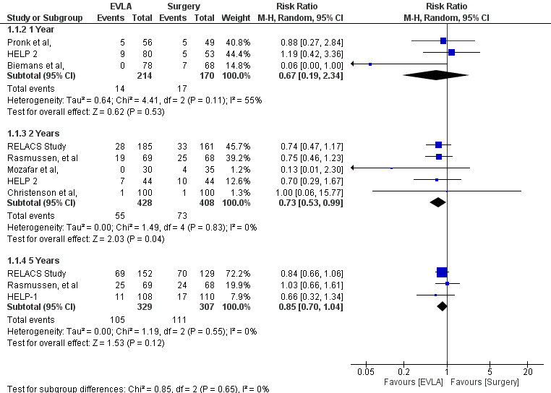
Figure (2): Forest plot of clinical recurrence.

Over all, eight RCTs reported the clinical recurrence rates over the period of follow-up, After two years of follow-up, the overall effect estimates favoured EVLA over surgery (RR 0.73, 95% CI [0.53 – 0.99]; P =0.04); the pooled studies showed no significant heterogeneity (p =0.083; I² =0%). In contrary, the overall effect estimates did not favour EVLA over surgery at one year (RR 0.67, 95% CI [0.19, 2.34]; P =0.53) and five years (RR 0.85, 95% CI [0.70, 1.04]; P =0.12); the pooled studies showed no significant heterogeneity (p =0.083; I2 =0%). Figure.7 shows the forest plot of clinical recurrence.
- Reflux rates

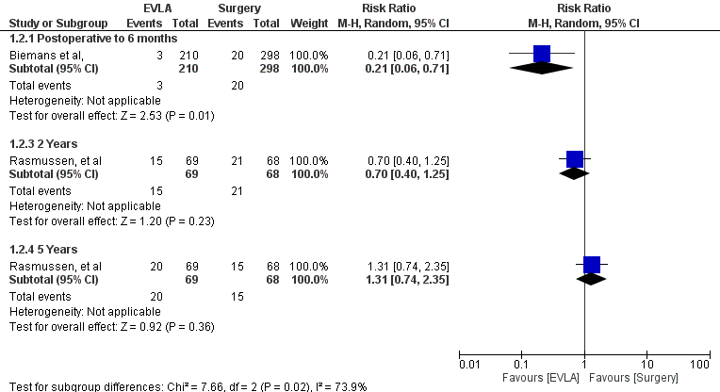
Figure (3): Forest plot of reflux rates.

Over all, two RCTs reported the reflux rates over the period of follow-up, After six months of follow-up, the overall effect estimates favoured EVLA over surgery (RR 0.2, 95% CI [0.06, 0.71]; P =0.01). In contrary, the overall effect estimates did not favour EVLA over surgery at two year (RR 0.70, 95% CI [0.40, 1.25]; P =0.23) and five years (RR 1.31 [0.74, 2.35]; P =0.36). Figure.8 shows the forest plot of reflux rates.
- Complete Success

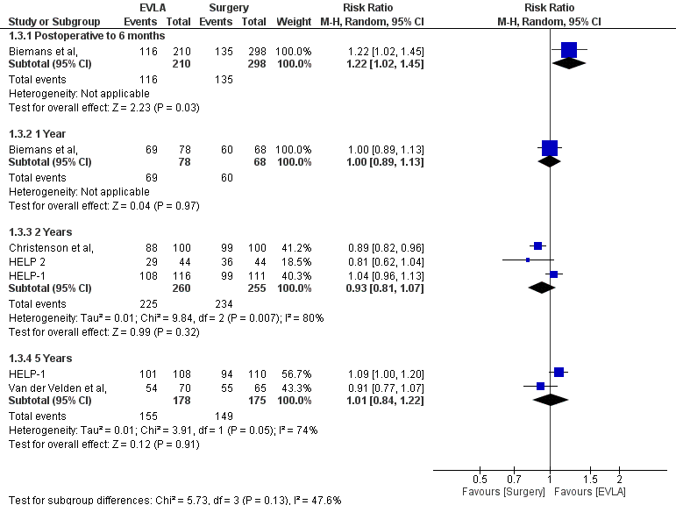
Figure (4): Forest plot of complete success rates.

Over all, five RCTs reported the complete success rates over the period of follow-up, After six months of follow-up, the overall effect estimates favoured EVLA over surgery (RR 1.22, 95% CI [1.02, 1.45]; P =0.03. In contrary, the overall effect estimates did not favour EVLA over surgery at other time points; the pooled studies showed significant heterogeneity (p =0.007; I2 =80%). Figure.9 shows the forest plot of complete success rates.
- Quality of Life Scores
The Aberdeen Varicose Vein Questionnaire

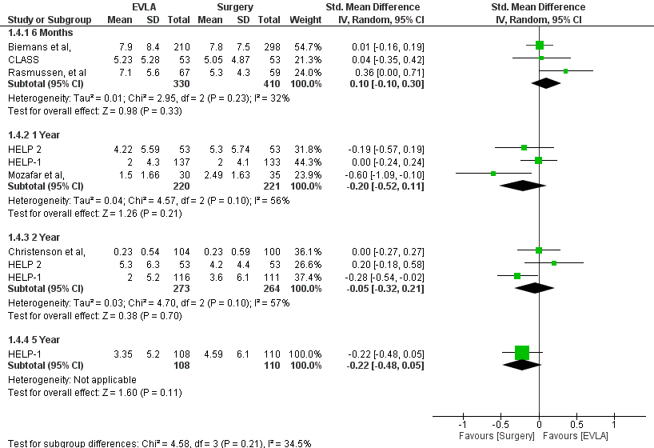
Figure (5): Forest Plot of AVVQ.

Over all, seven RCTs reported the change in AVVQ over the period of follow-up, After six months of follow-up, the overall effect estimates did not favour EVLA over surgery (SMD 0.10, 95% CI [-0.10, 0.30]; P =0.33); the pooled studies showed no significant heterogeneity (p =0.23; I² =32%). Similarly, the overall effect estimates did not favour EVLA over surgery at one year (P =0.21), two years (P =0.7), and five years (P =0.11); the pooled studies showed no significant heterogeneity (p >0.1). Figure.10 shows the forest plot of AVVQ.
- EQ-5D

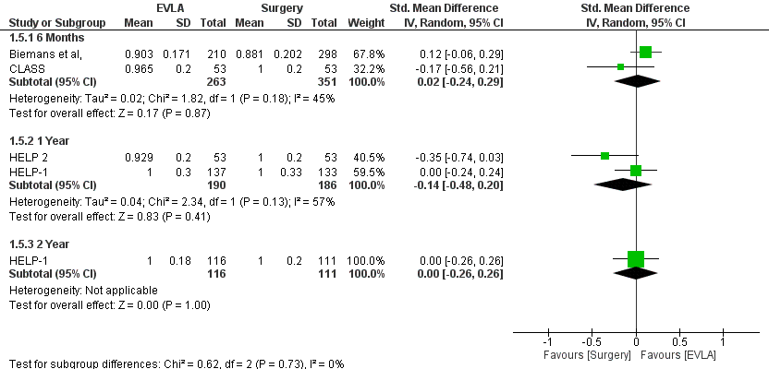
Figure (6): Forest Plot of EQ-5D.

Only four RCTs reported the change in EQ-5D over the period of follow-up, After six months of follow-up, the overall effect estimates did not favour EVLA over surgery (SMD 0.02, 95% CI [-0.24, 0.29]; P =0.87). Similarly, the overall effect estimates did not favour EVLA over surgery at one year (P =0.41) and five years (P =0.99). Figure.11 shows the forest plot of EQ-5D.
- SF-36 physical component

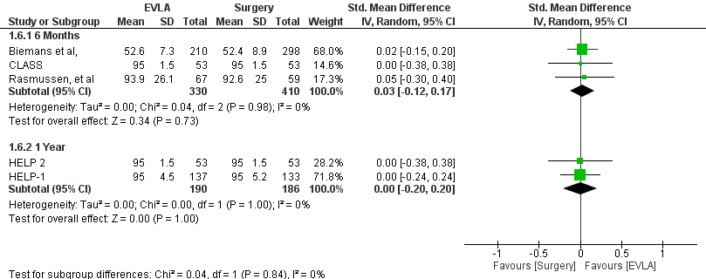
Figure (7): Forest Plot of SF-36.

Over all, four RCTs reported the change in the SF-36 over the period of follow-up, After six months of follow-up, the overall effect estimates did not favoure EVLA over surgery (SMD 0.03, 95% CI [-0.12, 0.17]; P =0.73). Similarly, the overall effect estimates did not favour EVLA over surgery after one year; the pooled studies showed no significant heterogeneity (p =0.98; I2 =0%). Figure.12 shows the forest plot of sf-36.
- Disease Severity
- HVVSS score

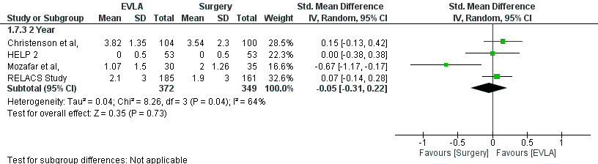
Figure (8): Forest Plot of HVVSS score.

Over all, four RCTs reported the change of HVVSS at two years of follow-up. The overall effect estimates did not favour EVLA over surgery (SMD -0.05, 95% CI [-0.31, 0.22]; P =0.73); the pooled studies showed significant heterogeneity (p =0.04; I² =68). The sensitivity analysis showed that the significant heterogeneity was resolved after removal of Mozafar et al, (P =0.81; I² =0%). Figure.13 shows the forest plot of HVVSS and Figure.14 shows the forest plot after removal of Mozafar et al,.

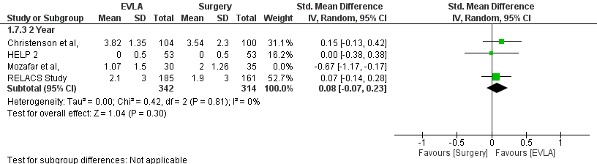
Figure (9): Forest Plot after removal of Mozafar et al.

4. Discussion
Primary varicose vein disease constitutes one of the most frequent inherited disorders worldwide; according to previous epidemiological studies, varicose vein disease affects 10–20% of the population in the Western world and lower prevalence in other parts of the world ⁽¹⁰⁾.
Although varicose veins are common, many patients remain asymptomatic and only a minority of them present for treatment. They entail a broad spectrum of cosmetic, psychological, medical and socio-economic implications. It was reported that varicose veins can lead to thrombophlebitis, varicose eczema, lipodermatosclerosis and ulceration ⁽⁴⁾.
Moreover, a previous UK study reported that almost 40,000 National Health Service operations were performed in the UK in 2001 at an estimated cost of £20–£25 million (excluding non-hospital costs) thus consuming significant healthcare resources ⁽¹¹⁾.
The majority of varicose vein patients have an incompetent saphenofemoral junction (SFJ) and long saphenous vein (LSV) reflux. Although the pathogenesis of varicose veins is not fully understood, the abolition of reflux appears crucial for successful treatment ⁽¹²⁾.
Conventional surgical management for varicose veins entails flush ligation of the SFJ, LSV stripping and stab avulsions of the varicosities. Although this surgical modality is safe and effective at short-term and midterm follow-up, it is not rare for recurrence, hematoma, and skin infection to occur after the surgical procedure. Rarely, massive bleeding due to injury to femoral veins, or even to the femoral artery during surgery, and mortality from pulmonary embolism and DVT can happen ⁽¹³⁾.
Therefore, novel treatment modalities have been developed over recent years to overcome the limitations of conventional surgery. Within the last two decades, radiofrequency ablation and endovenous laser treatment (EVLA) have been introduced as an important new endovenous ablative techniques for the minimally invasive treatment of superficial venous reflux and varicose veins. Although sclerotherapy has been a well-established technique for spider telangiectasia, recent reports have documented that administration of aerated or foamed sclerosants provides an excellent cost-effective option for treatment of varicose veins ⁽¹⁴⁾.
EVLA has emerged as an effective minimally-invasive procedure for the management of varicose veins. Faster recovery from EVLA, no need for hospital admission, no surgical incision, and early resumption of daily activity or work are advantages of this procedure. However, like other surgeries, EVLA still can cause operative or postoperative complications, such as hematoma, infection, skin burn, bruising, and catheter stabbing by laser fiber, or the broken catheter can be left in the body ⁽¹³⁾.
Over the recent years, many clinical studies and randomized controlled trials of high quality compared EVLA and conventional surgical procedures and showed conflicting results regarding the differences between both techniques in postoperative pain, recurrence rates, or returning to work or normal activity ⁽¹⁵⁾. Therefore, we performed the present systematic review and meta-analysis in order to evaluate the short and long-term outcomes of EVLA compared to conventional surgery.
In the present study, we included 17 reports of 11 eligible RCTs (Total No. of legs =2524). The majority of the included studies were from the UK or Netherlands with sample size ranged between 65 and 798 patients. All included studies recruited patients with great saphenous vein affection, except three studies which included patients with small saphenous vein affection ^{(16, 17, 18)}.
Varicose veins have traditionally been considered commoner in women. In addition, it was reported that varicose vein mainly affects patients in the late 40s and early 50s ⁽¹⁹⁾. In the present systematic review and meta-analysis, the average age of the patients ranged from 42-53 years old; while the majority of the patients were females.
The CEAP (clinical, etiology, anatomy, pathophysiology) classification was used to describe the degree of varicose veins. The “C” part of CEAP classification was more useful and practical in rating the severity of varicose veins. The purpose of treatment was to relieve symptoms and prevent the progression of varicose veins. Symptomatic patients with C2 to C6 diseases were indicated for management, especially those who had signs of chronic venous insufficiency, superficial thrombophlebitis, and bleeding ⁽²⁰⁾. In the present systematic review, the vast majority of the included studies recruited patients with C2 to C3 classification.
Clinical recurrence of varicose veins is known to be a common problem after conventional surgery. The incidence of those patients with recurrence after surgery was reported to be between 20% and 80%. Therefore, EVLA has been proposed as an alternative option to improve recurrence rates ⁽²¹⁾.
Overall, our analysis showed that eight RCTs reported the clinical recurrence rates over the period of follow-up, After two years of follow-up, the overall effect estimates favored EVLA over surgery (P =0.04). In contrary, the overall effect estimates did not favor EVLA over surgery at one year (P =0.53) and five years (P =0.12). On the other hand, the present study showed that five RCTs reported the complete success rates over the period of follow-up, After six months of follow-up, the overall effect estimates favored EVLA over surgery (P =0.03). In contrary, the overall effect estimates did not favor EVLA over surgery at other time points.
In concordance with our findings, van den Bos and colleagues ⁽²²⁾ performed a systematic review of Medline, Cochrane Library, and Cinahl to identify studies on the effectiveness of EVLA. All clinical studies (open, noncomparative, and randomized clinical trials) that used ultrasound examination as an outcome measure were included. After 3 years, EVLA was significantly more effective compared with stripping (AOR, 1.13; 95% CI, 0.40-1.87).
In agreement with our findings regarding the effect of EVLA at one year, Siribumrungwong and colleagues ⁽²³⁾ performed a systematic review and meta-analysis was to compare clinical outcomes between EVLA and surgery. An online search of MEDLINE and Scopus from 2000 to August 2011 was conducted and 28 RCTs were included. The primary failure and clinical recurrences at one year of follow-up were not significantly different between EVLA versus surgery with the pooled RR of 1.5 (95%CI:0.7, 3.0) for primary failure and 0.6 (95%CI:0.3, 1.1) for clinical recurrences.
While similar to our findings regarding the long-term recurrence rates, Kheirelseid and colleagues ⁽²⁴⁾ conducted a meta-analysis study to determine the long-term efficacy of currently available endovenous therapy methods for varicose veins compared with conventional surgery in the management of GSV-related varicose veins. A total of 9 RCTs comparing conventional surgery and endovenous therapy for treating lower extremity varicose veins with 5 years or more of follow-up were selected. There was no statically significant difference in recurrence rate in comparing EVLA with conventional surgery in treating GSV incompetence (36.6% vs 33.3%, respectively; pooled risk ratio, 1.35; 95% confidence interval, 0.76-2.37; P =.3).
The exact causes of such higher recurrence rate in conventional surgery group than EVLA group at 2-3 years after the operation and the absence of these differences at five years, are unclear. it is likely that the recurrence rate of surgery is higher than that of EVLA because of neovascularization ⁽²⁵⁾.
For describing gradual changes of the venous disease outcome assessment and success evaluation of different treatment strategies, a clinical venous severity score –The Homburg Varicose Vein Severity Score (HVVSS)– was implemented as an adjunct to CEAP and part of a venous severity scoring system in 2000, evaluated in several publications, and is now widely used as an outcome measurement parameter in randomized clinical trials. HVVSS has been developed for scoring the entire spectrum of venous diseases, from asymptomatic varicose veins to severe post-thrombotic syndrome ⁽²⁶⁾.
In the present systematic review and meta-analysis, four RCTs reported the change of HVVSS at two years of follow-up. The overall effect estimates did not favor EVLA over surgery (P =0.73).
It is well known that daily life is negatively influenced in patients with venous leg ulcers. However, quantitative studies have shown that invasive treatments of varicose veins in patients without leg ulcers result in the significant improved health‐related quality of life (HRQL) compared to before treatment. This suggests that patients who have varicose veins without leg ulcers experience a negative influence on their quality of life before treatment ⁽²⁷⁾.
Currently, different questionnaires exist to assess the quality of life in patients with varicose veins. The Aberdeen Varicose Vein Questionnaire (AVVQ) is used as quality of life outcome measure for varicose vein interventions. Data have shown that treatment of varicose veins results in significant improvement in health for patients, with an almost a halving of the AVVQ score compared to preoperative values. Furthermore, patients with the lowest pre-treatment scores have been found to benefit the least from intervention ⁽²⁸⁾.
EQ-5D is a well-known and widely used health status instrument that was developed by the EuroQol Group in the 1980s to provide a concise, generic instrument that could be used to measure, compare and value health status across disease areas ⁽²⁹⁾.
Our analysis showed that, after six months of follow-up, the overall effect estimates did not favor EVLA over surgery in terms of AVVQ, EQ-5D, SF-36. Similarly, the overall effect estimates did not favor EVLA over surgery at one year, two years, and five years.
In agreement with our findings, Hamann and Colleagues ⁽³⁰⁾ performed a systematic review and meta-analysis to compare the long-term efficacy of EVLA compared to conventional surgery. RCTs with follow-up 5 years were included. The results showed no significant differences in AVVQ between the treatments after 5 years.
Similarly, a previous Cochrane review by Nesbitt and Colleagues ⁽²⁵⁾ was conducted to determine whether EVLA has any advantages or disadvantages in comparison with open surgical saphenofemoral ligation and stripping of great saphenous vein varices. A total of eight compared EVLT with surgery were included. Quality of life scores generally increased similarly in all treatment groups with no significant differences.
Another Cochrane review compared the effectiveness of EVLA versus conventional surgery in the treatment of SSV. A total of three RCTs were identified. There were no significant differences in quality of life scores between EVLA and surgery ⁽³¹⁾.

Conclusion
EVLA is a safe and effective treatment alternative for patients with primary varicose veins. The present systematic review and meta-analysis show that EVLA has, at least, comparable efficacy to conventional surgery in terms of recurrence rates, disease severity, and quality of life. Further high-quality long-term studies are still needed to confirm our findings.

References
  - Tully RP. Vascular surgery. Handb. Clin. Anaesthesia, Fourth Ed., 2017. doi:10.1201/9781315164533.
  - Tan TW, Jahromi AH, Zhang WW. The Status of Vascular Surgery Practice in the United States. Vasc. Surg., Cham: Springer International Publishing; 2017, p. 281–7.
  - Vogel TR. Rutherford’s Vascular Surgery. JAMA 2011. doi:10.1001/jama.2011.1724.
  - Arora M. Management of varicose veins. JK Sci 2017a. 100(1): 185–189.
  - Boon R, Akkersdijk GJM, Nio D. Percutaneus treatment of varicose veins with bipolar radiofrequency ablation. Eur J Radiol 2010; 75(1): 43–47.
  - Werchek S. Diagnosis and treatment of venous leg ulcers. Nurse Pract 2010; 35(12): 46–53.
  - Szczeklik M, Szczeklik W, Aleksiejew - Kleszczyński T, Chwała M, Jagielska - Chwała M. Varicose Veins of Lower Extremities, Hemodynamics and Treatment Methods. Adv Clin Exp Med 2015; 24(1):5-14.
  - Desrochers A. Schwartz’s Principles of Surgery Tenth Edition. 2013.
  - Altman DG, Bland JM. Standard deviations and standard errors. BMJ 2005; 331:903.
  - Mishra S, Ali I, Singh G. A study of epidemiological factors and clinical profile of primary varicose veins. Med J Dr DY Patil Univ 2016;9:617.
  - Beale RJ, Gough MJ. Treatment options for primary varicose veins - A review. Eur J Vasc Endovasc Surg 2005.
  - Kumar A, Ouriel K. Handbook of endovascular interventions. 2013. doi:10.1007/978-1-4614-5013-9.
  - Bootun R, Onida S, Lane TRA, Davies AH. Varicose veins and their management. Surg (United Kingdom) 2016; 34(4): 165–171.
  - Gloviczki P and Gloviczki ML. Guidelines for the management of varicose veins. Phlebology 2012; 27(1_suppl): 2–9.
  - Lin F, Zhang S, Sun Y, Ren S, Liu P. The management of varicose veins. Int Surg 2015;100:185–9.
  - Nandhra S, El-Sheikha J, Carradice D, Wallace T, Souroullas P, Samuel N, et al. A randomized clinical trial of endovenous laser ablation versus conventional surgery for small saphenous varicose veins. J Vasc Surg 2015; 61:741–6.
  - Roopram AD, Lind MY, Van Brussel JP, Terlouw-Punt LC, Birnie E, De Smet AA, et al. Endovenous Laser Ablation versus Conventional Surgery in the Treatment of Small Saphenous Vein Incompetence: Short-Term Results of a Multicenter Randomized Controlled Trial. J Vasc Surg Venous Lymphat Disord 2013;1:106.
  - Samuel N, Carradice D, Wallace T, Mekako A, Hatfield J, Chetter I. Randomized clinical trial of endovenous laser ablation versus conventional surgery for small saphenous varicose veins. Ann Surg 2013;257:419–26.
  - So M, Khimani N, Ngyuen M. Chronic venous insufficiency. Pain Med. An Essent. Rev., 2017. doi:10.1007/978-3-319-43133-8_132.
  - Vasquez MA and Munschauer CE. Venous Clinical Severity Score and quality-of-life assessment tools: application to vein practice. Phlebology: The Journal of Venous Disease 2008; 23(6): 259–275.
  - Bush RG, Bush P, Flanagan J, Fritz R, Gueldner T, Koziarski J, et al. Factors associated with recurrence of varicose veins after thermal ablation: Results of the recurrent veins after thermal ablation study. Sci World J 2014; 1-7.
  - van den Bos R, Arends L, Kockaert M, Neumann M, Nijsten T. Endovenous therapies of lower extremity varicosities: A meta-analysis. J Vasc Surg 2009; 49(1): 230–239.
  - Siribumrungwong B, Noorit P, Wilasrusmee C, Attia J, Thakkinstian A. A systematic review and meta-analysis of randomised controlled trials comparing endovenous ablation and surgical intervention in patients with varicose vein. Eur J Vasc Endovasc Surg 2012; 44(2): 214–223.
  - Kheirelseid EAH, Crowe G, Sehgal R, Liakopoulos D, Bela H, Mulkern E, et al. Systematic review and meta-analysis of randomized controlled trials evaluating long-term outcomes of endovenous management of lower extremity varicose veins. J Vasc Surgery Venous Lymphat Disord 2018;6:256–70.
  - Nesbitt C, Eifell RKG, Coyne P, Badri H, Bhattacharya V, Stansby G. Endovenous ablation (radiofrequency and laser) and foam sclerotherapy versus conventional surgery for great saphenous vein varices. Sao Paulo Med J 2014; 132(1): 69.
  - Rass K, Daschzeren M, Gräber S, Vogt T, Tilgen W, Frings N. Construction and evaluation of a multidimensional score to assess varicose vein severity - The Homburg Varicose Vein Severity Score (HVVSS). Eur J Dermatology 2011. doi:10.1684/ejd.2011.1368.
  - Franz A, Wann-Hansson C. Patients’ experiences of living with varicose veins and management of the disease in daily life. J Clin Nurs 2016;25:733–41.
  - Staniszewska A, Tambyraja A, Afolabi E, Bachoo P, Brittenden J. The Aberdeen Varicose Vein Questionnaire, patient factors and referral for treatment. Eur J Vasc Endovasc Surg 2013; 46(6): 715–718.
  - Devlin NJ, Brooks R. EQ-5D and the EuroQol Group: Past, Present and Future. Appl Health Econ Health Policy 2017; 15(2): 127–137.
  - Hamann SAS, Giang J, De Maeseneer MGR, Nijsten TEC, van den Bos RR. Editor’s Choice – Five Year Results of Great Saphenous Vein Treatment: A Meta-analysis. Eur J Vasc Endovasc Surg 2017; 54(6): 760–770.
  - Paravastu SCV, Horne M, Dodd PDF. Endovenous ablation therapy (laser or radiofrequency) or foam sclerotherapy versus conventional surgical repair for short saphenous varicose veins. Cochrane Database Syst Rev 2016. doi:10.1002/14651858.CD010878.pub2.

5/20/2019

