**Synthesis of CuO Nanocrystal by Precipitation-Pyrolysis Method and Characterized by TEM and FTIR**

S Pradhan, A Acharya

HOD, Physics, Vedvyas Mahavidyalaya, Rorkela, Odisha, India1

SIT, Bhubaneswar, Odisha, India2

[aurobinda.acharya@gmail.com](mailto:aurobinda.acharya@gmail.com)

**Abstract:** In this Paper we are going to discuss the preparation of nanocrystal CuO and nanorod CuO by a combined precipitation-pyrolysis method, which involves initially preparing precursors and finally decomposing the precursors in a furnace with different annealing temperatures, which lead to the final products of copper oxide nanocrystals. The Characterization done through TEM and FTIR.

[S Pradhan, A Achary. **Synthesis of CuO Nanocrystal by Precipitation-Pyrolysis Method and Characterized by TEM and FTIR.** *Researcher* 2019;11(3):73-76]. ISSN 1553-9865 (print); ISSN 2163-8950 (online). <http://www.sciencepub.net/researcher>. 12. doi:[10.7537/marsrsj110319.12](http://www.dx.doi.org/10.7537/marsrsj110319.12).

**Keywords**: Synthesis; CuO; Nanocrystal; Precipitation-Pyrolysis Method; Characterize; TEM; FTIR

**Introduction**

Transition metal oxides have attracted much attention in recent years because of their size dependent optical properties and electronic structure [1]. Copper oxide is a transition-metal oxide with a monoclinic structure. It is a covalent semiconductor having an indirect band gap between 1.21 and 1.5 eV. Controlling the size, shape and structure of nanocrystals is technologically important because it will have strong effect on the optical, electrical, and catalytic properties. With the decreasing crystal size, CuO nanocrystals exhibit some unique properties like change in ionic character, ferromagnetic response etc [2]. Investigation of electronic properties of Cuo nanocrystals will provide more insight into the electronic correlation and also the electronic coherent states. As Copper oxide has more industrial applications like solar energy storage, semiconductors and catalysis, it attracts researchers to study its behavior at various size regimes. Nanocrystals could really have a good practical application only when they are in solid form. Hence copper oxide nanocomposites are made using Polymethyl methacrylate and Polyvinyl alcohol. Polymethacrylate has strong adhesion towards copper Oxide. The large surface area of nanoparticles also results in lot of interactions between the intermixed materials in nanocomposite, leading to special properties such as increased strength, increased chemical resistance and heat resistance [3,4]. Recent advances in producing highly luminescent quantum dots have led to the applications of quantum dots in imaging biological samples but the composition toxicity is a problem. Most of the quantum dots contain toxic heavy-metal elements such as Cd, Hg, Pb etc., which make them, unfit for some practical applications. [5,6] Nonlinear optical measurements in low dimensional materials continue to draw considerable attention of researchers. The optical switching, saturable absorption and optical limiting properties of nanomaterials have shown considerable promise. [7,8] The nonlinear optical measurements give information on nonlinear response of samples when irradiated with high intense laser beam. It gives knowledge about third order optical nonlinear effects of the samples. Nanoparticles research is currently an area of intense scientific research, due to wide variety of potential applications in bio medical, optical and electronic fields [9,10]. Nanoparticles are larger than individual atoms and molecules but are smaller than bulk solid. [11] At the small end of the size range, nanoparticles are often referred to as clusters, Nanospheres, nanocrystals, nanorods, nanoneedles, nanocups and Quantum dots.

**Nanoparticle**

As the size of the crystal is reduced, the number of atoms at the surface of the crystal compared to the number of atoms in the crystal itself increases. Other effects like Quantization effect, spatial confinement of charge carriers, super paramagnetism in magnetic materials etc. are due to the nano regime. Nanomaterials are classified into nanostructured materials and nanophase/nanoparticles materials. The former refers to the condensed bulk materials that are made up of grains with grain size in nanometer size range, while the later are usually dispersive nano particles. Nanocrystals are nanomaterials with at least one dimension less than 100 nm and that is single crystalline. Nanorods are material with length of few micrometers and width is of nanometer range. In nanorods combination of ligands acts as shape control agents. They bond to different facets of nanorods with different strengths. This allows different faces of the nanorods to grow at different rates, producing an elongated object.

**Band Structure of Bulk and Semiconducter Quantum dots**

The electronic band structure of solids describe the range of energies that an electron is forbidden or allowed to have in a solid. Band gap (energy gap) generally refers to the energy difference between the top of the valence band and bottom of the conduction band and it is a region of forbidden electron energy. In case of bulk crystals the energy levels are very close together. So they are described as continuous and here the band gap is a fixed parameter. It depends on the type of material and hence the emission frequencies are fixed. The size of bulk crystal is larger than the Bohr exciton radius, which is the distance between electrons in conduction band and holes in valence band. But in the case of quantum dots the energy levels are discrete which specifies that there is a finite separation between energy levels. This situation of discrete energy levels is called quantum confinement, and the size of a typical quantum dot is in the range of Bohr exciton radius. The quantum dots are called artificial atoms because they have discrete energy spectrum with small number of electron as that of an atom. Also, shell filling is according to the Hund’s rule for atoms.

**Quantum Size Effect**

As a result of geometrical constraint the electron feels the presence of the particle boundaries and respond to the changes in particle size by adjusting their energy levels. This phenomenon is called quantum confinement. The quantum confinement leads to the collapse of the continuous energy band of bulk material into discrete atomic like energy levels and this discrete structure of energy states leads to a discrete absorption spectrum of quantum dots which is in contrast to continuous absorption spectrum of bulk semiconductor. Changing the geometry of the surface of quantum dots changes the band gap energy. In case of small sized quantum dots the band gap will be energetically larger. So, we refer such a quantum dot to be blue shifted reflecting the fact that electron should fall to a greater distance in terms of energy thus producing a radiation of shorter wavelength. But, in case of larger sized quantum dots they are red shifted. Quantum dots of same material but different size have different band gap, which absorbs and emits different frequencies. Thus the material property changes dramatically because of quantum size effect.

**Properties of Quantum Dots**

Quantum dots confine both the electron and holes in all three dimensions giving out a high quantum yield. Being zero dimensional they have a sharper density of states. Quantum dots being more photostable they have little fluorescent degradation and greater extinction coefficient than traditional fluorescence materials. Quantum dots in contrast to traditional semiconductor materials can be moulded to different forms like thin sheets and can be easily combined with organic polymers, dyes etc. In colloidal form they can be processed to create junctions on substrates such as glass, plastics or metal sheets.

**Preparation**

The synthesis of Copper oxide nanocrystals is done by a combined precipitation-pyrolysis method, which involves initially preparing precursors and finally decomposing the precursors in a furnace with different annealing temperatures, which lead to the final products of copper oxide nanocrystals.

**Procedure for Preparing Precursor A**

Preparation of precursor A involves the following reaction. 0.3 M of aqueous ammonium carbonate is prepared by dissolving 4.714 g of ammonium carbonate in 100 ml distilled water. Similarly, 0.05 M of aqueous copper acetate is prepared by dissolving 4.991g of copper acetate in 500 ml of distilled water. Now, 50 ml of freshly prepared aqueous ammonium carbonate is rapidly added to 300 ml of aqueous copper acetate, and precipitate is formed. After a reaction time of 1minute, the precipitate formed is separated by a centrifuge process. Then they are washed with distilled water and ethanol to remove possible remnant ions in the final products, which are dried in air at 600 C and kept ready for further reaction.

**Procedure for Preparing Precursor B**

0.3 M of aqueous sodium hydroxide is prepared by dissolving 4.714 g of sodium hydroxide in 100 ml distilled water. Similarly, 0.05M of aqueous copper acetate is prepared by dissolving 4.991 g of copper acetate in 500 ml distilled water. 50 ml of prepared aqueous sodium hydroxide is mixed rapidly with 300 ml of aqueous copper acetate. After a reaction of 1 min the precipitate is formed which is separated by centrifuge process, and then washed with distilled water and ethanol. It is then dried in air at 600 C.

**Thermal Decomposition of Precursors**

Thermal decomposition of the precursors in a furnace with different annealing temperatures led to the final product of CuO nanocrystals and nanorods. Sample (S2) was prepared at 2000C by using precursor A under constant nitrogen flow. Annealing at temperatures 3000C, 4000C, and 5000C, samples (S3), (S4), and (S5) are prepared respectively from precursor A. without nitrogen flow the final product obtained was copper oxide nanocrystals. Sample (S6) was prepared by using precursor B with the reactant copper sulphate at an increased concentration 0.15 M, which is obtained by dissolving 3.742g of copper sulphate in 100 ml of distilled water and at an annealing temperature of 3000C. Here the final product obtained was copper oxide nanorods.

**Characterization**

The Prepared sample is Characterized by TEM and FTIR.

**Transmission Electron Microscope**

The TEM image is taken for different CuO nanocrystals samples prepared at different annealing temperaures which reveals the fact that the size of the synthesized CuO nanocrystals where in the range between 5nm to 15nm. Also, the TEM image showed that the size of the prepared CuO nanorod were of 6 to 15 micrometer in length and 10 to 30nm in width. The TEM images of the CuO nanocrystals is shown in the figure 8.1(a) and Figure 8.1(b) and CuO nanorod in Figure 9.1(c).

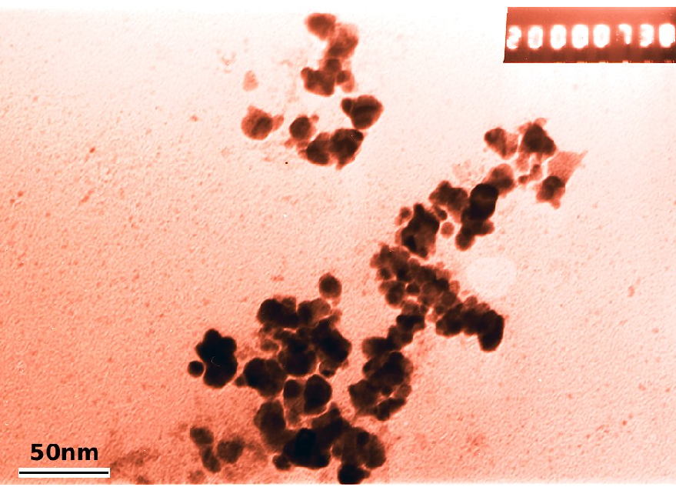

**Figure 8.1(a) TEM image of CuO nanocrystals.**

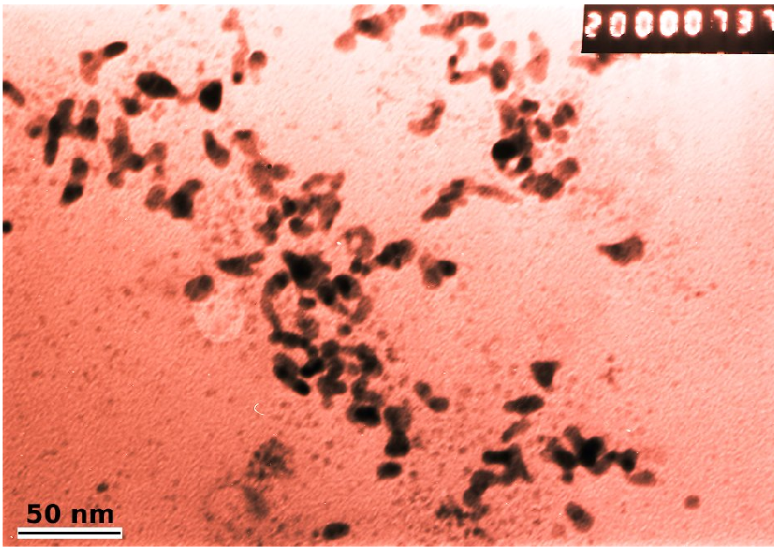

**Figure 8.1 (b) TEM image of CuO nanocrystals.**

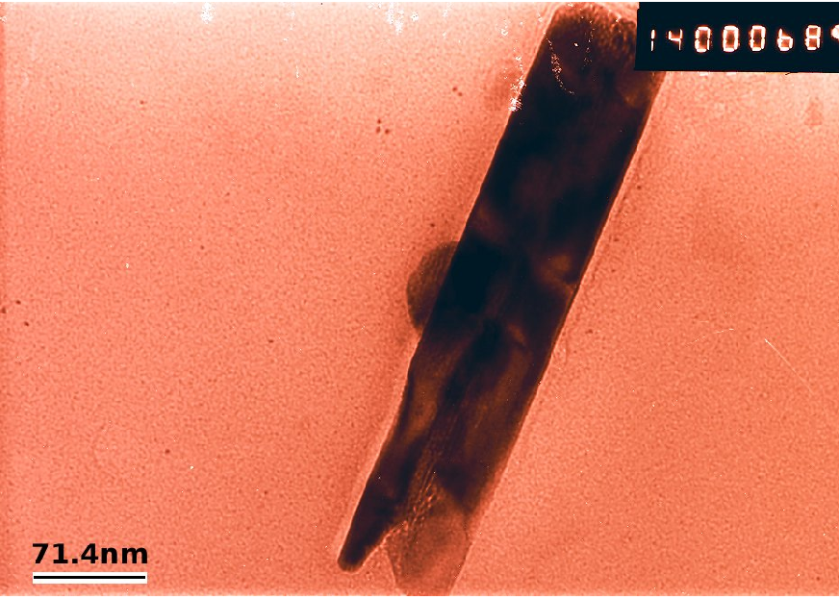

**Figure 8.1(c) TEM image of CuO nanorods.**

**Fourier Infrared Spectroscopy Studies (FTIR)**

The FTIR transmission spectra of CuO nanocrystals were taken at room temperature. The three vibrational modes are observed at 573 cm-1, 523 cm-1and 452 cm-1 these broad peaks are particular for CuO –II nanocrystals. Which is shown in Figure 8.2 (a) and 8.2(b) The high frequency mode at about 573 cm-1 is reported to be due to Cu – O stretching. Moreover, modes due to Cu2O are not seen, as infrared active modes of Cu2O appear at 610 cm-1 This reveals that the synthesized aocrystals comprises purely CuO phase without any trace of Cu2O.



**Figure 8.2(a) FTIR picture of CuO nanocrystal**

##### 

**Figure 8.2(b) FTIR picture of CuO nanocrystal**

**Conclusion**

The CuO nano crystal and Nano rod prepared by precipitation-pyrolysis method, which involves initially preparing precursors and finally decomposing the precursors in a furnace with different annealing temperatures. The Characterization involved are TEM and FTIR which shows that it is a good material for the Solar cell application.

**References**

1. Gawande, M.B.; Goswami, A.; Felpin, F.-X.; Asefa, T.; Huang, X.; Silva, R.; Zou, X.; Zboril, R.; Varma, R.S.Cu and Cu-Based Nanoparticles: Synthesis and Applications in Catalysis. Chem. Rev. 2016, 116, 3722–3811.
2. Mittiga, A.; Salza, E.; Sarto, F.; Tucci, M.; Vasanthi, R. Heterojunction solar cell with 2% efficiency based on a Cu2O substrate. Appl. Phys. Lett. 2006, 88, 163502.
3. Rai, B.P. Cu2O solar cells: A review. Sol. Cells 1988, 25, 265–272.
4. Zhou, J.; Ma, L.; Song, H.; Wu, B.; Chen, X. Durable high-rate performance of CuO hollow nanoparticles/graphene-nanosheet composite anode material for lithium-ion batteries. Electrochem. Commun. 2011, 13, 1357–1360.
5. Pendashteh, A.; Mousavi, M.F.; Rahmanifar, M.S. Fabrication of anchored copper oxide nanoparticleson graphene oxide nanosheets via an electrostatic coprecipitation and its application as supercapacitor. Electrochim. Acta 2013, 88, 347–357.
6. Park, J.C.; Kim, J.; Kwon, H.; Song, H. Gram-scale synthesis of Cu2O nanocubes and subsequent oxidation to CuO hollow nanostructures for lithium-ion battery anode materials. Adv. Mater. 2009, 21, 803–807.
7. Tamaki, J.; Maekawa, T.; Miura, N.; Yamazoe, N. CuO-SnO2 element for highly sensitive and selective detection of H2S. Sens. Actuators B 1992, 9, 197–203.
8. Kim, Y.-S.; Hwang, I.-S.; Kim, S.-J.; Lee, C.-Y.; Lee, J.-H. CuO nanowire gas sensors for air quality control in automotive cabin. Sens. Actuators B 2008, 135, 298–303.
9. Barreca, D.; Comini, E.; Gasparotto, A.; Maccato, C.; Sada, C.; Sberveglieri, G.; Tondello, E. Chemical vapor deposition of copper oxide films and entangled quasi-1D nanoarchitectures as innovative gas sensors. Sens. Actuators B 2009, 141, 270–275.
10. Zhang, Q.; Zhang, K.; Xu, D.; Yang, G.; Huang, H.; Nie, F.; Liu, C.; Yang, S. CuO nanostructures: Synthesis, characterization, growth mechanisms, fundamental properties, and applications. Prog. Mater. Sci. 2014, 60, 208–237.
11. Xu, C.; Tamaki, J.; Miura, N.; Yamazoe, N. Grain size effects on gas sensitivity of porous SnO2-based elements. Sens. Actuators B 1991, 3, 147–155.

3/25/2019