Behavioral aspects of investors’ decisions in the capital market based on Faten Zoghlami model, A case study of the stock market in Isfahan

Dr Mashaallah Valikhani Dehaghani¹, A’azam Ghorbani², Mohammad Malekmohammadi Faradonbeh³, Fatemeh Malekmohammadi Faradonbeh⁴, Azadeh Ahmadian Dehaghani⁵

¹Assistant Professor, Department of Governmental Management, Dehaghan Branch, Islamic Azad University, Esfahan, Iran
²M.A student, Department of Public Administration, Islamic Azad University, Dehaghan Branch, Esfahan, Iran
³M.A student, Department of Public Administration, Islamic Azad University, Dehaghan Branch, Esfahan, Iran
⁴M.A student, Department of Public Administration, Islamic Azad University, Dehaghan Branch, Esfahan, Iran
⁵Teacher of Isfahan Education and Training Organization and MA Student of Economical Systems Planning, Islamic Azad University, Dehaghan Branch, Esfahan, Iran

Abstract: Investment means changes in the amount of capital. Investor is someone who allocates his assets to others to increase his capital. Therefore investment must be done in assets to create value. Although the behavioral decisions of investors in the capital market are different and they invest while are influenced by various factors. Given the importance of this type of investment, this research attempts to examine the Behavioral aspects of investors’ decisions in the capital market and the most important factors influencing the encouragement or discouragement some investors in the capital market. So the descriptive survey method is used in this study. The statistical population is about 6000 people and the sample included 96 investors and brokers of the stock market in Isfahan. In this study, simple random sampling is used without replacement proportional to the sample size, as well as a questionnaire with 30 questions consistent with the proposed hypothesis and based on the modified model. All questions are discussed as packaging and comply with the five-choice Likert spectrum. In addition, the reliability of questionnaire is estimated 0.872 based on the Cronbach's alpha formula which shows the high value of the questionnaire. Library and field methods are used in data collection and the questionnaire is the research instrument. To analyze the data obtained from the questionnaires SPSS software is used in both descriptive and inferential statistics analysis and Lisrel software is used in the structural equation modeling analysis. The modified model of Faten Zoghlami, is used in this study. The results of the survey shows: The fourth hypothesis with the mean score of 7.203 is in the first order of importance, The third hypothesis with an mean score of 7.104 is in the second order of importance, The first hypothesis with an mean score of 6.536 is in the third order of importance, the ninth Hypothesis with an mean score of 6.036 is in the fourth order of importance, The seventh hypothesis with an mean score of 5.927 is in the fifth order of importance, the eighth Hypothesis with an mean score of 5.688 is in the sixth order of importance, the sixth Hypothesis with an mean score of 5.500 is in the seventh order of importance, the second Hypothesis with an mean score of 4.276 is in the eighth order of importance, the fifth Hypothesis with an mean score of 3.510 is in the ninth order of importance, the tenth Hypothesis with an mean score of 3.219 is in the tenth order of importance. Meanwhile, the fifth and tenth hypotheses with the title of “Sensitivity to the rumors in investment” were not approved.
[Mashaallah Valikhani Dehaghani, A’azam Ghorbani, Mohammad Malekmohammadi Faradonbeh, Fatemeh Malekmohammadi Faradonbeh, Azadeh Ahmadian Dehaghani. Behavioral aspects of investors’ decisions in the capital market based on Faten Zoghlami model; A case study of the stock market in Isfahan. Researcher 2019;11(3):59-72]. ISSN 1553-9865 (print); ISSN 2163-8950 (online). http://www.sciencepub.net/researcher. 11. doi:10.7537/marsrsj110319.11.

Keywords: behavioral decisions, investment, behavior of investors, capital market

Introduction
In many countries which implemented the privatization policies to have a better investment, the executives always allocate significant changes to entrepreneurs In order to attract domestic and foreign investment.
But there is a pre-requisite to establish these circumstances. The financial structures of companies and capital market must be reformed before the transfer.
After the decision-making by executives various financial reforms will take place to attract investors in the capital market.
In the implementation of privatization program, the government should have an appropriate plan, choose appropriate methods, reform the financial and organizational structures, and assign the various units.
Abundant supply of unlimited shares and bonds to invest in the stock market by government and the private sector has led to the excess supply in this sector. Therefore the total index of stock will decline especially in the stock.
Investors’ decisions with respect to the evasion of entering into the capital market increased the risk of investment losses and the sales of state-owned units will be in crisis.
It should be noted that the financial policies in the capital market and other factors that lead to successful privatization of companies in developed countries such as the UK will observe the determined behavior of investors in various capital markets.
Unfortunately privatization in Iran has not been like advanced industrial countries to have a positive impact on investors’ behavior decisions and attract them, but has made the investors to leave. Privatization began hastily and without review in Iran, so that about 391 companies were privatized in the first stage and this is no precedent anywhere in the world today.
The Iranian capital market was facing some problems and people offered their stock to sell to the stock market. The government forced the banks to buy the stock in order to prevent the collapse of the capital market. This means that the program is carried out without the necessary expertise and reflection.
Thus, given that the capital markets in countries such as Iran do not have a high volume, the financial reform is absolutely essential for the entry of investors.
Empirical evidence from studies in capital markets represent the fact that the decision-making process of investors and their behavior is very complex and a single model to predict their behavior in the market cannot be presented.
In many cases, investors act reasonably in the stock market and the identification of behavioral stimuli would not be possible.
Many studies have proven our irrational performance in the issues of investment and money. Most economic theories are based on this issue.
However, people try to act reasonably in the face of economic events and show that all available information is considered in the process of investment, but Researchers have questioned this issue and have found documents that show a lack of common sense in discussing investments. They seek to understand and explain the effects of human feelings in their investment decision-making process.
Statement of problem
Investors can take risks in some cases and sometimes escape risks. But the reality is that investors do not necessarily escape the risk and their reaction in the face of risk is the function of market. In other words, when he trusts the market he takes high levels of risk and vice versa. Therefore, it has been demonstrated that the emotional factors have a significant effect in investor’s decisions about pricing and willingness to take risk and many other decisions.
But the main question of this research is the study of the most important aspects influencing the decisions of investors who entered the stock market. And therefore there will be some cases hinder their success and the achievement of their goals. The most effective factor and the least one influencing the investors’ behaviors are issues that will be discussed in this paper.
The main objective of this research is to investigate the behavior of investors in the stock market. In this regard, some economic and cultural indices in connection with the investor sentiment in the stock market, risk-taking shareholders and investors, as well as confidence and risk tolerance to invest in the market and various variables such as behavioral decisions, investors, capital markets, have been investigated. Hence, the modified model of Faten Zoghlami is discussed as the main pattern to achieve the objectives of this research.
Behavioral decisions of investors
Behavior of investors
Economic factors attracting investors to the capital market in Iran
The most important issue that must be considered is that what makes entering or leaving investors in the capital market in the realm of economics especially in Iran. This section attempts to examine the economic factors that influence the behavioral decisions of investors to enter the capital market.
- Higher profits in the non-industrial sectors in Iran
Unfortunately, due to the low income of the investment in the industrial sector in Iran, the investor has no decision to enter this market and chooses other economic sectors to invest.
It has led to a relative decline in the industry and serious problems in the industrial sector of the world. (Group of authors, 1386: 34).
- The volatility of the stock market
The next issue on the lack attracting the investors to invest in the capital market is the instability, failure and lack of cohesion in the country's stock markets. So that many investors prefer another market to the stock market and a large amount of capital will be removed due to the high risk in the stock.
- Problems associated with financial statements
Lack of clear government policy in Iran, problems associated with financial statements and Problems associated with dividend stocks in companies will make the Investors to be in doubt to invest in these companies. The most important economic, social and cultural requirements for investors.
Creating different economical, social and cultural fields should be done in several ways.
- To create the legal and institutional development, and to accept the profit motive, to distribute and re-invest t in productive, business and financial activities, or to recognize private ownership and management.
- To reform terms of exchanges aimed at improving capital markets, labor, goods and services with minimum limits of government control.
- to accept the principles of competition and market mechanisms on the one hand and to accept activities and financial discipline, and a commitment to follow the stated policy objectives and lines in order to in order to create economic stability and public confidence in the capital market, business, manufacturing and service fields.
- To make clear the decisions and actions of executive officials, along with laws and regulations relating to the protection of judicial independence t in matters relating to disputes between people and government and to deploy cost-effective and impartial judicial system.
- To reduce the administrative agencies and government intervention in the national economy and to reduce the government's share of national output and government institutions and facilities through removing parallel machines with similar functions simultaneously. Reducing the amount of time employees and a budget for the government to increase the level of employment in the economic sector. To create a competition in banking and insurance activities, to develop capital market institutions and instruments in primary and secondary activities, to avoid the pricing of inputs, especially in manufacturing output.
- To limit liquidation activities, institutions and public sector enterprises in the production and distribution which have good conditions.
Psychological factors affecting capital market investors
In the current environment of capital markets in the world, the analysis of psychological factors is very important. This subject has entered the financial markets in a few decades with the title of BEHAVIORAL FINANCE.
Many internal and external factors can influence the buying process (investor’s mental black box). Such external factors can be economic, political and cultural factors. But internal factors include bio-rhythmic factors, the inherent power to analyze, matching the actual image of buyer and virtual image of company, the amount of risk-taking and self-esteem. The assessment of these factors can lead to a more precise understanding of the behavior of investors and provide the stock market and the economy. (Nasr, 2002:90-89).
Due to recent developments in the capital market, all internal and external factors should be considered carefully, because we face very different thoughts, ideas and mentalities of people and understanding their minds is very important. People analyze a lot of factors to invest their money, In other words, investors raise different approaches in mind to invest money (buyer’s Black box) and finally choose the option that is useful and profitable. Many factors affect the planning and decisions of individuals to invest in the capital market. These factors can be divided into two categories: internal factors and external factors. External factors include economic political and cultural issues, such as the ads of stock, the company's affairs and etc. But since the impact of these factors has been discussed by many analysts, the internal factors may be allocated to a special place. Individuals with regard to risk and return invest their money in places to get the most benefit. (Nasr, 2002:115-113).
Behavioral aspects of investors’ decisions
In the area of ​​investment and dealing with money, we always do not act reasonably. For this reason, there are particular areas of research which study the strange behavior of people in these areas. This paper refers to the behavior of investors in financial markets.
Doubts about the hypothesis of rationality
Economic theories are developed mainly on the basis that people behave in a reasonable manner and the information is used in the investment process. This hypothesis is the basis of market efficiency theory. But research shows that there is evidence which proves that our reasonable behavior is not inclusive. The research on Investors’ behavior emphasizes how human emotions influence the decision-making process. The results of this investigation will surprise you.
Facts
In 2001, a financial services research firm's study entitled "Quantitative Analysis of Investor Behavior” showed that Investors typically do not earn income from capital markets. During 17 years to December 2000, 500 Standard and Poor Index companies gained 29/16% of profit every year. While the average profit for the same period of the regular investors was 32/5 which shows the difference of 9%. Now the question is why such differences can be observed. In answering this question, there are a few explanations. (Jahankhany, 2003: 47-46).
Factors affecting the decision of investors in the market
Each investor may consider different factors when buying and selling shares. The results show that liquidity is the most important factor in the investment decisions of investors. After that factors such as the relative stability of profitability, return on equity, and stock price trends are also important and other factors are at the next level.
Brokers and investors have different views and agree on the effects of the most important factors on the management of companies, price changes, and the main location of operations. And there is no significant difference between their views. (Cole translated by Rafiee, 2001:315-314.).
Investors include different groups in the capital market, and individual investors are the biggest one in terms of number. They are individuals who participated in the stock market with their own personal knowledge and interest. Another group of brokers are participants who provide a service to investors in addition to their main duties. According to the history of their continued presence in the market, they buy and sell their stock for customers. Investors in the capital market, always use certain criteria and factors when deciding among different options to make a rational decision. (Mokhtarian, 2004:22).
Hypotheses
Main hypothesis
Behavioral aspects of investor’ decisions have a great impact on the capital market.
Secondary hypothesis
- Self- confidence has a significant impact on investors’ decisions.
- Confidence in capital markets has a significant impact on investors’ decisions.
- Spirit of opportunism has a significant impact on investors’ decisions.
- Power of analysis has a significant impact on investors’ decisions.
- Sensitivity to rumors has a significant impact on investors’ decisions.
- Conservatism has a significant impact on investors’ decisions.
- Trust has a significant impact on investors’ decisions.
- Previous success in the capital markets has a significant impact on investors’ decisions.
- Confidence in the capital market has a significant impact on investors’ decisions.
- Imitation in investment has a significant impact on investors’ decisions.
Methodology
The method used in this study is descriptive – survey. Library and field methods are used in data collection and all parts of books, journals and periodicals in various sources and websites and electronic journals were used in this study. The results of statistical analysis are designed and distributed Using Spss and Lisrel software based on research hypotheses.
Finally, it leads to prove or refute hypotheses. Descriptive statistics includes Frequency and statistics, calculation of mean, standard deviation and... And inferential statistics includes Pearson correlation coefficient, Friedman nonparametric test and component indicators in assumptions and questions from...
Research sample, the sample size and its calculation method
The sample size in this study is consisted of 96 people and the population is about 6000 people. Cochran's formula is used for determining the sample size. All stock market investors were included in the sample of this study.
Sample size and its calculation method
The study sample consisted of 96 people who were estimated using Cochran formula. Due to the size of the target population which is 6000 people, the sample size was as follows:

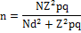

Total population:
At the confidence level of 95%:
Error value:

Sample size:

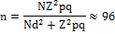

Sampling in this study is a simple random without replacement. Since there was no information about the distribution of data in the initial stage, also the distribution shape of population is not determined. To evaluate the research hypotheses on the fourth chapter, Student test is used for independent sample. But one of the requirements of the test is the normal variable of average scores. We test the normality using Kolmogorov-Smirnov Non-parametric test. The results of these tests are given in the table.
Conceptual model of research
Figure (1-1) Zoghlami adjusted model to determine the behavior aspects of investors’ decisions in the capital market
- Confidence
- Confidence in capital markets
- The spirit of opportunism
- Power of Analysis
- Sensitivity to rumors
- Conservatism
- Trust
- Previous success in capital markets
- Confidence in the capital market in the country
- imitation in the investment
Statistical Methods
SPSS software is used for data processing and Lisrel software is used for analyzing the path and structural equation modeling. The data was analyzed using descriptive and inferential statistics. Frequency, percentage, mean and standard deviation are used in the descriptive statistics. Independent sample T-test methods and Friedman nonparametric test were used in inferential statistics.
Table 1. Kolmogorov-Smirnov test for normal variables
Because significant levels in the table are more than the alpha value, so the hypothesis of normal variables cannot be denied at the level of 0.05 (which can be quite good). Therefore T-test can be used to test the average scores.
Inferential analysis of data
Student T-test was used to evaluate the research hypotheses for independent samples.
To check the research hypotheses, each average score should be compared with the number 3. If this average is greater than the number 3, the hypothesis is accepted. But if this average is less than or equal to the number 3, the hypothesis is not accepted.
First hypothesis: the amount of confidence in the capital market has a significant impact on investors’ decisions.
H0: The average score of first hypothesis has no significant difference with the number 3.
H1: The average score of first hypothesis has significant difference with the number 3.
Table 2. Summary of results for single-sample T-test for confidence
According to the table, because the significance level of test is smaller than the alpha value, so the hypothesis H0 is rejected. Thus the average score of the first hypothesis is significantly different from the number 3. According to the mean value of this hypothesis (3.806), the mean score of first hypothesis is greater than 3. Therefore, the research hypothesis that the confidence in the capital market has a significant impact on investors’ decisions is approved.
Second hypothesis: the confidence in the capital markets has a significant impact on investors’ decisions.
H0: The average score of second hypothesis has no significant difference with the number 3.
H1: The average score of second hypothesis has significant difference with the number 3.
Table 3. Summary of results for single-sample T-test for confidence in capital markets
According to the table, because the significance level of test is smaller than the alpha value, so the hypothesis H0 is rejected. Thus the average score of the second hypothesis is significantly different from the number 3. According to the mean value of this hypothesis (3.278), the mean score of second hypothesis is greater than 3. Therefore, the research hypothesis that the confidence in the capital market has a significant impact on investors’ decisions is approved.
Third hypothesis: the spirit of opportunism has a significant impact on investors’ decisions.
H0: The average score of third hypothesis has no significant difference with the number 3.
H1: The average score of third hypothesis has significant difference with the number 3.
Table4. Summary of results for single-sample T-test for the spirit of opportunism
According to the table, because the significance level of test is smaller than the alpha value, so the hypothesis H0 is rejected. Thus the average score of the third hypothesis is significantly different from the number 3. According to the mean value of this hypothesis (3.931), the mean score of third hypothesis is greater than 3. Therefore, the research hypothesis that the spirit of opportunism has a significant impact on investors’ decisions is approved.
Fourth hypothesis: power of analysis has a significant impact on investors’ decisions.
H0: The average score of fourth hypothesis has no significant difference with the number 3.
H1: The average score of fourth hypothesis has significant difference with the number 3.
Table 5. Summary of results for single-sample T-test for the power of analysis
According to the table, because the significance level of test is smaller than the alpha value, so the hypothesis H0 is rejected. Thus the average score of the fourth hypothesis is significantly different from the number 3. According to the mean value of this hypothesis (3.931), the mean score of fourth hypothesis is greater than 3. Therefore, the research hypothesis that the power of analysis has a significant impact on investors’ decisions is approved.
Fifth hypothesis: sensitivity to rumors has a significant impact on investors’ decisions.
H0: The average score of fifth hypothesis has no significant difference with the number 3.
H1: The average score of fifth hypothesis has significant difference with the number 3.
Table 6. Summary of results for single-sample T-test for the sensitivity to rumors
According to the table, because the significance level of test is smaller than the alpha value, so the hypothesis H0 is rejected. Thus the average score of the fifth hypothesis is significantly different from the number 3. Therefore, the research hypothesis that the sensitivity to rumors has a significant impact on investors’ decisions is approved.
Sixth hypothesis: the conservatism value has a significant impact on investors’ decisions.
H0: The average score of sixth hypothesis has no significant difference with the number 3.
H1: The average score of sixth hypothesis has significant difference with the number 3.
Table 7. Summary of results for single-sample T-test for the Conservatism
According to the table, because the significance level of test is smaller than the alpha value, so the hypothesis H0 is rejected. Thus the average score of the sixth hypothesis is significantly different from the number 3. According to the mean value of this hypothesis (3.594), the mean score of sixth hypothesis is greater than 3. Therefore, the research hypothesis that the conservatism has a significant impact on investors’ decisions is approved.
Seventh hypothesis: Trust has a significant impact on investors’ decisions.
H0: The average score of seventh hypothesis has no significant difference with the number 3.
H1: The average score of seventh hypothesis has significant difference with the number 3.
Table 8. Summary of results for single-sample T-test for the Trust value
According to the table, because the significance level of test is smaller than the alpha value, so the hypothesis H0 is rejected. Thus the average score of the seventh hypothesis is significantly different from the number 3. According to the mean value of this hypothesis (3.660), the mean score of seventh hypothesis is greater than 3. Therefore, the research hypothesis that the trust value has a significant impact on investors’ decisions is approved.
Eighth hypothesis: The previous success in the capital markets has a significant impact on investors’ decisions.
H0: The average score of Eighth hypothesis has no significant difference with the number 3.
H1: The average score of Eighth hypothesis has significant difference with the number 3.
Table 9. Summary of results for single-sample T-test for the previous success in the capital markets
According to the table, because the significance level of test is smaller than the alpha value, so the hypothesis H0 is rejected. Thus the average score of the Eighth hypothesis is significantly different from the number 3. According to the mean value of this hypothesis (3/549), the mean score of Eighth hypothesis is greater than 3. Therefore, the research hypothesis that the previous success in the capital markets has a significant impact on investors’ decisions is approved.
Ninth hypothesis: The confidence in the capital market in the economy has a significant impact on investors’ decisions.
H0: The average score of ninth hypothesis has no significant difference with the number 3.
H1: The average score of ninth hypothesis has significant difference with the number 3.
Table 10. Summary of results for single-sample T-test for the confidence in the capital market in the economy
According to the table, because the significance level of test is smaller than the alpha value, so the hypothesis H0 is rejected. Thus the average score of the ninth hypothesis is significantly different from the number 3. According to the mean value of this hypothesis (3/625), the mean score of ninth hypothesis is greater than 3. Therefore, the research hypothesis that the confidence in the capital market in the economy has a significant impact on investors’ decisions is approved.
Tenth hypothesis: imitation in the investment has a significant impact on investors’ decisions.
H0: The average score of tenth hypothesis has no significant difference with the number 3.
H1: The average score of tenth hypothesis has significant difference with the number 3.
Table 11. Summary of results for single-sample T-test for the imitation in the investment
According to the table, because the significance level of test is smaller than the alpha value, so the hypothesis H0 is rejected. Thus the average score of the tenth hypothesis is significantly different from the number 3. According to the mean value of this hypothesis (2.719), the mean score of ninth hypothesis is greater than 3. Therefore, the research hypothesis that the imitation in investment has a significant impact on investors’ decisions is approved.
Ranking of research hypotheses
Here the ranking of research hypotheses is discussed using Friedman non-parametric test.
Table 12. Table of ranking research hypotheses based on Friedman non-parametric test
Table 13. Summary of Friedman non-parametric test
The table shows that since the significance level of test is smaller than the alpha test value as a result, there is a significant difference between the average ranks of the hypothesis of the study. The mean rating for each of these parameters is specified in table 49-4 on priority basis.
Structural equation model and its explanation:
Structural equation model is a comprehensive statistical approach to test the hypotheses about the observed variables and latent variables. Through this approach the acceptability of specific theoretical models can be tested by using Correlated, non-experimental and experimental data.
A result of structural equation model is provided in a Path Diagram. The path diagram is a graphic representation of structural equation model. The three main components of this graph are rectangles, ellipses and arrows. After presenting the model by the structural equation modeling software, reforming the model is one of the most controversial aspects. Reforming the model requires matching a proposed and estimated model and it will be done by freeing parameters that have already been fixed, or fixing parameters that have been released before. In this case the parameters can be eliminated and the model can be improved.
When a model is estimated, the software program provides some statistics such as standard errors, T-Value and etc. on the evaluation of model. The most important indicator of model fit is chi-square test. But due to the fact that this test is under certain conditions, therefore some secondary indices are provided. The most important criteria include GFI, AGFI and RMSR.
The optimal condition for these tests is that GFI and AGFI values should be greater than 90% and when the number is closer to the number one the proposed model is a better model. RMSR values should be less so that the values at the distance of 0.05 and 0.08 are acceptable, at the distance of 0.1 and 0.08 are moderate and at the distance of more than 0.1 are weak.
Proposing a model using structural equation
In this research, LISREL software is used to analyze the structural equation. It should be noted that in this program, the observed variables related to the first to tenth hypotheses are shown respectively by f1 to f10 and latent variables are shown by the symbol f. Table 49-4 shows this.
Table 14. Table of acronyms used in the software
Programming codes for the analysis are as follows:
Raw Data from file 'F: \PROJECT\data.psf'
Sample Size = 96
Latent Variables f
Relationships
f1 = f
f2 = f
f3 = f
f4 = f
f5 = f
f6 = f
f7 = f
f8 = f
f9 = f
f10 = f
Set the Variance of f to 1.00
Path Diagram
In the following figure, the discussed model can be seen after entering the software.
Model1. The conceptual model diagram after entering the software
Stage 1: the initial model
The initial model includes all independent variables. The result is as follows. In this model, the numbers which are located on the arrows show the T-Value between two variables. As we see in this figure, the Chi value obtained with degrees of freedom equal to 35 and 122.58, and the P-Value of zero shows the weakness in the model. In addition, RMDEA is equal to 0.162 which shows the model is a weak. By a more detailed examination of the model it will be clear that the Absolute T-Value is less than 2 for the relation between f10 and f. This show is no relationship between the variables f and f10.
Model 2. Diagram of significant relationships between variables
Stage 2: the modified model
To modify the model and achieve a better model, the relationship between f and f10 should be removed and the LISREL software must be re-executed. The result is as follows. As we see in this figure, the Chi value obtained with degrees of freedom equal to 36 and 122.94, and the P-Value of zero shows the weakness in the model. In addition, RMDEA is equal to 0.159 which shows the effectiveness of the model.
Model 3. Diagram of original modified model
Stage 3: Adding Error variance
Software output in the previous step shows that adding three error variances between f7, f6, f9, f8 and between f10, f5 can help to improve the model. By adding these errors in the previous model, the following model will be provided. As we see in this figure, the Chi value obtained with degrees of freedom equal to 33 and 64.57, and the P-Value of 0.00083 shows the weakness in the model. In addition, RMDEA is equal to 0.1 which shows the effectiveness of the model.
Model 4. Diagram of modified model by adding the error variance
Stage 4: Final Model
At this point the software output shows that adding error variance between variables f7, f5 can help to improve the previous model. By adding this error, the following can be obtained. As we see in this figure, the Chi value obtained with degrees of freedom equal to 32 and 56.10, and the P-Value of 0.00529 shows the weakness in the model. In addition, RMDEA is equal to 0.078 which shows the effectiveness of the model. Thus because this amount is in the range of 0.05 and 0.08, the model has a good fit.
Model 5. Diagram of final structural equation model
The analysis results of structural equation model are summarized in the table below. As can be seen, P-value is considerably increased and the amount of RMSE is reduced. GFI and AGFI values are closer to the number one.
Table 15. Summary of structural equation model analysis
Overall findings of the study:
The study of decision making process can improve the quality of decision making and choosing the best investment among different types of investments. Because the investors are divided into two categories of investors.
Many investors consider Two strategies as their own behavior to achieve the goal.
But it is always advisable especially for newcomers that their decisions must be based on the first strategy.
Since the human participates in the process of decision making, the errors should also be considered. However, other factors cannot be ignored easily. As can be seen, buying the stock which remains on the table will cause the investors to buy without reflection and meditation.
Since the market should be subject to a two-sided traffic of data and it should have a number of informed and rational buyers and sellers, the problem is that the market is one-sided. This market has all buyers at one point of time and all sellers at another point of time and seeks for greater profits.
The results of the tests carried out in recent years have considered the effects of specific factors such as the role of unsubstantiated news in the capital markets as a way of investment, the impact of rumors surrounding the joint stock, following the major investment path, updating the required information, analyzing the situation in the capital markets.
Finally, it is noted that the investors should be able to decide correctly and make the right choice and avoid the emotional decisions without consulting the detailed analysis to make a reasonable decision.
Suggestions
Holding training courses for people interested in investing in various sectors of the stock market.
Establishing or enhancing formal institutions to advise the investors in the vicinity of the provincial market centers;
Providing comprehensive data set to investors on the capital market exchange offices throughout the country, when required;
Developing and distributing offices in markets across the country;
Financial liberalization on capital markets offices;
Attracting foreign investors in the capital market;
Avoiding ineffective government intervention and allowing more involvement of investors, and supported by the government;

Table 1. Kolmogorov-Smirnov test for normal variables
variable | number | maximum difference |  |  | Kolmogorov – Smirnov Statistics | Approximation value (Two-sided) | distribution of Variable
 |  | Absolute | Positive | negative
First hypothesis | 96 | 141 | 098 | 141- | 386.1 | 37 | normal
Second hypothesis | 96 | 119 | 107 | 119- | 164.1 | 133 | normal
Third hypothesis | 96 | 185 | 123 | 185- | 809.1 | 063 | normal
Fourth hypothesis | 96 | 115 | 115 | 106- | 124.1 | 159 | normal
Fifth hypothesis | 96 | 106 | 092 | 106- | 041.1 | 229 | normal
Sixth hypothesis | 96 | 109 | 102 | 109- | 071.1 | 202 | normal
Seventh hypothesis | 96 | 181 | 102 | 181- | 769.1 | 074 | normal
Eighth hypothesis | 96 | 182 | 118 | 182- | 784.1 | 093 | normal
Ninth hypothesis | 96 | 136 | 126 | 136- | 334.1 | 057 | normal
Tenth hypothesis | 96 | 169 | 169 | 090- | 656.1 | 097 | normal

Table 2. Summary of results for single-sample T-test for confidence
 | number | Average | Standard deviation | Test value = 3
 |  |  |  | T | df | P
First hypothesis | 96 | 3.806 | 0.626 | 12.603 | 95 | 0

Table 3. Summary of results for single-sample T-test for confidence in capital markets
 | number | average | Standard deviation | Test value = 3
 |  |  |  | t | df | P-value
Second hypothesis | 96 | 3.278 | 0.594 | 4.585 | 95 | 0

Table 4. Summary of results for single-sample T-test for the spirit of opportunism
 | number | average | Standard deviation | Test value = 3
 |  |  |  | t | df | P-value
Third hypothesis | 96 | 3.931 | 0.712 | 12.800 | 95 | 0

Table 5. Summary of results for single-sample T-test for the power of analysis
 | number | average | Standard deviation | Test value = 3
 |  |  |  | t | Df | P-value
Fourth hypothesis | 96 | 3.931 | 0.667 | 13.679 | 95 | 0

Table 6. Summary of results for single-sample T-test for the sensitivity to rumors
 | number | average | Standard deviation | Test value = 3
 |  |  |  | T | df | P-value
Fifth hypothesis | 96 | 2.976 | 0.774 | -0.308 | 95 | 0.759

Table7. Summary of results for single-sample T-test for the Conservatism
 | number | average | Standard deviation | Test value = 3
 |  |  |  | t | df | P-value
Sixth hypothesis | 96 | 3.594 | 0.762 | 7.635 | 95 | 0

Table 8. Summary of results for single-sample T-test for the Trust value
 | number | average | Standard deviation | Test value = 3
 |  |  |  | t | df | P-value
Seventh hypothesis | 96 | 3.660 | 0.792 | 8.164 | 95 | 0

Table 9. Summary of results for single-sample T-test for the previous success in the capital markets
 | number | average | Standard deviation | Test value = 3
 |  |  |  | t | df | P-value
Eighth hypothesis | 96 | 3.549 | 0.822 | 6.538 | 95 | 0

Table 10. Summary of results for single-sample T-test for the confidence in the capital market in the economy
 | number | average | Standard deviation | Test value = 3
 |  |  |  | t | df | P-value
ninth hypothesis | 96 | 3.625 | 0.771 | 7.941 | 95 | 0

Table 11. Summary of results for single-sample T-test for the imitation in the investment
 | number | average | Standard deviation | Test value = 3
 |  |  |  | T | df | P
tenth hypothesis | 96 | 2.719 | 0.896 | -3.075 | 95 | 0/003

Table 12. Table of ranking research hypotheses based on Friedman non-parametric test
Rating average | hypotheses
6.536 | First hypothesis
4.276 | Second hypothesis
7.104 | Third hypothesis
7.203 | Fourth hypothesis
3.510 | Fifth hypothesis
5.500 | Sixth hypothesis
5.927 | Seventh hypothesis
5.688 | Eighth hypothesis
6.036 | Ninth hypothesis
3.219 | Tenth hypothesis

Table 13. Summary of Friedman non-parametric test
number | 96
Pearson statistics | 199.658
Degrees of freedom | 9
P-value | 0

Table 14. Table of acronyms used in the software
Latent variable | independent variable | acronyms used in the software
Investors’ decision | Self- confidence | f1
 | confidence in the capital market | f2
 | The spirit of opportunism | f3
 | Power of Analysis | f4
 | Sensitivity to rumors | f5
 | Conservatism | f6
 | Trust | f7
 | The previous success in capital markets | f8
 | confidence in the capital market in the economy | f9
 | Imitation in the investment | f10

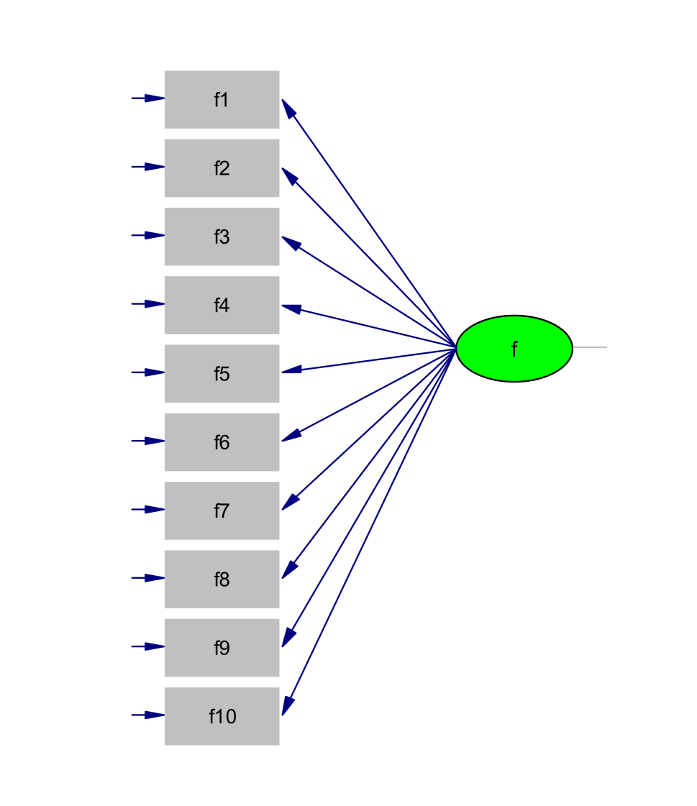
The conceptual model diagram after entering the software

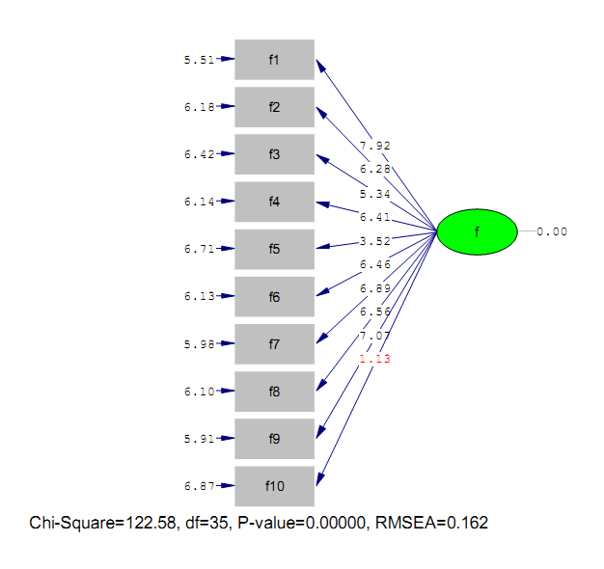

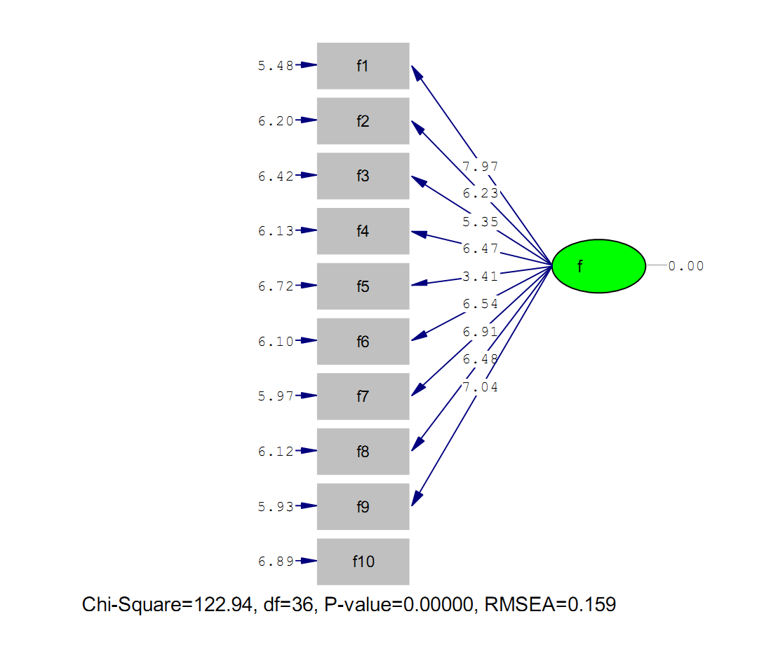

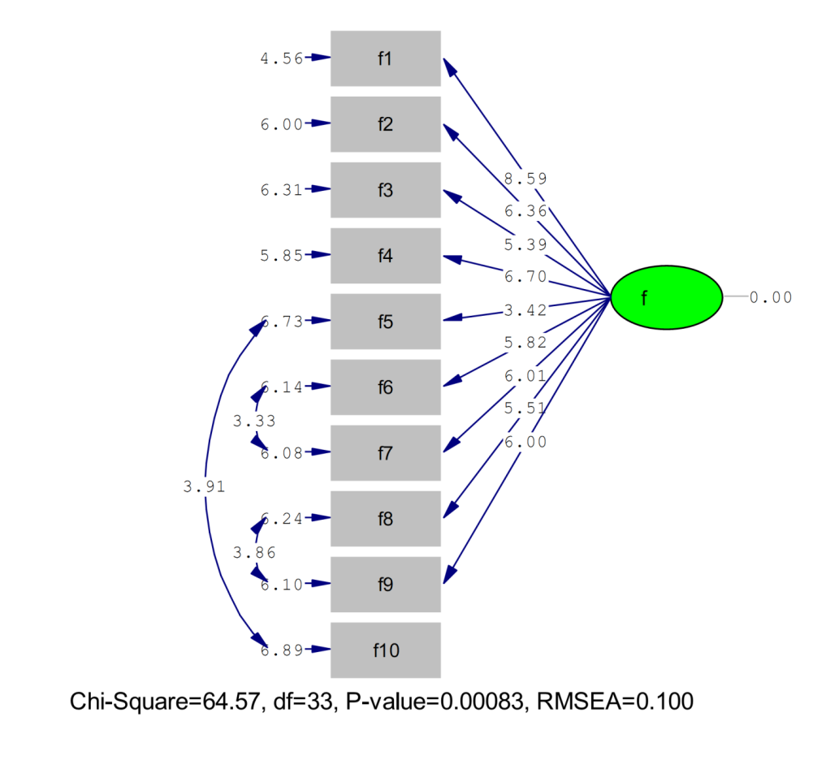

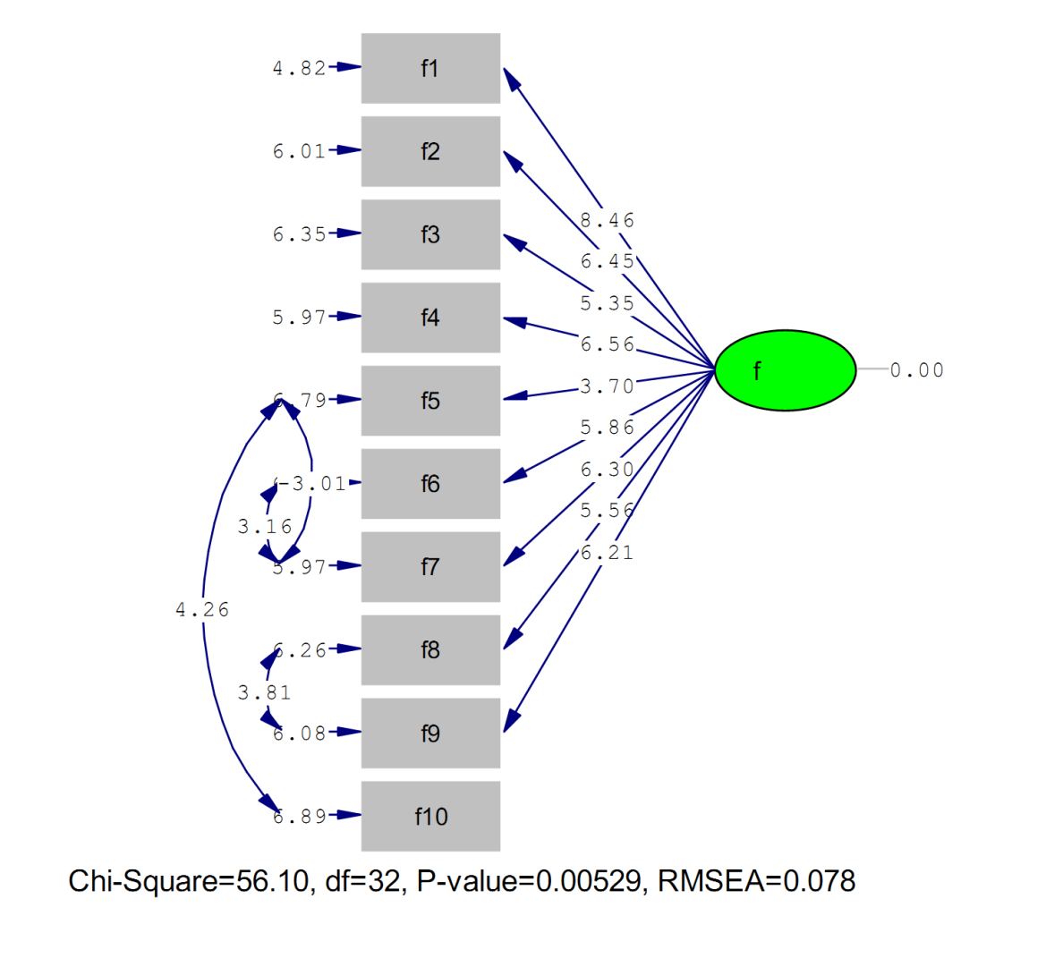

Table 15. Summary of structural equation model analysis
model | P-value | RMSEA | GFI | AGFI
1 | 0 | 0.162 | 0.79 | 0.68
2 | 0 | 0/159 | 0.79 | 0.69
3 | 0083.0 | 1.0 | 88.0 | 8.0
4 | 00529.0 | 078.0 | 92.0 | 87.0
model | P-value | RMSEA | GFI | AGFI
1 | 0 | 0.162 | 0.79 | 0.68
2 | 0 | 0.159 | 0.79 | 0.69
3 | 0083.0 | 1.0 | 88.0 | 8.0
4 | 00529.0 | 078.0 | 92.0 | 87.0

References:
  - M. Michael (2009). Translated by Badri Ahmad, Knowledge of Behavioral Finance and Investment Management, Keihan Publications.
  - P. J. Charles (2010). Translated by Tehrani Reza and Noorbakhsh Asgar, Investment Management, Negahe Danesh Publications.
  - Peterson, V. E. (2008). Translated By Khalili Abdoreza, Rumor and Public Thoughts, Aghlan Publications.
  - Privatization in India, Cultural Aide and International Affairs Publications, Institute of Labor and Social Welfare Publications.
  - VSa’adat E. (2004). Process of Decision Making in Organizations, University of Tehran Publications.
  - Cohn, R. A. and Lewellen, W. G. (May,2005). Individual Investor Risk Aversion and Investment Portfolio Composition, Journal of Finance.
  - Epstein, M. J. (1994). Social disclosure and the individual investor, Accounting, Auditing & Accountability Journal,94-109.
  - Hasan al tamimi. (2003). Investors perceptions of earning quality, auditor independence, Accounting Horizons,17-37-48.
  - Merilkas, A. and Prasad, d. (2003). Factor influencing Greek investor behavior on the Athens stock Exchange, paper presented at the Annual meeting of Academy of Financial Services, Colorado, October,8-9.
  - Olsen, Robert, (1998), Behavioral Finance and its lmplications for Stock-Price Volatility, Association for Investment Management and research, Financial Analysts Journal, Vol. 54, No 2. PP 10-18.
  - Riley, W. B. and Chow, K. V. (November1992). Asset Allocation and Individual Risk Aversion, Financial Analysts Journal. PP.21-19.
  - Shleifer, A. (1999). Inefficient Markets: An Introduction to behavioral finance. Oxford University Press.
  - Thaler, Richard (editor) (2003), Advances in Behavioral Finance, De long, J. Bradford, and Shleifer, Andrei, and Summers, Lawrence, and Waldmann, Robert, (1990), Noise trader risk in financial markets, Journal of Political Economy, Vol. 98, No. 4, PP.703-738.

3/25/2019

