**Improving the Quality of Photoreceivers Using Isotope Nanoengineering**

Nikolay M. Legkiy1 and Lubov M. Zhuravleva2

1MIREA - Russian Technological University, Vernadskogo Аv., 78, Moscow 119454, Russia.

2Russian University of Transport (MIIT), Obraztsova Str. 9, Build. 9, Moscow, 127994, Russia.

**Abstract: Annotation.** In a radio electronics sector, development and implementation of new tendencies are the most important part of the process that improves the efficiency of high technology industries at the modern stage. There are varies issues, especially relevant to improving the optoelectronic technologies, as there is a fast increase in the volume of information that is transmitted over the fiber optic communications systems. Therefore, one of the priorities is to improve the technical level of optoelectronic devices by creating advanced materials and manufacturing new products based on the isotope technologies.

[Nikolay M. Legkiy and Lubov M. Zhuravlev. **Improving the Quality of Photoreceivers Using Isotope Nanoengineering.** *Researcher* 2019;11(3):35-41]. ISSN 1553-9865 (print); ISSN 2163-8950 (online). <http://www.sciencepub.net/researcher>. 7. doi:[10.7537/marsrsj110319.07](http://www.dx.doi.org/10.7537/marsrsj110319.07).

**Keywords:** isotopes, fiber optic information transmission systems, nanostructures, photonics, and photoreceivers

**Introduction**

The radio electronics is part of a vast global high-tech industry. To keep developing that sector there is a need to improve the efficiency of optoelectronic elements, including those based on the next generation nanostructures. Today, developed countries tend to move from micro to nanoelectronics. There are so many modern and promising directions for the further development and one of them is the development of semiconductor materials based on new physical and technological principles, including isotope superlattices and production analysis of such nanostructures.

The use of nanostructured materials in optoelectronics is a promising sector of scientific research, and therefore many researchers are engaged in this subject [1, 2]. There are many promising directions for the research in the field of engineering semiconductor materials based on the isotopes of chemical elements to get new effects and optoelectronic characteristics.

**Isotope Nanoengineering in Photonics**

The main direction of isotope nanoengineering is to create new materials and nanostructures using isotopes of the same chemical element that have improved optoelectronic characteristics. To get those isotope nanostructures with the required characteristics we need to change physical and technical parameters of a semiconductor material, namely the width of a band gap, the effective mass and mobility of charge carriers, the refraction and absorption coefficients of light, electrical resistivity, and so on, along with different isotope concentrations of the same chemical element (isotope effect) [2-7].

The essence of the isotope effect is a change in the number of neutrons in the nucleus along with the same number of protons, therefore, within the last years, the isotope effect has become one of the most powerful methods of studying solid state physics [4-7]. When an isotope substitution occurs, for example, the change in the percentage composition of heavy isotopes at the source material, it changes a phonon wave function as well as an electron-phonon coupling constant. This is shown by the magnitude of shifts for Raman spectra of natural silicon and silicon isotopes shown in Fig. 1, determined by the difference in the mass of the silicon isotopes. The isotope effect is confirmed by the difference in a position of the longitudinal optical mode (Fig. 1), in dependence to the isotope number (M is a reduced mass of a primitive unit cell).

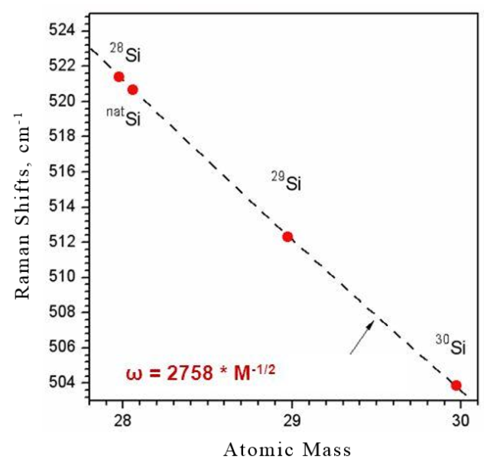

Fig. 1. The dependence of the maximum position of the optical mode on the type of silicon isotope [7]

In the last four decades, scientists have conducted detailed experiments to test the isotope effect using many semiconductors and dielectrics [5]. As a result, the isotope effect has important consequences for optoelectronics, namely there is the difference between the width of the band gap and the effective mass of an electron for different isotopes of the same chemical element. Thus, for example, when the isotope  is completely replaced by the isotope , then an increase in the width of the band gap would be *14.7 meV* in diamond [6]. The dependence of the width of the band gap for silicon is shown in Fig. 2.

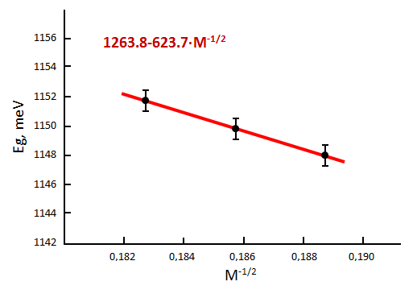

Fig.2. The dependence of the width of the band gap on the number of the silicon isotope [7]

As shown in Fig. 2, when the isotope mass increases (an argument  decreases) and the width of the band gap () goes up.

The value of the effective mass for different isotopes can be obtained using the mobility of the charge carriers and the amount of the electrical resistivity. Thus, the specific electrical resistivity (300 K) with increasing number (weight) of the isotope of a silicon single crystal [ (99,99%);  (99,92%);  (99,97%)]; increases within the limits of 100-200 Ohm/cm [7]. As the weight of the isotope decreases, the mobility of the electrons increases, namely the effective mass of the electron decreases. So, the isotopic purification of silicon allows to remove essentially all the heavy isotopes () as well as to double the electrons mobility and the speed of microprocessors [8]. Besides, there could be expected an even greater effect due to a faster speed of mobile charge carriers that is caused by the isotopic purification of the gallium, which is used in the solid solutions such as gallium arsenide and aluminate gallium arsenide. The material is often used to create nanostructures from multiple quantum wells.

There are the silicon isotopes substitution techniques such as a neutron transmutation doping (NTD) that increases the percentage of heavy isotopes and a gas centrifuge (GC), which decreases the percentage of heavy isotopes in the source material [9].

Molecular beam epitaxy (MBE) is a popularly used technique for fabricating of isotope multilayer nanostructures from different isotopes of the same chemical element. MBE technique is an ultra-high-vacuum technique for the deposition of thin films of various semiconductors and insulators layer-by-layer from an evaporated beam of particles [11].

Gas centrifuge (GC) is a widely used technique. Using the isotope purification of chemical elements from the heavy isotopes (enrichment) would significantly improve the optoelectronic characteristics of semiconductor materials, such as silicon, germanium, gallium, etc.

Many researches have been conducted to explore the functional materials for optoelectronics within the field of isotope nanoengineering, namely the goal was to improve the characteristics of bulk semiconductor crystals (BSC), multiple quantum wells (MQW) and superlattices (SL). The nanostructured materials based on MQW and SL relate to one-dimensional multilayer nanostructures. Considering their physical and technological properties, MQW and SL are similar (Fig. 3).

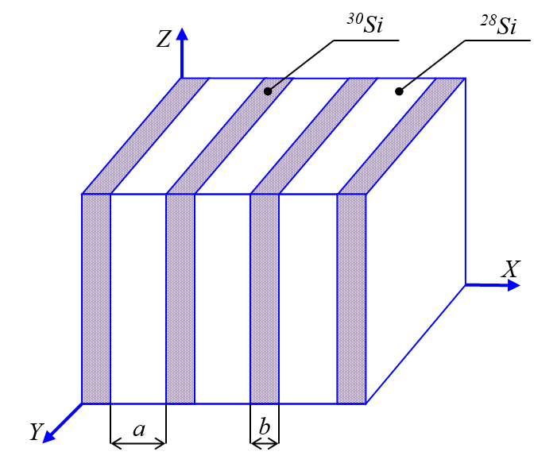

Fig.3. The silicon isotope superlattices (*a* – a quantum well, *b* – a barrier)

The difference lies between the width of the barriers *b* and the quantum wells, including the width of the wells a. The specific values *a* and *b* are determined by the semiconductor material. Thus, for GaAs multiple quantum well (MQW) dimensions are *b>10нм* along with a quantum well width of *6нм≤a≤10нм* [13]. In this case, each quantum well works as an independent nanostructure with levels of quantization of charge carriers in the wells, depending on the height of the potential barrier and the width of the well. When the dimensions are reduced, for example, *a=b≤6нм,* the MQW structure turns into the superlattices (SL), in which individual quantization levels are split into some subbands resulting in the conductance that rotate with the gaps (Fig. 4). The functional materials for optoelectronics that are based on the MQW and SL allow to build night vision and thermal imaging devices as well as the photoreceivers for ultra-long-range IR applications corresponding to the atmospheric window. The superlattice model plays an important role here, as it helps to develop new semiconductor materials with a small width of the band gap, which organic semiconductors can’t provide. In addition, the isotopically pure materials (homogeneous isotopic compositions) could provide even better results. So, using the isotope superlattices (ISL), we can build solar batteries that could hold the dark photons, which is very important for areas that have a limited number of sunny days [2].

**Improving the Quality of Photoreceivers**

To see the effectiveness of changing the isotope composition of a substance to improve the physical properties of the material, we need to consider the following example of the optoelectronic characteristics of the photoreceiver (the most common device in optoelectronics). Thus, the main parameters of the photoreceiver (PR) are sensitivity, detectability, a signal-to-noise ratio at a receiver's output *ρ*2out, and an error probability when elementary pulse is received *Perr*. If we decrease concentration of the heavy isotopes in the semiconductor material, which PR is made up, then it first increases the mobility of charge carriers, the light absorption coefficient and the quantum efficiency. Next it also reduces the number of electron sublevels in the band gap that influences the dark current. All that increases the photodetector’s sensitivity, decreases the dark current, rises *ρ*2out and lowers the error probability. The efficiency of isotope purification depends on a size of PR. To build the photoreceivers could be successfully used the bulk semiconductor crystals (BSC) and the MQW and SL nanostructures.

For the photoreceiver (PR), the main consequence of isotope purification of gallium arsenide is an increase in the absorption coefficient  and the quantum efficiency of  material.

The isotopic composition of gallium in  crystal consists of a mixture of 60.1%  and 39.9% .

We can treat the reduction of isotope concentration  as a decrease in the number of defects in the crystal lattice, which will affect the effective mass of the electron  and the width of the band gap . All the detailed changes to  and  can be found in the publication [14]. There are presented research results relative to the dependence  and  on the changes in the concentration of doping atoms in GaAs single crystals. Therefore, if we reduce the concentration of the heavy isotope  in gallium arsenide crystal by two orders of magnitude, then it could lower 1) the width of  to *0,06eV* and 2) the value of  by two times.

The quantum efficiency of  material has a significant effect on the optoelectronic characteristics of the photoreceiver. Here is the formula for calculating the value of [15]:

, (1)

where  - is the absorption coefficient;

- is the thickness of sample (BSC).

The absorption coefficient  is calculated as follows [13]:

,  (2)

where  - is the photon energy (a product of the Planck constant and the light of frequency);

 - is the coefficient of direct proportionality.

The dependency graph  for gallium arsenide gives the value of the coefficient *K* as follows [13]:

; . (3)

After the isotope purification of gallium from the heavy isotopes, including the changes of  was done, the absorption coefficient would be equal to :

; . (4)

According to (1), an increase in the quantum efficiency  for BSC from gallium arsenide, including the thickness of  would make:

 (5)

It is known that the value of  determines the sensitivity (a direct dependence), the detectability of material, which PR is made up, and the most importantly, the photocurrent value [15]. Therefore, the signal-to-noise ratio at the photoreceiver's output  will increase by a factor of 1,23 before and after the isotope purification of the bulk crystal. The increase in  will reduce the error probability by several orders of magnitude [16].

There are materials with the most effective properties for PR, namely they are the multiple quantum wells that consist of alternating layers of gallium arsenide (wells) and aluminate gallium arsenide (barriers) (Fig. 3) [13].

For the quantum wells, the value  and the formula (1) to calculate the quantum efficiency as follows [15]:

. (6)

Then after the isotopic purification, the value of the quantum efficiency for gallium arsenide per a quantum well (QW) increases as follows:

 (7)

Eventually, the isotopic purification of the material based on the MQW will increase the sensitivity of PR, the detectability, the photocurrent, and the value of  by a factor of 1,325 and will decrease *Perr* by several orders of magnitude [16].

The semiconductor superlattices (SL) are used in many different fields of science and technology and are the most promising material in optoelectronics. They can split the energy levels into some subbands resulting in the conductance and the gaps in the quantum wells.

The ability to change the isotopic composition of the material allows us to choose the location of the energy subbands in the quantum wells and the width of the energy gaps in the superlattices (SL) to develop the new semiconductors. This happens because we change the effective mass of the electron m and the width of the band gap *Eg* of SL material.

The width of the gaps and the conductivity subbands are determined by the base semiconductor as well as the width of the barriers and wells. Let’s say when we design optoelectronic devices based on the photoelectric effect and the intersubband transitions, it is very important to get the required width of the energy gap and the number of subbands in the quantum well. However, it is hard to get the desired result if we only match the parameters of wells *a* and *b* for the selected material.

It is known that after purification of silicon crystals from the heavy isotopes such as 29*Si* and 30*Si*, which make about 8% of all atoms, the mobility of electrons is two times higher [8].

It is also known that gallium consists of two isotopes (69Ga – 60,1%; 71*Ga* – 39,9%), and after purification of the crystal from the isotope 71*Ga* the mobility of electrons could be two times higher. Since gallium is lighter than silicon (the ratio *mэф* for *Si* and *Ga* equals: , where *m0* - is a mass of the electron in vacuum), we can expect a greater effect from the isotopic purification. In addition, the number of cycles such as acceleration and scattering for gallium is greater compared to silicon, and hence, the purification process is more efficient. As for silicon, collisions with a heavy isotope occur every 9 atoms on average and for gallium, every 2 atoms.

We can estimate the effect from the isotopic purification of gallium crystals for the superlattices, for this we need to use mathematical modeling for the dependence of the energy levels on the width of the well.

As noted above, the value of the effective mass after the purification from the heavy isotopes of gallium could be reduced by two times, namely it makes up to . The value of the width of the band gap  after the purification may make up: .

Fig. 5 shows the results of mathematical modeling for the distribution of the energy bands for SL using gallium arsenide (a quantum well) and aluminate gallium arsenide (a barrier), including Fig. 4a that doesn’t have the purification of the material and Fig. 4b that shows the purification of gallium from the heavy isotopes.

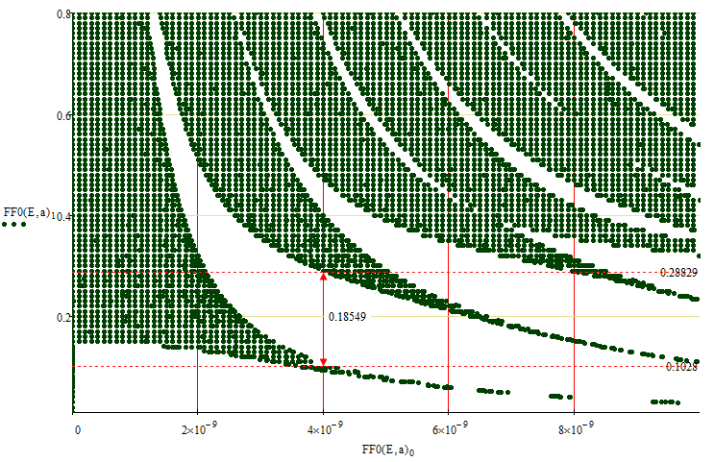

а)

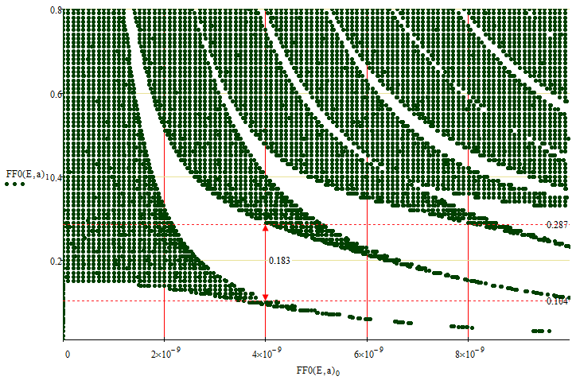

б)

Fig. 5. The dependences of the energy levels of SL: a - before the purification process and b - after the purification

The calculation of the width of the energy gap in the quantum well for the parameters *a*=*b*=4*нм* showed (see Fig. 4) that the purification reduces the width of the first energy gap by 3*мэВ*, So, that would be an important factor to get a certain long wavelength threshold for the photoelectric effect, for example, that might be used in security systems, detectors for hazardous substances, and many other useful devices.

Eventually, mathematical modeling proves the changes in the optoelectronic characteristics, namely the distribution of energy bands in the SL structure after the purification of gallium from the heavy isotopes.

The isotope superlattices can be used to design the new semiconductor materials for the photoreceivers for ultra-long-range IR up to 20 μm, which cannot be created in a regular way.

**Conclusions**

If we change the isotope composition of the original semiconductor then that affects the optoelectronic characteristics of the material, namely the mobility of charge carriers, the width of the band gap, the quantum efficiency, and so on.

When we create isotope materials we can also increase or decrease the percentage of the heavy isotopes in the material.

The most promising direction is the creation of the isotope superlattices, the next generation nanostructures. Using the isotope superlattices, we can develop the new semiconductor materials for the effective night vision and thermal imaging devices, the solar batteries that could hold the dark photons, the photoreceivers for ultra-long-range IR applications, the safety systems, the medical equipment, and so on.

Besides, the isotope purification of the original chemical element from the heavy isotopes will allow us to make more sensitive pixels for camcorders and built better intelligent video surveillance systems. So, the purification process of gallium from the heavy isotopes (photoconductor material) reduces the amount of digital noise in photos, increases the signal-to-noise ratio of the photoreceiver  reduces the error probability of PR by several orders of magnitude, and increases the probability of a correct detection at the device output to detect hazardous objects [17].

**Authors:**

Nikolay M. Legkiy1 and Lubov M. Zhuravleva2

1MIREA - Russian Technological University, Vernadskogo Аv., 78, Moscow 119454, Russia.

2Russian University of Transport (MIIT), Obraztsova Str. 9, Build. 9, Moscow, 127994, Russia.

**References**

1. Sigov A.S., Andrianova E.G., Zhukov D.O., Zykov S.V., Tarasov I.E. Quantum informatics: Overview of the main achievements. Rossiyskiy tekhnologicheskiy zhurnal (Russian Technological Journal). 2019; 7(1): 5-37. (in Russ.). DOI: 10.32362/2500-316X-2019-7-1-5-372.
2. Zhuravleva L.M., Plehanov V.G. Perspektivy primenenija izotopicheskoj nanoinzhenerii v telekommunikacionnyh sistemah. /Uspehi nanoinzhenerii: jelektronika, materialy, struktury, pod red. Dzh. Djevisa, M. Tompsona - M.: Tehnosfera, 2011. - S.478-491.
3. Zhuravleva L., Legkiy N., Plekhanov V. Isotopic nanostructure // Life Science Journal. - 2014;11(8s).
4. Plekhanov V., Zhuravleva L., Legkiy N. Using isotopic effect in nanostructures // Life Science Journal. - 2014;11(7s):306-309 (ISSN:1097-8135).
5. Cardona M., Thewalt M.L.W. Isotope effect on the optical spectra of semiconductors, Rev. Mod. Phys.// 77,1173-1224, 2005.
6. Collins A.T., Lawson S.C., Davis G., Kanda H. Indirect energy gap of diamond, Phys. Rev. Lett. // 65, 891-894, 1992.
7. Gusev, A.V., Gavva V.A., Gibin A.M. Poluchenie i svojstva stabil'nyh izotopov kremnija vysokoj himicheskoj i izotopicheskoj chistoty [Jelektronnyj resurs] // Institut himii vysokochistyh veshhestv RAN g. Nizhnij Novgorod. http://www.myshared.ru/slide/636165/.
8. Prtss Release (2001) of Isonics Corporation, Golden, Colorado.
9. Shlimak I.S. Nejtronnoe transmutacionnoe legirovanie poluprovodnikov: nauka i prilozhenie //Fizika tverdogo tela. - 1999.- T. 41, vyp.5. - S.794-798.
10. Zhuravleva L.M., Plehanov V.G. Izotopicheskoe sozdanie poluprovodnikovogo grafena // Nanotehnika. -2012.-#3.- S.34-39.
11. Borisenko V.E., Vorob'eva A. I., Utkina E.A. Nanojelektronika -M.: «Binom», 2009.- 223s.
12. Ruf, T. Teploprovodnost' izotopno-obogashhennogo kremnija //Solid State Communications. -2000. - T.115.-#5, s. 243.
13. Martines-Duart, Dzh. M. Nanotehnologii dlja mikro- i optojelektroniki - M.: Tehnosfera, 2007.- 368s.
14. Bogdanova V.A., Davletkil'deev N.A., Semikolenova N.A., Sidorov E.N. Jeffektivnaja massa jelektronov v sil'no legirovannom arsenide gallija pri uporjadochenii primesnyh kompleksov. // Fizika i tehnika poluprovodnikov, 2002, tom 36. vyp. 4, S. 407- 411.
15. Rozensher, Je. Vinter B. Optojelektronika - M.: Tehnosfera, 2006, 588 s.
16. Zhuravleva L.M., Ivashevskij M.R. i dr. Ocenka kachestva peredachi signalov sistem intellektual'nogo videonabljudenija // Proektirovanie i tehnologija jelektronnyh sredstv. 2017. #3. S. 10-15.
17. Fizika tverdogo tela / I.K.Vereshhagin, S.M. Kokin i dr. // M.: Vysshaja shkola, 2001.-236s.

3/20/2019