A Survey of Occurrence and Distribution of Phyllanthus Species in Nigeria

Wahab, Olasumbo Monsurat¹ and Ayodele, Abiodun Emmanuel²

^{1.} Department of Crop Production Technology, Federal College of Forestry, Ibadan. Nigeria
^{2.} Department of Botany, University of Ibadan, Ibadan. Nigeria
olasumbowahab@yahoo.com

Abstract: The genus Phyllanthus has a diversity of growth forms which are distributed in all tropical and subtropical regions of both hemispheres. As West African species of Phyllanthus have not been studied adequately and problems of identification as well as taxonomic confusion still persist, there is the need to provide basic information on the species. Therefore the present study carried out a floristic search of the taxa of Phyllanthus in Nigeria with a view to ascertaining how many species there are and determine the species boundaries. One hundred and forty two specimens comprising 55 field collections covering major Nigerian ecological zones and 87 representative herbaria materials from Forest Herbarium Ibadan, University of Ibadan herbarium and Obafemi Awolowo University herbarium were assessed. The most commonly distributed Phyllanthus species in Nigeria is P. amarus occurring in the far northern to the southern states. Although P. niruri and P. muellerianus had no record of collection in the far northern states, they are also well distributed over the central or middle-belt of Nigeria to the southern states. P. pentandrus is the fourth most distributed species, records being from the far northern states through the central and extending to few southern states. Most of the species under study occur in the Guinea savanna, lowland rainforest and the mangrove forest with P. amarus occurring in all the ecological zones. The species that have narrow distributional ranges are P. maderaspatensis confined to the Sudan savanna and P. urinaria restricted to the mangrove forest. Herbarium samples: P. fraternus, P. floribundus and P. physocarpus which do not occur in Nigeria were cases of misidentification; they are species of P. amarus, P. muellerianus and P. acidus respectively. The present study did not also document the misidentified species from the field.
[Wahab, Olasumbo Monsurat and Ayodele, Abiodun Emmanue. A Survey of Occurrence and Distribution of Phyllanthus Species in Nigeria. Researcher 2019;11(1):79-94]. ISSN 1553-9865 (print); ISSN 2163-8950 (online). http://www.sciencepub.net/researcher. 13. doi:10.7537/marsrsj110119.13.

Keywords: Phyllanthus species; field and herbarium study; distribution; Nigeria

1. Introduction
Plant distribution studies are carried out because they provide valuable information in several ways. The facts that distribution may be significant in the context of conservation of vegetation especially in the face of increasing destruction of plants in many parts of the world. Distribution patterns of species may yield information on the mechanism of speciation and dispersal as well as the determination of the relationship of floras.
The genus Phyllanthus has a diversity of growth forms including terrestrial or floating aquatics, pachycaulous succulents, trees, shrubs, climbers, annual and perennial herbs. Some species have flattened leaf-like stems or modified branchlets called phylloclades. All these growth forms are distributed in all tropical and subtropical regions of both hemispheres (Webster, 1994). They are found in open and shaded conditions in rocky areas, waste grounds, roadsides, on termitaria, cultivated fields and swamps in different vegetational zones including the grassland, derived savanna and rainforest. According to Webster (1994) and Silva (2009), despite the variety of growth forms, almost all Phyllanthus species express a specific type of growth called “phyllanthoid branching” in which the leaves on the main (vertical) plant axes are reduced to cataphylls while leaves on the plagiotropic (horizontal) axes are deciduous and floriferous. Indeed, leaf flower is the common name for all Phyllanthus species and ‘Phyllanthus’ means ‘leaf and flower’ because the flowers as well as the fruits are associated with the leaf (Cabieses 1993).
Some Phyllanthus species provide food, fruit, fuel, fodder, timber, dyes pharmaceutical and industrial products while others are extensively used in ethnomedicine (Rao, 2012). A survey of 300 ethnobotanical references of Phyllanthus species arranged taxonomically suggested some uses were clustered by subgenus (Holm-Nielsen, 1979). The genus forms one of the most important non-timber forest products in Southern India where a large number of forest dwelling and forest fringe communities depend on P. embelica L. and P. indofischeri Bennet (Ravikanth et al., 2012). As revealed by Sinha and Bawa (2002), unsustainable and destructive harvesting adversely affects regeneration of Phyllanthus species. To remedy the situation, domestication of the species and maintenance of in-situ gardens were suggested for long term conservation of the genetic resources. On the cultivation of Phyllanthus species, Kangsu Medical Institute (1975) recommended fertile, well-drained soil for growing P. urinaria L. To produce sufficient quantities for large scale extraction, a system was developed at the University of Florida Tropical Research and Education Center at Homestead, USA using black plastic mulch and trickle irrigation. Webster (1970) was of the opinion that the relative ease of growing herbaceous species of Phyllanthus in the greenhouse makes them to be attractive experimental objects for studying specialization in branching patterns. Phyllanthus acidus (L.) Skeel and P. embelica (Emblica officinalis Gaertner) are regionally cultivated for their fleshy edible fruits (Calixto et al., 1998). According to Murthy and Joshi (2007), P. emblica (Indian gooseberry) is grown in India, China, Taiwan, Indonesia, Malaysia, Thailand, Sri Lanka, Honduras and Costa Rica in orchards, home gardens, wastelands and forests. In these countries, P. emblica fruits are consumed and the plant parts utilized in local medicine systems. Tiwari et al., (2007) reported that well-drained deep fertile sandy loams are ideal for cultivation. P. acidus (Malay gooseberry) raised in many parts of the world including Australia, Brazil and Venezuela prefers moist soil (Murthy and Joshi, 2007). Probably the most economic importance of Phyllanthus species is their being used medicinally in various parts of the world.
Webster (1994) divided Phyllanthus into 10 subgenera, 68 sections and sub-sections. The subgenera are: Isocladus Webster, Kirganelia (Juss.) Webster, Cicca Linnaeus, Emblica Gaertner, Gomphidium (Baill.) Webster, Phyllanthodendron, Webster & Carpenter, Xylophylla Webster, Botryanthus Webster, Eriococcus (Hassk) Croiz & Metc. and Phyllanthus L. Of these, only Isocladus, Kirganelia and Phyllanthus are represented in Nigeria. Isocladus differs from Kirganelia and Phyllanthus by having no phyllanthoid branching. Although Isocladus and Kirganelia are made up of herbs, shrubs or trees, Phyllanthus consists of only herbs or low woody shrubs (Botanical Survey of India, 2014). Isocladus is represented by Phyllanthus maderaspatensis which belongs to the section Paraphyllanthus and is regarded as sister to all other species of Phyllanthus sensu lato (Kathriarachichi et al., 2006). Trees and shrub species, P. reticulatus, P. acidus, P. muellerianus and the herbaceous P. pentandrus Schum & Thonn belong to Kirganelia. The subgenus Phyllanthus comprises the herbaceous species. P. amarus, P. niruri, P. odontadenius and P. urinaria. According to Kathriachichi et al., (2006) subgenera Isocladus, Kirganelia and Phyllanthus are paraphyletic whereas other subgenera appear to be monophyletic.
Unlike other parts of the world, the West African species of Phyllanthus have not been studied adequately, problems of identification and taxonomic confusion still persist. There is therefore the need to provide basic information on these Phyllanthus species. Thus it is expedient to carry out a floristic search of the taxa of Phyllanthus in Nigeria with a view to ascertaining how many species there are and determine the species boundaries.

2. Materials and Methods
Field work and sampling
Fifty-five specimens were collected during field trips undertaken to different parts of the country for the collection and study of Phyllanthus species. Fresh samples of these species were collected from seventeen states and these are Oyo, Osun, Ondo, Lagos, Kwara, Niger, Benue, Adamawa, Kaduna, Sokoto, Plateau, Edo, Abia, Akwa Ibom, Enugu, Rivers and Cross River in Nigeria covering major ecological zones. Characters such as flower colour, fruit colour, number of perianth lobes as well as the colour of the leaf on both the adaxial and abaxial surfaces were recorded in the field notes as these might have changed or not available again after the specimens had been processed. Identification of the species was based on the characters used by Hutchinson and Dalziel (1954). Voucher specimens were prepared for all collections and deposited in the Herbarium of the Department of Botany, University of Ibadan, Ibadan, Nigeria (UIH). Photographs of the specimens were taken during the field trips with Digital camera (Sony Steady Shot DSC W530) for the picture database.
Herbarium studies
Eighty-seven representative herbarium materials presently deposited at Forest Herbarium Ibadan (FHI) of Forestry Research Institute of Nigeria, University of Ibadan Herbarium (UIH), Obafemi Awolowo University Herbarium (IFE) were studied. Three specimens were taken on loan from Nigerian Institute of Pharmaceutical Research and Development Herbarium (NIPRDH) while one specimen each was taken from University of Ilorin Herbarium (ILH) and Ahmadu Bello University Herbarium (ABUH) respectively for assessment. The list of the specimens studied is presented in Table 1.

3. Results
Field collections
A total of 55 fresh specimens were collected from different locations across seventeen states in Nigeria during field studies. These specimens represent nine species in the genus Phyllanthus: Phyllanthus acidus (L.) Skeels, Phyllanthus amarus Schum. & Thonn., Phyllanthus capillaris Schum. & Thonn., Phyllanthus muellerianus (O. Ktze) Exell, Phyllanthus niruri Linn., Phyllanthus odontadenius Mull. Arg., Phyllanthus pentandrus Schum. & Thonn., Phyllanthus reticulatus Poir. and Phyllanthus urinaria Linn. Figure 1 shows the collection sites of specimens of the genus Phyllanthus in Nigeria. Photographs of the specimens collected during the field studies are provided (Plates 1–9).
Herbarium studies
A list of taxa studied is presented in Table 1. Eighty-seven specimens representing nineteen species in the genus Phyllanthus: Phyllanthus acidus, Phyllanthus amarus, Phyllanthus beillei, Phyllanthus capillaris, Phyllanthus floribundus, Phyllanthus fraternus, Phyllanthus maderaspatensis, Phyllanthus mannianus, Phyllanthus muellerianus, Phyllanthus nigericus, Phyllanthus niruri, Phyllanthus niruroides, Phyllanthus odontadenius, Phyllanthus pentandrus, Phyllanthus physocarpus, Phyllanthus reticulatus, Phyllanthus rotundifolius, Phyllanthus sublanatus and Phyllanthus urinaria. Table 2 shows the distribution of members of the genus and the states where they occur in Nigeria.

Table 1: Herbarium specimens of Phyllanthus species examined
Taxa | Reference/ Herbarium number | Locality | Collector (s)/Collectors’ number (where indicated from herbarium study) | Date of Collection
Phyllanthus acidus (L.) Skeels | IFE 518 | Biological garden, OAU, Ife. | B. O. Daramola/ B08 | 17.09.2000
 | FHI 25674 | Forestry hills, Ibadan | R. W. J. Keay | February, 1950
Phyllanthus amarus Schum. & Thonn. | UIH 12922 | Jericho reservation, Ibadan | J. Lowe/2212 | 20.05.71
 | UIH 22022 | Zoology Department, U.I, Ibadan | Kuteyi R. R/2 | 13.11.91
 | UIH 11063 | Old farmland, Ibadan | 98 | 16.11.56
 | UIH 14260 | Bodija Cattleyard, Ibadan | G. Jackson | 24.11.70
 | UIH 19784 | University of Portharcourt, Rivers state | R. A. Freemann/11A | January, 1982
 | FHI 70064 | Ankpa, Igala, Kwara | Olorunfemi & Ibhanesebor | 21.05.73
 | FHI 73377 | Ajassor bridge, Nfum, S.E | Okeke, Ekwuno & others/ E & O 757 | 16.08.74
 | FHI 27564 | Quarters 680, Jericho, Ibadan | P. Wit/ PW 6 | 17.08.71
 | FHI 103399  FHI 89889  FHI 97140 | Wadata area, Makurdi  Along farmland, Gashaka, Gongola  Sapele, Bendel | Daramola/Emwiogbon/Oguntayo/DEO 595  Fagbemi F. A/326  Ariwaodo & Adesina / AA8 | 07.07.78  12.08.77  11.09.81
 | IFE 13856  NIPRDH 5884 | Borgu game reserve, Niger | B.O. Daramola | 27.09.01  29.08.06
Phyllanthus beillei Hutch. | FHI 5636 | Little Osse river, Owo, Ondo | A. C. Hoyle & J. P. M. Brenna | 24.08.43
 | FHI 61825 | Iseyin, Oyo | D. P. Stanfield | 02.05.65
Phyllanthus capillaris Schum. & Thonn. | FHI 84523 | Jauro-Umar camp area, Gembu, Gongola | B. O. Daramola / D 233 | 26.08.77
 | FHI 86495 | Akoko south, Oka, Ondo | Daramola & Ihe /BO 550 | 30.05.78
 | FHI 86973  FHI 78618 | Ogoja-Ikom road, Cross-river  Akapabuyo beach, Calabar | Emwiogbon & Daramola/608  Daramola, Macaulay & Oguntayo/C345 | 05.05.78  30.09.75
 | UIH 17453 | SHF hill, Yaounde, Cameroon | J. Lowe/3269 | 27.02.77
 | UIH 12270 | Umudike | Tuley & Redhead/705 | 17.08.64
 | IFE 2779 | CRIN station, Bende road, Umuahia | J. Medler/764 | 09.04.73
 | IFE 2781 | Roadside to Mayo-Ndaga, Mambilla Plateau | J. Medler/913 | 22.08.73
Phyllanthus floribundus Mull. Arg  Phyllanthus fraternus Webster  Phyllanthus maderaspatensis L. | FHI 104911  FHI 32082  FHI 6284  NIPRDH 4096  FHI 62771 | Iseyin-Oyo road, Oyo  Forestry hill, Ibadan  Benin  Sokoto-Illela motor road, Gwadabawa, Sokoto | B.O. Daramola/96  C.F.A. Onochie  A.P.D. Jones  M.G. Latilo | 24.03.93  March 1953  08.03.42  06.11.97  03.08.69
 | FHI 93997 | Kauwa F.R, Kukawa, Borno | Ekwuno & Fagbemi/EF 222 | 29.09.80
Phyllanthus mannianus Muell.  Arg. | FHI 77250 | Ngeliyaki, Mambilla North-East | Ekwuno P. O/311 | 26.11.75
 | IFE 2782 | Obudu Cattle ranch, Ogoja | J. Medler | 13.04.73
Phyllanthus muellerianus (O. Ktze) Exell | FHI 97072  FHI 46275  FHI 65767  FHI 88505  FHI 92098  UIH 21638  UIH 10235 | Okorshie, Obudu, C.R.S  Mambilla Plateau, N.E, Nigeria  Zoo garden, Enugu  Isanlu, Kwara state  Makurdi, Benue state  Okomu F.R  Biological garden, University of Ife | Ekwuno & Others/E & O1001  J.D. Chapman  J.A. Emwiogbon  Olorunfemi/Oguntayo/Ihe.284  Daramola/Emwiogbon/Oguntayo DEO 658  J. Lowe/4937  D. Gledhill | 19.09.81  07.07.72  17.08.72  04.10.78  03.01.80  10.03.91  10.01.68
 | UIH 10892 | Botanical garden, U.I, Ibadan | K.K. Agwu | 21.08.62
 | UIH 16816 | 10, Laird place, U.I, Ibadan | J. Lowe | 23.10.75
 | UIH 1927 | South of Kishi, Oyo | J. F. Redhead | 27.07.64
 | IFE 2747 | Igbetti rock, Oyo | J. Medler/577 | 06.02.71
 | IFE 2746B | O A U Campus, Ife | D. P. M. Guide/597 | January, 1967
 | IFE 2745A  NIPRDH 5559 | I A. R & T  Agricultural crop research station, Ilora | J. Medler/1059 | 17.07.74  08.04.04
Phyllanthus nigericus Brenan.  Phyllanthus niruri Linn. | FHI 36162A  FHI 70470  FHI 97017  FHI 56177  FHI 40000  FHI 89081  FHI 95587  FHI 60497  FHI 103424  UIH 21438 | Akure, Ondo  Enugu  Obudu, C. R. S  Adamawa division, Mambilla district, Plateau  Owo, Ondo  Duji F.R, Minna, Niger state  Bende F.R, Imo  Jalingo, N.E  Odoba,Otupko road, Benue  Nursery, Botany Dept, U.I, Ibadan | J.P.M. Brennan & R. W.J. Keay  Ekwuno P.O  -  -  -  -  -  -  -  J. Lowe/4866 | 03.01.48  16.10.73  11.02.82  29.01.58  04.05.57  19.02.77  06.09.81  08.05.72  17.06.78  23.11.89
 | UIH 1928 | Ibadan | A. J. C/598 | 10.08.33
 | UIH 1930 | Lagos | A. J. C/832 | December, 1934
 | IFE 16428 | Ibadan road, Ile-Ife, Osun | Akinwande O. | 27.06.11
 | ILH 185 |  |  | 09.04.84
 | ABUH 2522 |  |  | 02.08.88
Phyllanthus niruroides Mull. Arg. | FHI 42341  UIH 15562 | Igarra  Kolokuma area, Yenagoa Division, Rivers state | -  K. R. M. Williamson/339 | 22.09.58  06.11.73
Phyllanthus odontadenius Mull. Arg. | FHI 6217  UIH 14259 | Awka bathing pool, Awka, Onitsha  Borgu | A. P. D. Jones/1800  G. Jackson | 14.06.42  03.10.72
 | UIH 13797 | Kiama, Yenagoa area, Rivers state | Dr Williamson’s Assistant/A 13 | March, 1970
 | UIH 19713 | Calabar | - | December, 1981
 | UIH 21320 | Sapoba, Benin | J. Lowe/4812 | 03.04.88
Phyllanthus pentandrus Schum. &  Thonn. | IFE 2785B  FHI 83311  UIH 14257 | Idanre hills, Ondo  Ohumbe F.R  Argungu road | J. B. Hall/1258  -  G. Jackson | 20.04.69  13.06.77  13.10.70
 | UIH 12482 | Igbetti, Oyo | Z.O. Gbile & J. Olorunfemi | 22.10.68
 | IFE 2794 | Panyan, Plateau | J. B. Hall/2002 | 13.07.70
Phyllanthus physocarpus Mull.  Arg | IFE 2792  IFE 2795B | Borgu game reserve, near Kanji Dam, Ilorin  Road 7, OAU, Ile-Ife | I.B. Faremi  I. B. Faremi/1262 | 15.10.76  21.03.77
Phyllanthus reticulatus Poir. | FHI 40876  FHI 43451  FHI 19180  UIH 10866 | Owena Akure F. R, Ondo  Ife  -  Kano town Forest Nursery, Kano  Ikorodu | E. O. Bamgbala  M. G. Latilo  R. W. J. Keay  G. Jackson/2544A | 07.05.60  10.07.59  26.08.47  09.05.62
Phyllanthus rotundifolius  Phyllanthus sublanatus Schum. & Thonn. | IFE 2796  IFE 2798B  FHI 96993  UIH 2105  IFE 2800 | Shagumu, near new village, Ilorin  Shere Mountain, Bauchi  Okitipupa, Ondo  Oyo  Shagumu, near new village, Ilorin- | J. B. Hall  J. B. Hall/2133  Ibhanesebor & Osanyinlusi  - J. C/580  J. B. Hall/1304 | 11.06.69  18.07.70  15.07.82  08.08.37  11.06.69
Phyllanthus urinaria Linn. | UIH 21823  IFE 2802B | Odimodi, near Forcados, Delta state  Sha falls, Plateau | A. Egunyomi/8  J. B. Hall/2034 | 08.06.92  15.07.70
UIH – University of Ibadan Herbarium
FHI - Forest Herbarium Ibadan
IFE – Obafemi Awolowo University Herbarium
ABUH – Ahmadu Bello University Herbarium
ILH – University of Ilorin Herbarium
NIPRDH – Nigerian Institute of Pharmaceutical Research and Development Herbarium

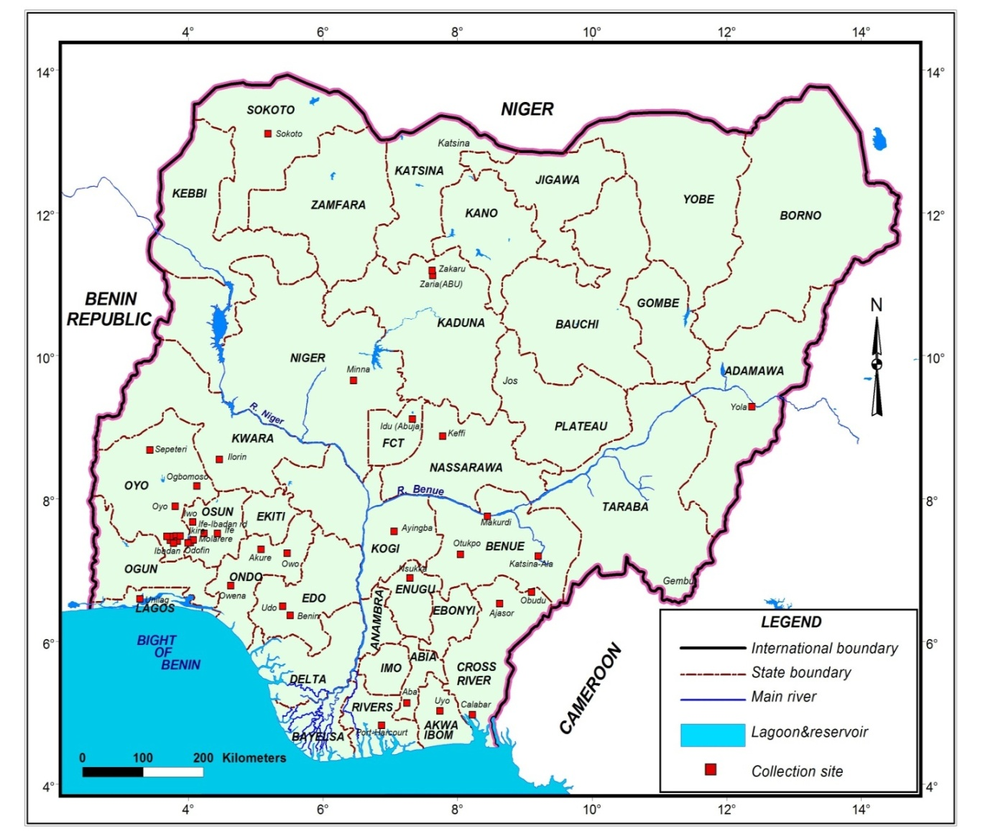
Figure 1: Collection sites of Phyllanthus species in Nigeria

Table 2: List of Phyllanthus species and the states where they occur in Nigeria
Zones | States in Nigeria | Pac | Pam | Pbe | Pca | Pfl | Pfr | Pma1 | Pma2 | Pmu | Pni1 | Pni2 | Pni3 | Pod | Ppe | Pph | Pre | Pro | Psu | Pur
North west | Sokoto |  |  |  |  |  |  | X |  |  |  |  |  |  | X
 | Kebbi
 | Zamfara
 | Katsina |  | X |  |  |  |  |  |  |  |  |  |  |  | X
 | Kano
 | Jigawa
North east | Taraba |  | X |  | X |  |  |  | X |  |  | X |  |  |  |  | X
 | Yobe
 | Bauchi |  |  | X |  |  |  |  |  |  |  |  |  |  |  |  |  | X
 | Gombe |  | X
 | Bornu |  | X |  |  |  |  | X
 | Adamawa |  |  |  | X
North central | Nassarawa
 | Niger |  | X |  |  |  | X |  |  |  |  | X |  | X | X
 | Abuja |  |  |  |  |  |  |  |  | X
 | Kaduna |  |  | X |  |  |  |  |  | X |  | X
 | Plateau |  |  | X | X |  |  |  | X | X | X | X |  |  | X |  |  | X | X
 | Kogi |  | X |  |  |  |  |  |  | X |  | X | X | X | X
 | Benue |  | X |  |  |  |  |  |  | X |  | X
 | Kwara |  | X |  |  | X |  |  |  | X |  | X |  |  |  |  | X |  | X
South west | Oyo | X | X | X |  | X |  |  |  | X |  | X | X |  | X |  |  |  | X
 | Ogun |  | X |  |  |  |  |  |  | X |  | X |  |  |  |  | X |  | X
 | Osun | X | X |  | X |  |  |  |  | X |  | X |  | X |  | X
 | Ekiti |  |  |  | X |  |  |  |  | X
 | Ondo |  | X | X | X |  |  |  |  | X | X | X |  | X | X | X |  |  | X
 | Lagos |  | X |  |  |  |  |  |  | X |  | X |  |  | X |  | X
South east | Enugu |  | X |  |  |  |  |  |  | X | X |  |  |  | X
 | Anambra |  |  |  |  |  |  |  |  | X |  |  |  |  | X |  |  |  | X
 | Ebonyi
 | Imo |  | X |  |  |  |  |  |  |  |  | X
 | Abia |  |  |  | X |  | X |  |  |  |  | X |  | X
South south | Edo |  | X |  |  | X |  |  |  | X |  | X |  | X
 | Delta |  |  |  |  |  |  |  |  |  |  |  |  |  |  |  |  |  |  | X
 | Bayelsa |  |  |  |  |  |  |  |  |  |  |  | X | X
 | Rivers |  | X |  |  |  |  |  |  |  |  |  | X | X
 | Akwa-Ibom
 | Cross River |  | X |  | X |  |  |  | X | X | X | X |  | X
Key:
Pac: Phyllanthus acidus; Pam: Phyllanthus amarus; Pbe: Phyllanthus beillei; Pca: Phyllanthus capillaris; Pfl: Phyllanthus floribundus; Pfr: Phyllanthus fraternus; Pma1: Phyllanthus maderaspatensis; Pma2: Phyllanthus mannianus; Pmu: Phyllanthus muellerianus; Pni1: Phyllanthus nigericus; Pni2: Phyllanthus niruri; Pni3: Phyllanthus niruroides; Pod: Phyllanthus odontadenius; Ppe: Phyllanthus pentandrus; Pph: Phyllanthus physocarpus; Pre: Phyllanthus reticulatus; Pro: Phyllanthus rotundifolius; Psu: Phyllanthus sublanatus; Pur: Phyllanthus urinaria

As shown in Table 2, the most commonly distributed Phyllanthus species in Nigeria is P. amarus occurring in the far northern to the southern states. Although P. niruri and P. muellerianus had no record of collection in the far northern states, they are also well distributed over the central or middle-belt of Nigeria to the southern states. P. pentandrus is the fourth most distributed species, records being from the far northern states through the central and extending to few southern states.
The species collected from the southern states only are P. acidus, P. physocarcus and P. urinaria. In contrast, P. maderaspatensis and P. mannianus are restricted to a few northern states. Records of collection revealed that certain species were found in the middle belt area and some southern states of Nigeria. The species are P. floribundus, P. fraternus, P. niruroides, P. odontadenius and P. sublanatus.
Phyllanthus species collected from states characterized by highland and montane areas (Plateau, Taraba and Adamawa) are P. beillei, P. capillaris, P. nigericus, P. rotundifolius and P. reticulatus. The distribution of Phyllanthus species based on the ecological zones of Nigeria shows that fourteen of the nineteen species under study occur in the Guinea savanna, lowland rainforest and the Mangrove forest. P. amarus occurs in all the ecological zones hence have the widest ecological distributional range. The species that have narrow distributional ranges are P. maderaspatensis confined to the Sudan savanna, P. physocarpus restricted to the lowland rainforest and P. urinaria to the mangrove forest.

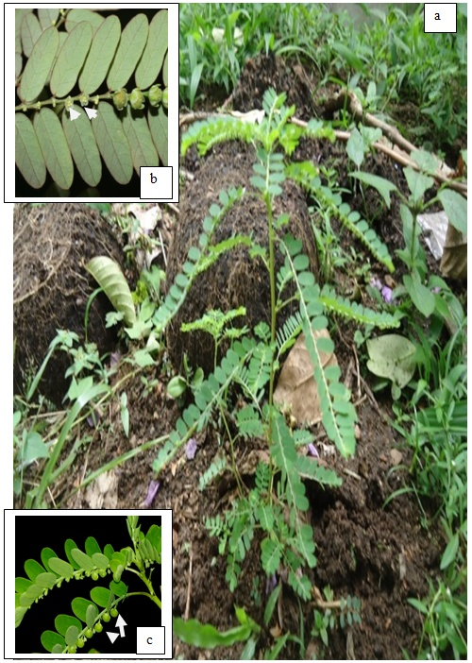
Plate 1: Photographs of Phyllanthus amarus showing
a: growth habit;
b: the flowers (arrowed) on the abaxial surface;
c: fruits (arrowed)

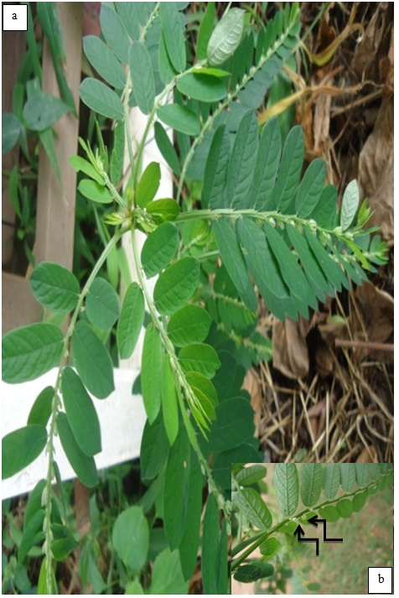
Plate 2: Photographs of Phyllanthus odontadenius showing
a: growth habit;
b: alternate leaf arrangement and the flowers (arrowed) on the abaxial surface;

b
c
b
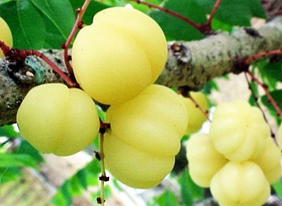
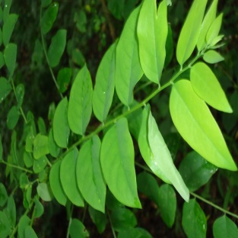
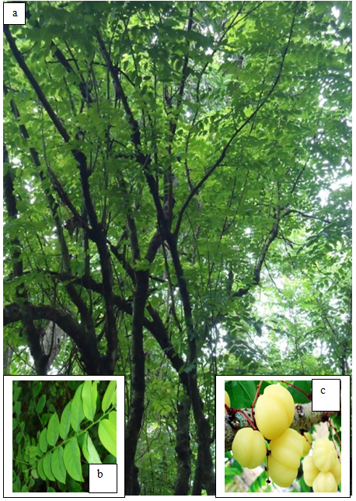
Plate 3: Photographs of Phyllanthus acidus showing
a: growth habit;
b: alternate leaf arrangement;
c: fruits

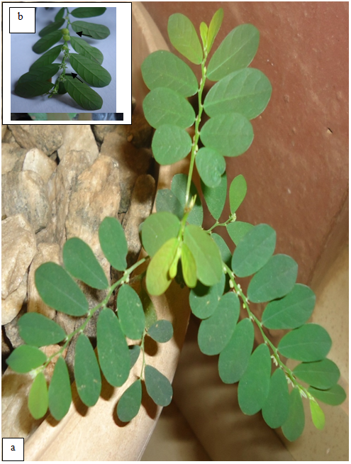
Plate 4: Photographs of Phyllanthus capillaris showing
a: growth habit;
b: fruits and flowers (arrowed) on the abaxial surface

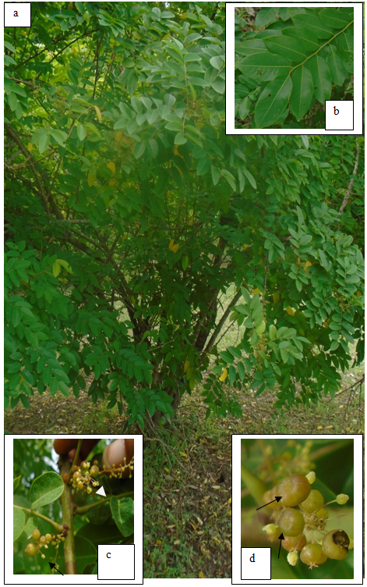
Plate 5: Photographs of Phyllanthus muellerianus showing
a: growth habit;
b: alternate leaf arrangement;
c: flowers (arrowed);
d: fruits (arrowed)

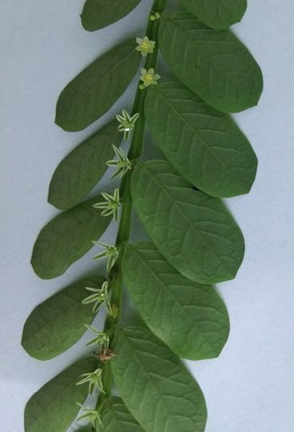
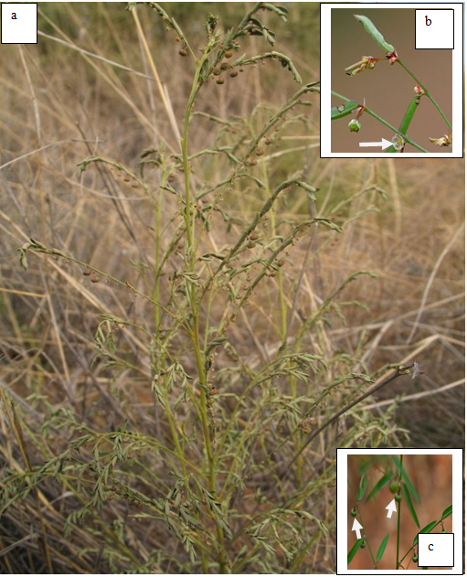
Plate 6: Pictures of Phyllanthus pentandrus showing
a: growth habit;
b: flowers (arrowed);
c: fruits (arrowed) and the linear shaped leaves

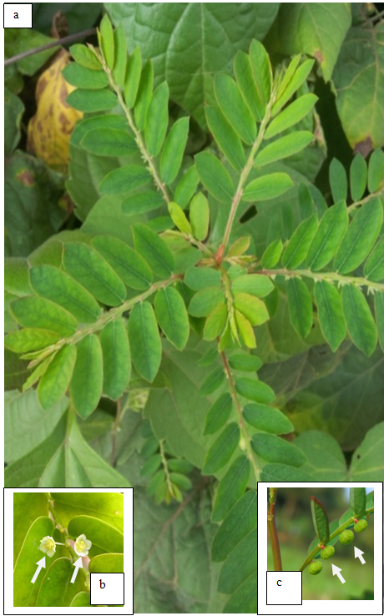
Plate 7: Photographs of Phyllanthus niruri showing
a: growth habit;
b: flowers (arrowed);
c: fruits (arrowed)

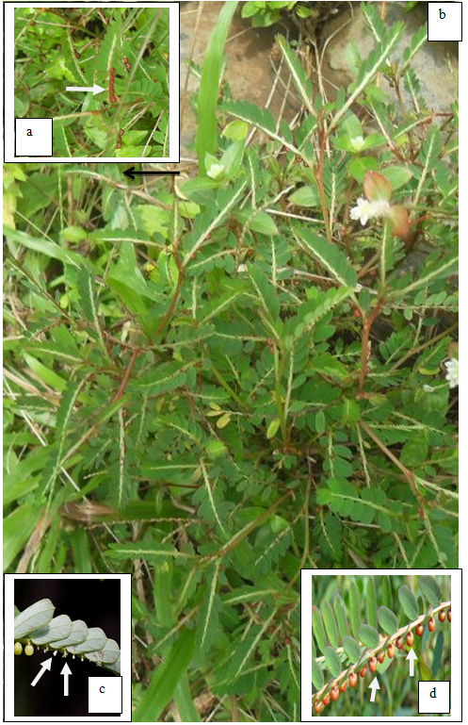
Plate 8: Photographs of Phyllanthus urinaria showing
a: alternate leaf arrangement and the reddish brown fruits (arrowed) on the abaxial surface;
b: growth habit;
c: flowers (arrowed);
d: fruits (arrowed)

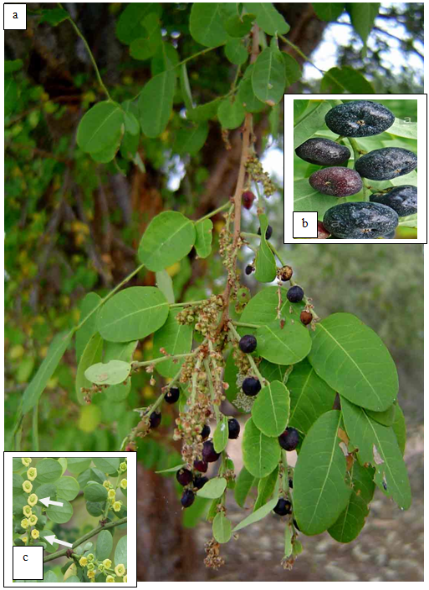
Plate 9: Photographs of Phyllanthus reticulatus showing
a: growth habit;
b: fruits;
c: flowers (arrowed)

4. Discussion and Conclusion
Phyllanthus is the largest genus of all the genera in the family Phyllanthaceae. The species in the genus are widely distributed in Nigeria with the herbaceous members of the genus generating a great deal of confusion among scientists regarding their identification. In many cases, misidentification of the taxa makes evaluation of the published information difficult (Rao et al., 1999). The most commonly distributed species in Nigeria is P. amarus occurring in the far northern to the southern states closely followed by P. pentandrus while the species collected from the southern states only are P. acidus, P. physocarpus and P. urinaria. In contrast, P. maderaspatensis and P. mannianus are restricted to a few northern states (Figure 1, Table 2). Most of the species under study occur in the Guinea savanna, lowland rainforest and the mangrove forest with P. amarus occurring in all ecological zones hence have the widest ecological distributional range while the species that have narrow distributional range are P. maderaspatensis confined to the Sudan savanna and P. urinaria restricted to the mangrove forest. That P. amarus was encountered in all ecological zones in the study was corroborated by the work of Webster (1986) where he reported the species (P. amarus) among other species studied as a ubiquitous pantropical weed. Three species: P. fraternus, P. floribundus and P. physocarpus found from herbarium study are cases of misidentification as they are species of P. amarus, P. muellerianus and P. acidus respectively. As they are not found in Nigeria (Hutchinson and Dalziel, 1954), the present study did not also document them from the field in Nigeria.

Corresponding author
Wahab Olasumbo Monsurat
Department of Crop Production Technology,
Federal College of Forestry, Ibadan. Nigeria
Telephone: +234-802 3516 870
E-mail: olasumbowahab@yahoo.com

References
- Webster, G.L. Synopsis of the genera and suprageneric taxa of Euphorbiaceae. 1994.
- Silva, M.J. Neotropical Phyllanthaceae. In: Milliken, W. Klitgard, B. & Baracat, A. Onwards Neotripikey-Interactive key and information resources for flowery plants of the Neotropics 2009. http://www.kew.org/science/tropamerica/neotropikey/families/Phyllanthaceae.htm
- Cabieses, F. Apuntes de medicina traditional. La Racionalizcion de lo lrracional. ‘Notes on Traditional Medicine.’Consejo Nacional de Ciencia Y Technologia CONCYTEC Lima-Peru 1993; Pp 414.
- Rao, B.R. Cultivation, economics and marketing of Phyllanthus species. In Phyllanthus species: Scientific evaluation and medicinal applications’ (ed: Kuttan, R and K.B. Harikumar). CRC Press, London. 2012; Pp 47-70.
- Holm-Nielsen, L.B. Comments on the distribution and evolution of the genus Phyllanthus. In K. Larsen, L. B. Holm-Nielsen [eds.] Tropical botany 1979; 277-290 Academic Press, London, UK.
- Ravikanth, G., Srirama, R., Senthilkumar, U., Ganeshaiah, K.N. and Shaankar, R.V. Genetic resources of Phyllanthus in Southern India. Identification of geographic and genetic hotspots and its implication for conservation. In ‘Phyllanthus species: Scientific evaluation and medicinal applications’ CRC Press London. 2012.
- Sinha, A. and Bawa, K.S. Harvesting techniques, hemiparasites and fruit production in two non-timber forest tree species in South India. For. Ecol. Manage 2002; 165: 289-300.
- Kangsu Medical Institute. Encyclopedia of Chinese Medicine. 3 vols. Shanghai Publisher of Science and Technology Chinese; English translations by M.P. Wong, Fox Chase Cancer Center, Philadelphia, PA. 1975.
- Webster, G.L. A revision of Phyllanthus (Euphorbiaceae) in the continental United States. Brittonia 1970; 22: 44-76.
- Calixto, J.B., Santos, A.R.S., Filho, V.C. and Yunes, R.A. A review of the plants of the genus Phyllanthus; their chemistry, pharmacology and therapeutic potential. Medicinal Research Review 1998; 18: 225-258.
- Murthy, Z. V. P. and Joshi, D. Fluidized bed drying of aonla (Emblica officinalis). Drying Technol 2007; 25: 883-889.
- Tiwari, J.P., Mishra, D.S., Misra, K.K., and Mishra, N.K. Indian gooseberry. In Medicinal and Aromatic crops, ed. Jitendra Singh 2007; 112-124. Jaipur, India, Avishkar.
- Botanical Survey of India. http://efloraindia/tanolist.action. 2014
- Kathriarachchi, H., Samuel, R., Hoffmann, P., Mlinarec, J., Wurdack, K.J., Ralimanana, H., Stuessy, T. F. and Chase, M. W. Phylogenetics of tribe Phyllantheae (Phyllanthaceae; Euphorbiaceae sensu lato) based on nrITS and Plastid matK DNA sequence data. American Journal of Botany 2006; 93(4): 637-655.
- Hutchinson, J and Dalziel, J.M. Revised by R. W. J. Keay. Flora of West Tropical Africa 1954; Vols 1-3. Crown Agents for Overseas Government and Administration, London.
- Rao, R.S., Sudhakar, S. and Venkanna, P. Flora of East Godavari District, Andhra Pradesh, India. Hyderbad, India: Indian National Trust for Art and Cultural Heritage 1999; pp. 632.
- Webster, G.L. A revision of Phyllanthus (Euphorbiaceae) in Eastern Melanasia. Pacific Science 1986; 40: 88-105.

Suggested Reviewers:
1: Professor T. R. Fasola
Email: fasolatr@gmail.com
2: Dr. O. O. Oyesiku
Email: sbusik1000@gmail.com
3: Dr. I. T. Gbadamosi
Email: gita4me2004@yahoo.com

1/23/2019

