The effect of attenuation and dispersion on the propagation of a short Gaussian pulse in optical fibers

M. S. Jasimª, H. A. Sultan^{b} and C. A. Emshary ^{b}

^{a-} Ministry of Education, Missan Directorate of Education, Gifted secondary school, Iraq.
^{b-} Department of Physics, College of Education for Pure Sciences, University of Basrah, Iraq.
hassabd67@yahoo.com

Abstract: Fiber optics being the most important in many of applications like medicine and communication. Manny factors affect the light propagation through it, like attenuation, dispersion and nonlinear effects. In this paper the effect of attenuation and dispersion on the propagation of a Gaussian pulse in optical fiber was studied by theoretical simulations. Nonlinear Schrodinger equation was solved by split step Fourier method using MATLAB. The study focused on the pulse intensity distribution with time and its distribution along the fiber under the effect of attenuation and dispersion. The pulse propagation is affected strongly with varying these parameters.
[M. S. Jasim, H. A. Sultan and C. A. Emshary. The effect of attenuation and dispersion on the propagation of a short Gaussian pulse in optical fibers. Researcher 2019;11(1):56-61]. ISSN 1553-9865 (print); ISSN 2163-8950 (online). http://www.sciencepub.net/researcher. 9. doi:10.7537/marsrsj110119.09.

Keywords: optical fibers, attenuation, dispersion, soliton

Introduction:
An optical fiber is a very clear glass capable of carrying the light pulses as information in the communication system. The two main elements of an optical fiber are its core and cladding. The core made of silica glass is the light transmission area of the fiber. The cladding is the layer completely surrounding the core. The difference in refractive index between the core and cladding is less than 0.5 percent. Optical fiber played a very important role due to its wide properties like high bandwidth, long distance transmission, and high level of security [1-4]. Dispersion is the main performance limiting factor in optical fiber communication. Dispersion greatly hampers the performance of optical fiber communication. When a pulse travels through an optical fiber it becomes broadened due to dispersion. The dispersion is proportional to the length of the fiber. Dispersion is a consequence of the physical properties of the transmission medium [2,5,8-9].

Attenuation:
Attenuation is one important characteristic of an optical ﬁber, since it determines the repeater spacing in a ﬁber transmission system. The lower the attenuation, the greater will be the required repeater spacing and lower will be the cost of that system. Representing by $P_{°}$the power launched at the input of a fiber of length L, the output power is given by [7]:
$P_{t}= P_{°} EXP (-αL)$……………………………… (1)
where α is the attenuation constant (absorption factor), (1/km), and it’s a gauge to losses the energy during upload the signal (pulse) in optical fiber [9-10]. Usually, the ﬁber attenuation is given in dB/km, using the relation [7]:
$α= -\frac{10}{L} Log \frac{P_{t}}{P_{°}}$…………………………………. (2)

Absorption is the way by which the energy of a photon is taken up by matter, typically the electrons of an atom. Thus, the light energy is transformed to other forms of energy for example, to heat. The absorption of light during wave propagation is often called attenuation [7].

Dispersion:

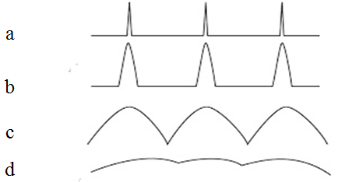
Figure (1): Distribution of pulse intensity with time at different distance. (a) initial pulses. (b) pulses start to separate (c) starting to overlap (d) pulses no longer recognizable [3].

Dispersion is defined as pulse spreading in an optical fiber. As a pulse of light propagates through a fiber, elements such as numerical aperture, core diameter, refractive index profile, wavelength, and laser line width cause the pulse to broaden. Dispersion increases along the fiber length. The overall effect of dispersion on the performance of a fiber optic system is known as Inter symbol Interference (ISI). Inter symbol interference occurs when the pulse spreading caused by dispersion causes the output pulses of a system to overlap, rendering them undetectable. As shown in figure (1).

The dispersion, D, can be calculated through the equation [10]:

$D=-\frac{2πC}{λ^{2}} β_{2}$………………………… (3),

where C is the velocity of light, $λ^{}$ is the wavelength, ${ β}_{2}$is the second-order dispersion factor.

Solution of NLSE:
The propagation of a short light pulse in optical fibers is governed by the Nonlinear Schrodinger Equation (NLSE) given by [10]:

$\frac{∂A}{∂z}+i\frac{β_{2}}{2}\frac{∂^{2}A}{∂t^{2}}+\frac{α}{2}A=iγ|A|^{2}A$………… (4),

Where $A$ is the pulse envelope, γ is the nonlinear parameter given by [10]:
$γ=\frac{2πn_{2}}{λA_{eff}}$……………………………. (5),
where $n_{2}$is the nonlinear refractive index and $A_{eff}$ is the effective area of the fiber core.

This type of equation can be solved efficiently using the split step Fourier method (SSFM) [7.10], where the fiber length is divided into N cells, each cell while will divided into two parts, the first is for the linear term of the NLSE, and the second is for the nonlinear one. Then eq. (1) gives:

$\frac{∂A}{∂z}=\left(L+N\right) A$…………………………….. (6),

Where, L=-$\frac{β_{2}}{2}\frac{∂^{2}A}{∂t^{2}}$ is the linear operator, and N= $iγ|A|^{2}$ is the nonlinear one.

The solution of eq. (3) from z to z+h will be:
$A\left(z,t\right)=\exp\left[h\left(L+N\right)\right]A(z,t)$…………. (7)

The first present numerical result obtained by using the parameters of optical fiber at a balance between the effects of $β_{2}$and γ, where α was assumed to be neglectable, $β_{2}$group velocity dispersion, and γ. Then the pulse will keep propagating with the same intensity shape without any change with respect to the distance and time, as shown in figure (2).

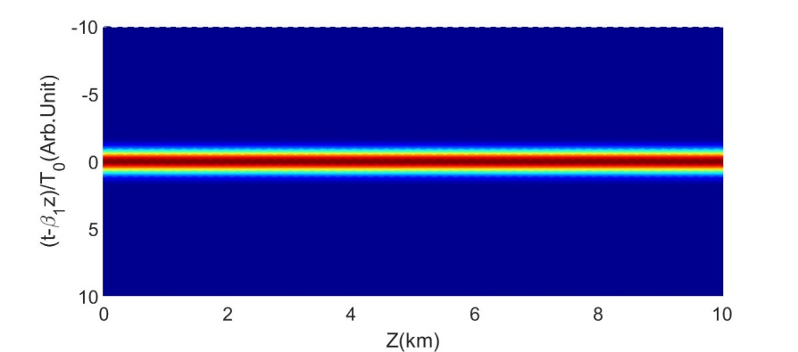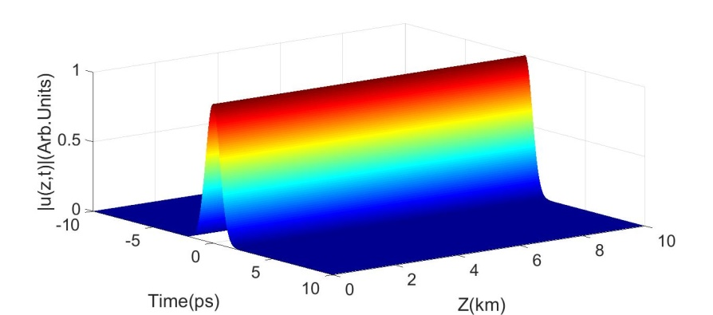
Figure (2): Image and surface plot of the propagation of Gaussian pulse for neglectable α and have a balance between the effects came from $β_{2}$and the come from γ.

By taken different values of the attenuation factor ($α)$. where $\left(α=0.0002, 0.002,0.02\right) dB/km)$, the absorption effect can be summarized by figure (3).

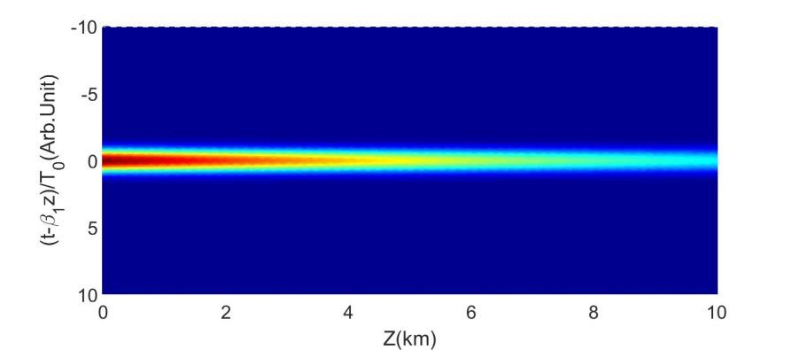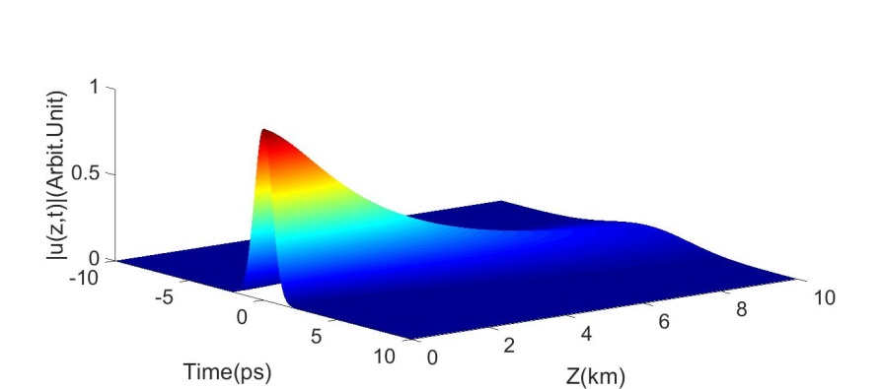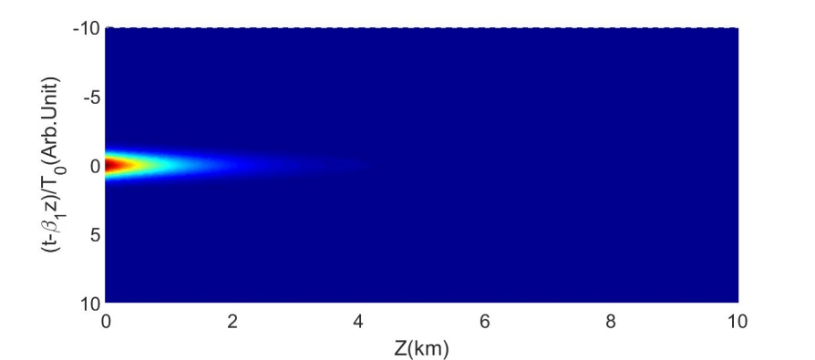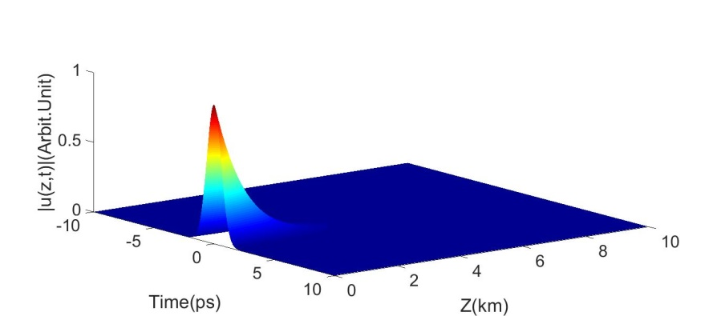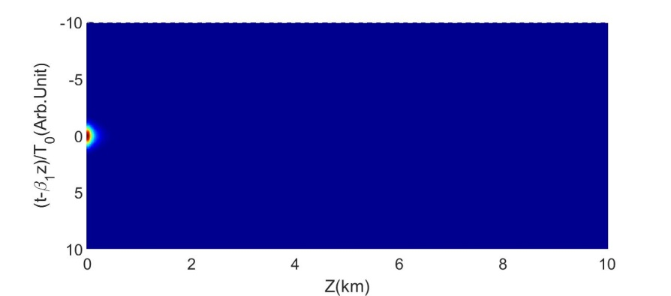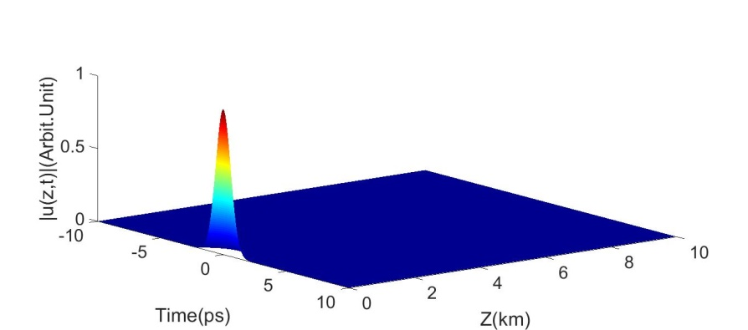Figure (3): Show propagation of pulse inner the fiber, and picture for pulse intensity change with distance and time when: $β_{2}=0.0006, γ=0.00003$, where (a) α=0.0002 dB/km, α=0.002 dB/km, (c) α=0.002 dB/km.
(c)
(b)
(a)

If the absorption is very small (α=0.0002 dB/km) and a weak nonlinearity, (γ=0.00003$w^{-1}{km}^{-1})$. GVD value determines the dispersion happen to the pulse, at a small value of ($β_{2}$), the pulse expansion (pulse width) will increased and the intensity is decreased with increased the distance inter the fiber as seen in figure (4a). With increasing ($β_{2}$), the pulse dispersion also increased, multiple, and complex shape of the pulse appeared as shown in figure (4b, c). Figure (5) explain of a Gaussian pulse shape is propagate of the fiber and also picture for change the pulse intensity with the distance and time, therein taken a change value for ($β_{2}$) as a following:

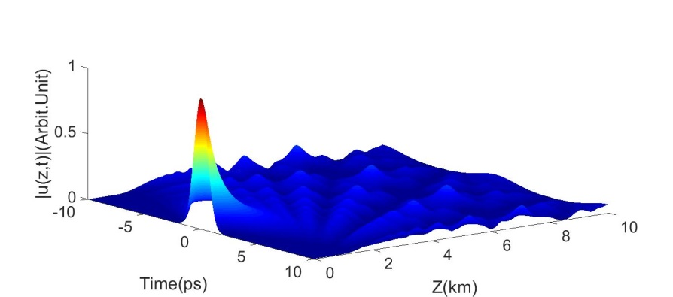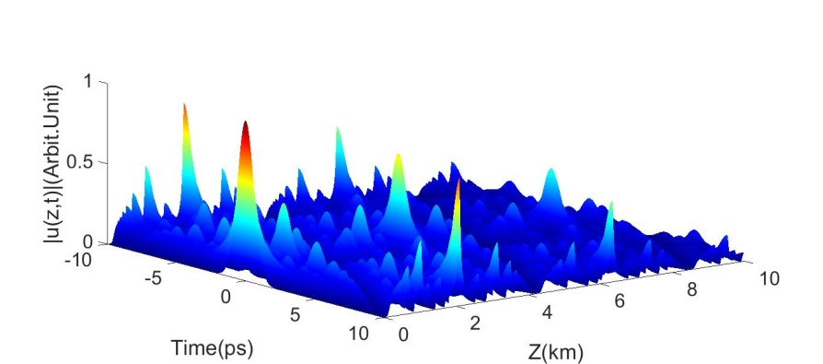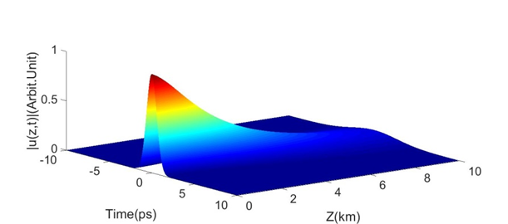
(a)
(b)
(c)

Figure (4): The propagation of a Gaussian pulse in the fiber and picture for change the pulse intensity with distance and time. (a) $β_{2}$=0.0006((${ps}^{2}$)/km), (b) $β_{2}$=0.006 ((${ps}^{2}$)/km), (c) $β_{2}$=0.06 ((${ps}^{2}$)/km).

The time behavior of the pulse in the fiber of two or three value along the fiber, at momentary pulse at the entrance, at half the distance and at the end of the fiber.

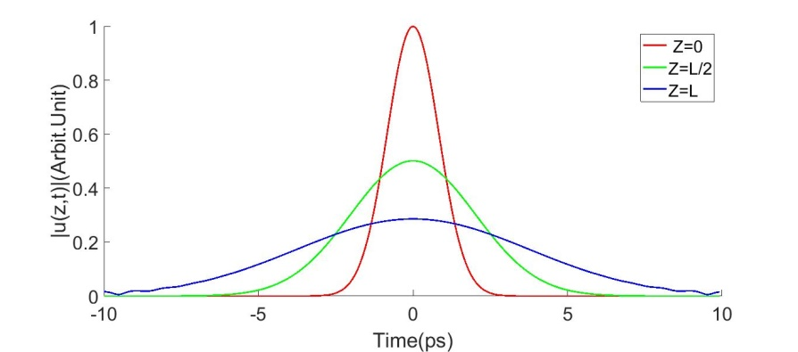

(a)

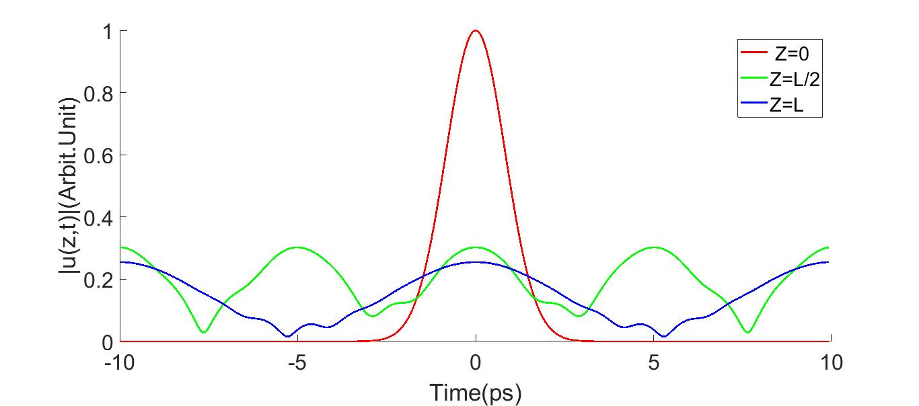
(b)

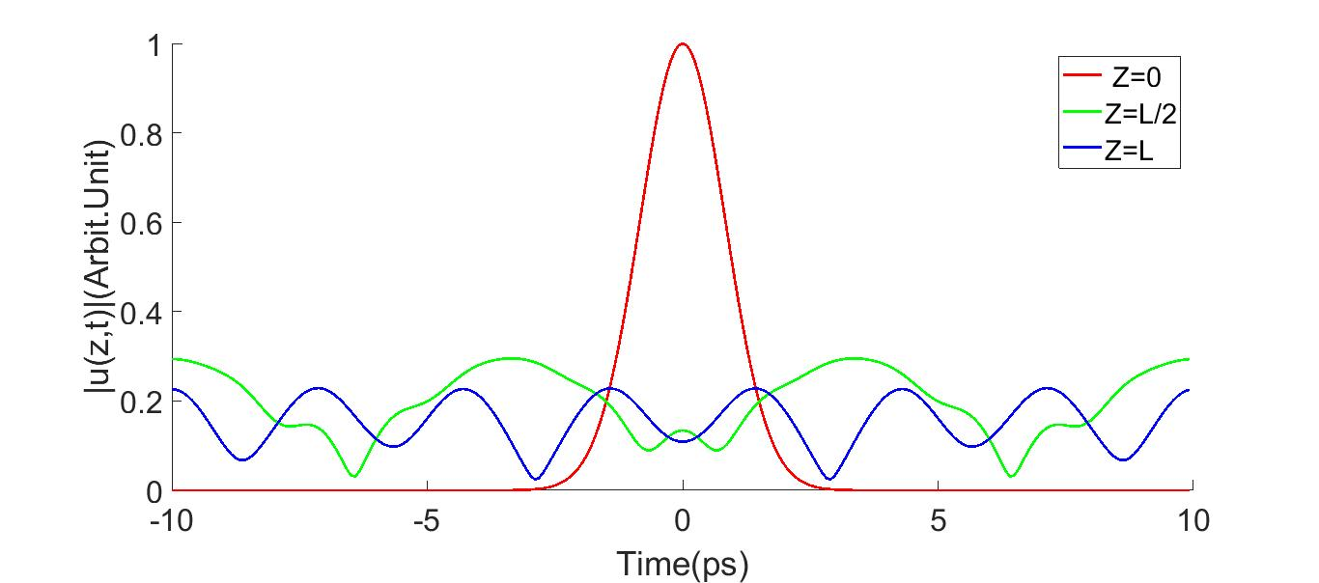
(c)

Figure (5): Change in the intensity of a Gaussian pulse in the optical fiber with the time. (a) $β_{2}$=0.0006 ((${ps}^{2}$)/km), (b) $β_{2}$=0.006 ((${ps}^{2}$)/km), (c) $β_{2}$=0.06((${ps}^{2}$)/km).

Conclusion:
Through simulations, we have shown that group velocity dispersion (GVD) should be realizable, dispersion in optical fibers limits the quality of signal transmission. where various value of $β_{2}$ in optical fiber have been discussed. Also the change and effect of $β_{2}$of the pulse with the distance and time was discussed. This paper explicates is whenever the ($β_{2}$) value increase the ratio dispersion increased too, since it is the major parameter in the GVD). The attenuation as it well known, decreases the pulse intensity along the fiber, it Play an important role in conjunction with the (GVD).

References:
- Paiva, C. R, Fotónica, Fibras Ópticas, DEEC, IST, (2008).
- Pires, J, Fibras Ópticas, IST, (2003).
- Mamhmudul Hasan, S. N. Shayokh Ahmed, Khawza Mohiuddin,” Study of Soliton Propagation Inside Optical Fiber for ultra-short pulse”, A Thesis, University Dhaka, Bangladesh, (2011).
- N. Ravi Teja, M. Aneesh Babu, T. R. S. Prasad, “Different Types of Dispersions in an Optical Fiber”, International Journal of Scientific and Research Publications, ( 2012).
- Grobe, K. and H. Braunisch, “A broadband model for single-mode ﬁbers including nonlinear dispersion,” Progress In Electromagnetics Research, PIER 22, 131–148, (1999).
- André Toscano Estriga Chibeles,” Dispersion Compensation and Soliton Transmission in Optical Fibers”, MSc, thesis, University of Technica de Lisboa, (2011).
- Govind P. Agrawal, P.,” Nonlinear Fiber Optics” 5rd Edition, University Rochester, New York, USA, (2013).
- Blow, K. J., and D. Wood, “Theoretical description of transient stimulated Raman scattering in optical ﬁbers,” IEEE J. Quantum Electron. 25, 2665–2673, (1989).
- R. W., R. and S. K. N, “Optical Networks a Practical Perspective”, 2nd ed., Academic Press, San Diego, CA, (2002).
- Agarwal, G. P., Nonlinear Fiber Optics (Optics and Photonics Series), 2nd ed., Academic Press, London, (1995).

1/20/2019

