A Review On Role Of Adjuvants For Vaccine Efficacy

Gizachew Gelaw

Bahir Dar University, college of Agriculture and environmental science, Bahir Dar University, P.O. Box. 5501.
Bahir Dar, Ethiopia
hagizee12@gmail.com

Abstract: Vaccines are the most effective and cost-efficient method for preventing diseases caused by infectious pathogens. Despite the great success of vaccines, development of safe and strong vaccines is still required for emerging new pathogens, re-emerging old pathogens, and in order to improve the inadequate protection conferred by existing vaccines. One of the most important strategies for the development of effective new vaccines is the selection and usage of a suitable adjuvant. Thus, formulation of vaccines with appropriate adjuvants Adjuvants are important components of vaccines and can affect the outcomes of vaccination. Past approaches of vaccine formulation with adjuvants were focused on single-type adjuvants such as alum or emulsions. As great progress has been made in the field of adjuvant research over last two decades, volcanologists are now able to select an appropriate adjuvant from classical adjuvants, immunostimulants or combinations thereof to enhance vaccine efficacy. Protein subunit or inactivated vaccines are usually less immunogenic than traditional vaccines. Therefore, to improve their immunogenicity, co-administration with an adjuvant is required. Adjuvants act via activation of the innate immune system and provide key signals that modulate the adaptive immune response. These results in the priming of antigen-specific The cells that exhibit signature cytokine profiles (Th1, Th2, and Th17) associated with protection. Based on this review the following recommendations are forwarded. During vaccine development and vaccination the role of adjuvants should take into consideration. Vaccination failure should be studied with consideration of adjuvants. Care should be taken when working with adjutants because of their reactogenecity property.
[Gelaw G. A Review On Role Of Adjuvants For Vaccine Efficacy. Researcher 2019;11(1):39-51]. ISSN 1553-9865 (print); ISSN 2163-8950 (online). http://www.sciencepub.net/researcher. 7. doi:10.7537/marsrsj110119.07.

Key Words: vaccine, adjuvant, vaccine, efficacy

1. Introduction
The advent of mass vaccination significantly reduced the morbidity or mortality of newborns and adults alike from various infectious diseases, which are otherwise unavoidable as a vast majority of the global population concentrate in cities with close contacts with one another. It is estimated that universal influenza vaccination alone saves 250,000 - 500,000 annual deaths worldwid (Del Giudice et al., 2009). With the global concerns for the ever increasing healthcare cost, vaccination remains one of the most cost effective way (De Gregorio et al.,2009) of managing healthcare costs in both emerging and developed countries.
Despite the long vaccine history and success design and development of efficacious and safe vaccine has been traditionally semi-empirical, even though recently noble methods are being developed (Chauhan et al.,2017).
Human vaccines have now been used for two centuries since, the first vaccination trial for cow pox by Edward Jenne (Knudsen et al., 2016).
They have been proven to be very effective in preventing or controlling the occurrence and spreading of numerous deadly diseases through improvement of the hosts innate and adaptive immune syste (Huang et al., 2017).
Adjuvants are different products added to vaccines to stimulate the production of antibodies against the vaccine to make it more effective. They have been used for decades to improve the immune response to vaccine antigens, most often in inactivated (killed vaccines)(Lee and Nguyen 2015).
In conventional vaccines, adding adjuvants into vaccine formulation is aimed at enhancing, accecelerating, and prolonging the specific immune responses to vaccine antigens. Newly developed purified subunit or synthetic vaccines using biosynthetic, recombinant and other modern technology are poor vaccine antigens and require adjuvants to provoke the desired immune respons (Chauhan and Tiwari 2017).
Chemically adjuvants are highly hetrogenous group of compounds with only one thing in common –their ablity to enhance the immune response. They are highly variable interms of how they affect the immune system and how serious their adverse reactions are, due to the resulting hyperreaction of the immune system (Israel). Vaccination is an effective approach to prevent the consequences of infectious diseases. Vaccines strengthen immunity and make individuals resistant to infections with pathogens. Although conventional vaccines are highly immunogenic, they are associated with some safety issues. Subunit vaccines are safe, but they require adjuvants to stimulate the immune system because of their weaker immunogenicity(Lee and Nguyen 2015).
Adjuvants are entities incorporated into vaccines to increase the immunogenic responses of antigens. They play a crucial role in increasing the potency and efficacy of vaccines. Different adjuvants have different modes of action; therefore, a better understanding of their immunology could provide guidance for the development of novel adjuvants. Numerous studies have been conducted using different types of adjuvants to characterize their potency and safety; however, in practice, only few are used in human or animal vaccines. This review aims to introduce the different modes of action of adjuvants and give insight into the types of adjuvants that possess the greatest potential for adjuvantcity (Hwang, and Bremer 2018).
Vaccines are the most effective and cost-efficient method for preventing diseases caused by infectious pathogens. Despite the great success of vaccines, development of safe and strong vaccines is still required for emerging new pathogens, re-emerging old pathogens, and in order to improve the inadequate protection conferred by existing vaccines. One of the most important strategies for the development of effective new vaccines is the selection and usage of a suitable adjuvant. Immunologic adjuvants are essential for enhancing vaccine potency by improvement of the humoral and/or cell-mediated immune response to vaccine antige (Roberts et al., 2010).
Thus, formulation of vaccines with appropriate adjuvants is an attractive approach towards eliciting protective and long-lasting immunity in humans. However, only a limited number of adjuvants is licensed for human vaccines due to concerns about safety and toxicity. We summarize current knowledge about the potential benefits of adjuvants, the characteristics of adjuvants and the mechanisms of adjuvants in human vaccines. Adjuvants have diverse modes of action and should be selected for use on the basis of the type of immune response that is desired for a particular vaccine. Better understanding of current adjuvants will help exploring new adjuvant formulations and facilitate rational design of vaccines against infectious diseases(Hui and Hashimoto 2008) meaning "to help" or "to aid". Adjuvants have been defined as agents added to vaccine formulations that enhance the immunogenicity of antigens and induce protection against infection.
Vaccines made from live-attenuated or inactivated pathogens can elicit robust protective immune responses because those vaccines contain naturally occurring adjuvants. In contrast, protein-based vaccines in most cases have limited immunogenicity although they have some advantages in terms of safety and cost-effectiveness. Thus, adjuvants are necessary to help these proteins become effective vaccines by inducing strong and long-lasting protective immune responses. Indeed, some protein-based vaccines have been successfully developed in use for human vaccines by mixing with aluminium salts (alum) ( Didierlaurent and Laupeze 2017). However, new vaccine targets will require not only strong antibody responses but also robust CMI including T helper (Th) cells and cytotoxic T lymphocytes (CTL). Alum alone will be insufficient. However, new vaccine targets will require not only strong antibody responses but also robust CMI including T helper (Th) cells and cytotoxic T lymphocytes (CTL). Alum alone will be insufficient for such cases because it is a poor inducer of T cell responses. The use of appropriate adjuvants will allow for vaccine formulations that selectively trigger innate immunity and/or adaptive (Didierlaurent and Laupeze 2017).
Adjuvants are crucial components of vaccines, both for human and animal applications. Adjuvants were initially developed empirically by co-formulating vaccine antigens with a variety of molecules including oils, salts, and carbons (Bastola and Noh 2017). Our growing understanding of the immune system, however, and in particular the innate immune system, has enabled us to develop adjuvants according to a more rational and focused approach rather than through “trial and error.” Indeed, adjuvant research has become an integral part of vaccine development. It combines a variety of disciplines, including chemistry, biochemistry, molecular biology, and immunology. Many novel adjuvant technologies have been developed or are in the pipeline for future vaccine candidates. Such novel technologies include combination adjuvants, which consist of more than one adjuvant component and which often act synergistically by stimulating and activating a variety of cells and immune mechanisms (Bastola and Noh 2017).
Today there are several hundred different types of adjuvants that are being used or studied in vaccine technology. In this review several of the best-known combination adjuvants, including virosomes, ISCOMs, montanides, emulsions and Adjuvant Systems, and summarize their performance and role for vaccine efficacy (Bonam and Partidos 2017).

Objective

General objective
To review the relationship between adjuvants, vaccines and immunity

Specific objective
To review the role of adjuvants
To review the nature and properties of adjuvants

2. Literature Review

2.1 Discovery and role of adjuvants

2.1.1 Discovery of adjuvant
Like many important medical breakthroughs, the discovery of the immune-enhancing effects of adding an adjuvant to a vaccine was serendipitous. Gaston Ramon, a French veterinarian, observed that the yield of tetanus and diphtheria anti-sera from horses was higher from animals that had developed an abscess at the injection site(Sato and Itamura 2010). By injecting starch, breadcrumbs or tapioca, he induced sterile abscesses at the site of injection with inactivated toxin, and thus was able to increase anti-sera production, confirming the hypothesis that substances able to induce local inflammation at the injection site were also able to enhance anti-sera yield. Around the same time, Alexander Glenny working with colleagues in London discovered the immune-enhancing effects of aluminum salts. Aluminum was first used in human vaccines in 1932 and was the only adjuvant in use in licensed vaccines for approximately 70 years. Despite its extensive and continuous use, the immune mechanism of action of aluminum remains incompletely understood (Dong and Kobinger 2013).
In 1926, Glenny et al. reported the adjuvant activity of aluminium compounds utilizing a suspension of alum-precipitated diphtheria toxoid (DT). Aluminium salts are the most widely used adjuvants in human vaccines. These adjuvants have been used in practical vaccination for more than 80 years and are generally considered stimulators of Th2(T-helper) immunity (Didierlaurent and Laupeze 2017). Until 2009 aluminium salt (referred to as “alum”) adjuvants were the only ones contained in vaccines licensed for human use in the United States. Alum is a component of licensed human vaccines such as Hepatitis A virus (HAV), Hepatitis B virus (HBV), human papilloma virus (HPV), diphtheria, tetanus, Haemophilus Influenzae Type b (Hib) and meningococcal. Although there are a number of adjuvants more potent than alum, they have not been used for human vaccine formulations due to high levels of toxicity. Surprisingly, despite the wide use of alum adjuvants in licensed human vaccines, the mechanisms of action are not well characterized. The most well-known mechanism of action of alum is the “depot effect”, first proposed by Glenny in 1925, whereby depot formation was cited to facilitate continuous antigen release from the injection site (Sato and Itamura 2010). Even though depot formation still remains somewhat controversial, recent studies have clearly demonstrated that depot formation is not required for alum adjuvanticity (Zhou and He 2011). Alum has been shown to facilitate humoral immunity via Th2 type immune responses (IgG1, IgE, IL-4, IL-5 and eosinophil). The advantages of alum are high safety record, antigen stabilization and augmentation of high and long-lasting antibody titer. However, alum does not have the ability to elicit Th1 type immunity or cytotoxic T cell responses and vaccines containing alum adjuvant cannot be sterilized by filtration, frozen or lyophilized(Toussi and Massari 2014).
Highly purified vaccine components frequently lack pathogen association molecular patterns (PAMP), which means that the initial innate immune response is not activated such that an effective downstream adaptive response occurs. It is thought that the primary mechanism of action of adjuvants is on the innate immune response (Figure 2). Adjuvants can act like PAMPs, triggering the innate immune response through a variety of mechanisms, to identify the vaccine components as a “threat”, with activation and maturation ofantigen presenting cells ( APC) and initiation of downstream adaptive immune activities (Vajdy 2011).

2.1.2 Role of adjuvants
The word "adjuvant" is derived from the Latin adjuvare, meaning“to help”or “to aid Adjuvants have been defined as agents added to vaccine formulations that enhance the im-munogenicity of antigens and induce protection against infection. Vaccines made from live-attenuated or inactivated pathogens can elicit robust protective immune responses because those vaccines contain naturally occurring adjuvants (Vinay and Kim 2013). In contrast, protein-based vaccines in most cases have limited immunogenicity although they have some advantages in terms of safety and cost-effectiveness. Thus, adjuvants are necessary to help these proteins become effective vaccines by inducing strong and long-lasting protective immune responses. Indeed, some protein-based vaccines have been successfully developed in use for human vaccines by mixing with aluminium salts (alum) ( Levast2014).
However, new vaccine targets will require not only strong antibody responses but also robust CMI including T helper (Th) cells and cytotoxic T lymphocytes (CTL)(Lee and Nguyen 2015).
Alum alone will be insufficient for such cases because it is a poor inducer of T cell responses. The use of appropriate adjuvants will allow for vaccine formulations that selectively trigger innate immunity and/or adaptive immunity to obtain a desired type of antigen-specific immune.
Responses (Weldon 2012).

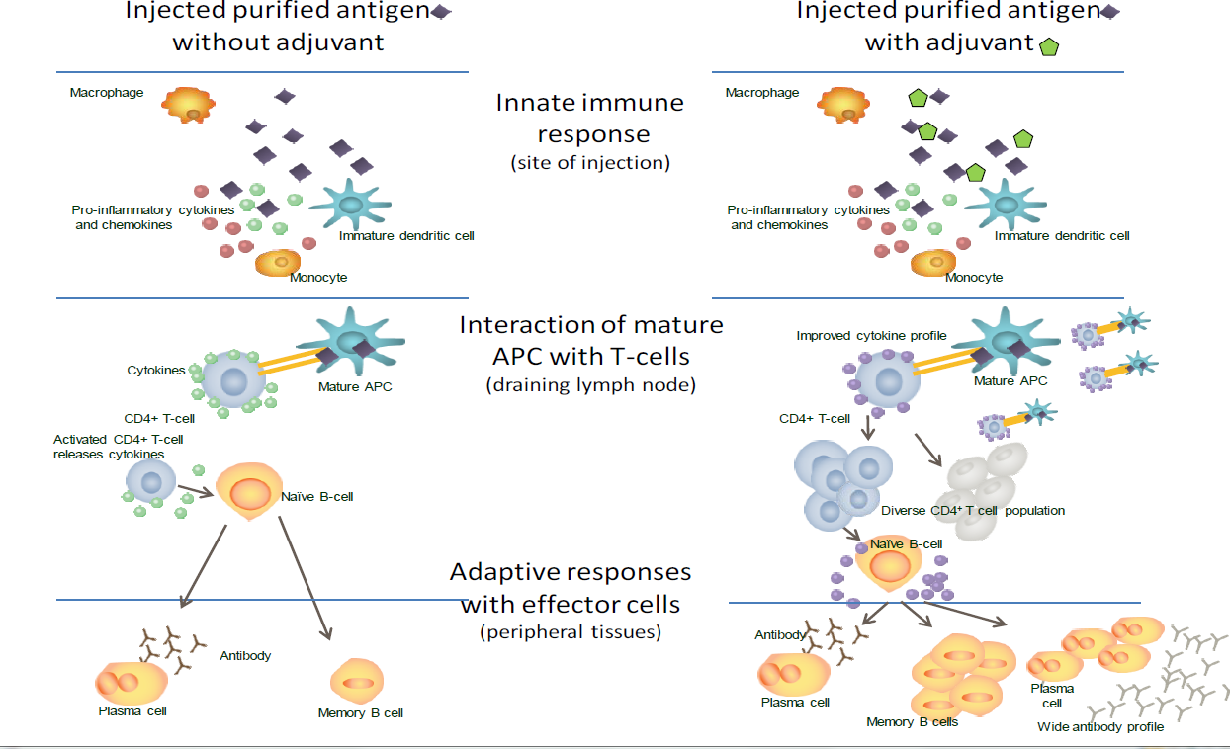
Figure 1. The immune response to vaccination with and without adjuvant (source: vaccine adjuvants from 1920 to 2015 and Beyond, Alberta Di Pasquale et al.,2015)

Adjuvants have been traditionally used to increase the magnitude of an adaptive response to a vaccine, based on antibody titer or ability to prevent infection, but a second role for adjuvant has become increasingly important: guiding the type of adaptive response to produce the most effective forms of immunity for each specific pathogen (Tornesello 2017). Thus, there are two distinct reasons to incorporatean adjuvant into a vaccine. Adjuvants are currently used clinically to:
(1) Increase the response to a vaccine in the general population, increasing mean antibody titers and/or the fraction of subjects that become protectively immunized;
(2) Increase seroconversion rates in populations with reduced responsiveness because of age (both infants and the elderly), disease, or therapeutic interventions, as in the use on the (Haensler 2013)to enhance the response of older subjects to influenza vaccine;
(3) facilitate the use of smaller doses of antigen, because the ability of an adjuvant to permit comparable responses with substantially lower amounts of antigen could be important in circumstances in which large-scale vaccination is urgent and production facilities limiting, as in the emergence of a pandemic influenza strain; and
(4) permit immunization with fewer doses of vaccine.
The requirement of many vaccines for multiple injections presents compliance issues and, in much of the world, significant logistic challenges.
Adjuvants can reduce the number of doses required to achieve protection.
Another reason for incorporating an adjuvant into a vaccine is to achieve qualitative alteration of the immune response. For vaccines currently under development, adjuvants are increasingly used to promote types of immunity not effectively generated by the non adjuvanted antigens. For example, adjuvants have been used in preclinical and clinical studies to(Montomoli, Piccirella et al. 2011):
(1) Provide functionally appropriate types of immune response (e.g., T helper 1 [Th1] cell versus Th2 cell, CD8+ versus CD4+ T cells, specific antibody isotypes);
(2) Increase the generation of memory-especially T cell memory (Carter and Reed 2010);
(3) Increase speed of initial response, which may be critical in a pandemic outbreak of infection; and (Subrahmanyam and Webb 2012).
(4) Alter the breadth, specificity, or affinity of the response (Smed-Sorensen and Lore 2013).

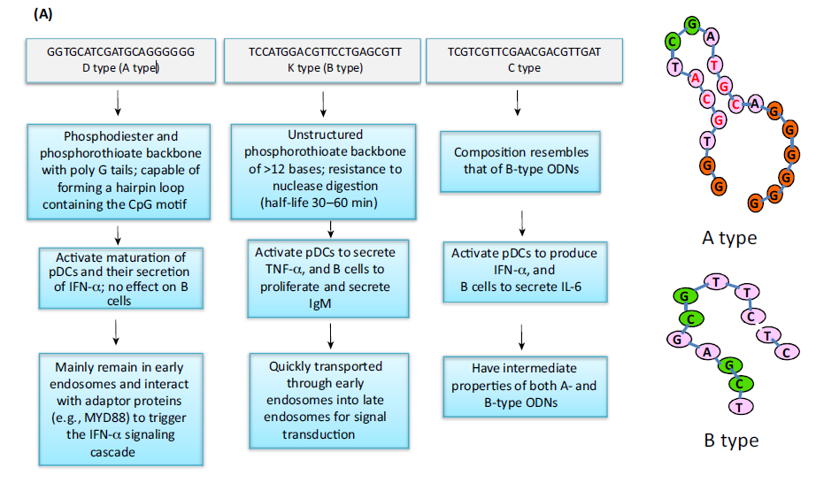

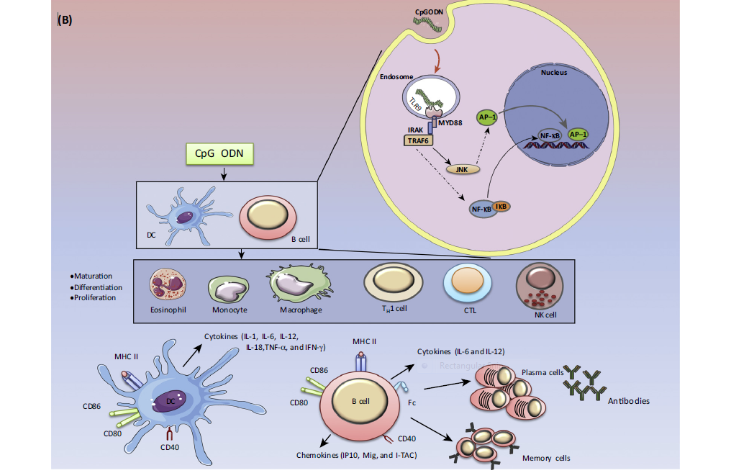
Figure 2. Structure and Mode of Action of CpG Oligodeoxynucleotides (CpG ODNs). (A) The three different types of CpG ODN (A, B, and C), their structures, and properties. (B) CpG ODNs modulate innate and adaptive immune responses in several ways. (A) The CpG ODN–TLR9 signaling pathway. TLR9 receptors are present on the endosomal membrane.

After internalization, CpG ODN activates elements of the MyD88/IRAK/TRAF6 pathway, leading to the simultaneously activation of two kinase pathways (MAPK/c-JUN and NF-kB) and the AP-1 and NF-kB promoter genes. (B) CpG ODN activates directly DCs and B cells acting as APCs. (Source: Trends in Pharmacological Sciences, September 2017, Vol. 38, No. 9 779).
Table 1. Summary of the Innate and Adaptive Components of the Immune System by Major Adjuvant (source: Robert L. Coffman etal. 2010). Cell press review: DOI 10.1016/j.immuni.2010.10.002.

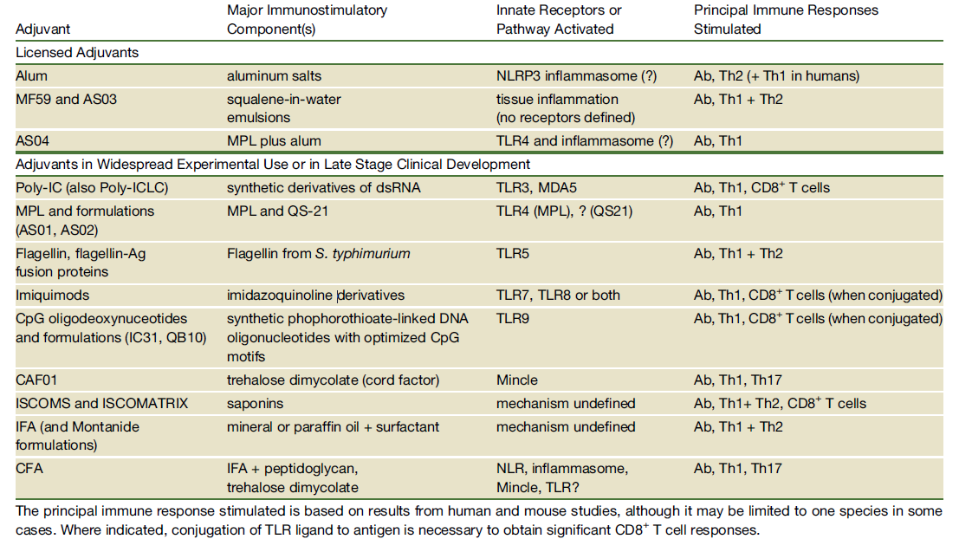

2.2 Types of adjuvants
Immunologic adjuvants can be classified by their sources, mechanisms of action, and physical or chemical properties. Table1 lists examples of the types of adjuvants under development and in testing for use with human vaccines(Portuondo, Ferreira et al. 2015).

2.2.1. Aluminium Salts (Alum)
In 1926, Glenny et al. reported the adjuvant activity of aluminium compounds utilizing a suspension of alum-precipitated diphtheria toxoid (DT) ( Gupta and Termini 2013). Aluminium salts are the most widely used adjuvants in human vaccines. These adjuvants have been used in practical vaccination for more than 80 years and are generally considered stimulators of Th2 immunity (Aachoui and Ghosh 2011). Until 2009 aluminium salt (referred to as“alum”) adjuvants were the only ones contained in vaccines licensed for human use in the United States. Alum is a component of licensed human vaccines such as Hepatitis A virus (HAV), Hepatitis B virus (HBV), human papilloma virus (HPV), diphtheria, tetanus, Haemophilus Influenzae Typeb (Hib) and meningococcal. Although there are a number of adjuvants more potent than alum, they have not been used for human vaccine formulations due to high levels of toxicity. Surprisingly, despite the wide use of alum adjuvants in licensed human vaccines, the mechanisms of action are not well characterized. The most well-known mechanism of action of alum is the “depot effect”, first proposed by Glenny in 1925, whereby depot formation was cited to facilitate continuous antigen release from the injection site(Gerdts 2015). Eventhough depot formation still remains somewhat controversial, recent studies have clearly demonstrated that depot formation is not required for alum adjuvanticity (Harandi 2009).

2.2.2 Oligonucleotides
Oligonuceotides (ODNs) are extensively studied as vaccine adjuvants. A major sub-class of ODNs is the unmethylated CpG ODNs resembling bacterial DNA structure. A series of review articles were recently published addressing CpGs as stand-alone or secondary immunotherapeutic agent (Portuondo, Ferreira et al. 2015), approaches for enhancement of immunostimulating effect of CpGs, microparticle mediated enhancement of immunostimulating effect of CpGs; dichotomous effects of CpG as an cancer vaccine adjuvant, use of various methods or lipids for improvement of CpG stability and delivery, and use of CpG -antigen conjugates for improvement of vaccine delivery and immunogenicity(Bastola, Noh et al. 2017). Non-CpG ODNs as TLR9 agonist include 5'-TC dinucleotide structure with a thymidine-rich sequence (Toussi 2014).

Table 2. licensed Adjuvants (source: Recent Advances of Vaccine Adjuvants for Infectious Diseases Sujin Lee and Minh Trang Nguyen 2015)
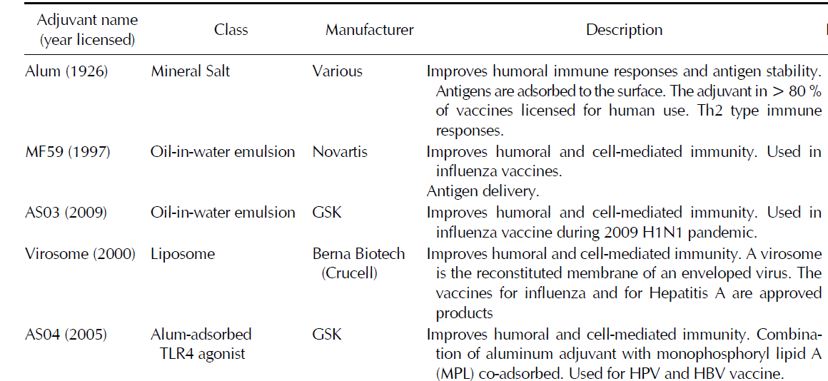

Immunomodulation of oligonuceotides (ODNs) is through activation of toll-like receptor 9 (TLR9). TLR9 is localized both intracellularly (endosomes of myeloid cells) and on the surface of epithelial cells (Subrahmanyam, P. and T. J. Webb 2012).
TLR9 agonists directly induce the activation and maturation of dendritic cells and enhance differentiation of B cells into antibody-secreting plasma cells. Since TLR9 signaling is not absolutely required in mice, other mechanisms of action could also be responsible for their immune enhancement, such as up-regulation of gene expression in mice, and formation of antigen- adjuvant complexes(Quirk, Brown et al. 2014). Combined use of vaccines and such immunostimulants is emerging as one of the innovative approaches in adjuvant development.
The CpG ODNs can be further classified into several categories (A-, B-, and C-class) based on their relative activity on B cell and NK cell activation and cytokine production. All classes can induce potent Th1 effects for a variety of antigens (Di Pasquale, Preiss et al. 2015). In reality, use of CpGs often generates a balanced and more effective immune response. For example, use of CpG 2007 (22-mer) not only enhanced antigen (hen egg lysozyme)-specific humoral responses, but also induced long-lasting cell mediated immune response against the model antigen (HEL) in calves after SC administration. Similar examples include CpG 1826 (20-mer) for OVA, CpG 7909 (a 24-mer, B-class) for HBsAg and for a pneumococcal vaccine (McElrath, M. J. (2017), three classes of CpGs for hepatitis C virus, and CpG ODN 2006 for inactivated gp120-depleted HIV-1 immunogen (Weldon, Zarnitsyn et al. 2012). A balanced effect can make a vaccine more effective against challenging disease such as tuberculosis. A balanced immunogenicity effect can be also obtained with a DNA vaccine administered with CpG-enriched plasmids (5-20 CpG copies).
CpG ODNs are quite effective in comparison with other adjuvants. They were demonstrated to be more effective than alum for Trypanosoma cruzi (parasite) antigens and rabies virus vaccine and even more effective than modified complete Freund's adjuvant (CFA with Mycobacterium butyricum instead of Mycobacterium tuberculosis)(Halliday, Turner et al. 2016). Because the effect of CpG is clearly dose-dependent in several studies, reducing the dose of CpG to 20 μg or less made it less effective than a higher amount of aluminum hydroxide in mice (Halliday, and Turner 2016).

2.2.3. Emulsions
Traditionally, two types of emulsions are used in pharmaceutical applications-water-in-oil (w/o) or oil-in- water (o/w). Both types have been tried as vaccine adjuvants. Complete Freund's adjuvant (CFA) is a historically-tested water-in-oil emulsion containing killed bacteria (D'Oro 2009).
It has been proven to be a very effective adjuvant and generate balanced immune response. The humoral immunogenicity enhancement of CFA is more effective than aluminum salts for a 42-amino acid amyloid- beta peptide antigen and for cystein proteinase antigen in mice (De Gregorio, D'Oro et al. 2009). However, severe toxicities have been observed even at a reduced dose, such as weight loss, leukocytosis, abdominal adhesions, granulomatous peritonitis, and disrupted hyalimized myofibers in mice(De Gregorio, D'Oro et al. 2009). Other animal toxicities include skin lesions in rats and arthritis in dogs. The toxicities of CFA led to the development of incomplete Freund’s adjuvant (IFA). With less toxicities, this adjuvant is less potent in mice. In addition, the water in oil emulsions were highly viscous and not stable. Further modified IFA systems (water-in-oil emulsions) were then developed, such as Montanide ISA 51, which contains mineral oil and mannide monooleate as a surfactant. This adjuvant is being tested clinically.
It appears to generate similar quality and intensity of immunogenicity to aluminum hydroxide but side reactions are not desirable, including granuloma, local pain, tenderness and erythema(Subrahmanyam and Webb 2012).
Montanide ISA 720 is another one (containing squalene, a metabolisable oil), which was shown to increase the humoral response to a malaria vaccine candidate in rhesus macaques and more potent than Alhydrogel A dose escalating phase 1 trial of a vaccine containing recombinant Plasmodium falciparum apical membrane antigen 1 (AMA1) formulated in Montanide ISA 720 did not show any vaccine- related serious adverse events (McElrath 2017).

2.2.4. Iscomatrix
The immune-stimulating complex (ISCOM) is an antigen- containing particulate system while ISCOMATRIX is the antigen-free, and structurally-similar system. It was first described more than 2 decades ago as a novel structure for antigenic presentation of membrane proteins with potent immunomodulatory capability. ISCOMATRIX system consists of a Quil A-based saponin mixture combined with cholesterol. This system enhances immunogenicity through several mechanisms, including recruitment and activation of APCs, extension of antigen presentation in the draining lymph node, enhancement of CD8 cross-presentation, induction of IFN-gamma and IL-6, etc (Honegr and Soukup 2015).
Association of antigen with ISCOMATRIX seems necessary for the optimal induction of cytotoxic T lymphocyte (CTL) responses. ISCOMATRIX as an adjuvant promotes both humoral and cellular immune responses due to the powerful immunomodulatory capability of saponin both preclinically and clinically. Subcutaneous injection of ISCOMATRIX®-adjuvanted 4 dengue virus envelope proteins (10 μg) resulted in adequate protection in both mouse and monkey challenge models(Mohan, Zhu et al. 2018). Such an immune enhancement effect of ISCOMATRIX (50 μg) on recombinant HIV gp120 vaccine can be significantly greater than that aluminum hydroxide.
Similarly, immunization of patients with a mixture of HPV16 E6E7 fusion protein and ISCOMATRIX adjuvant induced antigen specific cell mediated immunity in terms of antibody formation, delayed type hypersensitivity, in vitro cytokine release, and CD8 T cell responses(Piedrafita, Preston et al. 2013). To mitigate the potential safety issues related to ISCOMATRIX, Matrix M, the particles made of two selected and purified fractions of saponin, was developed and found to be effective to initiate strong immediate and long-term humoral immune response for influenza H5N1 vaccine with a balanced Th1/Th2 cytokine profile and high crossreactivity against drifted H5N1 viruses in mice (Subrahmanyam and Webb 2012).

2.3. The Benefits of adjuvants

The role of adjuvants explained by different scholars at different times. Decrease the dose of antigen needed (dose sparing), decrease the number of vaccine doses needed, enhance vaccine efficacy in infants, the elderly and immunocompromised people, increase functional antibody titer (Mohan, T., W. Zhu, et al.,2018).
The have also benefits regarding with, induce more rapid and long-lasting immune responses, induce robust cell-mediated immunity, provide broad protection (cross-reactivity), facilitate mucosal immunity, overcome antigen competition in combination vaccines (McElrath, M. J. 2017).
Vaccine adjuvants make vaccine more cost effective (fewer doses required), effective innate immune signals including danger signals, good immunomodulatory capacity and high specific antibody production). The also have the ablity antigen specific clonal expantion, generation of cytotoxic T cells, generation of long lasting adaptive immune response and can make antigen more potent.

Table 3: Schedule of Vaccination (Recommended National Veterinary Institute, Debre-Zeit, Ethiopia).
Type of vaccine | Species | Age | Dosage | Route | Immunity comments | Remark
List A
RP (Rinderpest)live | Bovine | ＞6month | 1ml | SC | Life long
FMD (Foot and mouth disease)live | Bovine | ＞4month | 4ml | SC | 6month | 1week of age for calves born of non-vaccinated dams
LSD (Lumpy skin disease) (live) | Bovine | _ | 1ml | SC | 1year
CBPP (live) | Bovine | _ | 1ml | SC | 1year | T144 may cause local reaction
PPR (Peste Des Petitis Ruminant)live | Ovine & Caprine | _ | 1ml | SC | 1year
Sheep and Goat Pox (live) | Ovine & Caprine | _ | 1ml | SC | 1year
AHS (African horse sickness)live | Equine | _ | 1ml | SC | 1year
NCD (Newcastle disease) | Avian |  |  | Nasal/ocular
Hitechner (live) | Chicken | 7-14days |  | Drinking water | Short prod. year | 1-7days for chicken do not maternal antibody
LASOTA (live) | Chicken | 21,45-60days |  | Drinking water | Short prod. year | booster

1/2-(Thermostabel) | Chicken | 21,45-60days |  | Drinking water/ocular | Short prod. year | booster
LASOTA (Inactivated) | Chicken | 18weeks |  | SC/IM | Short prod. year | booster
List B
Anthrax (live) | All | ＞3month | 1ml | SC | 1year | Pregnant animal ×
Bovine Pasteurellosis (killed) | Bovine | ＞3month | 2ml | SC | 1year
Ovine Pasteurellosis (killed) | Ovine | ＞3month | 1ml | SC | 1year
Blackleg (killed) | Bovine | ＞3month | 2ml | SC | 1year
CCPP (Contagious Caprine Pleuropneumonia) (Inactivated) | Caprine | ＞3month | 1ml | SC | 1year
Fowl Typhoid |  | At 6weeks | 0.2ml | SC | Pro.year | Booster at 12weeks
Diseases not in code
Fowl pox (live) |  | 3weeks | _ | Wing web | 1year | Booster 3 month later

2.4. Potential Safety Concerns around adjuvant Vaccines
Concerns about the safety of vaccination are not new, nor are these concerns specific to adjuvanted vaccines. Some of the concerns about adjuvanted vaccines are discussed in the following sections (Portuondo and Ferreira 2015).
Reactogenicity
By counteracting the poor immunogenicity of pure antigen in some vaccines, the addition of adjuvants may lead to an increase in local reactions such as pain, redness, swelling at the site of injection and sometimes general symptoms such as fatigue, malaise, myalgia and fever. Overall, the results of studies that have compared vaccines with and without adjuvant have shown a consistent trend toward increased reactogenicity, mainly at the injection site of the adjuvanted formulation (Honegr, Soukup et al. 2015). The most frequently reported symptom is pain at the injection site. Observed reactogenicity of adjuvanted formulations may be a consequence of the enhanced activation of the innate immune response induced by adjuvant at the site of injection, which is expressed as a local inflammatory response. As with other vaccines, the reactogenicity profile of any adjuvanted vaccine is specific to the antigen and the target population studied (Portuondo, Ferreira et al. 2015). Nevertheless, all licensed adjuvanted vaccines have shown a favorable benefit-risk ratio (Quirk and L. Brown 2014).
Immune-Mediated Diseases
Because adjuvants act directly as immune-stimulants there is a theoretical possibility that they may induce unwanted immune processes in the recipient that could trigger the onset of immune-mediated disease in susceptible individuals. Specific data collection methods including prolonged follow-up after vaccination have been devised to evaluate these adverse events of interest. Efforts are ongoing to identify any increased risk of immune-mediated disease after vaccination with adjuvanted vaccines (Harandi, Davies et al. 2009). The available evidence, which includes pooled analyses of clinical trial data and post-licensure epidemiological studies of varying design, has generally not shown an increased risk in immune-mediated diseases associated with adjuvanted vaccines (Quirk and L. Brown 2014).
An example of an immune-mediated disease that has repeatedly been potentially linked with vaccination is Guillain-Barré syndrome (GBS). The concern that immunizations might trigger GBS in susceptible individuals initially arose after a small increase in the incidence of GBS was observed after “swine flu” vaccines were used in the United States in 1976. Subsequent studies showed only a slight-to-no increase in risk after seasonal influenza vaccination during later seasons (Weldon, and Zarnitsyn 2012).
In 2009, mass vaccination with new adjuvanted pandemic H1N1 influenza vaccines started in Europe. The potential risk of GBS for these new vaccines was unknown, prompting studies in Europe and internationally to assess the risk of GBS after vaccination with adjuvanted pandemic vaccines. The results of these studies showed a non-statistically significant increase in GBS risk after vaccination, or an excess risk of one to three cases per million vaccinees, confirming the favorable benefit-risk profile of the vaccine (Piedrafita et al., 2013).
Another example of an immune-mediated disease potentially linked to vaccination occurred in 2010, when a number of cases of narcolepsy following vaccination with Pandemrix (H1N12009/AS03, Glaxo Smith Kline, Belgium) pandemic influenza vaccine were reported in some European Countries during the 2009 H1N1 influenza pandemic. Narcolepsy is a chronic neurological disorder caused by the brain’s inability to regulate sleep-wake cycles normally. It is a complex disease with a number of potentially contributing factors, including genetic and environmental factors, such as infections(Montomoli, Piccirella et al. 2011). The body of data accumulated suggests an increased risk of narcolepsy in individuals vaccinated with the vaccine versus the unvaccinated population. Further research is needed to better understand how other factors (genetic, environmental, circulating infections) associated with narcolepsy may have played a role. Other studies have been initiated to evaluate the biological plausibility by which vaccination may have triggered narcolepsy. In response, European Authorities, in collaboration with the vaccine manufacturer, promptly communicated the data gathered and regularly updated the vaccine label and the vaccine risk management plan. Authorities have also recognized that the benefit-risk profile of H1N12009/AS03 remains favorable, and have therefore recommended the maintenance of the marketing authorization (Christensen 2016).
Gulf War Syndrome. Gulf War Syndrome comprises an ill-defined and varying group of systemic symptoms that occurred in veterans of the 1991 Persian Gulf War. The cause is unknown but links have been suggested with post-traumatic stress or exposure to chemicals and/or biological weapons or vaccination against anthrax. An association was claimed between the presence of antibodies against squalene, an adjuvant used in the anthrax vaccine administered to soldiers, and the Gulf War Syndrome, based on the observation that antibodies to squalene were detected in the sera of most patients affected (Harris, Sharp et al. 2010). Further studies have subsequently shown that squalene was not present in vaccines administered to these soldiers. In addition, it is known that squalene is a component of the human body and low titers of anti-squalene antibodies are routinely found in healthy individuals. WHO Safety Committee in 2006 concluded that fears that squalene in vaccine could induce pathological anti-squalene antibodies are unfounded (Sayers et al.,2012).

Myofasciitis
In 1998, safety concerns about the use of aluminum in vaccines arose in France when deltoid muscle biopsies in patients with a constellation of symptoms including myalgia and fatigue, showed microscopic histological lesions called macrophagic myofasciitis (MMF). These lesions contained aluminum salts and where shown to persist for up to 10 years (Bastola, Noh et al. 2017). Because the MMF lesions occurred in the usual injection site in the deltoid, MMF was linked with the administration of aluminum-containing vaccines. At that time, the World Health Organization (WHO) and the French Medicine Agency, in consultation with experts, encouraged animal and epidemiological studies specifically designed to investigate the issue. Studies in animals, patients with MMF and healthy individuals suggest that MMF represents a “vaccination tattoo” (a marker of prior vaccination) and that aluminum and microscopic inflammation may persist at the injection site in the long-term. To date, there are no reliable scientific data showing that this “vaccination tattoo” causes symptoms or other consequences (Thompson and Staats 2011). Of note, the number of observed MMF cases is very small as compared to the millions of people who are vaccinated with aluminum-containing vaccines; information on the prevalence of MMF lesions in the healthy population are lacking; the symptoms reported by patients with MMF are non-specific and very common; and there is large variation in time elapsed between vaccination and symptom onset. A French study that reviewed the association between local MMF lesions and any generalized illness in the Cynomolgus monkey concluded that the persistence of aluminum-containing macrophages at the site of a previous vaccination was not associated with specific clinical symptoms or disease. In 2008 the WHO Global Advisory Committee on Vaccine Safety (GACVS) issued a statement concluding that: “From the most recent evidence available, there is no reason to conclude that a health risk exists as a result of administration of aluminium containing vaccines, nor is there any good reason for changing current vaccination practice (Gupta and Termini 2013).

Conclusion And Recommondations
Adjuvants have been used in vaccines for more than 90 years. Adjuvants were initially used in an empirical fashion to enhance the immune response to antigen, but became necessary components of many vaccines as purified antigens with lower immunogenicity were selected more and more frequently, as compared to live attenuated and whole-pathogen vaccine approaches. The ultimate goal of vaccination is to generate potent and long-term protection against diseases. Such protective immunity can be elicited by using vaccine formulations containing appropriate antigens and adjuvants.
Adjuvants are important components of vaccines and can affect the outcomes of vaccination. Past approaches of vaccine formulation with adjuvants were focused on single-type adjuvants such as alum or emulsions.
As great progress has been made in the field of adjuvant research over last two decades, vaccinologists are now able to select an appropriate adjuvant from classical adjuvants, immunostimulants or combinations thereof to enhance vaccine efficacy.
Protein subunit or inactivated vaccines are usually less immunogenic than traditional vaccines. Therefore, to improve their immunogenicity, co-administration with an adjuvant is required. Adjuvants act via activation of the innate immune system and provide key signals that modulate the adaptive immune response. These results in the priming of antigen-specific Th cells that exhibit signature cytokine profiles (Th1, Th2, and Th17) associated with protection. Based on this review the following recommendations are forwarded:-
- Even if there are many reviews conducted about adjuvants and their role in developed countries, developing countries should conduct farther research to know the role of adjutants.
- During vaccine development and vaccination the role of adjuvants should taken into consideration.
- Vaccination failure should be studied with consideration of adjuvants
- Care should be taken when working with adjutants because of their reactogenecity property
Corresponding author (Gizachew Gelaw Ayalew, email, hagizee12@gmail.com, phone,+251 0918815150, post 1541189.

References
  - Aachoui, Y. and S. K. Ghosh (2011). "Immune enhancement by novel vaccine adjuvants in autoimmune-prone NZB/W F1 mice: relative efficacy and safety." BMC Immunol 12(61): 1471-2172.
  - Bastola, R., G. Noh, (2017). "Vaccine adjuvants: smart components to boost the immune system." Arch Pharm Res 40(11): 1238-1248.
  - Bonam, S. R., C. D. Partidos, (2017). "An Overview of Novel Adjuvants Designed for Improving Vaccine Efficacy." Trends Pharmacol Sci 38(9): 771-793.
  - Carter, D. and S. G. Reed (2010). "Role of adjuvants in modeling the immune response." Curr Opin HIV AIDS 5(5): 409-413.
  - Chauhan, N., S. Tiwari (2017). "An overview of adjuvants utilized in prophylactic vaccine formulation as immunomodulators." Expert Rev Vaccines 16(5): 491-502.
  - Christensen, D. (2016). "Vaccine adjuvants: Why and how." Hum Vaccin Immunother 12(10): 2709-2711.
  - Circelli, L., M. Tornesello (2017). "Use of adjuvants for immunotherapy." Hum Vaccin Immunother 13(8): 1774-1777.
  - De Gregorio, E., U. D'Oro (2009). "Immunology of TLR-independent vaccine adjuvants." Curr Opin Immunol 21(3): 339-345.
  - Del Giudice, G., K. J. Stittelaar (2009). "Seasonal influenza vaccine provides priming for A/H1N1 immunization." Sci Transl Med 1(12): 3000564.
  - Di Pasquale, A., S. Preiss (2015). "Vaccine Adjuvants: from 1920 to 2015 and Beyond." Vaccines 3(2): 320-343.
  - Didierlaurent, A. M., B. Laupeze (2017). "Adjuvant system AS01: helping to overcome the challenges of modern vaccines." Expert Rev Vaccines 16(1): 55-63.
  - Dong, J. C. and G. P. Kobinger (2013). "Hypothesis driven development of new adjuvants: short peptides as immunomodulators." Hum Vaccin Immunother 9(4): 808-811.
  - Gerdts, V. (2015). "Adjuvants for veterinary vaccines--types and modes of action." Berl Munch Tierarztl Wochenschr 128(11-12): 456-463.
  - Gupta, S., J. M. Termini (2013). "Design of vaccine adjuvants incorporating TNF superfamily ligands and TNF superfamily molecular mimics." Immunol Res 57(1-3): 303-310.
  - Haensler, J. (2013). "[Introduction to novel vaccine adjuvants and their role in influenza vaccination]." Ann Pharm Fr 71(2): 104-108.
  - Halliday, A., J. D. Turner (2016). "The TLR2/6 ligand PAM2CSK4 is a Th2 polarizing adjuvant in Leishmania major and Brugia malayi murine vaccine models." Parasit Vectors 9(96): 016-1381.
  - Harandi, A. M., G. Davies (2009). "Vaccine adjuvants: scientific challenges and strategic initiatives." Expert Rev Vaccines 8(3): 293-298.
  - Harris, J., F. A. Sharp (2010). "The role of inflammasomes in the immunostimulatory effects of particulate vaccine adjuvants." Eur J Immunol 40(3): 634-638.
  - Honegr, J., O. Soukup (2015). "Structural Properties of Potential Synthetic Vaccine Adjuvants - TLR Agonists." Curr Med Chem 22(29): 3306-3325.
  - Huang, X., A. Karabudak (2017). "A novel immunization approach for dengue infection based on conserved T cell epitopes formulated in calcium phosphate nanoparticles." Hum Vaccin Immunother 13(11): 2612-2625.
  - Hui, G. S. and C. N. Hashimoto (2008). "Adjuvant formulations possess differing efficacy in the potentiation of antibody and cell mediated responses to a human malaria vaccine under selective immune genes knockout environment." Int Immunopharmacol 8(7): 1012-1022.
  - Hwang, C. S., P. T. Bremer (2018). "Enhancing Efficacy and Stability of an Antiheroin Vaccine: Examination of Antinociception, Opioid Binding Profile, and Lethality." Mol Pharm 15(3): 1062-1072.
  - Israeli, E., N. Agmon-Levin (2009). "Adjuvants and autoimmunity." Lupus 18(13): 1217-1225.
  - Knudsen, N. P., A. Olsen (2016). "Different human vaccine adjuvants promote distinct antigen-independent immunological signatures tailored to different pathogens." Sci Rep 6(19570).
  - Lee, S. and M. T. Nguyen (2015). "Recent advances of vaccine adjuvants for infectious diseases." Immune Netw 15(2): 51-57.
  - Levast, B., S. Awate (2014). "Vaccine Potentiation by Combination Adjuvants." Vaccines 2(2): 297-322.
  - McElrath, M. J. (2017). "Adjuvants: tailoring humoral immune responses." Curr Opin HIV AIDS 12(3): 278-284.
  - Mohan, T., W. Zhu (2018). "Applications of chemokines as adjuvants for vaccine immunotherapy." Immunobiology 223(6-7): 477-485.
  - Montomoli, E., S. Piccirella (2011). "Current adjuvants and new perspectives in vaccine formulation." Expert Rev Vaccines 10(7): 1053-1061.
  - Piedrafita, D., S. Preston (2013). "The effect of different adjuvants on immune parameters and protection following vaccination of sheep with a larval-specific antigen of the gastrointestinal nematode, Haemonchus contortus." PLoS One 8(10).
  - Portuondo, D. L., L. S. Ferreira (2015). "Adjuvants and delivery systems for antifungal vaccines: current state and future developments." Med Mycol 53(1): 69-89.
  - Quirk, E. K., E. L. Brown (2014). "Safety Profile of the Merck Human Immunodeficiency Virus-1 Clade B gag DNA Plasmid Vaccine With and Without Adjuvants." Open Forum Infect Dis 1(1).
  - Roberts, A., E. W. Lamirande (2010). "Immunogenicity and protective efficacy in mice and hamsters of a beta-propiolactone inactivated whole virus SARS-CoV vaccine." Viral Immunol 23(5): 509-519.
  - Sato, K. and S. Itamura (2010). "[Trends and perspectives in development of influenza vaccines]." Nihon Rinsho 68(9): 1697-1701.
  - Sayers, S., G. Ulysse (2012). "Vaxjo: a web-based vaccine adjuvant database and its application for analysis of vaccine adjuvants and their uses in vaccine development." J Biomed Biotechnol 831486(10): 13.
  - Smed-Sorensen, A. and K. Lore (2013). "Targeting dendritic cells for improved HIV-1 vaccines." Adv Exp Med Biol 762: 263-288.
  - Subrahmanyam, P. and T. J. Webb (2012). "Boosting the Immune Response: The Use of iNKT cell ligands as vaccine adjuvants." Front Biol 7(5): 436-444.
  - Thompson, A. L. and H. F. Staats (2011). "Cytokines: the future of intranasal vaccine adjuvants." Clin Dev Immunol 289597(10): 31.
  - Toussi, D. N. and P. Massari (2014). "Immune Adjuvant Effect of Molecularly-defined Toll-Like Receptor Ligands." Vaccines 2(2): 323-353.
  - Vajdy, M. (2011). "Immunomodulatory properties of vitamins, flavonoids and plant oils and their potential as vaccine adjuvants and delivery systems." Expert Opin Biol Ther 11(11): 1501-1513.
  - Vinay, T. N., Y. J. Kim (2013). "Inactivated vaccine against viral hemorrhagic septicemia (VHS) emulsified with squalene and aluminum hydroxide adjuvant provides long term protection in olive flounder (Paralichthys olivaceus)." Vaccine 31(41): 4603-4610.
  - Weldon, W. C., V. G. Zarnitsyn, (2012). "Effect of adjuvants on responses to skin immunization by microneedles coated with influenza subunit vaccine." PLoS One 7(7): 25.
  - Zhou, W. J., Y. J. He. (2011). "[Advancement of peptide vaccines for hematologic malignancies]." Zhongguo Shi Yan Xue Ye Xue Za Zhi 19(6): 1512-1517.

1/12/2019

