Rutting performance of Polyethylene, Lime and Elvaloy modified Asphalt Mixes

Kamran Muzaffar Khan ¹, Hanifullah ², Mujaddad Afzal ³, Faizan Ali ⁴, Afaq Ahmed ⁵, Tahir Sultan⁶

^{1*} Associate Professor, Department of Civil Engineering, UET Taxila, Pakistan. kamran.muzaffar@uettaxila.edu.pk
² Lecturer, Department of Civil Engineering, UET Taxila, Pakistan. hanif_civilengr@yahoo.com
^{3, 4} Research Associate, Department of Civil Engineering, UET Taxila, Pakistan. faceuet@hotmail.com
⁵ Lecturer, Department of Civil Engineering, UET Taxila, Pakistan. afaq.ahmad@uettaxila.edu.pk
⁶ Lecturer, Department of Civil Engineering, BZU Multan, Pakistan. chtahir786@hotmail.com

Abstract: A key element in the performance of asphalt is its resistance to rutting. Many modifiers can be used to improve the properties of asphalt and to enhance its rut resistance. This research is aimed to evaluate the effectiveness of Polyethylene modified, Lime modified and Elvaloy modified asphalt mixes in improving the performance of asphaltic concrete regarding rutting resistance and to compare it with the performance of conventional NHA (National Highway Authority Pakistan) Class-A mix. In this study the compacted asphalt mixes were tested for resistance to rutting by subjecting all the specimens to 10,000 repetitions of a loaded wheel and the rut depth for each specimen was determined using wheel tracking machine. Polyethylene modified mixes showed better resistance to rutting than all the other mixes and the conventional NHA class-A mix showed the poorest performance. The order of performance is polyethylene modified mix performed best, then lime modified mix, then elvaloy modified mix and then conventional (unmodified) NHA class-A mix. Results indicated that better quality asphalt concrete mixes regarding rut resistance can be prepared using lime modified mixes, polyethylene modified mixes and using polymer modified bitumen (PMB) in the HMA instead of unmodified bitumen.
[Kamran M. K, Haniffulah, Mujaddad A., Faizan A., Afaq A., Tahir S. Rutting performance of Polyethylene modified, Lime modified and Elvaloy modified Asphalt Mixes. Researcher 2018;10(11):46-54]. ISSN 1553-9865 (print); ISSN 2163-8950 (online). http://www.sciencepub.net/researcher. 8. doi:10.7537/marsrsj101118.08.

Keywords: Hot Mix Asphalt (HMA), Rutting, Low Density Polyethylene (LDPE), hydrated lime, PMB, Wheel tracker.

1. Introduction
Asphalt is a dark brown to black mixture of mineral aggregate and bitumen, in which bitumen used to cement mineral aggregates, obtained from natural lakes or from petroleum processing. Owing to viscoelastic nature of asphalt, it depends on both rate of loading and temperature. In high temperature or under persistent load asphalt shows viscous behavior and tend to flow and in low temperature or under rapid-applied load asphalt exhibits elastic behavior just like solids. (SP-1, 2003) [1].
In Pakistan temperature is high upto 60 C and trucks are over loaded that their EASLs Value is upto 22 times to standard EASLs value. Therefore phenomena of flowing in asphalt as viscous fluid is quite often, leads flexible pavement towards rutting, to cope up this problem mix design must be improved (mujaddad, 2011) [10]. According to Sinan Hınıslıog˘lu and Emine Ag˘ar Waste polymer modifier (nitrile rubber and polyethylene in 1:4 ratios) 8% by weight of bitumen exhibits improvement in mechanical properties of mix as compared to conventional mix design [2]. A variety of plastic wastes contain High Density polymers (Polyethylene) which can be used in asphalt concrete and it provide improved pavement to resist rutting because of its elevated stability and more Marshall Percentage. It also contributes to recycle plastic wastes and protect environment [3].
Moatasim, Cheng and Al-Hadidy AI has worked on high density polyethylene modifier and evaluate it in laboratory and found 5% of HDPE by weight of asphalt blend in 80/100 improve the performance of asphalt concrete mixtures [4]. Two years back AL-Hadidy with Qui Tan Yi also worked on low density polyethylene modified stone mastic asphalt pavement and done rheological tests and other homogeneity tests and conclude that SMA exhibits higher softening point with in minimum ductility range. Results also indicate that modified SMA satisfy the rain zone, high and low temperature performance requirement [5].
Huang, Oliver and Roger did the study to use of recycled solid waste materials in asphalt pavements and conclude that plastics, tires, waste glass and steel slag can be used as secondary materials in place of quarry aggregates in flexible pavement [6]. Hinisliog and Agar worked on the optimum percentage, mixing time and mixing temperature of the waste HDPE regarding mechanical properties of asphalt. They found that the binders showed the best mechanical properties when they were modified with 4% HDPE by using 30 minutes mixing time at 165 ˚C mixing temperature [7].
Muhammad T. Awwad and Lina Shbeeb in 2007 used polyethylene as an additive to improve properties of asphalt concrete mixtures and to determine the type and proportion of polyethylene which is the most suitable for use in asphalt mixes. They used two types of polyethylene i. e. HDPE and LDPE to coat the aggregates in various proportions in grinded and un-grinded form. The polyethylene was heated with coarse aggregates for all the specimens up to the temperature of 190 ˚C. The optimum modifier content which satisfied the criteria of having maximum Marshall Stability, maximum bulk density, minimum air-voids, and maximum VMA is 12 % by weight of bitumen, polyethylene modified asphalt mixtures reduce permanent deformation, raise fatigue resistance and give better bond between the bitumen and the aggregates”[8].
Yetkin Yildirim also put his efforts in polymer modified mix and design specifications for Elvaloy, rubber, SBS and SBR and try to correlate elastic recovery of polymer modified mix of laboratory to field [9].
Here we do comparison of conventional mix Polyethylene modified, Lime modified and Elvaloy modified asphalt mixes in improving the performance of asphaltic concrete regarding rutting resistance.
1.2. Rutting arises in Pakistan and use of modifiers in asphalt pavement
Rutting is rising pavement failure problem in Pakistan to cope up this problem the performance of polyethylene modified and lime modified HMA is evaluated and compare the performance of these asphalt mixes with unmodified and polymer modified binder of the same penetration grade. Therefore propose the rut resisting asphalt mixture suitable for local climate and loading conditions. To accomplish these objectives, lab tests were conducted on various asphalt mixture at two test temperatures using wheel tracking machine.
2. Literature Review
2.1. Elvaloy
Elvaloy is “an ethylene glycidyl acrylate (EGA) terpolymer that chemically reacts with asphalt”. As a result of the reaction, problems with separation during storage and transportation are avoided. Roads using Elvaloy have been in use since1991.
Witczak et al, (1995) investigated the behavior of Elvaloy modified asphalt concrete mixes. They used two asphalt binders of different grades and each of them was modified with 0%, 1.5% and 2%, Elvaloy by weight of asphalt binder. They concluded that the moisture sensitivity of the asphalt mixes decreases significantly by the addition of Elvaloy. They also found that when Elvaloy is used along with granite, the fracture temperature is increased significantly (less chances of fracture) than with diabase, limestone or granite aggregate treated with hydrated lime. [11]
Babcock et al. devised a lap shear test and compare it with DSR measurements for high temperature binder properties which relate well at high temperature. The results tell that above 6 °C binder failure tends to be cohesive failure, due to the loss of bond within asphalt. in contrast, at 6°C and colder, failure is adhesive, from a loss of adhesion between the binder and the aggregate. Since this shows that cold temperature failure of a pavement may be the result of loss of adhesion to the aggregate, a chemically reactive polymer is possible to perform better, and reactive elastomeric terpolymer does in fact do better in this test instead of SBS or the control/virgin bitumen. [12]
2.2. Lime
Hydrated lime, when used in asphalt concrete pavements, improves the rutting, cracking, stripping and aging behavior of asphalt. It can be used alone in the asphalt and can also be used with other additives to improve the asphalt performance and thus cause a considerable increase in the pavement’s service life with relatively less increase in the initial cost. The previous studies on lime modified asphalts revealed that the hydrated lime content, for optimum performance, to be added to the asphalt ranges from 10 to 20 percent by weight of the asphalt binder or 1 to 2 percent by weight of the total asphalt concrete mixture. Field studies also showed that lime modified asphalt concrete pavements have increased life span than the untreated pavements. LCCA for lime-treated pavements have shown that lime is also cost-effective.
Celaleddin E. Sengul et al. reduced filler and introduce hydrated lime in 2%, 4% and 6%, and test specimens by repeated creep test and compare hydrated lime specimen with various polimar mixes by marshal quotient and found that increase in percentage from 2% to 6% in lime increase deformation resistance. [13].
Mechanistic empirical modeling further demonstrates lime’s benefits for asphalt. Dynamic modulus testing of seventeen different mixtures on six different project sites across the United States showed that the addition of hydrated lime increases the dynamic modulus of the HMA mix between 17 and 50 percent.
A number of highway agencies have verified the usefulness of lime with cold in-place recycled (CIR) mixtures. Lime treatment of CIR mix increase their initial strength which permits the early opening of the facility to traffic and Improves resistance to moisture damage which considerably increases the functional performance of pavement.
2.3. Polyethylene
Polyethylene is a thermoplastic polymer and the most commonly used plastic in the world. It is obtained by the polymerization of ethane. It is primarily used in plastic bags and geo-membranes etc. It is a semi-crystalline material consists of long chains of repeated small molecules produced by combination of the ingredient monomer ethylene. It has a wide range of properties including good chemical, fatigue and wear resistance. In a molecule of polyethylene, there are repeated units of two carbon atoms and two hydrogen atoms are attached to each carbon atom. It is commonly known as polythene, although this name is not recognized scientifically. The ingredients of polyethylene are carbon and hydrogen. In the ethylene molecule (C₂H₄) two CH₂ groups are connected by a double bond.

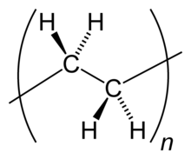
Fig. 1: The repeating unit of polyethylene

2.3.1. Use of Polyethylene in Asphalt
Hung Yeh et al., in their research, aimed to evaluate the properties of hot mix asphalt modified with various amounts of polyethylene. Using Dynamic Shear Rheometer, asphalt binder was characterized at intermediate and high temperatures. The tests conducted at temperature from 30˚C to 90 ˚C and the corresponding values of phase angle (δ), complex modulus (G*), storage modulus (G') and loss modulus (G") were obtained. The contribution of polyethylene modified asphalt binder to rutting was estimated by selecting the stiffness modulus G*/ Sinδ. Higher is the value of G*/ Sinδ, higher is the resistance of the binder to rutting. The binders were tested at various frequencies at a temperature of 30 ˚C and the effect of change in frequency on G*/ Sinδ was observed. The value of G*/ Sinδ was increased with increase in frequency and polymer concentration but decreased with increase in temperature. The value of G*/ Sinδ for asphalt blend with 3 % LDPE was higher than other 3% polymer modified binders i.e. HDPE and MPE. No significant change was observed between the asphalt blend with 5% LDPE and 5% HDPE at all frequencies. They concluded that LDPE in asphalt binder performs similar to HDPE regarding rut resistance up to the amount of 5% in frequency studies. The binder modified with LDPE behaved like a stiffer binder at high frequencies and is resistant to cracking at low temperature. The outcomes of their research can be summarized as [18]
"The addition of polyethylene to asphalt in various percentages improves the rutting properties of asphalt at high temperature and various frequencies, but it does not improve significantly the elastic resilience".
Serkan Tapkın (2009) studied the effect of polypropylene fibers on asphalt performance and observed a noticeable increase in marshall stability and decrease in flow values for the fiber-reinforced mixes [19].
Muhammad T. Awwad and Lina Shbeeb (2007) used polyethylene as an additive to improve properties of asphalt concrete mixtures and to determine the type and proportion of polyethylene which is the most suitable for use in asphalt mixes [8]. They used two types of polyethylene i. e. HDPE and LDPE to coat the aggregates in various proportions in grinded and un-grinded form. The polyethylene was heated with coarse aggregates for all the specimens up to the temperature of 190 ˚C which is enough to melt the polyethylene to such a level that it sticks to the surface of the aggregates. They concluded that
1- Bulk density increases with increase in modifier content and at certain amount of modifier it reaches the peak i. e., the highest bulk density is achieved. It started to decline significantly afterwards except LDPE. The HDPE modified mix gave the highest bulk density of 2.28 gm/cm³ when the amount of HDPE was 12% while the maximum bulk density of 2.27 gm/cm³ was attained by LDPE (in grinded state) modified mixture when the LDPE content was 16%.
2- The asphalt mixture modified with HDPE gave maximum stability of 2347 kg when its amount in the mix was 12% and it was added in grinded form. The stability of mixture modified with LDPE in grinded state increased with increase in polyethylene content and it was maximum at 18% modifier content and may further increase with increase in LDPE content.
3- " The flow of modified asphalt concrete mixtures were higher than unmodified mixes with few exceptions at 8% LDPE modification". The flow of HDPE modified mixes was higher than that of the other mixes. A continuous increase in flow was reported by the mixture modified with LDPE in grinded state.
4- The proportion of air voids of HMA first decreased with increase in modifier content until it reached the minimum and then started increasing with increase in modifier content.“Generally, the air voids proportion of modified mixes was higher than the unmodified mixes.”
5- The optimum modifier content which satisfied the criteria of having maximum Marshall Stability, maximum bulk density, minimum air-voids, and maximum VMA content was determined.
X Lu, Isaccson and J. Ekbald (1997) prepared asphalt by modifying the bitumen binder with various amounts of recycled polyethylene and pyrolytic oil residue derived from used tyres. They found that the optimum amount of these additives for improved performance at high and low temperatures was 10% pyrolytic oil and 1% polyethylene. [12]
Hinislioglu and Agar (2004) worked on the optimum percentage, mixing time and mixing temperature of the waste HDPE regarding mechanical properties of asphalt. They found that the binders showed the best mechanical properties when they were modified with 4% HDPE at a mixing temperature of 165 ˚C and mixing time of 30 minutes [ 7].
3. Experimental Material
3.1. Aggregates
Aggregates used in this study were obtained from a quarry in Margallah. The aggregates were supplied as a mixture of various sizes of particles which were then sieved in the laboratory to the desired sizes and then mixed according to the trial gradation. The trial blend was selected as the mid of the NHA class-A master band.
Table 1: Aggregate Gradation according to NHA Class-A
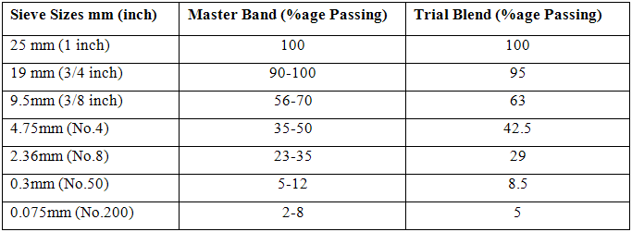

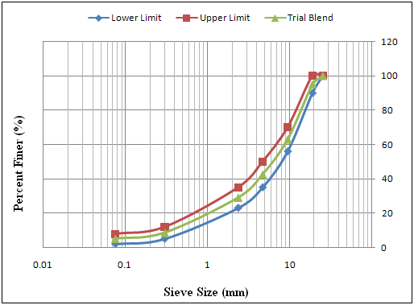
Fig 2: Gradation Curve for NHA class-A gradation

3.2 Asphalt Binders

Table 2: Properties of Unmodified 60/70 grade bitumen
Parameter Measured | Value | Standard (ASTM) | Max/Min
Ductility (cm) at 25 °C | 100 | D1134 | Min
Flash point (°C) | 232 | D92 | Min
Penetration (1/10 mm) at 25 °C | 60-70 | D5 | --
Loss on Heating (%) at 163 °C | 0.8 | D6 | Max
Penetration after loss on heating (1/10 mm) at 25 °C | 54 | D5 | Min
Ductility (cm) at 25 °C after loss on heating | 50 | D113 | Min

Table 3: Properties of PMB (Elvaloy 0.8%)
Parameter Measured | Value | Max/Min
Softening Point (°C) | 60 | Min
Flash point (°C) | 250 | Min
Consistency at 60 °C (Pa) | 1500 | Min
Loss on Heating (%) | 0.6 | Max
Viscosity at 165 °C (Pa) | 0.75 | Min
Stiffness at 25 °C (KPa) | 130 | Max

Two asphalt binders, one unmodified of 60/70 penetration grade and the other polymer modified, were used in this research. The binder content used for all the mixes was 4.3%. The unmodified asphalt binder and PMB (polymer modified bitumen) modified with 0.8% Elvaloy was supplied by the Attock Oil Refinery, Rawalpindi. The PMB modified with 0.8% Elvaloy is an example of AOR products developed specifically for the loading and prevailing environmental conditions of Pakistan. This is a polymer-based binder designed to produce a flexible, workable binder which results in a rut and fatigue crack resistant mix of HMA when used in road construction. The properties of both the binders are given in the table 3.2 and 3.3 as copied from the website of Attock Refinery.
3.3. Low Density Polyethylene (LDPE)
Low Density Polyethylene was used as an additive to modify the properties of asphalt mixtures. Low Density Polyethylene (LDPE) was used in the proportion 19% by weight of bitumen. To determine the optimum polyethylene content for Polyethylene modified samples, the Marshall samples (4" dia.) were tested in the UTM-5P. The values of the resulting accumulated strains showed that Accumulated Strain for 19% LDPE modified samples has the lowest value. In other words 19% LDPE modified samples indicates highest resistance to Rutting. Table 4 and Figure 3 show a relationship between accumulated strain and %age of polythene used in the samples.

Table 4: Relationship between Accumulated Strain and Amount of Polythene
Amount of Polythene (%) | Accumulated Strain (%)
5 | 1.4600
10 | 1.2804
15 | 1.1638
20 | 1.1271
25 | 1.2020

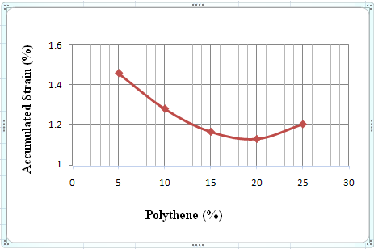
Fig 3: Relation between Accumulated strain and Amount of Polythene

3.4 Hydrated Lime
Hydrated lime was used in the amount of 1% by weight of total sample as recommended by National Lime Association. It was introduced to the mix at the time of mixing before heating with bitumen for sample preparation.
4. Methodology
4.1 Sample Preparation
Preparation of samples involve sieve analysis to separate the aggregates into frictions, mixing these fractions according to the required gradation and heating the mix along with the asphalt binder to the compaction temperature. Sieve analysis was performed manually as shown in Figure 2 according to NHA Class-A gradation. The gradation and quantity of each aggregate fraction is shown in Table 5.

Table 5: NHA Class-A Gradation
Sieve Sizes mm (inch) | Trial Blend (%age Passing) | Trial Blend  (% retained) | Wt. used for each sample (gm)
25 mm (1 inch) | 100 | 0 | 0
19 mm (3/4 inch) | 95 | 5 | 598
9.5mm (3/8 inch) | 63 | 37 | 3828
4.75mm (No.4) | 42.5 | 57.5 | 2452.5
2.36mm (No.8) | 29 | 71 | 1615
0.3mm (No.50) | 8.5 | 91.5 | 2452.5
0.075mm (No.200) | 5 | 95 | 418.5
Pan | 0 | 100 | 598

Test specimens were prepared in the laboratory using Roller Compactor. The compaction of specimens by the roller compactor was done in four stages. In the first stage, the specimen was compacted under a pressure of 2 bar (200kPa) with 10 cycles of passes. In the second stage, the specimen was further compacted under a pressure of 5 bar (500kPa) with 10 cycles of passes. In the 3rd stage, the specimen was further compacted under 4 bar pressure (400kPa) with 5 cycles of passes and in the 4th and final stage; the specimen was compacted under a pressure of 3 bar (300kPa) with 5 cycles of passes. Size of the specimen used was 305mm X 305mm X 50mm. Temperature of mix during compaction was 150⁰C.
Four types of mixes were prepared and total number of samples prepared was 16. The details are given in the table 6.

Table 6: Details of Mixes and Samples Prepared
Type of Mix | No. of Samples Prepared
Conventional (Unmodified) NHA Class-A | 4
Lime Modified | 4
Polyethylene modified | 4
Mix using PMB (modified with 0.8% elvaloy) | 4

4.2. Wheel Tracking Test
Wheel-tracking test was used to evaluate the rutting resistance of all the mixtures. All the asphalt concrete samples were subjected to 10,000 passes of a loaded wheel at the rate of 26.5 revolutions per minute i.e. 53 passes per minute. For each mix type, out of four samples, two samples were tested at a temperature of 30 °C and the remaining two were tested at 60 °C.

Table 7: Test temperatures and number of Specimens Tested
Type of Mix. | Test Temperature (°C) | No. of Specimens Tested
Conventional (Unmodified) NHA Class-A | 30 | 2
 | 60 | 2
Lime Modified | 30 | 2
 | 60 | 2
Mix Using PMB | 30 | 2
 | 60 | 2
Polythene Modified | 30 | 2
 | 60 | 2

4.3. Binder Extraction Test
The binder extraction test was performed on the LDPE modified mixtures using the centrifuge extractor and chlorinated solvent (carbon tetrachloride). For the extraction purpose the compacted asphalt concrete specimen was unmolded.
As the asphalt mixture was very hard and was not workable, thus it was placed in an oven. When it became hot enough to have sufficient workability, one kilogram of material was separated from it with the help of a trowel and was placed in the bowl of the extractor for the test.
Then the solvent (carbon tetrachloride) was poured onto the extraction bowl until the sample was entirely covered with it. The filter paper was placed on the bowl, the bowl was topped and the screw on the funnel clamp was tightened. Then the bowl containing the sample and solvent was placed in the machine and the lock nut was tightened.
A container was placed under the drain to catch the liquid extracting from the sample and the machine was started. When the flow of solvent to the container was stopped, the centrifuge was stopped. The top and the filter paper were removed from the extraction bowl and all the clinging particles were brushed back into the bowl. The aggregates in the extraction bowl were transferred to a pan and the presence and state of LDPE was examined.
5. Results And Discussion
All the samples were tested in the wheel tracker. The rut depth (mm) was measured with respect to the number of passes. The comparison showed that the rutting occurred in the samples of modified mixes at different temperatures (30 and 60⁰C) is less than that of the conventional mix 60/70 penetration grade. The difference in rutting of the lime modified and polyethylene modified bitumen was almost same at lower temperature of 30° C but it became more pronounced at higher temperatures as shown in the figures 4.5 and 4.6. The results are shown in below Tables and Graphs.
The binder extraction test was, later on, performed for the polyethylene modified asphalt mixtures. The extraction test revealed that the polyethylene was not properly distributed throughout the mixture and thus the mixture was not homogeneous. The polyethylene was hardened and was not fully melted because the maximum test temperature during the test was 150˚C and polyethylene requires the temperature more than 150˚C for complete melting (up to 190 ˚C). The improved rutting resistance of the polyethylene modified asphalt concrete mixtures was probably due to the rough surface cover that the polyethylene made around the aggregates. The polyethylene was also spread in the mixture making rougher surface texture which played a role in the improvement of rutting resistance of asphalt concrete mixes.

Type of Mixture | Maximum Rut Depth (mm) after 10,000 wheel passes
 | 30° C | 60° C
Conventional (Unmodified) NHA Class-A | 2.765 | 6.09
Lime Modified | 1.7 | 4.295
Mix Using PMB | 1.95 | 3.54
Polythene Modified | 1.68 | 2.95

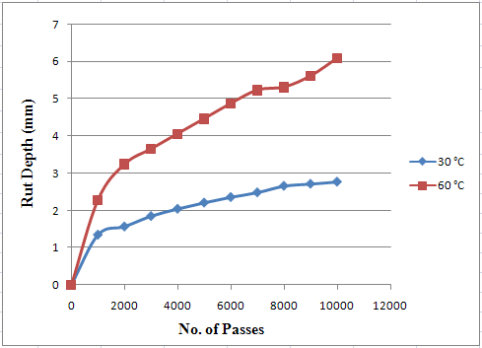
Fig 4: Wheel Tracking Test results for conventional HMA

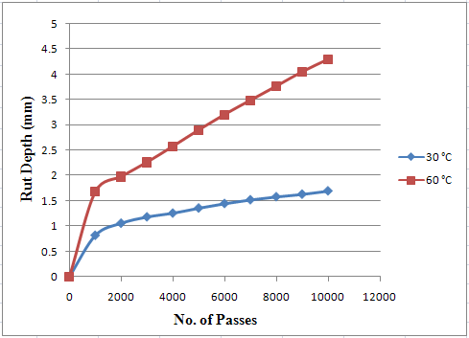
Fig 5: Wheel Tracking Test results for Lime modified HMA

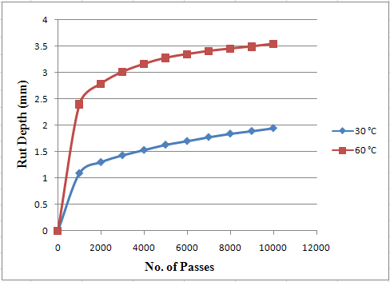
Fig 6: Wheel Tracking Test results for HMA using PMB
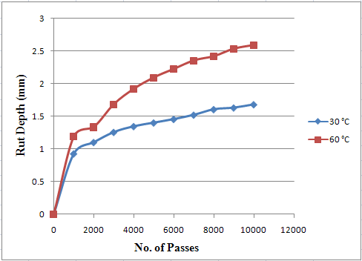
Fig 7: Wheel Tracking Test results for Polythene modified HMA

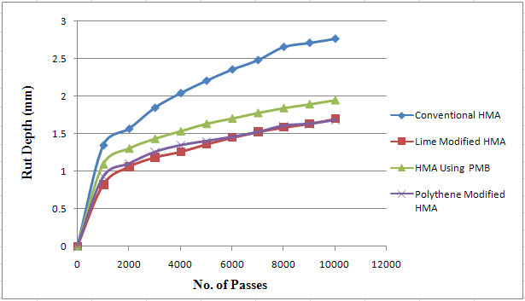
Fig 8: Comparison of Rut Depth for Various mixes (30 °C)

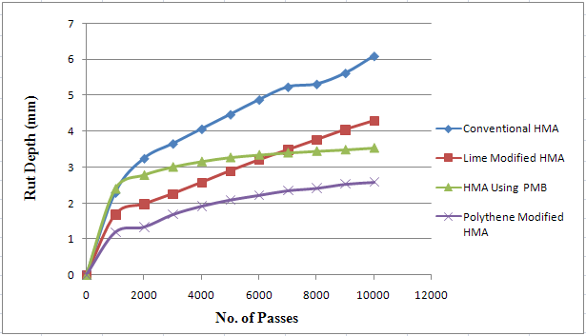
Fig 9: Comparison of Rut Depth for Various mixes (60 °C)

6. Conclusions
In this research the effectiveness of Polythene modified, lime modified and elvaloy modified asphalt mixes was evaluated regarding rutting resistance and to compare it with the performance of conventional NHA (National Highway Authority Pakistan) Class-A mix. The specimens were tested at 30 °C and 60 °C.
Major findings and conclusions of this study include the following:
- Rut depth increased with the increase in load repetitions and temperature for all mixes during Wheel Tracking Test.
- At 30 °C, Polythene and lime modified mixes showed better resistance to rutting than the mix using PMB and Conventional (Unmodified) mix. The mix prepared with PMB showed better performance than Conventional mix.
- At 60 °C Polythene modified mixes showed better resistance to rutting than all the other mixes and the conventional NHA class-A mix showed the poorest performance. The order of performance is polythene modified mix performed best, then lime modified mix, then elvaloy modified mix and then conventional (unmodified) NHA class-A mix.
- Better quality asphalt concrete mixes regarding rut resistance can be prepared using lime modified mixes, polythene modified mixes and using polymer modified bitumen (PMB) in the HMA instead of unmodified bitumen.

7. Recommendations
- The effect of modification on moisture susceptibility of asphalt mixes was not studied in this research. So, it is recommended that research should be conducted on this aspect.
- The effect of other modifiers such as Crumb Rubber, fiber Glass etc. should be evaluated to enhance the HMA properties according to local load climatic conditions.
- Field performance of modified asphalts should be studied.
Wheel tracking test can be referred as simple performance test for the comparison of rutting resistance of various asphalt mixes.

Corresponding Author:
Dr. Kamran Muzaffar khan
Engr. Mujaddad Afzal
Department of Civil and Environment Engineering
UET Taxila, Pakistan
E-mail: kamran.muzaffar@uettaxila.edu.pk
E-mail: mujaddadafzal@gmail.com

References
- “Superpave series No.1(SP-1)”, third edition. Revised 2003.
- Sangita, Tabrez Alam Khan, Sabina, D.K. Sharma.”Effect of waste polymer modifier on the properties of bituminous concrete mixes’. Construction and Building Materials 25 (2011) 3841–3848.
- Sinan Hınıslıog˘lu, Emine Ag˘ar, “Use of waste high density polyethylene as bitumen modifier in asphalt concrete mix”, Materials Letters 58 (2004) 267– 271.
- Moatasim Attaelmanan, Cheng Pei Feng, Al-Hadidy AI, “Laboratory evaluation of HMA with high density polyethylene as a modifier’, Construction and Building Materials 25 (2011) 2764–2770.
- Hadidy Al, Qui Tan Yi. 2009. “Effect of Polyethylene on life of flexible pavements” Construction and Building Materials vol. 23 pp. 1456- 14.
- Yue Huang, Roger N. Bird, Oliver Heidrich. “A review of the use of recycled solid waste materials in asphalt pavements”, Resources, Conservation and Recycling 52 (2007) 58–73.
- Sinan Hınıslıog˘lua,*, Emine Ag˘ar, “Use of waste high density polyethylene as bitumen modifier in asphalt concrete mix”. Materials Letters 58 (2004) 267– 271.
- Awwad M. T. and Lina Shbeeb.“The use of High density polyethylene in Hot Asphalt Mixtures” American Journal of Applied Sciences, (2007) 4 (6): 390-396.
- Y. Yildirim, Polymer modified asphalt binders, Construction and Building Materials 21 (2007) 66–72.
- Sensitivity Analysis of Design Variables in the AASHTO 1993 Design Guide Flexible Pavement Design Equation. Unpublished gradation work by Mujaddad Afzal.
- Witczak MW, Hafez I, Qi X. “Laboratory characterization of Elvaloy® modified asphalt” mixtures: vol. I – Technical report. College Park, Maryland: University of Maryland. 1995.
- Babcock GB, Statz RJ, Larson DS. “Study of asphalt binders using lap shear bonds”. Wilmington, DE: DuPonte website. No date. Available from: http://www.dupont.com/asphalt/lapshear/lapshear.html
- Celaleddin E. Sengul, Atakan Aksoy, Erol Iskender, Halit Ozen, “Hydrated lime treatment of asphalt concrete to increase permanent”.
- Kamal M. A. “Resilient behavior of asphalt concrete under repeated loading & effects of temperature” Journal of the Eastern Asia Society for Transportation Studies, (2005), Vol. 6, pp. 1329 – 1343.
- Goodrich J. L.”Asphalt and Polymer Modified Asphalt Properties Related to the Performance of Asphalt Concrete Mixes”, (1988), Proc. AAPT. Vol 57.
- Mohamed, El Hussein H., and Yue, Z., "Criteria for Evaluation of Rutting Potential Based on Repetitive Uniaxial Compression Test", Transportation Research Record1454, TRB, National Research Council, Washington, DC, (1994), pp. 74-8 1.
- "Permanent Deformation Response of Asphalt Aggregate Mixes", 1994, SHRP-A-415, Strategic Highway Research Program, National Research Council, Washington DC.
- “Evaluation of Modified Asphalt using Chlorinated and Maleated Waste Polymers”, 2002, William H. Daly, loan I. Negulescu, Pei-Hung Yeh, Louay N. Mohammad, LTRC Research Project No. LTRC Project N0. 345 State Project NO. 736-99,0212.
- Prediction of Marshall Test results for polypropylene modified dense bituminous mixtures using neural networks. Serkan Tapkin, Abdulkadir Çevik, Ün Usar, Expert Syst. Appl 01/2010; 37:4660-4670.

11/18/2018

