Relationship between the dimensions of culture and the dimensions of technology acceptance in Iranian Central Oil Field Company (ICOFC)

Farshad hajalian ¹, Hossein saneii ²

- Department of management, Firoozkooh Branch, Islamic Azad University, firoozkooh, Iran
- Department of management, Firoozkooh Branch, Islamic Azad University, firoozkooh, Iran
f_hajalian@yahoo.com, h_saneii@yahoo.com,

Abstract: The use of new technologies is one of the ways that underdeveloped countries use to reduce their gap with developed countries. This goal is achieved when different factors influencing the can be achieved with identification and control of various factors affecting the acceptance and use of technology. The main objective of this study was to investigate the relationship between the dimensions of culture and technology acceptance for Implemention of appropriate organizational culture to increase the technology acceptance in Iranian Central Oil Field Company of iran. The research is a cross-survey by target application. The research population is 950 people. Using a random sampling of a number of questionnaires were distributed among employees and 212 valid questionnaires were collected. Participants answered two questionnaire. The first questionnaire, assesses the Hofstede culture in six dimensions: power distance, uncertainty avoidance, masculinity, feminity, individualism and collectivism and the second questionnaire assesses four dimensions of davis technology acceptance model involves the perception of usefulness, attitude towards, perception of ease of use and using. The data from the questionnaires were analyzed by using structural equation modeling using software (LISREL v.8.8). Results of structural equation modeling showed that if uncertainty avoidance, masculinity and individualism are high in the members of a society, they won’t resist accepting and using technology. In other words, if the members of research population have high anxiety towards unknown future circumstances, they will look for ways to reduce this anxiety.
[Farshad hajalian, Hossein saneii. Relationship between the dimensions of culture and the dimensions of technology acceptance in Iranian Central Oil Field Company (ICOFC). Researcher 2018;10(11):36-45]. ISSN 1553-9865 (print); ISSN 2163-8950 (online). http://www.sciencepub.net/researcher. 7. doi:10.7537/marsrsj101118.07.

Key words: Acceptance Model (TAM), Hofstede culture

- Introduction
Today, new technologies are rapidly growing or being formed in developing countries. This increases the gap between these countries and developing countries. Purchasing, importing and using these technologies in developing countries are one of the approaches by which these countries maintain or decrease these gaps. However, despite the enormous costs of this approach, it is not always useful, confronts these countries with great challenges or is completely neglected after a slight usage and lack of proper utilization. Managers are well aware of the fact that technologies enter the market one after another and some are finally neglected with the arrival of alternative technologies. What have to inevitably occur to create competitive advantage and profitability is deployment of these technologies in the organization.
Several factors affect the method and the rate of deployment and usage of technology in the organization including national culture variables, social variables and organizational variables.
Culture in any organization can be divided into two parts: national culture and organizational culture. National culture related to the majority and all individuals of the society is constant at time and can survive for a long period of time and be passed from one generation to another. National culture affects organizational culture.
Culture is one of the most important barriers in accepting technology. If different cultural factors receive enough attention, efforts for transferring new technologies will be successful (Ebrahimi, 2010). National culture strongly affects technology acceptance and this effect may be inhibitor or stimulator (Hadizadeh, 2008).
This study examines the relationship between cultural factors on the adoption of technology.
Models of culture, Hofstede's cultural model is selected And the Technology Acceptance Model, Technology Acceptance Model Davis has been selected.
- Theoretical fundamentation
  - Culture
In Hofstede’s opinion, culture is a series of intellectual programs distinguishing members of a group from those of another one.
Geert Hofstede (Dutch) has conducted one of the most important studies on identifying the characteristics of national culture. His has concluded that four dimensions distinguishing cultures in different communities are as follows: (Hofstede,2000)
- Power distance: it is the extent to which the less powerful members of organizations and institutions expect and accept that power is distributed unequally.
- Uncertainty avoidance: it is a measure of anxiety in the members of a society or an organization towards unknown future circumstances.
- Individualism/ collectivism: it is a measure of the relationship between individuals and groups in a society.
- Masculinity/ Femininity: it is a measure based on which values ​​such as performance, success and competition between individuals of a culture overcome the values ​​such as quality of life, maintenance of good personal relationship, service and.... Masculinity and femininity are not considered equal to being male or female, but are known as relative terms. (Hofstede, 1997)
  - Technology
Technology has various definitions with different terms but common meanings, and can be the result of both new ideas (transferred innovation) as well as indigenous technologies. In both cases, it is a tool for serving the economic, social and cultural needs of the society (Adams, 1992).
Whatever technology is, it should be accepted and used by users. Acceptance is the decision to employ a new idea such as information technology as the best action. Acceptance occurs when the person accepts and uses a new idea. (chen, 2002). Figure 1 shows the main and underlying concept of all technology acceptance models by the user.

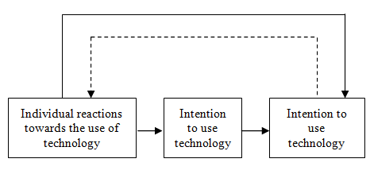
Fig. 1: Underlying factors in technology acceptance models by the user (Venkatesh, 2003)

Fred Davis introduced one of the most important technology acceptance models. Davis et al. introduced technology acceptance model based on the theory of reasoned action (TRA) and found that this model can better explain information technology acceptance by the user. Technology acceptance model is used in different researches for accepting various technologies - such as email, word processor, Web, enterprise resource planning (ERP) and e-commerce systems - by the user (Lu, Y. & Zhou, T. & Wang,2009).
The main purpose of technology acceptance model is to provide a basis for identifying the effects of external factors on internal beliefs, attitudes and intention to use (Davis, FD, 1989,985). This model has a descriptive approach in addition to its predictive aspect. Thus, managers can identify why a particular system may not be accepted and follow suitable corrective actions (Hu, 1999). Figure 2 shows technology acceptance model.

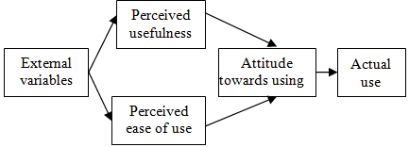

Fig. 2- technology acceptance model

Technology acceptance model is the result of psychological studies and has been used in the studies of information technologies (IT) systems.
- Actual use: Individual’s behavior towards new technology.
- Perceived ease of use (PEOU): The extent to which an individual believes that using the technology would be free of physical or mental effort.
Subjective perception of ease of use is the subjective probability formed in users towards the ease of use of various information technologies available at work to perform tasks; so that the less effort the method of above-mentioned technologies’ usage need to be learned, the more they are used (Klopping & Mckinney,2004).
- Perceived Usefulness (PU): The extent to which an individual believes that using the technology would enhance his job performance (Siegel, 2008).
Subjective perception of usefulness is the subjective probability formed in users towards the usefulness of various information technologies available at work to perform tasks; so that the more these technologies improve their organizational performance, the more they are useful and are used (Klopping & Mckinney,2004).
-External variables: External variables include any factor such as organizational factors, social factors, characteristics of computer systems such as type of hardware and software, teaching method and help of others in the use of computer systems affecting people’s subjective perceptions towards usefulness and ease of use of information technology (Davis, F.D., 1989).

3. Materials AND Methods
  - Research Methodology
The present study in terms of objectives, applications, and data collected as descriptive - survey and its analysis is based on the covariance matrix modeling by using agvyaby structural equation (SEM). The population of this research, is including employees of Iranian Central Oil Field Company working in staff units in 1390 and being among the users of Barid Samaneh Novin system (E-org). Barid Samaneh Novin system (E-org) is an office automation software doing internal and external communications of the organization quickly and without paper. which has a total staff of 950 people. Some of them were selected by simple random sampling and received questionnaires. Finally 212 valid questionnaires were collected and analyzed.
Hofstede cultural questionnaire and Davis's technology acceptance model (TAM) questionnaire were combined to form a unit questionnaire. Reliability and validity of the two questionnaires have been separately calculated and reported in previous researches and both of them have been acceptable. However, given the fact that the two questionnaires have been translated from original language into Persian and have been combined in the form of a unit questionnaire, their reliability and validity were evaluated again. Reliability was assessed using Cronbach's alpha and the results in Table 1.

Table1- Reliability of each questionnaire
validity | questionnaire
0.842 | Cultural questionnaire
0.913 | Davis's technology acceptance model (TAM) questionnaire

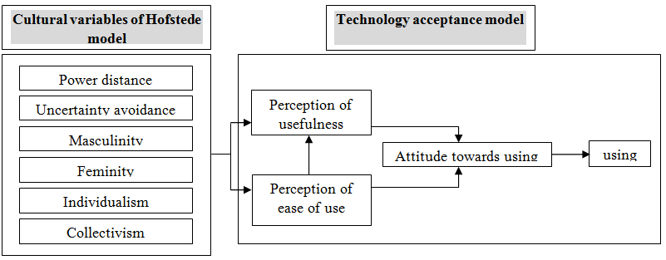
Fig.3-Conceptual model of the research

In order to analyze the data, structural equation is measured by using Software analysis of moment structures (AMOS v20) and the Statistical Package for Social Sciences (SPSS v.19).
  - Hypotheses
Based on existing literature and theory, hypotheses were tested in this study include:
H1: Power distance is associated with the perception of the technology usefulness.
H2: Power distance is associated with the perception of the technology ease of use.
H3: Uncertainty avoidance is associated with the perception of the technology usefulness.
H4: Uncertainty avoidance is associated with the perception of the technology ease of use.
H5: MasHculinity is associated with the perception of the technology usefulness.
H6: Masculinity is associated with the perception of the technology ease of use.
H7: Femininity is associated with the perception of the technology usefulness.
H8: Femininity is associated with the perception of the technology ease of use.
H9: Individualism is associated with the perception of the technology usefulness.
H10: Individualism is associated with the perception of the technology ease of use.
H11: Collectivism is associated with the perception of the technology usefulness.
H12: Collectivism is associated with the perception of the technology ease of use.
H13: Perception of ease of use is associated with the perception of the technology usefulness.
H14: Perception of ease of use is associated with attitude towards using technology.
H15: Perception of usefulness is associated with attitude towards using technology.
H16: Attitude towards using is associated with using technology.
4. The model Solving and interpreting its results:
Measurement models of cultural dimensions and technology acceptance variable are shown in modes of standardized estimation and significance coefficients in Figures 4 and 5 and Figures 6 and 7, respectively.

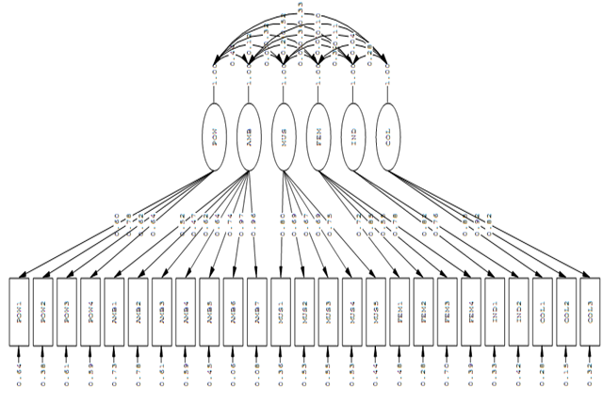
Fig 4- Measurement model of cultural dimensions in standardized estimation mode

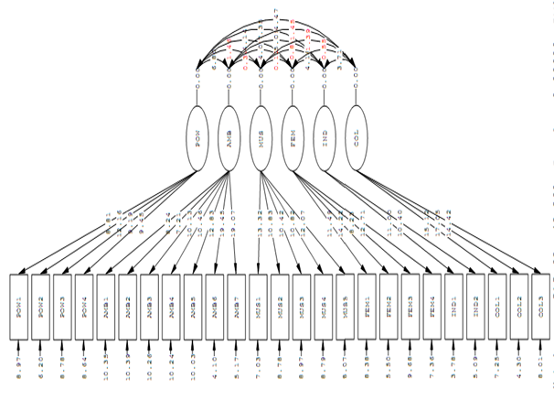
Fig5- Measurement model of cultural dimensions in significance coefficients mode

Estimation results (model), the measurement model fit indices are indicated. Chi square values were calculated according to the output end, the degree of freedom is less than the number 3. ARMSE amount equal to 0.067. Indices of GFI, AGFI and NFI, respectively, 0.84, 0.90 and 0.95.is the fit is relatively high. These numbers are indicative of relatively high fitness. Table 2 summarizes the results for a range of operating loads for variable culture are shown.

Table2- Indicator loading and dimensions of culture
Variable | Index | Average | Load Factor Model
Power distance | POW1 | 2.6923 | 0.60
 | POW2 | 2.9502 | 0.78
 | POW3 | 2.8190 | 0.62
 | POW4 | 3.1538 | 0.64
Uncertainty avoidance | AMB1 | 2.9050 | 0.52
 | AMB2 | 2.7421 | 0.47
 | AMB3 | 2.8326 | 0.62
 | AMB4 | 3.1403 | 0.64
 | AMB5 | 2.9729 | 0.74
 | AMB6 | 2.9729 | 0.97
 | AMB7 | 3.0136 | 0.96
Masculinity | MUS1 | 2.5204 | 0.80
 | MUS2 | 3.0271 | 0.69
 | MUS3 | 2.7557 | 0.67
 | MUS4 | 2.9005 | 0.69
 | MUS5 | 2.3801 | 0.75
Feminity | FEM1 | 3.2172 | 0.72
 | FEM2 | 2.8597 | 0.85
 | FEM3 | 3.5882 | 0.55
 | FEM4 | 3.0045 | 0.78
Individualism | IND1 | 3.2896 | 0.82
 | IND2 | 3.2670 | 0.76
Collectivism | COL1 | 3.2262 | 0.85
 | COL2 | 3.2081 | 0.92
 | COL3 | 3.1765 | 0.82

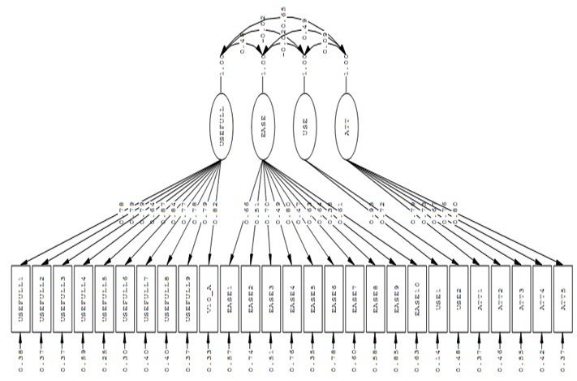
Fig6- Measurement model of technology acceptance variables in standardized estimation mode
Fig7- Measurement model of technology acceptance variables in significance coefficients mode

Estimation results (model), the measurement model fit indices are indicated. Chi square values were calculated according to the output end, the degree of freedom is less than the number 3. ARMSE amount equal to 0.083. Indices of GFI, AGFI and NFI, respectively, 0.90, 0.83 and 0.94. is the fit is relatively high. These numbers are indicative of relatively high fitness. Table 3 summarizes the results for a range of operating loads for variable technology are shown.

Table3- Indicator loading and dimensions of technology
Variable | Index | Average | Load Factor Model
Perception of usefulness | POW1 | 2.6923 | 0.78
 | POW2 | 2.9502 | 0.79
 | POW3 | 2.8190 | 0.79
 | POW4 | 3.1538 | 0.64
 | AMB1 | 2.9050 | 0.87
 | AMB2 | 2.7421 | 0.84
 | AMB3 | 2.8326 | 0.77
 | AMB4 | 3.1403 | 0.78
 | AMB5 | 2.9729 | 0.79
 | AMB6 | 2.9729 | 0.82
Perception of ease of use | AMB7 | 3.0136 | 0.66
 | MUS1 | 2.5204 | 0.51
 | MUS2 | 3.0271 | 0.70
 | MUS3 | 2.7557 | 0.49
 | MUS4 | 2.9005 | 0.80
 | MUS5 | 2.3801 | 0.47
 | FEM1 | 3.2172 | 0.63
 | FEM2 | 2.8597 | 0.64
 | FEM3 | 3.5882 | 0.38
 | FEM4 | 3.0045 | 0.61
using | IND1 | 3.2896 | 0.98
 | IND2 | 3.2670 | 0.72
Attitude towards using | COL1 | 3.2262 | 0.79
 | COL2 | 3.2081 | 0.73
 | COL3 | 3.1765 | 0.67
 | POW1 | 2.6923 | 0.76
 | POW2 | 2.9502 | 0.80
Estimation results (model fitness) in the measurement model of cultural dimensions and technology acceptance are presented in table 4.

Table4- Model fitness of cultural dimensions and technology acceptance
variable | Questions’ factor loading | $${x^{2}}/{df}$$ | ARMSE | GFI | AGFI | NFI
Cultural Dimensions | 0.47-0.97 | 1.98 | 0.067 | 0.84 | 0.90 | 95
Technology acceptance | 0.47-0.87 | 2.51 | 0.083 | 0.83 | 0.90 | 0.94

In this study structural equation modeling and especially path analysis are used to confirm or refute assumptions. Model fitness evaluation indices and fitted model shape are reported. Figures 8 and 9 show the structural model in modes of standardized estimation and significance coefficients. In other words, they show the effect of independent variables (cultural dimensions) on dependent variables (technology acceptance) of the study.

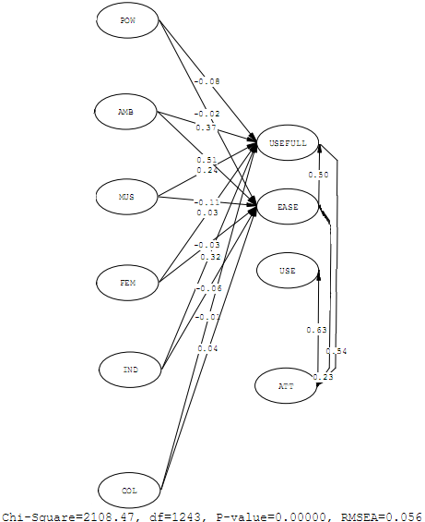
Fig8- Structural model in standardized estimation mode

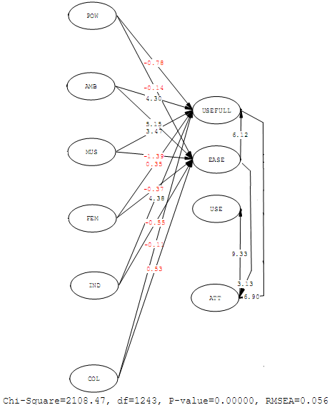
Fig9- Structural model in significance coefficients mode

Research hypotheses testing based on the structural equation modeling is shown in table 5.

Table5- Research hypotheses testing
variable | $${x^{2}}/{df}$$ | ARMSE | GFI | AGFI | NFI
Cultural Dimensions & Technology acceptance | 1.69 | 0.056 | 0.93 | 0.90 | 0.94

5. Conclusion and recommendations
The above-mentioned results indicate that among the four dimensions of Hofstede model only uncertainty avoidance, masculinity and individualism dimensions affect technology acceptance model of Davis, so that masculinity and individualism are significantly correlated with the perception of technology usefulness, and uncertainty avoidance is significantly correlated with the perceived ease of use of technology.
Significant relationship between national culture characteristics and technology acceptance model of Davis indicates that if national culture have higher levels of masculinity, individualism and uncertainty avoidance, technology will be more accepted and used in the organization.
According to the obtained results, the final research model is as presented in Figure 10.
Considering the presented model and discussions, we conclude that if uncertainty avoidance, masculinity and individualism are high in the members of a society, they won’t resist accepting and using technology. In other words, if the members of research population have high anxiety towards unknown future circumstances, they will look for ways to reduce this anxiety.

Table 6- Summary of research hypotheses test results (Source: research findings)
Effect | Significance | confirmation or refutation | Hypotheses
-0.08 | -0.78 | refutation | 1- Power distance on the perception of usefulness
-0.02 | -0.14 | refutation | 2- Power distance on the perception of ease of use
0.37 | 4.30 | confirmation | 3- Uncertainty avoidance on the perception of usefulness
0.51 | 5.51 | confirmation | 4- Uncertainty avoidance on the perception of ease of use
0.24 | 3.47 | confirmation | 5- Masculinity on the perception of usefulness
-0.11 | -1.39 | refutation | 6- Masculinity on the perception of ease of use
0.03 | 0.35 | refutation | 7- Femininity on the perception of usefulness
-0.03 | -0.37 | refutation | 8- Femininity on the perception of ease of use
0.32 | 4.38 | confirmation | 9- Individualism on the perception of usefulness
-0.06 | -0.55 | refutation | 10- Individualism on the perception of ease of use
-0.01 | -0.11 | refutation | 11- Collectivism on the perception of usefulness
0.04 | 0.53 | refutation | 12- Collectivism on the perception of ease of use
0.50 | 6.12 | confirmation | 13- Perception of ease of use on the perception of usefulness
0.23 | 3.13 | confirmation | 14- Perception of ease of use on the attitude towards using
0.54 | 6.90 | confirmation | 15- Perception of usefulness on the attitude towards using
0.63 | 9.33 | confirmation | 16- Attitude towards using on usage

Technology acceptance model

0.37
0.50
0.63
Perception of usefulness
Perception of ease of use

Attitude towards using

using

0.23
0.54
Cultural variables of Hofstede model
Uncertainty avoidance
Masculinity
Individualism
0.51
0.32
0.24

Fig 10- Final research model

References
- Ebrahimi Nazli & Sharan Kaur Garib Singh & Sigari Tabrizi Reza, Cultural Effect on Using New Technologies, World Academy of Science, Engineering and Technology, 2010,1030.
- Hadizadeh Moghadam Akram & Assar Parisa, The Relationship Between National Culture and E-Adoption: A Case Study of Iran, American Journal of Applied Sciences, 2008, 369-377.
- Hofstede, G. (2000). The information age across cultures. Proceedings of 5th AIM conference – Information Systems and Organizational Change. CD-Rom, 10.
- Hofstede, G. (1997). Cultures and organizations: software of the mind. London: Mc Graw Hill.
- Adams, D. A., & Nelson, R. R. (1992). Perceived usefulness, ease of use, and usage of Information Technology: a replication. MIS Quarterly, 16 (2).
- Chen, L., Gillenson, M.L., & Sherrell, D.L. (2002). Enticing online consumers: An extended technology acceptance perspective. Information & Management, 39, 705-719.
- Venkatesh, V., Morris, M.G., Davis, G.B., & Davis, F.D. (2003). User acceptance of information technology: Toward a unifie.
- Lu, Y. & Zhou, T. & Wang, B. (2009) Exploring Chinese Users’ Acceptance of Instant Messaging Using the Theory of Planned Behavior, the Technology Acceptance Model, and the Flow Theory, Computers in Human Behavior, Vol. 25, pp. 29-39.
- Davis, F.D., Bagozzi, R.P., & Warshaw, P.R. (1989). User acceptance of computer technology: a comparison of two theoretical models. Management Science, 35(8), 982-1003.
- Hu, P.J., Chau, Y.K., Sheng, L.R., & Tam, K.Y. (1999). Examining the technology acceptance model using physician acceptance of telemedicine technology. Journal of Management Information Systems, 16( 2), 91-112.
- Klopping, I. M., & Mckinney, E (2004). Extending the technology acceptance model and the task-technology fit model to consumer e-commerce. Information Technology, Learning, and Performance Journal, 22(1), 35-48.
- Siegel, D.M. (2008) Accepting Technology and Overcoming Resistance to Change Using the Motivation and Acceptance Model, Dssertation Submitted in Partial Fulfillment of the Requirements for the Degree of Doctor of Philosophy in the Department of Educational Research, Technology, and Leadership in the College of Education at the University of Central Florida Orlando.
- Davis, F.D.B., & Warshaw, P. R. (1989). User acceptance of computer technology: a comparison of two theoretical models. Management Science, 35 (8).

11/18/2018

