**Development of Superpave Performance Grading Map for Pakistan**

Kamran Muzaffar Khan1, Tahir Sultan2, Qazi Umar Farooq3, Kaffayatullah Khan4, Faizan Ali5

1. Associate Professor, Department of Civil Engineering, UET Taxila, Pakistan

2. Assistant Professor, Civil Engineering Department, Bhauddin Zikriya University, MultanPakistan

3 Assistant Professor, Department of Civil Engineering, UET Taxila, Pakistan

4. Assistant Professor, Iqra National University Peshawar Pakistan

5, Research Scholar, Department of Civil Engineering, UET Taxila, Pakistan

E-mail: [kamran.muzaffar@uettaxila.edu.pk](mailto:kamran.muzaffar@uettaxila.edu.pk)

**Abstract:** Binder plays a crucial role in asphalt performance, due to which it has been given immense importance by the asphalt industry. Binder grading systems are used to characterize binders based on their physical properties. Pakistan is facing the problem of rutting in asphaltic concrete due to extreme weather conditions and heavy traffic loadings. This work aims characterization of indigenous binder based on SUPERPAVETM binder requirements. Asphalt performance grades for Pakistan were formulated on the basis of comprehensive air temperature data collection and analysis. The whole country was divided into 7 different performance grade zones on the basis of previous 20 years temperature data collected from 30 weather stations. The recommended grades are PG 76-4, PG 70-10, PG 70-4, PG 64-10, PG 64-4, PG 58-10 and PG 58-4. Also a temperature zoning map has been proposed to be implemented in Pakistan.

[Kamran Muzaffar Khan, Tahir Sultan, Qazi Umar Farooq, Kaffayatullah Khan, Faizan Ali. **Development of Superpave Performance Grading Map for Pakistan.** *Researcher* 2018;10(10):88-94]. ISSN 1553-9865 (print); ISSN 2163-8950 (online). <http://www.sciencepub.net/researcher>. 10. doi:[10.7537/marsrsj101018.10](http://www.dx.doi.org/10.7537/marsrsj101018.10).

**Keywords:** Binder, Performance, Zoning, Asphalt

**1. Introduction**

Most of the National Highways and Motorways rut within few months/years after construction without completing their design life as shown in Figures 1 and 2. Pakistan being a developing country cannot spend its major capital on annual roads maintenance nor could construct rigid pavements due to heavy initial investment and bad riding quality.

The reason may be high temperature; overloading, practicing old methods/materials of mix design. Old binder grading systems are being practiced in pavement industry of Pakistan. Superpave Mix Design method addresses all of these problems. Especially the binder characterization is given immense importance in this system.

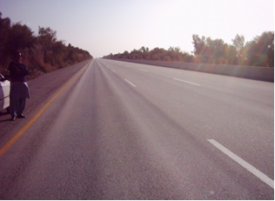

Figure 1. Severe Rutting on Motorway M-1



Figure 2: Rutting in Asphalt Layers due to Heavy Loading

The Superpave system evaluates asphalt binder on the performance, a mix design based on analysis process, advance and new testing methods and latest machinery [1]. Characterization of asphalt binders from new testing methods is much better than old ones [2]. Superpave mixes are better against rutting and other climatic distresses. As the PG system gives realistic and better results than marshall test results so it has been adopted efficiently by organizations since 2001 [3].

The Marshall method of mix design is the empirical approach for design and suffers the limitation of accuracy in determining the accurate effect of variation in the environmental and loading condition; furthermore compaction procedure in it does not actually relate and simulate the real field conditions of densification due to traffic [4, 5]. The SHRP developed the Long Term Pavement Performance (LTPP) in 1987 in which a lot of work has been done on pavement performance that leads to refine engineering practices to design, build and manage roads [6]. In the start SHRP developed certain model temperatures that gave an idea to adopt appropriate performance grade for asphalt binder. Before PG system lowest air temperature was taken as the temperature of pavement but PG system proved that pavement temperature is always higher than the lowest possible air temperature. [7].

The basic inspiration behind Superpave performance grading (PG) is that a Hot Mix asphalt binder’s properties should be associated with prevailing climatic conditions and aging considerations. As three principal asphalt binder grading systems are being practiced in pavement industry, i.e. Penetration, Viscosity and Performance Grading [8-10]. Dark asphalt act as a heat trap and it does not reflect back the solar radiations. So the pavement surface temperature is due to certain physical processes i.e. heat flow in vertical and horizontal directions and energy exchange in the form of evaporation and condensation [11]. Generally, for summer temperature the coefficient of variation (COV) is less as compared to winter temperature. Therefore, the summer temperature is considered more stable than that of winter temperature [12].

The first two approaches have limited ability for complete asphalt binder characterization, where as Superpave mix design system addresses hot mix asphalt pavement performance based issues such as rutting, fatigue and thermal cracking. A comprehensive research study for United States Department of Transportation (USDOT) “Background of Superpave mixture design and analysis”, in which they formulated basic guidelines for binder’s performance grading based on maximum and minimum pavement design temperatures [13]. The comprehensive information about the available refineries and binders in Pakistan [14] is given below in table 1 below.

Table 1. Summary of Binder Grading for Asphalts in Pakistan (M.W. Mirza et al) *Note: (A) for Attock Refinery and (K) for Karachi Refinery*

|  |  |  |  |  |  |
| --- | --- | --- | --- | --- | --- |
| **Sr.No** | **Refinery** | **Binder** | **Penetration Grade** | **Viscosity Grade** | **PG Grades of Available Asphalts in Pakistan** |
| 1 | Attock | A-PMB | Not Available | AC-40 | PG-76-16 |
| 2 | Attock | A-60/70 | Pen 60/70 | AC-20 | PG 58-22 |
| 3 | Attock | A-80/100 | Pen 60/70 | AC-10 | PG 58-22 |
| 4 | Karachi | K-40/50 | Pen 40/50 | AC-40 | PG 64-16 |
| 5 | Karachi | K-60/70 | Pen 60/70 | AC-20 | PG 64-22 |
| 6 | Karachi | K-80/100 | Pen 85/100 | AC-10 | PG 58-22 |

Regarding temperature selection the hottest seven day period was selected and the average maximum air temperature was calculated for each year. Then average of seven hottest temperatures across 20-year air temperature data was taken which presented the maximum air temperature data for a particular area. The criterion for minimum air temperature was somewhat different in the sense that for each year coldest day’s temperature was selected and from 20 years temperature data one temperature was selected which was the lowest. The conversion of air temperatures into pavement temperatures was the next step as for the selection of asphalt binder grades, the design temperatures were the pavement temperatures not the air temperatures.

**2. Investigational Program**

The experimental program includes the below mentioned steps:

1. The data for 30 weather stations in Pakistan regarding temperatures and respective latitudes and departures was recorded for 20 years of time period i.e. from 1987 to 2006 with the cooperation of Pakistan Meteorological Department in terms of average highest and lowest air temperatures. For all stations surface temperature was calculated using SUPERPAVE model for high temperature. The results are shown in **Table 5**.

2. Pakistan was divided into diverse climatic regions based on highest and lowest anticipated temperatures. For each station, pavement temperature has been obtained by taking the average of maximum values of 7 days air temperature and by using standard deviation high and low pavement temperatures at 98% reliability levels using SUPERPAVE model were obtained.

The term reliability here means that it is the percent probability in one year that the real temperature (one day below or seven days high) will not surpass the design temperature.

3. Performance grading map for Pakistan was generated subsequent to comprehensive analysis of highest and lowest pavement temperatures.

**3. Collection of Air Temperature Data across Pakistan**

Temperature data of following 30 stations as listed in **Table 5** was collected from Metrological Department of Pakistan from year 1987 to 2006. The location of each station has been shown on Pakistani map in **Figure 3.**

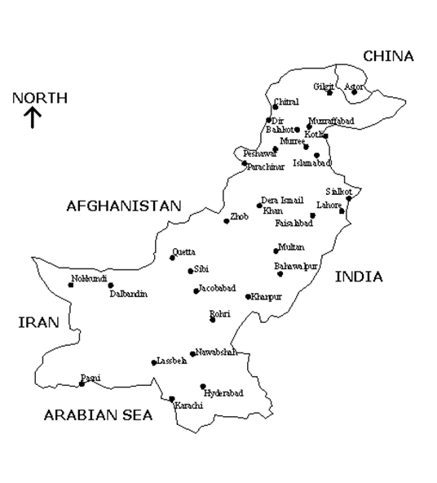

**Figure 3:** Location Map of 30 Weather Stations across Pakistan

**4. Analysis of Air Temperature Data**

Contrary to the previous grading systems i.e. Penetration and Viscosity the Superpave binder specification is theoretically based on performance rather than on empirical relationships between basic physical properties and observed performance. Performance graded binders are selected based on the climate in which the pavement would serve. Also it is dependent on no of Esals and speed of vehicles.

For example a binder classified as a PG 58-34 means that it will meet the high temperature physical property requirements up to a temperature of 58˚C and the low temperature physical property requirements down to - 34˚C. For a particular area the high and low temperatures grades would extend as far as necessary in the standard six-degree increments as stated by McGennis et al. (1995).

Maximum and minimum air temperatures were identified as shown in Table 5, using the standard procedure as described by McGennis et al. (1995). Maximum and minimum pavement design temperatures were calculated using the standard equations 1 and 2. Station wise precise performance grades were developed using statistical analysis with 98% reliability. The performance Grades for the 30 stations were established. A typical data for one station (Islamabad) has been presented in Tables 2, 3 and 4. Further, using these performance grades, the whole country was divided into seven zones.

Table 2. Air Temperature Data for Islamabad, Used as a Template

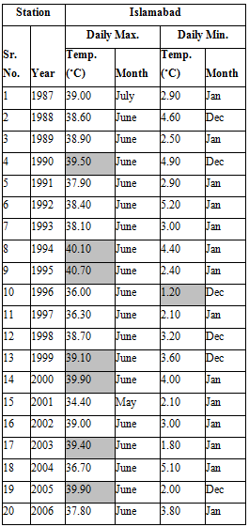

Table 3: Maximum Pavement Temperature for Islamabad

|  |  |  |
| --- | --- | --- |
| **T20mm = [Tair -0.00618 Lat2 + 0.2289 Lat + 42.2] x 0.9545 -17.78** | | |
| T20mm | Maximum Pavement Temperature @ Depth of 20 mm from the top of Pavement | **61.15** |
| T air | Seven Days Average Maximum air Temperature in °C | **39.800** |
| Lat | The Geographical Latitude of Project in Degrees 33°-43' | **33.72** |

Table 4: Minimum Pavement Temperature for Islamabad

|  |  |  |
| --- | --- | --- |
| **Tpav = 0.859 Tair +1.7˚C** | | |
| Tpav | Minimum Pavement Temperature | **2.73** |
| Tair | Minimum Air Temperature | **1.20** |

Table 5: Maximum and Minimum Air Temperatures for 30 Station

|  |  |  |  |  |  |
| --- | --- | --- | --- | --- | --- |
| **Station** | **Latitude** | **Departure** | **Elevation (m)** | **Maximum Air Temperature Tair (Max) (°C)** | **Minimum Air Temperature Tair (Min) (°C)** |
| Dalbandin | 28.90 | 64.38 | 848 | 44.94 | -0.80 |
| Hyderabad | 25.39 | 68.4 | 40 | 42.13 | 8.5 |
| Jacobabad | 28.28 | 68.48 | 58 | 46.36 | 5.20 |
| Karachi | 24.88 | 67 | 22 | 36.71 | 9 |
| Lasbella | 24.73 | 66 | 11 | 42.97 | 7.1 |
| Nawabshsh | 26.25 | 68.41 | 38 | 46.1 | 4.5 |
| Nokkundi | 28.83 | 62.75 | 682 | 44.5 | 1.2 |
| Pasni | 25.27 | 63.45 | 4 | 36.87 | 10.3 |
| Quetta | 30.20 | 66.91 | 1620 | 37.54 | -5.0 |
| Rohri | 27.68 | 68.85 | 58 | 44.99 | 4.9 |
| Sibbi | 29.55 | 67.9 | 130 | 46.91 | 4.7 |
| Zhob | 31.35 | 69.83 | 1405 | 38.63 | -7.4 |
| Astor | 35.37 | 74.85 | 8126 | 28.43 | -12.10 |
| Bahawalpur | 29.40 | 71.66 | 122 | 43.81 | 4.7 |
| Balakot | 34.38 | 73.35 | 508 | 36.24 | 0.10 |
| Chitral | 35.83 | 71.93 | 1499 | 37.17 | -2.10 |
| D. Ismail Khan | 31.83 | 70.83 | 172 | 42.13 | 2.10 |
| Dir | 35.20 | 71.98 | 1369 | 33.53 | -7.20 |
| Faisalabad | 31.42 | 73.08 | 185 | 41.96 | 3.10 |
| Gilgit | 35.90 | 74.61 | 1454 | 38.33 | -6.80 |
| Islamabad | 33.72 | 73.16 | 508 | 39.8 | 1.20 |
| Khanpur | 28.65 | 70.58 | 87 | 44.33 | 1.50 |
| Kotli | 33.53 | 73.92 |  | 39.36 | 1.50 |
| Lahore | 31.57 | 74.91 | 217 | 42.69 | 6.40 |
| Multan | 30.20 | 71.6 | 122 | 43.63 | 3.90 |
| Murree | 33.92 | 73.5 | 2126 | 27.26 | -5.30 |
| Muzaffarabad | 34.4073.5 | 73.5 | 508 | 39.03 | 1.20 |
| Parachinar | 33.90 | 70.08 | 1725 | 31.81 | -9.10 |
| Peshawar | 34.02 | 71.61 | 359 | 41.84 | 2.50 |
| Sialkot | 32.50 | 74.5 | 255 | 40.97 | 2.50 |

Superpave recommends the location for the high pavement design temperature at a depth 20mm below the pavement surface and the low pavement design temperature at the pavement surface, as studied by McGennis et al. (1995). Therefore using the following empirical equations 1 and 2 recommended by Asphalt Institute in Superpave Manual Series no. 1 and 2, air temperatures could be converted into the maximum and minimum pavement design temperature. (Superpave Manual Series No. 1 & 2).



Where

T20mm = High Pavement Design Temperature at a Depth of 20 Mm, 0C

Tair = Seven-Day Average High Air Temperature, 0C

Lat = The Geographical Latitude of the Project in Degrees.

**……………………………..……………………….. (2)**

Where

T min = Minimum Asphalt Pavement Temperature below Surface, 0C

T air = Minimum Air Temperature, 0C.

Table 6. Calculated performance grade on the basis of Maximum and minimum pavement Temperatures for 30 stations

|  |  |  |  |  |  |  |  |
| --- | --- | --- | --- | --- | --- | --- | --- |
| **Station** | **Maximum Pavement Temperature (°C)50% Reliability** | **Maximum Pavement Temperature (°C) 98% Reliability** | **Higher Grade** | **Minimum Pavement Temperature (°C) 50% Reliability** | **Minimum Pavement Temperature (°C) 98% Reliability** | **Lower Grade** | **Performance Grade** |
| Dalbandin | 66.79 | 70.79 | 76 | 1.01 | 1.01 | -4 | PG 76-4 |
| Hyderabad | 64.46 | 68.46 | 70 | 9 | 9 | -4 | PG 70-4 |
| Jacobabad | 68.21 | 72.21 | 76 | 6.17 | 6.17 | -4 | PG 76-4 |
| Karachi | 59.33 | 63.33 | 64 | 9.43 | 9.43 | -4 | PG 64-4 |
| Lasbella | 65.31 | 69.31 | 70 | 7.8 | 7.8 | -4 | PG 70-4 |
| Nawabshsh | 68.16 | 72.16 | 76 | 5.57 | 5.57 | -4 | PG 76-4 |
| Nokkundi | 66.37 | 70.37 | 70 | 2.73 | 2.73 | -4 | PG 70-4 |
| Pasni | 59.45 | 63.45 | 64 | 10.55 | 10.55 | -4 | PG 64-4 |
| Quetta | 59.55 | 63.55 | 64 | -2.60 | -2.60 | -4 | PG 64-4 |
| Rohri | 66.97 | 70.97 | 76 | 5.91 | 5.91 | -4 | PG 76-4 |
| Sibbi | 68.58 | 72.58 | 76 | 5.74 | 5.74 | -4 | PG 76-4 |
| Zhob | 60.42 | 64.42 | 70 | -4.66 | -4.66 | -10 | PG 70-10 |
| Astor | 49.98 | 53.98 | 58 | -8.69 | -8.69 | -10 | PG 58-10 |
| Bahawalpur | 65.65 | 69.65 | 70 | 5.74 | 5.74 | -4 | PG 70-4 |
| Balakot | 58.84 | 62.84 | 64 | 1.79 | 1.79 | -4 | PG 64-4 |
| Chitral | 58.24 | 62.24 | 64 | -0.1 | -0.1 | -4 | PG 64-4 |
| D. I. Khan | 63.69 | 67.69 | 70 | 3.5 | 3.5 | -4 | PG 70-4 |
| Dir | 54.88 | 58.88 | 64 | -4.48 | -4.48 | -10 | PG 64-10 |
| Faisalabad | 63.59 | 67.59 | 70 | 4.36 | 4.36 | -4 | PG 70-4 |
| Gilgit | 59.33 | 63.33 | 64 | -4.14 | -4.14 | -10 | PG 64-10 |
| Islamabad | 61.15 | 65.15 | 70 | 2.73 | 2.73 | -4 | PG 70-4 |
| Khanpur | 66.23 | 70.23 | 76 | 2.99 | 2.99 | -4 | PG 76-4 |
| Kotli | 60.76 | 64.76 | 70 | 2.99 | 2.99 | -4 | PG 70-4 |
| Lahore | 64.26 | 68.26 | 70 | 7.2 | 7.2 | -4 | PG 70-4 |
| Multan | 65.36 | 69.36 | 70 | 5.05 | 5.05 | -4 | PG 70-4 |
| Murree | 49.14 | 53.14 | 58 | -2.85 | -2.85 | -4 | PG 58-4 |
| Muzaffarabad | 60.29 | 64.29 | 70 | 2.73 | 2.73 | -4 | PG 70-4 |
| Parachinar | 53.49 | 57.49 | 58 | -6.12 | -6.12 | -10 | PG 58-10 |
| Peshawar | 63.04 | 67.04 | 70 | 3.85 | 3.85 | -4 | PG 70-4 |
| Sialkot | 62.48 | 66.48 | 70 | 3.85 | 3.85 | -4 | PG 70-4 |

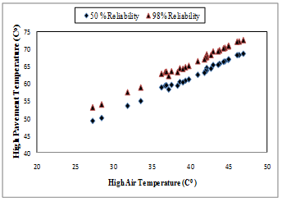

Figure 4. Relationship between High Air and Pavement Temperatures



Figure 5. Relationship between Low Air and Pavement Temperatures

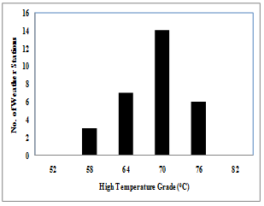

Figure 6. Number of Weather Stations having different High Temperature Grade

Figure 7. Number of Weather Stations having different Low Temperature Grade



**5. Zoning of Pakistan on the Basis of Pavement Temperatures**

Summary of the complete data for 30 stations has been presented as station wise performance grading. Different performance grading zones identified on 30 stations have been summarized in Table 7 and shown in Figure 8.

Table 7. Summary of Proposed Zoning for Pakistan

|  |  |  |
| --- | --- | --- |
| Zone | No. of stations in the Zone | Performance Grade |
| Zone-1 | 6 | PG 76-4 |
| Zone-2 | 13 | PG 70-4 |
| Zone-3 | 5 | PG 64-4 |
| Zone-4 | 2 | PG 58-10 |
| Zone-5 | 1 | PG 70-10 |
| Zone-6 | 2 | PG 64-10 |
| Zone-7 | 1 | PG 58-4 |

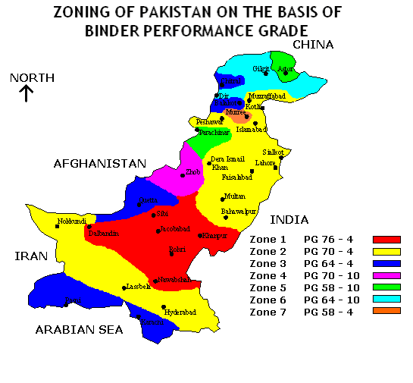

Figure 8. Performance Grading Map developed for Pakistan

**6. Conclusions**

This research was conducted to generate the suitable performance grade (PG) for asphalt in Pakistan. On the basis of results of the current research work following conclusions were derived:

• Presently Pakistan is using 60/70 grade bitumen from Attock Refinery Rawalpindi and National Refinery Karachi. The performance grade of locally available 60/70 grade asphalt has been found to be PG 64-28 when tested using DSR (Dynamic Shear Rheometer ), which could be used without any modification for only four zones namely, ZONE 3(PG 64-4), ZONE 4(PG 58-10), ZONE 6(PG 64-10) and ZONE 7(PG 58-4).

• For the hotter zones of the country, asphalt should be modified using polymer to achieve PG 76-4, PG 70-4 and PG 70-10 otherwise problem of premature rutting and other pavement failures would continue by using conventional 60/70 grade binder.

• Pakistan pavement industry should adopt SUPERPAVE specifications instead of Marshall Mix design procedure due to its versatility and rutting resisting capabilities.

• PG grading has been achieved on the basis of 50% and 98% level of reliability. But practically 98% reliability is the most suitable to counter uncontrolled heavy loadings and slow moving vehicles.

• Additional weather stations should be established in different provinces of Pakistan for the collection of more comprehensive temperature data. It would result in. more ample performance grading system. Test sections should be constructed in different zones of the country using the proposed respective binder flavours to check their performance.

**Acknowledgements:**

The authors deeply appreciate the cooperation made by Pakistan Meteorological Department for the provision of weather data.

**Corresponding Author:**

Dr. Kamran Muzaffar Khan

Department of Civil Engineering

University of Engg. And Technology

Taxila, Pakistan

E-mail: kamran.muzaffar@uettaxila.edu.pk

**References**

1. Strategic highway research program, national research council. Validation of relationships between specific properties and performance. SHRP A-409. WASHINGTON DC; 1994.
2. Strategic Highway Research Program, National Research Council. Binder characterization and evaluation. Test methods. SHRP-A- 370, vol. 4, Washington, DC; 1994.
3. Asi IM. Performance evaluation of SUPERPAVE and Marshall Asphalt mix design to suit Jordan climatic and traffic conditions. Constr Build Mater 2007; 21:1732–40.
4. Brown R, Kandhal P, Zhang J. Performance testing for hot mix asphalt. National Center for Asphalt Technology, Report No-05A, Auburn Univ., Alabama; 2001.
5. Federal Highway Administration. Innovation deserving expletory analysis laboratory. FHWA-RD-01-94; 1998.
6. Hassan FH, Al-Nuaimi A, Al-Oraimi S, Jafar TMA. Development of asphalt binder performance grades for Omani climate. Constr Build Mater 2008; 22(8):1684–90.
7. LTPP Seasonal Asphalt Concrete Pavement Temperature Models. Publication No. FHWA – RD-97-103; 1998.
8. Robert F, Mohamed M, Wang L. History of hot mix asphalt mixture design in the USA. J. Mater Civil Eng 2002;14(4):279–93.
9. Headquarters. Department of the army and the air force. Bituminous pavements standard practice. TM-822/AFM 88-6; 1990.
10. Fourbia F, Awbi HB. Building cluster and shading in urban canyon for hot dry climate. Part 1: air and surface temperature measurement. Renew Energy 2004; 22(2):249–62.
11. Tan SA, Fwa TF. Influence of pavement materials on the thermal environmental of outdoor spaces. Build Environ 1992; 27(3):289–95.

10/25/2018