Copepoda Parasites In Economically Important Fish Mugilidae (Mugil cephalus) and (Liza falcipinnis) From Lac Nokoue Lagoon In Republic Of Benin, West Africa.

^{1,2}Nike F. Aladetohun,² Nestor G. Sakiti, ³Emmanuel E. Babatunde.

¹Federal college of Fisheries and Marine Technology, Ahmadu Bello way, Victoria Island, Lagos, Nigeria. ²Laboratory of Parasitological and Ecology of parasites Department of Zoology and Genetics, Faculty of Sciences and Technology, University of Abomey Calavi, Republic of Benin, West Africa, ³Department of Marine Sciences, University of Lagos, Akoka, Lagos, Nigeria.
adenike63@yahoo.com

Abstract: Fish parasitology is an indispensable tool in aquatic health studies and a basic understanding of richness of a community parasitism in many localities is essential for instituting control. Many copepod parasites are ecto-parasites which negatively affect the appearance and reduced production of species of economically important fish, both from the wild and fish farms, thus making them difficult to market. In this study, copepod parasitic investigation was carried out in gills of 856 fish mugilidae (Mugil cephalus and Liza falcipinnis) in three stations (Ganvie, and Djdje and Zogbo) of Lac Nokoue lagoon. In the three stations, three species of parasitic copepod were found: Nipergasilus bora, Ergasilus latus and Ergasilus lizae The highest total percentage copepod prevalence was found in Ganvie (86.23%) and the least in Djdje (63.14%). There is significant difference P<0.05 in the rate of infestation of Liza falcipinnis at Djdje than the other two stations, where as Mugil cephalus shows no significant difference in the rate of infestation in the three stations. The research revealed higher number of parasite copepods during the rainy season.
[ Nike F. Aladetohun, Nestor G. Sakiti, Emmanuel E. Babatunde. Copepoda Parasites In Economically Important Fish Mugilidae (Mugil cephalus) and (Liza falcipinnis) From Lac Nokoue Lagoon In Republic Of Benin, West Africa. Researcher 2018;10(10):81-87]. ISSN 1553-9865 (print); ISSN 2163-8950 (online). http://www.sciencepub.net/researcher. 9. doi:10.7537/marsrsj101018.09.

Keywords: Copepod parasites, Mugilidae Fish, Lac Nokoue Lagoon

- Introduction
Even though spawning can be induced on an environmental basis, mullet farming still depends on fry or fingerlings stocked from natural water. This fact combined with behaviour of mullets, promotes disease including parasite infestation (Perpana and Overstreet 1981). This results in constant dissemination of disease-causing agent between cultured and natural population of mullet. Transmission can occur through water and intermediate host. Thus there is need for comprehensive study of parasites from natural stocks.
Lake Nokoue, is the largest coastal lagoons and the most productive brackish water body in Republic of Benin (Laleye and Moreau, 2004). Lake Nokoue was formally a lake until 1185 when it was artificially linked with the ocean through a channel (Lang et Paradis,1977). Majority of fish production (fish mugilidae inclusive) come from the lagoon (Laleye et al1993, Laleye et al, 2003, Niyonkuru et al, 2010). The Ganvie area is located near the floating village of Ganvie, where the water is characterised by a high level of organic pollution (Niyonkuru et al,2003). The fishing technique used by the fishermen from whom samples were obtained included gill nets, cast nets and acadjas (a traditional fish harvesting system using nets to encircle man-made brush packs of branches placed in the lagoon), (Gnohossous et al,2009).
Fish mugilidae are economically important and are important food fishes. The euryhalinity, eurythermality and their simple diet as well as their rapid growth, have made them the object of aquaculture in many parts of the world (Oren,1981). In Republic of Benin, these (Mugil cephalus and Liza falcipinnis) constitute important proportion of catches by artisanal or subsistence fishermen (Laleye et al,2003, Gnohossou,2009). They are of economic importance to the country.
Parasites have recently been highlighted as serious pathogenic problems in cultured mullet fish in marine and brackish water. Among the parasites, copepode family is commonly found on fishes cultured in brackish water (Noor El- Deen et al,2012), and therefore a threat to the developing Industry of finfish mariculture, (Ru¨ckert, et al,2008). Copepods are aquatic crustaceans which are diverse and are the most numerous metazoans in the water community with habitats ranging from fresh water to hypersaline conditions. Some copepods parasites of fishes all over the world may cause lesions that negatively affects the fisheries and aquaculture economies, (Barreiro and Francnete,2003).
Some studies have been carried out to discover the richness of community parasitic in many localities (Poulen and Rode, 1997, Sures and Street, 2001, Kimpela et al, 2006 and Boualleg et al, 2011). In Republic of Benin, many researchers have worked on parasites of fish, Dossou, (1985), Sakiti et al (1991), Sakiti, (1997), and Gbankoto et al, (2003) but no work has been carried out on parasites of mugilidae fish in Repulic of Benin.

- Materials and Methods
The study site, Lake Nokoue (Fig.1) is the largest lagoon, (Moreau, 2004), is a shallow, sub-tropical coastal lagoon (6⁰25N,2⁰36E) with surface of 150km and stretches 20km in its east-west direction by 11km in the north-south direction (Laleye et al, 2003). Lake Nokoue opens directly into the Atlantic ocean through channel at cotonou which is about 24.5km long.
For the purpose of this study, three stations were considered as sampling areas within the lagoon: Ganvie, Djdje and Zogbo (Fig.1). The Ganvie area is located at the northern part of the lake Nokoue lagoon, near the floating village of Ganvie where the water is characterised by a high level of organic pollution (Laleye et al,2003). The Djdje and Zogbo areas are located at the southern part of the lake and are partly influenced by Atlantic ocean waters. Sampling was carried out at each station both in the dry season (December-March, 2011) and the rainy (April-July,2012).

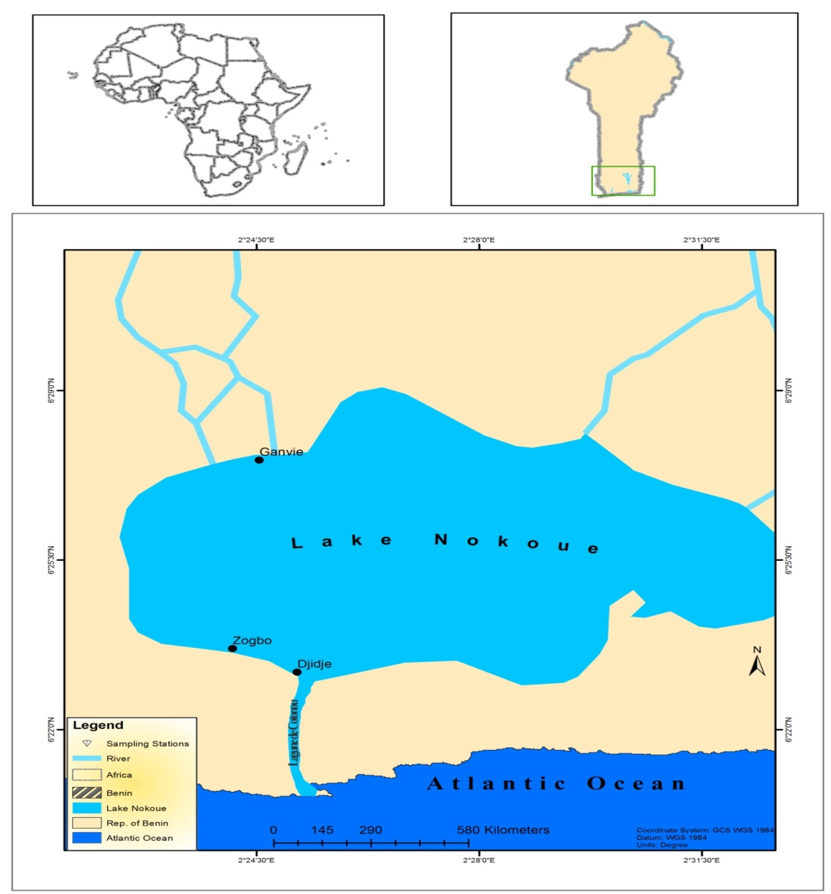
Figure 1: Location of lake Nokoue showing fish sampling stations.

Lake Nokoue Area
Area Stations | Longitude | Latitude
Djidje | 2⁰ 25’8.393”E | 6⁰23’11.077”N
Zogbo | 2⁰ 24’7.512”E | 6⁰23’40.162”N
Ganvie | 2⁰ 24’32.615”E | 6⁰27’33.77”N

Collection and analysis of water samples
Water samples were collected with 1dm 3 water samplers and stored in 1litre water bottles and analysed in the laboratory for pH, conductivity, salinity and turbidity using a multi-meter water checker (Horiba U- 12). Water sample was collected in 250 ml dissolved oxygen bottle and fixed with Winkler solution at each station. This was followed by dissolved oxygen estimation using Iodometric Winkler’s method. Water temperature was measured in situ using mercury-in-glass thermometers.
Sampling of the fish specimen and Parasitological examination
Mugil cephalus and Liza falcipinnis from the three stations were obtained by the assistance of fishermen. A total number of 856 fish specimen Mugil cephalus and Liza falcipinnis were examined for copepods parasites. In station 1 (Ganvie) number of fish examined were, (MC-115, L.F- 132). In station 2 (Djdje), (MC - 181, LF - 226) and station 3 (Zogbo), (MC - 96 and LF - 106). The collected fish were transported in ice boxes to the laboratory to and examined for parasites. The weight of the fish were taken using digital weighing balance and recorded. The standard length (SL), the total length (TL) and the fork length (FL.) were measured with the aid of meter rule.
After dissection, stereo-microscopic observation was made on gills, for the presence of copepod parasites. Checking of prepared slides for parasites for better observation was carried out using light microscope. The standard length (SL), the total length (TL) and the fork length (FL) were measured with the aid of meter rule. The host species was identified using Fisher et al. (1987). The standard length (SL), the total length (TL) and the fork length (FL) were measured with the aid of meter rule. The host species was identified using Fisher et al. (1987). Collected copepods were fixed and preserved in ethanol (70%). Copepods on gills were studied using stereo and light microscopy. Parasites species identification was based on morphological features according to Yamaguti (1963), Vassiliades, (1975), Kabata (1979) (Skryabin et al 1982), Ben-Hasseine, (1983), Kabré (1997), Kabre et al (1997), and Ho and Kim (2004) and (Moravec, (2007),.
Data analysis
The parasitological terms follow Bush et al. (1997): prevalence (P) is the number of fish infected with one or more individuals of a particular parasite species (or taxonomic group) divided by the number of hosts examined (expressed as a percentage):

Prevalence

Intensity (of infection, I) is the number of individuals of a particular parasite species in a single infected host (expressed as a numerical range); mean intensity (of infection, mI) is the average intensity, or the total number of parasites of a particular species found in a sample divided by the number of infected hosts:

Mean intensity
=

ANOVA test, using statistical software (SPSS) was also done on MC and LF to know the significant difference of copepod parasites infestation in each stations.

- Results
Physicochemical parameters of study area
The physicochemical parameters recorded at the three stations during rainy and dry seasons are presented in Table 1. Both in the rainy and dry season, the salinity levels were lowest in station1 (Ganvie) with 0 and 11.4 parts per thousand, but highest in station 2 (Djdje) with 0.8 and 29.5 parts per thousand salinity levels respectively. The highest salinity recorded at Djdje is because of its proximity to the sea, The lowest salinity value obtained can be explained by the proximity of the So River to the station (Laleye et al 2003). Generally low conductivity levels were recorded from all stations during rainy season, whereas relatively high levels which ranged from 19.5 mScm-1 in station 1 to 46.5 mScm-1 at station 2 were obtained in the dry season (Table 1). On the other hand, every station had higher turbidity, pH and DO levels during rainy than dry season (Table 1).

Table 1: Spatial and seasonal distributions of the physico-chemical parameters in some parts of Lake Nokoue.
Stations | WT (ºC) |  | PH |  | Cond. (mScm-1) |  | Turb. (NTU) |  | Sal. (ppt) |  | DO (Mg/l)
 | RS | DS | RS | DS | RS | DS | RS | DS | RS | DS | RS | DS
1 | 29 | 28 | 8.1 | 8.5 | 0.18 | 19.5 | 78 | 10 | 0 | 11.4 | 11.2 | 8.0
2 | 29 | 27 | 8.9 | 8.0 | 1.0 | 46.5 | 366 | 10 | 0.8 | 29.5 | 13.6 | 13.2
3 | 28 | 28.5 | 9.0 | 8.1 | 0.8 | 45.8 | 126 | 10 | 0.5 | 27 | 18.4 | 8.4
WT: Water temperature; Cond: Conductivity; Turb: Turbidity; Sal.: Salinity; DO: Dissolved oxygen; RS: Rainy season; DS: Dry season
Table 2: Copepods for Eight Months in Benin
MONTHS | La Ganvie |  | Djdje |  | Zogbo
 | M.C | L.F | M.C | L.F | M.C | L.F
Dec | 7 | 19 | 10 | 26 | 10 | 11
Jan | 18 | 10 | 16 | 29 | 9 | 18
Feb | 14 | 22 | 12 | 28 | 10 | 5
Mar | 5 | 8 | 8 | 19 | 11 | 17
Apr | 16 | 20 | 7 | 18 | 6 | 10
May | 11 | 13 | 13 | 20 | 7 | 7
June | 10 | 11 | 16 | 15 | 13 | 13
July | 12 | 17 | 14 | 6 | 10 | 10
Total | 93 | 120 | 96 | 161 | 76 | 91 | 637

A total number of 637 copepods parasites were found in the three station s (Table.2). Station 1(MC- 93, LF - 120), Station 2 (MC-96, Lf - 161 and the third station (MC 76, L F- 91). Total % copepod prevalence was highest in Ganvie 86.23% followed by Zogbo (82.67 %) and Dantokpa with 63.14% (Table 3). In all the three stations Liza falcipinnes (LF) has the highest percentage copepods parasite infestation [P (LF) > P (MC)].

Table 3: Percentage fish infested and percentage parasite prevalence in Benin
Location | No of Fish Examined |  | Total | No of Infested Fish |  | % Number of Fishes Infested | No of Copepod Parasite |  | % Parasite Prevalence |  | Total % Parasite Prevalence
 | MC | L.F |  | M.C | L.F |  | M.C | L.F | M.C | L.F
Ganvie | 115 | 132 | 247 | 90 | 110 | 80.97 | 93 | 120 | 43.66 | 56.34 | 86.23
Djdje | 181 | 226 | 407 | 150 | 201 | 86.24 | 96 | 161 | 37.35 | 62.65 | 63.14
Zogbo | 96 | 106 | 202 | 71 | 89 | 79.21 | 76 | 91 | 45.51 | 54.49 | 82.67
Total | 392 | 464 | 856 | 311 | 400 | 246.42 | 265 | 372 | 126.52 | 173.48 | 232.04

In all the three stations, percentage of copepod parasites prevalence was much higher in Liza falcipinnis than Mugil cephalus. In Ganvie MC (43.66%, LF (56.34%), Djide, MC (37.35%), LF (62.35%) and in Zogbo, MC (45.51%), LF (54.49%). Total percentage copepod parasites was highest in Ganvie (86.23%), and least in Djidje (63.14%) (Table 3).

Table 4: Prevalence rate of copepod during Dry and Rainy season
Season | Location | No of fish examined |  | No of copepods |  | % of Parasite prevalence |  | Total % parasite prevalence
 |  | M.C | L.F | M.C | L.F | M.C | L.F
Dry | Ganvie | 63 | 71 | 44 | 59 | 0.4272 | 0.5728 | 0.7687
 | Djide | 92 | 114 | 46 | 102 | 0.3108 | 0.6892 | 0.7185
 | Zogbo | 49 | 53 | 40 | 51 | 0.4396 | 0.5604 | 0.8922
Rainy | Ganvie | 52 | 61 | 49 | 61 | 0.4455 | 0.5545 | 0.9735
 | Djije | 89 | 112 | 50 | 59 | 0.4587 | 0.5413 | 0.9732
 | Zogbo | 47 | 53 | 36 | 76 | 0.4737 | 0.5263 | 0.6184

Further analysis was carried out to investigate the prevalence rate of copepods during dry and raining season. (Table 4). The prevalence rate during dry season; shows Ganvie (0.769), Djide (0.719), and Zogbo (0.892). The prevalence rate during the rainy season are Ganvie (0.974), Djide (0.973) and Zogbo (0.618). It is clearly shown in the analysis that the prevalence rate is higher in the rainy season than dry season. Zogbo shows highest percentage of parasite prevalence during dry season, while Ganvie shows highest copepod parasite prevalence during rainy season.

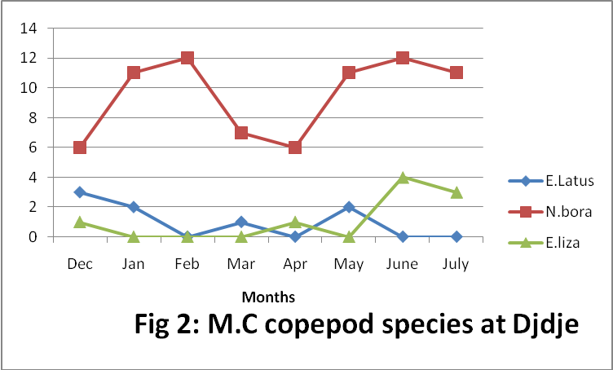

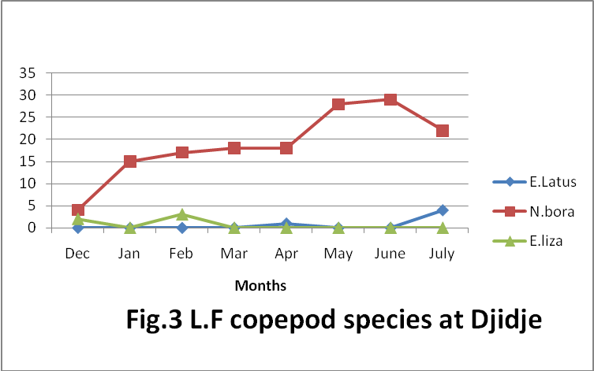

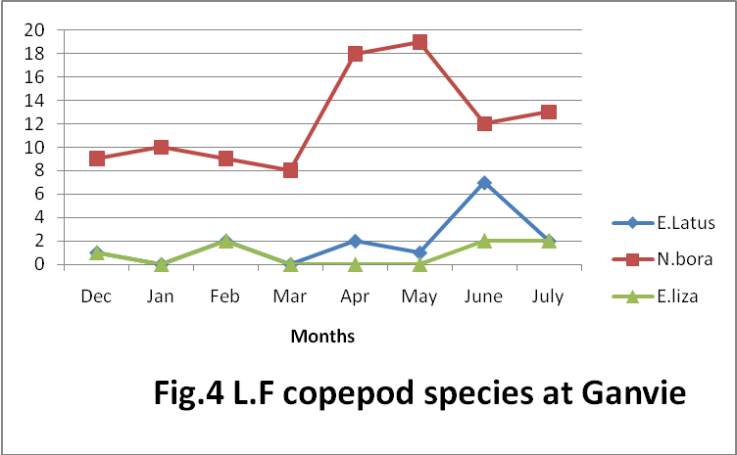

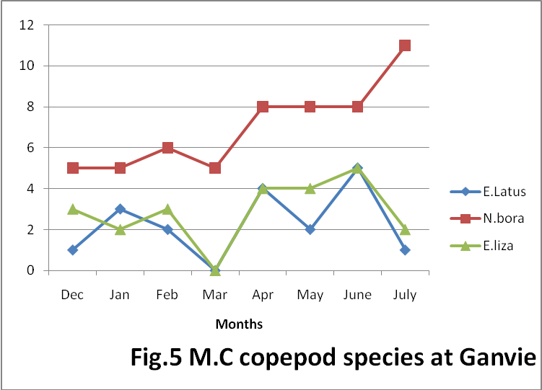
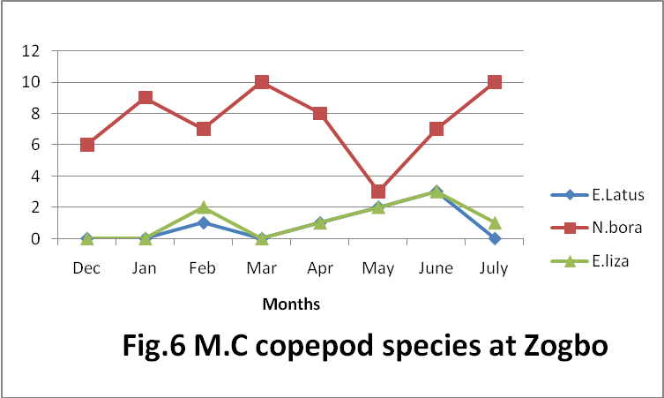

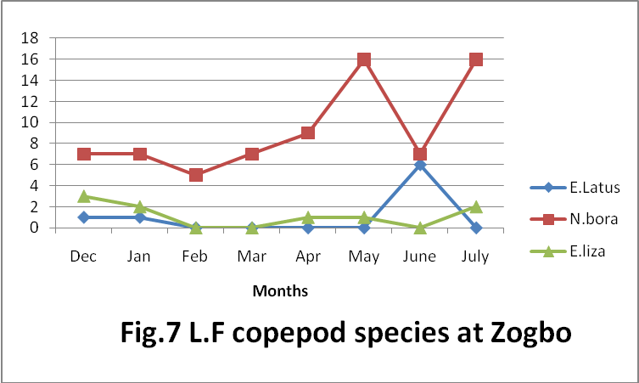
Figures 1-7 shows graphs of parasitic copepod species (E.Latus, N.bora and, E.Lizae) fonnd in both LF and MC in all the stations.

Table 5: Prevalence rate copepod species of Ganvie
 | E.Latus | N.bora | E.lizae | E.Latus | N.bora | E.Lizae
Ganvie | MC | MC | MC | LF | LF | LF
Dry | 2.804 | 9.813 | 2.336 | 1.402 | 16.822 | 1.402
Rain | 5.607 | 16.355 | 7.009 | 5.607 | 28.972 | 1.869

Table 6: Prevalence rate copepods species of Djdje
 | E.Latus | N.bora | E.liza | E.Latus | N.bora | E.liza
Djdje | MC | MC | MC | LF | LF | LF
Dry | 2.362 | 14.173 | 0.394 | 0 | 21.260 | 1.969
Rain | 0.788 | 15.748 | 3.150 | 1.969 | 38.189 | 0
Table 7: Prevalence rate copepods species of Zogbo
 | E.Latus | N.bora | E.liza | E.Latus | N.bora | E.liza
Zogbo | MC | MC | MC | LF | LF | LF
Dry | 0.599 | 19.162 | 1.198 | 1.198 | 15.569 | 2.994
Rain | 3.593 | 16.767 | 4.192 | 3.593 | 28.742 | 2.400
(N.bora: Nipergasilus bora, E.latus: Ergasilus latus and E.lizae: Ergasilus lizae)

In Ganvie, N.bora shows the highest percentage prevalence both in the dry season and rainy season in both MC (9.813%, LF 16.822%) and (MC,16.355, LF,28.972) (Table 5). Also in Djdje, N.boras shows highest percentage prevalence in dry season (MC,14.173, LF, 21.2598) and at rainy season (MC 15.148, LF, 38.189 (Table 6)), thesame in Zogbo, N. bora also shows highest percentage rate both in dry season MC (19.162 and LF, 15.569), and in rainy season (MC. 16.767% and LF,28.7437%) (Table 7).

- Discussion
In this research work, there is no doubt about the effect of seasonal variation on the physicochemical parameters in the sampling stations. The physicochemical parameters recorded at the three stations during rainy and dry seasons are presented in Table 1. During the year salinity was higher in Djdje than the other stations, because of its proximity to the sea. The lowest salinity value was obtained at Ganvie which can be explained by the proximity to the So river. (Table 1). This report agrees with that of Laleye et al.,2003. Generally low conductivity levels were recorded from all stations during rainy season, whereas relatively high levels which ranged from 19.5 mScm-1 in station 1 to 46.5 mScm-1 at station 2 were obtained in the dry season (Table 1). On the other hand, every station had higher turbidity, pH and DO levels during rainy season than dry season (Table 1). This report coincides with that of Yakub et al,2011.
Copepod parasites are common on fish hosts in coastal, marine and brackish waters (Vinoth et al,2010, Noor El – Deen et la., 2012). According to Vinoth et al,2010 Infestation can result in serious loss and damage of gill rakers and gill lamella which hinders respiration and eventually result in the death of fish and significant economic loss. In his work he also reported maximum copepoda parasite infestation was noticed in M. cephalus and L. Cailcarifer. (P. Vinnobaba 2007). The result of this work agrees with that of Barreiro and Fancinete, (2003), who worked on parasite copepod from fishes of Santa Cruz Channel and Suape area of Pernathatmbico, Brazil. He discovered that, 66% family mugilidae were infested with copepod parasite.
The highest total percentage copepod parasites recorded in Ganvie might have been caused by organic pollution resulting from the human settlement. Aladetohun et al,2013 (awating publication), in a similar work on copepod parasites of these species of mugilidae fish from Lagos lagoon, Nigeria also shows that, Liza falcipinnis had more copepod parasites than Mugil cephalus. In this work genuss Nipergasilus bora copepods had the highest frequency of occurrence and relative abundance than genus ergasilus. This agrees with Morella and Garippa,2001 in his work on parasites of grey mullets from Mistras lagoon, Western meditarranean, also reported Caligus apolus and Nipergasilus bora to be the most prevalent crustaceans.
Ben Hassine,1983 in his work on copepod parasites of mugilidae from the meditarrranean of France and Tunisia, reported Nipergasilus bora. Although Ergasilus lizae and Ergasilus latus were also found in all the three stations. Perperna and Lahav, 1971, also discovered copepod parasite (Ergasilus lizae) in grey mullets in Israel.
Tores and Bareiro (2003) in his work also revealed higher no of copepod parasites during rainy season which also agrees with the result of this present work Yashouv, 1972, reported reduction in the number of harvested fish was about 50% of those stocked, rather than the expected 90 % as a result of this infestation. Even though M. capito, Tilapia aurea and carp accompanied M cephalus, only M cephalus was involved in mortalities. Individual M. capito had about nine copepods compared with 100-120 on the emaciated M. cephalus.
In conclusion, high level of copepod parasites infestation of mugilidae fish (Mugil cephalus and Liza falcipinnis) in Lac Nokoue can cause serious health problems, fish mortalities and consequent production loss.

References
- Ben-Hassin, O. K. (1983). Les copépodes parasites de poisson mugilidae en mediterrannéoccidentalale (cotes francaises et tunisiaennes). These de Doctorat d’Etat, U. S. T. L. 452pp.
- Doussou, C. T. (1985) . Monogenous parasites de poissonsd’eaudounce au Benin (ouestafrican) ; These de doctoral d’etat. 116pp.
- Kabré G. B. (1997) : Parasites des poissons au Burkina Faso: Faunistique, ultrastructure, biologie. Thèse d’état, Univ. Ouagadougou, 265P. Kabata, Z. (1992): Copepods parasitic on Australian fish, XV, Family Ergasilidae (poecilastomatoida). Journal of Natural History, Vol. 26: pp 47- 66. Lang, J and Paradis, G.
- Markemitch, A. P. (1976): Parasitic copepods on fishes of the USSR published for the Smithsonia institution and the national science foundation, Washington, D. C. By the Indian national scientific documentation center, Hillside Road, New Delhi.
- Moravec, F. (2007). Nematode parasites of fishes: recent advances and problems of their research, Parassitologia 49: 155-160.
- Noor El- Deen, A. E; Abdel Hady, O. K; Shalaby, S. I and Mona S. Zaki. Field Studies on Caligus Disease among Cultured Mugil Cephalus in Brackish Water Fish Farms. Life Sci J 2012;9(3):733-737 (ISSN:1097-8135). http://www.lifesciencesite.com. 103.
- Paperna, I. & Lahav, M., 1971. New records and further data on fish parasites in Israel. Bull. Fish Cult. Israel (Bamidgeh), 16: 77–86.
- Paperna, I. & Overstreet, R. M. 1981. Parasites and diseases of Mullets (Mugilidae). In: Oren, O. H. (ed.) Aquaculture of Grey Mullets. IBP 26, Cambridge University Press, U. K.
- LANG, J & PARADIS, 1977. Un exemple d’environement se’dimentaire biode’tritique n0n carbonate’ marin et continental, h0l0cene, en climat intertropical [exDahomey]. Rev. Ge’ogr/ Phys. Ge’ol. Dyn., 19 (3)/ Paris:295-312.
- Ru¨ ckert. S,. Palm H. W and Klimpel. S 2008. Parasite fauna of seabass (Lates calcarifer) under mariculture conditions in Lampung Bay, Indonesia J. Appl. Ichthyol. 24 (2008), 321–327 The Authors Journal compilation _ 2008 Blackwell Verlag, Berlin ISSN 0175–8659.
- Sakiti, N. G. Blanc, E. Marques, A. and Bouix,.G. (1991). (Myxozoa, Myxosporea) du genre Myxobolus Butschili,1882 parasites de poisons de Cichlidae du la lac Nokoué au Benin (Afrique de l’Quest). J. Afri. Zool.105 :175-186.
- Sakiti, N. G. (1997). Myxosporidies et Microsporidies de poissons du Sub-Benin faunistigue, ultrastucture, biologie. In These de Doctorat d’etat UAC. 1-300.
- Schäperclaus, W. (1991): Fischkrankheiten (Fish diseases). Vol. 1, New Delhi, Amerind publishing. p.594.
- Vassiliades. g. (1975). Nematodes parasites des poissons d’eau douce de la Republique de Senegal Bullet de l’l. F. A. N. T.37, ser A. N.3.605-618.
- Laleye P. and Moreau j. 2004. Resources and contains of west africa coastal waters for fish production. In : Abban E, K., Casal C. M. V., Dunga P. and Falk T. M. (eds.), Biodiversity, Management and utilization of west Africa Fishes, Wordfish Center Conference, Proceedings Contribution n 1718. 28-30.
- Gnohossou, P., Atachi, P., Dauta, C. & Moreau, J. 2003. Influence of the salinity on the spatial distribution of the benthic fauna in lake Nokoue (Abstract). In : Picarts (ed.), proc. Intern. Conf. Pan Africa Fisheries Society, Coronou Benin.
- Gbankoto, A. Pampoulie, C. Marques, A. Sakiti, N. Dramane, K. (2003). Infection pattern of Myxobolus heterospora in two tilapia species (Teleostea: Cichlidae) and its potential effects in Diseases of Aquatic Organisms.55:120-131.
- Laleye P., Niyonkuru C., Moreau J. and Teugels G. G., 2003. Spatial and seasonal distribution on the ichtyofauna of lake Nokoue, Benin, West Africa Journal of Aquatic Science, 28, 151-161.
- Niyonkuru C., Laleye P., Hounkpe C. and Moreau j. 2003. Impact de la peche sur les resources aquatiques des plans d’eau du sud-Benin. Astracts Third International Conference of the Pan African Fisheries Society, Cotonou, Benin, 221.
- Niyonkuru C., Laleye P., Moreau j. 2010. Impact of acadja fisheries on the population dynamics of Sarotherondon melanotheron and Hemichromic fasciatus in a lake Nokoue (Benin, West Africa).

Gnonhossou P., 2006. La faune benthique d’ une lagune ouest-africaine (lac Nokoue au Benin) : diversite, abondance, variation temporelles et spatiales, place dans la chaine trophique. These de Doctorat en Sciences Agronomiques, Ecole Nationale Superieure Agronomique de Toulouse (France), 154 p. + annexes .
- Vinoth. R. , Ajith Kumar T. T, Ravichandran. S, M. Gopi. M, Rameshkumar. G,2010: Infestation of copepod parasites in the food fishes of Vellar estuary, Southeast coast of India. Acta Parasitologica Globalis 01/2010; 1:01-05.
- Yamagute, S. (1963). Parasitic Coopepoda and Brachiura of fish. Inter sciencepublishers, Inc. New York.
- Yakub A. S, Balogun, K. J. Ajani, G. E. Renner, K. O. Ariyo, A. A. Bello, B. O Nkwoji J. A and Igbo J K: Distribution of phytoplankton in some parts of Lagos Lagoon, Southwest Nigeria. Int. J. Biol. Chem. Sci. 5(1):150-163. ISSN1991-8631.

10/25/2018

