Fault Ride-Through Study and Control of a Wind Turbine Driving Squirrel Cage or Doubly-Fed Induction Generator; Comparative Study

Mahmoud Essam M. Harby¹, H. M. El Zoghby², Aboubakr Salem³, S.E. Elmasry⁴, Adel El Samahy⁵

Electrical Power and Machines Engineering, Faculty of Engineering, Helwan University, Egypt
¹ eng.mahmoudessam@Yahoo.com, ² helmy_028123288@yahoo.com, ³ aboubakr.salem.hu@gmail.com, ⁴drsaidelmasry@hotmail.com, ⁵ el_samahya@yahoo.com
Abstract: The renewable energy systems are going to take over most of the non-renewable energy systems, so lots of research is being done to ensure the stability and reliability of the renewable energy systems. This paper is concerned about the wind energy systems and ensuring their behaviour and performance during and after the abnormal cases like fault ride-through. Two complete models of a grid connected wind systems are going to be simulated in MATLAB program, the first one will be a grid connected wind turbine driving a three-phase squirrel cage induction generator SCIG and the other model will be a grid connected wind turbine driving a three phase doubly-fed induction generator DFIG. The frequency of each system will be displayed and compared to the frequency of the other system upon fault ride-through (three-phases SC fault) and under the effect of PID controller tuned by genetic algorithm technique. The different power responses and rotor speed of both generators are going to be analysed graphically and compared to each other upon fault ride-through and under the effect of the designed controller (genetic algorithm PID controller).
[Mahmoud Essam M. Harby, H. M. El Zoghby, Aboubakr Salem, S.E. Elmasry, Adel El Samahy. Fault Ride-Through Study and Control of a Wind Turbine Driving Squirrel Cage or Doubly-Fed Induction Generator; Comparative Study. Researcher 2018;10(10):68-72]. ISSN 1553-9865 (print); ISSN 2163-8950 (online). http://www.sciencepub.net/researcher. 7. doi:10.7537/marsrsj101018.07.

Keywords: fault ride-through, wind turbine, three-phases squirrel-cage induction generator, pitch angle controller, three- phase doubly-fed induction generator, genetic algorithm PID controller.

I. Introduction
In the recent ten years the world energy generation from the wind system has been growing rapidly, this is due to the many benefits of the wind energy. Lots of scientific work has been done with such energy resource which encouraged the stakeholders to develop the wind systems and invest much money on such fields. According to the global wind energy council GWEC the global installed wind power capacity until 2016 was 3,906 MW in Africa & Middle East, 203,685 MW in Asia, 153,729 MW in Europe, 15,296 MW in Latin America & Caribbean, 88,283 MW in North America, 4,823 MW in Pacific Region (Australia, New Zealand and Pacific Islands).
The statistics give an indication about the massive penetration of the wind energy systems into the world energy generation for example, according to the global wind energy council GWEC the global annual installed wind capacity in 2014 was 51,675 MW, in 2015 was 63,633 MW and in 2016 was 54,600 MW.
From another aspect, the world wind energy leading countries in 2016 were China and USA, where the added installed wind energy capacity during 2016 in China was 23,328 MW, USA was 8,203 MW, and Germany was 5,443 MW only in 2016.
In this paper a full simulation of a wind system connected to the grid is going to be provided, and a fault ride-through is going to be applied to the transmission lines between the system and the utility grid, which has effects on the frequency of the wind system output power, so a pitch angle controller will be designed to adjust the pitch angle of the wind turbine blades [1].
This case study is going to be applied on two different systems the first one will be a grid connected wind turbine driving SCIG and the second case study will be a grid connected wind turbine driving a three phase doubly-fed IG. The results of both cases are going to be compared together to ensure which one is more stable and robust against disturbances and transitional actions that may happen to the system.
II. Wind System Generators
There are three basic types of generators can be used with the wind systems, these generators are the three-phase squirrel-cage IG, the three phases doubly-fed IG, and three phases synchronous generator. This research is focusing on the state of the art type of generators, which is the three phase doubly-fed induction generator (DFIG), which can operate at speeds slightly above or below the synchronous speed, this advantage is very important for the large variable speed wind turbines, because the wind speed isn’t constant and may change anytime, So in case of using the synchronous type, which is locked to the speed of the grid it connected to and the speed of the wind got changed, so the synchronous generator can’t cope up with the change that happened on the wind speed because it’s locked to the grid speed, this leads to a large force on the hub or the gearbox. The main advantage of the three phases doubly-fed IG used with the wind systems that it can cope up with the change of the wind speed and maximize the output power, this is due to its innovative construction and principle of operation. Fig.1 shows a general layout of wind turbine driving a three phase doubly-fed induction generator DFIG and connected to the utility grid.
III. System Modelling
The wind turbine model is created in MATLAB software program. Fig. 2 illustrates the model of the proposed turbine. Fig. 3 presents the first case study system simulation built on MATLAB. Fig. 4 shows the second case study system simulation created by using MATLAB.

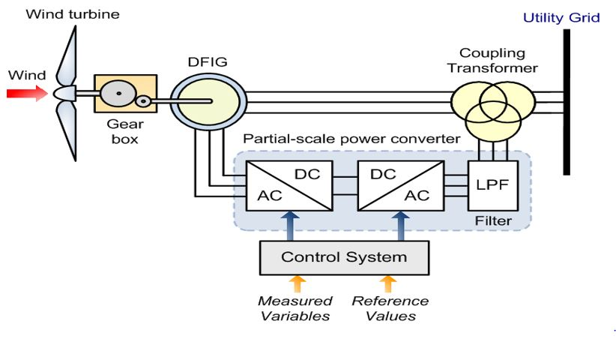
Fig. 1. General layout of the system.

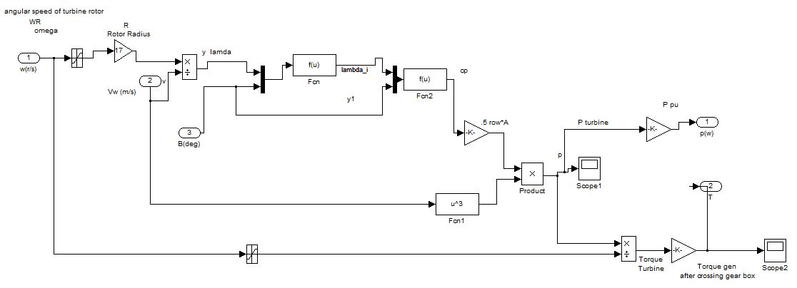
Fig. 2. Turbine model.

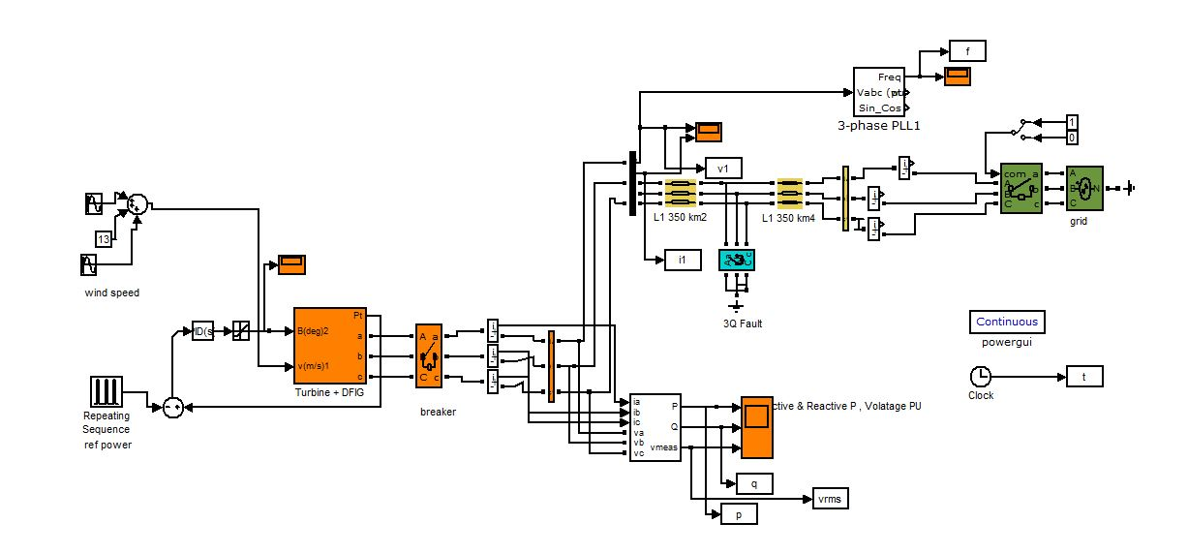
Fig. 3. Wind system driving DFIG.

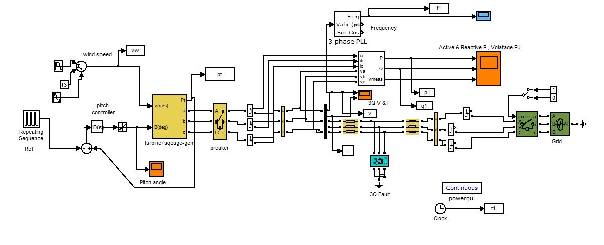
Fig. 4. Wind system driving SCIG.

IV. Three Phases Short Circuit (SC) Fault
The model consists of the wind turbine, the gearbox, the induction generator, the suitable step up transformer, the transmission line T.L and the utility grid. The target of this paper is to apply a severe fault on the wind system as described in Fig. 5 and Fig. 6.
The fault duration is 300 milliseconds and will be applied to the two case studies to check which type of generators is more stable and robust against disturbances, severe faults like three phase short circuit fault and transitional actions that may happen to the system [4].

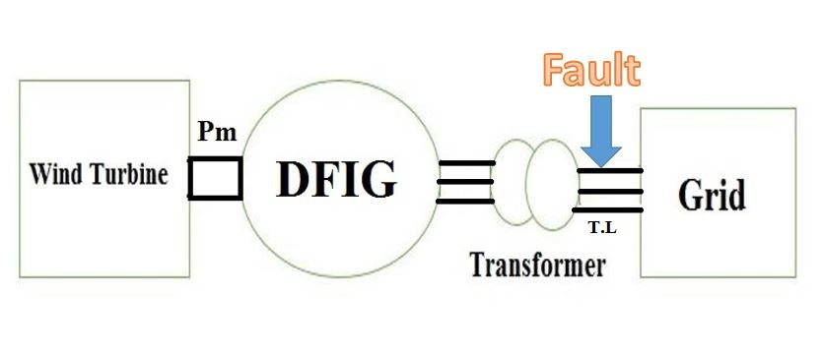
Fig. 5. General layout of the proposed system with DFIG.
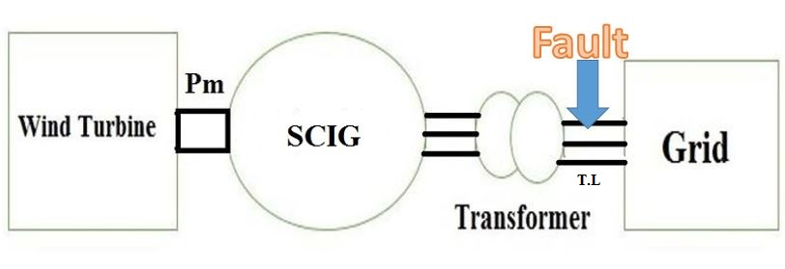
Fig. 6. General layout of the proposed system with SCIG.

V. Genetic Algorithm Technique
Fig. 7 illustrates the genetic algorithm steps in a simple flowchart. Fig. 8 presents the written M-Files.

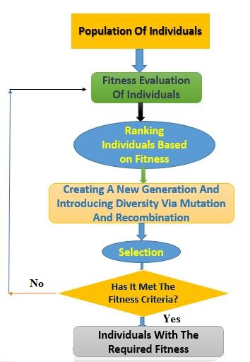
Fig. 7. Steps of the proposed optimization technique.
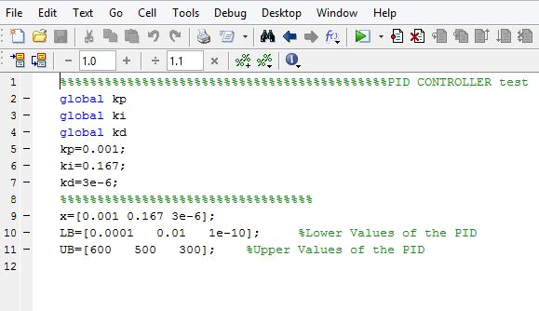
Fig. 8. Optimization technique MATLAB scripts.

This controller is designed to adjust and control the pitch angle of the turbine blades during the wind variations and other abnormal cases like three phases short circuit fault. The designed controller can mitigate the oscillation of the system frequency during severe faults that applied in this research. The genetic algorithm technique PID controller gain values for both case studies:

K_{P} = 0.538 K_{i} = 1.834 K_{d} = 0 (SCIG)
K_{P} = 456.647 K_{i} = 0.185 K_{d} = 0 (DFIG)

VI. Results

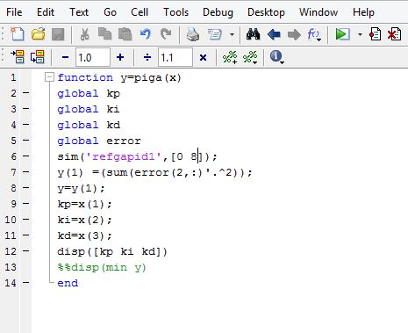

In this section the results of each case study are provided with an enhancing comparison with the other case study. Fig. 9 presents the effect of the severe fault on the system frequency for the two case studies (SCIG & DFIG). It can be noted that the response of the frequency in the DFIG case is better than the SCIG case for the same fault type, position and duration. Fig. 10 shows the effect of the severe fault on the DFIG & SCIG active power.

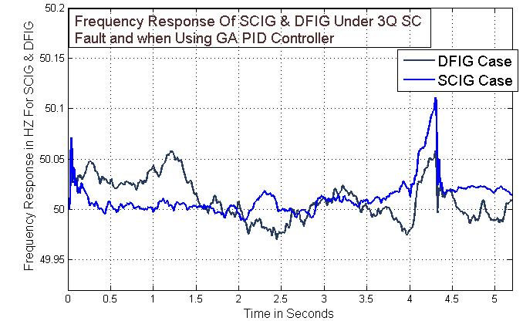
Fig. 9. Frequency response of both wind systems.

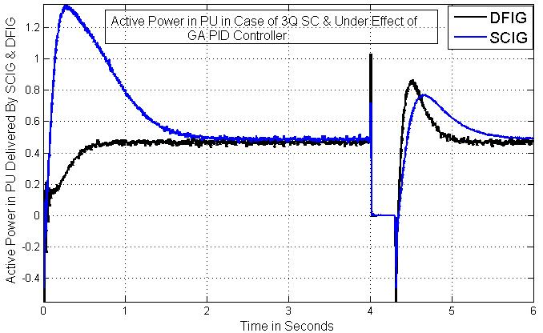
Fig. 10. Active power response.
Fig. 11 presents the effect of the severe fault on the DFIG & SCIG reactive power response. Fig. 12 illustrates the rotor speed response for both generators.

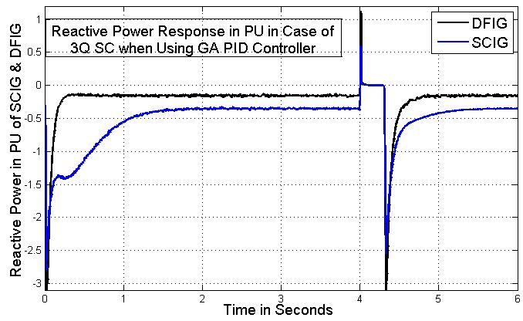
Fig. 11. Reactive power response.

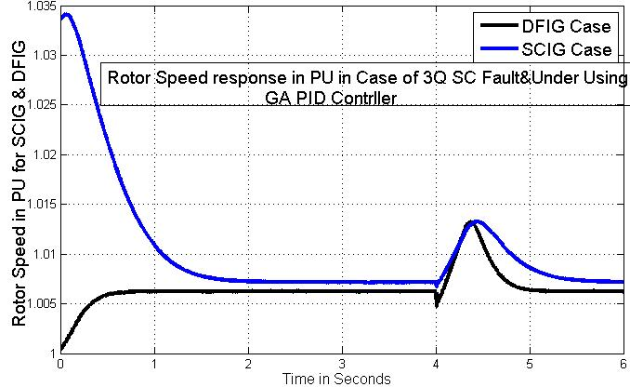
Fig. 12. DFIG & SCIG rotor speed in per unit.

VII. Conclusion
This research gives an overview about the different types of generators used in wind systems like DFIG and SCIG showing the difference between them and the performance of each during abnormalities like three phase short circuit fault. Also, a short description is provided showing the genetic algorithm technique idea and the main operation steps of it to get the suitable values of the PID controller gains. Finally, from the results and different analysis in this work, it’s highly recommended to use the DFIG in most of the wind systems due to its smooth performance and its ability to cope up with the system changes and disturbances.

References
- Griffin, I. and Bruton, J., 2003. On-line PID controller tuning using genetic algorithms. Dublin City University.
- Ben Smida, M. and Sakly, A., 2016. Pitch angle control for grid-connected variable-speed wind turbine system using fuzzy logic: A comparative study. Wind Engineering, 40(6), pp.528-539.
- Eckstein, R.H., Lazzarin, T.B. and Barbi, I., 2014. Proposed power and control system for small scale wind turbines connected to the grid.
- Ahuja, H., Sharma, S., Singh, G., Sharma, A. and Singh, A., 2016, February. Coordinated Fault Ride through Strategy for SCIG Based WECS. In Computational Intelligence & Communication Technology (CICT), 2016 Second International Conference on (pp. 424-429). IEEE.
- Mahony, T.O., Downing, C.J. and Fatla, K., 2000. Genetic algorithm for PID parameter optimization: minimizing error criteria. Process control and instrumentation, pp.26-28.
- Zoghby, H.M.E. and Sharaf, S.M., 2011. Dynamic Response of a Grid Connected Wind Farm with Different Types of Generators. International Journal of Power Electronics and Drive Systems (IJPEDS), 2(1), pp.85-98.
- Bakouri, A., Mahmoudi, H. and Abbou, A., 2016, November. Modelling and optimal control of the doubly fed induction generator wind turbine system connected to utility grid. In Renewable and Sustainable Energy Conference (IRSEC), 2016 International (pp. 807-812). IEEE.
- Harby, M.E.M., Elmasry, S.E. and El Samahy, A., 2017, December. Fault analysis and control of a grid connected wind turbine driving squirrel cage induction generator using genetic algorithm PID controller. In Power Systems Conference (MEPCON), 2017 Nineteenth International Middle East (pp. 1328-1332). IEEE.

10/25/2018

