A Study On The Bosnia And Herzegovina Geographical Weather Conditions And Natural Disasters Bosnia And Herzegovina monsoon Time Scale, Bosnia And Herzegovinanational Geoscope Project
Bosnia And Herzegovina weather Time Scale
Bioforecast & Irlapatism-A New Hypothetical Model Of Cosmology

Gangadhara Rao Irlapati

H. No.5-30-4/1, Saibabanagar, Jeedimetla, Hyderabad - 500 055, Telangana, India.
Email: scientistgangadhar@gmail.com

Abstract: Dominated by mountaneous and hilly terrain, and drained by major rivers to the north and east. Bosnia and Herzegovina has a climate that is as variable as the rest of the former yugoslova federation, with moderate continental climate. Conditions generally very cold winters and hot summers. Bosnia and Herzegovina resides in an area if active scismic accivity and earth tremors do happen a very so often, large scale earth quakes also occur. Flash floods and land slides etc disasters also hit the country. Bosnia and Herzegovinapossesses considerable water resources. There are many minerals such as bauxite, iron, and zinc and other brown coal, coke, lignite, barite, crushed stone, lime stone, salt, sand and gravel etc., available.
Keeping in view of all above geographical facts of the country, I have conducted many comprehensive studies on the Bosnia and Herzegovina weather conditions and natural calamities combined with my researches and proposed the Bosnia and Herzegovina Monsoon Time Scale, Bosnia and Herzegovina Weather Time scale and Bosnia and Herzegovina National Geoscope Project along with the other scientific results Bioforecast effect, Irlapatism-A New Hypothetical Model of Cosmology etc which can help to estimate the impending weather conditions and natural hazards of the country in advance to take mitigative measures and save the people, crops and other assets. For example-
By setting up the Bosnia and Herzegovina National Geoscope project and maintain, the country can be predicted the impending earthquakes(and / or storm surges, tsunamis, volcanic hazards etc geological hazards also) in advance. Earth’s underground mineral and water resources can still be found. Geoscope is also useful in emerging industries such as geothermal and geo-sequestration etc.
By establishing the Bosnia and Herzegovina Monsoon Time Scale and maintain, the country can be estimated the impending weather conditions and natural calamities rains, floods, landslides, avalanches, blizzard and droughts, extreme winter conditions, heavy rainfall, mudflows, extreme weather, cyclones, cloud burst, sand storms, hails, and winds etc in advance. Surface water resources can still be found.
[Gangadhara Rao Irlapati. A Study On The Bosnia And Herzegovina Geographical Weather Conditions And Natural Disasters Bosnia And Herzegovinamonsoon Time Scale, Bosnia And Herzegovinanational Geoscope Project Bosnia And Herzegovinaweather Time Scale Bioforecast&Irlapatism-A New Hypothetical Model Of Cosmology. Researcher 2018;10(9):74-104]. ISSN 1553-9865 (print); ISSN 2163-8950 (online). http://www.sciencepub.net/researcher. 9. doi:10.7537/marsrsj100918.09.

Key Words: Bosnia and Herzegovina Weather Time Scale, Bosnia and Herzegovina Monsoon Time Scale, Bosnia and Herzegovina National Geoscope Project, IRLAPATISM-A New Hypothetical Model of Cosmology, Bioforecast, Local Geoscope Centres, Regional Geoscope centres, Central Geoscope Centres.

1. Introduction:
The results of researches on Bosnia and Herzegovina such as Bosnia and Herzegovina Weather Time Scale, Bosnia and Herzegovina Monsoon Time Scale, Bosnia and Herzegovina National Geoscope Project, IRLAPATISM-A New Hypothetical Model of Cosmology, Bioforecast, Local Geoscope Centres, Regional Geoscope centres, Central Geoscope Centres are very useful in studying the weather conditions and natural disasters of the Country.

2. Bosnia And Herzegovinamonsoon Time Scale: Monsoon means a seasonal reversing wind accompanied by its corresponding weather changes and natural calamities in precipitation. We can not be said that a monsoon especially to be relevant to a particular country. Each and every country has its own monsoon winds and weather conditions. keeping in view of all above geographical facts and circumstances, after studying the weather conditions and natural disasters in the Afghanistan, I have invented the Bosnia and HerzegovinaMonsoon Time scale to estimate the weather conditions and natural calamities of surface of the country.
This is very useful to study the Bosnia and Herzegovinaweather changes and natural calamities such as monsoon movements, rains and other weather changes in advance. The Bosnia and Herzegovina Monsoon Time Scale – a Chronological sequence of events arranged in between time and weather with the help of a scale for studying the past’s, present and future movements of monsoon in the Bosnia and Herzegovina and its relationship with rainfall and other weather conditions and natural calamities of the country.
Prepare the Bosnia and HerzegovinaMonsoon Time Scale having 365 horizontal days from March 21st to next year March 20th of a required period comprising of a large time and weather have been taken and framed into a square graphic scale. The main weather events if any of the Bosnia and Herzegovinahave been entering on the scale as per date and month of the each and every year. If we have been managing the scale in this manner continuously, we can study the past, present and future movements of the monsoon and other weather and its weather conditions and natural calamities of the country. The Bosnia and HerzegovinaMonsoon Time Scale reveals many secrets of the monsoon and weather and its relationship with rainfall & other weather problems and natural calamities of the country.. The tracking date of main path & other various paths of the monsoon winds on the graph, denotes the onset of the monsoon and weather changes, monsoon pulses or low pressure systems, cyclones and other disturbances etc. And also we can find out many more secrets of the monsoon or weather conditions of the Bosnia and Herzegovinasuch as droughts, famines, cyclones, heavy rains, floods etc in the country by keen study of the Bosnia and HerzegovinaMonsoon Time Scale.
2.1. Uses:
By development of the Bosnia and HerzegovinaMonsoon Time Scale and maintain, the can be study and predict the monsoon movements, weather changes and its related impending weather conditions and natural calamities rains, floods, landslides, avalanches, blizzard and droughts, extreme winter conditions, heavy rainfall, mudflows, extreme weather, cyclones, cloud burst, sand storms, hails, and winds etc in advance.
2.3. Indian Monsoon Time Scale (1991):
For example, I have prepared the monsoon time scale for India by preparing the scale having 365 horizontal days from 1st April to next year March 31st of 128 years from 1888 to 2016 of the required period comprising of large time and weather have been taken and framed into a square graphic scale. The monsoon pulses in the form of low pressure systems over the Indian region have been entering on the scale in stages by 1 for low, 2 for depression, 3 for storm, 4 for severe storm and 5 for severe storm with core of hurricane winds pertaining to the date and month of the each and every year. If we have been managing the scale in this manner continuously, we can study the past’ present’s and future’s of the India Monsoon and its relationship with rainfall and other weather problems & natural calamities in India..
2.4. Analysis:
The India Monsoon Time Scale reveals many secrets of the Indian monsoon and its relationship with rainfall & other weather problems and natural calamities. For example, some bands, clusters and paths of low pressure systems along with the main paths of the Indian Monsoon (South-east monsoon and north-west monsoon) clearly seen in the map of the Indian monsoon it have been some cut-edged paths passing through its systematic zigzag cycles in ascending and descending orders which causes heavy rains & floods in some years and droughts & famines in another years according to their travel. For example, during 1871-1990’s, the main path of the Indian Monsoon was rising over June, July, August and creating heavy rains and floods in most years. During 1900-1920’s, it was raising over August, September and resulting good rainfall in more years. During 1965-2004’s it was falling over September and causing low rainfall and droughts in many years. At present it is rising upwards over June, July, August, September and will be resulting heavy rains & floods in coming years during 2004-2060. The tracking date of main path & other various paths such as south-east monsoon and north-west monsoon etc., of the Indian Monsoon denotes the onset of the monsoon, monsoon pulses or low pressure systems. And also we can find out many more secrets of the Indian monsoon such as droughts, famines, cyclones, heavy rains, floods, real images of the Indian monsoon, and onset & withdrawals of south east monsoon and north-west monsoon etc. by keen study of the Indian Monsoon Time Scale.
2.5 Principle:
This is an Astro-geophysical / Astro-meteorological phenomenon of effects of astronomical bodies and forces on the earth’s geophysical atmosphere. The cause is unknown however the year to year change of movement of axis of the earth inclined at 23½ degrees from vertical to its path around the sun does play a significant role in formation of clusters, bands & paths of the Indian Monsoon and stimulates the Indian weather. The inter-tropical convergence zone at the equator follows the movement of the sun and shifts north of the equator merges with the heat low pressure zone created by the rising heat of the sub-continent due to direct and converging rays of the summer sun on the India Sub-Continent and develops into the monsoon trough and maintain monsoon circulation.
We can make many more modifications thus bringing many more developments in the Bosnia and HerzegovinaMonsoon Time Scale. We can also make many more changes and development in the scales and make separate monsoon time scales in name of each and every Meteorological sub-divisions, Regions of the Bosnia and Herzegovinain accordance with the weather circumstances and natural calamities.

3. Bosnia And Herzegovinaweather Time Scales:
I have proposed the weather time scales for study the weather conditions and natural calamities of the country. Prepare the time scales for the entire country or region-wise or both, with 21 blocks. Each block should be divided into months and season wise analysis sections, containing certain prescribed cycle of years in which similar calendar years repeating one after another that leads similar weather conditions of those previous years to future years likely repeating every year approximately. The rainfall of the years, have been entering in the scale in percentages or as it is pertaining to month, season, annual wise of the each and every year. If we managing the scale in this manner continuously, we may assuming the weather conditions of the anterior years on the basis of the posteriors years weather. On the basis of the principle, we can assume that a considerable, of course it may be little chance of predication for an ensuing year by study the data of earlier years.
3.1. Uses:
Bosnia and HerzegovinaWeather Time Scale used to forecast the weather changes and rainfall etc in advance. All other meteorological natural hazards such as avalanches, cyclones, damaging winds, droughts and water shortage, floods, thunderstorms, tornadoes, tropical cyclones, typhoons etc can be predicted.
3.2 Principle:
I have conducted many extensive researches on the astronomical forces and its effects on the earth limate particularly on various regions of countries of the world. The variations in the solar cycle affects and stimulate the earth climate. The moon affects and stimulate the ocean tides and atmosphere too. The movement of axis of the earth inclined at 23 ½ degrees from vertical to its path around the sun affects and stimulate the earth weather and leads to formation of monsoons and seasons etc. So the astronomical forces affect and stimulate the earth climate it may be more or less but it is true. These scales may be taken as a part of scientific study of astronomical forces & its effects on the earth climate.
In the time and scale of the universe some things from astronomy to atom including living beings have been repeating once in every certain time or period. For example, the south and north magnetic poles have been shifting in every certain years of a period. The sun spots have been repeating once in every eleven years. The lunar and solar eclipses have also been occurring once in every 18.6 years. The seasons such as winter, autumn etc. also have been repeating once in every year in the same month of the year. The periodical menses in the females repeating once in every month.
3.3 Indian Weather Time Scale(1980):
For example, I have prepared a model Indian weather time scale along with hundreds of additional scales (1617 block scales, 12 months, 4 seasons, 50 regions & 150 above years were studied) in which all weather conditions such as rainfall, temperature, cyclones, river water etc of all homogeneous regions sub-divisions of India were studied and analyzed elaborately.
3.4 Studies Carried Out:
Firstly, see the Indian weather forecasting study model time scale. In this scale, the June, July, August and September months of the summer monsoon season were taken in a table in which the each month is also divided into three parts of the Telangana, Rayalaseema and Coastal Andhra regions. The monthly wise rainfall data of the months of the regions from 1870 to till available years are taken in the form of percentages or as it is and entering in the scale pertaining to the region wise of the each and every year. If we managing the scale in this manner continuously, we may assuming the weather conditions of the anterior years on the basis of the posterior years weather.
Example for assuming the dry season or suppose to predict the rainfall situation in the summer season of the ensuing year 2019: study the 7th cycle in which wet conditions in 10 years and dry conditions in 14 years were occurred in the month of June: wet conditions in 2 years and dry conditions in 22 years were occurred in the month of July: wet conditions in 4 years and dry conditions in 20 years were occurred in the month of August and wet conditions in 8 years and dry conditions in 16 years were occurred in the month of September. On the whole, wet conditions in 24 times and dry conditions in 72 times repeated in the summer monsoon season of the 7th cycle (As a result, there were dry conditions occurred in the 2002 year also). Therefore it is a considerable chance to predict that a dry season will be repeated in the ensuing year of 2019.
Example for assuming the wet season or suppose to predict the rainfall situation in the summer season of the ensuing year 2022: study the 10th cycle in which wet conditions in 13 years and dry conditions in 8 years were occurred in the month of June: wet conditions in 13 years and dry conditions in 8 years were occurred in the month of July: wet conditions in 9 years and dry conditions in 12 years were occurred in the month of August and wet conditions in 19 years and dry conditions in 2 years were occurred in the month of September. On the whole, wet conditions in 54 times and dry conditions 30 times were repeated in the summer monsoon season of the 10th cycle. As a result, there were wet conditions occurred in the 2005 years also. Therefore, it is a considerable chance to predict that a wet season will be occurred in the ensuing year of 2022.
In the same manner, we can study the remaining all Indian weather time scales of all Indian Homogeneous regions and subdivisions, states and districts of india. These may be useful in making and study the Bosnia and Herzegovinacountry weather.

4. Bosnia And Herzegovinanational Geoscope Project:
Keeping in view of all above facts and circumstances, After studying geological conditions and disasters in the Afghanistan, I have proposed the Bosnia and HerzegovinaNational Geoscope Project to estimate the earthquakes and underground mineral and water resources of the country.
This is very useful to study the Bosnia and Herzegovinaunderground mineral and water resources and natural calamities such as earthquakes (storm surges, tsunamis etc if the country has sea boundaries) in advance. The Bosnia and HerzegovinaNational Geoscope project is a mechanical architecture established in between the underground and observatory with the help of bore-well set up at three level centers i.e., Local Geoscope Centre, Regional Geoscope Centre and Central Geoscope Centre for maintaining the system in a coordinated manner for the entire country, proposed for conducting geological studies to know the earthquakes, ores and water currents etc. and natural calamities of the country.
G.R. Irlapati’S Geoscope(1987): For exampleI have conducted many researches on the earthquakes during the year of 1980-87 and invented the Geoscope which can help to forewarn the earthquakes in advance.
Geoscope means- a mechanical architecture established in between the underground and observatory with the help of bore-well proposed for conducting geological studies to know the earthquakes, underground mineral and water resources etc.
A borehole having suitable width and depth has to be dug. An observatory having research &analysis facilities has to be constructed on the borehole Apparatus & sensors to recognize the geo- physical and geo-chemical changes generated in the underground such as foreshocks, chemical changes, electrogeopulses, micro-vibrations, pressure, geomagnetic forces etc should be inserted into the underground and linked with the concerned analysis sections of the observatory that is above the ground to study the changes taking place in the underground.
That means-relative results of geological & geographical researches &developments of past, present and future should be interposed, coordinated and constantly developed. The apparatus related to the geology and geography such as Richter scale etc also should be set in the observatories of the Geoscope. we can make many more modern ideas& modifications thus bringing many more improvements & developments in the Geoscope.
And we can build many more types of Geoscopes thus connecting many more levels for national wide network, more and required geoscope centers should be established in the earthquake zones of the Bosnia and Herzegovinawhere earthquakes occur frequently and there should be establish a central office to co-ordinate and codify the data of warnings about the onset of earthquake. The central office should analysis the data and estimate the time, epicenter, area etc details of the impending earthquake and send to the authorities and people to take precautions.
4.1 Uses:
Geoscope can help to forewarn the earthquakes 6 to 18 hours in advance and also used to detect the mineral and, water resources of underground of the country. Storm surges, tsunamis, volcanic hazards etc geological hazard can still be predicted if the country has sea boundaries.
Earth’s underground resources like metallic resources such as iron, gold, silver, tin, copper, nickel, aluminum, chromium etc mine sites and non-metallic resources like sand gravel, gypsum, halite, uranium, dimension stones, etc. can be found. And
Geoscope is also useful In emerging industries such as geothermal and geo-sequestration etc.
Many kinds of super high remote sensing technology in the area of sensor physics, signal processing used specially image processing, electromagnetic detection technology etc should be used in the Geoscope.
Geophysical deep underground detectors and mineral exploration equipments, natural gas sensors etc should be used in the Geoscope.
Electromagnetic sensors may also be used in the Geoscope project.
4.2. Bosnia And Herzegovinanational Geoscope Project:
Many extensive researches were conducted on the national geoscopic forewarning system to detect the geological changes in advance. In this system, there should be established three level centers i.e., Local Geoscope Centre, Regional Geoscope Centre and Central Geoscope Centre for maintaining the system in a coordinated manner for the entire country of the Afghanistan.
4.3. Local Geoscope Centre:
One or more required number of Geoscopes should be established in the every expected earthquake zones of the Afghanistan. The observation personnel in the respective local Geoscopes should watch the onset of earthquakes day and night.
4.4 Regional Geoscope Centre:
There should be established some Regional Geoscopic Centre at important earthquake regions of the Bosnia and Herzegovina to co-ordinate and codify the information supplied by the local geoscopic centers of the earthquake zones of the Afghanistan.
4.5 Central Geoscope Centre:
There should be established a Central Geoscopic Centre to co-ordinate and codify the information supplied by the Regional Geoscopic Centers from all over of the country of the Bosnia and Herzegovinain a coordinated manner.
4.6 Performance:
Whenever a Local Geoscopic Centre sends warning about the onset of earthquakes, the observation personal should immediately send the information to its Regional Geoscopic Centre. The Regional Geoscopic Centre should analysis the information and send it to the Central Geoscopic Centre. The Central Geoscope Centre analyze the information supplied by the Local Geoscopic Centers, Regional Geoscopic Centers and estimates the epicenter, time, area to be affected urban places etc., details of the impending earthquake and send to the authorities, and media and warnings in advance to take precautions.
4.7. Types Of Geoscope Models
4.7.1 Simple Geoscope:
This is a simple construction involving no expenditure. A deep well having suitable width and depth has to be dug. Construct a room over the well. Wash the inner walls of the room with white Lime. Fix an ordinary electric bulb in the room.
4.7.2.Home Made Geoscope:
This construction involves no expenditure. Even students, children’s and science enthusiasts can make the Home-Made Geoscope and detect the earth-quakes 24 to 28 hrs in advance. By making certain changes and alterations, the house having a well can be converted into a Geoscope i.e., wash the inner walls of the house with white Lime. Fix ordinary electric bulbs in the room.
4.7.3 Performance:
Observe the colour of the room lighting daily. When the bulb glows, the light in room generally appears white in color, but before occurrence of an earth-quake, the room lighting turns blue in colour. The onset of earth-quake can be guessed by this “Seismic luminescence Emission”.
4.7.4 Principle:
Due to stress of continental plates and some other reasons on a place where there are favorable chances for earth-quake to occur, the pressure is induced in the underground. As a result, there is a steady rise in the pressure around the focus centre. Because of the large disparity in the magnitude of energies involved, gas anomalies such as (a) Helium emission (b) chemicoseismic anomalies of sulphur, calcium, nitrogen etc., chemical compounds (c) seismic atomic radiations of radioactive mineral compounds show up much earlier even at large distance from the epic-centre which enter the well through the underground springs. These gas anomalies occupy the room in this manner; emit radiation which gives blue colour (some times red) to the room.12.
4.8. Micro Geoscope:
Micro-Geoscope is an elaborate construction. For this model a deep bore-well having suitable width and depth has to be dug. An observatory having the most modern high-technological research facilities has to be constructed on that well. Most modern mechanical systems like electronic, physical and chemical sensors and apparatus to recognize the rise and fall of the underground water levels, micro-vibrations and waves generated in the underground, differences in pressure, temperature and other seismic activities should be inserted into the underground and linked with the concerned research analyzing departments of the observatory that is above the well to observe the seismic changes taking place in the underground. The results of researches on the quakes like Richter scale etc., also should be setup in the Geoscope. That means relative results of past, present and future pertaining to the earthquakes or seismic researches should be interposed, co-ordinate, and constantly developed. We can make many more changes thus bringing many more developments in the geoscope.
Observe the geophysical & geochemical changes such as foreshocks, chemical changes, ground water levels, strain in rocks, thermal anomalies, fractroluminescence’s gas anomalies, electrogeopulses, micro-vibrations, pressure, geomagnetic forces, etc taking place in the underground. The onset of earthquakes can be guessed by observing the aforesaid changes in the concerned analyzing departments of the observatory.
4.9. Studies:
I have proposed many type of studies to study the earth’s underground through the Geoscope. At present we discuss about two types of studies of many of them.
4.9.1.1 Seismic Luminescence Study:
This is a very easy and simple study in the Geoscope Project. Construct a room over a well having suitable width and depth. Wash the inner walls of the room with white lime. Fix an ordinary electric bulb in the room. (Otherwise by making certain changes and alternations any home or office having a well can be converted into the Geoscope. Wash the inner walls of the house with white lime. Fix an ordinary electric bulb but don’t fix fluorescent lamp in the house. This method involves no expenditure).
Observe the colour of the lightning in the Geoscope room daily 24 hours 365 days. When the bulb glows, the lightning in the room generally appears as white (reddish). But before occurrence of an earth-quake, the room lightning turns violet in colour.
Because, before occurring of an earthquake-gas anomalies such as radon, helium, hydrogen and chemico-mineral evaporations such as sulphur, calcium, nitrogen and other fracto-luminescence radiations show up earlier even at large distances from the epicenter due to stress, disturbances, shock waves and fluctuations in the underground forces. These gas anomalies & fracto luminescence radiations and other chemical evaporations enter into the well through the underground springs. When these anomalies occupy the room above the well, the room lighting turns violet in colour. The light in the room scattered in the presence of these gas anomalies, fracto-luminescence radiations and other chemico-mineral evaporations the ultra violet radiation is emitted more and the room lighting turns in violet colour. Our eye catches these variations in the radiation of the lighting in the room easily since_
- The violet rays having smaller wave length.
- The violet radiation having property of extending greatly.
- The light becoming weak in the violet region.
- The eyes having greater sensitivity to violet radiation.
Due to all reasons the room may appear violet in colour then we can predict the impending earth quakes 12 hours in advance.
4.9.2 Electro Geopulses Study:
This is also easy study to recognize the impending earth quake. A borehole having suitable width and depth has to be dug. An earth wire or rod should be inserted into the underground by the borehole and linked with the concerned analysis section having apparatus to detect, compare measure of the electric currents of the electric circuit of the earth systems. Otherwise by observing the home electric fans. etc. We can also study the electrogeopulses studies to predict the impending earth quake.
Observe the changes in the electric currents of the earth system 24 hours, 365 days. From a power station, the electricity is distributed to the far-off places. Normally the circuit of the power supply being completed through the earth system. Whenever if the disturbances occurs in the layers of the earth’s underground, the fluctuation rate will be more due to the earth quake obstructions such as pressure, faults, vibrations, water currents etc., of the earth’s underground. So we can forecast the impending earth quake by observing the obstruction of electric currents of circuit of the earth system in the observatory of the Geoscope and also by the obstruction sounds in the electric fans etc.
4.9.3 Super High Remote Sensing Technology Studies
Geoscope is also useful In emerging industries such as geothermal and geo-sequestration etc.
Many kinds of super high remote sensing technology in the area of sensor physics, signal processing used specially image processing, electromagnetic detection technology etc should be used in the Geoscope.
Geophysical deep underground detectors and mineral exploration equipments, natural gas sensors etc should be used in the Geoscope.
Electromagnetic sensors may also be used in the Geoscope project.
4.9.3 Conclusion: We can make many more modifications thus bringing many more developments in the Geoscope.

5. Bioforecast(1965):
I have conducted many researches on the bio forecasting methods and invented the bioforecast effect in 1965 by keen study and observations of the lisposcope experiments biolumicells studies. Although weakened by forecasting property with less successive rate, it is a primary and natural forecasting method. This is my invention which can help to forecast the weather changes 18 days in advance..
5.1 Uses:
Although weakened by forecasting property with less successive rate, it is a primary and natural forecasting method. This is my invention which can help to forecast the weather changes 18 days in advance.
5.2 Lisposcope: I first started the researches in 1963-65 @ 5 to 7 years age with little instruments such as papers and pencils, water drop etc. and invented the light spot scope (Liposcope). Liposcope is a simple but wonderful instrument which functions with a natural doctrine hidden secretly in the function of the eye which can help to find out some inventions and discoveries like biolumicells, bioforecast effect etc, Liposcope is my first invention.
Construction: Take one small glass/steel ball or water drop on an object and stand in sun the light. Expose the ball/drop to the sun rays. As a result of the sun rays, there will be a light spot in the drop/ball. Place the light spot closely to the eye. The light spot apperars many times bigger as a circular screen. The appearance in the screen of light spot is the surface of the eyeball. This can be proved by moving eyelids, the movement of eyelids, eye water and some bioluminescent particles on the eyeball can be observed in the screen of light spot.
Principle: The principle of the lisposcope is that the eye lens changes its focal length from a minimum distance to the object at infinity and can see the object. If the distance decreases below minimum, the clarity of vision decreases. At this position, the eye lens acts as a simple microscope and form virtual images of all objects in front of it. We can see them on the screen of light spot if place just unside its minimum distance.
5.3 Biolumicells:
I have discovered the biolumicells (Bioluminescentmicells) on the eyeball in 1964 in the Lisposcope experiments. These particles are a part and parcel of the human body, may be released within the human body and secreting to the eyeball through the eye water. This is my second invention.
In the lipscope observations we can see three types of bioumicells on the eyeball the first one is the most bright and active and it is seen rarely on the eyeball and this biolumicell is has high velocity, mechanical energy, spin around itself it. The second one has normal bright seen normally on the eyeball and the third and last one is bright less, it is seen frequently on the eyeball.
Looking the screen of light spot and move the eyelids. We can see some biolmicells on the eyeball. After finding a number of biolumicells all at once in cloud or group, you must count them without eyelid movement. Firstly, observe with one eye two or three times. Later on another eye. As we examine one after another with both eyes, we have to take into account the greatest number of particles.
Analyze the data and make a table with the particulars-date of observation, time of observation, number of particles and weather report. Firstly we must put the date, next the time of observation, then the number of particles available in the observation. Do the observations three or four times daily in the morning & evening and record the number. At last, record the weather report of the country on the same day. If we do our observations and analyze in that manner, we can notice that there is a relation between the differences in particles number in the table and the changes in the weather after about 18 days. If the particles number is minimum the weather after 18 days will be normal. On the other hand if the particles number is at maximum there will be a change in the weather after 18 days.
Principle: The cause is unknown however it can understand that generally biolumicells secrete in less or minimum levels at normal weather conditions, but over the formation of low pressure weather conditions, biolumicells begin to secrete at maximum levels due to a fall in weather pressure on the human body.
5.4 Experiments Carried Out:
Many experiments were carried out on the liposcope, biolumicells and its bioforecasting methods & it were successfully proved out in practice.
Great Prediction: The important prediction of the bioforecast effect was proved in 1991. In 1991, the Andhra Pradesh state council of science & Technology, The Andhra Pradesh Remote Sensing Applications Centre and the Andhra Pradesh Science Centre were conducted experiments on the relationship between the biosphere and atmosphere (explore the inter-connection of earths geomagnetic field with natural calamities and their effect on human impulse). In these observations, the maximum level of the biolumicells were recorded between 7th to 11th of April, 1991. It is the sign of the ensuring cyclone of the 28th April 1991. The three directors of the said institutions were met in the Andhra Pradesh state Council of Sciences & Technology on 9TH, April 1991 and discussed about the prediction. As predicted on 9th April 1991, in the meeting a severe cyclone was formed in Bay of Bengal and struct the Bangladesh on 28th April 1991. As a result, thousands of people were killed and crores of rupees property was damaged. This is the great prediction by the bioforecast and the remaining predictions were weak.

6. Irlapatism-A New Hypothetical Model Of Cosmology:
There are many space disasters also cause damage to the human beings hence it is necessary to know about the universe. The cosmos is made up of universes in infinite number, having similar structure and properties, embedded one in each other and extended in ascending and descending order. To explain and justify this model, there are three universes so far known to us (a) Geo-Universe (b) Atomic-Universe (c) Energy-Universe. These three are having similar structure and properties, embedded one in each other and extended in ascending and descending order. Of these three, we known some extent about the internal structure and properties of the Geo-Universe but we do not known its external structure. We know some extent about the external structure and properties of the Energy-Universe but we do not know its internal structure. Between of these three universes, we came to know a large extent about the internal & external structure and properties of the Atomic-Universe. Hence, I have taken the similarities of internal structure & properties between the Geo-Universe & Atomic-Universe to propose that all the universes in ascending and descending order of the creation are having similar internal structure and properties. The similarities of external structure & properties between the Atomic Universe and Energy-Universe are taken to propose that all the universe in ascending and descending order of creation are having similar external structure and properties. And the manner in which of these three universes i.e., embedded one in each other, extended in ascending and descending order to propose that all the universes in ascending and descending order of the creation are embedded one in each other and extended in ascending and descending order.
6.1 Similar External Structure & Properties
According to the model, all the universes in ascending and descending order of the creation are having similar external structure and properties. To justify this, I have taken many similarities between the atom and photon. For example:

Atomic-Universe | Energy-Universe
1) The atom appearing in several forms such as Hydrogen to uranium etc., being due to the Internal structure having different atomic particles at various numbers | 1) The particle “Photon” related to energy appearing in several forms such as radio waves, gamma rays, violet rays etc being may be probably due to the internal structure having different particles at various numbers.
2)The atom exhibiting several physical and chemical Properties such as weight, colour, taste, hardness etc being due to the internal structure having different particles at various number. | 2)The particle “photon” related to energy exhibiting properties such as wave length, colour, temperature etc being may be Probably due to the internal structure having different particles at various number.

6.2 Similar Internal Structure & Properties
According to the model, all the universes in ascending and descending order of the creation are having similar internal structure and properties. To explain and justify this, I have taken many similarities between the atomic-universe and Geo-Universe.

Atomic-Universe | Geo-Universe
1) Various atomic particles at different sizes in several numbers are present in the atom. | 1) Various astronomical objects at different sizes in several numbers are present in the Geo-Universe.
2) These atomic particles having three types of charges at negative, positive and neutral states are present in the atom. | 2) These astronomical objects having three type of charges at positive, negative and neutral states are present in the Geo-Universe
3) Positively charged protons are present in the nucleus. | 3) Stars built by atoms having positive charged nucleus are present in centre of the Geo-Universe
4) Neutrons at neutral state are present in the Nucleus. | 4) Planets at neutral state are present in Centre of the Geo-Universe.
5) Negatively charged electrons are present at large distance of the atomic nucleus in the atom | 5) There is a concept that anti-matter cosmic bodies built by atoms having negatively charged nucleus are present at large distance of the Geo-Universe.
6) Additional neutrons called isotopes are present. | 6) Additional planets called satellites around the planets are present.
7) Radiation emitting from the atom. | 7) Cosmic rays emitting from the Geo- Universe.
8) There is a property of nuclear fission is in the atom. | 8) There is a property of super Nova is in the Geo- Universe.

6.3 Descending Order Of Creation
The Geo-Universe that means the Universe seen around our earth is having magnificent structure and properties such as galaxies, stars and planets and some planets such as earth having continents, countries, oceans, trees, animals. Cyclones, human beings etc. Such Geo-Universe being built by Universes of its descending order of creation that means atoms.
Atomic-Universe that means the atom present in several forms from hydrogen to uranium etc is another universe having magnificent structure and properties such as electrons, protons, neutrons, etc., and continents, countries, oceans, cyclones, trees, animals, human beings may be present on some neutrons having suitable conditions exactly similar to the earth planet resembling in the Geo-Universe. Such atomic Universe being built by universes of its descending order of creation that means energy particle ‘photons”.
The Energy-Universe that means the particle “photon” related to energy present in several forms of electromagnetic radiation is also another universe having magnificent structure and properties resembling to Geo-Universe and atom. Such Energy-Universe may also being built by Universes of its descending order of creation that is not yet known to us.
Thus the descending order of creation continuous infinitely.
6.4 Ascending Order Of Creation
The Energy-universe that means the particle related to energy “photon” having magnificent structure and properties is being as a primary syntactic unit in the universe of its ascending order of creation that means atom. All components in the atom are built by these “photons” in infinite number. Such each and every energy particle “photon” is basis to an infinite descending order of creation.
The Atomic—Universe that means the “Atom” having magnificent structure and properties is being as a primary syntactic unit in the universe of its ascending order of creation that means in our Geo-Universe. All components in the Geo-Universe such as stars, planets etc., are built by these atoms in infinite number. Such each and every atom is basis to an infinite descending order of creation.
The Geo-Universe that means the “Universe” seen around our earth having magnificent structure and properties is being as a primary syntactic unit in the universe of its ascending order of creation that is not yet known to us. All components in that Universe are built by these Geo-Universes in infinite number. Such each and every Geo-Universe in that ascending creation is basis to an infinite descending order of creation.
Thus the ascending order of creation continuous infinite.
6.5 Cosmic-Environments
The fill of structure and characteristics in the universe of the cosmos proposed as cosmic environments. For example the fill of structure and characteristics like galaxies, stars, planets etc in the Geo-Universe proposed as Geo-Environment, the fill of structure and characteristics like proton, neutrons and electrons etc in the Atomic-Universe proposed as Atomic-Environment and the fill of structure and characteristics in the Energy-Universe that means in the photon that is not yet known proposed as Energy-Environment.
6.6 Space Weather
The fill of structure and characteristics like galaxies, Stars, Planets and their orbits and other physical forces etc that surrounds in the universe proposed as space atmosphere, the state of galaxies, stars, planets, nebulas. Pulsars etc at a particular region over a long period of time proposed as space-climate, the state of characteristics of space- climate like solar wind flares, asteroids etc at a particular region during a short period of time proposed as space-weather.
6.7 Space Regions
The state of space atmosphere being in still proposed as “Inactive Space Region”, the state of space atmosphere being in active proposed as “Active Space Region” The region of space atmosphere in which the celestial bodies are more widespread areas proposed as “Space High Pressure Area”, the less widespread areas proposed as “ Space Low Pressure Area”.
6.8 Space Low Pressure Systems
Some space times, happens variation of differences of pressure in the space-climate, At such a juncture, the celestial bodies and other space dust present in the space high pressure area will try to occupy the space low pressure area all at once. In this attempt, they will whirl around the space low pressure area. The centre of space low pressure area itself is the black-hole and the circular whirling celestial bodies & other space dust etc caused by the space low pressure area proposed as Galaxy.
6.9 Space Disaters
Geomagnetic storms caused disturbed the earth’s weather and magnetosphere caused by the solar winds. Several space weather phenomena just like solar energy particle events, geomagnetically induced currents, ionosheric disturbances that cause radio and rador scintillations, disruption of navigation by magnetic compass and electrical systems, communications, satellite hardware damage, mains electricity grid, geological explorations, pipe linesand common radiation like heat heatwaves, extreme temparatures, airburst etc to human due to intense solar flares release very high particles that can cause radiation poisoning to human.

7. Solar Flares: Solar flares are a brief eruption of intense high energy radiation from the sun’s surface, associated with 11 years sun spots cycle and causing radio and magnetic disturbances and also high temparatures, heat waves on the earth.

8. Conclusion:
We can make many studies on the weather conditions and natural calamities of the country thus inventing many more forecasting systems and proposing mitigative measures for the welfare of people of the country Afghanistan.

Note:
This article was published before as: [Gangadhara Rao Irlapati. A Study On The Bosnia And Herzegovina Geographical Weather Conditions And Natural Disasters Bosnia And Herzegovinamonsoon Time Scale, Bosnia And Herzegovinanational Geoscope Project Bosnia And Herzegovinaweather Time Scale Bioforecast&Irlapatism-A New Hypothetical Model Of Cosmology. Academ Arena 2017;9(1s): 324-354]. (ISSN 1553-992X). http://www.sciencepub.net/academia. 17. doi:10.7537/marsaaj0901s1717.

References
1. Mooley DA, Shukla J(1987); Charecteristics of the west ward-moving summer monsoon low pressure systems over the Indian region and their relationship with the monsoon rainfall. centre for ocean-land atmospheric interactions, university of Maryland, college park, MD.
2. All india monthly and seasonal rainfall series, 18711993, B. Parthasarathy, A. AMunot, D. R. Kothawale, Theoritical and applied climatology,1994, Springer.
3. Das P. K. and B. L. Bose,1958, Numerical study of movement of monsoon depression, Ind. journal of meteor. geophysics.
4. Analysis of variability and trends of extreme rainfall events over india using 104 years of gridded daily rainfall data, M. Rajeevan, J. Bhate, A. K. Jaswal, Geophysical Research letters,2008, online library.
5. Jadhav, S. K. and A. A. Munot,2004; statistical study of the low pressure systems during summer monsoon season over the Indian region, mausam,55,15-30.
6. Clusturing of low pressure system during the Indian summer monsoon by intra seasonal oscillations, bn. goswani, rs. ajaya mohan, prince kxavier, and d. sengupta, centre for atmospheric and oceanic studies, Indian institute of science, bangolour, india.
7. Composite structure of monsoon low pressure system and its relation to Indian rainfall, v. krishna murthy and rs. ajaya mohan, 2010, j. climate,23,4285-4305.
8. Indian monsoon university of st Andrews www.andrews.ac.uk/dibz/asia/monsoon/html.
9. Indian monsoon /meteorology/britanica/.com www.britanica.com/science /indian monsoon.
10. The global monsoon system: research and fore cast; caos. iisc. in/ faculty/ bng/ iwm-iii-bng-overview.
11. Climate predictron centre-global monsoon; www.cpc ncep. noaa. gov, climate.weather
12. The global monsoon system, www.wcrp-climate.org/documents/ monsoon –factssheet.
13. www/en-wikipedia.org/wiki/cyclic model
14. The Steinhardt-turok model.
15. The Baun-frampton model.
16. Loop quantum cosmology.
17. En.wikipedia.org/wiki/multiverse.
18. Heliocentric model.
19. Geocentric model.
20. Copernican model.
21. Heliocentric model vs geocentric model.
22. en.wikipedia.org/wiki/big bang theory
23. en.wkipedia.org/wiki/steadystate theory
24. www.astro.ucla.edu/-wright/steady stat
25. www.ncdc.noaa.gov/data-access/numerical-weather-prediction
26. En.wikipedia.org/wiki/numerical- weather- prediction
27. The history of numerical weather prediction –NOAA.
28. Fundamentals of numerical weather prediction/ebooks.cambridge.org
29. Ken ring, the moon and lunar science predict weather.
30. Moon predict weather lore / www.almanac.com/content/moon-lore-weather
31. Climate change, sunspots activity & lunar /cosmic cycles (www.the longerview. com.au/sunmoon-climate.html.
32. Astrometeorology & agriculture by Robert nelson.
33. Marvis. Dr. H. B. journal American(NY)1 oct 1938.
34. Goss, M. J. geophysical reviews, march 1953.
35. Jevons. w. s. nature,14 nov 1878.
36. Hove, JimTen, astrological journal 15(3)17-23.
37. Luby, w. A. popular Astronomy dec 1940.
38. Nelson. J. H. cosmic pattern, their influence on man and his communications 1974 American federation of astrologers.
39. Nelson J. H, RCA review, April 1951.
40. Nelson JH, J. geocosmic research, summer 1974.
41. Meteorology astrology (Astrometeorology) lewis. james. R, march 2003, astrology book 2003, p453.
42. www.physics for ums.com/threads/astro-meteorology
43. Improved seasonal drought forecasts using reference evapotranspiration anomalies, danielj, MCEvoy, justin l Huntington, john F Mejia, Michael T Hobbins, geophysical research letters,14-1-2016.
44. Encyclopedia of solid earth physics geophysical journal international,129,319-329.
45. Operational earth quake forecasting.
46. Advances in geophysics volume 28B books.google.co.in
47. System earth via geodetic-geophysical space techniques-frank M Flenchtner, Thomas gruber, andreas guntner-2010, science forecasts.
48. Department of meteorology and geophysics (www.univie.ac@department of meteorology and geophysics.
49. Shear-wave splitting: New geophysics and earth quakes; link springer.com
50. Operational earth quake forecasting www.geos.ed.ac.uk
51. www.quakefinder.com.
[Gangadhara Rao Irlapati. A Study On The Bosnia And Herzegovina Geographical Weather Conditions And Natural Disasters Bosnia And Herzegovinamonsoon Time Scale, Bosnia And Herzegovinanational Geoscope Project Bosnia And Herzegovinaweather Time Scale Bioforecast&Irlapatism-A New Hypothetical Model Of Cosmology. Academ Arena 2017;9(1s): 324-354]. (ISSN 1553-992X). http://www.sciencepub.net/academia. 17. doi:10.7537/marsaaj0901s1717.

Appendicies (Irlapatism)
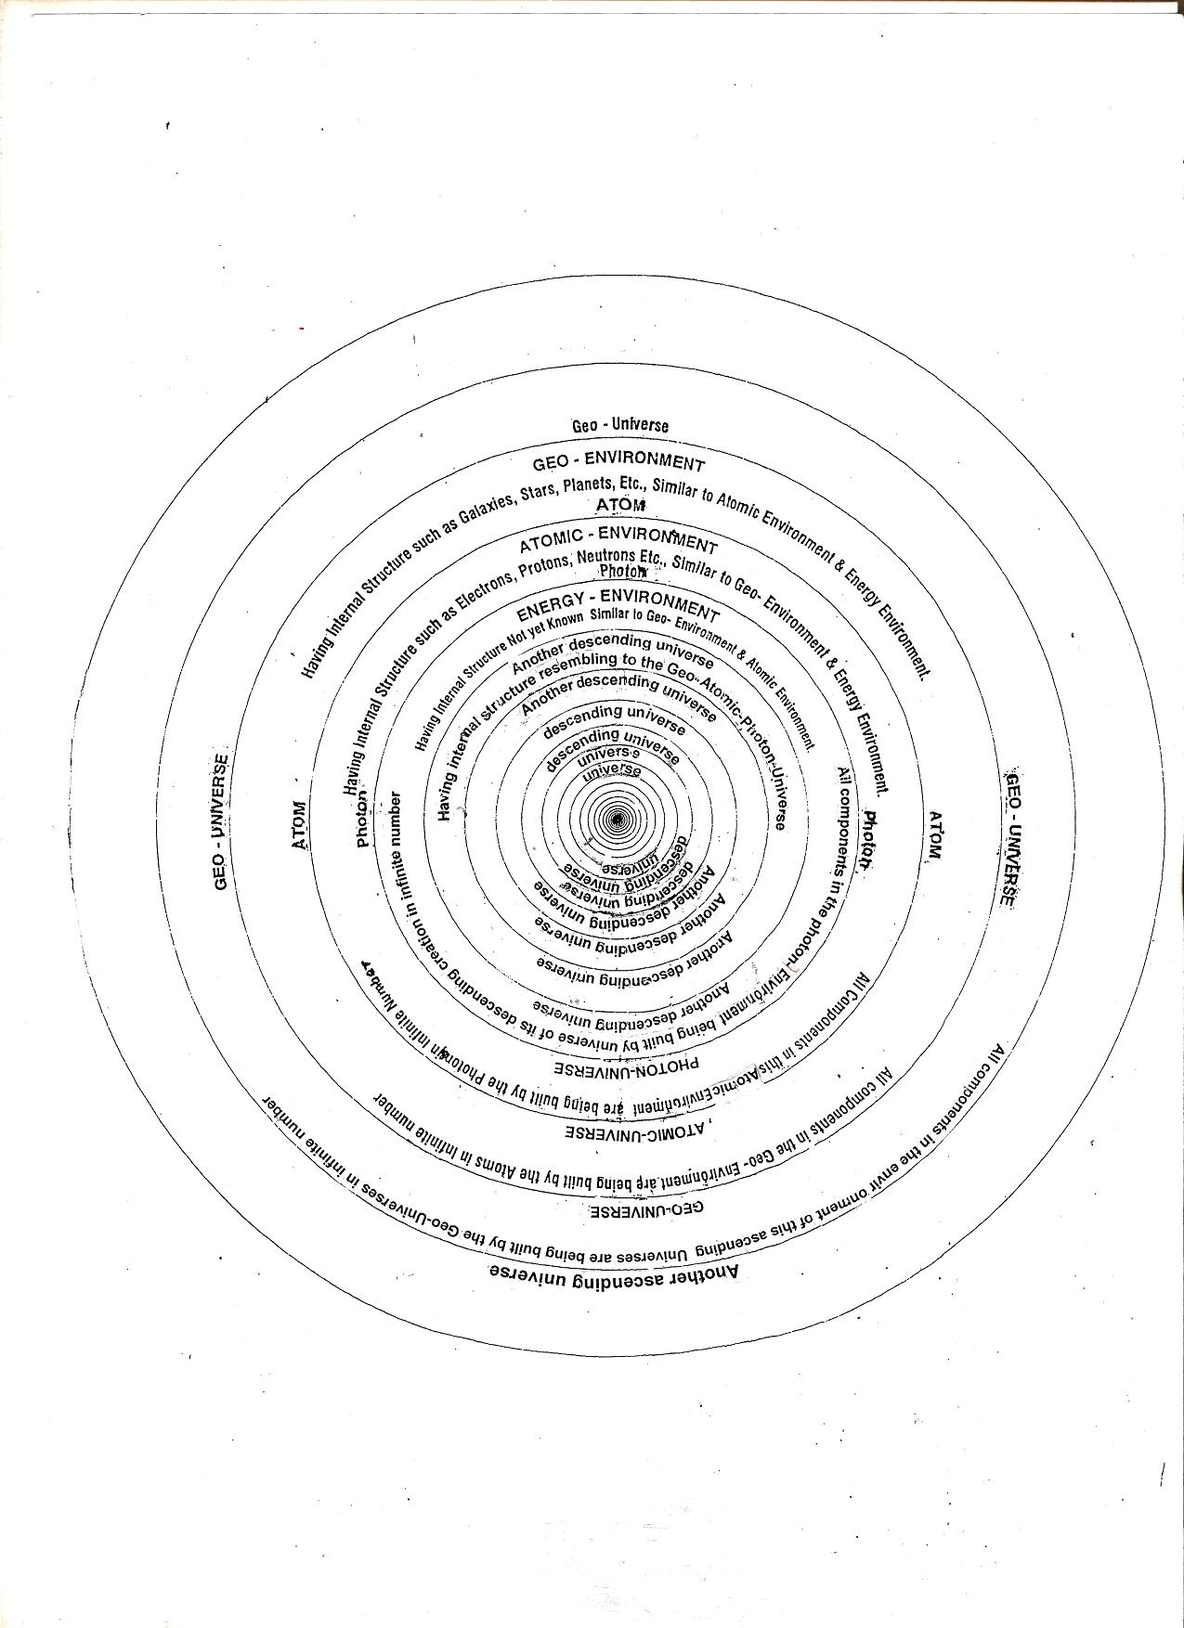

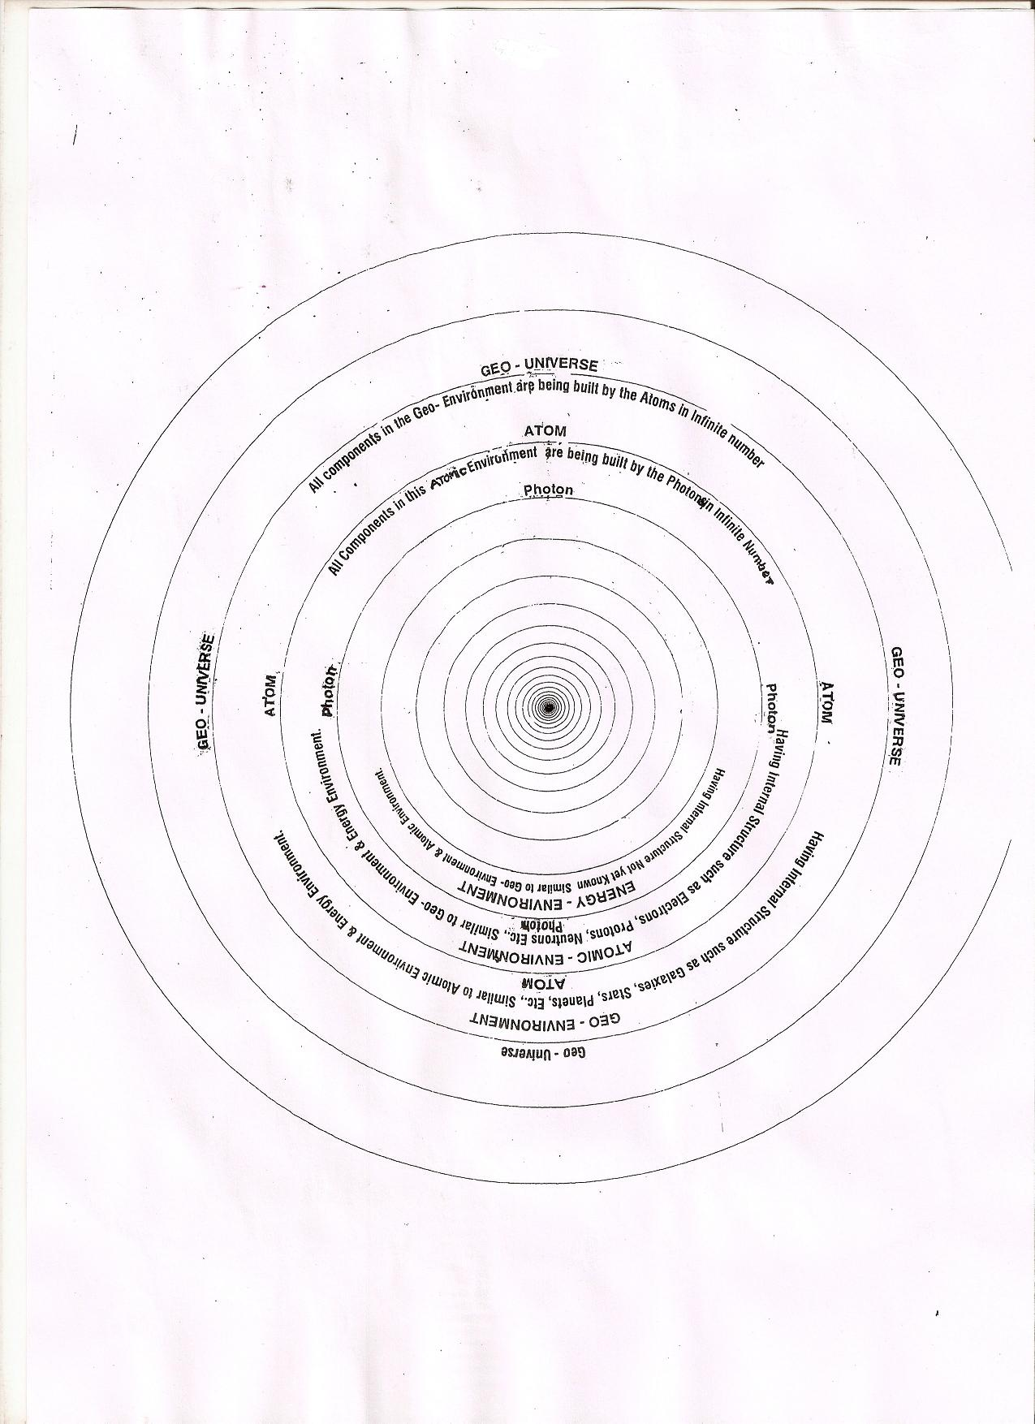

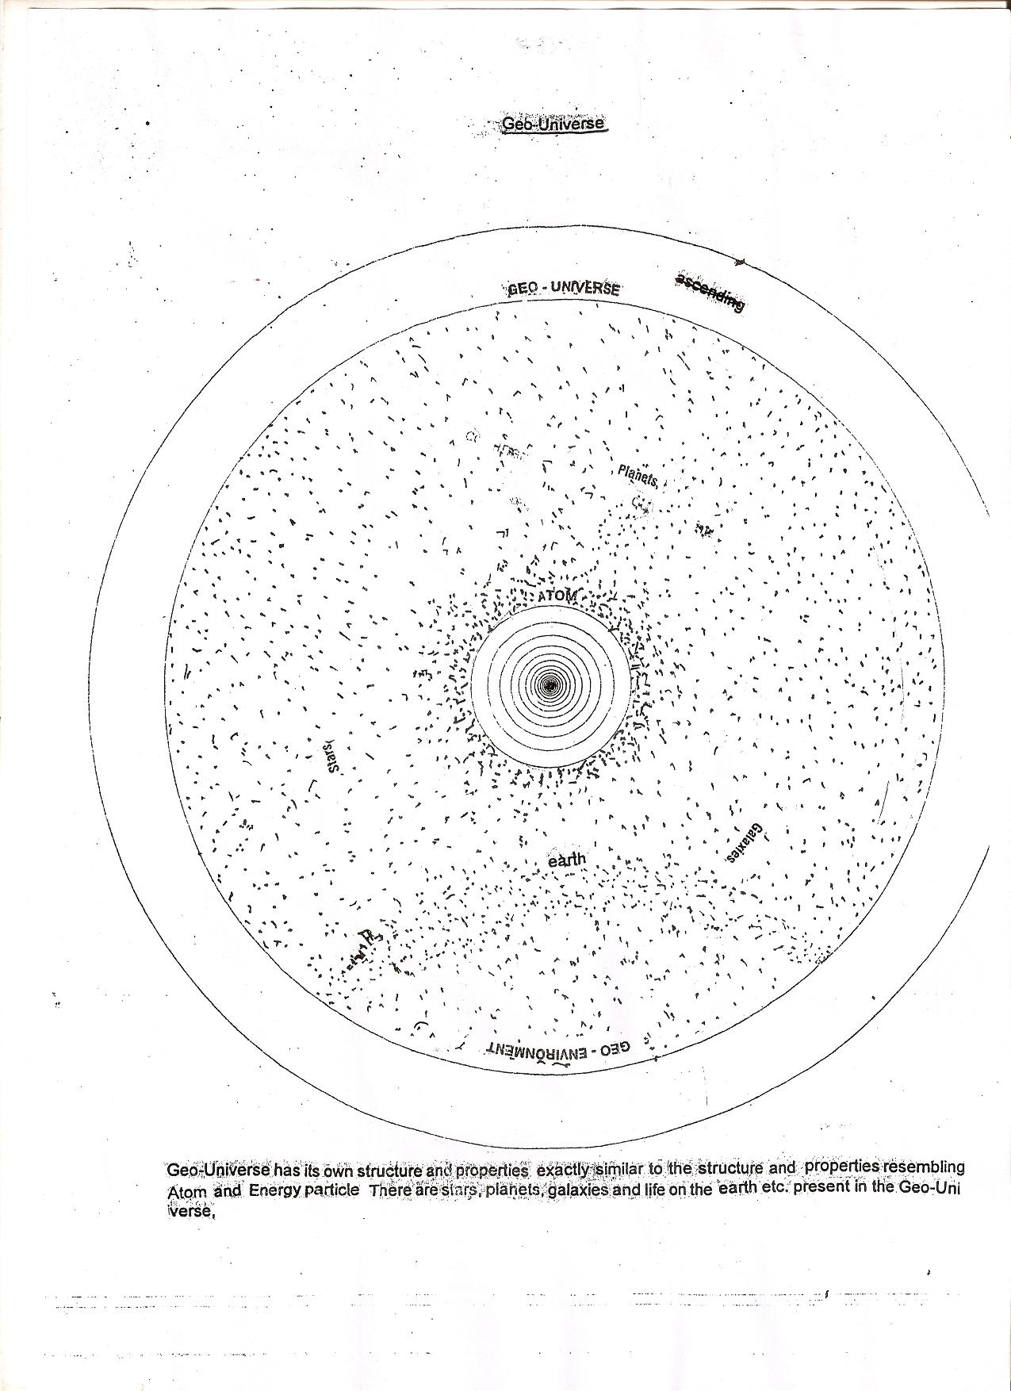

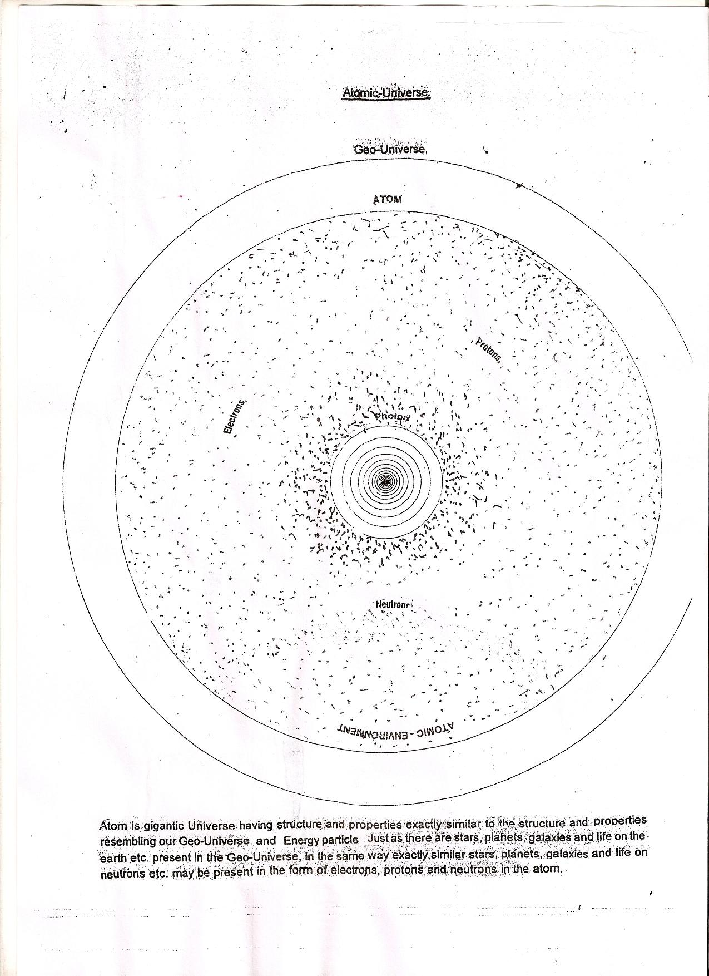

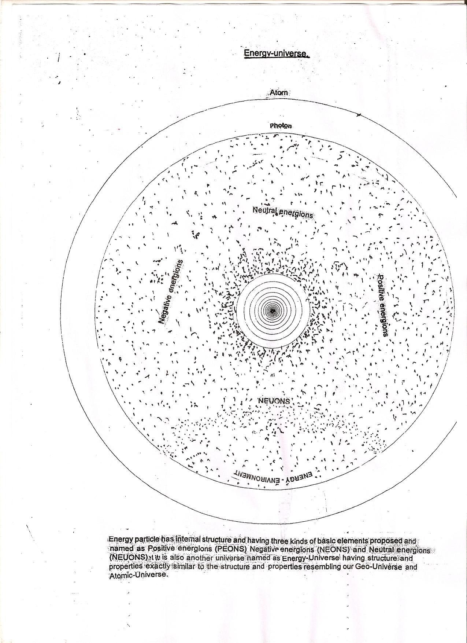

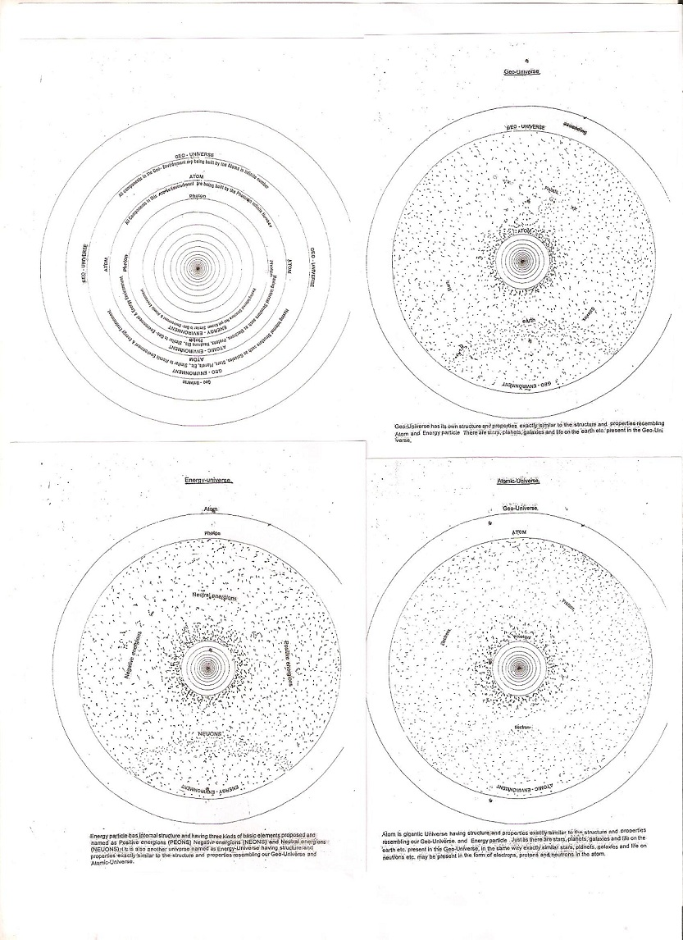

Appendises (Bioforecast)

Analysis Of Data Of Bio Forecast
Date of Experiment | Number of Biolumicells | Actual Weather
1-May-1991 | 8
2-May-1991 | 14
3-May-1991 | 19
4-May-1991 | 20
5-May-1991 | 28
6-May-1991 | 22
7-May-1991 | 50
8-May-1991 | 65
9-May-1991 | 83
10-May-1991 | 89
11-May-1991 | 72
12-May-1991 | 40
13-May-1991 | 30
14-May-1991 | 14
15-May-1991 | 11
16-May-1991 | 6
17-May-1991 | 12
18-May-1991 | 3
19-May-1991 | 10
20-May-1991 | 8
21-May-1991 | 16
22-May-1991 | 9
23-May-1991 | 12
24-May-1991 | 5
25-May-1991 | 6 | Low
26-May-1991 | 10 | Low
27-May-1991 | 19 | Depression
28-May-1991 | 8 | Cyclone
29-May-1991 | 3 | Cyclone
30-May-1991 | 11 | Depression
31-May-1991 | 9 | Depression

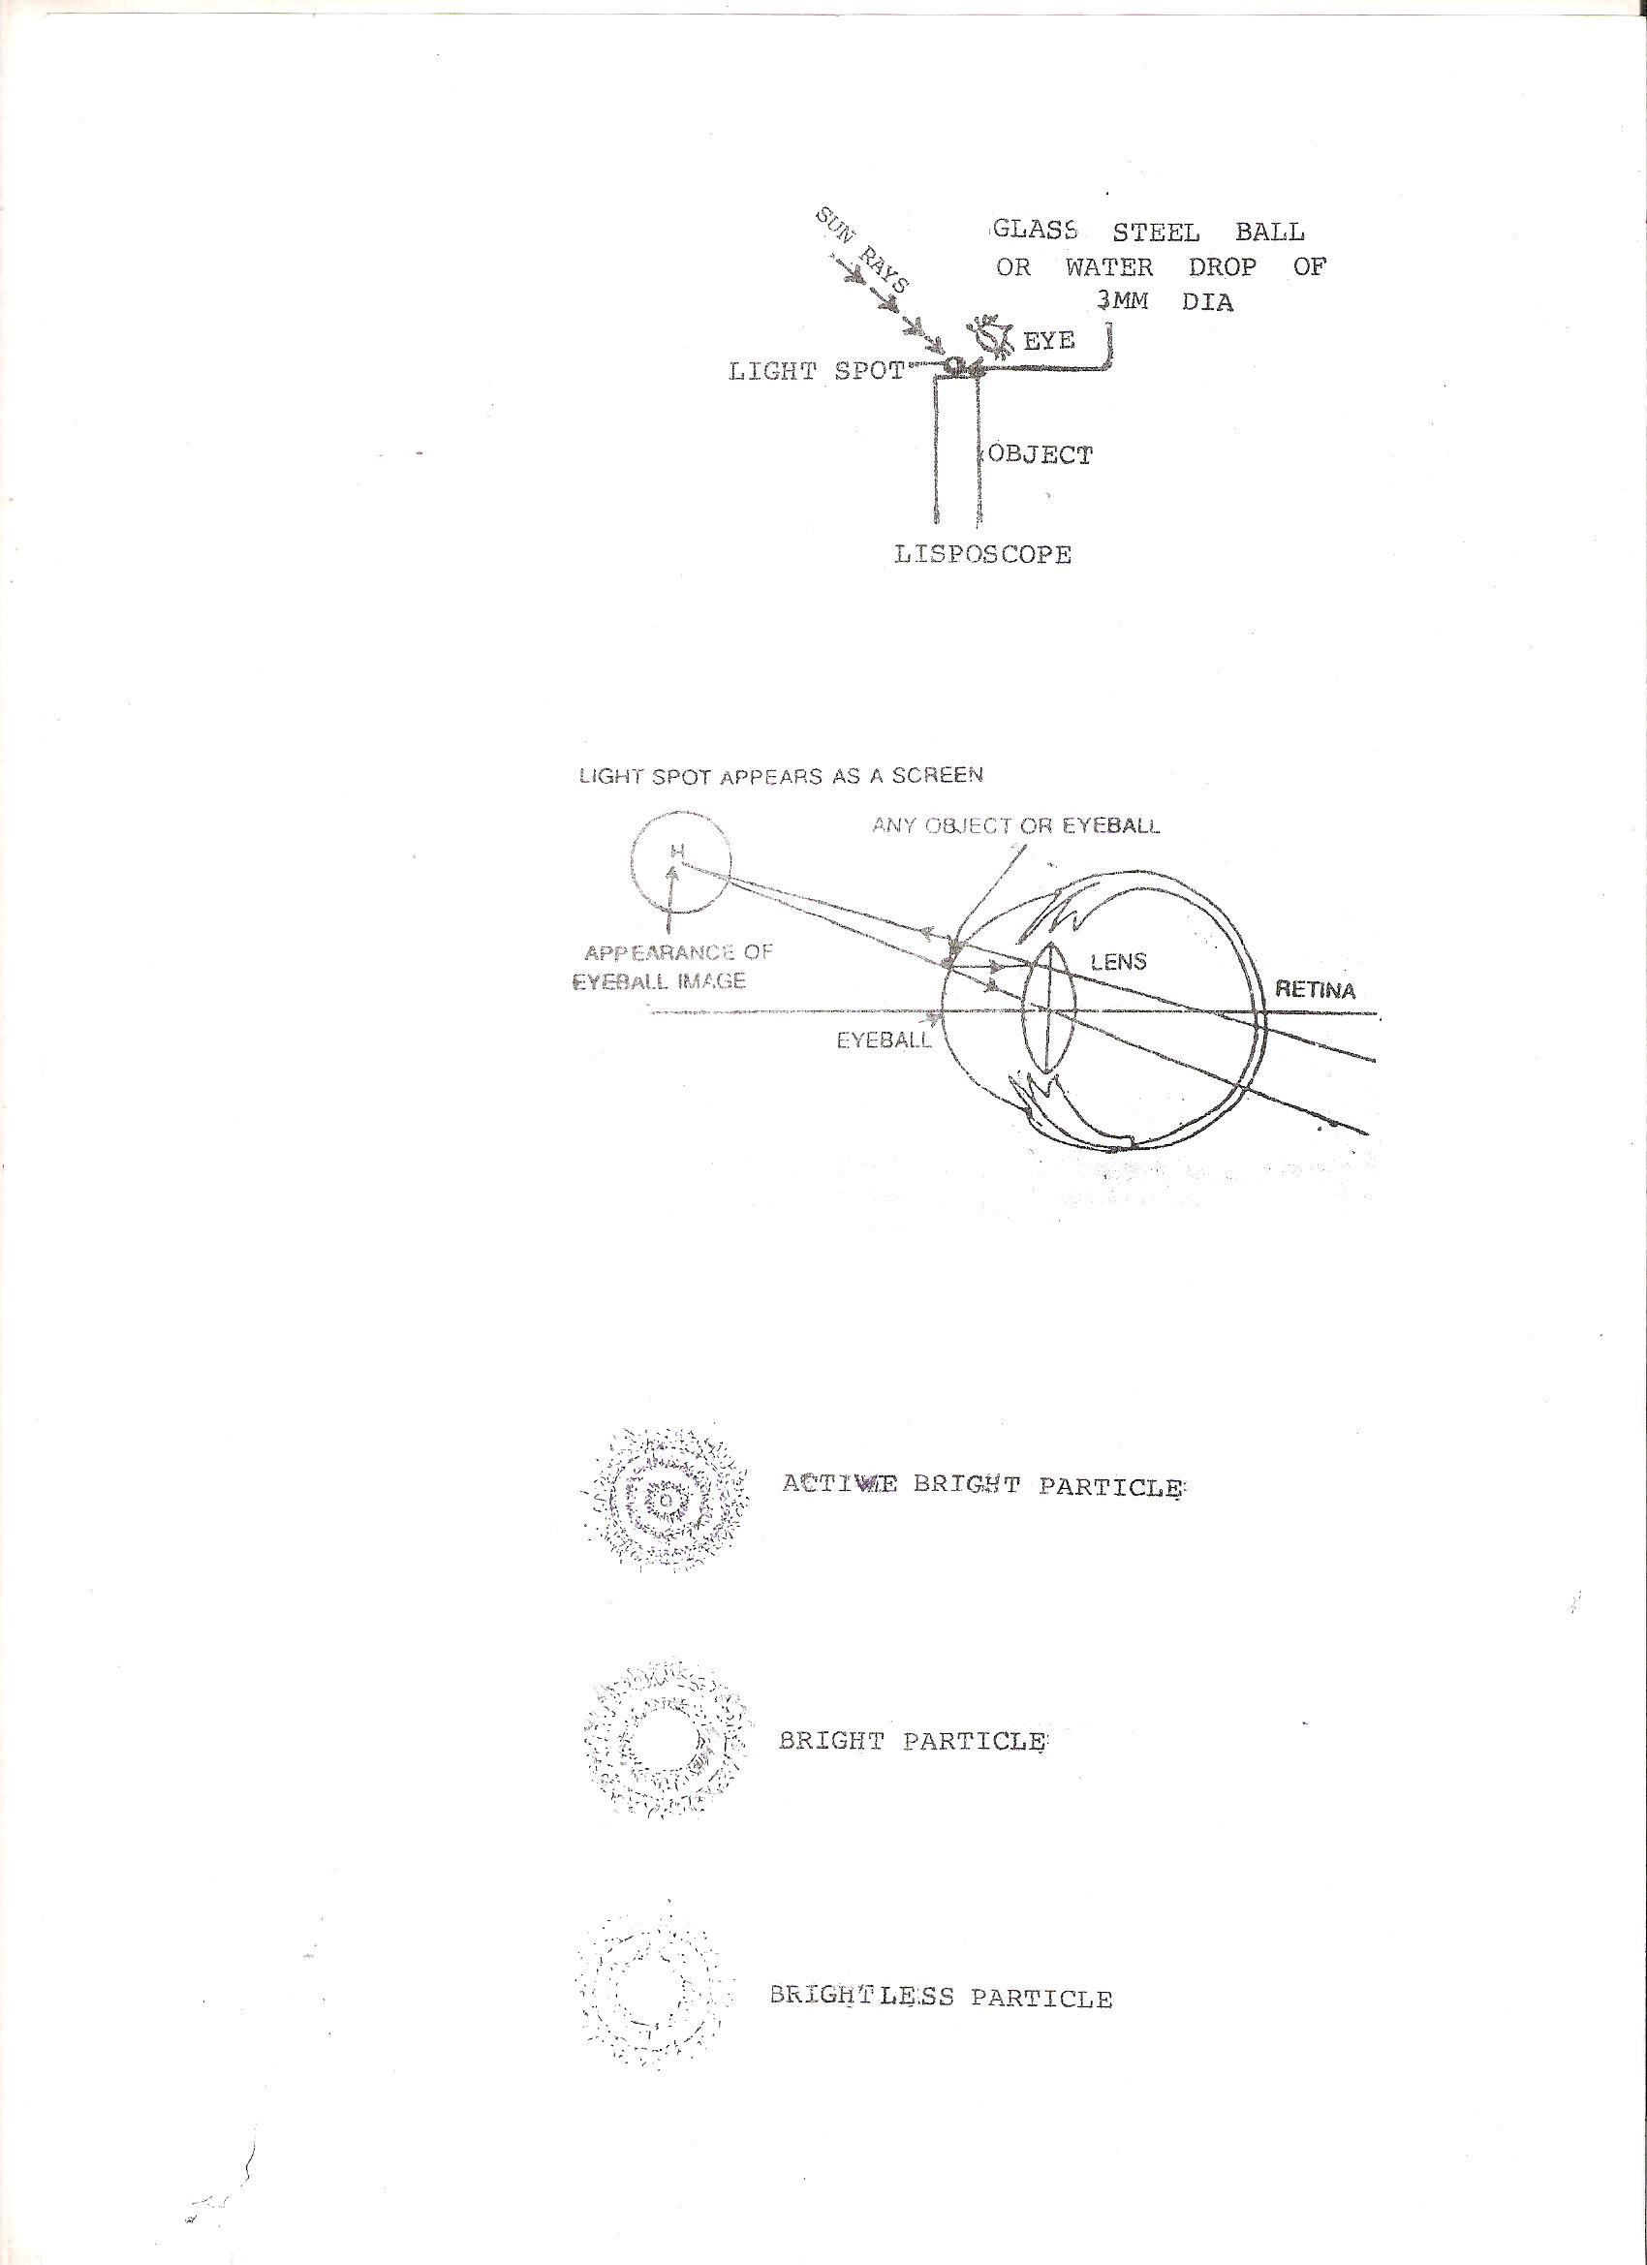

Appendices (Geoscope)

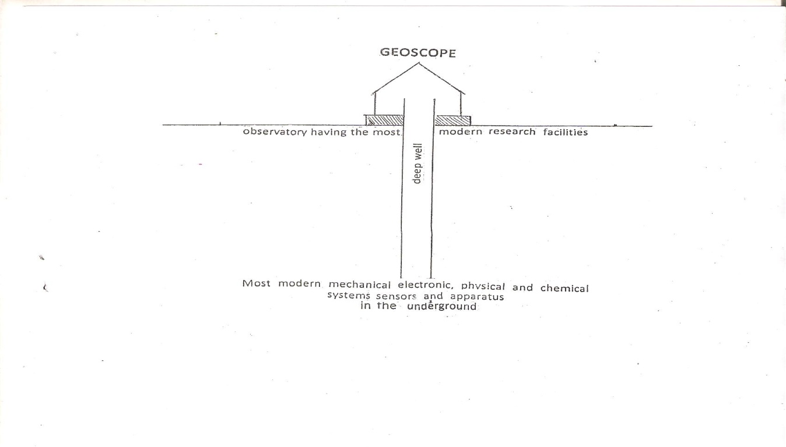
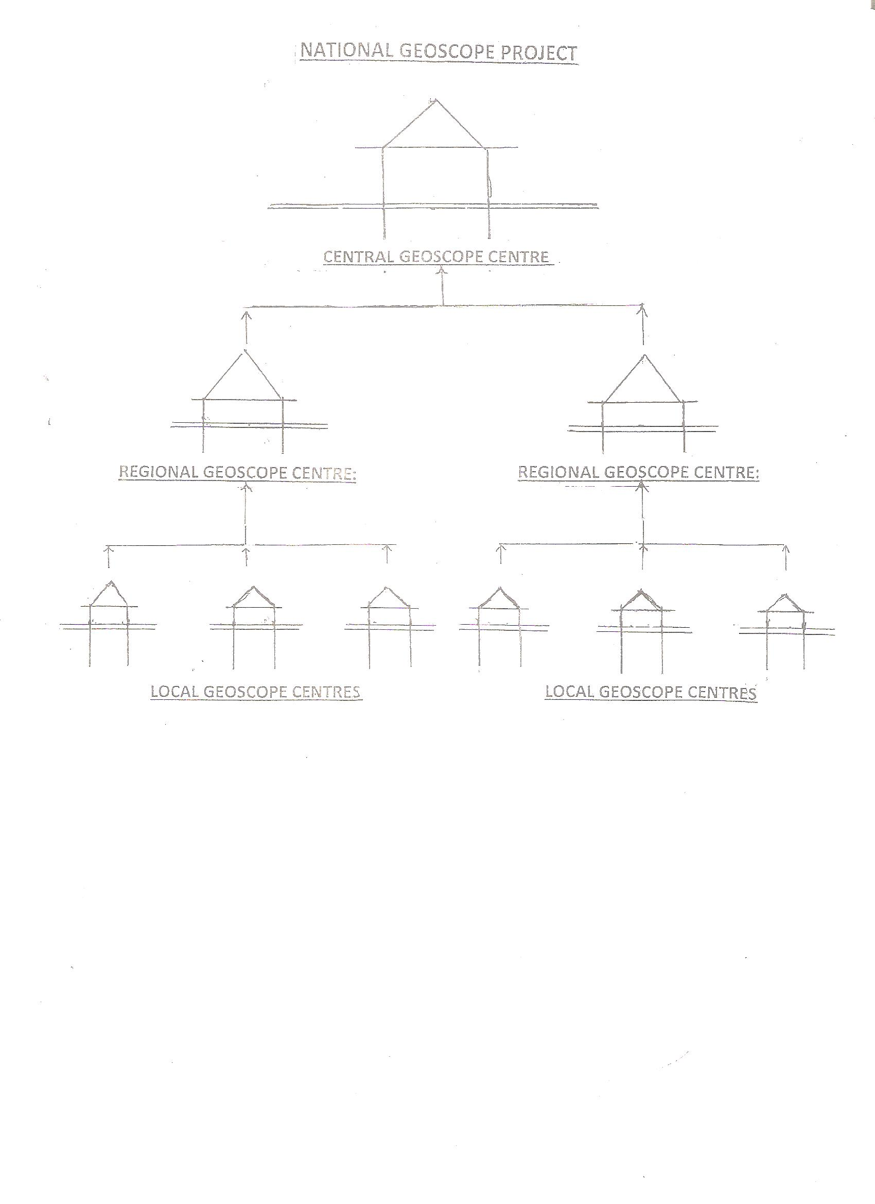

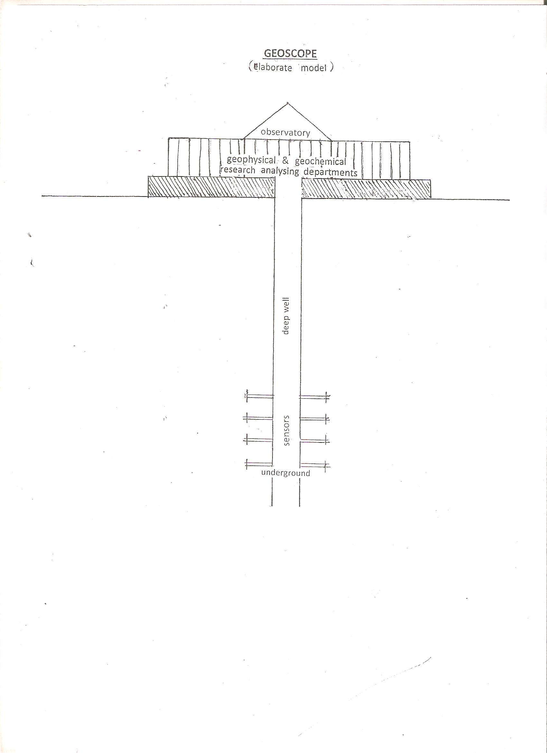
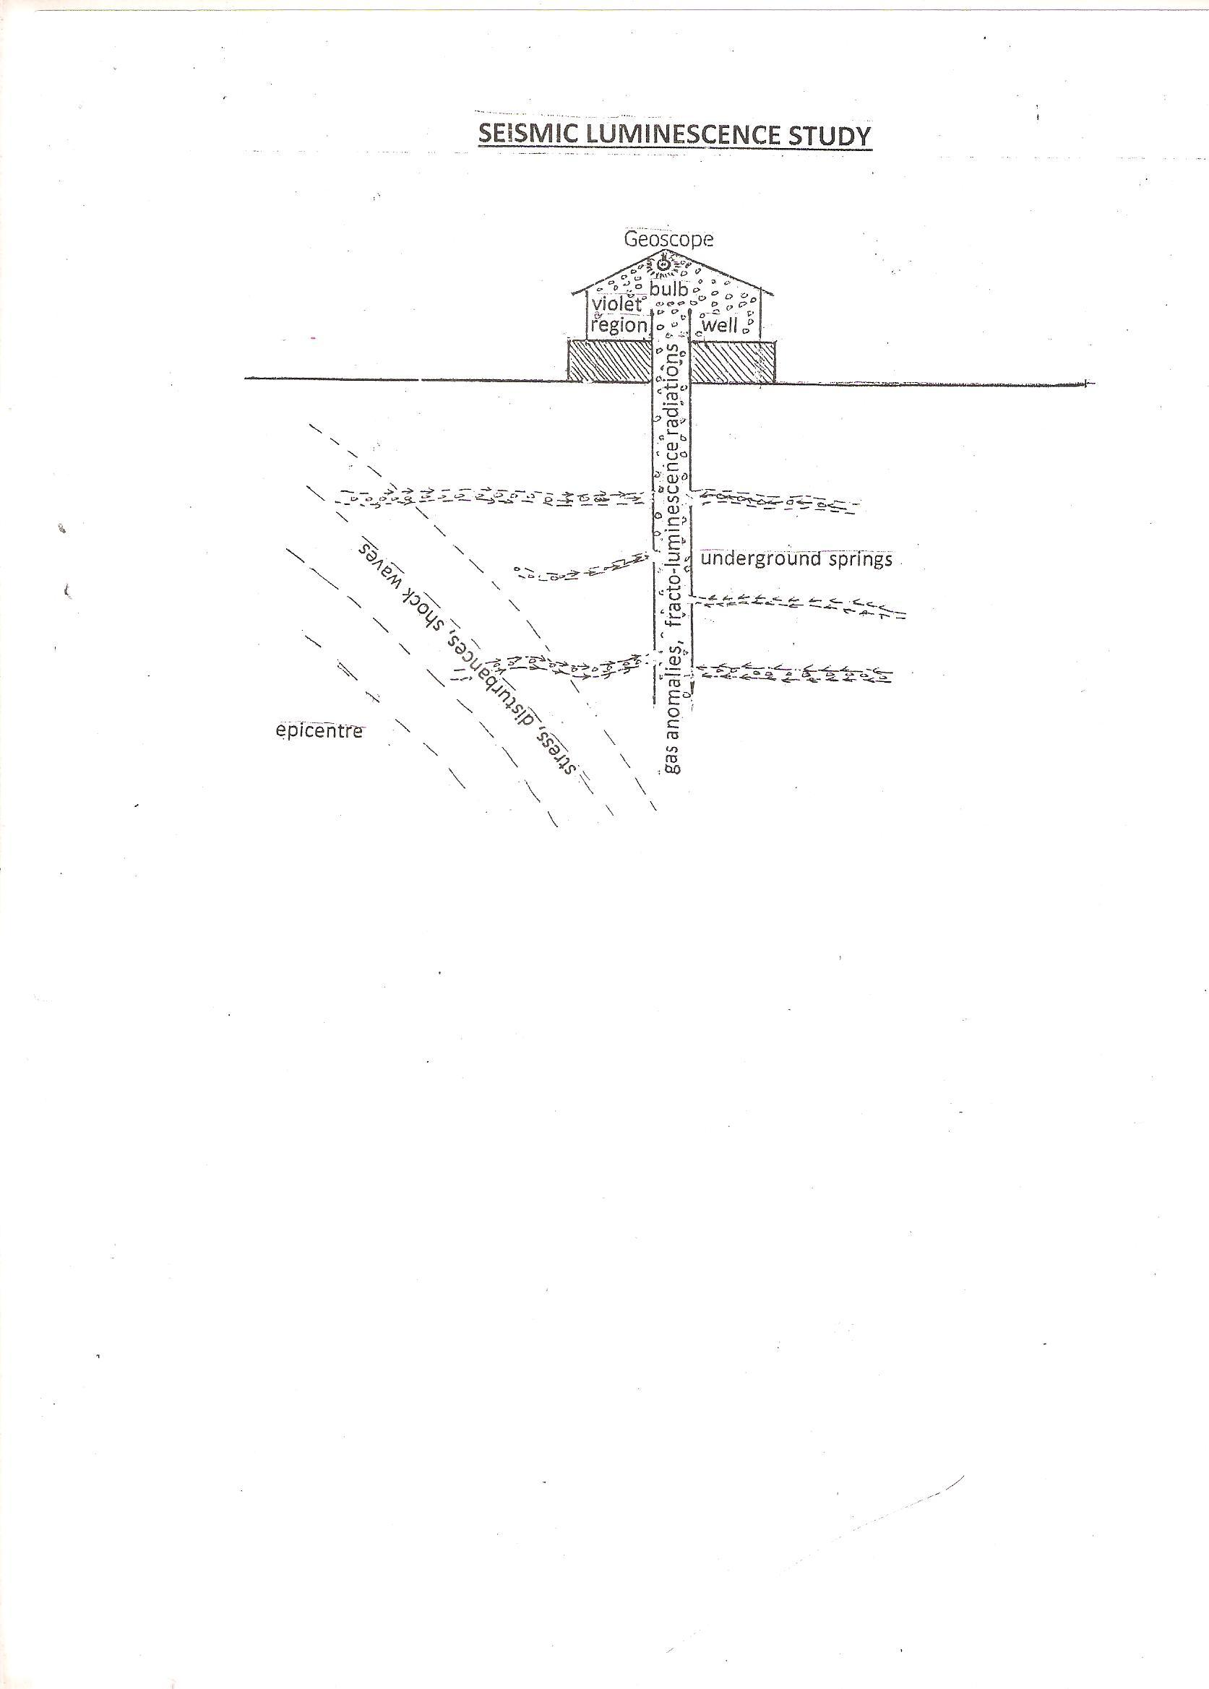
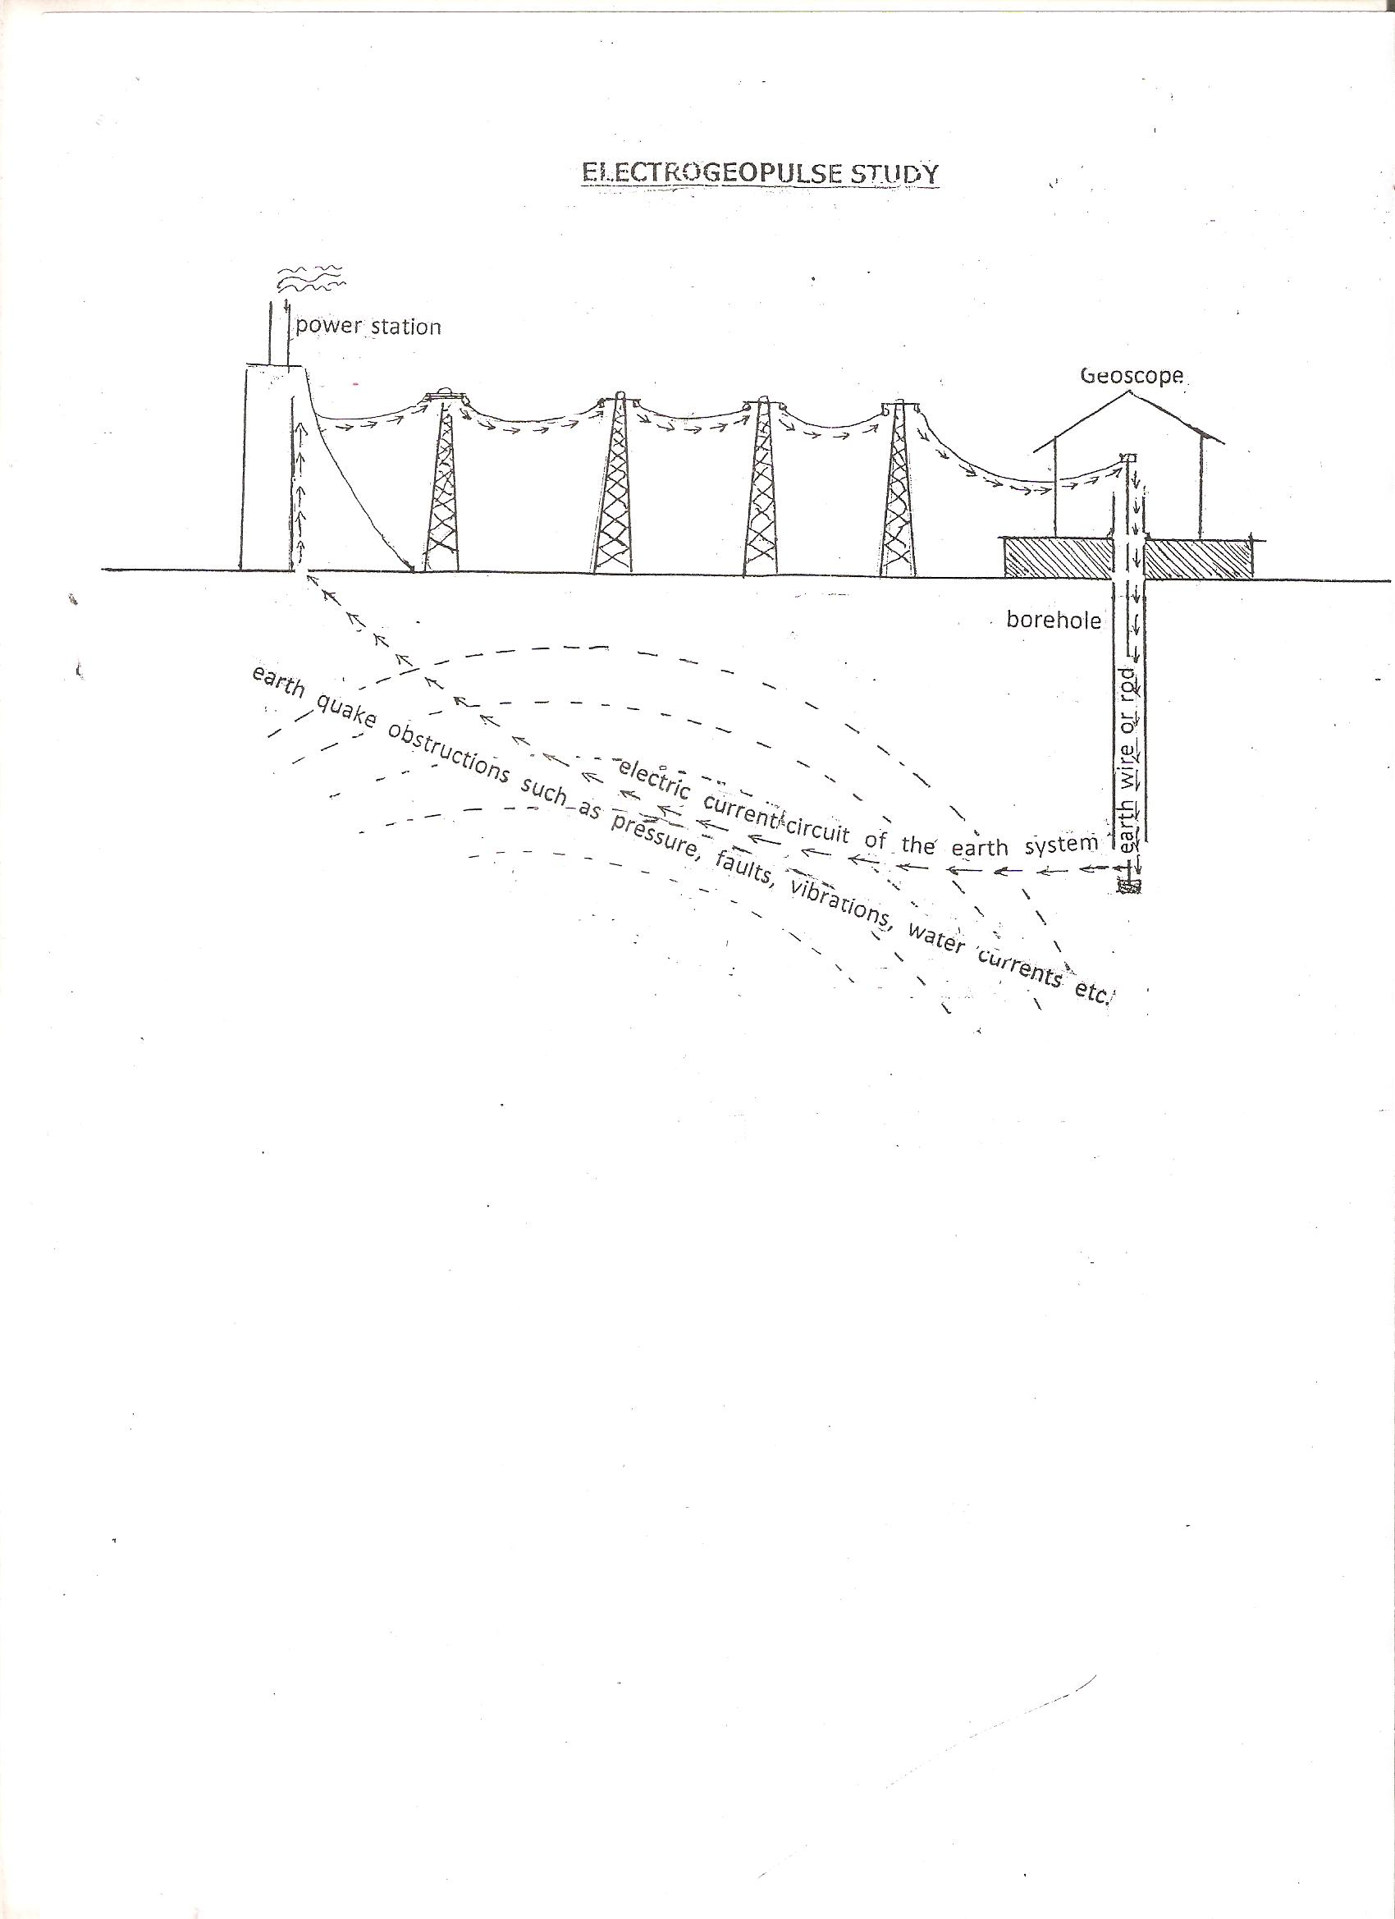

Appendises (Model Scale-Weather Forecasting Scale)

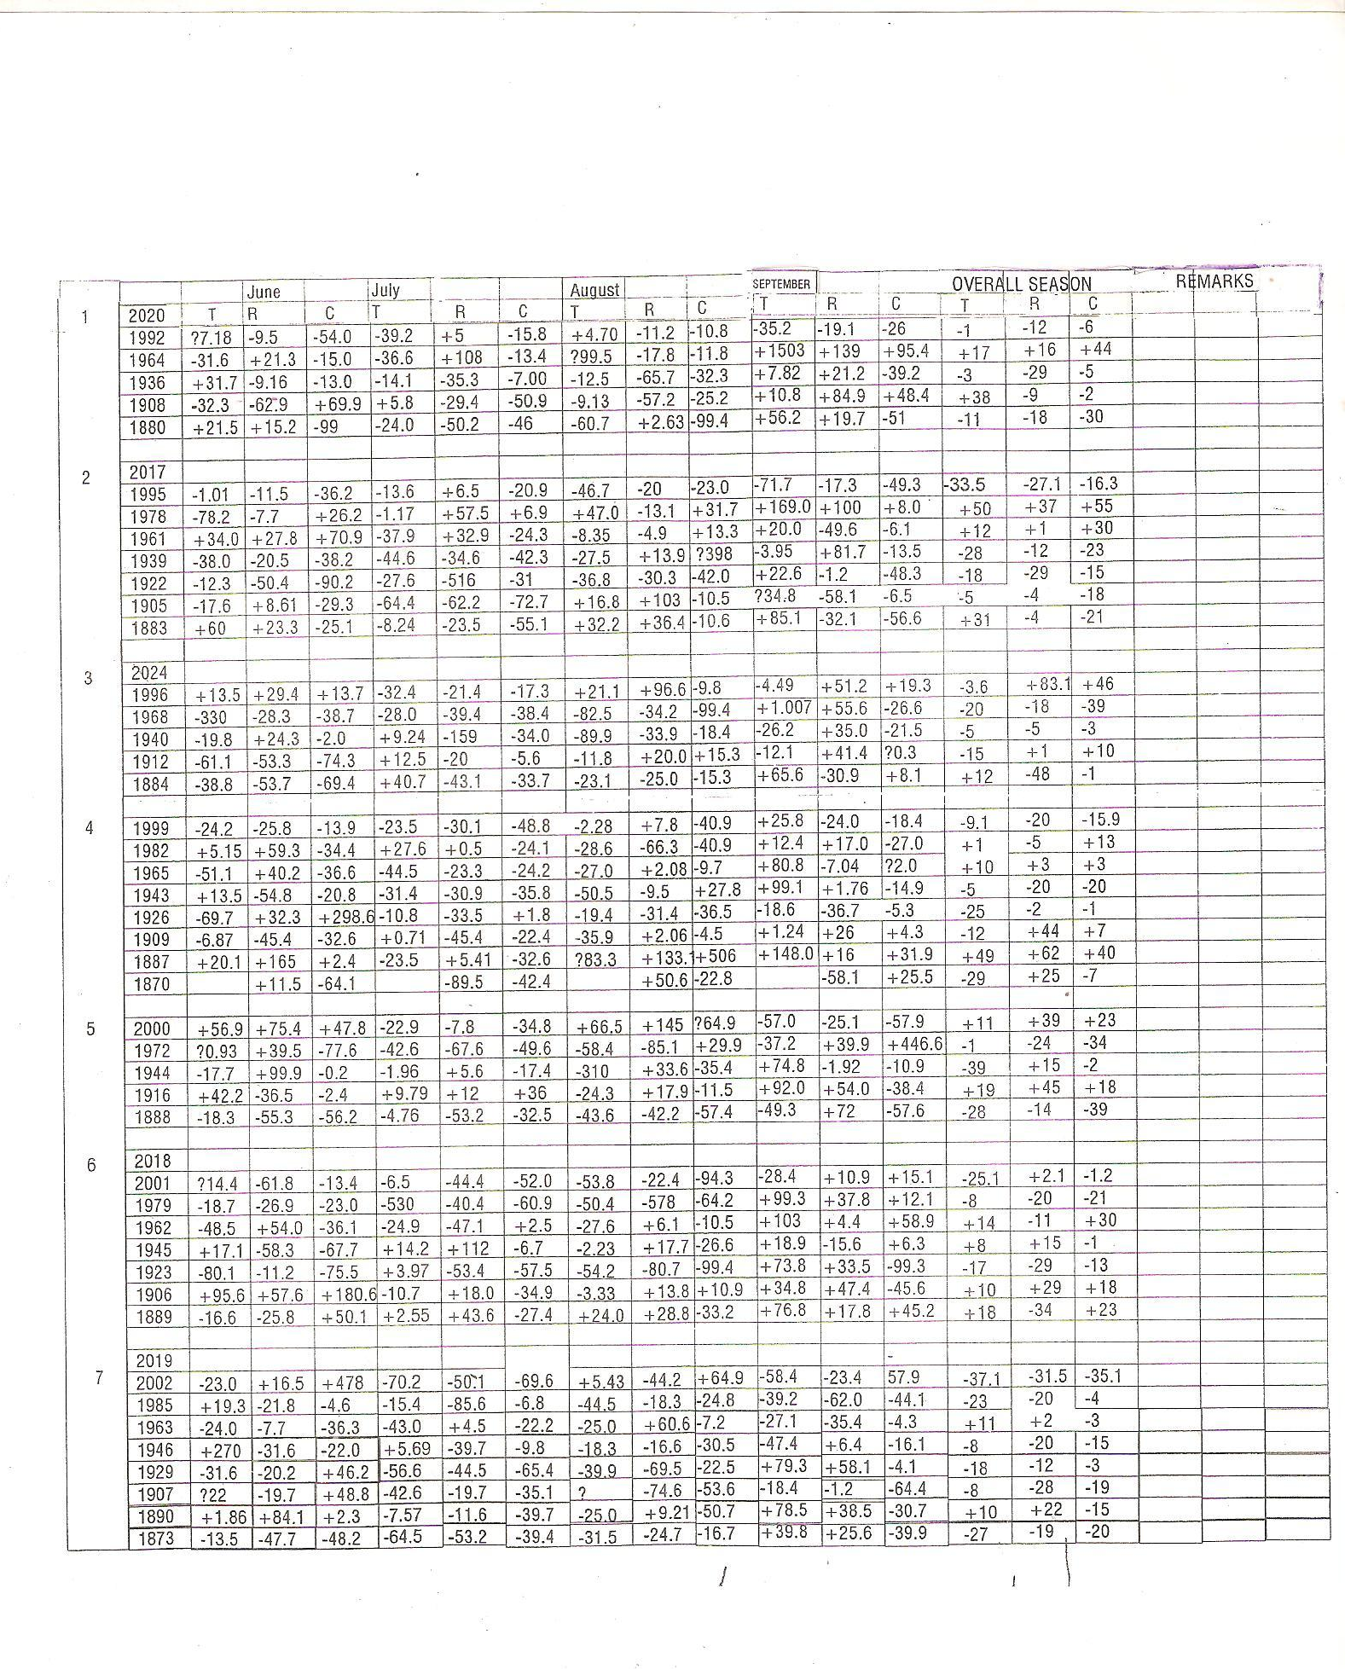

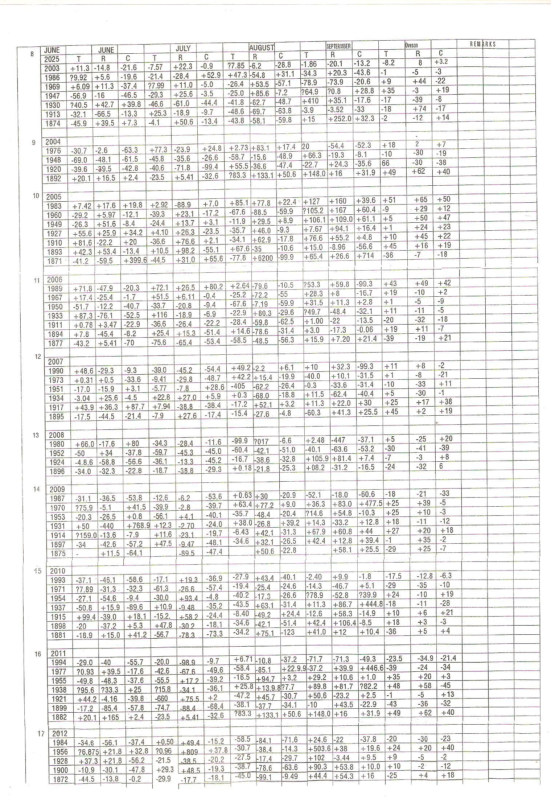

Appendices (Indian monsoon time scales)

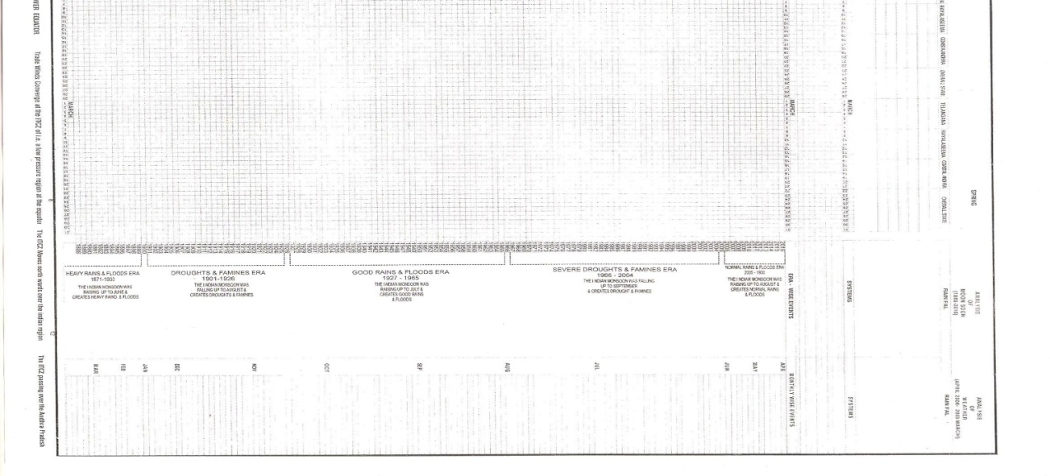
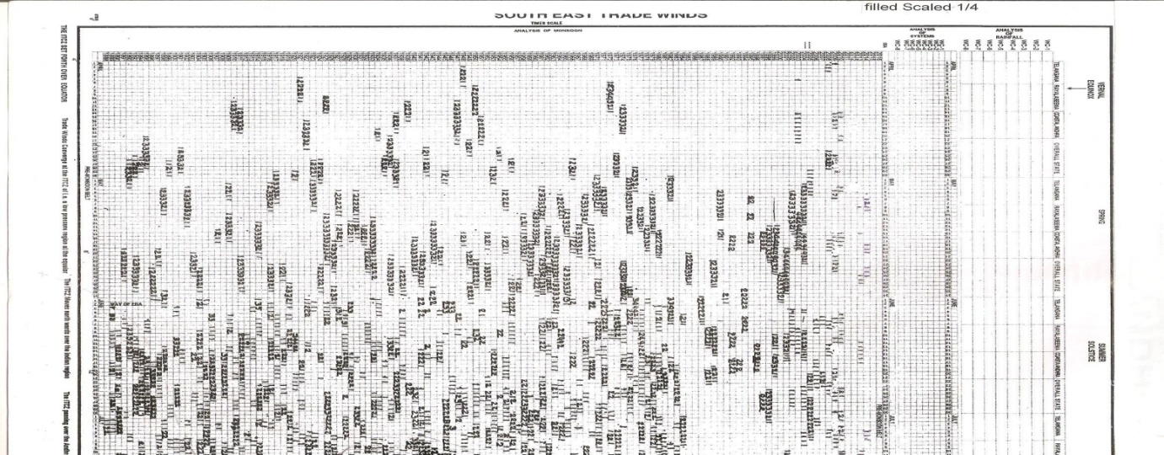
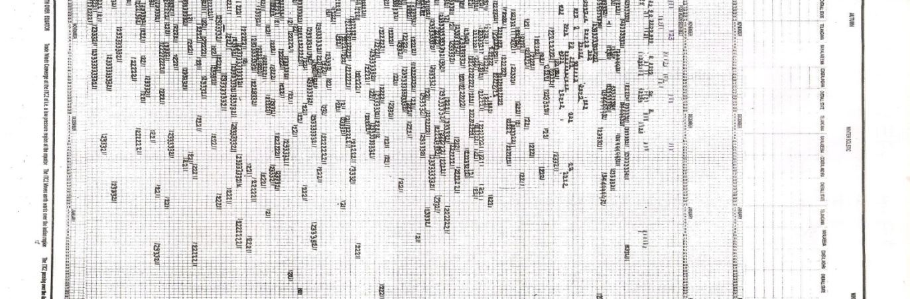
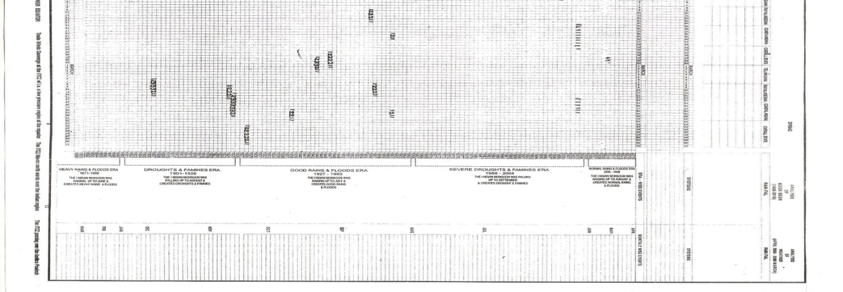
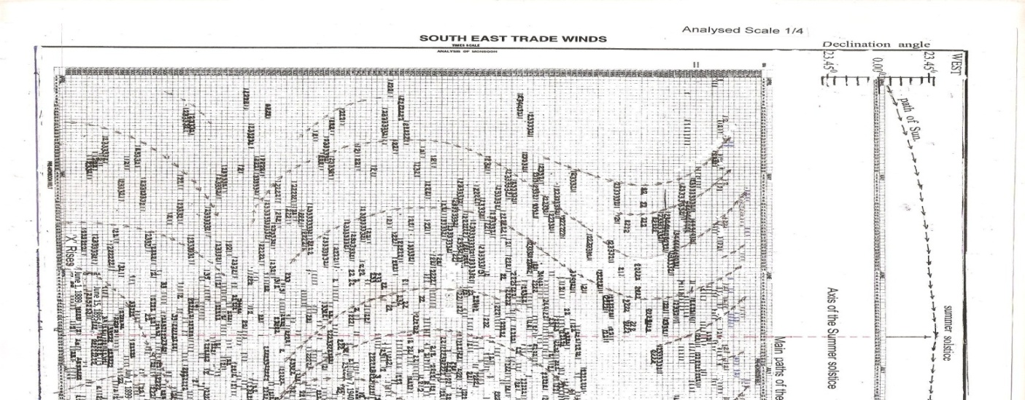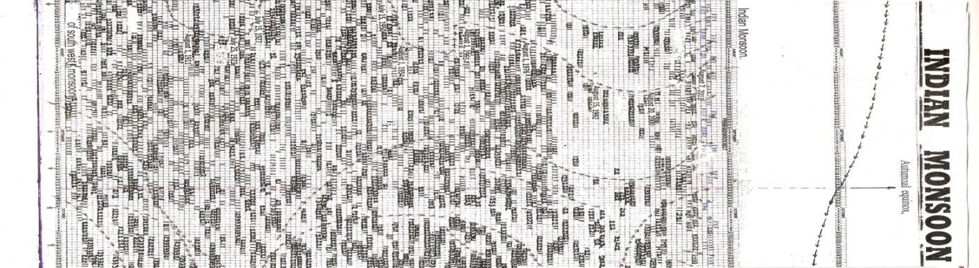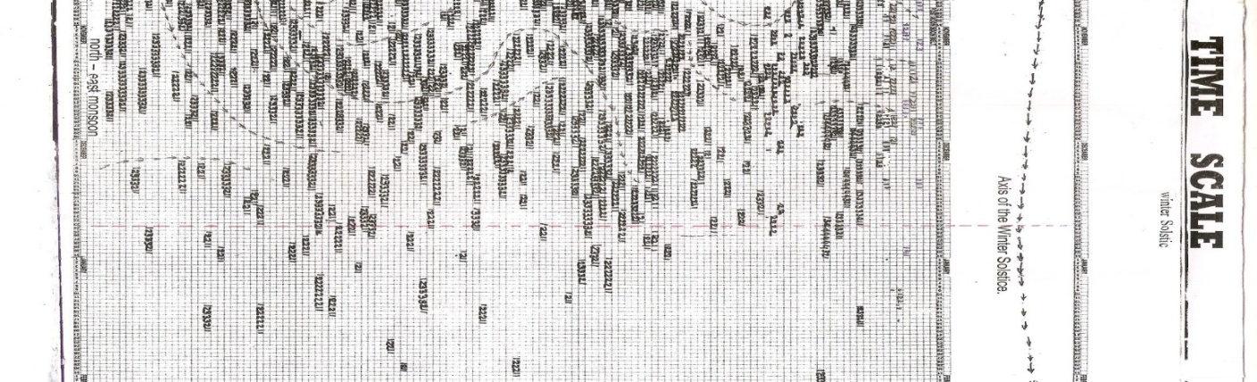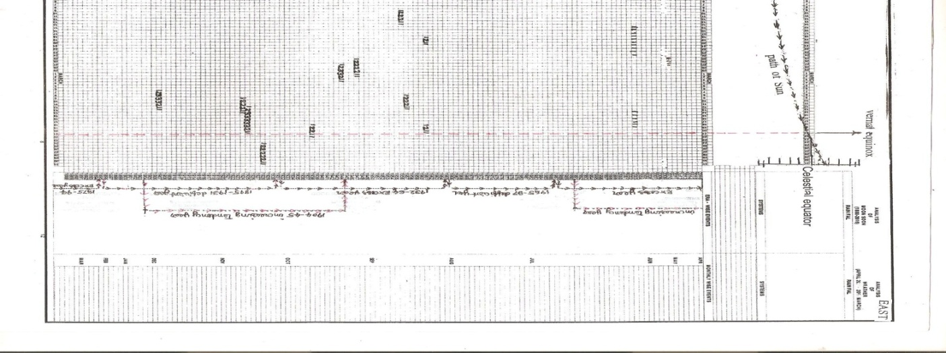

1/25/2017

