Technology Advances with Smartphone Applications, Electron Stethoscope & Real-Time Monitoring System and Its Impact on Clinical Practices in Veterinary Medicine.

Berhanu Wakjira ^{*1}, Teshale Sori²

School of veterinary medicine of Jimma University and College of veterinary medicine and agriculture of Addis Ababa university Ethiopia, Jimma Ethiopia.
berhanu.wakjira25@gmail.com

Abstract: The objective of this paper is some technological developments of smart phone applications, electron Stethoscope and Real-time monitoring systems and their diagnostive purposes and others like vaccinological technologies their comparisons in to human and Veterinary medical that create some new technical and technological workings for the cases of animal disease diagnosis, treatments and preventions, To change our country visions in to new technological applications for veterinary medical practices and the word technology means different in to different peoples or individuals. Many of us think of smartphones or sophisticated computers as cutting-edge technology and perhaps don’t imagine much in the way of technological advancement is occurring in everyday veterinary clinical practice. The truth is a lot of advancements in a variety of technologies are taking place in veterinary practice, and it is some of these this article will explore. Technology is, for me, anything that helps us to do our jobs better, whether it be enabling us to perform tasks faster, more effectively, or to enable us to achieve a better outcome for our patients and clients. In essence, technological advances should, and usually do, enhance both our personal and working lives. Sustainable food production capable of feeding a growing human population is a significant global challenge, and is a priority encompassed within the United Nations Millennium Development Goal to ‘eradicate extreme poverty and hunger’. Infectious diseases reduce the productivity of farm animals, and the globalized trade of animals and their products increases the threat of disease incursion. Accurate and rapid diagnostic tests are an essential component of contingency plans to detect, control and eradicate such diseases.
[Berhanu Wakjira Teshale Sori. Technology Advances with Smartphone Applications, Electron Stethoscope & Real-Time Monitoring System and Its Impact on Clinical Practices in Veterinary Medicine. Researcher 2018;10(9):24-39]. ISSN 1553-9865 (print); ISSN 2163-8950 (online). http://www.sciencepub.net/researcher. 5. doi:10.7537/marsrsj100918.05.

Key Words: - Technology, Clinical practices, Impacts of Technology, Veterinary medicine, Smart phone Diagnosis and test and Treatments.

1. Introduction
Technology is, for us, anything that helps us to do our jobs better, whether it be enabling us to perform tasks faster, more effectively, or to enable us to achieve a better outcome for our patients and clients. In essence, technological advances should, and usually do, enhance both our personal and working lives. There are three areas in which we see advances in technology in practice. The first is clinical technology; the classic ‘vetty’ gadgets, gizmos and systems that make the process of diagnosing, treating and managing our patients easier and more effective. Secondly, there are the advances in practice management and client communication technologies, an area which in my opinion has probably seen the biggest changes and which offer the biggest opportunities for really impacting on our clinics’ bottom lines. The third focus is the use of technology in education and, important in ensuring our personal and professional growth and where technology is certainly having a big impact Hopper-Losenicky (2017).
Over the past few years, the use of computers, electron stethoscope and Smart phone technology in large animal education has flourished. In the mid-1980s, spreadsheet programs were used to evaluate dairy herd ration formulation and economics. The computers would be started at the beginning of class, and it would take 10 to 15 minutes just to load the software. Five years later, getting forage analysis reports via electronic mailboxes seemed like magic. During the 1990s computer speed increased exponentially, as did development of software, the internet, and digital processing. Today we have handheld personal desktop assistants (PDAs) available on the farm that enable us to process more information than desktop computers available only a few years ago. We can capture digital images on our camera, download them into our electronic medical record, and create Derived Versatile Disc (DVD) slideshows for rounds. Although keeping up with new technology can be daunting for educators, the possibilities for delivery of veterinary medical information in the next 15 years appear to be boundless. Veterinary students will need certain skills upon graduation to allow them to access, manipulate, and interpret information technology obtained from multiple sources. This article will cover aspects of food animal and equine education, the influence of the internet on veterinary education, and advancements in information technology. Saeed & Jabbar, ( 2017).
Veterinary radiology is a long established subject discipline in veterinary science. It is fair to say that every veterinary graduate alive today would have received formal training in this subject irrespective of their date or place of graduation. Despite or perhaps because of this long ancestry, it is worthwhile examining the extent of the subject’s boundaries and its place in veterinary medicine. One can ask what imaging modalities fall under the remit of the subject and why they do so. Veterinary activities have always been concerned with the diagnosis and treatment of disease, with clinical and experimental animal research, and with agriculture, to select but a few areas of interest. How great a contribution can veterinary imaging make to these areas? The limits of what radiologists can and cannot do becomes unclear as the breakdown of traditional barriers between disciplines, considered essential to progress in medical education and scientific progress, continues Adler et al. (1995). It has always been the case that the collection and use of image-related data are not the sole preserve of veterinary radiologists; uncertainties can exist as to who should be involved. The radiology community, both users and suppliers alike, has to ask what value imaging brings to collaborative work and how this value is best realized Baker, (2011).
General objective:-
On this Seminar it was express about Smart phone applications, electron stethoscope, Real-time recording systems for disease diagnosis and isolation in human animals and other like vaccine productions to disease control and prevent and comperes in human health and veterinary Medicines created as some new technical and technological workings for the case of disease diagnosis.
Specific objectives:-
To introduce new smart phone technology applications for disease diagnosis purposes beside to phone services, To inform the new advanced technology that liked in between smart phone and electron stethoscope for physical and physiological changes, To adopt with technological animal and human diagnosis purposes and To advance our knowledge with new technology of New vaccines and gynecological materials besides to real-time recording system technology.
2. The Uses Of Technology Advances, Smart Phone Applications, Electron Stethoscope, Real-Time Recording Systems & Its Impact On Clinical Diagnosis And Practices In Veterinary Medicine.
The uses of mobile devices are growing at alarming rates. It is projected by 2018 mobile technology numbers will have not only exceeded the earth’s population, but Wi-Fi will become the past and 4G will control all mobile technology. This indicates the vast abilities and advances mobile devices will have Index, (2014). While human medicine is more advanced with actual monitoring systems for physiological problems, the veterinary field is not like that of human liked with new technological advancement when we compere it. Currently there have been several veterinary apps and devices made to help veterinarians treat patients to their greatest potential, a few including; text book apps, such as the Merck Veterinary Journal, programs to run a practice via mobile devices, and medical references. Despite the rapidly growing number of advancements in mobile human healthcare technology, utilization in the field of clinical veterinary medicine is not widespread. New apps are being created every- day for both human and veterinary medicine, while human medicine may be farther along in numbers the veterinary world is not far behind. With that said these technologies have the potential to improve the quality of patient care as well as their outcomes, they just need to be put to use.
A quick review on PubMed reveals that when searching the terms “medical” and “smartphone,” 140 hits are obtained as compared to the search of “veterinary” and “smartphone,” where only 1 hit results and is in fact an article on smartphone use in human medical applications Andrews et al. (2015). The use of information technology in large animal practice began with the management of production records in dairy practice. A single dairy farm may have thousands of animals and track information concerning milk production, lactation number, and stage of lactation, pen location, estrous cycle parameters, health issues, and breeding, among other things. The sorting functions of these programs alone have made them valuable, allowing for the generation of action lists for reproductive evaluation or examination. As an example, the ability to retrieve a listing of cows between 35 and 45 days post-breeding for pregnancy examination from a group of 1,000 cows in a matter of seconds has allowed veterinarians and farm staff to manage these large herds Andrews et al. ( 2015).
It is also used for parasitic egg counting as the figure 1 show to us and examination - Before examining clinical specimens, the smartphone microscope was evaluated using a grid distortion target with 500 μM spacing’s (Thorlabs, Newton, NJ), U.S. Air Force (USAF) resolution target and a depth-of-field target (Edmund Optics, Singapore). Images acquired using the smartphone microscope was ported to the public domain program Image Rasband, (1997).
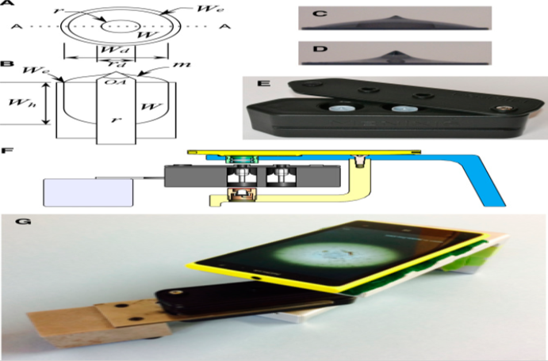
Figure 1 Axisymmetric meniscus (AxM) fluidics and Nokia Lumia1020 Smartphone microscope.

Schematic of the particle-accumulating fluid cell, (A) top view showing: rod (r); well (W); and well edge (We) and (B) transverse cross section of (A) along the line A-A showing: the meniscus (m); rod diameter (rd = 3 mm); well diameter (Wd =8 mm); well depth (Wh = 12.1 mm). Profile images showing menisci in the apparatus shown in (A and B) showing the cone positioned with its apex (75° open angle (OA) 1.80 mm above the well edge and containing (C) 0.500 mL and (D) 0.480 mL of fluid. (E) Photograph of the cassette (30 × 35 × 100 mm) incorporating two fluid wells. (F) Schematic cross section showing the smartphone, cradle, cassette and cassette rack. (G) Photograph of the apparatus schematically shown in (F). and combined into single images using the Extended Depth of Field plugin.26,27 A stool sample (2 g) from a person known to be positive for A. lumbricoides, was homogenized in saturated sodium chloride (50 mL) and strained through a 250 μM aperture sieve, Levecke et al. (2011). which rendered the eggs buoyant in a fecal slurry. Aliquots of the mixed slurry were removed by pipette, applied to the fluid wells of the cassette as it should indicated on figure 2 and left to equilibrate for 10 minutes before imaging. The Human Ethics Committee of the University of Otago granted approval (code H13/017) for the use of anonymized stool specimens, which would have otherwise been discarded. The sample used here was sourced and assessed by a competent technician from an independent laboratory, Levecke et al. (2011), that contained buoyant objects accumulated by an axisymmetric meniscus (AxM) formed about the rod (3 mm diameter). (A) Image acquired at 4.5× precapture digital zoom with the focus set at 300/1,000. (B) Image acquired of the same scene as in (A), except with the focus set at 700/1,000 (C) Extended depth of field composite imaged derived from (A), (B) and a third image of the same scene as in (A) and (B) except with the focus set at 500/1,000 (not shown). (D) Digitally zoomed portion of a region corresponding to the square black frame (inset) in (C) indicating example Ascaris lumbricoides ova (e), debris (d), and air bubbles (b).
The software programs also provide an excellent way for veterinarians to interpret herd problems even prior to large declines in performance: for example, monitoring individual cows’ milk production and producing alerts when production drops by 10%. Graphical displays of herd performance, such as milk production by lactation number, allow the veterinarian, student, and producer to quickly see trends that suggest the need for intervention. Currently, milk production and herd health indices can be recorded into Dairy Herd Improvement Association (DHIA) computer databases and transferred onto farm desktop computers Simons & Ehehalt, (2002) or to handheld PDAs with Palma software for use cow-side to facilitate immediate hearing, observations on Smart phone applications & give decisions. During veterinary examinations, the producer, veterinarian, and student can have informed discussions, with the aid of this information, to allow for immediate treatment decisions. Beef cattle software has also been developed to help with herd management on both desktop and PDA platforms. Ferguson et al. (2002) Recently, a comparison of beef cattle production software was performed Abazov et al. (2005).
2.1. Applications Of Smart Phone In Cardiac And Pulmonary Auscultation
Aside from providing increased precision and audible advantage over the conventional Stethoscope, digital stethoscopes have also been studied for their utility of screening for obstructive coronary artery disease. As it shows on figure 3 turbulent blood flow occurs due to hemo-dynamically significant coronary artery disease and manifests as intracoronary murmurs. However, conventional stethoscopes lack the auscultation power to detect these murmurs. As they studied the correlation between diagnoses of coronary artery disease using an electronic stethoscope and lesions noted on cardiac connective tissue (CT). Makaryus et al. ( 2013).

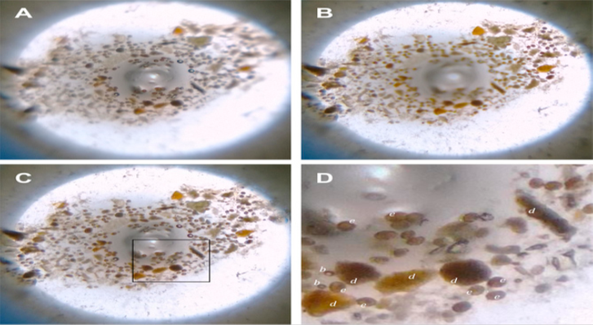
Figure 2 Smartphone microscopy of slurry of human feces positive for soil-transmitted helminthes (STH);

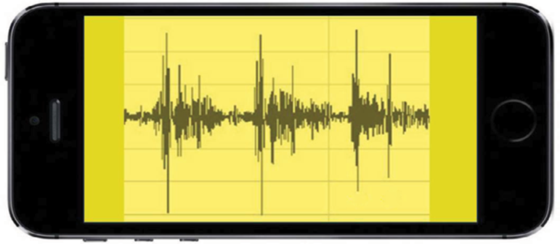
Figure 3. Simulated phonocardiogram of normal S1 and S2 heart sounds seen on portable device through Bluetooth® integration Leng et al. ( 2015). Note: S1 and S2 represent the first and the second heart sound respectively 2.2. Opportunities and drivers for the development of simple, rapid diagnostics for livestock diseases

The development of simple, portable diagnostic devices is now considered a priority for animal diseases. This idea is echoed within various independent reports following major outbreaks of foreign animal diseases, such as foot and mouth disease (FMD) Anderson, (2002) and by research funded by the Department for Environment, Food and Rural Affairs (Defra) and the Economic and Social Research Council (www.genomicsnetwork.ac.uk/innogen). International organisations, such as the Food and Agriculture Organization of the United Nations (FAO) and the OIE, stress that governments could save billions of dollars by stepping up the control of high- impact animal diseases but, to achieve this, access to rapidly deployable, decentralised diagnostics that permit active case control of diseases is required Anderson, (2002).
2.2.1. Clinical Technology And Electronic Stethoscope Interconnected With Smart Phone Through Bluetooth And Its Disease Sensations.
A digital stethoscope is able to convert an acoustic sound to electronic signals, which can be further amplified for optimal listening. These electronic signals can be further processed and digitalized to transmit to a personal computer or a laptop Leng et al. (2015). The diagnostic power provided by digital stethoscope auscultation to a physician can assist in altering management in patient care.
As it would be shown on figure 4 below the digital stethoscope consists of three different modules, data acquisition, preprocessing, and signal processing, before the listener can appreciate the auscultated sound. The data acquisition module involves a microphone and a piezoelectric sensor. It is responsible for filtering, buffering, and amplification of the auscultated sounds, as well as conversion of the acoustic sound to a digital signal. The preprocessing module filters the digital signal and removes any artifacts. These digital data are then forwarded to the signal-processing module, which will package the information in a higher-order classification and cluster the data for a clinical diagnostic decision Leng et al. ( 2015).

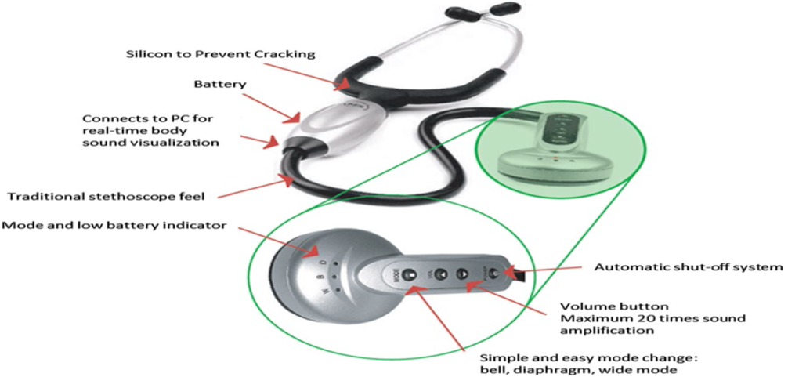
Figure 4. The digital electrical stethoscope that used for auscultations and diagnostic purposes Leng et al. ( 2015).

In some miscellaneous Heart Sounds, the opening snap is a high-pitched diastolic sound produced by rapid opening of mitral valve in mitral stenosis (MS) or tricuspid valve in tricuspid stenosis (TS). The ejection sound (ES) is the most common early systolic sound which results from abnormal sudden halting of the semilunar cusps as they open during early systole. The mid-systolic click (MSC) is a Heart Failure sound in mid systole that results from the abrupt halting of prolapsing mitral valve leaflets’ excursion into the atrium by chordae Thayer, (1908). As the figure5. shows during cardiac auscultation, the physicians are particularly interested in abnormal sounds, and various types of murmurs, which may suggest the presence of a cardiac pathology and also provide diagnostic information.

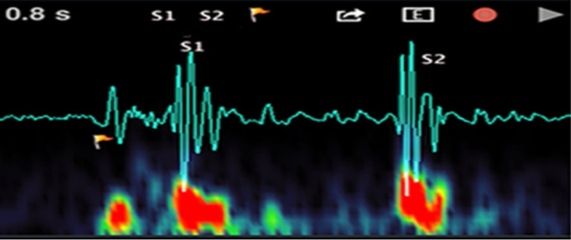
Figure 5 Two primary heart sounds: S1 and S2 Leng et al. (2015).

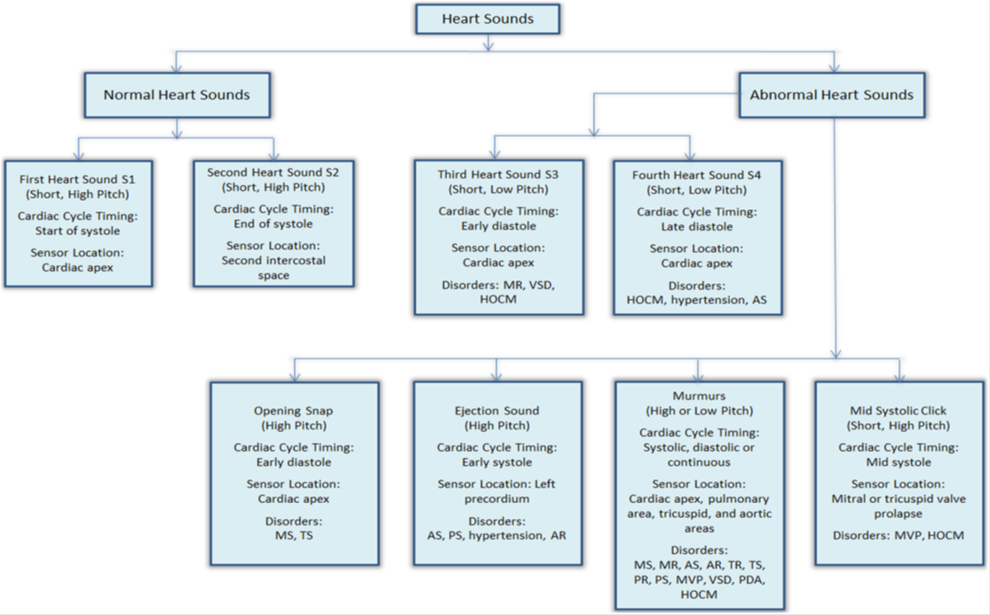
Figure 6. Characteristics of heart sound Leng et al. (2015)

The review results on the state-of-the-art products are provided in this section, validating the needs, problems and gaps from the medical and market point of view as well as from a technology push perspective with an overview tabulated in figure 6. Development of the electronic stethoscope is gaining an edge over traditional stethoscope mainly due to the advanced sensor technologies, digital signal processing techniques as well as the digital sound transmission capabilities of digital stethoscopes (.http://www.thinklabs.com/.) Most stethoscope manufacturers are focusing on developing the devices with enhanced acoustics, better performance and innovative designs. One example of the state-of-the-art electronic stethoscope has been given in figure 7. Almost all electronic stethoscopes in the market are equipped with configurable filters with different frequency response modes for listening to the heart, lungs and even other human body sounds. These band pass filters with user-selectable pass-band frequencies are easy to implement and cost-effective. Besides the basic filtering mechanism, novel sensor design and noise reduction algorithm are also implemented in the products from 3 M, Thinklabs, Welch–Allyn and JABES to suppress the ambient noise, as well as the friction noise due to either patient’s body motion or physician’s hand tremor (http://www.thinklabs.com/).

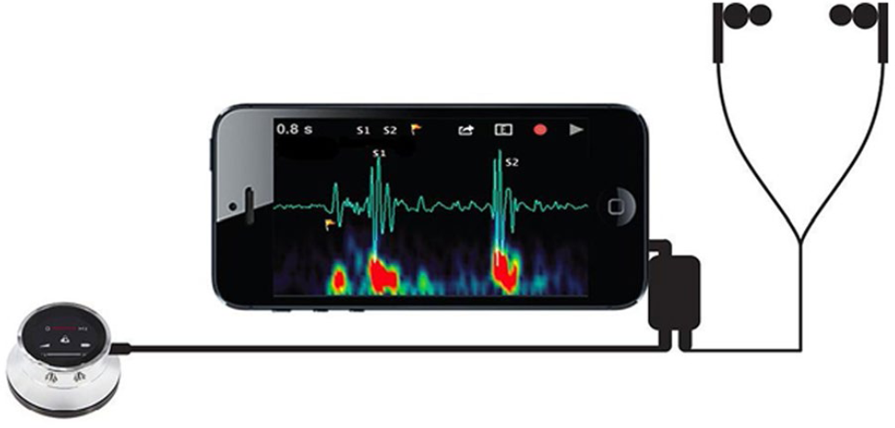
Figure 7. Electronic stethoscope with smart mobile phone heart rate examinations Leng et al. (2015).

Unlike the acoustic stethoscope, the transducers on a digital stethoscope are of wide variety. One of the transducing methods involves the microphone in the chest piece. The sound signals are detected by the stethoscope diaphragm, which is transferred to another diaphragm inside the microphone. This allows for the conversion of a simple and direct acoustic sound to an electrical signal. The signal can then be displayed as a phonocardiogram on an electronic device (Figure 7). However, two diaphragms separated by an air path can result in excessive ambient noise signals and inaccurate electrical signal transfer Leng et al. (2015).
The good classification performance obtained suggests that these techniques are potentially useful for medical application, even though it is still premature to look at their real diagnostic value as will be discussed in later sections. Extreme learning machine (ELM), as another new machine learning method, has attracted extensive attention recently due to its remarkable advantages such as fast operation, straightforward solution and strong generalization Huang, Zhu, & Siew, (2006). However, the use of ELM in HS analysis is found to be very limited in the literature. The diagnostic potential in this domain of ELM has definitely not been sufficiently explored as yet, and so further research is required in this direction.
Confidence in your ability to do best by your patients is of paramount importance. With the Littman Model 3200 Electronic Stethoscope you'll always be at your best. The Littman 3200 offers incredible auscultation by eliminating up to 85% of distracting background noise and amplifying body sounds by up to 24 times. The built-in LCD displays frequency selection, sound leveling, battery life and your patient's heart rate. Lightweight and comfortable to use. The Littman 3200 comes with built-in Bluetooth technology which is capable of recording patient body sounds and appending them to medical reports or sending them to peer's for further analysis. Unrivaled in its ease-of-use and 21st century technology, the 3M Littman 3200 Electronic Stethoscope assures you are bringing the best to patient care Ohshimo, et al, ( 2016).
2.3. Real-Time Monitoring System-Online (Rtms-On)
This technique is intended to detect the early stages of infection in sentinel animals by measuring physical or physiological changes through in-vivo sensors. The information is then remotely transmitted in real-time and an alert is issued when a certain threshold is reached Schiller et al. (2010). Main Advantages, Less invasive than continuous sampling, Real-time transmission of data, High sensitivity to early detect changes in patterns, like increased temperature, reduced water consumption or decrease in motion, potentially saving costs associated with surveillance of subclinical low prevalent or absent diseases. The figure 8. drawbacks/Limitations, Cost limits the use in chosen sentinels, Requires prioritizing diseases and animals based on risk factors and knowledge about disease epidemiology, Signals any potential infection independently of the etiology.

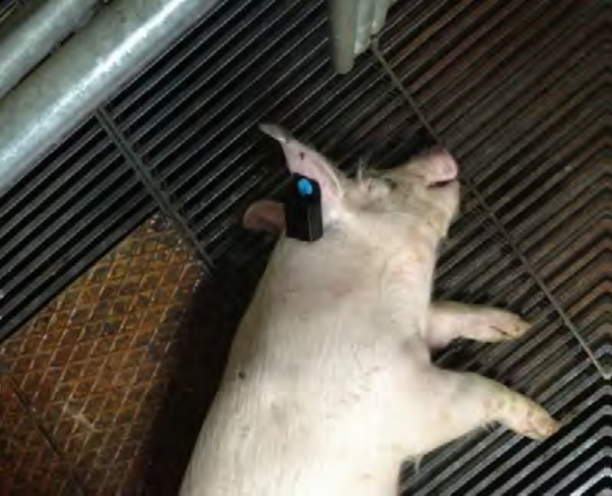
Figure 8. The Real-time monitoring system-online (RTMS-ON)

Sentinel animals are used in surveillance as a cost-effective tool to enhance early detection of health threats, such as notifiable diseases ( figure 8). Once chosen by a risk-based approached, sentinel animals are periodically sampled. This method can miss infection if it occurs between two sampling periods. It is also an expensive method that requires continuous resources to trigger a potential alarm. The onset of infection is characterized by the presence of fever and pain that can lead to less movement and eventual prostration. The monitoring of animal and environmental indicators in animal health and production provides an excellent opportunity to improve the capacity of response to emerging threats. Schiller et al. (2010).
Procedure:- RFID systems have two main components: a transponder (transmitter-responder) and a transceptor (transmitter-receptor). Hand-made transponders are inserted in the body of the animal and contain a microchip with a unique identifier, and two sensors to measure motion and body temperature. Transceptors emit a continuous signal which results in data transmission once the transponder detects it. Transmission is amplified through a radio-frequency device that can be placed as an ear tag or a collar. Transceptors contain a unit to process the data, an antenna and autonomous battery life. In pigs, the RFID must be less than 4 cm away from the inserted transponder, because body fat can hamper data transmission. Data stored in transceptors can be downloaded through Wi-Fi or cable internet connection to a core server, to any computer, smart phone or mobile device Schiller et al. (2010).

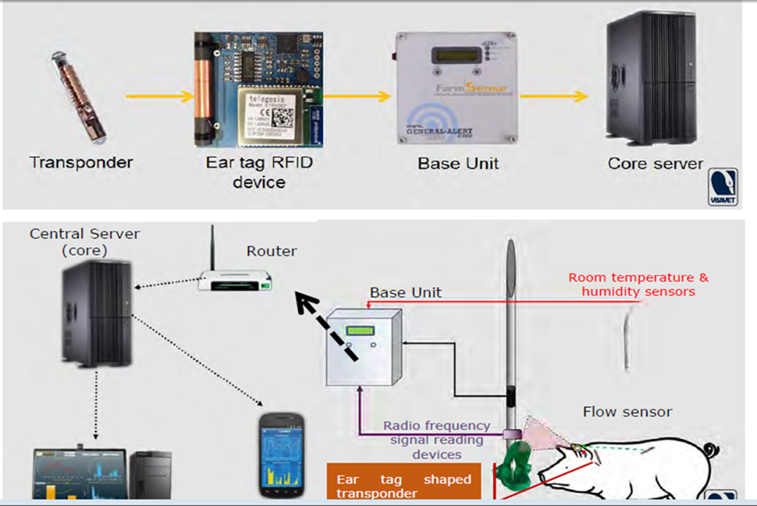
Figure 9 The RFID transmission process in the central ( core server) Schiller et al. ( 2010).

2.4. The Influence of the Internet on Veterinary Education
The Internet has had perhaps the greatest influence on veterinary medical education of all types of informational technology. It has been demonstrated that the primary use of computers in education has been for information retrieval and communication Waldhalm & Bushby, (1996) Internet serves exactly these purposes, but on a very large scale. Students and educators are not limited by the availability of information on one site, but can make use of educational materials from around the world. Dascanio, (2003).
A great way for students to become familiar with current issues and to get practical guidance is to become a member of a veterinary discussion list, or “listserv.” The major ones that focus on large animal veterinary medicine are Equine Clinicians Network, Dairy-L, American Association of Bovine Practitioners-L, Beef-L, American Association of Equine Practitioners’ Listserv, and EqRepro-L Dascanio, (2003). These discussion lists bring together academicians, private practitioners, students, and industry professionals in an open forum format. Any topic in a list’s subject area may be discussed, giving each participant an opportunity to learn from others’ experiences.
2.5. Evolution and Historical Perspective
An improvement of electronic and digital devices for medical and animal production purposes associated to the networks and computation development were observed in veterinary field. The Information Communications Technologies were progressively applied in research and teaching veterinary schools and medical institutes or in enterprises related to these areas. Technological advances, relative decreasing cost of equipments, similitude with human medicine and socioeconomic development were some responsible of factors for this evolution and their democratization in all veterinary and animal production fields. Initially, the majority of these medical and instrumental materials including biosensors were usually, only physically connected to a screen or to other similar output signal viewer for human observation and interpretation. For example, before these two decades i.e (1980-1990), the data of animal and human imaging diagnoses was stored in analogical devices for learning and teacher purposes. However, the videodisc technology, was stimulated by the development of several interactive healthcare centers like the Consortium of North American Veterinary Interactive New Concept Education (CONVINCE) Simões, (2010).
Around 1990s, personal computers (PCs) were democratized, at least in developed countries, induced by technological advances. The veterinary learning and research was widely enhanced in some fields, using bioinformatics and statistical programs stored in diskette or local drive, but without significant network connections (intra or internet). In 1991, the first 3W online site takes place in the Conseil Européen pour la Recherche Nucléaire (CERN) by Timothy John Berners-Lee (see http://www.w3.org/WWW/).
These facts originated a revolution in veterinary education, similar to other scientific fields, opening the door to Internet 1 and Web 1. Initially, workstations, PCs and laptops were used to access websites primarily text-based by narrowband and dial-up liaisons Denwood, et al, (2008). In 1994, an experimental free veterinary Web service, the Net Vet Website (http://netvet.wustl.edu/vet.htm), was launched in order to collect veterinary medicine and animal welfare resources Dascanio, (2003). The contents were not only text based but integrated veterinary imagery Cheng, (2007; Denwood et al. (2008). Like the described in figure 1. This service had a Web based and open access pioneer importance’s, in late 1990s, due to the connection to several local veterinary and governmental institutions (universities and government departments), mainly in United States of America (US), Canada, Australia and European countries.
2.6. Constraints and Challenges of Veterinary Technological Development
The veterinary students and veterinary nurse and technician students´ attitudes toward the “classical” (CD-ROMs based) CALs and their enhancement, regarding international animal- health issues programs, play a fundamental role to future tendencies on professional field. A study, performed by French et al, (2007), evidenced that the students‟ at some European and US Veterinary schools, in 2004, considered the interactive CD-ROMs informative fact- based or case-based with parasite database/encyclopedia and International Animal Health (scenarios from Chile, South Africa and Mexico) contents, respectively. However, any changing students’ attitudes toward the international veterinary medicine, in this study, were demonstrated.
With Internet technological advances, veterinarian, veterinary schools or colleges Nick et al. (2007) and other institutions are expanding their interactivity with Web sites. In fact, according to Dede, (2002), in the next years, three complementary technologies interfaces should be present in learning and specific education forms: the classical “world to the desktop” interface, the interfaces for “ubiquitous computing” and (“Alice-in-Wonderland”) Multi-User Virtual Environments (MUVE) interfaces (see table 1).

Table 1 Main (predictive) category for ICTs development in general education and training. Data collected from Dede, (2002).
Interfaces | Description / Use
“World to the desktop” | The computer desktop providing access to distant experts and archives, enabling collaborations, mentoring relationships and virtual communities-of-practice.
“Ubiquitous computing” | Portable wireless devices infuse virtual resources as we move through the real world. The early stages of “augmented reality” interfaces are characterized by research on the role of “smart objects” and “intelligent contexts” in learning and doing.
“Alice-in-Wonderland” multi-user virtual environments | Participants‟ avatars interact with computer-based agents and digital artifacts in virtual contexts.  The initial stages of studies on shared virtual environments are characterized by advances in Internet games and work in virtual reality.

The interactive veterinary software (using local disks or Web 2) can be applied to case-based scenarios, like heard health management, epidemiological and clinical studies in all animal species or in many other fields. These resources have great advantages for learning and practical training: student’s can take decisions face to a normal, urgent or emergent scenario; no live animals are required, the simulations can be infinitively repeated in any time and any local with different decisions. The CALs packages can be also authored by students under teacher’s staff supervision and can provide a complementation or alternative to classical didactic teaching with more performances examinations results Denwood et al. (2008).
Obviously, the use of CALs can´t definitively eliminate the animal use for teacher and researcher proposes, but can used for training students before they use in the classroom or at veterinary hospital. This represents a rational management criterion with a responsible and limited animal use. Consequently, the human ethical behavior and animal welfare are improved. Some problems could be finding in these CALs, like the partial capacity to develop and present several probable or improbable scenarios according to the student decisions. Consequently, the full simulation of a dynamic environment, like in real situations may be not possible. Many CALs created in last decade were based in CD-ROMs storage. However, the quickly interactive and platform technological advances, and the medicine veterinary developments implicate hardware upgrades and software updates for these programs or/and the creation of expensive new programs. For the generality of teachers is not possible to create or modify CALs for curricula adaptation due to their limited occupational time and skills in this authoring informatics field Denwood et al., (2008). However, like in traditional mobility programs students, the linguistics differences between the first and second languages have an important role to literacy skills and competences Cárdenas-Hagan, et al. (2007). In the digital world, that problem persists, but the use of social networking sites associated with mobile digital devices is an important tool to improve cross-linguistic effectiveness Meurant, (2008).
Other than linguistics differences, important positive or negative potential social and economic forces can influence the implementation of scalable and sustainable e-learning academic or scholarship systems. Using social field theories, a general e-learning policy field for the academy was proposed by Parchoma, (2006). This author considers two principal potential restraining and four driving vector forces in order to implement a feasible e-learning system (figure 9).
Smartphones have been increasingly adapted in various health care applications in recent years. According to the applications, the use of smartphone-based healthcare practice can be divided into two categories: out-of-clinic use and in-clinic use Batista & Gaglani, (2013). Out-of-clinic smartphone use covers most of the software applications (apps) and the corresponding devices for the daily monitoring of the health and wellness. Smartphones can also be used to promote a healthy life style and help people get access to useful medical information when they need it. Built-in sensors inside the mobile devices or external wearable sensors measure people’s health-related activities such as heartbeat and breathing during walking, running, or sleeping Mateo, et al. (2015). Unlike older generations of at-home monitoring equipment that require manual record keeping, these applications usually have a high-level of automation in terms of the recording and processing of the measured data, and usually the information is stored in a personalized profile that can be securely transmitted to a cloud center to perform processional medical analysis. Such applications usually present the data in an appealing graphic fashion to users and provide simple suggestions or conclusions. On the other hand, the in-clinic applications of smartphones involve the diagnostics of specific types of diseases and are supposed to help make clinical decisions.

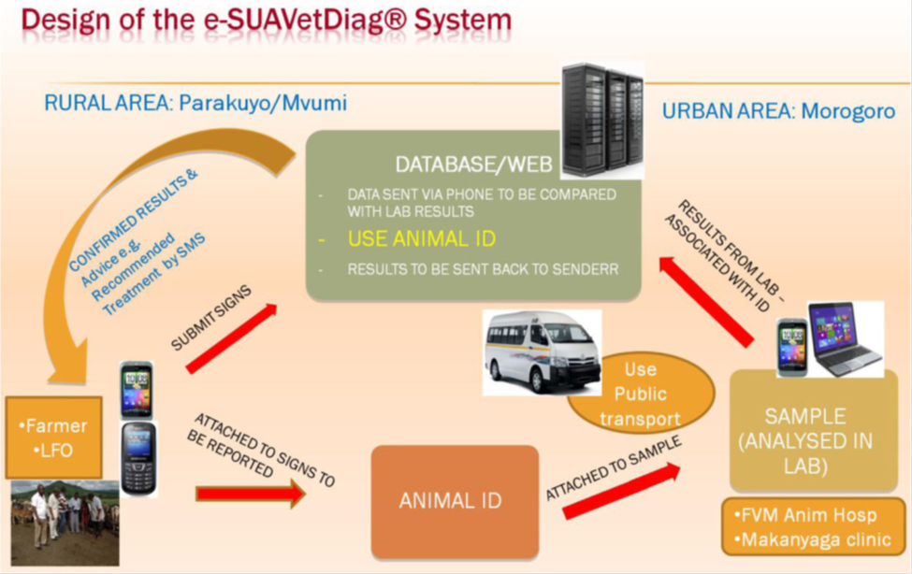
Figure 10. The e-based diagnostic system designed to support prompt diagnosis and advice to livestock keepers

The importance of Smartphone-based reporting and surveillance systems for early detection of emerging and reemerging diseases is clear. For example, during the Rift Valley Fever outbreaks of 1997 in Kenya, high rates of abortion and death of livestock likely occurred well before the human epidemic, during which over 400 people died due to the disease before reports of animal cases had been received at the national level Shears, (2000). Smartphone-based systems can also provide details about the demography of the sick entity and clinical signs of the disease, which enhances the opportunity for early detection of unusual syndromes in the area which may be directly linked to emerging or remerging diseases (figure 10). When it comes to the health of their livestock, people quickly notice unusual signs and tend to report these to health authorities, provided a working system is in operation Halliday et al. (2012). Novel approaches are also being developed to combine singles that may exist in multiple data sources associated with syndromic surveillance Halliday et al. (2012).

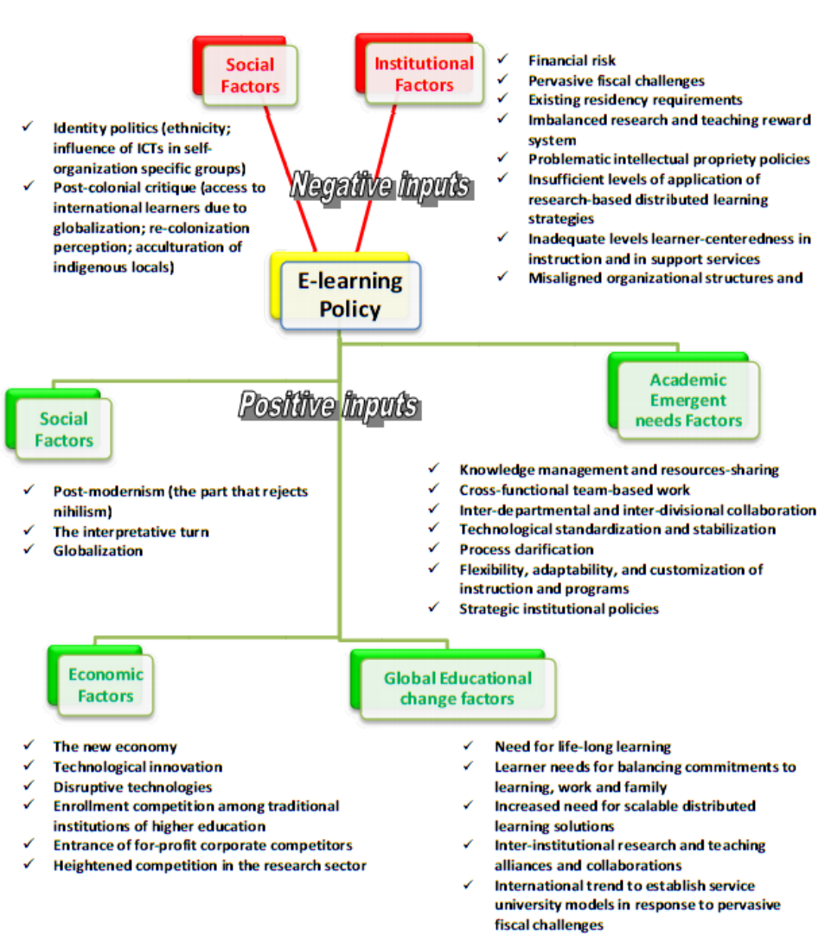
Figure 11. Mains potential positive and negative factors to affect e-learning strategies in academic systems. Modified from Parchoma, (2006).

2.7. Imaging Modalities

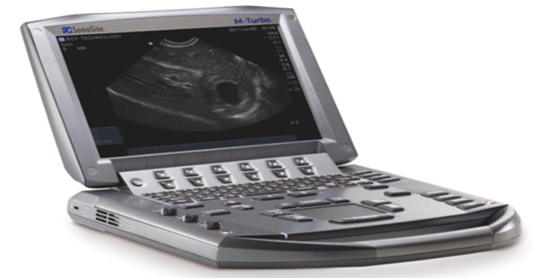
Figure 12. Digital imaging and diagnostive device

Veterinary imaging has the privilege and challenges that growth continued development of current and new imaging technologies and modalities. Despite the range of imaging technologies, most of them are based on either sound or electromagnetic waves. They provide both anatomical and functional information; the two are to some extent mutually exclusive, so hybrid techniques or novel imaging agents are used to bring functionality to anatomical studies and vice versa. Thus, positron emission tomography (PET) images are superimposed up on MRI and CT images (Figure11), and intravenous contrast is employed in CT and ultrasound imaging. Optical imaging in an emerging modality that promises information on morphology, physiology, and tissue composition Justinski, (2014). Simplifying our modalities to tissue interactions with sound or electromagnetic waves is useful for the purposes of overview but in their application, even the modalities that fall under therem it of the veterinary radiologist, digital radiography–computed radiography, magnetic resonance imaging, scintigraphy (including PET in limited cases) and ultrasound imaging, are so complex and nuanced in their use that few individuals can be completely at ease with all of them. Some degree of specialization will naturally result, raising questions about the need for certification and at what stage in training it should occur. Un certainty remains as to level of specialization the market will be and also whether complexity in modalities will continue to increase.

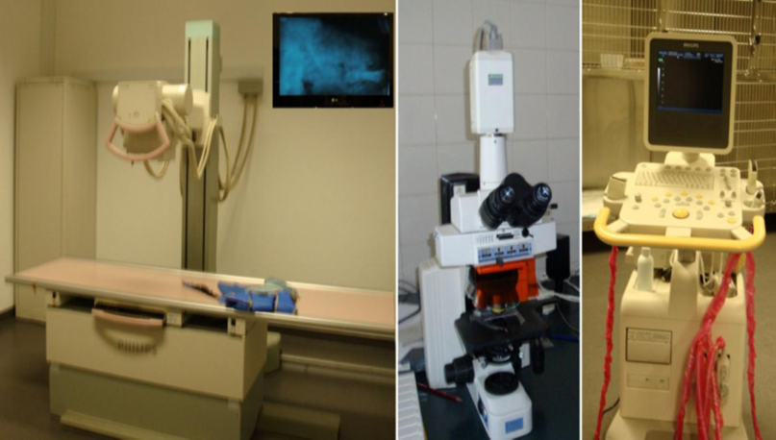
Figure 13. Veterinary Diagnostic Imaging. The democratization, in recent years, of electronic and digital devices.

Veterinary diagnostic imaging. The democratization, in last years, of electronic and digital devices 29 conceiving digital or digitalized imagery for radiologic (left image), histologic (central image) and echo graphic 30 (right image) diagnoses in veterinary centers, improved animal care, teacher and learning contents, and 31 decreased costs. Imaging diagnosis was one of the more important pioneer ICTs use in Medicine and Veterinary 32 fields. Many telemedicine services image-based, like echocardiography analysis, were firstly launched according 33 the Web development feasibility. In this last decade (1990s), hard books or journals and Compact Disc Read - Only Memory (CD-ROM) were the main vehicles for technical and scientific information, preserving copyrights and royalties. Additionally, in the 1994, the Web was also used by commercial librarians in order to buy and share health sciences resources, located on the Internet Gruwell, (2007), essentially for scholar and research purposes.
These online courses or contents were commonly based in the Blackboard Learning System (WebCT; http://www.webct.com/) or the open source Modular Object-Oriented Dynamic Learning Environment (Moodle; http://moodle.org/) based platform. More recently, the interactive approach can be done by simulation technology for teaching and assessment. This technology was progressively increased and is leaderships in health learn and training in human medicine. The contact limitation of students with real case-patient based, quickly health care delivery changes, patient safety improvement, medical errors minimization, and the out-door demonstration of professional competence and clinical safety assessment contributed for this development Scalese, et al. (2008).
At parallel time, the physical and wireless connections of electronic sensors with computers were improved for learn, research Bley & Bessei, (2008), public health, animal health cares and commercial purposes. From the last few years, due to automatic identification and data capture, the Radio- Frequency Identification (RFID) technology associated to miniaturized tags can provides continuous or periodical evaluations of biomedical parameters according to the biosensor features. Several training in clinical and chirurgical rooms for animals can take place using these tags. When associated with simulation technology and social networks can represent the onset of Multi-User Virtual Environments (MUVE) interfaces, like the predicted by Dede Dede, (2002). In large animals, several studies contributed to food animal chain traceability using these technologies Gosálvez et al. (2007).
Other than RFID technology, the image capture by remote sensing‟s (satellite images) associated with geographic information systems (GISs) are also used for epidemiological surveillance to predict, monitor and control epizootic diseases in large scale of the globe (Rinaldi, et al (2006). Many biological agents of diseases need intermediate hosts or vectors to complete their life cycle and/or infection, respectively. This assumes a greater importance for geographic dissemination of enzootic and zoonotic diseases when climatic changes are considered.
Some dangers and constraints of ICTs use in veterinary education were reported, mainly in research and learning aspects. Short Short, (2002) consider that small research and academic centers may do not have capacity to compete with large academic centers or some veterinary practices are difficult to replicate by computers. There are also some evidences of poor digital results due to insufficient technologies development or to different student’s impact using new technologies Jonas-Dwyer & Sudweeks, ( 2007). For example, a novel user interface device was tested by Treanor et al. (2008) in order to approach efficiency between optical and virtual microscope for learning purposes.
2.8. Veterinary Vaccines Technology and Their Importance to Animal Health and Public Health
Technology has radically changed and enhanced our day to day lives: internet, high speed trains, email, nanotechnology, etc. A similar revolution continues to take place in the medical sector, both human and animal. This is mainly due to the constant emergence of new diseases, or re-emergence of diseases which can mutate and change, or diseases which are currently impossible to vaccinate against. With climate change we are seeing more and more diseases move due to ticks, mosquitoes and flies appearing in countries where they previously were not seen. Disease essentially knows no borders and it is only through new developments in technology and science that we can remain at the ready to control them DuPont et al. (1995).
New diseases are constantly emerging and the animal health sector sees this challenge and the important role it plays. If we look at Bluetongue for example, each of the 25 different serotypes of the disease requires a different vaccine. Over the last 15 years, there have been six different Bluetongue serotypes in Europe alone. Avian influenza viruses, to take another example, are estimated to have led to the culling of 200 million birds in Asia alone, with losses of more than 10 billion US dollars for the region’s poultry sector. Diseases are constantly mutating and new diseases are emerging. Cutting-edge research and biotechnology are vital to combat these DuPont et al. (1995).
Investing in R & D and ensuring innovation remains at the core of our business is vital. The first use of biotechnology in the medical world is recognized as the first production of human insulin in 1978. Advances in science and technology have come to the fore in the development of new or improved vaccines to prevent and control diseases such as Avian Influenza, Foot and Mouth Disease, Rabies, and Classical Swine Fever Alexandersen, et al. (2002) One of the earliest developments in animal health was the Aujeszky’s disease vaccine. It allowed a successful eradication programme in several European countries. Similarly, Rabies is a success story which affects people and animals. There is a Rabies vaccine which has been highly successful in large parts of Europe. If we look on a global level and see that each year 55,000 people die of Rabies, mostly children, and know this is preventable, you can see how a Rabies vaccine can change lives and societies and know the value of vaccines and new technologies.
The animal health sector holds to the premise that preventing is better than curing, and with this premise vaccination is vital. Vaccines are an essential part of the veterinarian’s toolbox. Through vaccination the vet can improve the natural immunity of the animal by stimulating the response before the disease strikes. It allows farmers to protect entire flocks or herds and it keeps our pets safe and healthy from deadly diseases. In addition it ensures our food safety in that it protects animals from harmful foodborne pathogens, such as Salmonella. Advances in animal health have or could also benefit human health; the development of a vaccine for dogs against cancerous Melanoma is something that could be looked at from a human health angle (Weyer, et al. (2009). As Ana and her grandfather know first-hand, vaccines are an essential tool in the veterinarian’s toolbox that have profoundly influenced and improved world health. Until Louis Pasteur and Emile Roux developed the first Rabies vaccination in 1885, every Rabies infection resulted in death. Today, vaccines can prevent Rabies in both humans and animals, and vaccination programmes have eliminated this disease in many parts of the world. Vaccination was an essential tool in eradication campaigns against Rinderpest (cattle plague), the second disease ever to be eradicated from the globe as officially declared by the UN’s Food and Agriculture Organisation (FAO) and the World Organisation for Animal Health (OIE) in (2011) Marshall & Levy, (2011) & (Weyer et al., ( 2009).

3. Conclusions and Recommendations
As it was indicated different technology can have great value specially in relations to human and veterinary medicine which can plays a crucial roles for disease diagnosis, identifications, managements and controls specially in developed countries and some of developing countries like special microscope, electron microscope, radiology, tomography, x-ary, endoscope, colonoscopy were applied and now a day they have been established different new technologies like electro stethoscope which plays a vital role with Smartphone through Bluetooth and some were through electric conducting slurry wires and the Whisper Veterinary Stethoscope. This electronic stethoscope records and analyzes lung sounds, then classifies them in a lung score ranging from 1 to 5. On the other hand we also had seen the real-time monitoring on-line systems. This technique is intended to detect the early stages of infection in sentinel animals by measuring physical or physiological changes through in-vivo sensors. The information is then remotely transmitted in real-time and an alert is issued when a certain threshold is reached beside to this the first use of biotechnology in the medical world is recognized as the first production of human insulin in 1978. Advances in science and technology have come to the fore in the development of new or improved vaccines to prevent and control diseases such as Avian Influenza, Foot and Mouth Disease, Rabies, and Classical Swine Fever, whereas when we see in our country we have good animal productions in number but poor in quality so, it would be recommended that as one profession let we put base line for them, to the next generation a base line concerning quality work, love of technology and let we introduce our day to day papers that we have been published on-line in to practical to improve our productions like our neighbors Uganda, Tanzania, Kenya and etc to with new technologies like electro stethoscope, Smartphone applications for diagnosis and pharmaceutical purposes and different simulations with computerized system and even let we train our rural animal health works to make familiar with computer services because much of our workers were unable to open and close computer and they use their smart phones for communication and somewhat for face book applications.

References
- Abazov, V. M., Abbott, B., Abolins, M., Acharya, B. S., Adams, M., Adams, T.,… Ahsan, M. (2005). Search for the Flavor-Changing Neutral Current Decay B s 0→ μ+ μ− in p p¯Collisions at s= 1.96 T e V with the D0 Detector. Physical Review Letters, 94(7), 71802.
- Adler, S., Kanter, S. L., Horn, J. P., Harvey, J., & Bernier, J. G. M. (1995). The undergraduate medical curriculum: centralized versus departmentalized. Academic Medicine: Journal of the Association of American Medical Colleges, 70(8), 671–675.
- Alexandersen, S., Zhang, Z., & Donaldson, A. I. (2002). Aspects of the persistence of foot-and mouth disease virus in animals—the carrier problem. Microbes and Infection, 4(10), 1099–1110.
- Anderson, I. (2002). Foot and mouth disease: Lessons to be learned inquiry report HC888. London: The Stationary Office.
- Andrews, C. M., Bulloch, L., Dennison, T., Elder, J., Mitchell, A., Rivenbank, M. T.,…
- Gallicchio, V. S. (2015). Mobile Technology in Veterinary Clinical Medicine.
- Baker, J. A., & Lo, J. Y. (2011). Breast tomosynthesis: state-of-the-art and review of the literature. Academic Radiology, 18(10), 1298–1310.
- Batista, M. A., & Gaglani, S. M. (2013). The future of smartphones in health care. AMA Journal of Ethics, 15(11), 947–950.
- Bley, T. A. G., & Bessei, W. (2008). Recording of individual feed intake and feeding behavior of Pekin ducks kept in groups. Poultry Science, 87(2), 215–221.
- Cárdenas-Hagan, E., Carlson, C. D., & Pollard-Durodola, S. D. (2007). The cross-linguistic transfer of early literacy skills: The role of initial L1 and L2 skills and language of instruction.
- Language, Speech, and Hearing Services in Schools, 38(3), 249–259.
- Cheng, L. I. (2007). Ode to Pathology Images Online! Toxicologic Pathology, 35(4), 618–619.
- Christopher Shivelton, 2013. Queen, BSc, BVSc, MRCVS, 2013. takes a look at ho technology developments impact life in practice and beyond.
- Dascanio, J. J. (2003). The use of information technology in large animal veterinary education.
- Journal of Veterinary Medical Education, 30(4), 326–330.
- Dede, C. (2002). Vignettes about the future of learning technologies. 2020 Visions: Transforming Education and Training through Advanced Technologies, 18–25.
- Denwood, M., Dale, V. H. M., & Yam, P. (2008). Development and evaluation of an online computer-aided learning (CAL) package to promote small-animal welfare. Journal of Veterinary Medical Education, 35(2), 318–324.
- DuPont, H. L., Chappell, C. L., Sterling, C. R., Okhuysen, P. C., Rose, J. B., & Jakubowski, W.
- (1995). The infectivity of Cryptosporidium parvum in healthy volunteers. New England Journal of Medicine, 332(13), 855–859.
- Ferguson, R. B., Hergert, G. W., Schepers, J. S., Gotway, C. A., Cahoon, J. E., & Peterson, T. A.
- (2002). Site-specific nitrogen management of irrigated maize. Soil Science Society of America Journal, 66(2), 544–553.
- French, B. C., Hird, D. W., Romano, P. S., Hayes, R. H., Nijhof, A. M., Jongejan, F.,… Gay, J.
- M. (2007). Virtual international experiences in veterinary medicine: an evaluation of students’ attitudes toward computer-based learning. Journal of Veterinary Medical Education, 34(4), 502 -509.
- Gosálvez, L. F., Santamarina, C., Averós, X., Hernández-Jover, M., Caja, G., & Babot, D. (2007). Traceability of extensively produced Iberian pigs using visual and electronic identification devices from farm to slaughter. Journal of Animal Science, 85(10), 2746–2752.
- Gruwell, C. A. (2007). Evolution of the web revolution. Medical Reference Services Quarterly, 26(3), 85–90.
- Halliday, J., Daborn, C., Auty, H., Mtema, Z., Lembo, T., Barend, M.,… Cleaveland, S. (2012).
- Bringing together emerging and endemic zoonoses surveillance: shared challenges and a common solution. Phil. Trans. R. Soc. B, 367(1604), 2872–2880.
- Hopper-Losenicky, K. (2017). Inspiration and Aspiration: Women in STEM Careers Reflect on Role Models, Media Portrayals, and Influences on Occupational Goals. Fielding Graduate University.
- Huang, G.-B., Zhu, Q.-Y., & Siew, C.-K. (2006). Extreme learning machine: theory and applications. Neurocomputing, 70(1–3), 489–501.
- Index, C. V. N. (n.d.). Global Mobile Data Traffic Forecast Update, 2013-2018 [Internet]. San Jose: Cisco; [updated 2014 Feb 5, cited 2014 May 3].
- Jonas-Dwyer, D., & Sudweeks, F. (2007). Informing students using virtual microscopes and their impact on students’ approach to learning. Informing Science, 10(2007).
- Justinski, K. (2014, February 20). Compact rechargeable battery-screw connection of cell holders. Google Patents.
- Leng, S., San Tan, R., Chai, K. T. C., Wang, C., Ghista, D., & Zhong, L. (2015). The electronic stethoscope. Biomedical Engineering Online, 14(1), 66.
- Levecke, B., Behnke, J. M., Ajjampur, S. S. R., Albonico, M., Ame, S. M., Charlier, J.,…
- Kotze, A. C. (2011). A comparison of the sensitivity and fecal egg counts of the McMaster egg counting and Kato-Katz thick smear methods for soil-transmitted helminths. PLoS Neglected Tropical Diseases, 5(6), e1201.
- Maier, W., Altwegg, L. A., Corti, R., Gay, S., Hersberger, M., Maly, F. E.,… Eberli, F. R. (2005). Inflammatory markers at the site of ruptured plaque in acute myocardial infarction: locally increased interleukin-6 and serum amyloid A but decreased C-reactive protein.
- Circulation, 111(11), 1355–1361.
- Makaryus, A. N., Makaryus, J. N., Figgatt, A., Mulholland, D., Kushner, H., Semmlow, J. L.,…
- Taylor, A. J. (2013). Utility of an advanced digital electronic stethoscope in the diagnosis of coronary artery disease compared with coronary computed tomographic angiography. The American Journal of Cardiology, 111(6), 786–792.
- Marshall, B. M., & Levy, S. B. (2011). Food animals and antimicrobials: impacts on human health. Clinical Microbiology Reviews, 24(4), 718–733.
- Mateo, G. F., Granado-Font, E., Ferré-Grau, C., & Montaña-Carreras, X. (2015). Mobile phone apps to promote weight loss and increase physical activity: a systematic review and meta analysis. Journal of Medical Internet Research, 17(11).
- Meurant, R. C. (2008). The key importance of L2 digital literacy to Korean EFL pedagogy: College students use L2 English to make campus video guides with their cell phone videocams, and to view and respond to their videos on an L2 English language social networking site.
- International Journal of Hybrid Information Technology, 1(1), 65–72.
- Ohshimo, S., Sadamori, T., & Tanigawa, K. (2016). Innovation in analysis of respiratory sounds.
- Annals of Internal Medicine, 164(9), 638–639.
- Parchoma, G. (2006). A proposed e-learning policy field for the academy. International Journal of Teaching and Learning in Higher Education, 18(3), 230–240.
- Rasband, W. S. (1997). 1997–2007. ImageJ. Bethesda, MD: US National Institutes of Health.
- Reid, S. M., Ebert, K., Bachanek-Bankowska, K., Batten, C., Sanders, A., Wright, C.,… Ferris, N. P. (2009). Performance of real-time reverse transcription polymerase chain reaction for the detection of foot-and-mouth disease virus during field outbreaks in the United Kingdom in 2007.
- Journal of Veterinary Diagnostic Investigation, 21(3), 321–330.
- Rinaldi, L., Musella, V., Biggeri, A., & Cringoli, G. (2006). New insights into the application of geographical information systems and remote sensing in veterinary parasitology. Geospatial Health, 1(1), 33–47.
- Reid S. M., Ebert K., Bachanek-Bankowska K., Batten C., Sanders A., Wright C., Shaw A. E., Ryan E. D., Hutchings G. H., Ferris N. P., Paton D. J. & King D. P. (2009). – Performance of real time reverse transcription polymerase chain reaction for the detection of foot-and-mouth disease virus during field outbreaks in the United Kingdom in 2007. J. Vet. Diagn. Invest., 21 (3), 321 330. doi:10.1177/104063870902100303.
- Saeed, M. A., & Jabbar, A. (2017). ‘ Smart Diagnosis ’ of Parasites using Smartphones, (October). https://doi.org/10.1128/JCM.01469-17
- Scalese, R. J., Obeso, V. T., & Issenberg, S. B. (2008). Simulation technology for skills training and competency assessment in medical education. Journal of General Internal Medicine, 23(1), 46–49.
- Schiller, I., Oesch, B., Vordermeier, H. M., Palmer, M. V, Harris, B. N., Orloski, K. A.,…
- Waters, W. R. (2010). Bovine tuberculosis: a review of current and emerging diagnostic techniques in view of their relevance for disease control and eradication. Transboundary and Emerging Diseases, 57(4), 205–220.
- Shears, P. (2000). Communicable disease surveillance with limited resources: the scope to link human and veterinary programmes. Acta Tropica, 76(1), 3–7.
- Short, N. (2002). The use of information and communication technology in veterinary education.
- Research in Veterinary Science, 72(1), 1–6.
- Short, N., Maddison, J., Mantis, P., & Salmon, G. (2007). Veterinary e-CPD: a new model for providing online continuing professional development for the veterinary profession. Journal of Veterinary Medical Education, 34(5), 689–694.
- Simões, J. C. C. (2010). Information communication technology applied to veterinary education in early XXI century. Veterinary. Com, 3(1), 1–29.
- Simons, K., & Ehehalt, R. (2002). Cholesterol, lipid rafts, and disease. The Journal of Clinical Investigation, 110(5), 597–603.
- Thayer, W. S. (1908). On the early diastolic heart sound (the so-called third heart sound). The Boston Medical and Surgical Journal, 158(19), 713–726.
- Treanor, D., Jordan-Owers, N., Hodrien, J., Wood, J., Ruddle, R., & Quirke, P. (2008). A virtual reality powerwall compared to the conventional light microscope: results of a pilot study. The Journal of Pathology, 216, S43.
- Waldhalm, S. J., & Bushby, P. A. (1996). Bringing information technology into the veterinary curriculum. In Seminars in veterinary medicine and surgery (small animal) (Vol. 11, pp. 96–99).
- Weyer, J., Rupprecht, C. E., & Nelthland, L. H. (2009). Poxvirus-vectored vaccines for rabies areview. Vaccine, 27(51), 7198–7201.
- World Organisation for Animal Health, 2017. (OIE) (2017). – Manual of diagnostic tests and vaccines for terrestrial animals, 7th Ed. OIE, Paris. Available at: www.oie.int/international standardsetting/terrestrial-manual/access-online/ (accessed on 13 July 2017).

9/25/2018

