Review On African Horse Sickness

Befikadu Hurisa and Tsehaye Neges

¹Graduates of Veterinary Medicine, Collage of Veterinary of Medicine and Animal Sciences, University of Gondar, Ethiopia, P.O. box. 196.

Phone: +251915516658; Email: thesunneges@gmail.com

Abstract: African horse sickness (AHS) is an infectious but non-contagious arthropod borne viral disease affecting all species of Equidae. It is an Office International des Epizooties (OIE), listed disease and has been classified as a notifiable disease worldwide and it is endemic to sub-Saharan, central and east Africa. This seminar paper is aimed to provide information on the etiology, host range, epidemiology, methods of prevention and control of AHS as well as its economic significance. AHS is caused by a virus of the Reoviridae family, genus Orbivirus which is transmitted by haemotophagous midges of the genus Culicoides. The disease exclusively affects members of the Equidae family under natural conditions. Four clinical presentations of the African horse sickness have been described, each associated with a specific pathogenesis and mortality ranging between 95% (Pulmonary form) to 0% (fever form). Diagnosis may be made on the basis of typical clinical signs and isolation of the virus in the laboratory. Apart from supportive therapy there is no treatment for this disease. The husbandry modification, vector control and vaccination are the principal method of prevention and control of AHS. The disease was tremendous economic concern in southern Africa where horses were important for transportation and as draft animals. AHSV is rarely zoonotic; it may cause encephalitis, chorioretinitis and disseminated intravascular coagulation in laboratory workers when they are in contact with the virus. Ethiopia is facing serious and repeated outbreak of AHS in different regions. Due to its fatality and economic significance, awareness creation among equine owners and annual vaccination should be undertaken to control this disease.

[Befikadu Hurisa and Tsehaye Neges. Review On African Horse Sickness. Researcher 2018;10(8):1-10]. ISSN 1553-9865 (print); ISSN 2163-8950 (online). http://www.sciencepub.net/researcher. 1. doi:10.7537/marsrsj100818.01.

Key words: African horse sickness, Culicoides, Orbivirus

1. Introduction
Ethiopia has the largest equine population, probably with highest density per square kilo meter in the world (Alemayehu, 2004) and it has a total of 6.9% of the World’s and 42.4% of Africa’s equine population. Moreover it has 65% of all African mule, almost 50% of horses and 30% of donkeys. As per results from the livestock survey in Ethiopia, there are about 2.03 million horses, 6.21 million donkeys and 0.38 million mules (CSA, 2012). Despite their importance, equids are the most neglected and affected animals by a series of health and welfare problems. Among infectious diseases which cause severe socio-economic losses to the equine owning population and the national economy in general is African horse sickness (Shelima et al., 2007).
Equine play important role in the Ethiopia in the transportation of farm products, fodder, firewood, agriculture inputs, construction, and waste materials in both rural and urban transport system which is low cost and viable which provides the best alternatives in places where the infrastructure is insufficiently developed (Alemayehu and Benti, 2009).
African Horse Sickness is an acute or sub-acute vector-borne viral disease of horses and related equine species characterized by severe pyrexia, widespread hemorrhage, and edematous exudations. It is primarily an infection of horses, with mortality as high as 95%. Susceptibility and mortality decreases for mules (80%) and donkeys in that order (OIE, 2000).
African horse sickness virus (AHSV) is the etiological agent of African horse sickness (AHS), OIE listed disease. AHS is non-contagious but nevertheless it is a serious disease of equids. The disease is endemic to sub-Saharan Africa (Coetzer and Guthrie, 2004). And is transmitted by midges (Culicoides spp.), under favorable climatic conditions. The extension of the insect’s range due to climate change makes the international spread of AHS a very real possibility (Purse et al., 2005). Due to climate change the vector appears to be spreading and increasing the number of equines at risk. AHS is endemic to sub-Saharan Africa but has escaped occasionally from this geographical area into Northern Africa, the Middle East, the Arabian Peninsula, India and Pakistan (Mellor and Hamblin, 2004). Nowadays no effective treatment exists for AHS and consequently control of the disease relies on vaccination, control of animal movements and prevention of bites by Culicoides. AHS vaccines, based on attenuated AHS vaccine, have been in use in South Africa for almost 100 years and permitted the subsistence of horses in that part of the world (Coetzer, 2004).
Therefore the objectives of this Seminar Paper is:
    - To review the etiology, host and epidemiology of AHS.
    - To review on the economic importance of the disease AHS.
    - To summarize methods to prevent and control of AHS.

2. African Horse Sickness

2.1. History
Historically, AHS was first recorded south of the Sahara Desert in the mid-1600s with the introduction of horses to southern Africa. In southern Africa the first major outbreak occurring in 1719 when over 1700 animals died. Subsequently and over the next 217 years at least 10 major and several lesser outbreaks of AHS have been recorded, the largest being in South Africa in 1854–1855 when over 70 000 horses died. In 1959-61, the first documented outbreak of AHS out of its traditional enzootic region of Africa occurred in the Middle East (Israel, Iran, Pakistan, Afghanistan, India, Turkey, Iraq, Syria, Lebanon, Jordan, and Cyprus). During this outbreak, as many as 300,000 animals died or were destroyed. India reported 90% mortality in Equidae involved in 1987 Spain had an outbreak of AHS, which later spread to Portugal. It was suspected that the disease reached the country from subclinically infected zebras imported from Namibia, Africa. Zebras show no clinical signs when infected with the virus but can have viraemia, and therefore be infectious for the arthropod vector, for as long as 6 weeks. During this outbreak, it was found the virus was effectively spread by a non-traditional Culicoides species, increasing the list of potential vectors capable of transmitting the virus (Barnard, 1998).

2.2. Etiology
There are currently nine recognized serotypes of AHSV worldwide, the virus is inactivated at a PH of less than 6 or greater or equal to 12 or by formalin, acetyl ethylene amine derivatives, or radiation (Mellor and Hamblin, 2004). The AHSV is a double-stranded RNA virus from the genus Orbivirus (family Reoviridae), and as such, it is morphologically similar to other Orbivirus such as Bluetongue virus (BTV), Epizootic hemorrhagic disease virus (EHDV), and Equine encephalosis virus (EEV). The virion, which is approximately 70 nm in diameter, is made up of a two-layered icosahedra capsid and are, unenveloped (Figure 1). This capsid encloses the genome which comprises ten segments of linear double stranded RNA (Mertens et al., 2005). The virus consists of 7 structural proteins known as viral proteins (VP). These VP are organized into two distinct layers in a capsid. The outer capsid layer consists of proteins VP2 and VP5. The core or inner capsid consists of both minor and major proteins. The major proteins are VP3 and VP7 and the minor proteins are VP1, VP2 and VP6. Which are involved in virus attachment and cell entry These are the most variable proteins and as such are used to determine the virusserotype (usually VP2) (Mertens, 2003).

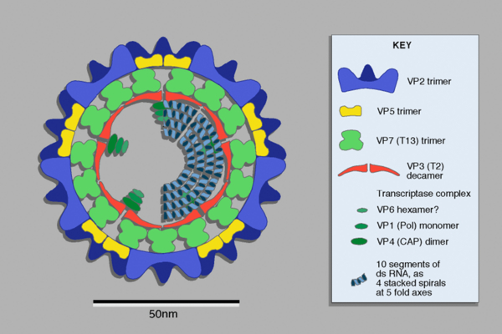
Figure 1: Diagram of Orbivirus structure

Figure published in Virus Taxonomy: VIIIth Report of the International Committee on Taxonomy of Viruses, Mertens P.P.C., Attoui H., Duncan R., Dermody T.S. (Eds.), Reoviridae, pp. 447–454.

2.3. Epidemiology

2.3.1. Geographical distribution of AHS
At present AHSV is endemic in tropical and sub-tropical areas of Africa south of the Sahara occupying a broad band stretching from Senegal in the west to Ethiopia and Somalia in the east, and extending as far south as northern South Africa (Mellor and Boorman, 1995). It spreads regularly to Southern Africa and only occasionally to Northern Africa. A few outbreaks have occurred outside Africa, in the near and Middle East and Iberian Peninsula. In the Republic of South Africa outbreaks of AHS were recorded in almost the whole country. The decline in the number of AHS outbreaks over the last decades of the 20th Century, particularly in the southern areas of South Africa, is partly due to the elimination of large free-ranging populations of zebra (Equus burchellii), which are considered to be the natural cycling host for the virus (Venter et al., 2006).

.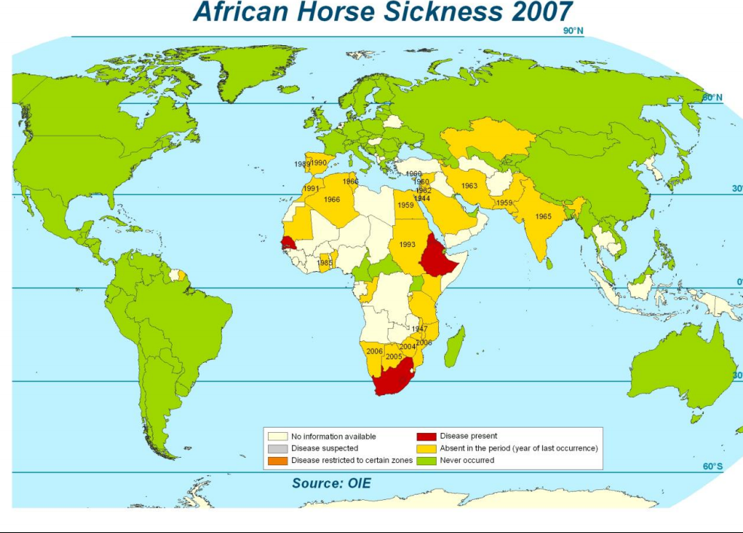
Figure 2: African horse sickness geographical distribution
Source: (OIE, 2007).

2.3.2. Host range
All equid species and crossbreeds are susceptible to infection but because of the high mortality rate frequently recorded in horses and occasionally mules these should be regarded as accidental or indicator hosts. Zebra have long been considered the natural vertebrate host and reservoir of AHSV, and are believed to play a vital role in the persistence of the virus in Africa. This species rarely exhibits clinical signs of infection. Indeed, the failure of AHSV to become established outside tropical and sub-tropical regions of Africa, where zebra principally reside, indicates that horses, mules and donkeys generally speaking are not long-term reservoirs of AHSV and are not involved in the permanent persistence of the virus. The sole exception may be AHSV-9, which survives perfectly well in West Africa where zebra no longer occur (Boinas et al., 2009).
Dogs are susceptible to experimental infection with AHSV and may die from the effects of the virus. Infection also occurs readily following ingestion of infected horse meat. Infection in camels is rare and inapparent and no details are available on the level and duration of viraemia, if any. It is likely that like the dog this species has no significant role in the epidemiology of AHS (Kahn, 2005).

2.3.3. Vector and transmission
Transmission of the African Horse Sickness virus (AHSV) is achieved through the Culicoides midge spp. Culicoides spp. (Family Ceratopogonidae) are biting midges and are amongst the most abundant and smallest of all haemotophagous insects being only 1 to 3mm in size with more than 1400 species having been identified (Figure 3). Culicoides spp. are crepuscular (peak activity is between sunset and sunrise) and only the females blood-feed. Adult vector longevity dropped three fold when temperatures rose from 15°C to 30°C (Mellor et al., 2000). Egg development rates within the females increase as temperature rises and so there is a shorter period between batches of eggs and so more batches are laid and thus more blood meals required by the vector females (Whitman et al., 2002). This increases the midge’s vector potential. The insect vector only lives a few weeks, usually 10-20 days but up to 90 days in exceptional cases Most Culicoides species can survive for long periods as the fourth instar larvae. The virus can also be transmitted by other haemotophagous insects like mosquitoes, Aedes, culex, and Anopheles spp. and by brown dog ticks, Rhipicephalus sanguineous (Rooney and Robertson, 2000). The spread of the disease is influenced by climatic conditions which favors the spread of carrier insects (vector) including warm, moist weather and high rain fall, as well as spread by wind dispersal. It is likely that the virus persists (over winter) in other known species in Africa when the insect is not alive. This explains why the disease doesn’t persist in other countries following an outbreak (Mullen, 2002).

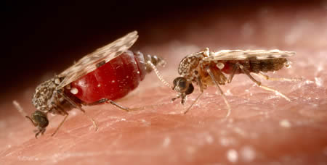
Figure 3: Adult biting midge, showing blood filled abdomen; Source: (Erasmus, 1998).

2.3.4. Morbidity and mortality
Morbidity and mortality vary with the species of animal, previous immunity and the form of the disease. The pulmonary form of African horse sickness is nearly always fatal, and the mortality rate in the cardiac form is usually 50% or higher. In the mixed form, mortality rate estimates vary from approximately 70% to greater than 80%. In contrast, horsesickness fever very rarely results in death. Horses are particularly susceptible to the more severe forms of African horse sickness. The mixed and pulmonary forms tend to predominate in susceptible horse populations, and the mortality rate is usually 50% to 95%. In other species of Equidae, AHS is generally less severe. In mules, the mortality rate is approximately 50%, and in European and Asian donkeys, 5% to 10%. Death is rare in African donkeys and zebra. Animals that recover from African horse sickness develop good immunity to the infecting serotype and partial immunity to other serotypes (Mellor and Hamblin, 2004).

2.4. Pathogenesis
AHS is a generalized disease of blood and lymphatic vessels. Clinical signs and lesions are related to endothelial damage and increased permeability, varying in severity with the infecting AHSV strain and serotype and the host susceptibility. After biting of an infected Culicoides, the virus multiplies in endothelium of lymph capillary vessels and regional lymph nodes, and a primary viraemia occurs. Dissemination to capillary vessels of many organs then occurs, mainly to the lungs, large intestine, and lymphoid organs, causing a secondary viraemia (Coetzer and Guthrie, 2004). The incubation period and severity as well as overall outcome of a disease are determined mainly by virus virulence and susceptibility of the animal. AHSV may cause severe pathological symptoms in the vertebrae hosts (Mertens et al., 2000). That can progress rapidly from the first symptom to death. In susceptible horses, viraemia may last between 4 and 8 days, and rarely is longer than 21 days. The onset of viraemia is usually accompanied by fever, which persists until viraemia disappears (Laegreid et al., 2004).
In experimentally infected horses, high concentration of virus is found in the spleen, lungs, caecum, pharynx, choroid plexus and most lymph nodes by the second day after inoculation. This precedes the onset of fever or detectable viraemia. By the third day after inoculation, it is present in most organs (Coetzer et al., 2004).

2.5. Clinical sign
Four different forms of African horse sickness exist: the peracute (pulmonary) form, the subacute edematous (cardiac) form, the acute (mixed) form, and horsesickness fever. Symptomatic infections occur most often in horses and mules. The pulmonary and mixed forms usually predominate in susceptible populations of horses. The pulmonary form is also the most common form in dogs. The mildest form, horsesickness fever, tends to be seen in horses with partial immunity, mules and donkeys (Radostits et al., 2007).
The peracute or pulmonary form: The pulmonary form of African horse sickness usually begins with an acute fever (39-41), followed by the sudden onset of severe respiratory distress. Infected animals often stand with forelegs spread, head extended, and nostril is fully dilated. There may be periods of recumbence and terminally quantities of frothy fluid may be discharged from the nostrils. Other clinical signs may include tachypnea, forced expiration, profuse sweating, spasmodic coughing, and frothy serofibrinous nasal exudates. Dyspnea usually progresses rapidly and the animal often dies within a few hours after the respiratory signs appear (Radostits et al., 2007).

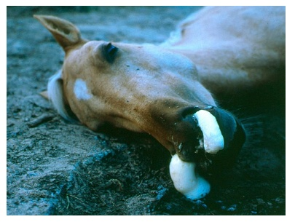
Figure 4: Horse suffering from severe respiratory distress
Source: (Picture courtesy of the Institute for Animal Health, Pirbright).

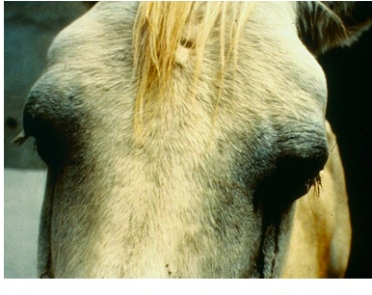
Figure 5: Horse exhibiting oedema of supraorbital fossae

Source (Picture courtesy of the Institute for Animal Health Pirbright.).

The subacute edematous or cardiac form: The cardiac form of African horse sickness usually begins with a fever that lasts for 3 to 6 days. Shortly before the fever starts to subside, edematous swellings appear in the supraorbital fossae and eyelids. These swellings later spread to involve the cheeks, lips, tongue, intermandibular space, laryngeal region and sometimes the neck, shoulders and chest. It is important to note that no edema of the lower leg is observed. Other clinical signs, usually seen in the terminal stages of the disease, can include severe depression, colic, ecchymoses on the ventral surface of the tongue, and petechiae in the conjunctivae. Death often occurs from cardiac failure (MacLachlan and Dubovi, 2011).
The acute or mixed form: in the mixed form of African horse sickness, symptoms of both the pulmonary and cardiac forms are seen. In most cases, the cardiac form is subclinical and is followed by severe respiratory distress. Occasionally, mild respiratory signs may be followed by edema and death from cardiac failure. The mixed form of African horse sickness is rarely diagnosed clinically, but is often seen at necropsy in horses and mules (Boinas et al., 2009).
Horse sickness fever: is a very mild form of the disease and is frequently not diagnosed clinically. The most characteristic finding is a rise of the rectal temperature (39 to 40 °C) lasting one to three days followed by a drop in temperature to normal, and 100% recovery. Other symptoms are generally mild and may include mild anorexia or depression, edema of the supraorbital fossae, congested mucous membranes and an increased heart rate. It also occurs in species such as donkeys and zebras which are resistant to the development of clinical disease (Knipe and Howley, 2007).

2.6. Pathology
The pathological features are most prominent in the pulmonary and cardiac forms. The most striking features of the pulmonary form are severe edema of the lungs and hydrothorax. Several liters of pale yellow fluid which may coagulate on exposure to air are found in the thoracic cavity. Epicardial and endocardial hemorrhage of the endocardium may be evident. Congention of the mucosa of the stomach and patchy congetion of the serosa and item of the mucosa of the intestine appear (Seifer, 1996). The most characteristic sign of the cardiac form are the distinctly yellowish gelatinous edema of the subcutaneous and intramuscular connective tissues of the head and neck, which in sever case extends to the back, shoulder and chest. The eye lid supraorbital fossae, lips, cheeks, tongue and intermandibular space are commonly involved. Similarly, the lesions in gastro intestinal system are usually more severe than in the pulmonary form (Anon, 1998). There are few published report on the histopathology of AHS. However, exudative pneumonia, congestion of alveolar capillaries, arterioles and venuules as well as perivasculitis is evident. Degeneration and necrosis of mycocytes, edema of the myocardium with infiltration of cell, plasma cell as well as lysis of necrotic mycocytes appear (Coetzer et al., 1994).

2.7. Diagnosis
AHS can be diagnosed based on clinical signs and characteristic lesions combined with an appropriate history and epidemiological information. However, other signs and lesions are less specific for sub-acute form of AHS, and other diseases such as equine encephalosis, equine infectious anemia, equine morbillivirus pneumonia, equine viral arthritis, babesiosis and purpura haemorrhagica may be confused with one or other forms of AHS and should be excluded (OIE, 2012).
2.7.1. Clinical diagnosis
AHS considered an exotic disease outside Africa. Clinical diagnosis of the pulmonary and cardiac forms is not difficult, the edema of supraorbital fossae is characteristic of the disease; excess pleural and pericardial fluid at postmortem provides a further reason to suspect the disease especially in endemic area and in appropriate season (Radostits et al., 2007).
2.7.2. Laboratory diagnosis
At laboratory level African horse sickness can be diagnosed by isolating the virus or detecting its nucleic acids or antigens (OIE, 2012). Virus isolation is particularly important when outbreaks are seen outside endemic areas. AHSV can be isolated in embryonated eggs, by intracerebral inoculation of newborn mice, or in cell cultures. Suitable cultures for inoculation include baby hamster kidney (BHK-21), monkey stable (MS) and African green monkey kidney (Vero) cells. AHSV antigens can be detected with ELISAs (Crafford et al., 2011). A reverse-transcription polymerase chain reaction (RT-PCR) technique is used to detect viral RNA. A recently developed type-specific RT-PCR assay can be used for rapid serotyping (Rodriguez-Sanchez et al., 2008). Traditionally laboratory has relied on detection of antibodies by serological tests and direct demonstrations of virus by isolation in cell culture of living cells or laboratory animal (Reed et al., 2005). A specimen for the laboratory diagnosis includes blood in anticoagulant (during the early febrile phase) and small pieces (2-4g), spleen, lung and mediastenal lymph node (Sahle, 2005).
2.7.3. Differential diagnosis
According to OIE (2006) and (Erasmus, 2000), clinical sign associated with AHSV are clearly not pathognomonic and other disease to consider are listed below
Viral
- Equine infectious anemia (Retroviridae)
- Equine viral arterites (Artetriviridae)
- Equine encephalosis (Reoviridae) (often occurs concurrently with AHSV, differenciatable by absence of edema and lower mortality rate
Bacterial
- Anthrax (Bacillus anthracis)
Protozoan
- Trypanosomiasis (tyrpanosoma evansi)
- Piroplasmosis (Babesia caballi and Babesia equi)
2.8. Treatment
Apart from supportive treatment, there is no specific therapy for AHS. Affected animals should be well nursed, fed and rested, as the slightest exertion may result in death as a result of cardiac failure. After recovery they should be rested for at least four weeks before being returned to light work As babesisosis may be complication of AHS, blood smear as well as body temperature should be taken regularly and, if found positive, animal should appropriately treated (Hirsh and Zee, 1999).
2.9. Prevention and control of AHS
Polyvalent and to a limited extent monovalent vaccines are used for immunization. A polyvalent vaccine, formalin-inactivated spleen tissue (viscerotropic) vaccine gives immunity for one year. Second vaccine is a mouse brain attenuated live virus (neurotropic) vaccine which is also a polyvalent prophylactic immunization against AHS is very efficient methods of preventing serious losses (Coetzer et al., 2004). AHSV is non-contagious and can only be spread via the bites of infected vector species of Culicoides. Methods of control and prevention therefore include Husbandry modification, Vector control, and vaccination (Mellor and Hamblin, 2004).
2.9.1. Husbandry modification
This measure is aimed at denying or reducing vector access to susceptible animals. Most vector species of Culicoides including C. imicolaa are exophilic so stabling susceptible equids during times of maximum vector activity (i.e. the crepuscular periods and during the night) will significantly reduce biting rates and hence the likelihood of infection. In addition, if obvious portals of access to such housing such as windows and doors are screened with material of fine mesh (e.g. sand-fly netting) or with coarser material impregnated with insecticide (e.g. a synthetic pyrethroid) this will further reduce biting rates (Meiswinkel et al., 2000).
2.9.2. Vector control
It is rarely possible to completely eliminate populations of vector Culicoides. The main aim, is to reduce the number of potentially infecting bites that susceptible animals receive to levels where maintenance of an epidemic becomes unsustainable. Vector control can be tackled in a number of ways but it is important to remember that a combination of approaches is likely to yield the best results (Anderson and May, 1991). Infection of susceptible horse can be prevented to a large degree by stabling them some hours before sunset and letting them out a few hours after sun rise as Culicoides species are nocturnal and are not inclined to enter building (Seifert, 1996).

2.9.4. Vaccination
Annual immunization with polyvalent live attenuated vaccine (LAV) is currently the mainstay for control in endemic areas of Africa. In South Africa, a commercial polyvalent AHSV-LAV is supplied by Onderstepoort Biological Products as two separate vials: Combination1 (comb1) and Combination 2(comb2), which is administered at least three weeks apart. Comb1 includes AHSV types 1, 3 and 4 (AHSV-1, 3, and 4). Comb2 includes AHSV-2, 6, 7 and 8. Whole genome sequences of strains included in these vaccines are published (Guthrie et al., 2015). The current formulation, which does not include either AHSV-5 or 9, was introduced into use in 1994. Serological cross-reaction reportedly occurs between certain types: AHSV-1 with AHSV-2, AHSV-3 with AHSV-7, AHSV-6 with AHSV-9, AHSV-8 with AHSV-5, whereas AHSV-4 does not exhibit cross-reaction with other types. Different types are allocated to the two combinations based on these cross reactions (von Teichman et al., 2010). Immune response of horses to immunization with AHSV-LAVs has been investigated, however the viral kinetics following immunization have not been characterized (Pretorius et al., 2012). No killed or subunit vaccines are currently manufactured commercially. Animals that recover from the disease develop solid life-long immunity against the infecting viral serotype (CFSPH, 2012).
2.10. Importance of the disease:
Economic Importance
African horse sickness is an economically highly important non-contagious but infectious disease that is transmitted by various species of midges Horse played a very important role in transportation, was vital in military operations and was used for draught power in agriculture and mining. Heavy losses as a result of AHS were therefore very disruptive and experienced very negatively. Although horses are nowadays seldom used for these purposes, many have considerable monetary value as performance horses or animals used for other forms of recreation. The disease is currently an economic concern because of costs associated with preventive measures in enzootic areas, monitoring for introduction of disease in neighboring unaffected areas and restrictions on importation of horses from countries in which the disease enzootic. The high case fatality rate and morbidity of the disease in out breaks is another source of loss (Thompson et al., 2012).
Outbreak of AHS often results in significant equine losses; an estimated 300,000 animals died or were destroyed in the Middle Eastern 1959-1960 outbreak alone. The most recent outbreak in South Africa resulted in 500 equine deaths (Radostits, 2007).
Public health importance
Very rarely AHSV can be zoonotic; the first evidence of this came when the laboratory workers, exposed to the virus during vaccine manufacture developed encephalitis, chorioretinitis and disseminated intravascular coagulation (Anon, 1998). Humans are not natural hosts for the African horse sickness virus, and no cases have been seen after contact with field strains. However, a neurotropic vaccine strain, adapted to mice, can cause encephalitis and retinitis in humans (Swanepoel, 2001).

3 Epidemiology Of African Horse Sickness In Ethiopia
Equines are of great significance in the development of Ethiopia, particularly in the farming and transport systems. A livestock survey of rural areas indicates that there are approximately 2.03 million horses, 6.21 million donkeys and 0.38 million mules in the country (CSA, 2012). Although these animals provide both economic and social benefits to equine owning communities, they are often neglected and are affected by a series of health and welfare problems (Shelima et al., 2007).
Equine play important role in the Ethiopia in the transportation of farm products, fodder, firewood, agriculture inputs, construction, and waste materials in both rural and urban transport system which is low cost and viable which provides the best alternatives in places where the infrastructure is insufficiently developed On the other hand, many factors contribute to the poor performance and health of Equidae. Among the most important one is a viral disease like African horse sickness characterized by high morbidity and mortality rates is worth enough to be mentioned. Hence, it is the viral diseases characterized by up to 95%, 50%, and 10 % mortality rate in horse, donkey and mule respectively (Alemayehu and Benti, 2009).
Ethiopia is facing serious and repeated outbreak of AHS in different regions. The Virus Neutralization Test (VNT) indicated that two serotypes of AHS were involved in the outbreak occurred in 2002-2003 in Southern Ethiopia (Awassa, Hossana, Wondogenet and Hagerselam), Western Ethiopia (Jimma, Bedelle, Nekemte, Horroguduru and chaliya) and Central Ethiopia (Debrzait, Meki, Zeway, Filtimo and Bekejo) serotypes 9 and 6 were isolated from blood, spleen and lymph nodes. The identification of serotype 6 represents the first report in Ethiopia. Of the nine serotype identified, type 9 is predominantly found throughout the African content and it is the only serotype previously identified in Ethiopia (Aschalew et al., 2005). The outbreak affected horses vaccinated with monovalent vaccines containing type 9 AHSV. It is well documented that in spite of its wide distribution, serotype 9 of AHSV has a lower virulence than other serotypes, killing few horses in enzootic areas (Seifert, 1996). The outbreak encountered in 2002–2003, however, resulted in high mortality (Aschalew et al., 2005).

4. Conclusion And Recommendations
African horse sickness is a serious, often fatal insect borne viral disease of Equidae, endemic to Africa. It is spread by arthropod vectors (primarily Culicoides species-biting midges), with mortality in horses as high as 95%. As a consequence its severity in horses and its proven capacity for sudden and rapid expansion, AHS is listed by the OIE as a notifiable disease. Annual immunization with polyvalent live attenuated vaccine (LAV) is currently the mainstay for control in endemic areas of Africa. Ethiopia is facing serious and repeated outbreak of AHS in different regions. The Virus Neutralization Test (VNT) indicated that two serotypes of AHS were involved in the outbreak occurred in 2002-2003 in Southern Ethiopia, Western Ethiopia and Central Ethiopia.
Based on the above concluding remarks the following points are recommended.
- Equine owners should be acquainted with the disease AHS and associated predisposing factors in order to take proper control measures such as vector control and vaccinating their animal timely.
- There should be annual vaccination programs for horses, mules, and donkeys in their order of importance at different agro-ecological zone with appropriate serotype vaccine.
- There is need to conduct further research to isolate and identify the serotypes of AHS to prepare effective vaccines in order to decrease the high prevalence and tackle losses from the disease.

Corresbonding author:

Befikadu Hurisa And Tsehaye Neges

DVM, Graduates of Veterinary Medicine, University of Gondar, Ethiopia

Phone: +251915516658

Email: thesunneges@gmail.com

References
- Alemayehu, C. A. (2004): Case studies on reproductive activity of equine in relation to environmental factor in central Ethiopia. PHD thesis, Humboldt University of Berlin.
- Alemayehu, L. and Benti, D. (2009): Study on Reproductive Activity and Evaluation of Breeding Soundness of Jacks (Equis asinus) in and around Debre Zeit, Ethiopia. Live Res Rural Dev, 21: 42- 45.
- Anderson, R. M. and May, R. M. (1991): Infectious diseases of humans: dynamics and control, Oxford University Press, Oxford.
- Anon, (1998): Foreign Animal Disease, United States Of America Health Association: Virginia: Carter printing company, Pp: 41-49.
- Aschalew, Z., S. Teshale, P. Keith, G. Feseha, E. Bojia. (2005): Isolation and identification of circulating serotypes of AHSV in Ethiopia. In: USA Veterinary solutions. LLC. Int. J. Appl. Res. Vet. Med., 3(1): 40-42.
- Barnard, J. H. (1998): Epidemiology of African horse sickness and the role of the zebra in South Africa. Arch. Virol. Suppl, 14:13–19.
- Boinas, F., Calistri, P, P., Domingo. Aviles, M. M., Lopez, B. M., Sanchez, B. M. and Sanchez-Vizcaino, J. M. (2009): Scientific review on African Horse Sickness, Pp: 1-62.
- Central Statistical Authority (CSA) (2012): Statistical report on livestock and livestock characteristics. In: Federal Democratic Republic of Ethiopia. CSA, Central Agricultural Census Commission, Ethiopian Agricultural Sample Enumeration.
- Coetzer, J. A. W. and Guthrie, A. J. (2004): African horse sickness, In: J. A. W. Coetzer and R. C. Tustin (eds.): Infectious Diseases of Livestock, 2nd edn, Cape Town: Oxford University Press Southern Africa, Pp: 1231–1246.
- Coetzer, J. A. W. (2004): African horse sickness. In: Tustin. JAWCRC, editor: Infectious diseases of livestock. 2nd ed. Cape Town, Southern Africa: Oxford University Press; Pp: 1231–46.
- Coetzer, J. A. W., Thomson, G. R., and Tustin, R. C. (1994): Infectious disease of livestock with special referenceto south Africa. vo11. Capetown: Oxford Univeristy press, p.460-472.
- Crafford, J. E., Guthrie, A. J., van-Vuuren, M., Mertens, P. P. C., Burroughs, J. N., Howell, P. G., Batten, C. A. and Hamblin, C. (2011): A competitive ELISA for the detection of group-specific antibody to equine encephalosis virus. J. Virol. Methods 174: 60–64.
- Erasmus, B. J. (2000): The pathogenesis of African Horse Sickness. Proceedings of Third International conference on Equine Infectious Diseases, Paris: Karger, pp: 1-11.
- Guthrie, A. J., Coetzee, P., Martin, D. P., Lourens, C. W., Venter. (2015): Complete genome sequences of the three African horse sickness virus strains from a commercial trivalent live attenuated vaccine. Genome Announc 3 (4): pp: 814-15.
- Hirsh, D. C and Zee, Y. C. (1999): Veterinary Microbiology, USA: Black well Science, 12 Pp: 435-436.
- Kahn, C. M. (2005): The Merck Veterinary Manual, 9th ed. Merck and Co., INC. White house staion, N. J., USA, Pp: 556-557.
- Knipe, D. M. and Howley, P. M. (2007): Fields Virology. Kluwer Academic Press, Pp: 235-240.
- 5ed. Vol. II. USA: Welters Kluwer.
- Laegreid, W. W., Skowronek, A., Stone-Marschat, M. and Burrage, T. (2004): Characterization of virulence variants of African horsesickness virus. Virology, 195: 836-9.
- MacLachlan, N. G. and Dubovi, E. J. (2011): Fenner’s Veterinary Virology, 4th ed. China: Academic Press, Journal, 81(9): 458-461. Pp: 285-287.
- MacLachlan. N. J. and Guthrie, A. J. (2010): Re-emergence of bluetongue, African horse sickness, and other Orbivirus diseases, Vet. Res. 41: 11–12.
- Meiswinkel, R., Baylis, M. and Labuschagne, K. (2000): Stabling and the protection of horses from Culicoides bolitinos (Diptera: Ceratopogonidae), a recently identified vector of African horse sickness, Bull. Entomol. Res. 90: 509–515.
- Mellor, P. S. and Hamblin, C. (2004): African horse sickness. Vet Res, 35, 54:445-466.
- Mellor, P. S., Boorman, J. and Baylis, M. (2000): Culicoides Biting Midges: Their role as Arbovirus vectors. 45: 307-340.
- Mellor, P.S. and Boorman, J. (1995): The transmission and geographical spread of African horse sickness and bluetongue viruses, Ann. Trop. Med. Parasitol. 89: 1–15.
- Mertens, F., Larramendy, M., Gustavsson, A., Gisselsson, D., Rydholm, A., Brosjo, O., Mitelman, F., Knuutila, S. and Mandahl, N. (2000): Cancer Genet. Cytogenet. 116: 89-96.
- Mertens, P.P.C. and Mellor, P.S. (2003): Bluetongue, State Vet J, 13:18–25.
- Mertens, P.P.C., Maan, S., Samuel, A.and Attoui, H. (2005): Orbivirus, Reoviridae. In Virus Taxonomy. Edited by Fauquet CM, Mayo MA, Maniloff J, Desselberger U, Ball LA. London: Academic Press; Pp: 466–483.
- Mullen, G.R. (2002): Biting midges (Ceratopogonidae). In: Medical and Veterinary Entomology. Eds. Mullen G., & Durden, L. Academic Press. London.
- Office International Des Epizootics. (2012): African horse sickness. In: Manual of Diagnostic Tests and Vaccines for Terrestrial Animals. Office International des Epizooties, World Organization for Animal Health, Paris, Pp: 1–12.
- Office International Des Epizootics. (2000): Manual of Standards for Diagnostic Tests and Vaccines. Paris, Organization International des Epizootics, Pp: 178–188.
- Office International Des Epizootics. (2008): Manual of diagnostic tests and vaccine for terrestrial animals, 5th ed. New York, W.B. Saunders Company Ltd, Pp. 582-583.
- OIE (World Organisation for Animal Health) (2006): Handistatus II. July 2006.
- Pretorius, A., Van-Kleef, M., Van-Wyngaardt, W. and Heath, J. (2012): Virus-specific CD8+ Tcells detected in PBMC from horses vaccinated against African horse sickness virus. Vet Immunol Immunopathol, 146:81–6.
- Purse, B. V., Mellor, P. S., Rogers, D. J., Samuel, A. R., Mertens, P. P. and Baylis, M. (2005): Climate change and the recent emergence of bluetongue in Europe. Nat Rev Microbiol 3, 171:181.
- Radostits, O.M., Blood, D.C. and Gay, C.C. (1994): Veterinary Medicine, a Text Book of the Disease of Cattle, Sheep, Pigs, Goats and Horses. 8th ed. London: Ballier Tindal, pp: 946-948.
- Radostits, O.M., Gay, C.C., Hinchcliff, K.W. and Constable, P.D. (2007): Veterinary Medicine, a Text Book of the Diseases of Cattle, Sheep, Pigs, Goats and Horses. 10th ed. London: Sounders Company, Pp: 1179-1183.
- Reed,S.M., Bayly,WM. and Sellon,D.C. (2005):Equine Internal Medicene,2nd ed. USA Saunders, Pp 582-583.
- Rodriguez-Sanchez, B., Fernandez-Pinero, J., Sailleau, C., Zientara, S., Belak, S., Arias, M. and Sanchez-Vizcaino, J.M. (2008): Novel gel-based and real-time PCR assays for the improved detection of African horse sickness virus. J. Virol. Methods 151:87–94.
- Rooney,J.R.and Robertson,J.L. (2000):Equine Pathology1st ed. Lowa State University Press,Ames,Blacksburg,Virginia, Pp:156.
- Sahle,M. (2005):standared veterinary laboratory diagnostic manual:virology,vol.1, Ethio –French project,”quality and sanitary aspects of animal products in Ethiopia” MoARD,animal health department, addis abeba, Pp: 36.
- Seifert, H.S.H. (1996): Tropical Animal Health, 2nd Ed. Dordrecht CTA-kluwer Acadamic Publisher, Pp: 234-240.
- Shelima, B., Dinka, H., Abelti, A., Mume, T., Geleta, T., Chala, R. (2007): Major constraints and health management of carthorses in the mid rift valley of Ethiopia. In: Pearson, R.A., Muir, C.J., Farrow, M. (Eds.), Proceedings of an International Colloquium held at Addis Ababa University, Ethiopia. Pp: 231–341.
- Swanepoel, R. (2001): Encephalitis and Chorioretinitis associated with neurotropic African horse sickness virus infected in laboratory workers. Virological and serological investigations. South African Medical Journal, 81(9): 458-461.
- Thompson, G.M., Jess, S. and Murchie, A.K. (2012): A review of African horse sickness and its implications for Ireland. Irish Veterinary Journal, 65: pp: 9.
- Vanniekerk, M., Van-staden, V., Van-Dijk A.A. and Huismans, H. (2001): Variation of African horse sickness virus nonstructural protein NS3 in South Africa, Journal of General virology, 82: 149-158.
- Van-Rensburg, L.B.J., De-Clerk, J., Groenewald, H.B. and Botha, W.S. (1981): An outbreak of African horse sickness in dogs. J. S. Afr. Vet. Assoc. 52:323–325.
- Venter, G.J., Koekemoer, J.J., Paweska, J.T. and Koekemoer, J.J.O. (2006): Investigations on outbreaks of African horse sickness in the surveillance zone in South Africa, Revue Scientifique et Technique, 25(3): 1097-109.
- Von-Teichman, B.F, Dungu, B.and Smit, T.K. (2010): In vivo cross-protection to African horse sickness Serotypes 5 and 9 after vaccination with Serotypes 8 and 6. Vaccine, 28(39):6505–17.
- Whitman, E.J., Mellor, P.S. and Baylis, M. (2002): Effect of temperature on the transmission of Orbiviruses by the biting midge, Culicoides sonorensis. Medical and Veterinary Entomology, 16 (2):147-156.

8/5/2018

