Relation between Beta and Gamma function By using Laplace transformation

Dr. Dinesh Verma

Associate Professor
Yogananda College of Engineering & Technology, Jammu
Email: drdinesh.maths@gmail.com

Abstract: Normally it has been noticed that differential equation is solved typically. The Laplace transformation makes it easy to solve. The Laplace transformation is applied in different areas of science, engineering and technology. The Laplace transformation is applicable in so many fields. Laplace transformation is used in solving the time domain function by converting it into frequency domain. Here we have applied Laplace transformation in linear ordinary differential equations with constant coefficient and several ordinary equations wherein the coefficients are variable. Laplace transformation makes it easier to solve the problems in engineering applications and makes differential equations simple to solve. In this paper we will discuss the relation between beta and gamma function by using Laplace transformation.
[Dinesh Verma. Relation between Beta and Gamma function By using Laplace transformation. Researcher 2018;10(7):72-74]. ISSN 1553-9865 (print); ISSN 2163-8950 (online). http://www.sciencepub.net/researcher. 9. doi:10.7537/marsrsj100718.09.

Key words: Laplace transformation, Inverse Laplace transformation, beta function, gamma function, convolution theorem.

Sub area: Laplace transformation
Broad area: Mathematics

- Introduction:
Laplace transformation is a mathematical tool which is used in the solving of differential equations by converting it from one form into another form. commonly it is effective in solving linear differential equation either ordinary or partial. It reduces an ordinary differential equation into algebraic equation. Ordinary linear differential equation with constant coefficient and variable coefficient can be easily solved by the Laplace transformation method without finding the generally solution and the arbitrary constant. It is used in solving physical problems. This involving integral and ordinary differential equation with constant and variable coefficient. It is also used to convert the signal system in frequency domain for solving it on a simple and easy way. It has wide applications in different fields of engineering and techniques besides basis sciences and mathematics.
Definition
Let F (t) is a well defined function of t for all t ≥ 0. The Laplace transformation of F (t), denoted by f () or L {F (t)}, is defined as
L {F (t)} =
Provided that the integral exists, i.e. convergent. If the integral is convergent for some value of, then the Laplace transformation of F (t) exists otherwise not. Where the parameter which may be real or complex number and L is is the Laplace transformation operator.
The Laplace transformation of F (t) i.e. exists for>a, if
F (t) is continuous and is finite. It should however, be keep in mind that above condition are sufficient and not necessary.
Laplace transformation of some elementary function:
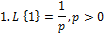
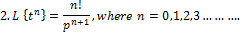
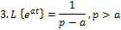
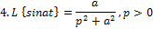
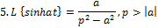
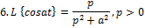
7.
Proof: By the definition of Laplace transformation, we know that
1. L {F (t)} = then L {1} =
= - ) =
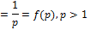
2. L {F (t)} = then.
L { } =
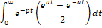
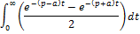
)
=

=
Therefore,
Definition of Beta function:
The integral , which converges for is called the beta function and is denoted by Thus,
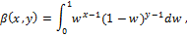
Where,
Beta function is also known as Eulerian
integral of first kind.
Definition of Gamma function:
The gamma function is defined as the definite integral
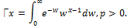
Gamma function is also known as Euler’s
Integral of second kind.

- Methodology:
Relation between beta and gamma function:
Here we have two methods to show that the relation between beta and gamma function, first method is by using the definition of beta and gamma function and second method is by the convolution theorem of Laplace transformation.
Proof of convolution theorem:
By the definition of Laplace Transformation
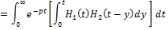

Where the double integral is taken over the infinite region in the first quadrant deceitful linking the limit
Changing of order of integration
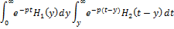
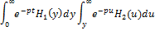
Hence
(I) we know that by the definition of gamma function
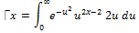
………. (1)
Similarly,
………. (2)
Therefore,
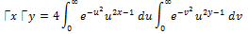
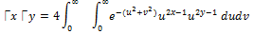
Hence,
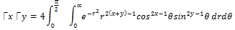
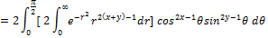
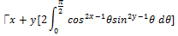
Hence,
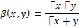
(II) Relation between beta and gamma function by using Laplace transformation:
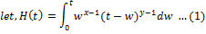
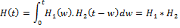
By convolution theorem of Laplace transformation,
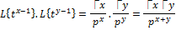
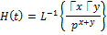
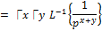
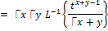
From (1),
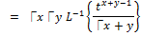
Putting t=1
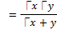

Conclusion:
This paper presents the relation between beta and gamma function by using the convolution theorem of Laplace transformation. The primary use of Laplace transformation is converting a time domain functions into frequency domain function. Laplace transformation is a very useful mathematical tool to make simpler complex problems in the area of stability and control.

References:
- B. V. Ramana, Higher Engineering Mathematics.
- Dr. B. S. Grewal, Higher Engineering M Mathematics.
- Dr. S. K. Pundir, Engineering Mathematics with ga gate tutor.
- Erwin Kreyszig, Advanced Engineering Mathematics, Wiley, 1998.
- J. L. Schiff, The Laplace Transform: Theory and applications, Springer Science and Business Media (1999).
- Advanced engineering mathematics seventh edition, peter v. Oneil.

7/25/2018

