Evaluation of six methods to prediction of reference evapotranspiration based on air temperature in Khuzestan province

Elahe Zoratipour¹, Amir Soltani Mohammadi²

¹ ⁻M. Sc. Student of Irrigation and Drainage, Faculty of Water Sciences Engineering, Shahid Chamran University of Ahvaz, Ahvaz, Iran
e.zoratipour@yahoo.com
²⁻ Associate professor of Irrigation and Drainage, Faculty of Water Sciences Engineering, Shahid Chamran University of Ahvaz, Ahvaz, Iran
A.soltani@scu.ac.ir

Abstract: The reference evapotranspiration (ET0), is one of the important components of the hydrological cycle, which needs to be precisely estimated for optimal water resources management. The present study aim to evaluation of six different methods to predict reference crop evapotranspiration based on air temperature in 11 stations of Khuzestan province in Iran. For this reason, the monthly weather data of the study stations was used during the statistical period 1996-1996. The results of the methods were compared with the result of the FAO Penman – Monteith method (PMF-56) and in order to evaluate the performance of the methods, were used statistical indices of R² and RMSE. The results showed that among the methods examined, Blaney and Criddle and Hargreaves and Samani methods had the best performance, having the highest coefficient of determination, were, on average 0.93 and 0.94 respectively, and the lowest Root Mean Square Error (RMSE), respectively, was 1.29 and 1.1 mm per day, on average, at study stations.
[Zoratipour E, Soltani Mohammadi A. Evaluation of six methods to prediction of reference evapotranspiration based on air temperature in Khuzestan province. Researcher 2018;10(5):84-88]. ISSN 1553-9865 (print); ISSN 2163-8950 (online). http://www.sciencepub.net/researcher. 11. doi:10.7537/marsrsj100518.11.

Keywords: ET0; Air temperature; PMF-56; Khuzestan province

1. Introduction
Evapotranspiration is the integrated process of evaporation and transpiration and is affected by meteorological variables, crop characteristics, and management practices, as well as environmental characteristics and in fact, the water evaporated from a reference surface, and was presented to quantify evaporative demand of the atmosphere, independent of the crop growth parameters and management practices (Pandey et al, 2016). Reference evapotranspiration (ETo) plays a key role in irrigation systems design, water management under irrigated and rainfed production. Developing irrigation systems efficiently using water, is essential to stabilize the production system (Djaman et al, 2015). Methods of lysimeters and soil water change (water balance) have been used to directly measure of ET. These methods, though often expensive and complicated, are effective means of validating and calibrating ET models (Mattar et al, 2016). According to the studies, experimental methods for estimating evapotranspiration are based on three types of temperature-based methods, radiation-based methods, and mass-transfer methods (Xu and SINGH, 2002). Several studies have been conducted on the calibration and evaluation of different models of reference evapotranspiration in Iran and other countries. Asong Tellen, (2017), The six methods of reference evapotranspiration (ETo), including: Papadakis (1966), Turc (1961), Blaney and Criddle (1950), Blaney and Criddle modified by Shih et al. (1977), Penman modified by Frere and Popov (1979) and Stephens and Stewart (1963) modified by Jansen and Haise, were compared with the FAO-56 Penman-Monteith formula using rain-fed grass data within the period of 15 years (1967 to 1982) in Yaounde. Ultimately, the Stephens and Stewart (1963) method had the best and closest result to the FAO-56 method. Almorox et al. (2015), By evaluating 11 methods of temperature based models to estimate ETo and PET at 4362 weather stations worldwide, Concluded that these methods have a high error rate and a relatively low correlation compared to the FAO-56 model in tropical weather. Valipour)2015( evaluated the temperature-based models, in comparison to the FAO-PMN model, using linear regression under different weather conditions in 31 provinces of Iran. The results showed that the Hargreaves-Samani modified model predicts evapotranspiration better than other models in most provinces of Iran. Tabari et al. (2011) valuated 31 reference evapotranspiration methods under humid conditions based on pan evaporation-based, temperature-based, radiation-based and mass transfer-based methods at Rasht station. According to the results, Blaney and Criddle, Hargreaves, Snyder and two Radiation methods have a best performance compared to the PMF-56 model. Xu and singh (2002), Investigates the estimation of potential evapotranspiration using three methods based on temperature, radiation and mass transfer. The results indicate advantage of the blaney-Criddle models, Hargreaves, Makkink, PriestleyTaylor and Rohwer, compared to the PMF-56 model. Babamiri1and Dinpazhoh (2016) use of 20 different methods of estimating the reference evapotranspiration and evaluated ET0 based on three general categories of air temperature, solar radiation and mass transfer in monthly timescale at the Urmia Lake watershed. The aforementioned methods were compared with the results of the PMF-56 method. The results showed that hargreaves method was recognized as the best method among the methods based on air temperature. Nazari and kaviani (2016), investigated various experimental and combined methods of estimating reference crop evapotranspiration in Qazvin Plain. For this purpose, the data of the meteorological station and combined methods were used on a daily basis during the one-year period. By reference to the lysimetric data and evaporation pan, evaluate different equations. The results showed that the experimental method of Hargreaves-Sarmani of temperature group is the best method for estimating reference crop evapotranspiration in Qazvin Plain.
The aim of this research was to estimation reference evapotranspiration in 11 provinces of Khuzestan province in Iran, using the meteorological data of the studied stations and the use of six temperature-based models, In order to determine the best model under climatic conditions of each station and is based on a comparison with the FAO Penman Montieth reference method.

2. Materials and Methods
Khuzestan province with an area of about 64057 km², located in the southwest of Iran. In this study, climatic data (from 1996 to 2005) has been collected, related to eleven stations located in Khuzestan province in Iran. The location of the province and the stations studied are shown in Figure 1. Also table 1 provides the characteristics of the studied stations.

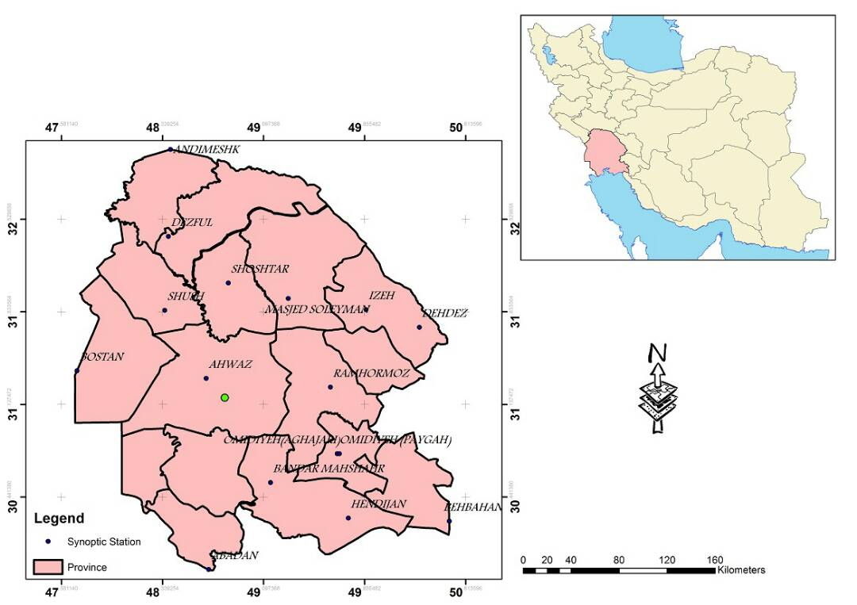
Figure 1. Location of the area and stations studied in Khuzestan province

The data used in this study include maximum, minimum and average temperature, dew point temperature, average relative humidity, wind speed, number and maximum sunshine and precipitation, on a monthly scale, Which was received from the Office of the Meteorological Organization of Khuzestan province and used for the study of six experimental methods of estimating the reference crop evapotranspiration, including temperature-based models. The PMF-56 method as a reference method was used to compare the results to determine the best model for each station. In table 2 six methods are presented for estimating ET0, based on air temperature.

Table 1. Specifications of studied stations located in Khuzestan province
Station | Altitude (m) | latitude |  | Longitude |  | Statistical period
 |  | Degree | Minutes | Degree | Minutes
Abadan | 6.6 | 30 | 22 | 48 | 15 | 1996-2005
Ahvaz | 22.5 | 31 | 20 | 48 | 40 | 1996-2005
Omidieh | 34.9 | 30 | 46 | 49 | 39 | 1996-2005
Izeh | 767 | 31 | 51 | 49 | 52 | 1996-2005
Bostan | 7.8 | 31 | 43 | 48 | 0 | 1996-2005
BandarMahshahr | 6.2 | 30 | 33 | 49 | 9 | 1996-2005
Behbahan | 313 | 30 | 36 | 50 | 14 | 1996-2005
Dezful | 143 | 32 | 24 | 48 | 23 | 1996-2005
Ramhormoz | 150.5 | 31 | 16 | 49 | 36 | 1996-2005
Shushtar | 67 | 32 | 3 | 48 | 50 | 1996-2005
MasqedSoleiman | 320.5 | 31 | 56 | 49 | 17 | 1996-2005
Table 2. Six methods chosen to estimate ETo based on air temperature and parameters associated with each model
parameter | Reference | Formula | Model
T, 𝜑 | Thornthwaite (1948) | ETo=$16{(10\frac{T_{a}}{I})}^{i}$  $$I=\sum_{n=1}^{12}{({0.2T_{a})}^{1.514}}$$  i =6.75$*{10}^{-7}I^{3}-7.71*{10}^{-5}I^{2}+1.7912*{10}^{-2}I+0.49239$ | Thornthwaite
T, RH | Schendel (1967) | ETo=16$*\frac{T_{a}}{RH}$ | Schendel
T, u, Tmin, Tmax, RH, n, 𝜑 | Hargreaves and  Samani (1985) | ETo=0.408${*0.0025*(T}_{a}+16.8)*({T_{max}+T_{min})}^{0.5}*R_{a}$ | Hargreaves and Samani
T, n, RHmin, 𝜑, u | Blaney and Criddle (1950) | ETo=a+b [P (0.46$T_{a}+8.13)]$ | Blaney and Criddle
T, u, Tmin, Tmax, RH, n, 𝜑 | Trajkovic (2007) | ETo=$0.408*0.0023*\left(T_{a}+17.8\right)*({T_{max}-T_{min})}^{0.424}*R_{a}$ | Trajkovic
T, Td, Z,L | Linacre ( 1977) | ETo=$\frac{\frac{500(T_{a}+0.006z)}{(100-L)}+15(T_{a}-T_{d})}{80-T_{a}}$ | Linacre ( 1977)

In Table 2, ET0 is the reference evapotranspiration in (mm / day) in all equations, except the thornthwaite equation, which is in (mm / mount).${T_{d },T}_{a}$, ${ T}_{max}$ and $T_{min}$, are the average monthly temperature, dew point temperature, maximum temperature and minimum temperature (ºC), $RH,$ average relative humidity (%),$R_{a}$, extraterrestrial radiation (MJ/$M^{2}/day$), Z, elevation of location (m), L is latitude by degrees, I, i, a, b, P, are experimental coefficients. The best model for the study station and the best performance of each of the models are determined using the statistical indices of the determination coefficient (R²) and the Root Mean Square Error (RMSE) and the best performance of each model at the station was determined and ranked based on the resulting values:
$$RMSE=\sqrt{\frac{\sum_{i=1}^{n}{{(P_{i}-O_{i})}^{2}}}{n}}$$
$$R^{2}=\frac{[{\sum_{i=1}^{n}{(P_{i}-\overline{P}) (O_{i}-\overline{O})}]}^{2}}{\sum_{i=1}^{n}{{\left(P_{i}-\overline{P}\right)}^{2}}\sum_{i=1}^{n}{{\left(O_{i}-\overline{O}\right)}^{2}}}$$
In the high statistical indices $P_{i}$ and $O_{i}$, the predicted values using each model and the value obtained by the PMF-56 method, $\overline{P}$ and $\overline{O}$ are the average of the predicted values using each model and the value obtained by the PMF-56 method and n is the total number of data.

3. Results
According to the results obtained from the comparison of different methods of evapotranspiration estimation, Blaney and Criddle and hargreaves and Samani methods, with the highest coefficient of determination, were recognized as the best method at all stations (with average 0.93 and 0.94 ) (Table 3). Based on the Root Mean Square Error (RMSE), also the best results are related to the Blaney and Criddle and Hargreaves and Samani methods, which is equivalent to 1.29 and 1.1 mm per day, respectively. According to the ranking of the statistical indices, the Blaney and Criddle and hargreaves and Samani methods, with the highest determination coefficient and the lowest RMSE is taken the best result. Then Trajkovic, Linacare, Thornthwaite, and Schendel will be ranked next.
According to the results obtained from the calculation of the reference evapotranspiration) ET0) and the comparison with the PMF-56 method, Blaney and Criddle and Hargreaves and Samani methods, have a high accuracy in the ET0 estimation. According to the results, the results of this study are in agreement with the results of tabari et al. (2011) and Xu and Singh (2002).
Figure 2 was designed to determine the best model for each station in comparison with its error and based on temperature-based methods, Which indicates the advantage of Blaney and Criddle method, among the methods of temperature and at most stations, including Ahvaz, Shoshtar, Bostan, Mahshahr, Behbahan and Izeh cities. Then the Hargreaves and Samani method are ranked next in Dezful, Masjed Soleiman and Ramhormoz cities and then Linacare method in the cities of Omidieh and Abadan.

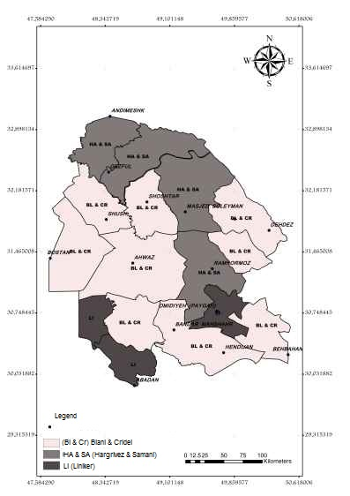
Figure 2. The best models related to temperature-based methods at each station

T able 3. The best results of comparison of temperature methods at study stations
temperature methods | $$R^{2}$$ | Rating | RMSE | Rating | Total ratings | station
Linacare | 0.93 | 1 | 1.86 | 1 | 2 | Abadan
Blaney and Criddle | 0.98 | 1 | 0.67 | 1 | 2 | Ahvaz
Linacare | 0.94 | 1 | 3.52 | 2 | 3 | Omidieh
Blaney and Criddle | 0.96 | 1 | 0.71 | 1 | 2 | Izeh
Blaney and Criddle | 0.96 | 1 | 0.74 | 1 | 2 | Bostan
Blaney and Criddle | 0.90 | 1 | 1.22 | 1 | 2 | BandarMahshahr
Blaney and Criddle | 0.90 | 1 | 3.21 | 2 | 3 | Behbahan
Hargreaves and Samani | 0.96 | 2 | 0.65 | 1 | 3 | Dezful
Hargreaves and Samani | 0.91 | 2 | 0.95 | 1 | 3 | Ramhormoz
Blaney and Criddle | 0.92 | 1 | 1.19 | 1 | 2 | Shushtar
Hargreaves and Samani | 0.97 | 2 | 1.71 | 1 | 3 | MasqedSoleiman

4. Discussions
The results showed that among the methods based on temperature, Blaney and Criddle and Hargreaves and Samani methods, were recognized as the best methods with a determination coefficient of 0.93and 0.94. Based on the results of ranking, the Blaney and Criddle method, with the highest determination coefficient at most stations and with the lowest root mean squared error is the best result.

Corresponding Author:
Elahe Zoratipour, M. Sc.
Student of Irrigation and Drainage, Faculty of Water Sciences Engineering, Shahid Chamran University of Ahvaz, Ahvaz, Iran.
E-mail:e.zoratipour@yahoo.com

References
- Asong Tellen, V.2017. Acomparative analysis of reference evapotranspiration from the surface of rainfed grass in Yaounde, calculated by six empirical methods against the penmanmonteith formula. Tellen Earth Perspectives. Earth Perspective, 4(4):1-8.
- Almorox, J. Quej, V.H and Marti, P. 2015. Global performance ranking of temperature-based approaches for evapotranspiration estimation considering Koppen climate classes. Contents lists available at ScienceDirect. Journal of Hydrology,528: 514–522.
- Babamiri, O. and Dinpazhoh, Y. 2016. Comparison and evaluation of twenty methods for estimating reference evapotranspiration based on three general categories: Air Temperature, Solar Radiation and Mass Transfer in the Basin of Lake Urmia. J. Water and Soil Sci. (Sci. & Technol. Agric. & Natur. Resour.), 20(72): 145-161.
- Blaney, H.F. and Criddle, W.D.1950. Determining water requirements in irrigated areas from climatological and irrigation data. Soil conservation service technical paper 96, Soil conservation service. US Department of Agriculture, Washington.
- Djaman, K. Balde, A.B. Sow, A. Muller, B. Irmak, S. Diaye, M.N. Manneh, B. Moukoumbi, Y.D. Futakuchi, K. and Saito, K. 2015. Evaluation of sixteen reference evapotranspiration methods under sahelian conditions in the Senegal River Valley. Contents Lists Available at ScienceDirect. Journal of Hydrology,3: 139–159.
- Hargreaves, G.L. and Samani, Z.A.1985. Reference crop evapotranspiration from temperature. Appl Eng Agric 1(2):96–99.
- Linacre, E. T. 1977. A simple formula for estimating evapotranspiration rate in various climates using temperature data alone. Agr. Mete. 18: 409-424.
- Mattar, M.A. Alazba, A. A. Alblewi, B. Gharabaghi, B. and Yassin, M.A. 2016. Evaluating and calibrating reference evapotranspiration models using water balance under hyper-Arid environment. Water Resour Manage 30:3745–3767.
- Nazari, R. and Kaviani, A. 2016. Evaluation of potential evapotranspiration and evaporation pan with lysimeter values in a semi-arid climate (Case study: Ghazvin Plain). Ecohydrology, 1(3): 19-30.
- Pandey, P.k. Dabral, P.P and Pandey,V. 2016. Evaluation of reference evapotranspiration methods for the northeastern region of India. International Soil and Water Conservation Research, 4: 52–63. Schendel, U.1967. Vegetations was serverbrauch und –was serbedarf. Habilitation, Kiel, p 137.
- Tabari, H. Grismer, M. E. and Trajkovic, S. 2011. Comparative analysis of 31 reference evapotranspiration methods under humid conditions. Irrigation Science.
- Thornthwaite, C.W.1948. An approach toward a rational classification of climate. Geogr Rev 38:55–94.
- Trajkovic S.2007. Hargreaves versus Penman–Monteith under Humid Condition. J Irrig Drain Eng ASCE. 133:38–42.
- Valipour, Mohammad. 2015. Temperature analysis of reference evapotranspiration models. Royal Meteorological Society. 22: 385–394.
- XU, C.Y. and SINGH, V. P. 2002. Cross Comparison of Empirical Equations for Calculating Potential Evapotranspiration with Data from Switzerland. Water Resources Management 16: 197–219.

5/20/2018

