A comparative evaluation of different doses of propofol preceded by fentanyl on intubating conditions and pressor response during tracheal intubation without muscle relaxants in children

Marwa Hosny Ibrahim Ali

Department of Anesthesia, Aswan University Hospital, Egypt
marwahosny11@yahoo.com

Abstract: Background: The aim of our study was to assess of tracheal intubation by different doses of propofol preceded by fentanyl for successful tracheal intubation and to see its effectiveness in blunting pressors response in children aged 2-12 years. Methods: This prospective, blind, randomized study was conducted on 60 ASA grade I and II children, between 2 and 12 years undergoing elective surgery who were divided into three groups. The children received different doses of propofol (group I, 2.5 mg/kg; group II, 3.0 mg/kg; and group III, 3.5 mg/kg) preceded by a fixed dose of fentanyl (2 µg/kg) 5 min earlier. The tracheal intubating conditions were graded based on scoring system devised by Helbo-Hensen et al. with Steyn modification which includes five criteria; ease of laryngoscopy, degree of coughing, position of vocal cords, jaw relaxation, and limb movement and graded on a 4-point scale. Heart rate (HR) and mean arterial pressure (MAP) changes were also noted. Results: Tracheal intubating conditions were acceptable in 25% of the patients in group I, while significantly higher (P<0.001) in group II (80%) and in group III (90%). The pressor response was not effectively blunted in group I (increases in HR), while effectively blunted in groups II and III. A fall in hemodynamic was seen in group III indicated by a decrease in MAP and HR. No airway complications were noted. Conclusions: Propofol 3 mg/kg (group II) preceded by fentanyl 2 µg/kg is the safest option dose combination in our study. It provides acceptable intubating conditions in 80% patients, blunts pressor response to intubation without significant cardiovascular depression.
[Marwa Hosny Ibrahim Ali. A comparative evaluation of different doses of propofol preceded by fentanyl on intubating conditions and pressor response during tracheal intubation without muscle relaxants in children. Researcher 2018;10(5):16-24]. ISSN 1553-9865 (print); ISSN 2163-8950 (online). http://www.sciencepub.net/researcher. 3. doi:10.7537/marsrsj100518.03.

Keywords: Tracheal intubation; Propofol; Fentanyl; Intubating conditions; Pressor response

1. Introduction
Endotracheal intubation is the most important and crucial step during the administration of general anaesthesia. It is more so in pediatric patients. Insufflation of the trachea for the purpose of ether anaesthesia was introduce in 1909 in USA and in 1912 in UK, (Holzman 1998). Later, tracheal intubation became a part of the anaesthesia practice. It was usually performed under deep inhalation anaesthesia with ether. The same technique was continued with halothane and of late, sevoflurane is gaining attent ion, especially in the paediatric anaes thesiapractice. Neuromuscular blocking agents which aid tracheal intubation were first introduced into the clinical practice in 1942 in USA, (Holzman 1998). The neuromuscular blocking agents have made technique of endotracheal intubation much easier, but not without the risks of subjecting the patient to potential risks. Several workers have successfully used a combination of propofol and a short-acting opioid to facilitate tracheal intubation in children. Most of the studies revealed improvement in intubating conditions with increasing dosages of either propofol or opioid. Increasing dose of short- acting opioids may cause muscle rigidity, prolonged apnea and delayed recovery, while increasing dose of propofol can lead to cardiovascular depression, and therefore, the search is for an optimal dose combination.

2. Patient and Methods
After approval from hospital ethical committee, this prospective, blind, randomized study was conducted during the period from October 2015 to December 2016. This study was conducted in 60 patients of American Society of Anesthesiologists (ASA) I and II, aged 2-12 years scheduled for elective surgery, after taking consent from parents. Patients with anticipated difficult intubation, increased risk of regurgitation, history suggestive of cardiorespiratory illness, and known sensitivity to the drugs used were excluded from this study. Patients were randomly allocated into three groups, Groups 1, II and III, by a closed envelope technique the opening of envelope by the senior resident and the preparation of propofol by another one with dilution by normal saline in fixed volume 15 ml. After a thorough preanesthetic checkup, children were kept nil per oral for 2 hours for clear fluids, and 6 hours for feeds and solids. EMLA cream was applied to potential sites of venous cannulation 1 hour prior to induction. In the preanesthesia room, an intravenous (IV) cannula of 22 or 24 G was inserted and patients were shifted into the operating theater and preinduction monitoring initiated with monitors like non-invasive blood pressure, pulse oximetry, and electrocardiogram. All patients preceded by a fixed dose of fentanyl (2 µg/kg) which was injected over a period of 10 sec, 5 min earlier and atropine 0.01 5 min. before propofol induction. In all Groups, Xylocaine 1.5 mg/kg was injected intravenously before anesthesia was induced with Propofol 2.5,3, 3.5 mg/kg over a period of 30 sec intravenously. Laryngoscopy and intubation were attempted 150 sec after induction of anesthesia and Patient and Methods.
After approval from hospital ethical committee, this prospective, blind, randomized study was conducted during the period from October 2015 to December 2016. This study was conducted in 60 patients of American Society of Anesthesiologists (ASA) I and II, aged 2-12 years scheduled for elective surgery, after taking consent from parents. Patients with anticipated difficult intubation, increased risk of regurgitation, history suggestive of cardiorespiratory illness, and known sensitivity to the drugs used were excluded from this study. Patients were randomly allocated into three groups, Groups 1, II and III, by a closed envelope technique the opening of envelope by the senior resident and the preparation of propofol by another one with dilution by normal saline in fixed volume 15 ml. After a thorough preanesthetic checkup, children were kept nil per oral for 2 hours for clear fluids, and 6 hours for feeds and solids. EMLA cream was applied to potential sites of venous cannulation 1 hour prior to induction. In the preanesthesia room, an intravenous (IV) cannula of 22 or 24 G was inserted and patients were shifted into the operating theater and preinduction monitoring initiated with monitors like non-invasive blood pressure, pulse oximetry, and electrocardiogram. All patients preceded by a fixed dose of fentanyl (2 µg/kg) which was injected over a period of 10 sec, 5 min earlier and atropine 0.01 5 min. before propofol induction. In all Groups, Xylocaine 1.5 mg/kg was injected intravenously before anesthesia was induced with Propofol 2.5,3, 3.5 mg/kg over a period of 30 sec intravenously. Laryngoscopy and intubation were attempted 150 sec after induction of anesthesia and patients were ventilated via face mask with 100% oxygen in the meantime. Additional bolus of 1 mg/kg of propofol was given if laryngoscopy was not possible due to muscle spasm, coughing, or excessive movements. In patients of all groups if intubation was not possible after two attempts, suxamethonium 2 mg/kg body weight was given and intubation was completed and these patients excluded from the study. In all patients laryngoscopy was done using Macintosh blade and trachea was intubated with an appropriate sized uncuffed, preformed South Pole oral endotracheal tube. Intraoperatively patients were ventilated with 100% oxygen, assested ventilation for 5-10 min on 3% sevoflurane until good spontaneous ventilation then isoflurane 2-3% with gas flow rates of 4-6 l/min using an Ayres T piece circuit.

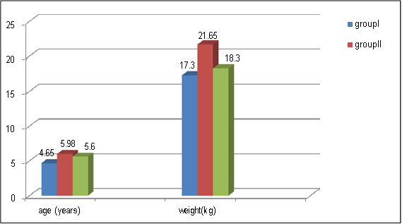
Figure (1): Demographic profile.

The tracheal intubating conditions were graded based on scoring system devised by Helbo-Hansen et al., which includes three criteria; ease of laryngoscopy, degree of coughing, and position of vocal cords. In addition two further criteria, jaw relaxation, and limb movements were also observed as modified by Steynet al. The sum of the scores of these five individual variables was computed as the Helbo-Hansen (Steyn's modification, Table 1) score. Total score of 5 was considered to be excellent, 6-10 good, 11-15 poor, and 16-20 bad. Total scores were divided into clinically acceptable and not acceptable scores (total score ≤ 10 acceptable, >10 unacceptable) (Table 1). Heart rate and noninvasive mean arterial pressure (MAP) were noted at different time intervals (preinduction, postinduction and postintubation at 0, 1, 3, 5 and 10 min). Measurements at 1 min after injection of atropine were taken as baseline values.

Table 1: Intubating condition scores (Steyn modification of Helbo- Hansen).
 | 1 | 2 | 3 | 4
Laryngoscopy | Easy | Fair | Difficult | Impossible
Vocal cords | Open | Moving | Closing | Closed
Coughing | None | Slight | Moderate | Severe
Jaw relaxation | Complete | Slight | Stiff | Rigid
Limb movements | None | Slight | Moderate | Severe (jerky)

Data are presented as mean (SD) or number (%). Statistical analysis was performed with chi-squared test and sign-rank test for non- parametric data and one-way ANOVA with multiple range tests for parametric data, and P-value <0.05 was considered statistically significant.

3. Results
Demographic profile was comparable in all the three groups (Figure 1 and Table2).
Laryngoscopy: In group I, laryngoscopy was easy (score 1) in 85% of children and fair (score 2) in 15% of children. In group II, laryngoscopy was easy (score 1) in 90% of children and fair (score 2) in 10% of children and in group III, laryngoscopy was easy in all children (score 1), figure (5).

Table (2): Demographic data for the groupe of patients studied (mean ± sd).
 | Group I  (propofol 2.5mg/kg) | Group I I  (propofol 3mg/kg) | Group I I I  (propofol 3.5mg/kg)
Age (years) | 4.65 ±2.52 | 5.98 ±2.46 | 5.6 ±2.69
Weight (kg) | 17.3 ±4.5 | 21.65 ±3.4 | 18.3 ±4.2
Gender (M/F) | 11/9 | 15/5 | 14/6
ASA (I/ I I) | 18/2 | 16/4 | 17/4

Intubating conditions:

Table (3): Comparison of intubating conditions in different groups.
 | Group I  (propofol  2.5mg/kg) | GroupII  (propofol 3mg/kg) | GroupIII  (propofol 3.5mg/kg)
Laryngoscopy | 85 (score 1)  15 (score 2) | 90 (score 1)  10 (score 2) | 100 (score 1)
Vocal cords | 85 (score 1)  15 (score 2) | 90 (score 1)  10 (score 2) | 100 (score 1)
Coughing | 15 (score 1)  25 (score 2)  50 (score 3)  10 (score 4) | 35 (score 1)  50 (score 2)  15 (score 3) | 55 (score 1)  35 (score 2)  10 (score 3)
Jaw relaxation | 60 (score 1)  25 (score 2)  15 (score 3) | 80 (score 1)  20 (score 2) | 100 (score 1)
Limb movements | 55 (score 1)  15 (score 2)  30 (score 3) | 65 (score 1)  35 (score 2) | 75 (score 1)  25 (score 2)
Total intubation score | 25 (<=2)  75 (>2) | 80 (<=2)  20 (>2) | 90 (<=2)  10 (>2)
The values given are in percentage.

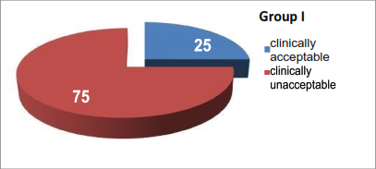
Figure (2): Total intubation score Group I.

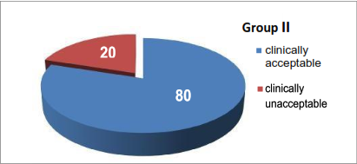
Figure (3): Total intubation score GroupII.

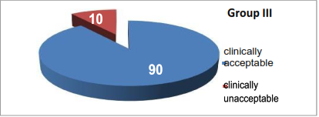
Figure (4): Total intubation score Group III.

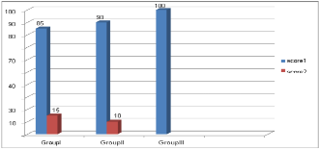
Figure (5): Laryngoscopy.

Position and movement of vocal cords: In group I, vocal cords were open (score 1) in 85% children and moving (score 2) in the remaining 15% of children. In group II, vocal cords were open (score 1) in 90% of children and moving (score 2) in 10% of chi ldren and in group III, vocal cords were open (score 1) in 100% of children, figure (6).

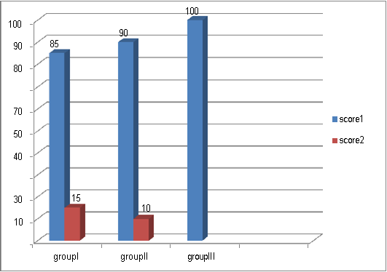
Figure (6): Position and movement of vocal cords.

Coughing: In group I, there was no coughing (score 1) in 15% of children, 25% of children had a slight cough (score 2), 50%of children had moderate cough (score 3), and 10% of children had severe cough (score 4). In group II, no coughing (score 1) occurred in 35% of children, slight cough (score 2) in 50% of children, and moderate cough (score 3) in 15% of children. In group III, 55% of children had no cough (score 1), 35% of children had slight cough (score 2), and 10% of children had moderate cough (score 3), figure (7).
Jaw relaxation: In group I, jaw relaxation was complete (score 1) in 60%, slight (score 2) in 25% and stiff (score 3) in 15% of children. In group II, jaw relaxation was complete (score 1) in 80% children and slight (score 2) in 20% children. In group III, jaw relaxation was complete (score 1) in all children, figure (8).

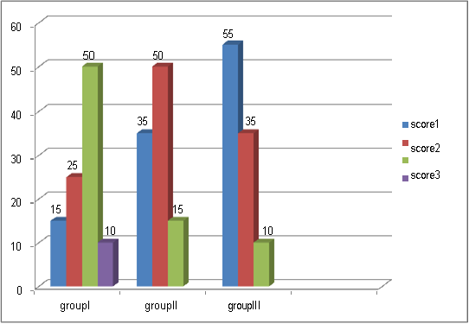
Figure (7): Coughing.

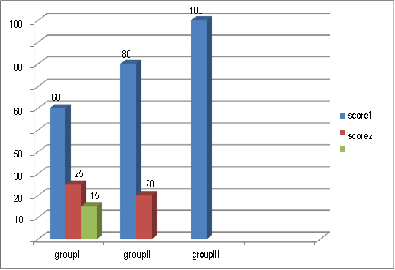
Figure (8): Jaw relaxation

Limb movements: In group I, there was no limb movements (score 1) in 55% children, slight (score 2) in 15% children and moderate (score 3) in 30% of children. In group II, 65% of children showed no limb movement (score 1) and 30% had slight limb movement (score 2) and 5% of children had moderate (score 3) limb movements. In group III, there was no limb movements (score 1) in 75% of children and slight (score 2) in 25% of children. The total score. The tracheal intubating conditions were consi dered adequate in 25% of patients in group I, in 80%in group II, and in 90%of patients in group III. There was a statistically significant difference in total score between groups I and II, and groups I and III (P < 0.001), figure (9).
Hemodynamic variables
Heart rate: Group I showed a significant increase in HR from baseline during intubation (P < 0.001), 1 min after intubation (P < 0.001), 3 min after intubation (P < 0.01), 5 min after intubation (P < 0.05), and 10 min after intubation (p<0.05). Group II showed no significant changes in HR from baseline. Group III showed a significant decrease in HR from the baseline after propofol injection (P < 0.01), and significant decrease in HR 1 min (P < 0.05), 3 min (P < 0.05), 5 min (P < 0.01) And 10 min (p<0.01) aft er intubation. Intergroup analysis for HRs between groups I and II showed no statistically significant difference except during laryngoscopy when HR in group I was significantly higher than group II (P < 0.05). Analysis between groups I and III showed significant difference in HR after propofole induction (P < 0.02), during laryngoscopy (P < 0.05), during intubation (P < 0.01), 1 min after intubation (P < 0.01), 3 min after intubation (P < 0.01), 5 min after intubation (P < 0.01), and 10 min after intubation (p<0.05). Whereas comparison between groups II and III showed no statistically significant differences in HRs, (Figure 10 and Table 4).
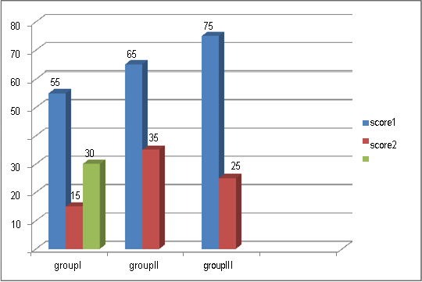
Figure (9): Limb movements.

Table (4): Comparison of heart rate among different groups.
Groupe | Baseline (T0) | After propofol (T1) | During intubation (T2) | 1 min after intubtion (T3) | 3 min after intubation (T4) | 5 min after intubation (T5) | 10 min after intubation (T6)
I | 101.150  ±12.33 | 103.200  ±11.37 | 117.850  ±17.91**** | 114.700  ±18.97**** | 111.950  ±16.98*** | 108.700  ±16.91* | 108.900  ±16.98
II | 102.500  ±15.69 | 102.550  ±18.82 | 106.350  ±16.88 | 104.650  ±17.80 | 102.450  ±16.70 | 100.150  ±12.21 | 102.550  ±11.330
III | 102.300  ±13.42 | 93.750  ±9.82*** | 101.00  ±15.33 | 97.050  ±14.49* | 96.000  ±12.34* | 94.900  ±9.07*** | 91.150  ±11.85
Coding used for p-value throughout the study is as follows: * p<0.05; ***p<0.01; ****p<0.001.

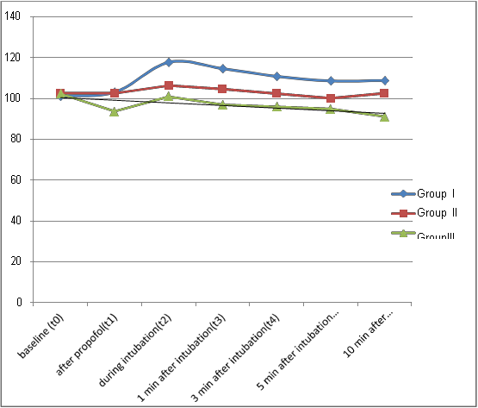
Figure (10): Comparison of heart rate among different groups.

Table (5) Comparison of mean arterial pressure among different groups.
Groupe | Baseline (T0) | After propofol  (T1) | During intubation (T2) | 1 min after intubtion (T3) | 3 min after intubation (T4) | 5 min after intubation (T5) | 10 min after intubation(T6)
I | 81.90  ±4.02 | 69.500  ±4.09**** | 71.300  ±4.78**** | 72.300  ±4.50**** | 72.700  ±5.40**** | 72.700  ±5.88**** | 72.700  ±5.40****
II | 83.300  ±3.79 | 70.900  ±3.86**** | 72.500  ±4.44**** | 73.600  ±4.13**** | 74.300  ±4.86**** | 75.600  ±5.37**** | 75.600  ±4.68****
III | 83.700  ±3.90 | 70.900  ±3.81**** | 74.200  ±6.25**** | 74.600  ±4.35**** | 75.600  ±6.00**** | 76.400  ±5.14**** | 76.300  ±6.25****
Coding used for P-value throughout the study is as follows: ****P < 0.001.

Mean arterial pressure: The horizontal, i.e. intragroup analysis vs baseline showed a significant decrease in MAP from 5 min after fentanyl injection until 10 min after intubation in all three groups (Table 5). There was no statistically significant difference in MAP among the three groups at various time intervals. There was no significant change among the three groups in SpO2. Intubation was successfully performed in all the 60 patients at the first attempt and no serious airway complication, i.e. laryngospasm, bronchospasm, desaturation (SpO2 < 90%) or emesis was seen in any patient.
Intubation attempts: Intubation was successfully performed at the first attempt in 65% of patients in Group I, 92.2% of patients in Group II and in 97.4 % of patients in Group III, with no serious airway complications, i.e. laryngospasm, bronchospasm, desaturation (SpO2<90%) or emesis was seen in any patient, (Figure11).

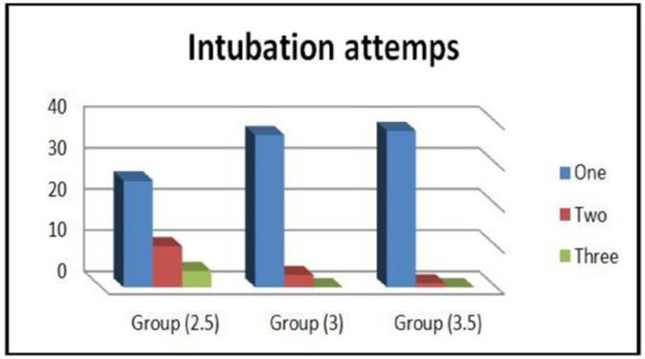
Figure (11): Intubation attempts.

4. Discussion
Laryngoscopy and tracheal intubation are essential skills associated with the practise of anesthesia. Neuromuscular-blocking drugs block neuromuscular transmission at the neuromuscular junction, (Dorlands Medical Dictionary 1996). causing paralysis of the affected skeletal muscles. This is accomplished either by acting presynaptically via the inhibition of acetylcholine (ACh) synthesis or release or by acting postsynaptically at the acetylcholine receptors of the motor nerve end- plate. While some drugs act presynaptically (such as botulinum toxin and tetanus toxin), those of current clinical importance work postsynaptically. In clinical use, neuromuscular block is used adjunctively to anesthesia to produce paralysis, firstly to paralyze the vocal cords, and permit intubation of the trachea, and secondly to optimize the surgical field by inhibiting spontaneous ventilation, and causing relaxation of skeletal muscles. Because the appropriate dose of neuromuscular-blocking drug may paralyze muscles required for breathing (i.e., the diaphragm), mechanical ventilation should be available to maintain adequate respiration. Patients are still aware of pain even after full conduction block has occurred; hence, general anesthetics and/or analgesics must also be given to prevent anesthesia awareness. Since these drugs may cause paralysis of the diaphragm, mechanical ventilation should be at hand to provide respiration. In addition, these drugs may exhibit cardiovascular effects, since they are not fully selective for the nicotinic receptor and hence may have effects on muscarinic receptors, (Ostergaard et al., 1989). If nicotinic receptors of the autonomic ganglia or adrenal medulla are blocked, these drugs may cause autonomic symptoms. Also, neuromuscular blockers may facilitate histamine release, which causes hypotension, flushing, and tachycardia. Succinylcholine is the muscle relaxant of choice for tracheal intubation in short procedures and for rapid sequence induction when there is risk of aspiration. It may trigger a transient release of large amounts of potassium from muscle fibers. This puts the patient at risk for life-threatening complications, such as hyperkalemia and cardiac arrhythmias. Certain drugs such as aminoglycoside antibiotics and polymyxin and some fluoroquinolones also have neuromuscular blocking action as their side effect, (Paradelis et al., 1976).
Undesirable side effects such as muscle pain, increase in intraocular and intracranial pressure have limited succinylcholine use. The incidence of prolonged apnea, masetter spasm, malignant hyperthermia, and even cardiac arrest related to succinylcholine is not insignificant among children, (Hopkins1995). Rapidly acting nondepolarizing muscle relaxants such as rocuronium may provide good intubating conditions in 90 s; however, they have prolonged duration of action which could be troublesome in a difficult airway. Moreover histamine release and anaphylaxis are also known side effects with these agents. Propofol, one of the most frequently used induction agent, has favorable depressant effect on the pharyngeal and laryngeal reflexes, (Saarnivaara & Klemola 1991) and the muscle tone. The induction with propofol is quick and smooth, with rapid awakening during recovery, (Deutschman et al., 1994). With the advent of short-acting opioids, their use in combination with propofol for tracheal intubation without neuromuscular blocking agents has been well documented. Numerous studies have stressed the advantages of propofol, such as a low cumulative effect which offers fast recovery of consciousness after surgery, an antiemetic effect, a diminished pressor response to laryngoscop y and tracheal intubation, and a lower incidence of airway complications, in adults and pediatric patients. However, a larger apparent volume of distribution for propofol is consistent with a higher induction dose requirement in children than in adults. (Simon et al., 2002). Various scoring system for assessing intubating conditions have been used in the past. Scoring systems of (Alcock et al., 1990, Saarnivaara & Klemola 1991 and Scheller et al., 1992). have considered only local factors such as jaw relaxation, cord movement, ease of mask ventilation, coughing, etc. However, we used the scoring system of Helbo- Hansen with Steyn modification, (Steyn et al., 1994), which included both local as well as distal factors, limb movements for better assessment. This scoring system has also been used earlier by (Blair et al., 2004 and Robinson et al., 1998) for assessing intubating conditions with propofol and remifentanil oralfentanil.
In our study, comparing varying doses of propofol preceded by a fixed dose of fentanyl (2 ug/kg)1), acceptable intubating conditions were seen in 25% of patients in group I (propofol 2.5 mg/kg), which was significantly lower than in groups II and III (P < 0.001). Intubating conditions were found acceptable in 80% of patients in group II (propofol3.0mg/kg) and 90% in group III (propofol 3.5 mg/kg) with no statistically significant difference between the two groups. (Fatima etal.,2001) with the same dose combination, found acceptable intubating conditions in 20%, 75%, and 80% of patients in each group. However, they used only three criteria for assessing the intubating conditions:
(i) The degree of difficulty inlaryngoscopy; (ii) The intensity ofcoughing; (iii) and the presence of vocal cordmovement.
Comparing the pressor response to intubation, we found that the response was not obtunded in group I as evidenced by 17% increase in HR, while it was effectively blunted in groups II and III, where there was no significant increase in HR from baseline after intubation. (Blair et al., 2004), found a significant increase in HR in response to intubation with remifentanil l mg/kg and propofol 3 mg/kg, while (Robinson et al., 1998) found the pressor response effectively blunted with remifentanil 1 mg/kg in combination with propofol 4 mg/kg. (Blair et al., 2004) comparing a fixed dose of propofol (3 mg/kg)1) with varying doses of remifentanil (1.0, 2.0 or 3.0 mg/kg)1) found acceptable intubating conditions in 50%,69%, and 82% of patients. While, (Robinson et al., 1998) comparing a combination of propofol (4 mg/kg)1) with either alfentanil (15 mg/kg)1) or remifentanil (1 mg/kg)1) did not find any significant difference in the overall intubating conditions between the twogroups.
In our study, two factors that made the intubating scores unacceptable in most cases were coughing (60% of patients in group I) and limb movements (30% of patients in group I). Coughing and limb movements were also found as limiting factors in studies by (Steyn et al., 1994 and Blair et al., 2004). Excellent intubating conditions, i.e. a score of 1 in every category has been described by (Blair et al., 2004) in 29%, 35%, and 48% of patients with varying doses of remifentanil. Using the same criteria, we found excellent intubating conditions in 15%, 35%, and 55% of our patients in groups I, II, and III, respectively. Comparing the pressor response to intubation, we found that the response was not obtunded in group I as evidenced by 17% increase in HR, while it was effectively blunted in groups II and III, where there was no significant increase in HR from baseline after intubation. (Blair et al., 2004) found a significant increase in HR in response to intubation with remifentanil 1 lg/kg) and propofol 3 mg/kg), while (Robinson et al., 1998) found the pressor response effectively blunted with remifentanil 1 lg/kg) in combination with propofol 4mg/kg).
In our study, a consistent and similar fall in MAP (16–18%) was seen in all the three groups, but in group III (propofol 3.5 mg/kg), it was also associated with fall in HR (11%) implying a fall in cardiac output. (Klemola & Hiller 2004) also found a 12% fall in MAP and 8% fall in HR with a dose combination of 4.0 lg/kg) remifentanil and 3.5 mg/kg) propofol, while de (Fatima et al., 2001) did not find any significant changes in hemodynamics. This fall in cardiac output may not be well tolerated in high-risk patients, where it could become significant. This decrease in HR and MAP after fentanyl and propofol is due to the synergistic action of the twodrugs. Fentanyl blunts hemodynamic responses to laryngoscopy and intubation and propofol decreases sympathetic nervous activity. (Bryson et al., 1995). Also baroreceptor reflex control of HR may be depressed by propofol. (Deutschman et al., 1994). The possible development of severe hypotension is the limiting factor with the use of propofol, although (Schrum et al., 1994) demonstrated that it was transient in healthy, normovolemic children. Topical laryngeal spraying of lidocaine as suggested by (Abouleish et al., 1999) can be used as an adjunct to the technique of tracheal intubation without muscle relaxant for further improving the intubating score with no effects on hemodynamics.

References
- Abouleish A, Berman J, Nguyen NC et al., Topical lidocaine as adjunct to intubation without muscle relaxant in pediatric patients. Anesth Analg 1999; 89: 1328.
- Alcock R, Peachey T, Lynch M et al., Comparison of alfentanil with suxamethonium in facilitating nasotracheal intubation in day case anaesthesia. Br J Anaesth 1990; 70: 34–37.
- Benet, Leslie Z, Kroetz, Deanna L. and Sheiner, Lewis B The Dynamics of Drug Absorption, Distribution and Elimination. In, Goodman and Gillman's The Pharmacological Basis of Therapeutics, (Hardman, J.G, Limbird, L.E, Molinoff, P.B., Ruddon, R.W, and Gilman, A.G., eds) The McGraw-Hill Companies, Inc.,1996, pp. 3-27.
- Blair JM, Hill DA, Wilson CM et al., Assessment of tracheal intubation in children after induction with propofol and diff erent doses of remifentanil. Anaesthesia 2004; 59:27–33.
- Borgeat A, Wilder Smith OH, Saiah M et al., Subhypnotic doses of propofol possess direct antiemetic properties. Anesth Analg 1992; 74: 539–541.
- Bowman WC. "Neuromuscular block". British Journal of Pharmacology.2006;147 (S1): S277–S286.
- Bradshaw K. Imaging the upper airways. Paediatr Respir Rev 2001; 2: 46–56.
- Brown OE. Structure and function of the upper airway. In: Westmore RF, Muntz HR, McGill TJI, eds. Pediatric Otolaryngology, Principles and Practice Pathways. New York: Thieme Medical Publishers, 2000: 679–688.
- Brunton LL, Lazo JS, Parker KL. "Goodman & Gilman's The pharmacological basis of Therapeutics". New York: McGraw-Hill. pp. 2006;220–223. ISBN0071624422.
- Bryson HM, Fulton BR, Faulds D. Propofol: an update of its use in anaesthesia and conscious sedation. Drugs 1995; 50: 513–559.
- Cauldfield H. Investigations in paediatric obstructive sleep apnoea: do we need them? Int J Pediatr Otorhinolaryngol 2003;67: (Suppl. 1): S107–S110.
- Chan J, Edman J, Koltai P. Obstructive sleep apnoea in children. Am Fam Physician 2004; 69: 1147–1154.
- Correia, M.A., Drug Biotransformation. in Basic and Clinical Pharmacology, (Katzung, B. G., ed) Appleton-Lange, 1998, pp 50-61.
- Cote CJ, Lerman J, Todres ID et al., eds. A Practice of Anaesthesia for Infants and Children, 4th edn. Philadelphia, PA: Saunders Elsevier, 2009: 237–273.
- Deutschman CS, Harris AP, Fleisher LA. Changes in heart rate variability under propofol anaesthesia: a possible explanation for Propofol induced bradycardia. Anesth Analg 1994; 79: 373–377.
- Dickison AE. The normal and abnormal pediatric airway. Recognition and management of obstruction. Clin Chest Med 1987; 8:583– 596.
- Dolin, S. J. "Drugs and pharmacology" in Total Intravenous Anesthesia, pp. 13-35 (Nicholas L. Padfield, ed), Butterworth Heinemann, Oxford, 2000.
- Dorlands Medical Dictionary (1996). "Open channel and competitive block of the embryonic form of the nicotinic receptor of mouse myotubes by (+)-tubocurarine". J. Physiol. 495 (Pt 1): 83–95.
- Ellis H, Feldman S, Harrop-Griffiths W. Anatomy for Anaesthetists, 8th edn. Oxford: Blackwell Publishing, 2003.
- Erhan E, Ugur G, Alper I et al., Tracheal intubation without muscle relaxants: remifentanil or alfentanil in combination with propofol. Eur J Anaesthesiol 2003; 20: 37–43.
- Fatima de Assunacao Braga A, da Silva Brage FS, Braga Poterio GM et al., The effect of different doses of propofol on tracheal intubating conditions without muscle relaxants in children. Eur J Anaesthesiol 2001; 18:384–388.
- Gupta A, Kaur R, Malhotra R, Kale S. Comparative evaluation of different doses of propofol, preceded by fentanyl on the intubating conditions and the pressor response during tracheal intubation without muscle relaxants. Paediatric Anaesthe 2006; (4): 399-405.
- Harley EH. Asymmetric tonsil size in children. Arch Otolaryngol Head Neck Surg 2002; 128: 767–769.
- Harnsberger HR. Handbook of Head and Neck Imaging. Chicago: Mosby – Year Book,1995.
- Healy GB. Introduction to Disorders of the Upper Airway. In: Westmore RF, Muntz HR, McGill TJI, eds. Pediatric Otolaryngology, Principles and Practice Pathways. New York: Thieme Medical Publishers, 2000: 763–774.
- Helbo-Hansen S, Ravlo O, Trap Andersen S. The influence of alfentanil on the intubating conditions after priming with vecuronium. Acta Anaesthesiol Scand 1988; 32: 41–44.
- Holzman R. Anatomy and embryology of the paediatric airway. Anesthesiol Clin North America 1998; 16: 707–727.
- Hopkins PM. Use of suxamethonium in children. Br J Anaesth 1995; 75: 675–677.
- Horn MH, Kinnamon DD, Ferraro N et al., Smaller mandibular size in infants with a history of an apparent life-threatening event. J Pediatr 2006; 149: 499–504.
- Katzung BG. Basic Principles-Introduction, in Basic and Clinical Pharmacology (Katzung, B. G., ed) Appleton-Lange, 1998, pp 1- 33.
- Kawashima S, Niikuni N, Chia-Hung L et al., Cephalometric comparisons of craniofacial and upper airway structures in young children with obstructive sleep apnea syndrome. Ear Nose Throat J 2000; 79: 499–506.
- Klemola UM, Hiller A. Tracheal intubation after induction of anaesthesia in children with propofol–remifentanil or propofol–rocuronium. Can J Anaesth 2004; 47:854–859.
- Kohler M, Lushington K, Couper R et al., Obesity and risk of sleep related upper airway obstruction in Caucasian children. J Clin Sleep Med 2008; 4: 129–136.
- Li AM, Chan D, Wong E et al., The effects of obesity on pulmonary function. Arch Dis Child 2003; 88: 361–363.
- Monahan K, Kirchner HL, Redline S. Oropharyngeal dimensions in adults: effect of ethnicity, gender, and sleep apnoea. J Clin Sleep Med 2005; 1: 257–263.
- Nandi PR, Charlesworth CH, Taylor SJ et al., The effect of general anesthesia on the pharynx. Br J Anaesth 1991; 66: 157–162.
- Ohki M, Naito K, Cole P. Dimensions and resistances of the human nose: racial differences. Laryngoscope 1991; 3: 276–278.
- Ostergaard D, Engbaek J, Viby-Mogensen J. "Adverse reactions and interactions of the neuromuscular blocking drugs". Medical toxicology and adverse drug experience. 1989;4 (5):351–68.
- Paradelis AG, Triantaphyllidis C, Logaras G."Neuromuscular Blocking Activity of Aminoglycoside Antibiotics". Pharmacology of Antibiotics. 1976; p. 359. doi:10.1007/978-1-4684-3123-0_51. ISBN 978-1-4684-3125-4.
- Proctor DF, Anderson IB, editors. The nose. Amsterdam: Elsevier Biomedical Press; 1982.
- Raghavendra, T. "Neuromuscular blocking drugs: discovery and development". Journal of the Royal Society of Medicine. 2002;95 (7): 363–367.
- Randerath WJ, Sanner BM, Somers VK. Sleep Apnoea –Current Diagnosis and Treatment. Basel: Karger Publishers,2006.
- Ray RM, Senders CW. Airway management in the obese child. Pediatr Clin North Am 2001; 48: 1055–1063.
- Roberts JL, Reed WR, Matthew OP et al., Assessment of pharyngeal airway stability in normal and micrognathic infants. J Appl Physiol 1985; 58: 290–299.
- Roberts JT. Clinical Management of the Airway. Philadelphia, PA: W.B. Saunders Company, 1994.
- Robinson DN, O’Brien K, Kumar R et al., Tracheal intubation without neuromuscular blockade in children: a comparison of propofol combined either with alfentanil or remifentanil. Paediatr Anaesth 1998; 8: 467–471.
- Runcie CJ, Mackenzie SJ, Arthur DS et al., Comparison of recovery from anaesthesia induced in children with either propofol or thiopentone. Br J Anaesth 1993; 70: 192–195.
- Saarnivaara L, Klemola UM. Injection pain, intubating conditions and cardiovascular changes following induction of anaesthesia with propofol alone or in combination with alfentanil. Acta Anaesthesiol Scand 1991; 35: 19–23.
- Scheller MS, Zornow MH, Saidman LJ. Tracheal intubation without the use of muscle relaxants: a technique using propofol and varying doses of alfentanil. Anesth Analg 1992; 75: 788–793.
- Schrum SF, Hannallah RS, Verghese PM et al., Comparison of propofol and thiopental for rapid anaesthesia induction in infants. Anesth Analg 1994; 78:482–485.
- Shribman AJ, Smith G, Achola KJ. Cardiovascular and catecholamine responses to laryngoscopy with and without tracheal intubation. Br J Anaesth 1987; 59: 295–299.
- Simon L, Boucebci KJ, Orliaguet G et al., A survey of practice of tracheal intubation without muscle relaxant in paediatric patients. Paediatr Anaesth 2002; 12:36–42.
- Steyn MP, Quinn AM, Gillespie JA et al., Tracheal intubation without neuromuscular block in children. Br J Anaesth 1994; 72: 403–406.
- Stoelting, R. K. and Miller, R.D. Intravenous Anesthetics, in Basics of Anesthesia, 4th edition, pp. 58-69, Churchill-Livingstone, 2000.
- Wheeler DS, Wong HR, Shanley THP, eds. Pediatric Critical Care Medicine, Basic Science and Clinical Evidence. New York: Springer, 2007.
- Wheeler M, Cote CJ, Todres ID, The Pediatric Airway in Cote CJ, Lerman J, Todres ID et al., eds. A Practice of Anaesthesia for Infants and Children, 4th edn. Philadelphia, PA: Saunders Elsevier, 2009: 237–273.
- Woods AW, Allam S. Tracheal intubation without the use of neuromuscular blocking agents. Br J Anaesth 2005; 94: 150–158.
- Zauder HL. The Macintosh laryngoscope blade. Anesthesiology 2005; 102: 241–242.
- Zielnik-Jurkiewicz B, Olszewska-Sosin´ska O. The nasal septum deformities in children and adolescents from Warsaw, Poland. Int J Pediatr Otorhinolaryngol 2006; 70: 731–736.

5/10/2018

