Role of AMF in enhancing the growth of Cenchrus ciliaris under different field capacities.

Ayidh S. Albaqami^{1*}, Abdul Aziz A. Alqarawi¹ and Abdulaziz A. Al Sahli²

¹ Department of Plant Production, College of Food and Agriculture Sciences
² Department of Botany & Microbiology, College of Science, King Saud University, P.O. Box 2460 Riyadh, 11451, Saudi Arabia
*Corresponding author’s email: albgemi1404@gmail.com; Tel: +966552074282

Abstract: Plants in their natural environment are exposed to various abiotic stresses such as drought, salinity, extreme temperatures. Drought severely impairs plant growth and development and hampers performance of plants. It inhibits many metabolic processes and eventually constraints plant growth. We investigated whether the role of AMF can be major factor in improving the efficiency of Cenchrus ciliaris growth under different field capacities. Results showed that AMF inoculated seedlings of C. ciliaris had significantly higher growth at low field capacities than those of Non-AMF inoculated plants. It is concluded that AMF fungi may play a positive role under drought conditions and helps in improving the efficiency of the C. ciliaris to grown under drastic adverse abiotic drought conditions.
[Ayidh S. Albaqami, Abdul Aziz A. Alqarawi and Abdulaziz A. Al Sahli. Role of AMF in enhancing the growth of Cenchrus ciliaris under different field capacities. Researcher 2018;10(5):10-15]. ISSN 1553-9865 (print); ISSN 2163-8950 (online). http://www.sciencepub.net/researcher. 2. doi:10.7537/marsrsj100518.02.

Keywords: Abiotic Stress; Drought; AMF inoculation; Efficiency

Introduction
Plants in their natural environment are exposed to many biotic and abiotic stresses. Abiotic stresses, such as drought, salinity, extreme temperatures, and metal and chemical toxicity are serious threats to vegetation (Audet and Charest, 2009; Rabia et al., 2016). These stresses lead to a series of morphological and physiological changes that adversely affect plant growth and productivity (Wang et al., 2000).
Drought, being the most important environmental stress, severely impairs plant growth and development, limits plant production and the performance of plants, more than any other environmental factor (Shao et al., 2009). It is a natural phenomenon that occurs when water availability is signiﬁcantly below normal levels over a long period and the supply cannot meet the existing demand. It’s one of the major environmental factors that inhibits many metabolic processes and eventually constrains plant growth (Pustovoitova et al. 1992; Chaves et al. 2004).
The harsh and stressful conditions like drought, salinity, low nutrients, high temperature etc. are common in the rangelands of Saudi Arabia. The biomass production of most of the grasses in such conditions is generally low which could be enhanced by application of Arbuscular Mycorrhizal Fungi (AMF). Belowground diversity of AMF may be a major factor contributing to the adaptation and maintenance of plant biodiversity and to ecosystem functioning (Requena et al., 2001; van der Heijden et al., 1998).
Buffelgrass (Cenchrus ciliaris L.) is drought-tolerant bunch grass that produces forage for the livestock industry (Burton et al., 1993). It is native to dry sandy areas, and is widely spread in Saudi Arabia and many other arid and semi-arid zones. It can be found naturally in rangelands, along roadsides and in the agricultural lands of Saudi Arabia (Chaudhary, 1989). It has been observed that Buffelgrass has grown drastically around the natural areas of King Saud University, Riyadh, Saudi Arabia replacing native vegetation inspite of heavy drought conditions. The main objective of this study was that: Does AMF play any role in improving the efficiency of the C. ciliaris to withstand the harsh water scarce environmental condition?

Materials and Methods
Source of Seeds and Soil:
Seeds of range plant, Cenchrus ciliaris, were collected from Plants growing naturally around King Saud University (KSU) Campus, Riyadh, Saudi Arabia. The seeds were surface sterilised with sodium hypochlorite, washed thoroughly with distilled water, and healthy seeds were selected for the experiments.
The experiment was carried out in plastic pots with 1kg of soil capacity. Soil used in the experiment was a sandy-loam and was collected from Agricultural Research Station of the College of Food and Agricultural Sciences, King Saud University in Dirab near Riyadh.
Inoculum Application
Soil based inoculum (soil containing spores, AM colonized roots and extraradical mycelium) obtained from the trap-culture pots was mixed with the sand-loam soil before filling the pots. The non-mycorrhizal treatment got the same inoculum but autoclaved for 1hr at 121ºC.
Experimental Design
The experiment was a (5 x 2 x 4) complete factorial design comprising four treatments (100%, 75%, 50% and 25%) of Field Capacity (FC) and two inoculation (Mycorrhizal and Non-mycorrhizal) treatments with five replications for each treatment. Pots were arranged in a randomized manner.
The experiment was carried out in a Green House of Plant Production Department, College of Food and Agricultural Sciences, King Saud University, Al-Riyadh. The day and night temperatures were maintained at 30ºC and 24ºC, respectively, with 12 hours of photoperiod.
Growth parameters
Plants from all the treatments were harvested after growth period of 100 days. The harvested samples were the separated into leaves, stems and roots. Leaf area was measured using a portable leaf area meter (Li-Cor, Lincoln, NE, USA). Dry weights were recorded after drying the samples at 70ºC for 48 hours.
Mychorrizal colonization
The experimental soil of each treatment was processed and the AMF spores were extracted by the already established wet sieving and decanting method (Gerdemann and Nicolson, 1963) with some modifications (Al-Qarawi et al., 2012). The intensity of structural root colonization was estimated as described in details by (Al-Qarawi et al., 2012; Dhar and Mridha, 2006).
Percent colonization was calculated by the following formula:

$$\%colonization \frac{total no. of AMF postive segments}{total no. of segments studied}x100$$

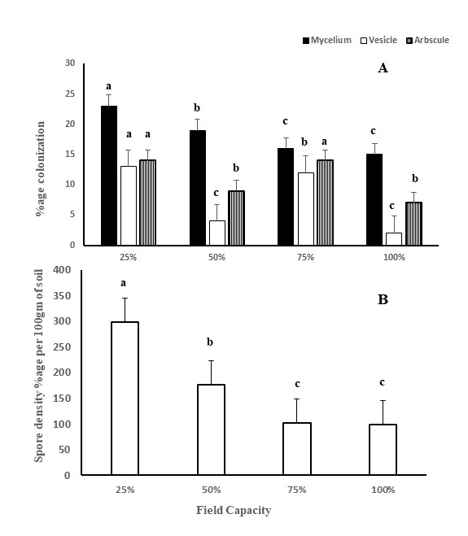
Figure 1:- Showing (A) percent root colonization and (B) spore density in the root and rhizosphere of C. ciliars under different field capacity.

Photosynthetic pigments
The photosynthetic pigments (chlorophyll a, b and carotenoids) were extracted from leaves of the experimental plant. The extract was centrifuged 10,000/g for 10 min. the absorbance of the supernatant was estimated spectrophotometrically at 480, 510, 645, 663nm (T80 UV/VIS Spectrometer, PG Instruments Ltd, USA), acetone was used as blank (Arnon, 1949).
Statistical analysis
The data was statistically analyzed using the program SAS (SAS, v.9.1) and the differences in means was determined by the least significant differences (LSD) (α=0.05) test.
Results and Discussion
Results showed that root colonization and spore density of AMF increased significantly in 25% followed by 50% field capacity (Figure 1 A & B & Figure 2). The significantly high percentage of mycelium at 50% and 25% field capacity may have helped plant to withstand drought by increasing root surface area of the target plant. This is in disagreement with the findings of (Al-karaki et al. 2004) which indicated that AMF root colonization was positively correlated with field capacity.

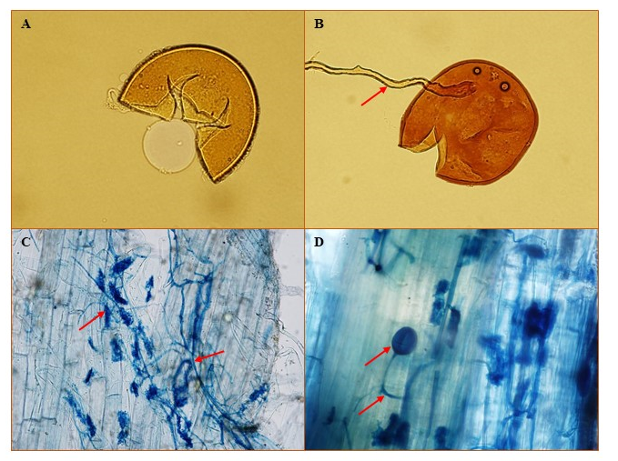
Figure 2:- showing (A & B) crushed spore AMF, (C & D) AMF fungal structures viz: arbuscules, coiled hypae and vesicles in the roots of C. ciliaris grown under different 25% field capacity.

Results generally showed that seedling with higher field capacity had higher above ground biomass content, root biomass and leaf area index (Figure 3, A). But, the AMF inoculated seedling showed higher biomass content compared to Non-AMF inoculated seedlings at their respective field capacities (Figure 3, B & C) especially at 25% field capacity, AMF inoculated seedling showed significant increase in aboveground biomass. Also, with respect to root biomass and leaf area index, the AMF inoculated seedlings showed higher root biomass and leaf area index compared to Non-AMF induced seedlings at their respective field capacities (Figure 3 B & C). The same had been reported by (Gong et al. 2013 & Liu et al. 2015) which showed that biomass of host plants inoculated with AMF fungi was higher than that of Non-AMF plants under drought conditions.

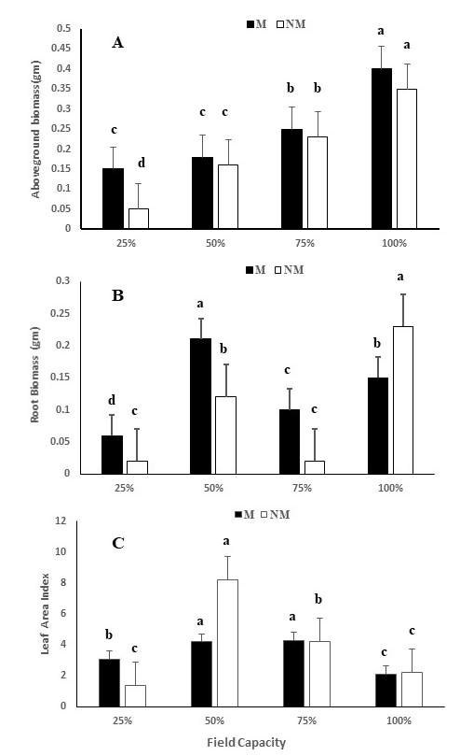
Figure 3:- showing effect of field capacity on (A) above ground biomass, (B) root biomass and (C) leaf area index of C. ciliaris in presence and absence of AMF.

The photosynthetic pigments viz; carotenoids and chlorophyll a & b decreased with the increase in drought conditions for both mycorrhizal and non-mycorrhizal inoculated seedlings of C. ciliaris (Table 1). However, mycorrhizal inoculated seedlings for each treatment had significantly higher photosynthetic pigment content than its related non-mycorrhizal inoculated plants, showing higher significance at 100% field followed by 75% field capacity respectively. The results of this experiment are consistent with the results of (Barida et al. 2007; Afsaneh et al. 2014) which showed that the amount of chlorophyll decreased with the increase in water stress.

Table 1:- Role of AMF on photosynthetic pigment contents in C. ciliars under different field capacity.
Field Capacity | Carotenoids |  | Chlorophyll a |  | Chlorophyll b
 | M | NM | M | NM | N | NM
25% | 2.90c  + 0.34 | 2.31c  +0.03 | 0.63f  +0.14 | 0.74f  +0.03 | 0.46d  +0.04 | 0.25e  +0.01
50% | 3.41b  +1.00 | 2.62c  +0.55 | 2.29d  +0.99 | 1.25e  +0.48 | 1.04c  +0.07 | 0.92d  +0.25
75% | 4.89a  +1.86 | 1.86c  +0.40 | 4.56b  +1.09 | 2.60d  +0.20 | 1.76b  +0.38 | 0.86d  +0.03
100% | 5.08a  +1.64 | 2.08c  +0.09 | 7.28a  +0.84 | 3.53c  +0.95 | 2.68a  +0.40 | 1.37b  +0.31

In conclusion, results demonstrated that AMF fungi may play a positive role under drought conditions and helps in improving the efficiency of the C. ciliaris to grown under drastic adverse abiotic drought conditions.

Reference
- Arnon DI. Copper enzymes in isolated chloroplasts. Polyphenoloxidase in Beta vulgaris. Plant physiology 1949; 24(1):1.
- Al-Karaki G, McMichael BZ, Zak J. Field response of wheat to arbuscular mycorrhizal fungi and drought stress. Mycorrhiza 2004;14(4):263-9.
- Al-Qarawi AA, Mridha MA, Alghamdi OM. Diversity of structural colonization and spore population of arbuscular mycorrhizal fungi in some plants from Riyadh, Saudi Arabia. J. Pure Appl. Microbiol 2012; 6:1119-25.
- Audet P, Charest C. Contribution of arbuscular mycorrhizal symbiosis to in vitro root metal uptake: from trace to toxic metal conditions. Botany 2009; 87(10):913-21.
- Burton G, Janick J, Simon J. African grasses. New crops. Wiley, New York 1993, 294-298.
- Chaudhary SA. Grasses of Saudi Arabia, National Herbarium, National Agriculture and Water Research Center, Ministry of Agriculture and Water, Riadh, Kingdom of Saudi Arabia. Google Scholar 1989.
- Chaves MM, Oliveira MM. Mechanisms underlying plant resilience to water deficits: prospects for water-saving agriculture. Journal of experimental botany 2004; 55(407):2365-84.
- Dhar PP, Mridha MA. Biodiversity of arbuscular mycorrhizal fungi in different trees of madhupur forest, Bangladesh. Journal of Forestry Research 2006; 17(3):201-5.
- Gerdemann JW, Nicolson TH. Spores of mycorrhizal Endogone species extracted from soil by wet sieving and decanting. Transactions of the British Mycological society 1963; 46(2):235-44.
- Gong M, Tang M, Chen H, Zhang Q, Feng X. Effects of two Glomus species on the growth and physiological performance of Sophora davidii seedlings under water stress. New Forests 2013; 44(3):399-408.
- Liu T, Sheng M, Wang CY, Chen H, Li Z, Tang M. Impact of arbuscular mycorrhizal fungi on the growth, water status, and photosynthesis of hybrid poplar under drought stress and recovery. Photosynthetica 2015; 53(2):250-8.
- Parida AK, Dagaonkar VS, Phalak MS, Umalkar GV, Aurangabadkar LP. Alterations in photosynthetic pigments, protein and osmotic components in cotton genotypes subjected to short-term drought stress followed by recovery. Plant Biotechnology Reports 2007; 1(1):37-48.
- Pustovoitova T, Zholkevich V. Basic trends in the investigation of drought effects on physiological processes in plants. Fiziol Biokhim Kul’t Rast. 1992;24:14-27.
- Rabia S, Muhammad T, Chanda A. Review paper: Agricultural and environmental effects on wheat’s Quality and yield. Researcher 2016; 8(7):72-81.
- Requena N, Perez-Solis E, Azcón-Aguilar C, Jeffries P, Barea JM. Management of indigenous plant-microbe symbioses aids restoration of desertified ecosystems. Applied and environmental microbiology 2001; 67(2):495-8.
- Shao HB, Chu LY, Jaleel CA, Manivannan P, Panneerselvam R, Shao MA. Understanding water deficit stress-induced changes in the basic metabolism of higher plants–biotechnologically and sustainably improving agriculture and the ecoenvironment in arid regions of the globe. Critical Reviews in Biotechnology 2009; 29(2):131-51.
- Shool A, Shamshiri MH. Effect of arbuscular mycorrhizal fungi and Pseudomonas fluorescence on chlorophyll fluorescence and photosynthetic pigments of pistachio seedlings (Pistaciavera cv. Qazvini) under four water regimes. Eur J. Exp Biol. 2014; 4:246-52.
- Van der Heijden MG, Klironomos JN, Ursic M, Moutoglis P, Streitwolf-Engel R, Boller T, Wiemken A, Sanders IR. Mycorrhizal fungal diversity determines plant biodiversity, ecosystem variability and productivity. Nature 1998; 396(6706):69.
- Wang Z, Xiong Y, Wang M. Study on expert system of irrigation forecast and decision making for water saving. Institute of Agricultural Soil Water Engineering of North West Science and Technology University of Agriculture Forestry, Yangling, Shaanxi. 2000.

5/7/2018

