**Weibull-Halfnormal Mixture Distribution and Its Properties**

Maradesa Adeleke

Department of Statistics, Federal university of Technology, Akure

[maradprime1@gmail.com](mailto:maradprime1@gmail.com)

**Abstract:** This research study the generalization of weibull and halfnormal Distribution (WHND) called weibull-halfnormal distribution (WHND) through its distribution function and mathematical derivation of its moment, reliability, cumulative distribution function, hazard rate function, probability density function and application to telecommunication data. The distribution was found to generalize some known distributions thereby providing a great flexibility in modeling heavy tailed, skewed and bimodal distributions.

[Maradesa Adeleke. **Weibull-Halfnormal Mixture Distribution and Its Properties.** *Researcher* 2018;10(4):82-93]. ISSN 1553-9865 (print); ISSN 2163-8950 (online). <http://www.sciencepub.net/researcher>. 11. doi:[10.7537/marsrsj100418.11](http://www.dx.doi.org/10.7537/marsrsj100418.11).

**Keywords:** Weibull-Halfnormal Distribution (WHND), Moment generating function, Hazard Function, Reliability

**1 Introduction**

Weibull distribution is a continuous probability distribution. It is one of different distributions used to describe particle size with major application in survival analysis, weather forecast and reliability engineering. The half-normal distribution is a special case of the folded normal and truncated normal distributions. It was used to model brownian movement and can also be used in the modeling measurement data and lifetime data. Let X~N (0,σ2), then Y = |X| follows half normal distribution. The Half-normal is a fold at the mean of an ordinary normal distribution with mean zero, where σ is the scale parameter. Mixing weibull and halfnormal distribution together results to Weibull-halfnormal distribution. This proposed mixture distribution has more number of parameters as compared to their respective parent distributions and it has wider applicability exceeding modeling particle size but in modeling many stochastic processes and stochastic phenomena which cannot be easily modeled by two parameters probability density (parent distribution) such as disease growth, epidemiological studies of disease, buying behavior of consumers towards certain economic product etc.

**1.1 Overview of the Research**

Many researchers have worked on aspect of compounding two or more probability distributions to obtain family of hybrid distributions which are more efficient than their parent distributions due to addition of more parameters which increase the flexibility of the mixture of distributions in tracking many random phenomena which cannot be easily modeled by their parent distributions. Many authors have also worked on compounding beta distribution with other distributions. The beta family of distribution became popular some years back and which include beta-normal (Eugene & Famoye, 2002) [2]; beta-Gumbel (Nadarajah & Kotz, 2004) [3], beta-Weibull (Famoye, Lee & Olugbenga, 2005) [4], Beta-exponential (Nadarajah & Kotz, 2006) [5]: bata-Rayleigh (Akinsete & Lowe, 2009) [6]: beta-Laplace (Kozubowski Nadarajah, 2008) [7]: beta-pareto (Akinete, Faye & Lee, 200) [8], Barreto-Souza, Santos, and Cordeiro (2009) constructed Beta generalized exponential, Beta-half-Cauchy was presented by Cordeiro, and Lemonte (2011), Gastellares, Montenegero, and Gauss derived Beta Log–normal**,** while Morais, Cordeiro, and Audrey (2011) introduced Beta Generalized Logistic, the Beta Burr III Model for Lifetime Data, Beta–hyperbolic Secant (BHS) by Mattheas, David (2007), Beta Fre´chet by Nadarajah, and Gupta (2004), Beta-halfnormal by Akomolafe and Maradesa (2017), beta-Gamma, beta-f, beta-t, beta-beta, beta-modified weibull, beta-nakagami among others. Some articles also evolved regarding exponential-pareto by Kareema Abdul Al-Kadim and Mohammed Abdulhussain and exponential gamma mixture.

In the view of this, this research work aims at compounding Weibull with Halfnormal distribution so as to obtain its corresponding hybrid version called Weibull-Halfnormal Distribution (WHND). The proposed distributions can be used to describe many random phenomena.

**2 Derivation of Weibull-Halfnormal Distribution (WHND)**

The probability density function of the mixture of Weibull-Halfnormal distribution has the following form:

= (1)



Where is the vector of parameters of WHND. and represent the parameters of the parent distributions. and are the mixing proportion, and .



where is the pdf of weibull distribution and



and are the parameter vector of weibull and halfnormal distribution respectively. From (1), the pdf of Weibull-Halfnormal can be developed as follows:



= (2)



Therefore, (2) is the pdf of Weibull-Halfnormal distribution (WHND). From (2), we can obtain the cdf of Weibull-Halfnormal distribution. When the parameter , the distribution becomes Exponential-Halfnormal Mixture Distribution (EHND). Also, when , WHND becomes Rayleigh-Halfnormal Mixture Distribution (RHND).



= (3)



= (4)



The (4) is the cdf of Weibull-Halnormal distribution.

**2 Moment**

**E ()** = (5)



= (6)



Let y = ; ; dx =



m = , dm = , dx =



Put for *dx*, y and m in (6),

=



= (7)



= dm + (8)



= (9)



= (10)



= (11)



Since m = ;; x = and y = ; , x =



Put for *x* in (12),

= (12)



= (13)



= (14)



= (15)



= .. (16)



= (17)



= (18)



= (19)



(20)



(21)



(22)



┌ (24)



(25)



(26)



(26)



(27)



(28)



The mean of Weibull-Halfnormal is,



The variance is:

Var (x) = = (29)



**2.1 Skewness and Kurtosis**

=



By applying Binomial Expansion

=



= =



=



=. - (28)



=. (29)

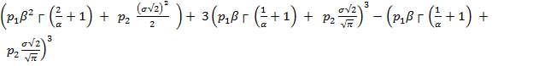

.2 (30)

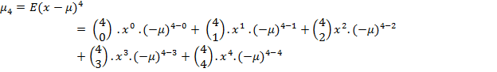

= =



=



=

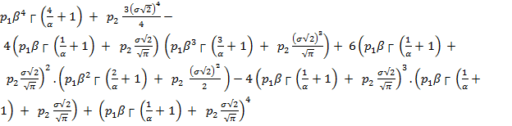

(31)

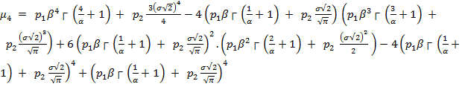

(32)

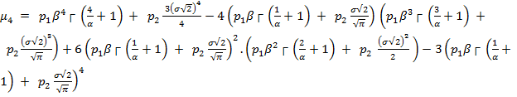

**2.1.1 Skweness**

**=**

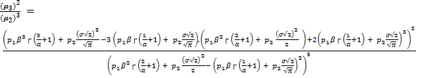

**2.1.2 Kurtosis**

**=**



**=**

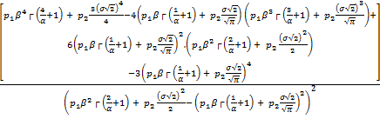

**2.2 Moment Generating Function**

= (33)



= (34)



The (34) above is the mgf of Weibull-Halfnormal distribution

**2.3 Reliability**

R (x) = 1- (35)



**2.4 Hazard Function**

H (x) =

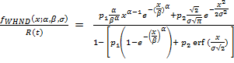

**2.5 Odd function**

**O (x) =**  =

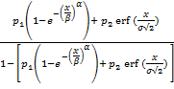

**2.6 Maximum Likelihood Estimation**

Lf (x;) = (36)



The log likelihood function is given as:

ln Lf (x;) = (37)



By obtaining the partial derivatives with respect to each of the parameter and solve the resulting equation, we can obtain the estimate of the parameters which can be used to test the hypothesis about the consistency, stability and efficiency of the mixture distribution over its parent distributions. This can be done via numerical estimation (Newton-Raphson algorithm).

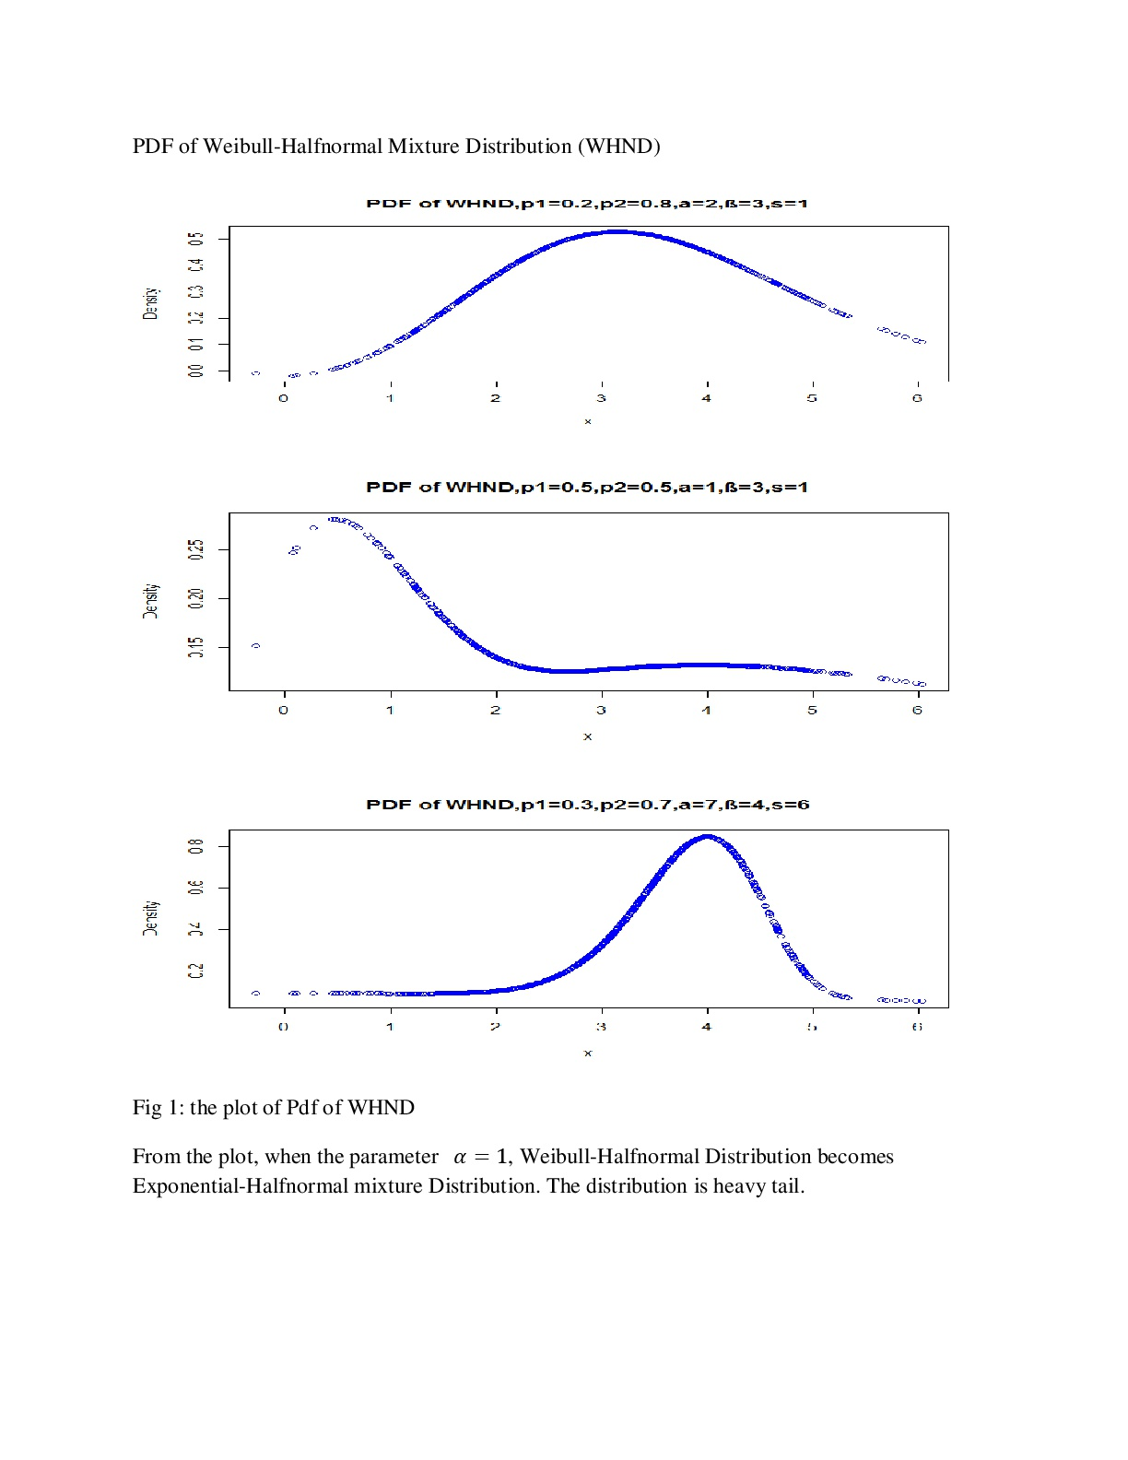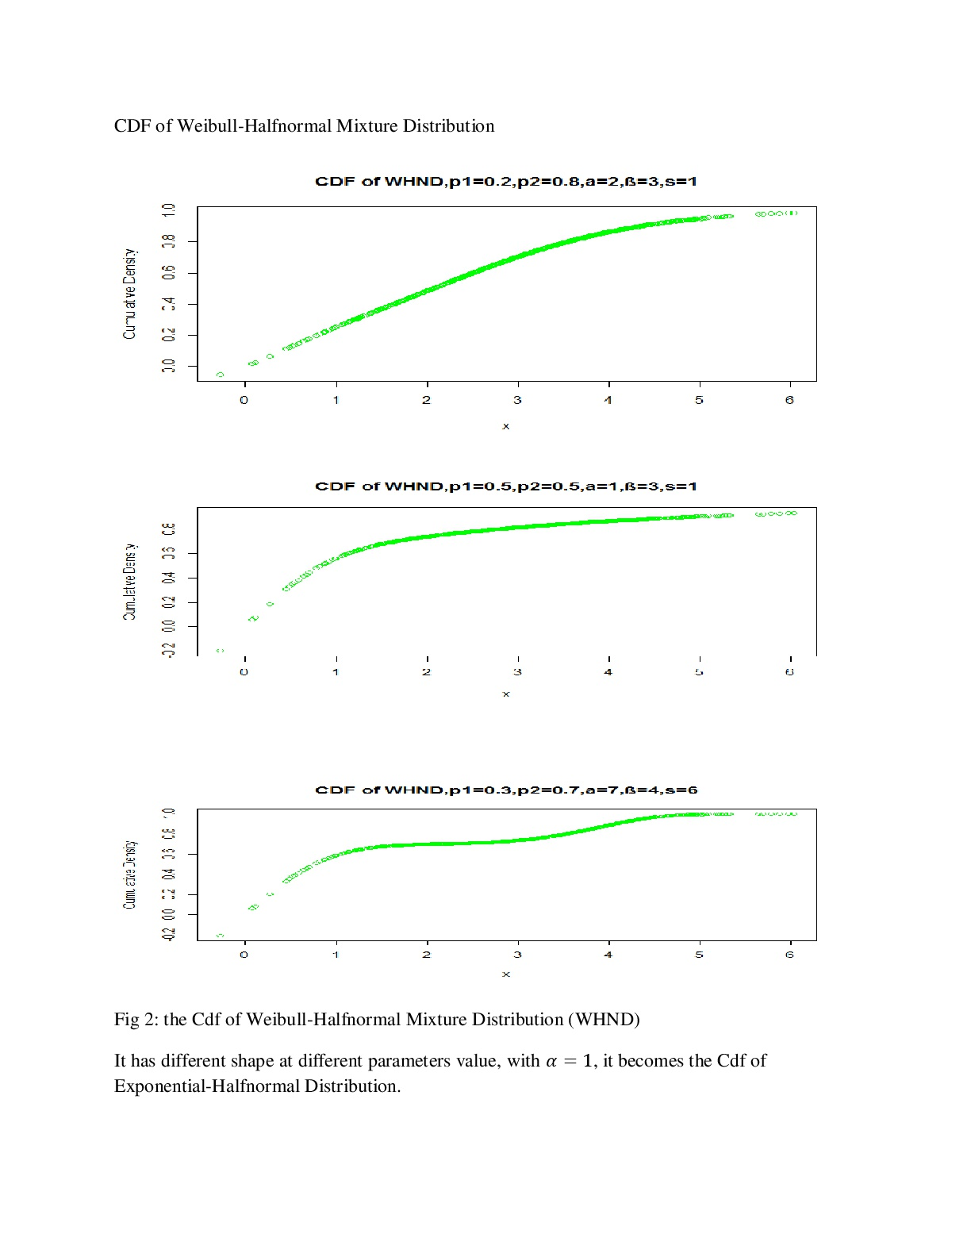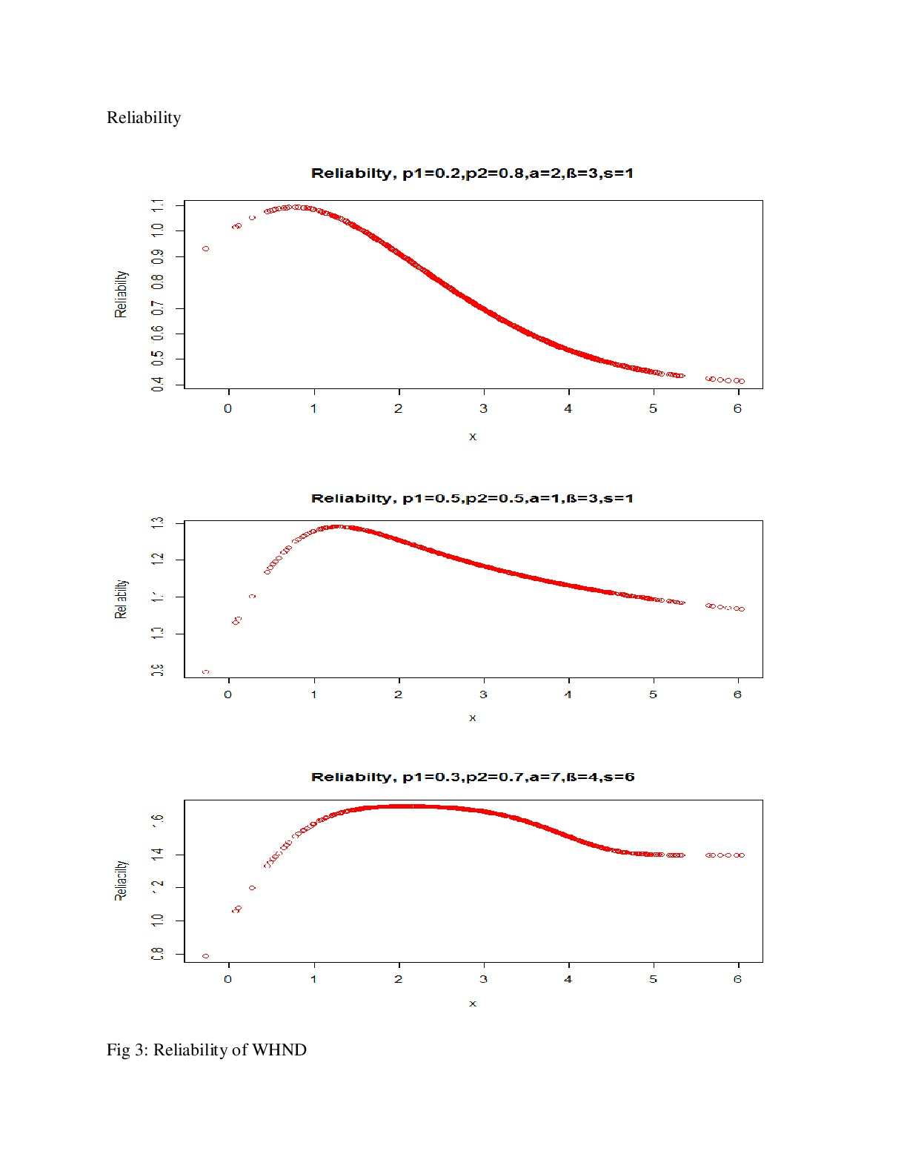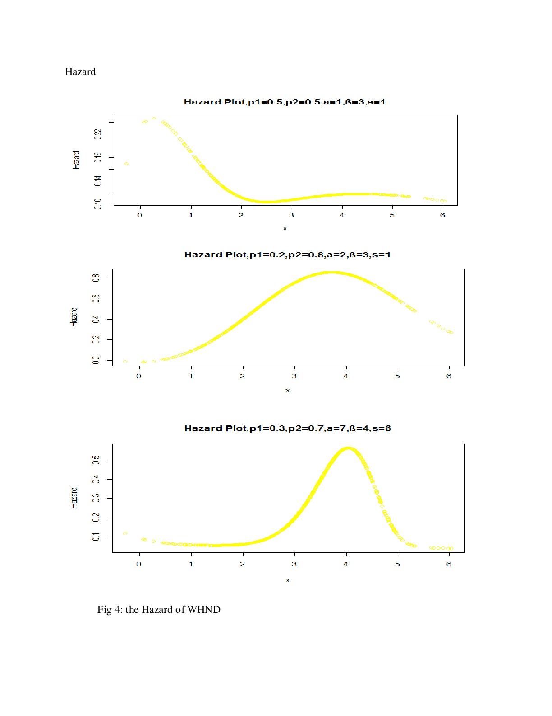

**3 Numerical Analysis**

The data used in this research was collected from standard business center major in selling Globalcom (GLO) data plan for monthly data subscription for the populace of Dugbe Ibadan. The sales record for complete 31 days was collected, and this depicts the pattern of data consumption of people for GLO monthly data plan. Weibull-Halfnormal Distribution (WHND) and its parents distributions are fitted to the data. The data is shown in appendix 1.

**3.1 Accessing Normality**

Since the Pdf of the distribution is heavily tail, then it can be used to capture non-normal data. That is, WHND will be reasonably good in modeling the data with skewed distribution, heavily tailed distribution, leptokurtic and platykurtic distribution.

**H0**: the data is normalα (0.05) VS **H1**: the data is not normal α (0.05)

Shapiro-Wilk normality test

data: GLO

w = 0.66074, p-value = 0.0000003216

Since p value (0.0000003216) < α (0.05), then there is great statistical evidence about not accepting the null hypothesis and conclude that the data tested (GLO data) are not from a normally distributed population (the data are not normal). Then the WHND can be fitted to the data because the distribution of WHND shows heavy tail. Therefore WHND can be used to capture non-normal data.

**Table 1**: **Parameter Estimates**

|  |  |  |  |
| --- | --- | --- | --- |
| Distributions |  |  |  |
| WHND=0.7643, =0.2357 | = 1.5548(0.3011) | =18.3216(3.8041) | =13.0098(2.6636) |
| Weibull (WD) | =1.62258 (0.1966723) | =15.93805 (1.8655406) |  |
| Halfnormal (HND) |  |  | =17.219809 (1.95321) |

**3.2 Likelihood Ratio Test**

**Hypothesis**

H0: the fit is not good for WHND ( =0) α = 0.05



H1: the fit is good for WHND ( > 0)



= 2 () = 2(107.665+95.98454) = 407.29908



**Decision Rule**

If T > do not accept H0, accept if otherwise. = 21.4335



**Decision**

Since (21.4335), we have statistical reason not to accept H0 and conclude that the Weibull-Halfnormal Distribution (WHND) fits the data reasonably well as compared to the parent distribution (Weibull Distribution, WD). We can therefore say that the fit is good for WHND. For this, we can say that WHND provides a better fit a compared WD when using telecommunication data. The additional parameter (σ) gives WHND this flexibility. and , due to the lower value of loglikelihood () of WHND as compared to of weibull distribution (WD), then WHND is said to provide a better fit in capturing telecommunication data as compared to weibull distribution. Additional parameters give WHND flexibility over Weibull.



**3.3 Wald Test**

H0:



H1: σ0



Decision Rule:

Accept H0 if



q is the number of parameters in the model or the number of rows of the variance-covariance matrix

=, at q = 4, is 9.48772904



**Decision**

Since the w (63.67184) >, then we have statistical reason not to accept H0 and conclude that WHND captures telecommunication (monthly browsing data plan) data reasonably well as compared to parent distributions because of the additional parameter that controls the flexibility of the distribution.



**3.1 Conclusion**

Compounding distributions lead to formulation of hybrid distribution with increased number of parameters as compared to its parent distributions. The proposed distribution is said to have more stability, consistency and flexibility in modeling data with heavily skewed or bimodal distribution. The proposed distribution is said to capture the telecommunication data reasonably well as compared to parent distribution.

**References**

1. Alzaatreh, A. Lee, C. and Famoye, F., (2013). A new method for generating families of continuous distributions. Metron, 71(1), 63–79.
2. Akinsete, A., Famoye, F., and Lee, C., (2008). The beta- pareto distribution, Statistics 42(6), 547-563.
3. Akomolafe A. A and Maradesa A., (2017). Beta-halfnormal Distribution and Its Properties, International journal of Advance Research and Publication vol 1 issued 4 (17-22).
4. Ashour S. K and Eltehiwy M. A., (2013). Transmuted Lomax distribution, America Journal of Applied Mathematics and Statistics vol1, 6:121-127.
5. Badmus, N. I., Ikegwu, M. and Emmanuel, (2013). The Beta-Weighted Weibull Distribution: Some properties and application to Bladder Cancer Data, Applied and Computational Mathematics 2:5.
6. Barreto-Souza, W., Cordeiro G. M., and Simas A. B., (2011). Some results for beta Frechet distribution. Communications in Stat Statistics Theory & Methods, 40, 798–811.
7. Burr, I. W., (1942). Cumulative frequency functions. Annals of Mathematical Statistics, 13, 215-232.
8. Cordeiro G. M., and de Castro, M., (2011). A new family of generalized distributions. Journal of Statistical Computation and Simulation 81(7), 883-898.
9. Cordeiro, G. M., Simas, A. B. and Stosic, B. D., (2011). Closed form expressions for moments of the beta Weibull Distribution, Annals of the Brazilian Academy of Sciences, 8 83, 357-373.
10. Eugene, N., Lee, C, and Famoye, F., (2002): Beta-normal distribution and its applications. Communications in Statistic: Theory and methods, 31(4), 497-512.
11. El-Bassiouny, A. H., Abdo, N. F., Shahen, H. S., (2015). Exponential Lomax Distribution, International Journal of Computer Application volume 121(13), 24-29.
12. Famoye, F., Lee, C. and Olumolade, O., (2005). The Beta-Weibull distribution. Journal of Statistical Theory, 4,121–136.
13. Famoye, F., Lee, C. and Eugene, N., (2004). Betanormal distribution: bimodality properties and application. Journal of Modern Applied Statistical Methods, 3, 85-103.
14. Jones, M. C., (2004). Families of distribution arinsing from distribution of order statistic test 13(1-43) .
15. Kareema A. K. and Mohammed A. B., (2013). Exponential Pareto Distribution, Journal of Mathematical theory and modeling, vol 3, no 5, pp (135-146).
16. Merovci F. and Puka L., (2014). Transmuted Pareto Distribution, Probstat Forum vol7, (1-11).
17. Mahmoud M. R. and Mandouh R. M., (2013). Transmuted frechet, Journal of Applied Science Research vol9 no 10 pp (555-561).
18. Marcelo B., Indranil G., and Cordeiro G. M., (2016), General results for the transmuted Family of Distributions and New Models, Journal of Probability and Statistics.
19. 29 Mohammad D., and Muhammad A., (2014), on the Mixture of Burr XII and Weibull Distribution, Journal of Statistics Application and Probability, J. Sta. Appl. Pro. 3, No 2, 251-267.http://dx.doi.org/10.12785/jsap/03215.
20. Nadarajah, S., and Kotz, S., (2006). “The exponentiated type distribution’, Acta Applicandae Mathematica, vol 92, no2, pp (97-111).
21. Naradarajah, s., (2006). “The exponential Gumbel distribution with climate application, “Environmetrics vol 17, no 1, pp (13-23).
22. Okorie E., Akpanta A. C., and Ohakwe J., (2016). The exponential Gumbel Type 2 Distribution: Properties and Application, international Journal of Mathematics and Mathematical Science Volume (2016), Article ID 5898356, 10 pages http://dx.doi.org/10.1155/2016/5898356.
23. Shittu, O. I., and Adepoju, A. K., (2013). On the Beta-Nakagami Distribution: Progress in Applied Mathematics 5:49-5.

**Appendix 1**

The data below shows sales record for complete 31 days, and it depicts the pattern of data consumption of people for GLO monthly data plan. It represents the number of subscribers who come to purchase GLO data for their monthly data subscription.

10,60,14,4,4,5,1,19,16,15,18,12,14,17,15,11,23,12,11,18,16,18,14,16,17,10,13,8,9,10,11

**Appendix 2**

> x <-c (10,60,14,4,4,5,1,19,16,15,18,12,14,17,15,11,23,12,11,18,16,18,14,16,17,10,13,8,9,10,11)

> #Fit x data with fitdist

> fit.w <- fitdist (x, "weibull")

> summary (fit.w)

Fitting of the distribution ' weibull ' by maximum likelihood

Parameters:

estimate Std. Error

shape 1.62258 0.1966723

scale 15.93805 1.8655406

Loglikelihood: 107.665 AIC: 219.3299 BIC: 222.1979

Correlation matrix:

shape scale

shape 1.0000000 0.3254296

scale 0.3254296 1.0000000

HALFNORMAL

Maximum Likelihood estimation

BFGS maximization, 2 iterations

Return code 0: successful convergence

Log-Likelihood: 110.6945

1 free parameters

Estimates:

Estimate Std. error t value Pr (> t)

[1,] 17.219809 1.95321 42.54 2.16e-16

WEIBULL-HALFNORMAL

Maximum Likelihood estimation

BFGS maximization, 38 iterations

Return code 0: successful convergence

Log-Likelihood: -95.98456

3 free parameters

Estimates:

Estimate Std. error t value Pr (> t)

[1,] 1.5548 0.3011 5.163 0.000000242 ***

[2,] 18.3216 3.8041 4.816 0.000001462 ***

[3,] 13.0098 2.6636 4.884 0.000001038 ***

---

Signif. codes: 0 ‘***’ 0.001 ‘**’ 0.01 ‘*’ 0.05 ‘.’ 0.1 ‘ ’ 1

--------------------------------------------

> g<-vcov (h)

> g

[,1] [,2] [,3]

[1,] 0.09066969 0.4986833 -0.07253575

[2,] 0.49868328 14.4708821 -0.39894662

[3,] -0.07253575 -0.3989466 7.09490302

> v<-hessian (h)

> v

[,1] [,2] [,3]

[1,] -13.6992639 0.46895821 -0.1136868

[2,] 0.4689582 -0.08526513 0.0000000

[3,] -0.1136868 0.00000000 -0.1421085

var<-vcov (h)

> coe<-matrix (coef (h))

> coet<-t (coe)

> g<-coet%*%var%*%coe

> uu<-solve (g)

> w<-coet%*%solve (var)%*%coe

> w

[,1]

[1,] 63.67184

4/25/2018