Geographical Parameters Related to Abiotic Climatic Factors in district Hisar, Haryana (India)

¹Sudesh and ²Mamta

¹Assistant Professor, Department of Geography, C.R.M. Jat College, Hisar, Haryana (India)
²Assistant Professor, Department of Geography, F.C. Women College, Hisar, Haryana (India)
Email: ¹sudeshranveer@gmail.com and ²mamtakhushi63@yahoo.com

Abstract: Hissar is the administrative headquarters of Hisar district of Hisar division in the state of Haryana which is located in North western India. It is located 164 Km (102 mi) to the West of New Delhi, India's capital, and has been identified as a counter-magnet city for the National Capital Region to develop as an alternative center of growth to Delhi. Hisar is located at 29.09°N and 75.43°E in western Haryana. Hisar has a continental climate, with very hot summers and relatively cool winters. The main characteristics of climate in Hisar are dryness, extremes of temperature, and scanty rainfall. Monthly geographical parameters related to abiotic climatic factors, i.e., temperature (high and low), rainfall/day, humidity, dew point, wind, pressure and visibility was observed from January, 2017 to December, 2017 in district Hisar, Haryana (India). To record above mentioned geographical parameters, direct observation method (Dagar et al., 2001) was followed. During the study, monthly average±S.E. of high temperature (⁰C) 32.83±1.08 and low temperature (⁰C) 18.75±0.97 was observed. Rainfall/day with an average±S.E. of 2±0.00, humidity (%) with an average±S.E. of 60.16±1.81, dew point (⁰C) with an average±S.E. of 16.08±0.99, wind (Km/h) with an average±S.E. of 3.83±0.01, pressure (mbar) with an average±S.E. of 1007.66±4.48 and visibility (Km/h) with an average±S.E. of 3.25±0.11 was observed from January, 2017 to December, 2017 in district Hisar, Haryana (India).
[ Sudesh and Mamta. Geographical Parameters Related to Abiotic Climatic Factors in district Hisar, Haryana (India). Researcher 2018;10(4):42-48]. ISSN 1553-9865 (print); ISSN 2163-8950 (online). http://www.sciencepub.net/researcher. 6. doi:10.7537/marsrsj100418.06.

Keywords: Temperature (high and low), rainfall/day, humidity, dew point, wind, pressure, visibility, Hisar.

Introduction:
The latest scientific assessment, the earth’s climate system has demonstrably changed on global scale; and warming (of 0.1°C per decade) is observed over the last 50 years is attributable to human activities. The Intergovernmental Panel on Climate Change (IPCC) projects that the global mean temperature may increase between 1.4 and 5.8 degrees Celsius by 2100. The impact would be particularly severe in the tropical areas, which mainly consist of developing countries, including India. Perception, threats and assessments of risks are viewed by various countries with varying positions though per capita of India’s emissions is one fourth of the global average, top 10% of urban population of India emit below the global average per capita emission (Parekh and Parekh, 2002).
Abiotic components are and ecological factor that acts of living components during any part of their life. Abiotic factors are the factors that are either physical or chemical factors that are the characteristic of the environment being studied. Many ecological studies have been done about the importance of the major abiotic factors which control the physical and biological components in an ecosystem at various ranges of time and space. Many factors influence every part of our environment: things like how tall trees grow, where animals and plants are found, and why birds migrate. There are two categories of these factors: abiotic and biotic. Abiotic factors are the non-living parts of the environment that can often have a major influence on living organisms. Abiotic factors include water, sunlight, oxygen, soil and temperature (Ashraf et al., 2008).
Water (H₂O) is a very important abiotic factor – it is often said that “water is life.” All living organisms need water. Plants must have water to grow. Even plants that live in the desert need a little bit of water to grow. Without water, animals become weak and confused, and they can die if they do not rehydrate. Sunlight is the main source of energy on Earth, which makes it an extremely important abiotic factor. Sunlight is necessary for photosynthesis, the process by which plants convert carbon dioxide (CO₂) and water to oxygen (O₂) and sugar – food for the plants that later becomes food for animals. Without the sun, plants could not live, and without plants, animals could not live! The sun’s heat is also extremely important – see the section on Temperature below (dagar et al., 2001).
Like water, oxygen (O₂) is another important abiotic factor for many living organisms. Without oxygen, humans would not be able to live! This is true for the many other living organisms that use oxygen. Oxygen is produced by green plants through the process of photosynthesis, and is therefore directly

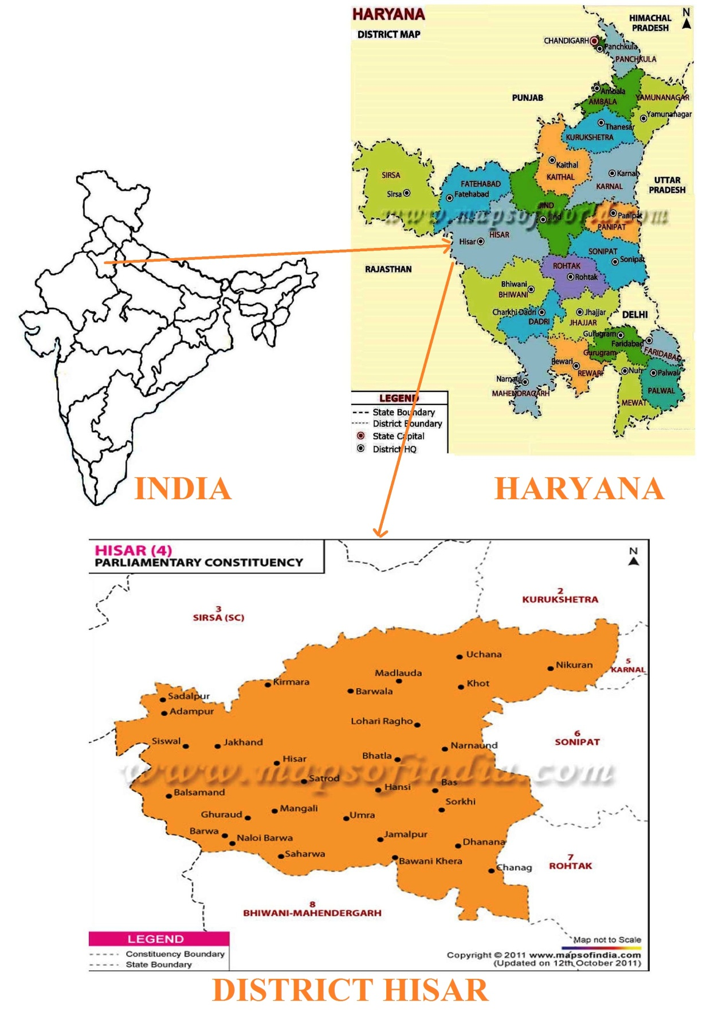
Fig. 1. Study area is district Hisar, Haryana (India).

linked to sunlight (NRAA, 2011 and NCAER, 2013). Soil is often considered an abiotic factor since it is mostly made up of small particles of rock (sand and clay) mixed with decomposed plants and animals. Plants use their roots to get water and nutrients from the soil. Soils are different from place to place – this can be a big factor in which plants and animals live in a certain area (ICAR, 2010).
Temperature is an abiotic factor that is strongly influenced by sunlight. Temperature plays an important role for animals that cannot regulate their own body temperature, such as reptiles. Unlike humans, whose normal body temperature is usually around 98.6°F, reptiles (such as snakes and lizards) cannot maintain a constant body temperature. Reptiles are usually found in warm regions around the planet. To regulate their body temperatures, reptiles will sun themselves on rocks, which absorb heat from sunlight and then radiate heat back into the environment (Wag et al., 2007 and Singh, 2010).
Due to less and scanty information are available on geographical parameters related to abiotic climatic factors in Haryana, particular. So the present study was planned in geographical parameters related to abiotic climatic factors, i.e., temperature (maximum and minimum), rainfall/day, humidity, dew point, wind, pressure and visibility in district Hisar, Haryana (India).

Materials and Methods:
The climate of Haryana over most of the year is of a pronounced continental character. It is very hot in summer and markedly cold in winter. The rainfall in the region is low and erratic except in parts of the Karmal and Ambala districts. The rainfall is unevenly distributed during the year except for two well marked seasons. One is the monsoon period lasting from the middle of June to the end of September on which autumn crop and spring sowing depend and the other is the winter rains which occur from December to February, benefiting rabi crop. Rainfall is meager, particularly in the districts of Mahendragarh and Hissar. Haryana is extremely hot in summer at around 45 °C (113 °F) and mild in winter. The hottest months are May and June and the coldest December and January. The climate is arid to semi-arid with average rainfall of 354.5 mm.
The present study was planned in district Hisar, Haryana (India). Hissar is the administrative headquarters of Hisar district of Hisar division in the state of Haryana in north western India. It is located 164 km (102 mi) to the west of New Delhi, India's capital, and has been identified as a counter-magnet city for the National Capital Region to develop as an alternative center of growth to Delhi. Hisar is located at 29.09°N 75.43°E in western Haryana. It has an average elevation of 215 m (705 ft) above mean sea level. The region is part of the alluvial Ghaggar-Yamuna plain and its southern and western portions mark a gradual transition to the desert. Ghaggar and Drishadvati Rivers once flowed through the city. According to tectonic map, the district lies on Delhi-Lahore Ridge which is bounded by thrusts and no earthquake of any significance has originated in the zone in the past. Only one instance has been recorded of a famine occurring in the city in 1837–38. Hisar has a continental climate, with very hot summers and relatively cool winters. The main characteristics of climate in Hisar are dryness, extremes of temperature, and scanty rainfall. The maximum daytime temperature during the summer varies between 40 and 46 °C (104 and 115 °F). During winter, its ranges between 1.5 and 4 °C. Maximum temperature recorded is 48.3 °C (118.9 °F) in May, 1944, whereas the minimum temperature recorded is −3.9 °C in January 1929. Annual average maximum and minimum temperature is 32.3 °C (90.1 °F) and 15.4 °C (59.7 °F), respectively. Relative humidity varies from 5 to 100%.
Hisar is located on the outer margins of the South-West monsoon region. The average annual rainfall is around 429 mm (16.9 in), most of which occurs during July and August. The annual highest rainfall of 793.6 mm (31.24 in) was recorded in 1976 and the lowest of 145.2 mm (5.72 in) in 2000. Dew is observed in December and January. Hot winds, locally known as loo, are strong and frequent from May to July. Occasionally, dust-storms are experienced during summer and hail-storms during February to April. Fog prevails generally in December and January. Thunderstorms also occur during post monsoon season and summer.
Monthly geographical parameters related to abiotic climatic factors, i.e., temperature (maximum and minimum), rainfall/day, humidity, dew point, wind, pressure and visibility in district Hisar, Haryana (India) was observed from January, 2017 to December, 2017. To record above mentioned geographical parameters, direct observation method (Dagar et al., 2001) was followed.

Results and Discussion:
The Indian climate has undergone significant changes showing increasing trends in annual temperature with an average of 0.56°C rise over last 100 years (IPCC, 2007; Rao et al,. 2009; IMD, 2010). Warming was more pronounced during post monsoon and winter season with increase in number of hotter days in a year (IMD, 2010). Even though, there was slight increase in total rainfall received, number of rainy days decreased. The rainfed zone of the country shown significant negative trends in annual rainfall (De and Mukhopadhyay, 1998; Lal, 2003, Rao et al., 2009). The semi arid regions of the country had maximum probability of prevalence of droughts of varying magnitudes (20-30%), leading to sharp decline in water tables and crop failures (Samra, 2003). By the end of next century (2100), the temperature in India is likely to increase by 1-5 0C (De and Mukhopadhyay, 1998; Lal, 2003; IPCC, 2007; IMD, 2010). According to the estimates of NATCOM (2004), there will be 15-40% increase in rainfall with high degree of variation in its distribution. Apart from this, the country is likely to experience frequentlyoccurring extreme events like heat and cold waves, heavy tropical cyclones, frosts, droughts and floods (NATCOM, 2004).

Table 1: Monthly geographical parameters related to abiotic climatic factors in district Hisar, Haryana (India) from January, 2017 to December, 2017.
Month of year | Temperature (⁰C) |  | Rain  (/day) | Humidity  (%) | Dew Point (⁰C) | Wind  (Km/h) | Pressure  (mbar) | Visibility  (Km/h)
 | High | Low
January | 21 | 7 | 1 | 72 | 8 | 2 | 1018 | 3
February | 25 | 10 | 2 | 67 | 10 | 3 | 1015 | 4
March | 31 | 15 | 1 | 59 | 14 | 3 | 1011 | 4
April | 38 | 21 | 1 | 39 | 13 | 3 | 1007 | 4
May | 42 | 25 | 1 | 37 | 16 | 4 | 1001 | 4
June | 41 | 28 | 3 | 49 | 21 | 4 | 998 | 4
July | 37 | 27 | 7 | 67 | 25 | 4 | 997 | 4
August | 36 | 27 | 6 | 72 | 25 | 3 | 1000 | 4
September | 36 | 25 | 2 | 70 | 23 | 3 | 1004 | 4
October | 35 | 19 | 0 | 58 | 17 | 2 | 1010 | 4
November | 29 | 13 | 0 | 62 | 12 | 1 | 1014 | 3
December | 23 | 8 | 0 | 70 | 9 | 2 | 1017 | 3
Mean±S.E. | 32.83±1.08 | 18.75±0.97 | 2±0.00 | 60.16±1.81 | 16.08±0.99 | 2.83±0.01 | 1007.66±4.48 | 3.25±0.77

Fig. 2. Temperature variation (high and low) in district Hisar, Haryana (India) from January, 2017 to December, 2017.

During the study, monthly variation in high temperature was varied from a minimum 21⁰C (in the month of January, 2017) to a maximum of 38⁰C (in the month of April, 2017) with an average±S.E. of 32.83±1.08 while in low temperature it was varied from a minimum 7⁰C (in the month of January, 2017) to a maximum of 28⁰C (in the month of June, 2017) with an average±S.E. of 18.75±0.97 was observed (Table 1 and Fig. 2). Also, rainfall/day was observed from a minimum 1day/month (in the month of January, March, April and May, 2017) to a maximum of 7days/month (in the month of Julyl, 2017) with an average±S.E. of 2±0.00 was observed (Table 1 and Fig. 3).
As far as, during the present study, humidity was varied from a minimum 37% (in the month of May, 2017) to a maximum of 72% (in the month of January and august, 2017) with an average±S.E. of 60.16±1.81 was observed (Table 1 and Fig. 4). Similarly, dew point was varied from a minimum 8⁰C (in the month of January, 2017) to a maximum of 25⁰C (in the month of July and August 2017) with an average±S.E. of 16.08±0.99 was observed (Table 1 and Fig. 5). Also, wind (Km/h) was varied from a minimum 1Km/h (in the month of October, 2017) to a maximum of 4 Km/h (in the month of May, June and July, 2017) with an average±S.E. of 3.83±0.01 was observed (Table 1 and Fig. 6). Pressure was also varied from a minimum 997 mbar (in the month of July, 2017) to a maximum of 1018 mbar (in the month of January, 2017) with an average±S.E. of 1007.66±4.48 was observed (Table 1 and Fig. 6). Also, visibility was varied from a minimum 3/Km (in the month of January, November and December, 2017) to a maximum of 4/Km (in the whole month of year 2017) with an average±S.E. of 3.25±0.11 was observed (Table 1 and Fig. 6).

Fig. 3. Rain/day in district Hisar, Haryana (India) from January, 2017 to December, 2017.

Fig. 4. Humidity (%age) in district Hisar, Haryana (India) from January, 2017 to December, 2017.

Fig. 5. Dew point (ºC) in district Hisar, Haryana (India) from January, 2017 to December, 2017.

(a)

(b)

(c)
Fig. 6. (a) Wind (Km/h), (b) pressure (mbar) and (c) visibility/Km in district Hisar, Haryana (India) from January, 2017 to December, 2017.
Conclusion:
The distribution of biodiversity on earth is usually diverse and their numbers fluctuate in relation to the different abiotic factors and land use patterns of the soil. The aim of the present study is to determine the monthly as well as seasonally effects of abiotic factors (physico-chemical properties) on biodiversity, distribution and relative abundance of species under different land use pattern. This is also help in the study of variation of climatic condition on weather of district Hisar, Haryana (India).

Corresponding author:
Mrs. Mamta
Assistant Professor,
Department of Geography,
F.C. Women College, Hisar,
Haryana (India)
Email: mamtakhushi63@yahoo.com
Contact No. +91-9034473467

References:
- Ashraf, M., Athar, H.R., Harris, P.J.C. and Kwon, T.R. 2008. Some prospective strategies for improving crop salt tolerance. Adv Agron 97: 45–110.
- Dagar, J.C., Singh, G., and Singh, N.T. 2001. Evalution of forest and fruit tree used for rehabilitation of semiarid alkali-sodic soil in India. Journal of Arid land Research and Management;15(2):115-133.
- De, U.S. and Mukhopadhyay, R.K.. 1999. Severe heat wave over the Indian subcontinent in 1998 in perspective of global climate, Curr. Sci., 75, 1308-1315.
- ICAR. 2010. Degraded and Wastelands of India Status and Spatial Distribution. Indian Council of Agricultural Research, KAB-I, Pusa, New Delhi.
- IMD, 2010. Annual Climate Summary 2010. India Meteorological Department, Pune. Government of India, Ministry of Earth Sciences, 27.
- IPCC. 2007. Climate Change - Impacts, Adaptation and Vulnerability. Parry, M.L., Canziani, O.F., Palutikof, J.P., vander Linden, P.J. and Hanson, C.E. (eds) Cambridge University Press, Cambridge, UK, 976.
- Lal, M. 2003. Global climate change: India’s monsoon and its variability. J. Env. Studies Policy, 6, 1-34.
- NATCOM, 2004. India’s initial national communication to the United Nations framework- convention on climate change. Ministry of Environment and Forests, 268.
- NCAER. 2013. Agricultural Outlook and Situation Analysis: Reports Quarterly Agricultural Outlook Report: January–March 2013; National Council of Applied Economic Research, 11, I.P. Estate, New Delhi.
- NRAA. 2011. Challenges of Food Security and its Management. National Rainfed Area Authority (NRAA), NASC Complex, DPS Marg, New Delhi.
- Parikh, J.K., & Parikh, K. 2002. Climate Change: India’s Perceptions, Positions, Policies and Possibilities. OECD. Retrieved July 29, 2010, from http://www.oecd.org/dataoecd/22/16/1934784.pdf.
- Rao, G.G.S.N., Rao, A.V.M.S. and Rao, V.U.M. 2009. Trends in rainfall and temperature in rainfed India in previous century. In: Global climate change and Indian Agriculture case studies from ICAR network project, (Ed.: PK Aggarwal), ICAR Publication, New Delhi. pp.71-73.
- Samra, J.S. 2003. Impact of Climate and Weather on Indian Agriculture. Indian Soc. Soil Sci., 51: 418-430.
- Singh, R.B. 2010. Towards a Food Secure India and South Asia: Making Hunger History. APAARI, Bangkok.
- Wang, W., Vinocur, B. and Altman, A. 2007. Plant responses to drought, salinity and extreme temperatures towards genetic engineering for stress tolerance. Planta. 218:1-14.

4/25/2018

