Investigating the Efficiency of Brand Efficiency on Improving Its Commercial Performance in Mahshahr Petrochemical Industries

Foad Barieian¹, Saeed Shavval Poor^{2*}

¹Department of Business Management, Faculty of Humanities, Persian Gulf International Branch, Islamic Azad university, khorramshahr, iran
²Department of Business Management, Faculty of Humanities, Persian Gulf International Branch, Islamic Azad university, khorramshahr, iran
Corresponding Author: saeed shavval poor ^{2*}

Abstract: The present study aimed to investigate the effect of brand sustainability on the commercial performance of Mahshahr petrochemical industry. The study method was applied survey. Based on this, 384 employees of Mahshahr Petrochemical Industries Company were selected by simple random sampling method using Cochran formula. The data gathering tool was a researcher-made questionnaire based on related studies that included 24 items about the research variations. Data were analyzed using spss and smart pls software. The results of data analysis showed confirmation of research hypotheses, so that social media had a positive and significant effect on brand sustainability and business performance. Transparency has a positive and significant effect on brand sustainability and business performance. Social responsibility also has a positive and significant effect on brand sustainability and business performance.
[Foad Barieian, Saeed Shavval Poor. Investigating the Efficiency of Brand Efficiency on Improving Its Commercial Performance in Mahshahr Petrochemical Industries. Researcher 2018;10(3):53-59]. ISSN 1553-9865 (print); ISSN 2163-8950 (online). http://www.sciencepub.net/researcher. 7. doi:10.7537/marsrsj100318.07.

Key Words: Social Media, Transparency, Social Responsibility, Business Performance, Mahshahr Petrochemicals

Introduction
The best performance presentation in a desirable, reliable and proportionate manner is the thing that provides the survival and continuity of organizations in order to make customers satisfied and loyal by meeting their expectations and wishes. Organization’s business performance is a broad concept dependent on many components. The increase in intensity of competition resulting from the globalization process and the increasing use of information technology in the business environment has led companies to set their brand marketing activities in a way that present their best performance. Social media has caused many changes in commercial business approaches through their influence on branding concept. Accordingly, research‘s generalities will be studied in this chapter. In continue, the research problem plan will be stated in order to provide a subjective view of the nature, importance and necessity of the research. Therefore, statement of problem and the questions which are going to answer are firstly discussed and then, some topics about the importance, necessity and benefits of research is presented and next, research’s general and partial goals will be explained. Theoretical framework, research’s hypotheses, research method and subject, time and space domain of research is identified at the next stage and then, keywords that are frequently used in research and the focus of research is based on the conceptualization of these elements are conceptually and operationally defined. Finally, the type of research variables will be determined in order to carry out the research based on a specific framework.
Research history
Researches done inside the country
In this study, Shahbandarzadeh and Kebgani (2017) have tried to identify the most important factors that affect customer loyalty and thus the sustainability of a commercial brand. The past research with theme of loyalty to the brand has been firstly investigated and the most important factors affecting the commercial brand loyalty have been identified. In continue,, a conceptual model has been presented about the factors affecting brand loyalty according to past research in which satisfaction, trust, attitude toward brand, commitment, brand identity and quality, advertisement, distribution and price were identified as the most important factors affecting brand loyalty. According to this research’s results, the quality of the product with value equivalent to 0.22 and product satisfaction with a value of 1.059 are respectively considered as the main factors of the companies’ growth and profitability based on the assessment of the dimensions affecting the brand loyalty. In a study entitled "The Study of the Function of the Social Responsibility and Media Theory", have examined various social responsibility theories and criticized and studied the views of their critics and commentators. They believe that media must be as a tribune for exchanging interpretation and critique and present a picture of different groups of society.
Heidar Zadeh and Samad Zadeh (2016) conducted a research with the purpose of finding relationship between company’s social responsibility and dynamic abilities and firm’s competitive benefit. According to results obtained from research’s hypotheses test based on existence of a direct relationship between company’s social responsibility, intellectual capital and sustainable competitive advantage, we can deduce that the companies of the Saipa automobile group have been able to follow and implement different principles and dimensions of company’s social responsibility in order to effectively manage and promote their intellectual capital and differentiate it from others.
Research done abroad
In a research, Akin and Yilmaz (2016) have studied the level of social responsibility of banks’ personnel and managers in Turkey so that they investigate banks’ responsibility. Traditionally, the main goal of banks’ financial management is shareholders’ stock maximization and on the other hand, the banks are obliged to explain the method of their performance to stockholders through annual reports. One of the studies conducted in this regard is relates to the social responsibility of the banking system of Turkey, which has taken the level and quality of responsibility and accountability into account through the analysis and evaluation of various components in the annual reports of banks.
Wang et al (2015) studied company brand’s special value and business performance by using multiple regressions and structural equation pattern in order to discover the causal relationship between companies’ social responsibility in high technology Taiwanese companies during the period 2010-2013. The results obtained from regression analysis show that economic dimension of companies’ social responsibility and stimulus of brand’s name value credit are considered as positive and remarkable factors. The brand development’s incentive factor has a positive and remarkable impact on business performance of company’s brand.
Research’s hypotheses
- The social media expansion has a positive and significant effect on business performance.
- The social media expansion has a positive and significant effect on brand sustainability.
- The increase in transparency has a positive and significant effect on business performance.
- The increase in transparency has a positive and significant effect on brand sustainability.

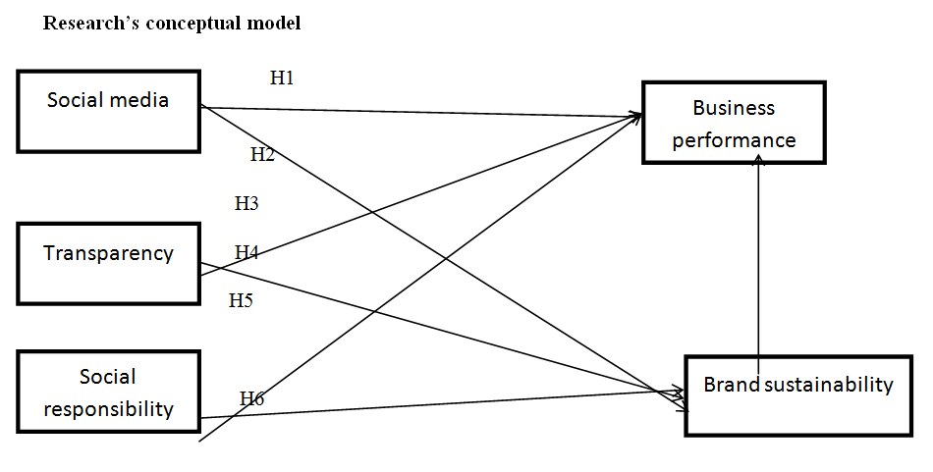
Figure 1. Research Model

Statistical population and sample
This research’s statistical population includes all customers of of Mahshahr Petrochemical Industries.
Sampling is emphasized in social researches because of following reasons:
- Economizing on various research costs.
- Time reduction in research’s operational stages and analysis.
- Increase in human resource productivity involved in various researches (Khaki, 2001).
Data anaysis method
At this stage, the researcher tries to examine information and data in order to test the hypothesis and evaluate it by using various methods and relying on the criterion of reason. At the analysis stage, it is important for author to analyze data and information in the direction of research goal, answering the research questions and evaluating their self-directed hypotheses. Data obtained from questionnaire will be analyzed by software SPSS and smart pls. research’s data will be also analyzed in two sections including descriptive statistic such as mean and demographic analyses and inferential statistic section in the form of Kolmogorov-Smirnov tests, correlation test and structural equation analysis by using software smart pls.
Descriptive statistic analysis of research’s variables
Central indexes such as mean ad dispersion indexes such as standard deviation have bbeen calculated in table 1. The mean value for continuos variable shows middle level of data and standard deviation shows the amount of data dispersion.

Table 1. Research’s variables condition
 | Social media | Transparency | Social responsibility | Brand sustaniability | Business performance
Correct number | 384 | 384 | 384 | 384 | 384
non-response | 0 | 0 | 0 | 0 | 0
Mean | 3.49 | 3.49 | 3.53 | 3.45 | 3.60
Standard deviation | 0.868 | 0.715 | 0.679 | 1.014 | 0.961
Minimum | 1.33 | 1.66 | 2.0 | 1.33 | 1.75
Maximum | 5.0 | 4.66 | 4.66 | 5.0 | 5.00
Total | 1342.0 | 1343.66 | 1357.33 | 1325.66 | 1385.25

As it is observed in table 2 and Table 3, variable “ social responsibility” has the highest mean (3.53) and variable “brand sustainability” has the lowest mean (3.45).

Research’s hypotheses’ test
At first, the assumption of statistical population normalization has been tested using Kolmogrov-Smirnov test. The results of this test are presented in the below table 2.

Table 2. Research’s hypotheses’ test
 |  | Social media | Transparency | Social responsibility | Brand sustainability | Business performance
number |  | 384 | 384 | 384 | 384 | 384
Normal parameters | Mean | 3.49 | 3.49 | 3.53 | 3.45 | 3.60
 | Standard deviation | .868 | .715 | .679 | 1.01 | .961
The maximum number of differences | The exact value | .159 | .192 | .209 | .190 | .168
 | Positive | .124 | .192 | .098 | .125 | .116
 | negative | -.159 | -.157 | -.209 | -.190 | -.168
Tset statistic |  | .159 | .192 | .209 | .190 | .168
Significance level |  | .000 | .000 | .000 | .000 | .000

Given that significance level in tables 3 and Table 4 for this test is more than the considered level of 5%. Therefore, there is no reason for rejecting null hypotheses and this means the distribution of research indices is normal.

Table 3. Pearson correlation
 |  | Social media | transparency | Social responsibility | Brand sustainability
Business performance | Pearson correlation | .422** | .150** | 6.17** | .403**
 | Significance level | .000 | .003 | .000 | 0.000
 | number | 384 | 384 | 384 | 384

Table 4. Indexes of research’s variables reliability
 | Cronbach’s Alpha | Rho-A | validity
Social media | 0.778 | 0.801 | 0.851
Transparency | 0.873 | 0.906 | 0.896
Business performance | 0.926 | 0.93 | 0.948
Social responsibility | 0.784 | 0.854 | 0.84
Brand sustainability | 0.911 | 0.912 | 0.934

The results of table 3 show that there is a positive and significant correaltion between business performance and social media, transparency, brand sustainability and social responsibility.

Evaluation of the reliability of measuring instrument
Factor loads and alpha coefficients of each of the structures are presented in figure 2 and tables 2. The values of these tables show the adequate and suitable reliability of the structures.

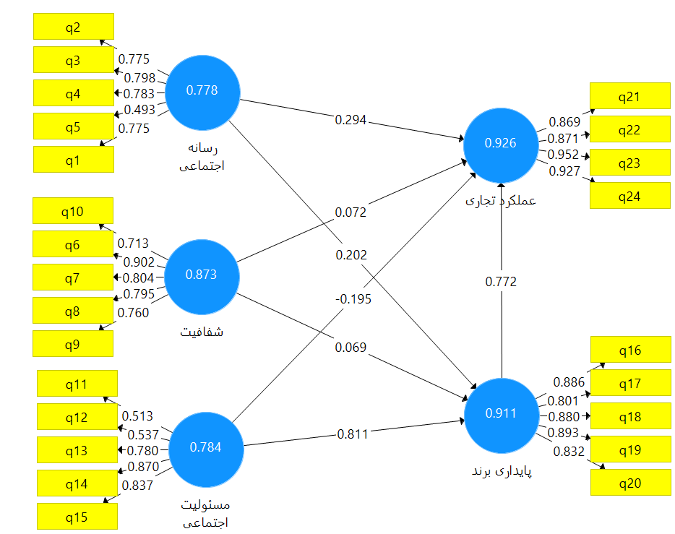
Social responsibility
Brand sustainability
Business performance
Transparency
Social media
Figure 2. The results of confirmative factorial analysis of research’s variables

Structural pattern test
The proposed conceptual model was investigated through the structural equation modeling method in order to investigate the effects of each of the variables on the business performance and the least partial squares were used for model estimation according to the research hypotheses. The tested model in table 4-8 has shown the relationship between research’s variables.
T-coefficients for research’s paths have been reported in figure 4-9. T- Coefficients are significant at level of 0.05. Coefficient estimation and variance of research’s variables have been reported I table 4.
Discussion and conclusion
According to analysis of data obtained from each hypothesis, the findings and analysis of research’s hypotheses are presented separately.
The first hypothesis: Social media has a significant effect on business performance.
According to table 4-7, obtained Pearson correlation coefficient between dynamism capabilities and organizational learning of Khorramshahr Customs is equal to 0.727. Also, the obtained significance level (0.000) is less than the estimated error level of 0.05. Therefore, dynamism capability has a significant effect on organizational learning of Khorramshahr Customs. Also, in Table 4-15, in the analysis of the dynamism-learning capabilities path, the level of significance is less than the level of error. This result is consistent with the results of the research Halpern (2012) and Weinberg and Pahlevan (2011).
The second hypothesis: Social media has a significant effect on brand sustainability.
According to table 4, obtained Pearson correlation coefficient between dynamism capabilities and organizational innovation of Khorramshahr Customs is equal to 0.273. Also, the obtained significance level (0.002) is less than the estimated error level of 0.05. Therefore, dynamism capability has a significant effect on organizational innovation of Khorramshahr Customs. Also, in Table 4-15, in the analysis of the dynamism-learning capabilities path, the level of significance is less than the level of error. This result is consistent with the results of the research Halpern (2012) and Weinberg and Pahlevan (2011).

Social media
Brand sustainability
Social responsibility
Transparency
Business performance
Figure 3. T-coefficient of research’s tested pattern

The third hypothesis: Transparency has a significant effect on business performance.
According to table 4, obtained Pearson correlation coefficient between organizational learning and organizational performance of Khorramshahr Customs is equal to 0.659. Also, the obtained significance level (0.000) is less than the estimated error level of 0.05. Therefore, organizational learning has a significant effect on organizational learning of Khorramshahr Customs. Also, in Table 4-15, in the analysis of the organizational performance capabilities path, the level of significance is less than the level of error. This result is consistent with the results of the Bergeron and Branshine (0227) and Patel et al (2003).

The fourth hypothesis: Transparency has a significant effect on brand sustainability.
According to table 6, obtained Pearson correlation coefficient between organizational innovation and organizational performance of Khorramshahr Customs is equal to 0.483. Also, the obtained significance level (0.000) is less than the estimated error level of 0.05. Therefore, organizational innovation has a significant effect on organizational significance of Khorramshahr Customs. Also, in Table 4, in the analysis of the organizational performance capabilities path, the level of significance is less than the level of error. So, research’s hypothesis is confirmed. This result is consistent with the results of the Bergeron and Branshine (0227) and Patel et al (2003).

References
- Andrews. R. (2007). Organizational Social Capital and Public Service Performance. Presented In 9th Publice -Management Research Conference, Tucson University of Arizona, pp: 1-41.
- Armstrong, M. (1993). A Handbook of Personnel Management Practice. 4th Ed. London: Kogan Page.
- Behn Bruce, K, D.; DeVries Delwyn, Lin Jing (2010), "The determinants of transparency in nonprofit organizations: An exploratory study”. Advances in Accounting, incorporating Advances in International Accounting, 26, 6–12.
- Boughelaf, Jamila 2011. Mobile phones, social media and the Arab, credemus Associates.
- Choudhury, N. (2014). "World Wide Web and Its Journey from Web 1. 0 to Web 4. 0.", International Journal of Computer Science and Information Technologies, 5 (6): 8096-8100.
- Clifton، Rita. and Maughan، Esther. (2000). The future of the brands: twenty-five visions. New York University Press and Interbrand.
- Cotterrell, R. (2000). “Transparency, mass media, ideology and community”. Cultural Values, 3,414–426.
- Cutt, J. Murry, V. (2002). Accountability and Effectiveness Evaluation in Non Profit Organization. Rouledge is an imprint of taylor francis group.
- Davcik, N. S., Vinhas da Silva, R., & Hair, J. F. (2015). Towards a unified theory of brand equity: conceptualizations, taxonomy and avenues for future research. Journal of Product & Brand Management, 24(1), 3-17.
- Deloitte (2014). Media Consumer Survey: Australian media and digital preferences (3rd ed.). Sydney: Deloitte Touche Tohmatsu.
- Eltantawi, Nahed & Wiest, Julie B. 2011. "Social Media in the Egyptian Revolution: Reconsidering Resource Mobilization Theory" Journal of Communication.
- Farooq, O., Payaud, M., Merunka, D., Valette-Florence, P. (2013). The Impact of Corporate Social Responsibility on Organizational Commitment: Exploring Multiple Mediation Mechanism. Journal of Business Ethics. 1-19.
- Florini, Ann. (2002). Increasing Transparency in Government, International Journal on World Peace 19: 3, 3-37.
- Georgieva, D. (2008). A Dutch opinion in catching the corruption: openness, transparency, social control. Retrieved on Sept, 14, 2008.
- Gond, J. p., Akremi, A., Igalens, J., Swaen, V. (2010). Corporate Social Responsibility Influence on Employees. Nottingham University Business School. International Centre for Corporate Social Responsibility.1-47.
- Hahn, V. (2008). “Committees, sequential voting and transparency”. Mathematical Social Sciences. 56, Issue 3, 366–385.
- He, H., Li, Y., & Harris, L., (2012), Social identity perspective on brand loyalty, Journal of Business Research, 65, 648–657.
- Kanagaretnom, k. (2010). Trust and reciprocity with transparency & repeated interactions Journal of Business Research G3, 241- 247.
- Kaplan, A. M., & Haenlein, M. (2010). Users of the world, unite! The challenges and opportunities of Social Media. Business Horizons, 53(1): 59-68.
- Kayaman, R., & Arasli. H. (2007), Customer based brand equity: evidence from the hotel industry, Managing Services Quality, 17 (1), 92-109.
- Lindsay, B. R., 2011. Social Media and Disasters: Current Uses, Future Options, and Policy Consideration. Congressional Research Services Report, No. 7-5700.
- Littlejohn, S. W. & Foss, K. A. (2009). Encyclopedia of communication theory, Los Angeles, Calif: Sage.
- Maignan, I., Ferrell, O. C., & Ferrell, L. (2005). A stakeholder model for implementing social responsibility in marketing. European Journal of Marketing, 39(9–10), 956–977.
- Nightingale, V. (2011). The handbook of media audiences. Malden: Wiley Blackwell.
- Obalola, Musa (2008), Beyond philanthropy: Corporate Social Responsibility in the Nigerian insurance industry, Social Responsibility Journal, Vol.4, No.4, PP. 538-548.
- Rawlins Brad, L. (2008)."Measuring the relationship between organizational transparency and employee trust". Public Relations Journal, 2(2), 254-274.
- Schau, J. H., Muniz, M. A. & Arnould, J. E. (2009). “How brand community practices create value”, Journal of Marketing, 73 (5), pp. 30–51.
- Stephens, Pamela J., Collective Criminality and Individual Responsibility: The Constraints of Interpretation (2014). Fordham International Law Journal,. 37(1): 501-506.
- Taprial, V. & Kanwar, P. (2012). Understanding Social Media, bookboon. com: Ventus Publishing Aps.
- Valand, T & Heide, M (2005), Corporate social Responsiveness: Exploring the Dynamics of Bad Episodes, European management journal, Vol. 23, No.5, pp. 495-506.

3/20/2018

