**Studying the relationship between social capital and knowledge management, organizational learning culture and financial performance of Social Security Organization Branch of Ahvaz**

Seyed Naji Sharifinia1, Mahmoud Gheytasvand2*

1.Department of Accounting, Persian Gulf International Branch, Islamic Azad university, khorramshahr, iran

2.Department of Accounting, Persian Gulf International Branch, Islamic Azad university, khorramshahr, iran

Corresponding Author: Mahmoud Gheytasvand2*

**Abstract:** The present study aimed to investigate the relationship between social capital and knowledge management, organizational learning culture and financial performance in Social Security Organization Branch of Ahvaz. The statistical population of this study have composed of all staff in the Social Security Organization Branch of Ahvaz. Whose number is equal to 200. Which according to Morgan’s table, the sample size is 127, which were selected by stratified relative method and questionnaires were distributed among them. All information of field requirements by Four questionnaires Questionnaire social capital, knowledge management Questionnaire, Questionnaire organizational learning culture, financial performance were collected. Questionnaire validity by technique content validity and Questionnaire reliability by technique a Cronbach's alpha test was confirmed. Structural equation modeling technique SEM (Software AMOS-22), were used to test the research hypotheses. Results showed between social capital and knowledge management, organizational learning culture and financial performance of Social Security Organization Branch of Ahvaz has a significant relationship.

[Seyed Naji Sharifinia, Mahmoud Gheytasvand. **Studying the relationship between social capital and knowledge management, organizational learning culture and financial performance of Social Security Organization Branch of Ahvaz.** *Researcher* 2018;10(3):46-52]. ISSN 1553-9865 (print); ISSN 2163-8950 (online). <http://www.sciencepub.net/researcher>. 6. doi:[10.7537/marsrsj100318.06](http://www.dx.doi.org/10.7537/marsrsj100318.06).

**Keywords:** social capital, knowledge management, organizational learning culture, financial performance

**Introduction**

Social capital as a new concept compared to physical and human sources plays a more important part in organizations and societies. Today, in sociology, economics and recently management and organization, social capital has been used widely. Social capital refers to links and communications among members of a network as a valuable source, insomuch that it helps to realize members’ goal through creating norms and mutual confidence. In the absence of social capital, other assets lose their effects and it causes problems for taking paths leading to economical and cultural development. Boosting confidence and communicative channels among people is called social capital which is considered as important capabilities and assets of an organization. Moreover, intelligent personnel are the most important capital in each organization. Using creativity power, creating modern institutional processes, new technologies as well as developing new products and services they guide organization to competitive advantage. Purposeful investment in training and developing knowledge management leads to innovative attempts in the organization. In a general speaking, information technology has faced human and especially various organizations to a situation which need modern tools and approaches proportion to current situation. In the past, organizations made attempts to seek information and knowledge, but today they are facing to a great deal of information and data, insomuch that, their classification, summarization and usage need to make measures as well as applying related hardware, software and technologies. Accordingly, the present research aims to study the link between social capital, knowledge management, institutional learning culture as well as financial performance in the Ahwaz social security organization.

Literature review

In a research called “relationship between social capital and level of organizational readiness to establish knowledge management among personnel of Mazandaran mental health institution”, Mehr Ara et al (2014), found that, there is a link between social capital and level of organizational readiness to establish knowledge management, insomuch that the more social capital increases, the more organizational readiness to establish knowledge management will increase as well.

In an article called “studying effects of knowledge management capabilities on financial performance of National Iranian Drilling Company” Karami Makvandi and Valikhani (2015), suggested that knowledge management capabilities have a marked effect on financial performance of National Iranian Drilling Company. Moreover, other aspects like, capabilities of knowledge management, technology support, structural focus, cultural learning, knowledge achievement, transformation, knowledge maintenance as well as knowledge transfer have substantial effect on the financial performance of National Iranian Drilling Company.

In a research, Chen and Lowern (2013) studied effect of social capital on accelerating knowledge transfer. They believe that one important point to transfer knowledge in multinational companies is capabilities of organization culture to speed up knowledge transfer and they state that, unreliability and improper communications are the most important reasons to decrease speed of knowledge transfer, especially modern sciences.

In an article called “effect of knowledge and social capital on organizational dynamic ability” Rejisen et al (2014) found that, knowledge management has a substantial effect on organizational dynamic ability, but social capital lacks such a marked influence.

In a research called “promotion of entrepreneurial bias with accumulation of social capital and knowledge management” Lio et al (2015) concluded that social capital affects knowledge management and its application. Moreover, social capital and entrepreneurial bias are completely balanced by knowledge management.

Hypotheses

Null hypothesis

There is a significant link between social capital and knowledge management, organizational learning culture as well as financial performance.

Alternative hypotheses

There is a significant link between social capital and knowledge management.

There is a significant link between social capital and organizational learning culture.

Population, sample and sampling method

Using a sample of 200 personnel working at Ahwaz social security organization research was performed. Given the Morgan table, population at least needs 127 staff selected by random sampling.

Conceptual research model

Given previous researches and literature review the following diagram 1 suggests the conceptual model.

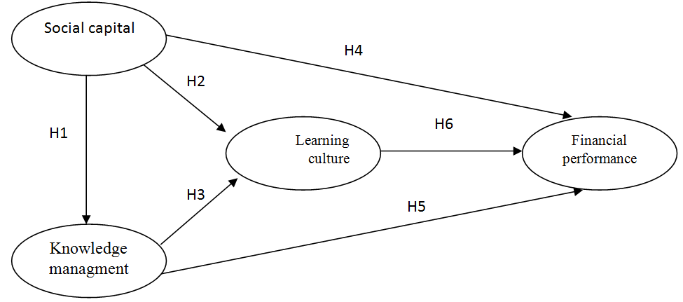

Diagram 1. Conceptual model (Biranvand et al, 2014)

Data analysis

* Validity of questionnaire was checked by content-face validity.
* Reliability of questionnaire was checked by Cronbach’s alpha technique in SPSS software.

Descriptive statistics

* Using SPSS softwar, descriptive analysis (demography), frequency distribution tables 1-4 and diagrams 2-4 were done.
* A KMO test was applied to check power of test and adequacy of sample size before hypotheses testing.
* A Shapiro Wilk test was done to analyze normality of data. Using SPSS software data were analyzed and type of related tests were determined.
* The null hypothesis tested using structural equation model (SEM), path analysis test (AMOS22 software).

Inferential statistics

To confirm research model, confirmatory factor analysis and structural equations in inferential statistics were used and hypotheses studied in 95% significance level.

KMO test

To study power of a test as well as to confirm adequacy of sample size, KMO test was used before investigating hypotheses. The test secures the first purpose of the factor analysis. It means that, it determines whether variances of research variables are affected by the common variance of some lateral and substantial factors.

Table 1. KMO test results

|  |  |  |
| --- | --- | --- |
| Aspects | KMO | Results |
| Social capital |  | Power of test and sample adequacy is accepted |
| Knowledge management |  | Power of test and sample adequacy is accepted |
| Organizational learning culture |  | Power of test and sample adequacy is accepted |
| Financial performance |  | Power of test and sample adequacy is accepted |

As it can seen in table 2, KMO level is more than 0.7 for all scales. Therefore, sample size is adequate.

Hypotheses testing

Five structural models practiced in “Amos-22” software were used to study research hypotheses. To assess model equations standard regression coefficients were used. Standard coefficients vary from -1 to +1. Hence, when critical ratio is more than 1.96, regression coefficient is in 95% significance level, but if the critical ratio is more than 2.75, the regression coefficient will be at 99% significance level. However, when significance level is less than 0.05, standard regression coefficient is in 95% significance level. But, when significance level is less than 0.01, standard regression coefficient is in 95% significance level.

Structural model of the null hypothesis

H0: there is not a significant relationship between social capital and knowledge management, organizational learning culture as well as financial performance.

H1: there is a significant relationship between social capital and knowledge management, organizational learning culture as well as financial performance.

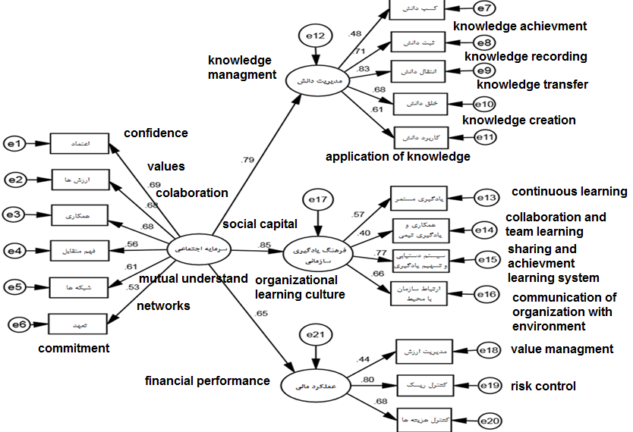

Diagram 2. structural model of the null hypothesis in standard estimation

According to practiced indicators of the total structural model, to study the null hypothesis the model is accepted.

Table 2. practiced indicators of null hypothesis structural model

|  |  |  |
| --- | --- | --- |
| Indicator | Optimum limit | structural model of the null hypothesis |
| X2/df | Three and less than three | 104/1 |
| RMR | Almost zero | 011/0 |
| GFI | 0.9 and more | 906/0 |
| AGFI | 0.9 and more | 954/0 |
| NFI | 0.9 and more | 908/0 |
| RFI | 0.9 and more | 981/0 |
| IFI | 0.9 and more | 936/0 |
| TLI | 0.9 and more | 917/0 |
| CFI | 0.9 and more | 935/0 |
| PNFI | 0.5 and more | 709/0 |
| PCFI | 0.5 and more | 741/0 |
| RMSEA | Less than 0.08 | 026/0 |

According to the structural model of the null hypothesis, the following table 3 suggests standard coefficients between variables and their significance level for studying the null hypothesis.

Table 3. Studying the null hypothesis

|  |  |  |  |  |  |  |  |  |
| --- | --- | --- | --- | --- | --- | --- | --- | --- |
| Relation | | Standard cofficient of knowledge managment | Standard cofficient of organizational learning culture | Standard cofficient of financial performance | Critical ratio of knowledge managment | Critical ratio of organizational learning culture | Critical ratio of financial performance | results |
| Social capital | knowledge management, organizational learning culture and financial performance | 0.79 | 0.85 | 0.65 | 4.502 | 5.129 | 3.680 | There is a significant positive relationship in 99% significance level |
| Null hypothesis is accepted |

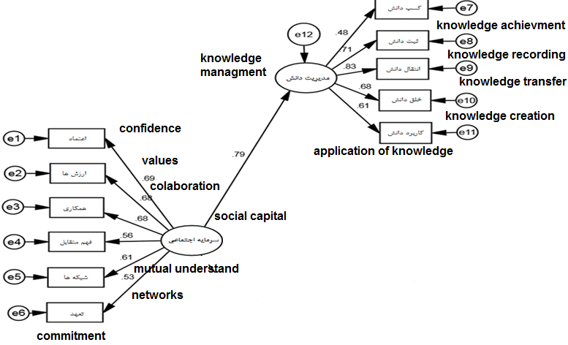

Diagram 3. structural model of the first alternative hypothesis in standard estimation

Given the table 4, results are summarized as follow:

There is a significant positive link between social capital and knowledge management, organizational learning culture as well as financial performance in 99% significance level in the Ahwaz social security organization (critical ratio 4.502, 5.129 and 3.680 was more than 2.57).

To specify above hypothesis it can be drawn that, social capital and knowledge management, organizational learning culture as well as financial performance are closely related to each other. It means that, the population enjoys results of higher correlation coefficients in the relation.

Social capital has a marked effect on the organizational learning culture.

Structural model of the first alternative hypothesis

H0: there is not a significant relationship between social capital and knowledge management in the Ahwaz social security organization.

H1: there is not a significant relationship between social capital and knowledge management in the Ahwaz social security organization.

According to practiced indicators of the total structural model, the model is accepted to study the null hypothesis. According to the first structural model, the following table 4 suggests standard coefficients between variables and their significance level to study the first alternative hypothesis.

Table 4. Studying the first alternative hypothesis

|  |  |  |  |  |  |
| --- | --- | --- | --- | --- | --- |
| Relation | | Standard cofficients | Critical ratio | R2 | results |
| Social capital | knowledge management, | 0.54 | 563.3 | 0.29 | There is a significant positive relationship in 99% significance level |
| The first alternative hypothesis is accepted |

As it can see in table 5, results are summarized as follow:

There is a significant positive link between social capital and knowledge management in 99% significance level in the Ahwaz social security organization (critical ratio 3.563 is more than 2.57).

Since standard coefficient is 0.54, so, social capital has a positive effect on knowledge management. It means that, the more social capital increases, the more knowledge management increases as well.

Social capital is lonely responsible for 29 percent of changes in knowledge management.

Structural model of the second alternative hypothesis

H0: there is not a significant relationship between social capital and organizational learning culture in the Ahwaz social security organization.

H1: there is a significant relationship between social capital and organizational learning culture in the Ahwaz social security organization.

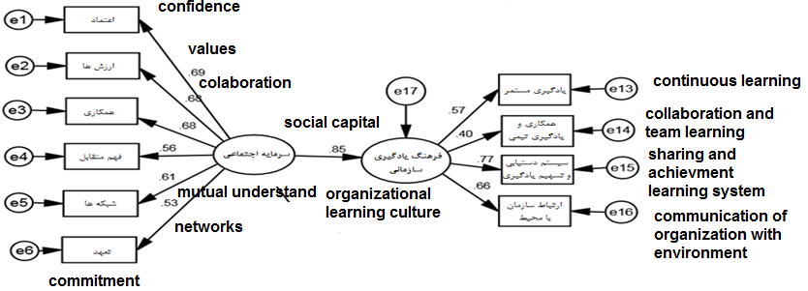

Diagram 4. structural model of the second alternative hypothesis in standard estimation

According to second structural model, table 5 suggests standard coefficients between variables and their significance level to study second alternative hypothesis.

Table 5. Studying second alternative hypothesis

|  |  |  |  |  |  |
| --- | --- | --- | --- | --- | --- |
| Relation | | Standard cofficients | Critical ratio | R2 | results |
| Social capital | organizational learning culture | 0.6 | 4.172 | 35 | There is a significant positive relationship in 99% significance level |
| second alternative hypothesis is accepted |

As it can be seen in table 5, results are summarized as follow:

There is a significant positive link between social capital and organizational learning culture in 99% significance level in the Ahwaz social security organization (critical ratio 4.172 is more than 2.57).

Since standard coefficient is 0.60, so, social capital has a positive effect on organizational learning culture. It means that, the more social capital increases, the more knowledge organizational learning culture increases as well.

Social capital is lonely responsible for 35 percent of changes in organizational learning culture.

Conclusion

Null hypothesis findings

There is a significant link between knowledge management, institutional learning culture as well as financial performance and social capital. Effect of independent variable, social capital, on dependent variables, knowledge management, institutional learning culture as well as financial performance, were 0.79, 0.85 and 0.62, respectively. Given coefficients are positive, so social capital has a positive effect on knowledge management, institutional learning culture as well as financial performance. It means that, the more social capital increases in the organization, the more knowledge management, institutional learning culture and financial performance will increase. Moreover, institutional learning culture has a substantial effect on social capital.

Findings of the first alternative hypothesis

There is a significant link between social capital and knowledge management in the Ahwaz Social Security Organization. Effect of the independent variable, social capital, on the dependent variable, knowledge management, was 0.54.

Additionally, social capital estimated 29 percent of changes in the knowledge management.

Moreover, as the path coefficient is 0.54, so it could be concluded that, there is a significant, positive link between social capital and knowledge management. Hence, increased social capital in the company develops knowledge management and vice versa. On other words, the more social capital increases, the more knowledge management will increase. Again, social capital estimated 29 percent of changes in the knowledge management.

Findings of the second alternative hypothesis

There is a significant positive link between social capital and institutional learning culture in Ahwaz social security organization. Effect of independent variable, social capital, on the dependent variable, institutional learning culture, was 0.6. Additionally, social capital estimated 35 percent of changes in the institutional learning culture. Moreover, as the path coefficient is 0.60, so it could be concluded that, social capital had a direct effect on the institutional learning culture in the Ahwaz social security organization. Research findings suggest a significant positive link between social capital and institutional learning culture. The findings are consistent with those in Ahmadi research (2012). Findings suggest that there is a positive, significant link between social capital and institutional learning culture, insomuch that, increased social capital develops institutional learning culture and vice versa.

**References**

1. Ahmadi, A. A. (2012). Role of the Social Capital in Effectiveness of Knowledge Management within Iran Khodro Diesel Company, International Journal of Learning & Development,2, (​1).
2. Alguezaui, S, Filieri, R. (2010). investigating the role of social capital in innovation: sparse versus dense network. Journal of Knowledge Management,14(6), 891-909.
3. Chen, J. Shiu, Lovvorn, AlS. (2011). The speed of knowledge transfer within multinational enterprises: the role of social capital. International Journal of Commerce and Management, 21(1), 46-62.
4. Cantner U, Joel K, & Schmidt T,. (2011). The effects of knowledge management on innovativesuc cess–an empirical analysis of German firms. Research Policy, 40(10), 1453-1462.
5. Fatehi, Z. (2011). Knowledge management (concepts, principles, goals and models). 1st ed. Tehran: Publications Office of Research and Risk Control Sepah.
6. Fukuyama, F. (1995). Trust: The Social Virtues and the Creation of Prosperity, Penguin Books, New York, NY. 1995.
7. Foley, M. W., & Edwards, B. (1997). Is it time to disinvest in social capital?, Journal of Public Policy, 19, 141 -147.
8. Fugate, B, S., Stank, T, P., & Mentzer, J. T. (2009). “Linking improved knowledge management to operational and organizational performance". Journal of Operations Management, 27, 247–264.
9. Goh, S., Richards, G. (1997); "Benchmarking the learning capabilities of organizations"; European Management Journal; 15(5), 575-583.
10. Halpern, D. (2005). Social Capital, Polity Press, Cambridge.
11. Hansen, Don R., and Maryanne M. Mowen. (2005). Management Accounting, 7th Edition. Singapore: South-Western, a Division of Thomson Learning Inc.
12. Hsiu‐Yen, H. (2009)."Organizational Learning Culture's Influence on Job Satisfaction, Organizational Commitment, and Turnover Intention among R & D Professionals in Taiwan during an Economic Downturn". Ph. D. thesis. St. Paul, MN: University of Minnesota.
13. Joo, J., & Lee, S, M. (2009). "Adoption of the Semantic Web for overcoming technical limitations of knowledge management systems". Journal of Expert Systems with Applications, 36, 7318–7327.
14. Johnson, S. G, Schnatterly, K, Hill, A. D. (2013). Board Composition Beyond Independence: Social Capital, Human Capital, and Demographics. Journal of Management, 39(1), 232-262.
15. Johnson, Scott G., Schnatterly, Karen., Hill, Aaron D. (2013). Board Composition Beyond Independence: Social Capital, Human Capital, and Demographics. Journal of Management, 39(1), 232-262.
16. Kaplan, M, Ogut, A, Mehmet, D. (2014) The relationship between organizational le Arning and financial performance, Journal of WEI Business and Economics, Volume 3 Number 2.
17. Kang, J, Kim, K, Henderson, W. (2002). Economic value added: Financial performance Measure. Journal of accounting, Volume10,48-60.
18. Liua, C. H, Lee, T. (2015). Promoting entrepreneurial orientation through the accumulation of social capital, and knowledge management, International Journal of Hospitality Management 46, 138–150.
19. Maurer, I, Bartsch, V., Ebers, M. (2011). The Value of Intra-organizational Social Capital: How it Fosters Knowledge Transfer, Innovation Performance, and Growth. Organization Studies, 32(2), 157-185.
20. Martınez, Ricardo., Jand, Francisco., Ruiz-Palomino, Pablo. (2012). Knowledge acquisition’s ediation of social capital-firm innovation. Journal of Knowledge Management, 16(1), 61-76.
21. Mary M, C, & Hari B. B,.)2003(. Examining The Link Between Managing knowledge, Organizational Learning and Performance. Organizational Learning and Knowledge.
22. Mihi Ramírez A, Morales V. J. G, & Rojas R. M,.)2011(. Knowledge Creation, Organizational Learning and Their Effects on Organizational Performance. Inzinerine Ekonomika-Engineering Economics, 22(3), 309-318.
23. Petrou, A, Daskalopoulou, I. (2013). Social capital and innovation in the services sector. European Journal of Innovation Management, 16(1), 50-69.
24. Paldam, M. (2000). Social capital: one or many? Definition and measurement, Journal of economic surveys, 14( 5), 629-2000,653.
25. Prewitt, V. (2003); "Leadership development for learning organizations"; Leadership & Organization Development Journal; 24(2), 58‐61.
26. Reijsen1, J. U, Helms, R, Batenburg, R & Foorthuis, R. (2014). The impact of knowledge management and social capital on dynamic capability in organizations, Knowledge Management Research & Practice advance online publication.
27. Seibert, S. Kraimer. M; Linden, Robert).​(2001)​. "A Social Capital Theory of Career Success". Academy of Management Journal, 44(2).
28. Tolbert, A. S., McLean, G. N., Myers, R. C. (2002); "Creating the global learning organization"; International Journal of Intercultural Relations;26, 463-472.
29. Wickramasinghe N,. (2006). Knowledge creation: a meta frame work. International Journal of Innovation and Learning, 3(5), 558-573.

3/18/2018