Surgical Outcome of Peripheral Neurectomy in Trigeminal Neuralgia: Retrospective Study

Osama Mohamed Elghannam, Mohamed Hasan Mansour and Yasser Elshaer

Department of Neurosurgery, Al-Azhar Faculty of Medicine, Al-Azhar University, Cairo, Egypt. elshaeryasser@gmail.com

Abstract: Numerous surgical procedures are mentioned for trigeminal neuralgia. Peripheral neurectomy was practiced for the first time in the 18th century with limited success. This procedure provides exact, complete, and long-lasting effect. It can be done on supraorbital, supratrochlear, infratrochlear, infraorbital nerve, and inferior alveolar, lingual, and mental nerves. Neurectomy of the peripheral branches of trigeminal nerve is the simplest, safest, and minimally invasive surgical method that can be carried out as an outpatient procedure under local anesthesia.
[Osama Mohamed Elghannam, Mohamed Hasan Mansour and Yasser Elshaer. Surgical Outcome of Peripheral Neurectomy in Trigeminal Neuralgia: Retrospective Study. Researcher 2018;10(3):7-10]. ISSN 1553-9865 (print); ISSN 2163-8950 (online). http://www.sciencepub.net/researcher. 2. doi:10.7537/marsrsj100318.02.

Keywords: Neurectomy, Trigeminal Neuralgia, Microvascular Decompression

1. Introduction:
Trigeminal neuralgia which also called Fothergill’s disease [1] is defined as “unilateral disorder characterized by brief electric shock-like pain, abrupt in onset and termination, and limited to the distribution of one or more divisions of the trigeminal nerve (2). The exact cause is unclear but believed to involve loss of the myelin around the trigeminal nerve. ⁽³⁾ This may occur due to compression from a blood vessel (superior cerebellar aretery) as the nerve exits the brain stem. The trigeminal nerve is a mixed cranial nerve responsible for sensory data such as tactition (pressure), thermoception (temperature), and nociception (pain) originating from the face above the jawline; it is also responsible for the motor function of the muscles of mastication, the muscles involved in chewing but not facial expression.
The main treatment of trigeminal neuralgia is medical treatment and it is usually effective in most cases. However, in some cases medical treatment may fail to relieve pain. After all options of conservative treatment have been exhausted, various surgical methods are used in order to relieve the pain. Peripheral neurectomy, even though is the oldest technique, is an ideal treatment of choice in those patients who are refractory to medical therapy and patients who cannot offered and indicated for invasive procedures in general anesthesia.

2. Patients and Methods:
Patients admitted at neurosurgery department of Al-Azhar university hospitals between (2015 to 2017). The diagnosis will based on a detailed history, clinical examination. All the patients will be investigated preoperatively with computerized tomography scanning or magnetic resonance imaging (MRI) to rule out the underlying structural abnormalities such as tumors. Inclusion criteria: All patients of either gender, presenting with the features of trigeminal neuralgia, especially those having persistent pain even after conservative treatment Exclusion criteria: 1-The patients below 35 years. 2-Previously treated cases with neurectomy.
Aim of study: The aim of this study is to evaluate the efficacy of peripheral neurectomy in 15 cases of trigeminal neuralgia as minimally invasive surgical treatment modality.

3. Results:
The results of the treatment were classified into four groups as follows:
Group 1: Excellent – pain relief was defined as total loss of pain without requiring a course of carbamazepine.
Group 2: Good – Occasional pain; no medication required.
Group 3: Fair – mild to moderate pain but relieved with modest amount of carbamazepine.
Group 4: Poor –pain relief as no significant relief even with carbamazepine treatment.
The neurectomies performed for various branches of trigeminal nerve were as follows: mental (n=5); Inferior Alveolar (n=6); Infraorbital (n=2). supraorbital (n=2). No case of the neurectomy of lingual and Supratrocheal nerve was recorded in this study. All neurectomies were performed as primary procedures in 14 cases and one after failed microvascular decompression.
Of the total patients, 9 (60%) were females and 6 (40%) were males (F:M = 1.5:1). The third division of trigeminal nerve (mandibular division/inferior alveolar nerve) was most commonly affected by the disease (6 patients [40%]). Mental nerve (5 patients [33.3% ]. The second division (maxillary division/infraorbital nerve) was involved in two patients (13.3%). The first division (supraorbital nerve) was affected in two patient (13.3%). The right side of the face was affected in ten patients (66.6%) whereas the left side in five patients (33.3%). Bilateral involvement was seen in none.
Following neurectomy, pain was relieved in all cases. The patients were followed up on 7th postsurgical day and thereafter, reviewed at 3 months, 6 months, 1 year, 1.5 years, 2 years, 3 years, or as soon as pain recurred. The pain-free period was thus evaluated. Postsurgical pain relief varied from 12 to 36 months.
10 patients (66.6%) had excellent pain relief lasting from 12 to 36 months without any medications. In two patients (13.3%), there was a good response in which there was an occasional pain but no medications were required.
In two patients (13.3) there was fair response as recurrence of pain after 14–31 months of the peripheral neurectomy occurred. These patients were again prescribed tablet carbamazepine but this time at a lower dose of 200 mg 12 hourly. Interestingly, those refractory to even higher doses of carbamazepine before neurectomy were relieved of symptoms at a low dose of carbamazepine in cases of pain recurrence following neurectomy. one patient (6.6%) had poor pain relief lasting from 12 to 36 months. He did not respond even to higher doses of carbamazepine. He were referred for further surgical interventions.

Table 1: Summary of demographic, follow up and outcome characteristic of 15 patients treated for trigeminal neuralgia
No. | Age (years) | sex | Site involved | Nerve involved | Follow up (years) | outcome
1 | 42 | F | Left | Inferior alveolar | 3 | excellent
2 | 50 | F | Right | Inferior alveolar | 3 | excellent
3 | 61 | F | Left | Mental | 2 | excellent
4 | 40 | M | Right | Supraorbital | 2 | bad
5 | 55 | F | Left | Mental | 2 | excellent
6 | 58 | F | Right | Inferior alveolar | 1 | good
7 | 41 | M | Left | Inferior alveolar | 1 | excellent
8 | 45 | M | Right | Infraorbital | 2 | excellent
9 | 50 | F | Right | Infraorbital | 2 | excellent
10 | 56 | M | Right | Mental | 2 | fair
11 | 44 | F | Left | Inferior alveolar | 3 | good
12 | 42 | F | Right | Mental | 3 | excellent
13 | 45 | M | Right | Inferior alveolar | 1 | excellent
14 | 60 | F | Right | Supraorbital | 0 | excellent
15 | 59 | M | Right | Mental | 3 | fair

4. Discussion:
Peripheral neurectomy was practiced for the first time in the 18th century with limited success. This procedure provides exact, complete, and long-lasting effect. It can be done on supraorbital, supratrochlear, infratrochlear, infraorbital nerve, and inferior alveolar, lingual, and mental nerves. Neurectomy of the peripheral branches of trigeminal nerve is the simplest, safest, and minimally invasive surgical method that can be carried out as an outpatient procedure under local anesthesia.
Most of the studies done for neurectomy were published 20–50 years ago. In 1965, Quinn and Weil reported a retrospective case series of 63 patients with 112 neurectomies. Pain relief period of 24–32 months was reported within a follow-up period of 0–9 years. In our study, the mean pain-free period was 24 months, which is not so varied with the above findings.
We found an average pain relief of 24 months in contrast to the study of Grantham and Segerberg with an average pain relief period of 33.2 months in a case series of 55 patients who had undergone 55 neurectomies with follow-up for 5 months to 8 years (4). The difference may be attributed by the fact that their study reported 33.2-month pain relief period just for supraorbital and infraorbital nerves, but the findings of our study are on an average for all the three divisions of trigeminal nerve.
There was a difference of 2.5 month pain-free period between our findings and Freemont's study. Freemont studied on 146 patients, of whom 26 patients underwent neurectomy and noted an average of 26.5 months of pain-free period following a single peripheral neurectomy (5). The difference may be attributed to the use of fatty tissue for packing the foramen following neurectomy in his study. In our study, the remnants of the nerve were just cauterized deep in the foramen. Our finding of patients with recurrence of pain being responsive to low doses of carbamazepine is consistent with Freemont's finding.
Comparable with the study of Agrawal and Kambalimath on 28 patients, our study also found low doses of tablet carbamazepine to be effective in patients having recurrence of pain following neurectomy (6).
Case report 1
45 years old male complained from severe cruciating shock like electrical pain affecting his rightcheek, upper teeth and upper jaw for 1.5 years. The pain increased by shaving and sometimes by eating solid food. The pain presented into recurrent attacks up to 30 attacks per day. patient was diagnosed as trigeminal neuralgia. patient was prescribed carbamazepine with initial dose of 200 mg orally per day but pain persisted. The dose was increased over one year to 800 mg per day with addition of pregabalin 300 mg orally per day but no satisfactory relief of her pain. MRI brain was done and showed no abnormality. The patient was offered peripheral neurectomy with full explanation of the procedure, benefits and potential complications and he agreed. Before surgery right inferior orbital nerve block was done leading to significant relief of his pain and it was confirmatory that his pain was due to inferior orbital nerve neuralgia.
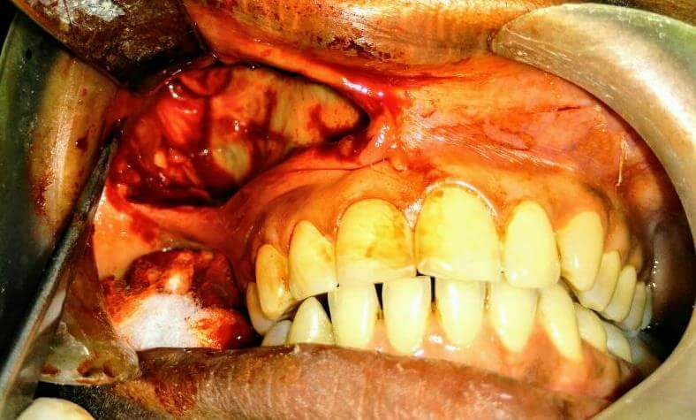
Figure 1: infraorbital nerve
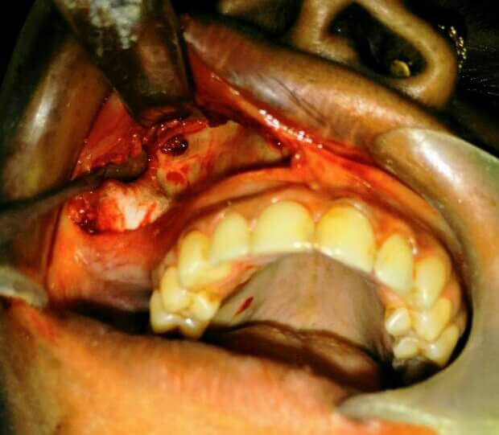
Figure 2: infraorbital foramen
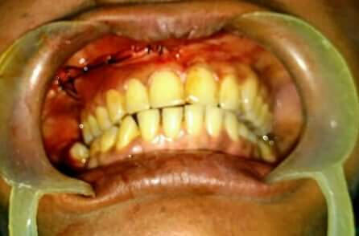
Figure 3: suturing of the incision

Procedure: Access to the infraorbital nerve was through intra oral approach. After taking upper vestibular incision infra orbital foramen was visualized and infra orbital nerve and its peripheral branches were identified and avulsed.
Case 2

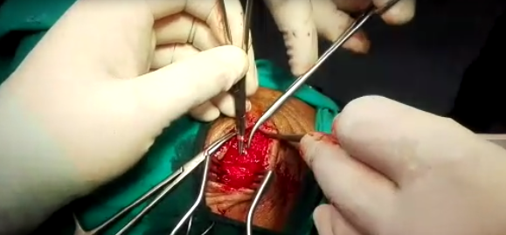
Figure 4: supraorbital incision

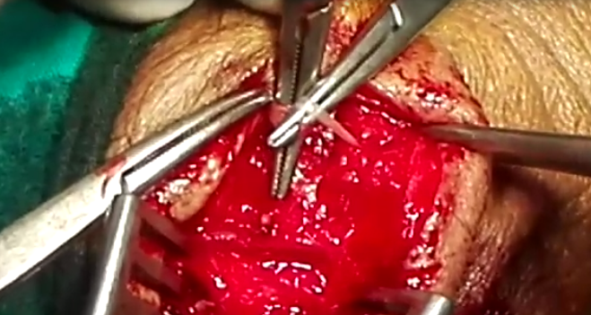
Figure 5: supraorbital nerve

A 60-year-old woman with a history of severe, shock like and throbbing pain in the right forehead region, lasting for 5–10 s that increased on talking, chewing, smiling, with strong breeze and cold water while washing his face since last 4 years. She was diagnosed as trigeminal neuralgia and underwent micro vascular decompression 2 year ago. After 6 month of surgery pain started to appear again. she received carbamazepine with initial dose of 200 mg daily but no improvement of pain. Dose was increased up to 800 mg daily with no satisfactory relief of pain. Patient offered micro vascular decompression but she refused. The patient was offered peripheral neurectomy with full explanation of the procedure, benefits and potential complications and she agreed.

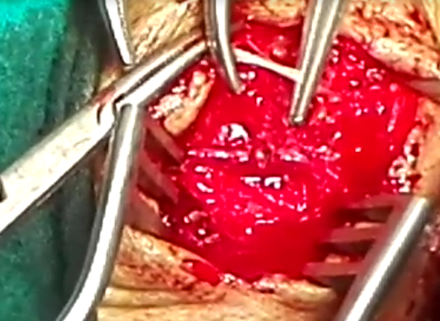
Figure 6: supraorbital nerve

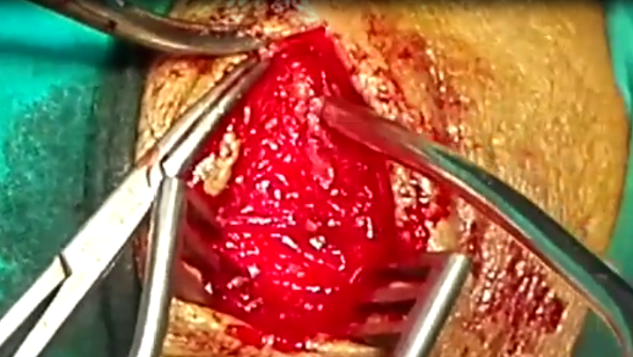

Figure 7: supraorbital foramen

Before surgery right supra orbital nerve block was done leading to significant relief of his pain and it was confirmatory that her pain was due to supra orbital nerve neuralgia.

Conclusion
TN is the most common neurologic cause of facial pain. Surgical treatment should only be considered if patients become refractory to drug therapy or adverse effect sufficient to mandate drug cessation. Peripheral neurectomy is a minimal invasive form of surgery, safe and effective for elderly patients, for those living in rural places who cannot avail major neurosurgical facilities and for those patients who are reluctant to major neurosurgical procedures. Although recurrence is associated with a considerable number of cases, peripheral neurectomy seems to be promising for a considerable period of time with minimal mortality, morbidity, and postoperative complications.

References:
- Stookey B, Ranshoff J (1959) Trigeminal neuralgia: its historyand treatment. Charles C Thomas, Springfield, 10–10.
- Stiles MA, Mitrirattanakul S, Evans JJ. Clinical Manual of Trigeminal Neuralgia. 1st ed. United Kingdom: Informa Healthcare; 2007. p. 102.
- Obermann, Mark (2010-03-01). Treatment options in trigeminal neuralgia". Therapeutic Advances in Neurological Disorders. 3 (2): 107–115.
- Grantham EG, Segerberg LH. An evaluation of palliative surgical procedures in trigeminal neuralgia. J Neurosurg 1952;9:390-4-.
- Freemont AJ, Millac P. The place of peripheral neurectomy in the management of trigeminal neuralgia. Postgrad Med J 1981;57:75-6.
- 6-Agrawal SM, Kambalimath DH. Peripheral neurectomy: A minimally invasive treatment for trigeminal neuralgia. A retrospective study. J Maxillofac Oral Surg 2011;10:195-8.

3/5/2018

